In-silico Study of Novel Dimeric flavonoid (OC251FR2) from the Seeds of Garcinia kola Heckel (Clusiaceae) Against Alpha Estrogen Receptor (ER-α) of Breast cancer
Tunmise T. Eugene-Osoikhia¹*, Nnenna W. Odozi¹, Emmanuel O. Yeye ², Mohammed Isiaka¹, Ibrahim A Oladosu¹
¹Department of Chemistry, University of Ibadan, Oyo State, Nigeria.
²Department of Basic Sciences, Adeleke University, Ede, Osun State, Nigeria.
*Corresponding author: kemitunmise@yahoo.co.uk, +2348030487007
Insilico Pharmacology

Figure S1: ¹H-NMR spectrum of OC251FR2
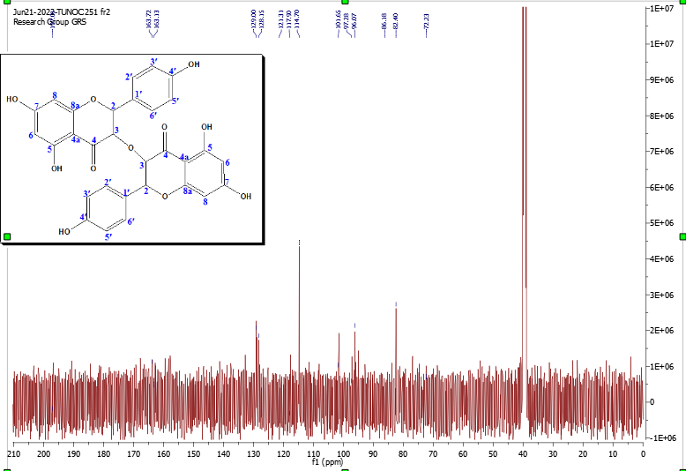
Figure S2: ¹³C-NMR spectrum of OC251FR2

Figure S3: Expanded ¹³C-NMR spectrum of OC251FR2
Figure S4: The HMBC spectrum of OC251FR2

Figure S5: The ¹H-¹H COSY spectrum of OC251FR2

Figure S6: HSQC spectrum of OC251FR2

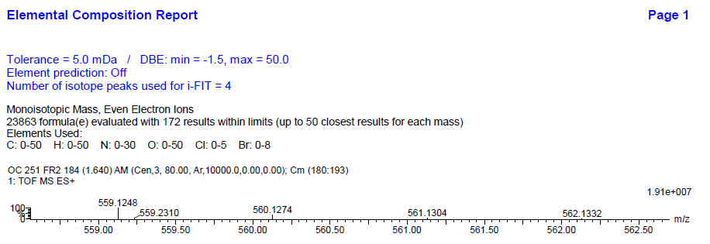
Figure S7a: The mass spectrum of OC251FR2
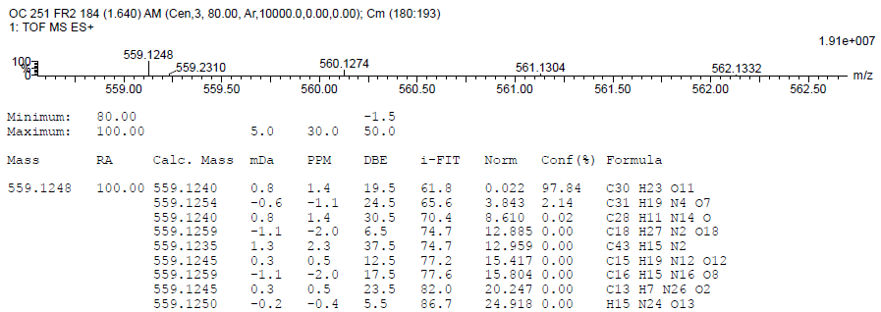
Figure S7b: The mass spectrum of OC251FR2

Figure S8: NOESY spectrum of OC251FR2

