Supplemental Figure 1. Peak Exercise Metabolic Equivalent of Task (MET) by Patient and Session. The pre-test was conducted at session 1 and the post-test was at session 24. Data is missing for Patient A’s 23rd session.

Supplemental Figure 2. Heart Rate by Patient and Session. The pre-test was conducted at session 1 and the post-test was at session 24. Data is missing for Patient A’s 23rd session. The lightest shade indicates pre-exercise heart rate at rest, the medium shade represents peak exercise hear rate, and the darkest shows heart rate five-minutes post exercise.

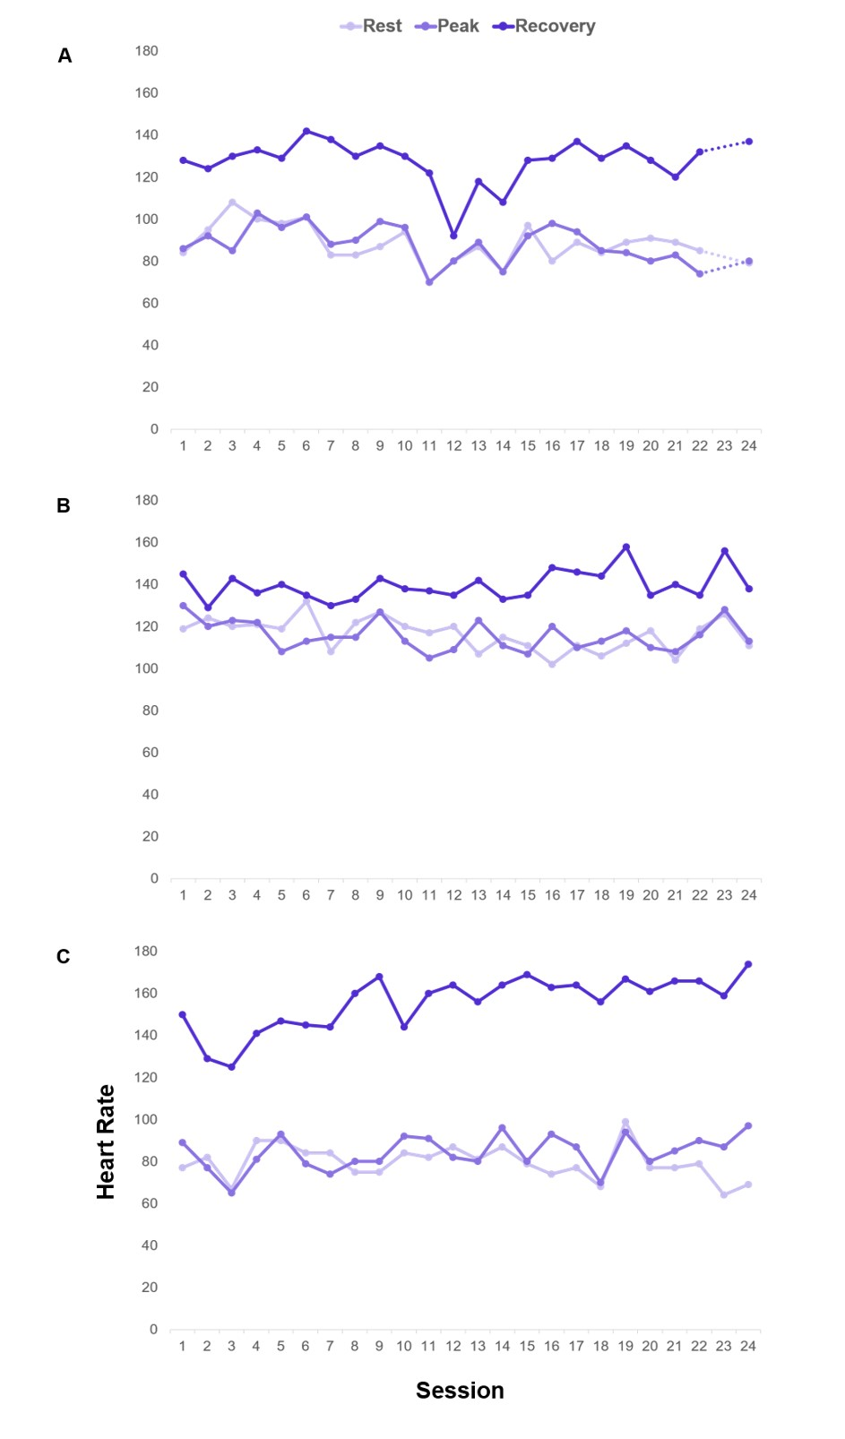

Supplemental Figure 3. Systolic and Diastolic Blood Pressure Readings by Patient and Session. The pre-test was conducted at session 1 and the post-test was at session 24. Data is missing for Patient A’s 23rd session. The red lines represent systolic readings and purple lines represent diastolic blood pressure (mm Hg). The lightest shade indicates pre-exercise blood pressure at rest, the medium shade represents peak exercise blood pressure, and the darkest shows blood pressure five-minutes post exercise.

