Table 4
CBZ and Its Main Degradation Products
Serial Number | Molecular Formula | Molecular Weight | Structural Formula
P-237 | C₁₅H₁₂N₂O | 237
P1-267 | C₁₅H₁₀N₂O₃ | 267
P2-253 | C₁₅H₁₂N₂O₂ | 253
P3-284 | C₁₅H₁₂N₂O₄ | 284 | 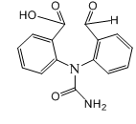
P4-208 | C₁₄H₉NO | 208
P5-196 | C₁₃H₉NO | 196
P6-224 | C₁₄H₉NO₂ | 224
P7-180 | C₁₃H₉N | 180
P8-271 | C₁₅H₁₄N₂O₃ | 271

