Preparation and characterization of g-C₃N₄ @ L-arginine as a highly -efficient and recyclable catalyst for the synthesis of 1, 4-dihydropyridine, 4H-chromene, and 2, 3-dihydro quinazoline derivatives
Zeinab Tajik, Hossein Ghafuri ^{*a}, Nastaran Ghanbari, Payman Hanifehnejad

Catalysts and Organic Synthesis Research Laboratory, Department of Chemistry, Iran University of Science and Technology, Tehran 16846‑13114, Iran.
Email: ghafuri@iust.ac.ir

Page | Content
S1 | Title page
S2 | General procedure for preparation of the bulk g-C₃N₄ and g-C₃N₄ nanosheets
S2 | General procedure for preparation of the g-C₃N₄@L-arginine
S4 | Characterization of the g-C₃N₄@L-arginine
S9 | Chemical characterization of Chemical characterization Ethyl 2, 7, 7-trimethyl-5-oxo-4-(4-hydroxylphenyl)-1,4,5,6,7,8-hexahydroquinoline-3-carboxylate (5c)
S10 | Chemical characterization of Ethyl 1,4,7,8-tetrahydro-2,7,7-trimethyl-4-(4-nitrophenyl)-5(6H)-oxoquinoline-3-carboxylate (5d)
S12 | Chemical characterization of 2-phenyl-2, 3-dihydro-4(1H)-quinazolinone (13a)
S13 | Chemical characterization of 2-(4-chloro-phenyl)-2, 3-dihydro-1H-quinazoline-4-one (13b)
S15 | Chemical characterization of 2-amino-4-(4-nitrophenyl)-7,7-dimethyl-5-oxo-5,6,7,8-tetrahydro-4H-chromene-3-carbonitrile (9c)

Preparation of bulk g-C₃N₄ and g-C₃N₄ nanosheets
For the synthesis of bulk g-C₃N₄, the melamine was heated at 550 ℃ temperature in a furnace at the ramp 2.5 ℃ min ⁻¹ in static air for 4 h. A yellow powder was obtained, which was grounded with a ball mill. For the synthesis of g-C₃N₄ nanosheets, first bulk g-C₃N₄ (1.0 g) was stirred in H₂SO₄ (20 mL) at 90 ℃ for 5 h, then diluted with ethanol (200 mL) and was stirred again at room temperature for 2 h. The resulting product was dispersed in the 100.0 mL of water/isopropanol (1:1) and sonicated for 6 h. Finally, the formed suspension was centrifuged (5000 rpm) for g-C₃N₄ nanosheets separation.
Preparation of g-C₃N₄@L-arginine
Nanosheets g-C₃N₄ (1.0 g) were dispersed in dry toluene (20.0 mL) then, 1,3dibromopropane (2.0 mL) was added to the solution, and the reaction mixture was refluxed under N₂ atmosphere for 24 h. Finally, the product was filtered and was washed with ethyl acetate, and dried at room temperature. The resulting product was solved in a mixture of water and methanol (1:1) then, L-arginine (1mmol), K₂CO₃ (1.0 mmol), and NaI (1.0 mmol) were added. The solution was stirred at room temperature for 24h; the reaction mixture was washed with water and methanol and dried at room temperature.

Scheme S1. Synthesis of g-C₃N₄@L-arginine

Characterization of the g-C₃N₄@L-arginine

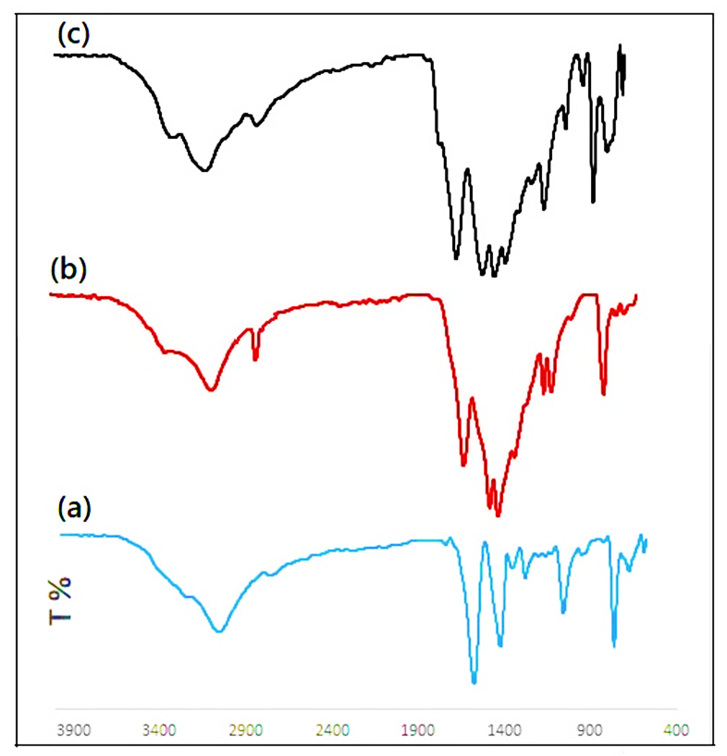

Figure 1. FT-IR spectra of (a) nanosheets g-C₃N₄, (b) modified g-C₃N₄, (c) g-C₃N₄@L-arginine.

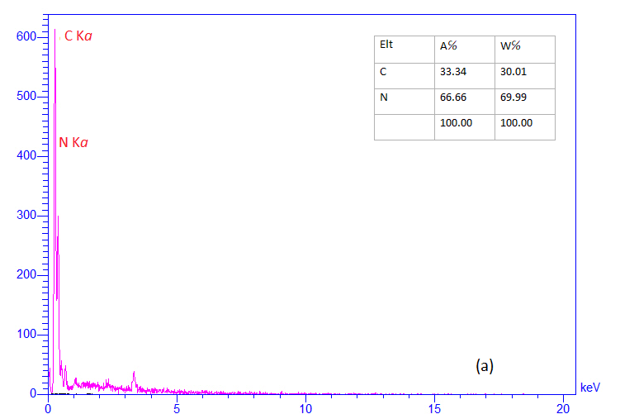
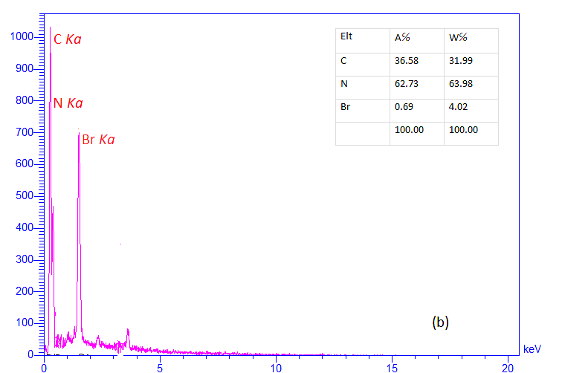
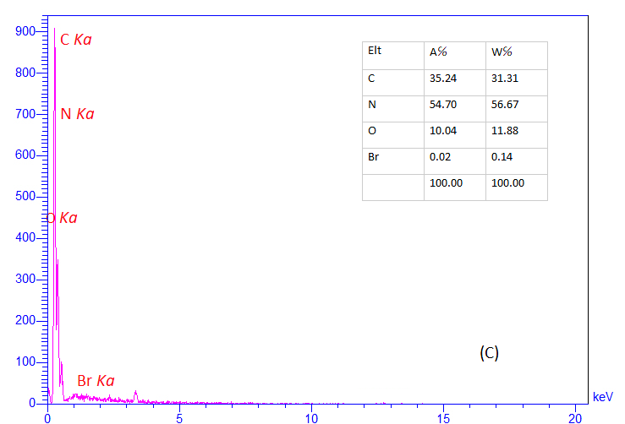
Figure 2. EDX spectrum of (a) nanosheets g-C₃N₄, (b) modified g-C₃N₄, (c) g-C₃N₄@L-arginine.

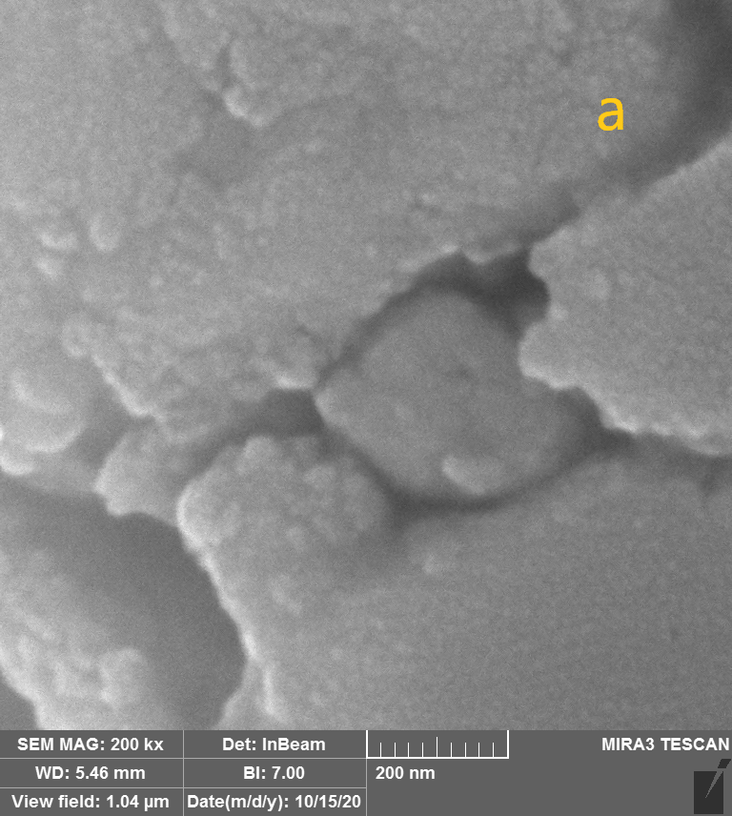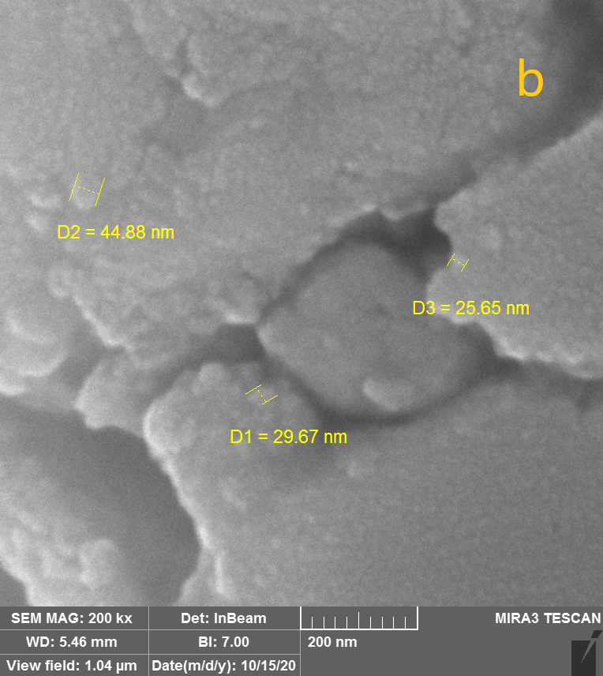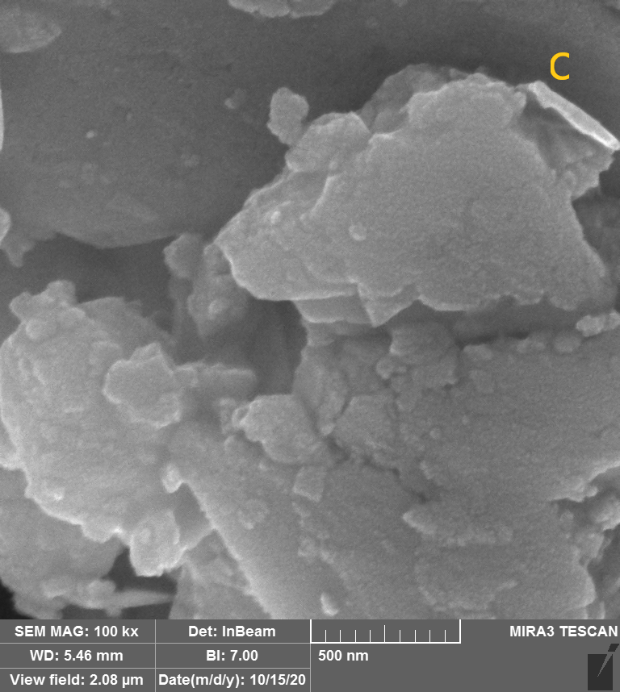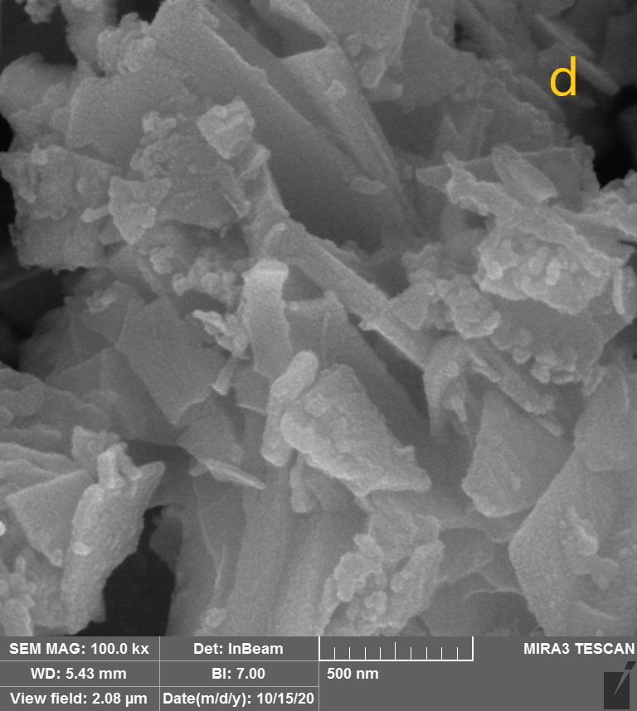
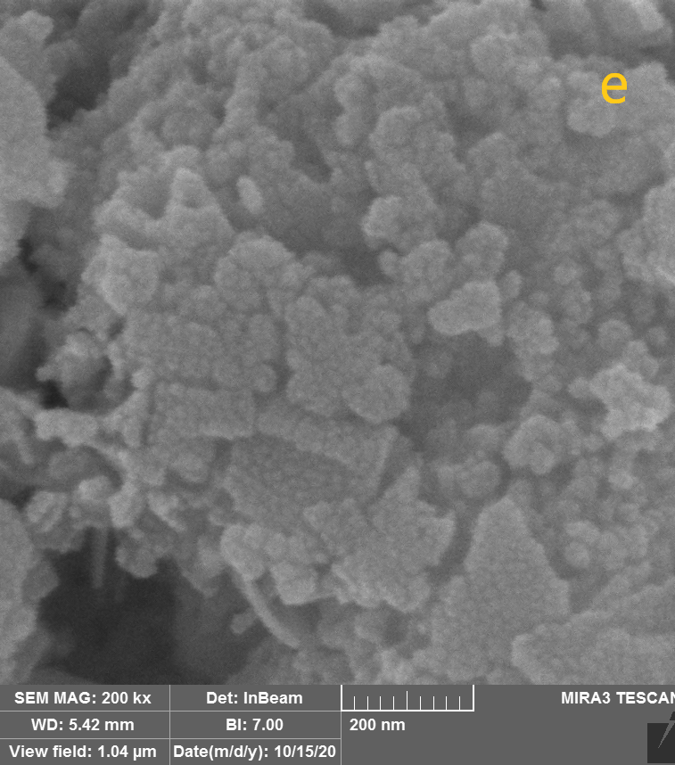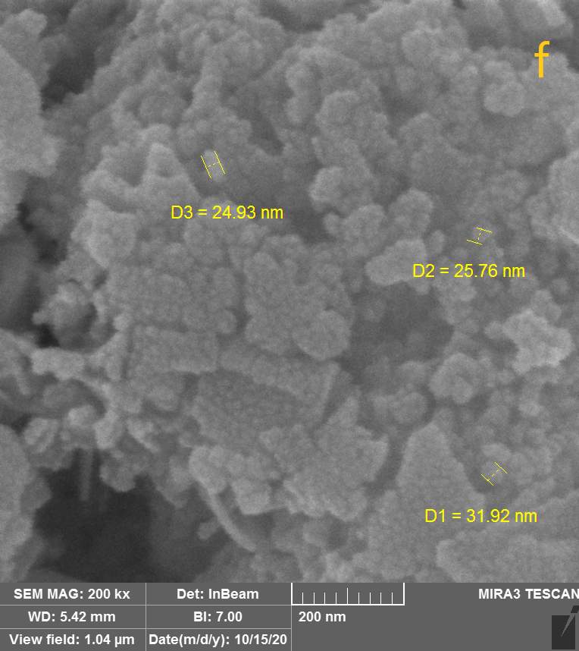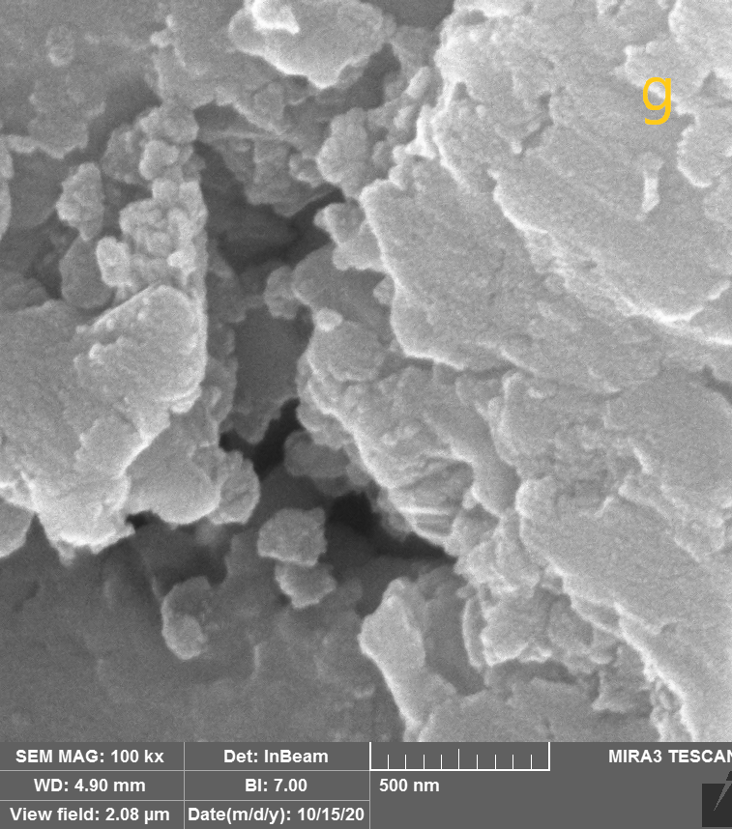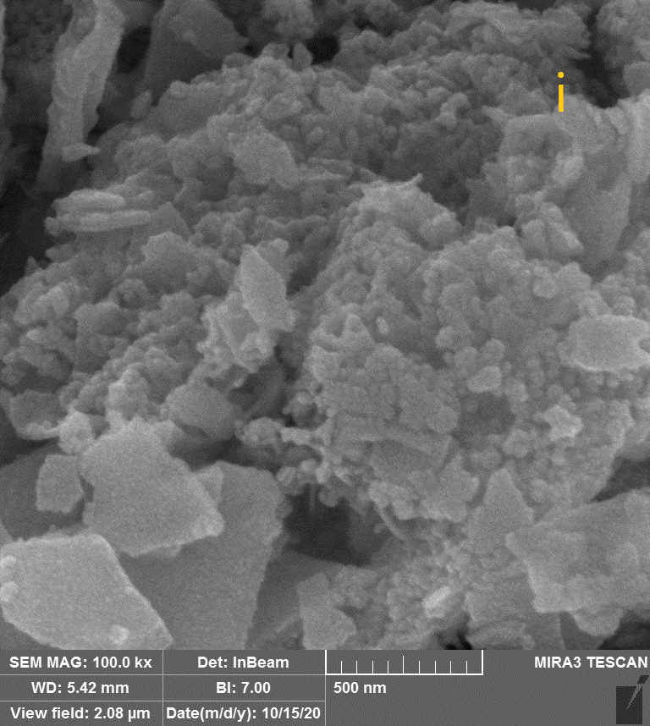
Figure 3. FE-SEM image of nanosheets g-C₃N₄ (a, b, c, and d), and g-C₃N₄@L-arginine (e, f, g, i).

Figure 4. XRD pattern of (a) nanosheets g-C₃N₄, (b) g-C₃N₄@L-arginine.

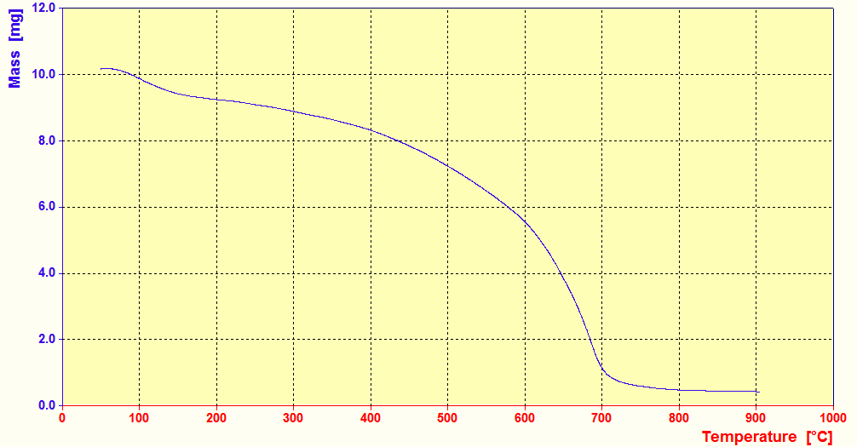
Figure 5. TGA analysis of g-C₃N₄@L-arginine.

General procedure for the synthesis of 1, 4-dihydropyridine derivatives
A mixture of aldehyde (1.0 mmol), ethyl acetoacetate (1.0 mmol), dimedone (1.0 mmol), ammonium acetate (1.0 mmol), g-C₃N₄@L-arginine (20.0 mg), and ethanol (2.0 mL) was added in a round bottom flask and refluxed at 70 ℃. When the reaction was completed (was monitored by TLC), the catalyst was separated by filtration.
General procedure for the synthesis of 2,3-dihydro quinazoline derivatives
In a round bottom flask, aldehyde (1.0 mmol), isotonic anhydride (1.0 mmol), ammonium acetate (2.0 mmol), and g-C₃N₄@L-arginine (20.0 mg) were added and refluxed in ethanol (2.0 mL) at 70℃. After completion of the reaction (was monitored by TLC), the catalyst was removed by filtration and washed with ethanol.

General procedure for the synthesis of 4H-chromene derivatives
In a usual experiment, in a round bottom flask were added aldehyde (1.0 mmol), dimedone (1.0 mmol), malononitrile (1.0 mmol), g-C₃N₄@L-arginine (20.0 mg), and ethanol (2.0 mL). Then refluxed at 70 ℃ until the reaction was completed (was monitored by TLC), at last, catalyst separation and crystallization was performed as above.

1. Selected Spectral Data:

  - Ethyl 2, 7, 7-trimethyl-5-oxo-4-(4-hydroxylphenyl)-1,4,5,6,7,8-hexahydroquinoline-3-carboxylate (5c)

FTIR (KBr, cm-1): 3270, 3194, 3071, 2957, 1678, 1645, 1481, 1377, 1214 cm-1. 1H NMR (500 MHz, DMSO): δ H (ppm)= 0.85(s, 3H, CH3), 1.0(s, 3H, CH3), 1.13(t, 3H, CH3), 1.9-2.41(m,4H, 2CH2), 2.25(s, 3H, CH3), 3.95-3.99(q, 2H, OCH2), 4.73(s, 1H, Ar-CH), 6.54(d, 2H, Ar-H), 6.93(d, 2H, Ar-H), 8.95(s, 1H, NH), 9.01(s,1H, OH).

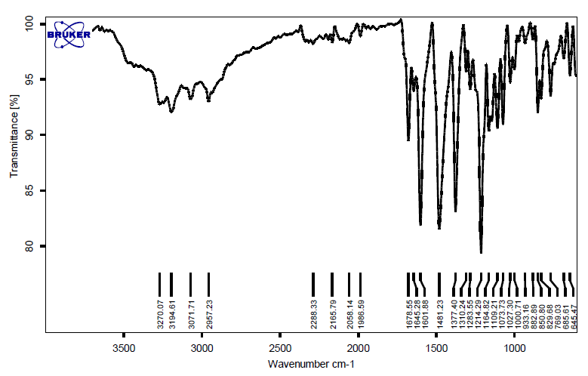
Fig. S1. FT-IR spectrum of the Ethyl 2, 7, 7-trimethyl-5-oxo-4-(4-hydroxylphenyl)-1,4,5,6,7,8-hexahydroquinoline-3-carboxylate (5c)

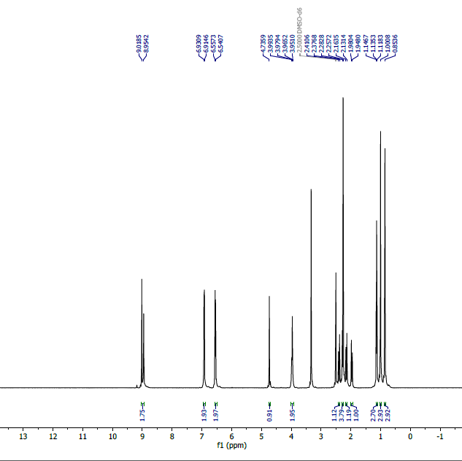

Fig. S2. ¹HNMR spectrum of the Ethyl 2, 7, 7-trimethyl-5-oxo-4-(4-hydroxylphenyl)-1,4,5,6,7,8-hexahydroquinoline-3-carboxylate (5c)

  - Ethyl 1,4,7,8-tetrahydro-2,7,7-trimethyl-4-(4-nitrophenyl)-5(6H)-oxoquinoline-3-carboxylate (5d)
FTIR (KBr, cm-1): 3276, 3210, 3076, 2969, 2902, 1703, 1641, 1530, 1379 cm-1. 1H NMR (500 MHz, DMSO): δH (ppm)= 0.83(s, 3H, CH3), 1.01(s, 3H, CH3), 1.11(t, 3H, CH3), 1.96-2.46(m,4H, 2CH2), 2.31(s, 3H, CH3), 3.93-4.0(m, 2H, OCH2), 4.97(s, 1H, Ar-CH), 7.5-7.61 (m, 4H, Ar-H), 7.97(s, 1H, NH), 9.23(s,1H, OH).
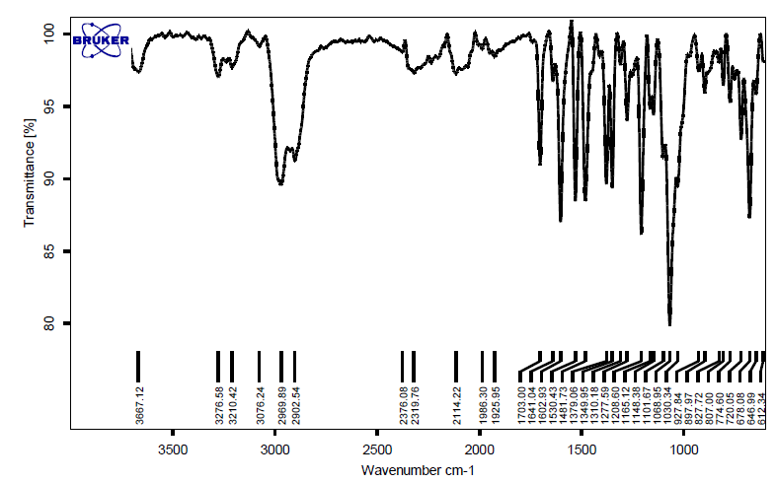

Fig. S3. FT-IR spectrum of the Ethyl 1,4,7,8-tetrahydro-2,7,7-trimethyl-4-(4-nitrophenyl)-5(6H)-oxoquinoline-3-carboxylate (5d)

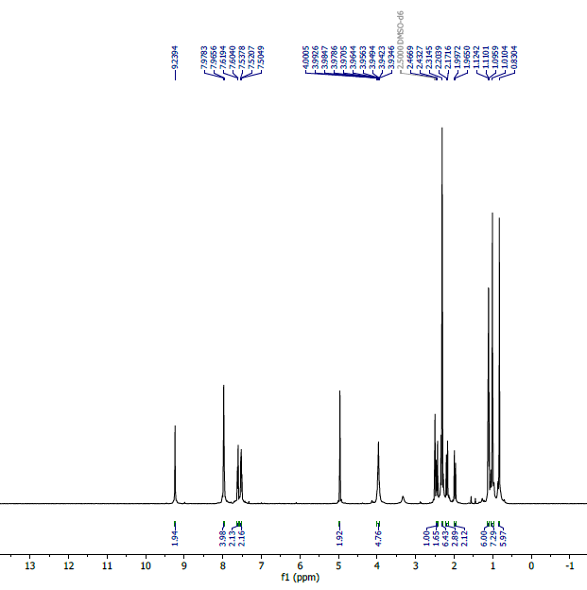
Fig. S4. ¹HNMR spectrum of the Ethyl 1,4,7,8-tetrahydro-2,7,7-trimethyl-4-(4-nitrophenyl)-5(6H)-oxoquinoline-3-carboxylate (5d)

  - 2-phenyl-2, 3-dihydro-4(1H)-quinazolinone (13a)
FTIR (KBr, cm-1): 3300, 3176, 2981, 1651, 1610, 1507, 1440, 1385, 745 cm-1. 1H NMR (500 MHz, DMSO): δ H (ppm)= 5.75(s, 1H, CH), 6.67(t, 1H, Ar-H), 6.74(d, 1H, Ar-H), 7,1(s, 1H, NH), 7.23(t, 1H, Ar-H), 7.34(t, 1H, Ar-H), 7.38(t, 1H, Ar-H), 7.49(d, 1H, Ar-H), 7.60(d, 1H, Ar-H), 8.27(s, 1H, CONH).
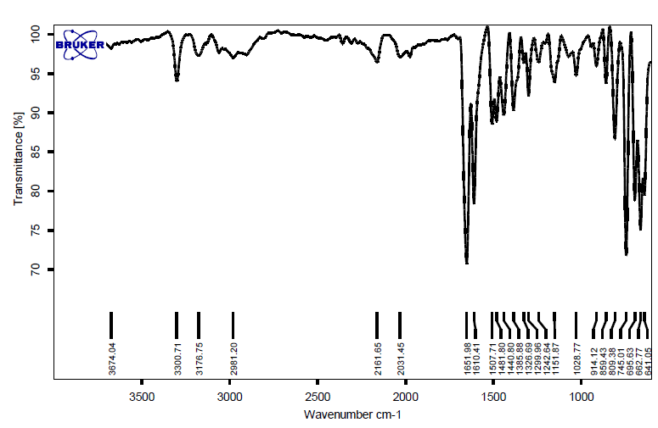
Fig. S5. ¹HNMR spectrum of the 2-phenyl-2, 3-dihydro-4(1H)-quinazolinone (13a)
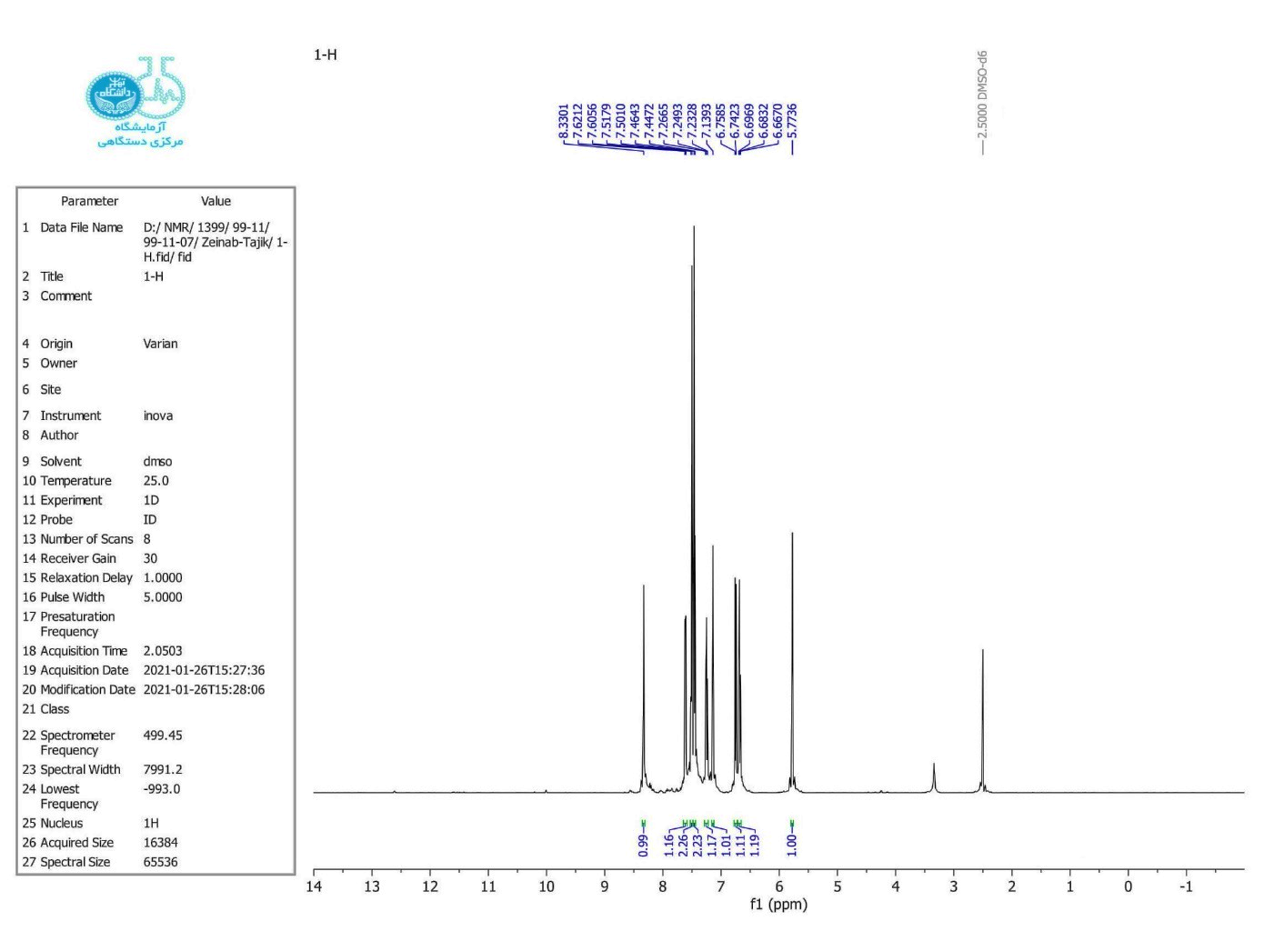
Fig. S6. 1HNMR spectrum of the 2-phenyl-2, 3-dihydro-4(1H)-quinazolinone (13a)
  - 2-(4-chloro-phenyl)-2, 3-dihydro-1H-quinazoline-4-one (13b)
FTIR (KBr, cm⁻¹): 3305, 3184, 3062, 1654, 1606, 1431, 1090, 749 cm⁻¹. ¹H NMR (500 MHz, DMSO): δ H (ppm)= 5.77(s, 1H, CH), 6.68(t, 1H, Ar-H), 6.74(d, 1H, Ar-H), 7,1(s, 1H, NH), 7.24(t, 1H, Ar-H), 7.45(d, 1H, Ar-H), 7.50(d, 1H, Ar-H), 7.61(d, 1H, Ar-H), 8.27(s, 1H, CONH).
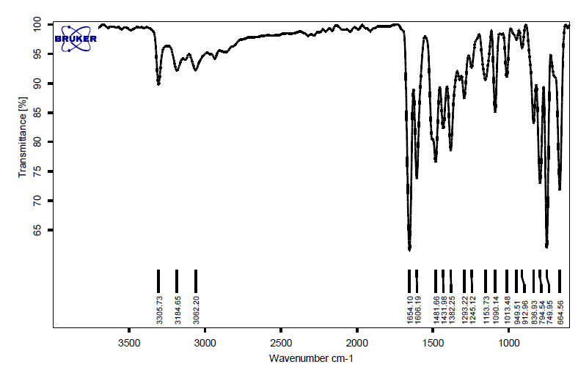
Fig. S7. 1HNMR spectrum of the 2-(4-chloro-phenyl)-2, 3-dihydro-1H-quinazoline-4-one (13b)

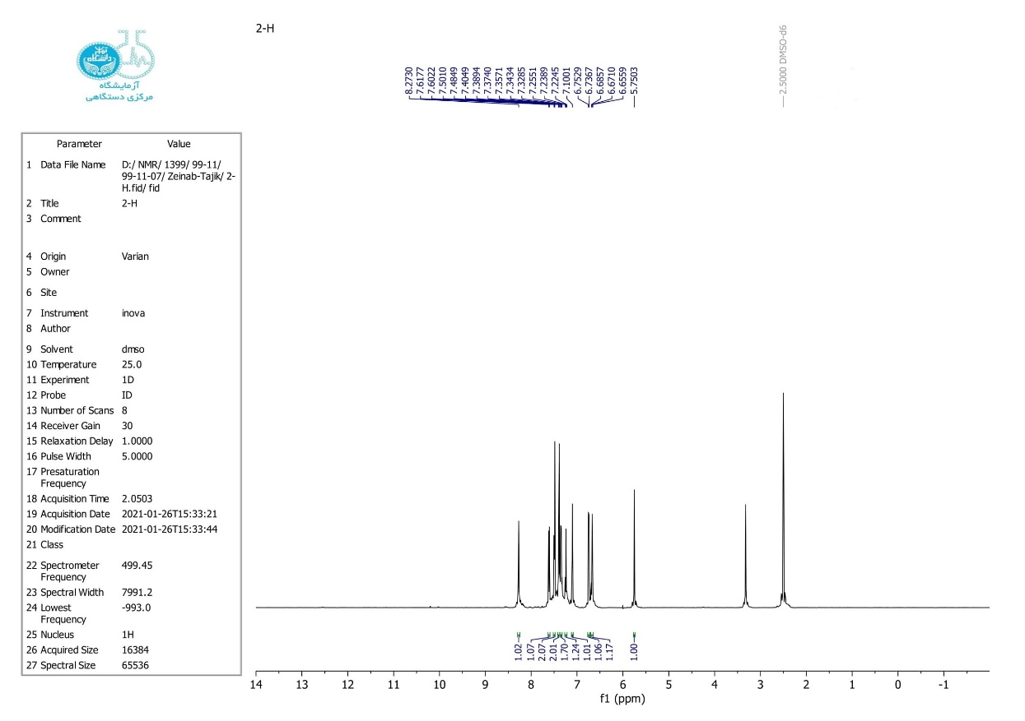
Fig. S7. 1HNMR spectrum of the 2-(4-chloro-phenyl)-2, 3-dihydro-1H-quinazoline-4-one (13b)
  - 2-amino-4-(4-nitrophenyl)-7,7-dimethyl-5-oxo-5,6,7,8-tetrahydro-4H-chromene-3-carbonitrile (9c)
FTIR (KBr, cm-1): 3403, 3312, 3170, 2969, 2881,2181, 1668, 1626, 1517, 1345, 856 cm-1.1 H NMR (500MHz, DMSO): δ H (ppm)= 0.95(s, 3H, CH3), 1.04(s, 3H, CH3), 2.09-2.53(m, 4H, 2CH2), 4.36(s, 1H, CH), 7.1(s, 2H, NH2), 7.43-8.17(m, 4H, Ar-H).
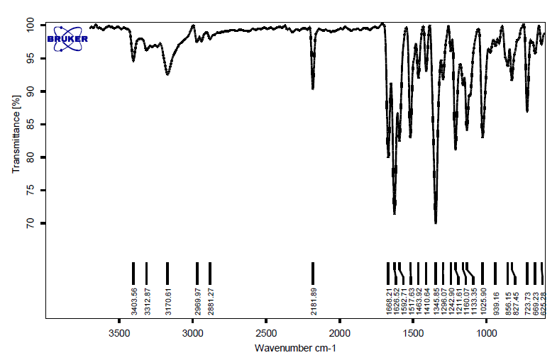

Fig. S8. 1HNMR spectrum of the 2-amino-4-(4-nitrophenyl)-7,7-dimethyl-5-oxo-5,6,7,8-tetrahydro-4H-chromene-3-carbonitrile (9c)
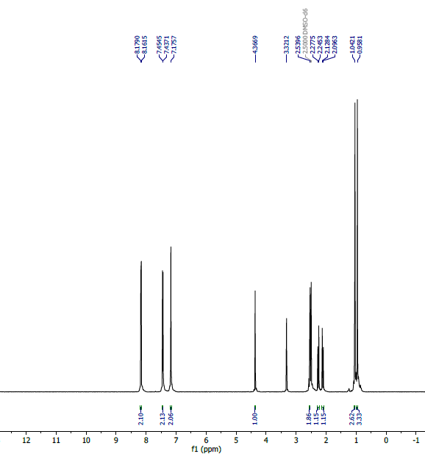
Fig. S9. 1HNMR spectrum of the 2-amino-4-(4-nitrophenyl)-7,7-dimethyl-5-oxo-5,6,7,8-tetrahydro-4H-chromene-3-carbonitrile (9c)

