SUPPORTING INFORMATION

Arbuscular mycorrhizal fungi richness reduces soil N₂O emissions while increasing maize grain nitrogen uptake

Chenxi Zhang ^{1,2, †}, Cheng Feng ^{1†}, Ruofei Wang ¹, Bhoopander Giri ³, Xing Li ¹, Frank S Gilliam ⁴, Ziwei Zhang ¹, Minghui Tian ^{1,2}, Lei Cheng ⁵, Xuelin Zhang ^{1,}*

¹ College of Agronomy, Henan Agricultural University, Co-construction State Key Laboratory of Wheat and Maize Crop Science, China
² Lincang Branch Company of Yunnan Tobacco Company, Lincang, China
³ Department of Botany, Swami Shraddhanand College, University of Delhi, Delhi, India
⁴ Department of Earth and Environmental Sciences, University of West Florida, Pensacola, the United States of America
⁵ MOE Key Laboratory of Biosystems Homeostasis & Protection, College of Life Sciences, Zhejiang University, Hangzhou, China

Corresponding author.
Xuelin Zhang, Email: xuelinzhang1998@163.com (X. Zhang).

Type of paper: Primary research article
†These authors contributed equally to this work and should be considered co-first authors.
SUPPLEMENTARY FIGURES
Figure S1. The pot experiments were carried out with different AMF treatments, and gas collection chamber was inserted into the pot during the periods of maize growth.
Figure S2. Dynamics of soil N₂O emission during maize growth periods.

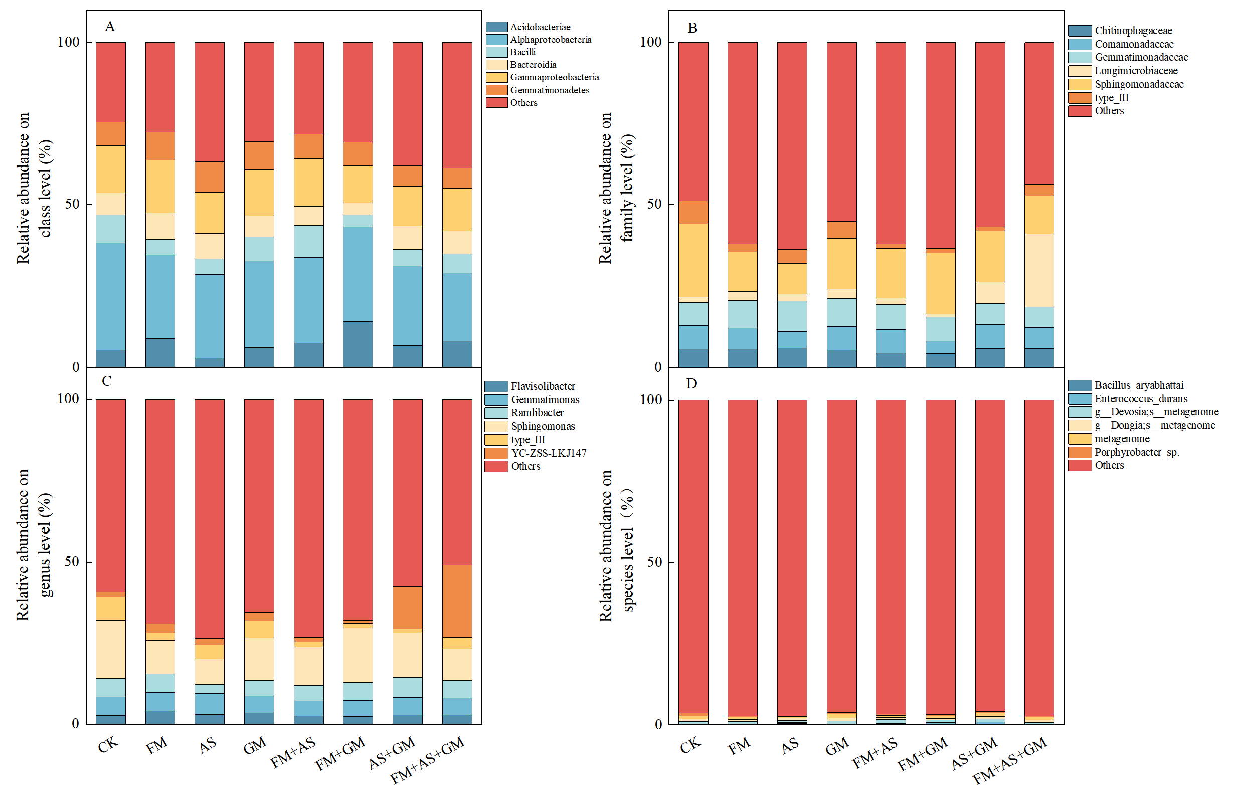
Figure S3. The relative abundance of bacteria community compositions on class (A), family (B), genus (C) and species (D) levels of each AMF treatment.

Figure S4. Effects of different AMF treatments on the relative abundance of Acidobacteriota, Actinobacteriota, Proteobacteria at phylum level (A), Alphaproteobacteria, Gammaproteobacteria at class level (B), Acidobacteriales and Sphingomonadales at order level (C), Sphingomonadaceae and type_III at family level (D), Sphingomonas and type_III at genus level (E) and Porphyrobacter_sp. at species level (F) for soil bacteria community compositions by one-way ANOVA in 2020, respectively. Different lowercase letters within each group indicate significant differences at P < 0.05, using Tukey’s multiple-range tests.

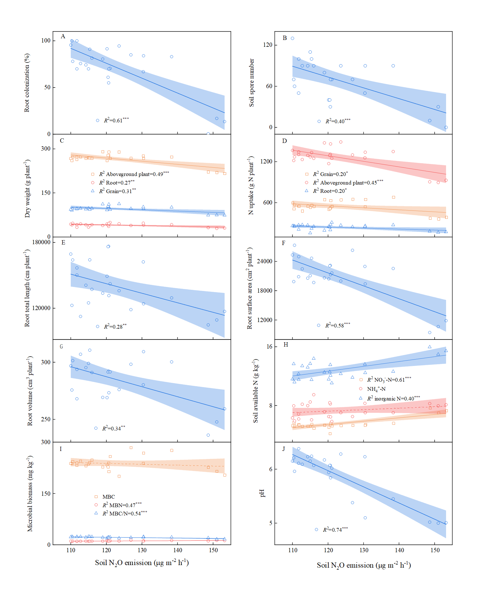 Figure S5. Relationships between soil N₂O emission and root colonization (A), AMF spore number in soil (B), maize dry weight (C), maize N uptake (D), root length (E), root surface (F), and root volume (G), soil available N (H), microbial biomass C and N (I), and soil pH (J). The significant levels are labelled as: *, p < 0.05; **, p < 0.01; ***, p < 0.001.
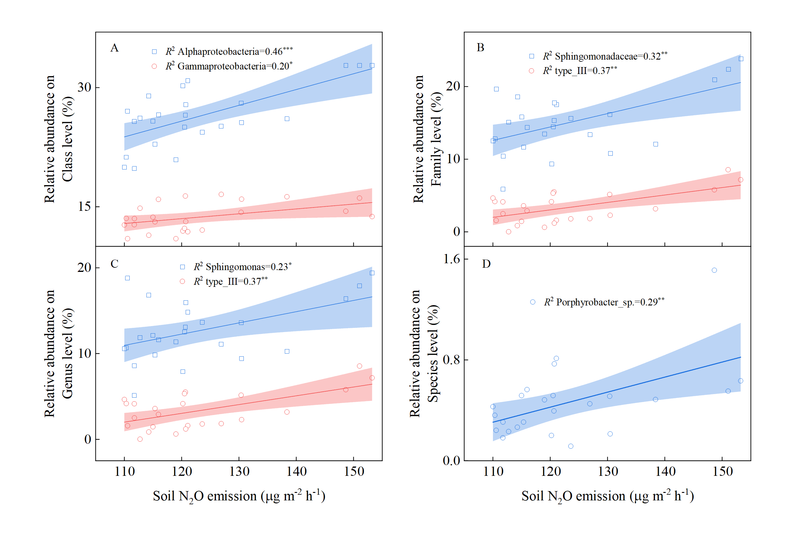
Figure S6. Relationships between soil N₂O emission and the relative abundance of Alphaproteobacteria, Gammaproteobacteria at class level (A), Sphingomonadaceae and type_III at family level (B), Sphingomonas and type_III at genus level (C) and Porphyrobacter_sp. at species level (D) of soil bacteria community compositions, respectively. The significance levels are labelled as: *, P < 0.05; **, P < 0.01; ***, P < 0.001, respectively.

SUPPLEMENTARY TABLES
Table S1. Composition of each arbuscular mycorrhizal fungi inoculum.
Treatments | Number | Species | Weight (g)
CK | 0 | － | 100 g sand
FM | 1 | Funneliformis mosseae | 100
AS | 1 | Acaulospora scrobiculata | 100
GM | 1 | Gigaspora margarita | 100
FM+AS | 2 | F. mosseae, A. scrobiculata | 50+50
FM+GM | 2 | F. mosseae, G. margarita | 50+50
AS+GM | 2 | A. scrobiculata, G. margarita | 50+50
FM+AS+GM | 3 | F. mosseae, A. scrobiculata, G. margarita | 33.3+33.3+33.3

Table S2. Results (F-values and P-values) of analysis of repeated measures linear mixed models of sampling times (Time), mycorrhizae effects (AMF) and their interactions on soil N₂O emission rates over the experimental periods in 2020.
 | F | P
Time | 47.99 | 0.001
AMF | 28.24 | 0.001
Time × AMF | 4.47 | 0.001
P values: *, p < 0.05; **, p < 0.01; ***, p < 0.001

Table S3. Comparison of soil bacteria alpha diversity for coverage, richness, and diversity among different AMF treatments (Values are means ± SE, n = 3) by the one-way ANOVA in 2020. Values followed by the different letters in the same column are significantly different at P < 0.05 level among treatments according to Tukey’s multiple comparison.
Treatment | Coverage  (%) | Richness |  |  | Diversity
Treatment | Coverage  (%) | observed_  species | Chao1 | Ace | PD_whole_tree | Shannon | Simpson
CK | 0.98±0.001d | 1700±86bc | 2139±54a | 2153±86cd | 173±5.52ab | 7.94±0.43a | 0.98±0.003ab
FM | 0.98±0.001bc | 2032±101a | 2226±383a | 2440±168ab | 167±8.68bc | 8.21±0.57a | 0.99±0.001a
AS | 0.99±0.002ab | 1573±96c | 2087±506a | 1854±154e | 147±1.11d | 7.79±0.96a | 0.98±0.008ab
GM | 0.99±0.001abc | 2012±145a | 2147±437a | 2026±174de | 183±6.35a | 8.17±0.44a | 0.99±0.003ab
FM+AS | 0.99±0.002ab | 2125±105a | 2440±227a | 2496±191a | 157±10.64cd | 8.18±0.71a | 0.98±0.007ab
FM+GM | 0.99±0.001abc | 1828±48b | 1931±171a | 1996±163de | 167±4.57bc | 7.87±0.64a | 0.98±0.001ab
AS+GM | 0.99±0.004a | 1761±11b | 2192±528a | 2213±160bcd | 166±8.91bc | 8.07±0.35a | 0.98±0.003ab
FM+AS+GM | 0.99±0.001cd | 2131±98a | 2374±350a | 2400±41abc | 188±16.1a | 7.81±1.09a | 0.96±0.034b
Values within the same column followed by different letters indicate significant differences (P < 0.05).

