SUPPLEMENTARY DATA I: Sources of the geo-spatial data included in the Global Peatland Map 2.0
Reference for ‘own data’: These datasets have been developed over 10 years as part of the Global Peatland Database (GPD). We developed mapping approaches that link various science networks, methodologies and databases, including those of peatland/landscape ecology for understanding where and how peatlands may occur, those of remote sensing for identifying possible locations, and those of pedology (legacy soil maps) and (palaeo-)ecology for ground truthing. Such integration of old field data, specialized knowledge, and modern RS and GIS techniques enables acquiring comprehensive, detailed and relative reliable overview. The GPD is a living and rapidly growing collection of currently 50,000 publications (including books, congress proceedings, reprints, grey literature and maps) und countless digital files, legacy maps, and GIS datasets dealing directly and indirectly with peatland occurrence and condition worldwide and through the ages. A small part of the book collection is already accessible via the Peatland and Nature Conservation International Library (PeNCIL): https://greifswaldmoor.de/pencil-142.html
Major relevant publications produced with the GPD include Barthelmes et al. 2015, Joosten 2009 and Joosten et al. 2017.
Country | Data source type | Peatland indicator | Year of source / creation | Reference
Albania | edited | peat / peatland | 2021 | Tanneberger, F., and 58 others (2017) The peatland map of Europe. Mires and Peat, 19, 1–17.
Albania | edited | peat / peatland | 1958 | Tanneberger, F., and 58 others (2017) The peatland map of Europe. Mires and Peat, 19, 1–17.
Andorra | external data | peat / peatland | 2013 | Tanneberger, F., and 58 others (2017) The peatland map of Europe. Mires and Peat, 19, 1–17.
Armenia | external data | peat / peatland | 2016 | Tanneberger, F., and 58 others (2017) The peatland map of Europe. Mires and Peat, 19, 1–17.
Azerbaijan | external data | peat / peatland | 2014 | Tanneberger, F., and 58 others (2017) The peatland map of Europe. Mires and Peat, 19, 1–17.
Austria | external data | peat / peatland | 1992 | Tanneberger, F., and 58 others (2017) The peatland map of Europe. Mires and Peat, 19, 1–17.
Belarus | external data | peat / peatland | 2016 | Tanneberger, F., and 58 others (2017) The peatland map of Europe. Mires and Peat, 19, 1–17.
Belgium | external data | ecosystem | 2016 | Decleer, K.,Wouters J., Jacobs S., Staes J., Spanhove T., Meire P., van Diggelen, R. (2016) Mapping wetland loss and restoration potential in Flanders (Belgium): an ecosystem service perspective. Ecology and Society 21(4), 46.
Belgium | external data | ecosystem | 2016 | Tanneberger, F., and 58 others (2017) The peatland map of Europe. Mires and Peat, 19, 1–17.
Belgium, | external data | ecosystem | 2013 | Tanneberger, F., and 58 others (2017) The peatland map of Europe. Mires and Peat, 19, 1–17.
Bosnia Herzegovina | external data | peat / peatland | 2013 | Tanneberger, F., and 58 others (2017) The peatland map of Europe. Mires and Peat, 19, 1–17.
Bulgaria | external data | peat / peatland | 2014 | Tanneberger, F., and 58 others (2017) The peatland map of Europe. Mires and Peat, 19, 1–17.
Bulgaria | digitalised | peat / peatland | 1995 | Michev, T. (ed.) (1995) National action plan for the conservation of the most important wetlands in Bulgaria. Ministry of Environment, Sofia, Bulgaria, 55 p.
Croatia | external data | peat / peatland | 2014 | Tanneberger, F., and 58 others (2017) The peatland map of Europe. Mires and Peat, 19, 1–17.
Czechia | external data | geology | 2014 | Tanneberger, F., and 58 others (2017) The peatland map of Europe. Mires and Peat, 19, 1–17.
Denmark | external data | vegetation | 2009 | Skov- og Naturstyrelsen (2009) Naturbeskyttelsesloven, Lovbekendtgørelse nr. 933 af 24.09.2009 om naturbeskyttelse. [Nature Protection Act, Act no. 933 of 24.09.2009 on nature protection] (in Danish)
Estonia | edited | peat / peatland | 2021 | Kmoch, A. 2017. Soil map of Estonia – Mullastikukaart, National Soilmap of Estonia, dataset deposit, https://datadoi.ee/handle/33/103; https://doi.org/10.15155/re-72 (2017)  Kmoch, A., Kanal, A., Astover, A., Kull, A., Virro, H., Helm, A., Pärtel, M., Ostonen, I., Uuemaa, E. (2021) EstSoil-EH: A high-resolution eco-hydrological modelling parameters dataset for Estonia. Earth  System Science Data 13: 83–97.
Faroer | digitalised | peat / peatland | 2006 | Tanneberger, F., and 58 others (2017) The peatland map of Europe. Mires and Peat, 19, 1–17.
Finland | external data | peat / peatland | 1988 | Tanneberger, F., and 58 others (2017) The peatland map of Europe. Mires and Peat, 19, 1–17.
France | external data | peat / peatland | 2014 | Tanneberger, F., and 58 others (2017) The peatland map of Europe. Mires and Peat, 19, 1–17.
France | external data | peat / peatland | 2013 | Tanneberger, F., and 58 others (2017) The peatland map of Europe. Mires and Peat, 19, 1–17.
Georgia | external data | peat / vegetation | 2016 | Tanneberger, F., and 58 others (2017) The peatland map of Europe. Mires and Peat, 19, 1–17.
Germany | edited | organic soil | 2021 | Tanneberger, F., and 58 others (2017) The peatland map of Europe. Mires and Peat, 19, 1–17.
Greece | edited | peat / peatland | 2016 | Tanneberger, F., and 58 others (2017) The peatland map of Europe. Mires and Peat, 19, 1–17.
Hungary | edited | peat / peatland | 2018,  1980 | Pásztor, L., Laborczia, A., Bakacsi, Z., Szabó, J., Illés, G. (2018) Compilation of a national soil-type map for Hungary by sequential classification methods, Geoderma 311, 93-108
Iceland | external data | land cover | 2021 | Environment Agency of Iceland (2021) National Inventory Report - Emissions of greenhouse gases in Iceland from 1990 to 2019. Reykjavik, Iceland, 323 p. + Annexes.
Ireland | external data | peat / peatland | 1981 | Tanneberger, F., and 58 others (2017) The peatland map of Europe. Mires and Peat, 19, 1–17.
Italy | external data | ecosystem | 2015 | Tanneberger, F., and 58 others (2017) The peatland map of Europe. Mires and Peat, 19, 1–17.
Italy | edited | organic soil | 2021 | Gardin L., Chiesi M., Fibbi L., Maselli F. (2021) Mapping soil organic carbon in Tuscany through the statistical combination of ground observations with ancillary and remote sensing data, Geoderma 404, 115386.
Italy | digitalised | organic soil | 1966 | Tanneberger, F., and 58 others (2017) The peatland map of Europe. Mires and Peat, 19, 1–17.
Latvia | external data | peat / peatland | 2013 | Tanneberger, F., and 58 others (2017) The peatland map of Europe. Mires and Peat, 19, 1–17.
Lichtenstein | external data | peat / peatland | 2016 | Tanneberger, F., and 58 others (2017) The peatland map of Europe. Mires and Peat, 19, 1–17.
Lithuania | edited | peat / peatland | 2004 | Lithuanian Geological Survey (2005) Lietuvos durpynų ir pelkių žemėlapis. [Map of peatlands and mires in Lithuania], 1:200,000. GIS dataset.
Luxemburg | external data | ecosystem | 2007 | Tanneberger, F., and 58 others (2017) The peatland map of Europe. Mires and Peat, 19, 1–17.
Luxemburg | external data | vegetation | 2014 | Tanneberger, F., and 58 others (2017) The peatland map of Europe. Mires and Peat, 19, 1–17.
Moldova | external data | peat / peatland wetland | 2016 | Tanneberger, F., and 58 others (2017) The peatland map of Europe. Mires and Peat, 19, 1–17.
Montenegro | edited | peat / peatland | 2014 | Tanneberger, F., and 58 others (2017) The peatland map of Europe. Mires and Peat, 19, 1–17.
Netherlands | external data | peat / peatland | 2018 | Wageningen Environmental Research (Alterra) (2018)
North Macedonia | external data | peat / peatland | 2016 | Tanneberger, F., and 58 others (2017) The peatland map of Europe. Mires and Peat, 19, 1–17.
Norway | external data | ecosystem | 2015 | Tanneberger, F., and 58 others (2017) The peatland map of Europe. Mires and Peat, 19, 1–17.
Poland | external data | peat / peatland | 2014 | Tanneberger, F., and 58 others (2017) The peatland map of Europe. Mires and Peat, 19, 1–17.
Portugal | edited | peat / peatland | 2016,  2022 | van Giersbergen, Quint (2022) Mapping European Greenhouse gas emissions of drained peatlands. MSc- thesis. Wageningen University, The Netherlands.
Portugal | external data | peat / peatland | 2014 | Tanneberger, F., and 58 others (2017) The peatland map of Europe. Mires and Peat, 19, 1–17.
Romania | external data | peat / peatland | 1993 | Tanneberger, F., and 58 others (2017) The peatland map of Europe. Mires and Peat, 19, 1–17.
Serbia | digitalised | peat / peatland | 2014 | Tanneberger, F., and 58 others (2017) The peatland map of Europe. Mires and Peat, 19, 1–17.
Slovakia | external data | peat / peatland | 2012 | Tanneberger, F., and 58 others (2017) The peatland map of Europe. Mires and Peat, 19, 1–17.
Slovenia | external data | peat / peatland | 2002 | Tanneberger, F., and 58 others (2017) The peatland map of Europe. Mires and Peat, 19, 1–17.
Spain | edited | peat / peatland | 2015 | Tanneberger, F., and 58 others (2017) The peatland map of Europe. Mires and Peat, 19, 1–17.
Svalbard | own data | peat / peatland | 2015 | Tanneberger, F., and 58 others (2017) The peatland map of Europe. Mires and Peat, 19, 1–17.
Sweden | external data | peat / peatland | 2022 | Ågren, A.M., Hasselquist, E.M., Stendahl, J., Nilsson, M.B., Paul, S.S. (2022) Delineating the distribution of mineral and peat soils at the landscape scale in northern boreal regions, Soil 8, 1–17.
Switzerland | external data | peat / peatland | 2010 | Tanneberger, F., and 58 others (2017) The peatland map of Europe. Mires and Peat, 19, 1–17.
Turkey | digitalised | peat / peatland | 2014 | Tanneberger, F., and 58 others (2017) The peatland map of Europe. Mires and Peat, 19, 1–17.
Ukraine | edited | peat / peatland | 2014 | Tanneberger, F., and 58 others (2017) The peatland map of Europe. Mires and Peat, 19, 1–17.
Ukraine | external data | peat / peatland | 2010 | Tanneberger, F., and 58 others (2017) The peatland map of Europe. Mires and Peat, 19, 1–17.
United Kingdom | external data | land cover | 1988 | Copyright Scottish Government, contains Ordnance Survey data © Crown copyright and database right
United Kingdom | external data | land cover | 1988 | Copyright Scottish Government, contains Ordnance Survey data © Crown copyright and database right
United Kingdom | external data | peat / peatland | 2020 | Evans, C., Rawlins, B., Grebby, S., Scholefield, P., Jones, P. (2015) Glastir Monitoring & Evaluation Programme. Mapping the extent and condition of Welsh peat. Welsh Government  (Contract reference: C147/2010/11). NERC/Centre for Ecology & Hydrology (CEH Project: NEC04780).
United Kingdom | digitalised | peat / peatland | 2017 | Evans, C., Artz, R., Moxley, J., Smyth, M-A., Taylor, E., Archer, N., Burden, A., Williamson, J., Donnelly, D., Thomson, A., Buys, G., Malcolm, H., Wilson, D., Renou-Wilson, F., Potts, J. (2017) Implementation of an emission inventory for UK peatlands. Report to the Department for Business, Energy and Industrial Strategy, Centre for Ecology and Hydrology, Bangor 88pp.
United Kingdom | digitalised | peat / peatland | 2017 | Evans, C., Rawlins, B., Grebby, S., Scholefield, P., Jones, P. (2015) Glastir Monitoring & Evaluation Programme. Mapping the extent and condition of Welsh peat. Welsh Government (Contract reference: C147/2010/11). NERC/Centre for Ecology & Hydrology (CEH Project: NEC04780).
United Kingdom | external data | peat / peatland | 2008 | Derived from 1:50 000 scale BGS Digital Data under Licence 2006/072 British Geological Survey © NERC. National Soils map © Cran◻eld University (NSRI) © Crown Copyright and database rights [2023]. © Natural England copyright (2023), reproduced with the permission of Natural England, https://www.gov.uk /help/termsconditions © Crown Copyright and database right (2023).

SUPPLEMENTARY DATA II: Tables
Table S.1: An overview of the different land uses (kha) per country. The first 40 columns show peatland land cover based on the land uses on peat soils that where not covered by Witjes et al., 2022 land use map and the other columns are based on the detailed (agricultural) land use map of d’Andrimont et al., 2021, which was the first choice map.
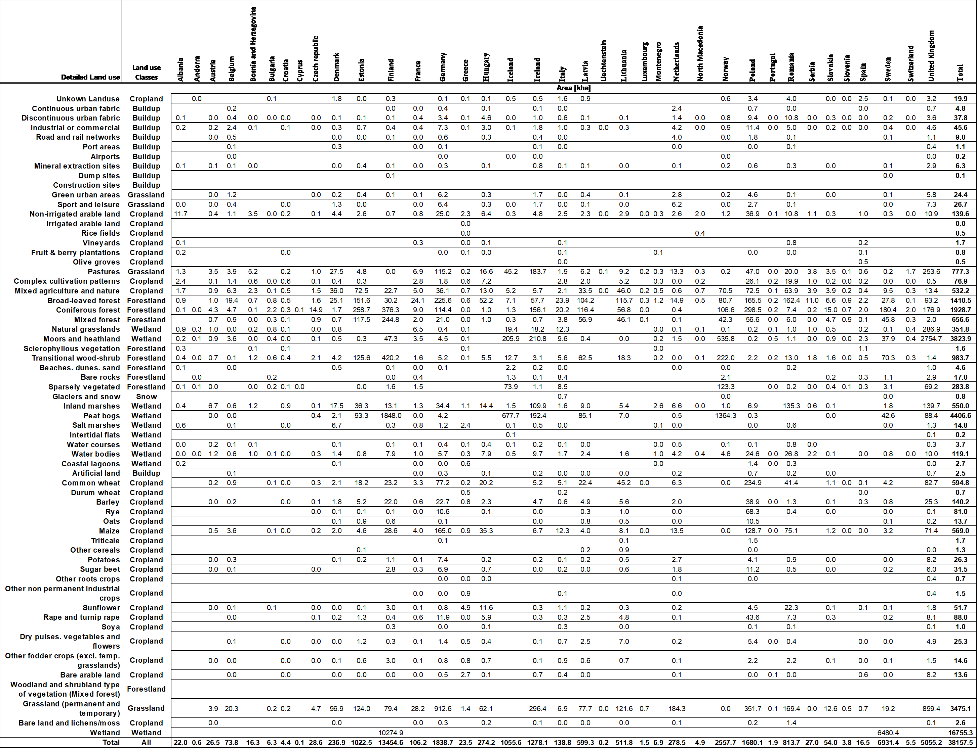
Overlaying the land use map for peatlands with this productivity map resulted in the mean and standard deviation productivity index per country as shown in Table S1. Here only for the countries where information in the NIR reporting was available about the deviation of shallow and deep where evaluated. The mean productivity index (PI) for grassland is 6.321 and for forestland 6.079. It can be observed that the PI for countries in colder climates (towards boreal) have a lower PI than the countries towards more temperate climatic conditions.

Table S.2: Mean productivity index (PI) per country based on the two land use classes grassland and forestland with corresponding standard deviation.
 | Grassland |  | Forestland
Countries | Mean  (PI) | Std.dev  (PI) | Mean  (PI) | Std.dev  (PI)
Sweden | 4.13 | 2.25 | 5.93 | 0.81
Lithuania | 5.01 | 1.07 | 4.86 | 0.74
Hungary | 5.48 | 0.86 | 5.43 | 0.75
Finland | 5.56 | 1.12 | 5.00 | 1.84
France | 5.91 | 1.78 | 6.26 | 1.56
Slovakia | 5.96 | 0.69 | 5.78 | 0.97
Austria | 6.01 | 1.55 | 6.10 | 1.40
Ireland | 6.52 | 2.25 | 6.49 | 2.04
Czech | 6.73 | 0.51 | 6.69 | 0.24
Denmark | 6.98 | 1.14 | 6.75 | 1.11
Germany | 7.20 | 1.24 | 6.86 | 1.02
Netherlands | 8.01 | 1.65 | 7.16 | 1.54
Latvia | 8.67 | 2.08 | 5.74 | 1.06
Average | 6.32 | 1.41 | 6.08 | 1.16

When applying the mean grassland PI value to distinguish if a peat grassland is shallow drained (below 6.321 PI) or deep drained (above 6.321 PI), 8 out of 13 countries listed above in Table 3 where estimated good (within a ±5% range) to the NIR reporting deviation of deep/shallow drained grassland (Martin & Couwenberg, 2021). When applying -1 standard deviation of the mean (4.915 PI) as tipping point for grassland only Finland and Ireland where correctly estimated according to the NIR reporting (Martin & Couwenberg, 2021). Therefore, in this research the mean PI value of the productivity map developed by JRC in 2013 is assumed to be a quite good estimator of when a grassland is deep or shallow drained. Because there is no EU wide information available about the deviation of nutrient rich and nutrient poor forestland and wetlands this research used the same method (mean of the 13 listed countries above) as tipping point value. Forestland and wetlands this tipping point value was set to 6.079 PI.

Table S3: The absolute and cumulative fraction of total EU+ area and emissions of agricultural land (Grassland and Cropland) on peat soils. The countries above the green line area countries that have similar (±20%) area and emissions in this study and in the NIS 2023. The numbers used for the hotspot map are indicated in bold where the ratio, is the correction used to correct the in this research spatial emission map to the most accurate total emission. 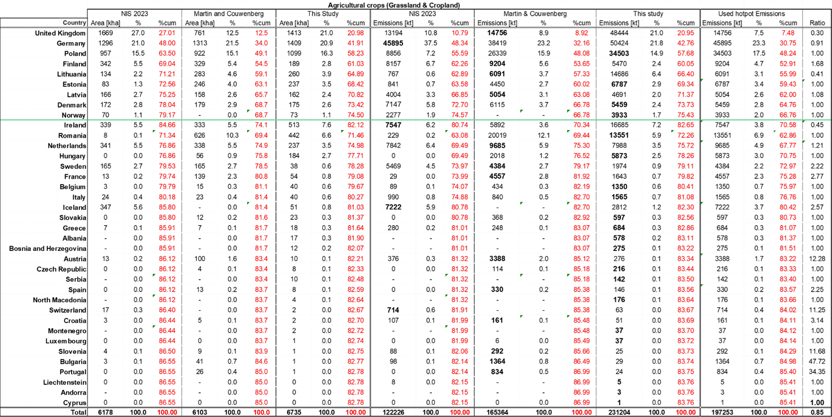

Table S4: The absolute and cumulative fraction of total EU+ area and emissions of Forest Land on peat soils. The numbers used for the hotspot map are indicated in bold where the ratio, is the correction used to correct the in this research spatial emission map to the most accurate total emission and area.
