Risk of Neurologic or Immune-Mediated Adverse Events After COVID-19 Diagnosis in the United States
Additional File

Shelby S. Fisher, MPHª
Arnstein Lindaas, MA^{b}
Stella G. Muthuri, PhD^{c†}
Patricia C. Lloyd, PhD^{d}
Joann F. Gruber, PhD^{d}
Morgan M. Richey, PhD^{e†}
Hai Lyu, MS^{b}
Angela S. Cheng, MPH^{b}
Lisa S. Kowarski, MPH^{c†}
Mollie M. McKillop, PhD^{c†}
Christine Bui, MPH^{e}
Tainya C. Clarke, PhD^{d}
Jeffrey Beers, MD^{c}
Timothy Burrell, MD^{c}
Pablo Freyria Duenas, MA^{b}
Yangping Chen, MPH^{b}
Minya Sheng, MS^{c†}
Richard A. Forshee, PhD^{d}
Steven A. Anderson, PhD^{d}
Yoganand Chillarige, MPA^{b}
Mary S. Anthony, PhDe
Azadeh Shoaibi, PhD^{d†}
J. Bradley Layton, PhDe

† Affiliation at the time of study conduct
ª RTI International, Research Triangle Park, NC, USA
^{b} Acumen LLC, Burlingame, CA, USA
^{c} IBM Consulting, Bethesda, MD, USA
^{d} US Food and Drug Administration, Center for Biologics Evaluation and Research, Silver Spring, MD, USA
^{e} RTI Health Solutions, Research Triangle Park, NC, USA
Corresponding Author:
J. Bradley Layton, PhD
RTI Health Solutions
3040 East Cornwallis Rd, PO Box 12194
Research Triangle Park, North Carolina, USA 27709
Office: +1.919.541.8885
Fax: +1.919.541.7222
jblayton@rti.org

sTable 1. Covariates for AE-Specific Propensity Score Models
Covariate | Model form | Guillain-Barré syndrome | Bell's palsy | ENC | Narcolepsy | ITP | TM
Age ª | Age, age², age³ | X | X | X | X | X | X
Sex ª | Binary | X | X | X | X | X | X
County/MSA and state of residence ª | Categorical, indicator for each level | X | X | X | X | X | X
Race/ethnicity ^{c} | Categorical, indicator for each level | X | X | X | X | X | X
Dual Medicare/Medicaid eligibility^{b} | Binary | X | X | X | X | X | X
Reason for entering Medicare ^{b} | Categorical, indicator for each level | X | X | X | X | X | X
Hospitalization status on Time 0 ª | Binary | X | X | X | X | X | X
SNF/LTC residence on Time 0 ^{a, b} | Binary | X | X | X | X | X | X
Animal exposure/bites or rabies | Binary |  |  | X |  | X
Antiphospholipid syndrome | Binary |  |  |  |  | X | X
Autoimmune disorders | Binary | X | X | X |  | X | X
Brain lesions related to secondary narcolepsy | Binary |  |  |  | X
Cancer | Binary |  | X |  |  | X
Chronic lymphocytic leukemia | Binary |  |  |  |  | X
Chronic lung disease | Binary |  |  |  |  |  | X
Dementia/neurological conditions | Binary | X | X | X | X |  | X
Diabetes mellitus, type 1 or 2 | Binary |  | X |  |  |  | X
Hemiplegia/paraplegia | Binary | X |  |  |  |  | X
Herpes simplex virus infection | Binary | X | X | X |  | X
Immunocompromised state ª | Binary | X | X | X | X | X | X
Infection associated with GBS | Binary | X
Infection associated with ITP | Binary |  |  |  |  | X
Inpatient surgery | Binary | X
Mental health conditions | Binary |  | X |  | X
Nutritional deficiencies | Binary |  |  |  |  |  | X
Obesity | Binary | X | X |  | X
Pneumonia or lower respiratory tract infection | Binary | X |  | X |  | X | X
Pregnancy ^{c} | Binary |  | X
Sepsis | Binary |  |  |  |  | X
Stroke/cerebrovascular disease | Binary |  |  |  | X
Trauma | Binary | X
Tuberculosis | Binary |  |  |  |  | X
Inpatient hospital stays before Time 0 | Categorical, indicator for each level | X | X | X | X | X | X
ED visits | Categorical, indicator for each level | X | X | X | X | X | X
Outpatient visits | Categorical, indicator for each level | X | X | X | X | X | X
SNF/LTC stay ^{d} | Binary | X |  | X |  | X | X
Influenza vaccination in previous year | Binary | X | X | X | X | X | X
AE = adverse event; ED = emergency department; ENC = encephalitis/encephalomyelitis; GBS = Guillain-Barré syndrome; HS = hemorrhagic stroke; ITP = immune thrombocytopenia; LTC = long-term care; MSA = metropolitan statistical area; SNF = skilled nursing facility; TM = transverse myelitis; TTS = thrombosis with thrombocytopenia syndrome.
ª Matching variables were included in all propensity score models.
^{b} Only included in Medicare.
^{c} Only included in MarketScan.
^{d} SNF and LTC both included in Medicare; only SNF included in MarketScan.
Sources: National Institute of Neurological Disorders and Stroke [1-5]; National Heart, Lung, and Blood Institute [6].
References:
1. NINDS. National Institutes of Health. Guillain-Barré syndrome. 31 July 2023. https://www.ninds.nih.gov/health-information/disorders/guillain-barre-syndrome. Accessed 2 November 2023.
2. NINDS. National Institutes of Health. Bell's palsy fact sheet. June 2018. https://catalog.ninds.nih.gov/sites/default/files/publications/bells-palsy.pdf. Accessed 9 February 2023.
3. NINDS. National Institutes of Health. Meningitis and encephalitis fact sheet. June 2018. https://catalog.ninds.nih.gov/sites/default/files/publications/meningitis-encephalitis.pdf. Accessed 9 February 2023.
4. NINDS. National Institutes of Health. Narcolepsy fact sheet. 25 April 2022. https://catalog.ninds.nih.gov/sites/default/files/publications/narcolepsy.pdf. Accessed 9 February 2023.
5. NINDS. National Institutes of Health. Transverse myelitis. 20 January 2023. https://www.ninds.nih.gov/health-information/disorders/transverse-myelitis. Accessed 2 November 2023.
6. NHLBI. National Institutes of Health. Immune thrombocytopenia (ITP). 2022. https://www.nhlbi.nih.gov/health/immune-thrombocytopenia#What-causes-ITP? Accessed 14 July 2022.

sTable 2. Characteristics of Individuals With a COVID-19 Diagnosis Included in the Cohort Study and Those Excluded for Failing to Match
A. MarketScan
Characteristic | COVID-19 diagnosis (exposure) group retained by matching | Individuals with a COVID-19 diagnosis who failed to match
Total unique individuals | 319,300 | 39,006
Demographic characteristics
Age, years
Mean (SD) | 41.8 (13.6) | 44.1 (13.6)
Median (Q1, Q3) | 43 (30, 53) | 47 (33, 56)
Age groups, n (%)
18-34 years | 105,842 (33.15) | 10,485 (26.88)
35-49 years | 101,071 (31.65) | 12,060 (30.92)
50-64 years | 112,387 (35.20) | 16,461 (42.20)
Sex, n (%)
Female | 178,975 (56.05) | 22,793 (58.43)
Male | 140,325 (43.95) | 16,213 (41.57)
US geographic region, n (%)
Northeast | 62,215 (19.48) | 949 (2.43)
North central | 71,170 (22.29) | 1,788 (4.58)
South | 149,868 (46.94) | 26,883 (68.92)
West | 36,037 (11.29) | 9,057 (23.22)
Unknown | 10 (0.00) | 329 (0.84)
Hospitalized on Time 0, n (%) | 4,046 (1.27) | 8,738 (22.40)
Comorbidities, n (%)
Animal exposure/bites or rabies | 976 (0.31) | 124 (0.32)
Antiphospholipid syndrome | 160 (0.05) | 28 (0.07)
Autoimmune disorders | 12,677 (3.97) | 1,759 (4.51)
Brain lesions related to secondary narcolepsy | 30 (0.01) | 2 (0.01)
Cancer | 13,421 (4.20) | 1,987 (5.09)
Chronic lymphocytic leukemia | 213 (0.07) | 41 (0.11)
Chronic kidney disease or renal disease (other than end-stage renal disease) | 6,052 (1.90) | 1,495 (3.83)
Chronic liver disease | 10,763 (3.37) | 1,566 (4.01)
Chronic lung diseases | 32,616 (10.21) | 4,285 (10.99)
Dementia or other neurologic condition | 19,722 (6.18) | 2,551 (6.54)
Diabetes, Type 1 or 2 | 33,117 (10.37) | 6,374 (16.34)
Disseminated intravascular coagulation ª | 24 (0.01) | 9 (0.02)
Heart conditions | 37,470 (11.74) | 5,494 (14.09)
Hemiplegia or paraplegia | 857 (0.27) | 202 (0.52)
Herpes simplex infection | 6,082 (1.90) | 709 (1.82)
Hypertension | 78,717 (24.65) | 13,371 (34.28)
Immunocompromised state | 37,672 (11.80) | 5,422 (13.90)
Infection associated with GBS | 17,961 (5.63) | 2,091 (5.36)
Viral infection associated with ITP | 1,290 (0.40) | 209 (0.54)
Infection associated with myocarditis/pericarditis | 16,753 (5.25) | 2,322 (5.95)
Inpatient surgery | 1,985 (0.62) | 379 (0.97)
Lipid abnormality | 73,480 (23.01) | 10,908 (27.96)
Mental health conditions | 73,913 (23.15) | 10,422 (26.72)
Nutritional deficiency | 2,088 (0.65) | 374 (0.96)
Obese or severely obese | 63,585 (19.91) | 9,775 (25.06)
Peripheral vascular disease | 4,393 (1.38) | 733 (1.88)
Pneumonia or lower respiratory tract infection | 41,355 (12.95) | 5,598 (14.35)
Pregnancy | 2,616 (0.82) | 266 (0.68)
Sepsis | 1,277 (0.40) | 340 (0.87)
Sickle cell disease or thalassemia | 750 (0.23) | 112 (0.29)
Smoking/nicotine dependency | 11,536 (3.61) | 1,391 (3.57)
Stroke or cerebrovascular disease | 4,730 (1.48) | 715 (1.83)
Thromboembolism | 3,531 (1.11) | 642 (1.65)
Thrombophilia | 1,096 (0.34) | 137 (0.35)
Trauma | 204 (0.06) | 38 (0.10)
Tuberculosis | 138 (0.04) | 21 (0.05)
Healthcare utilization, n (%)
Inpatient stays in previous 365 days
0 | 305,018 (95.53) | 36,528 (93.65)
1-2 | 13,162 (4.12) | 2,138 (5.48)
≥ 3 | 1,120 (0.35) | 340 (0.87)
ED visits in previous 365 days
0 | 255,758 (80.10) | 30,760 (78.86)
1-2 | 54,798 (17.16) | 7,022 (18.00)
≥ 3 | 8,744 (2.74) | 1,224 (3.14)
Outpatient provider visits ^{b} in previous 365 days
0 | 2,076 (0.65) | 248 (0.64)
1-2 | 56,880 (17.81) | 5,749 (14.74)
3-5 | 76,244 (23.88) | 7,326 (18.78)
6-10 | 76,772 (24.04) | 8,223 (21.08)
≥ 11 | 107,328 (33.61) | 17,460 (44.76)
SNF/LTC stay ^{c} | 341 (0.11) | 104 (0.27)
Influenza vaccination in previous year | 90,018 (28.19) | 12,166 (31.19)
COVID-19 = coronavirus disease 2019; ED = emergency department; GBS = Guillain-Barré syndrome; ITP = immune thrombocytopenia; LTC = long-term care; Q1 = first quartile, Q3 = third quartile; SD = standard deviation; SNF = skilled nursing facility; US = United States.
ª This serves as an outcome-specific exclusion criterion when the condition is evaluated as an outcome, but history of the condition serves as a covariate for analyses of other outcomes.
^{b} Unique days on which an outpatient visit occurred.
^{c} SNF and LTC both identified in Medicare; SNF identified in MarketScan.
B. Medicare
Characteristic | COVID-19 diagnosis (exposure) group retained by matching | Individuals with a COVID-19 diagnosis who failed to match
Total unique individuals | 1,017,410 (1,017,410) | 68,008 (68,008)
Demographic characteristics
Age, years
Mean (SD) | 77.7 (8.6) | 80.8 (9.0)
Median (Q1, Q3) | 76.0 (71.0, 84.0) | 81.0 (73.0, 88.0)
Age groups, n (%)
65-79 years | 629,709 (61.9) | 31,064 (45.7)
≥ 80 years | 387,701 (38.1) | 36,944 (54.3)
Sex, n (%)
Female | 590,584 (58.0) | 34,257 (50.4)
Male | 426,826 (42.0) | 33,751 (49.6)
US geographic region, n (%)
Northeast | 218,277 (21.5) | 9,103 (13.4)
North central | 250,139 (24.6) | 19,879 (29.2)
South | 385,012 (37.8) | 31,590 (46.5)
West | 161,002 (15.8) | 7,093 (10.4)
Unknown | 2,980 (0.3) | 343 (0.5)
Race/ethnicity, n (%)
American Indian/Alaska Native | 7,510 (0.7) | 928 (1.4)
Asian | 16,819 (1.7) | 904 (1.3)
Black or African American | 90,997 (8.9) | 9,789 (14.4)
Hispanic/Latin American/Latinx | 26,460 (2.6) | 1,640 (2.4)
White | 845,042 (83.1) | 53,588 (78.8)
A race/ethnicity not listed | 13,898 (1.4) | 730 (1.1)
Not provided | 16,684 (1.6) | 429 (0.6)
Dual Medicare/Medicaid eligibility, n (%) | 297,499 (29.2) | 30,409 (44.7)
Original reason for Medicare eligibility, n (%)
Age | 860,430 (84.6) | 53,381 (78.5)
Disability | 150,916 (14.8) | 14,052 (20.7)
End-stage renal disease | 6,064 (0.6) | 575 (0.8)
Hospitalized on Time 0, n (%) | 166,154 (16.3) | 67,764 (99.6)
SNF/LTC ª residence on Time 0, n (%) | 250,193 (24.6) | 33,311 (49.0)
Comorbidities, n (%)
Animal exposure/bites or rabies | 3,105 (0.3) | 130 (0.2)
Antiphospholipid syndrome | 829 (0.1) | 40 (0.1)
Autoimmune disorders | 93,071 (9.1) | 5,722 (8.4)
Brain lesions related to secondary narcolepsy | 519 (0.1) | 54 (0.1)
Cancer | 272,867 (26.8) | 16,744 (24.6)
Chronic lymphocytic leukemia | 6,995 (0.7) | 576 (0.8)
Chronic kidney disease or renal disease (other than end-stage renal disease) | 276,654 (27.2) | 29,364 (43.2)
End-stage renal disease | 20,229 (2.0) | 2,489 (3.7)
Chronic liver disease | 80,781 (7.9) | 5,759 (8.5)
Chronic lung diseases | 293,426 (28.8) | 25,836 (38.0)
Dementia or other neurologic condition | 350,351 (34.4) | 34,022 (50.0)
Diabetes, Type 1 or 2 | 406,448 (39.9) | 33,886 (49.8)
Disseminated intravascular coagulation ª | 324 (0.0) | 28 (0.0)
Heart conditions | 614,855 (60.4) | 49,731 (73.1)
Hemiplegia or paraplegia | 61,853 (6.1) | 7,582 (11.1)
Herpes simplex infection | 16,959 (1.7) | 948 (1.4)
Hypertension | 823,414 (80.9) | 59,938 (88.1)
Immunocompromised state | 438,954 (43.1) | 27,919 (41.1)
Infection associated with GBS | 51,279 (5.0) | 4,484 (6.6)
Viral infection associated with ITP | 3,702 (0.4) | 237 (0.3)
Infection associated with myocarditis/pericarditis | 111,923 (11.0) | 11,207 (16.5)
Inpatient surgery | 43,070 (4.2) | 5,421 (8.0)
Lipid abnormality | 733,659 (72.1) | 48,762 (71.7)
Mental health conditions | 441,954 (43.4) | 35,803 (52.6)
Nutritional deficiency | 80,039 (7.9) | 9,196 (13.5)
Obese or severely obese | 233,833 (23.0) | 16,401 (24.1)
Peripheral vascular disease | 318,384 (31.3) | 28,432 (41.8)
Pneumonia or lower respiratory tract infection | 237,118 (23.3) | 22,636 (33.3)
Sepsis | 59,822 (5.9) | 8,147 (12.0)
Sickle cell disease or thalassemia | 2,611 (0.3) | 177 (0.3)
Smoking/nicotine dependency | 64,705 (6.4) | 5,848 (8.6)
Stroke or cerebrovascular disease | 228,802 (22.5) | 21,214 (31.2)
Thromboembolism | 77,562 (7.6) | 7,678 (11.3)
Thrombophilia | 11,107 (1.1) | 763 (1.1)
Trauma | 24,546 (2.4) | 3,371 (5.0)
Tuberculosis | 2,585 (0.3) | 218 (0.3)
Healthcare utilization, n (%)
Inpatient stays in previous 365 days
0 | 729,890 (71.7) | 37,200 (54.7)
1-2 | 204,101 (20.1) | 19,704 (29.0)
≥ 3 | 83,419 (8.2) | 11,104 (16.3)
ED visits in previous 365 days
0 | 572,454 (56.3) | 26,433 (38.9)
1-2 | 282,442 (27.8) | 22,149 (32.6)
≥ 3 | 162,514 (16.0) | 19,426 (28.6)
Outpatient provider visits^{b} in previous 365 days
0 | 93 (0.0) | 13 (0.0)
1-2 | 21,024 (2.1) | 1,189 (1.7)
3-5 | 51,668 (5.1) | 2,598 (3.8)
6-10 | 118,531 (11.7) | 5,352 (7.9)
≥ 11 | 826,094 (81.2) | 58,856 (86.5)
SNF/LTC stay | 295,527 (29.0) | 36,920 (54.3)
Influenza vaccination in previous year | 570,066 (56.0) | 33,767 (49.7)
COVID19 = coronavirus disease 2019; ED = emergency department; GBS = Guillain-Barré syndrome; ITP = immune thrombocytopenia; LTC = long-term care; Q1 = first quartile, Q3 = third quartile; SD = standard deviation; SNF = skilled nursing facility; US = United States.
ª This serves as an outcome-specific exclusion criterion when the condition is evaluated as an outcome, but history of the condition serves as a covariate for analyses of other outcomes.
^{b} Unique days on which an outpatient visit occurred.

sTable 3. Association of a COVID-19 Diagnosis With Adverse Events, Cohort Design, Follow-Up Starting on the Day After Time 0
Data Source | Exposure group | Outcome cases | Person-time (days) | Crude cumulative incidence ª (95% CI) | Crude HR (95% CI) | sIPT-weighted HR (95% CI)
Guillain-Barré syndrome
MarketScan | COVID-19 | 10 | 26,740,943 | 5.12 (1.82-8.43) | 9.99 (1.28-78.02) | 9.57 (1.23-74.74)
MarketScan | Comparator | 1 | 26,735,597 | 1.48 (0.00-4.37) | — | —
Medicare | COVID-19 | 31 | 80,000,492 | 5.06 (3.14-6.98) | 1.93 (1.02-3.64) | 1.97 (1.04-3.74)
Medicare | Comparator | 17 | 86,246,732 | 13.59 (0.00-34.59) | — | —
Bell’s palsy
MarketScan | COVID-19 | 109 | 26,710,491 | 112.77 (72.11-153.41) | 1.21 (0.91-1.61) | 1.13 (0.85-1.50)
MarketScan | Comparator | 90 | 26,715,066 | 69.66 (50.80-88.51) | — | —
Medicare | COVID-19 | 756 | 79,823,029 | 208.27 (187.29-229.25) | 1.18 (1.05-1.31) | 1.11 (1.00-1.24)
Medicare | Comparator | 690 | 86,050,482 | 178.03 (156.21-199.85) | — | —
Encephalitis/encephalomyelitis
MarketScan | COVID-19 | 11 | 26,738,915 | 5.28 (1.99-8.58) | 2.20 (0.76-6.33) | 1.99 (0.69-5.77)
MarketScan | Comparator | 5 | 26,737,424 | 6.17 (0.00-13.19) | — | —
Medicare | COVID-19 | 109 | 80,018,307 | 27.43 (19.21-35.65) | 1.43 (1.02-2.00) | 1.36 (0.96-1.94)
Medicare | Comparator | 81 | 86,269,166 | 16.45 (11.65-21.24) | — | —
Narcolepsy
MarketScan | COVID-19 | 32 | 26,713,507 | 39.46 (19.08-59.83) | 1.33 (0.79-2.26) | 1.21 (0.71-2.05)
MarketScan | Comparator | 24 | 26,712,918 | 25.32 (10.44-40.20) | — | —
Medicare | COVID-19 | 169 | 79,956,203 | 45.05 (34.55-55.56) | 1.21 (0.96-1.54) | 1.11 (0.88-1.42)
Medicare | Comparator | 149 | 86,209,713 | 49.80 (16.16-83.42) | — | —
Immune thrombocytopenia
MarketScan | COVID-19 | 42 | 26,717,156 | 27.58 (17.99-37.16) | 2.10 (1.23-3.58) | 2.06 (1.20-3.53)
MarketScan | Comparator | 20 | 26,720,031 | 16.54 (7.76-25.33) | — | —
Medicare | COVID-19 | 497 | 79,815,901 | 108.20 (95.62-120.78) | 1.40 (1.22-1.61) | 1.36 (1.18-1.57)
Medicare | Comparator | 377 | 86,057,511 | 103.37 (78.81-127.93) | — | —
Transverse myelitis
MarketScan | COVID-19 | 2 | 26,740,060 | 0.68 (0.00-1.62) | 2.00 (0.18-22.04) | 2.30 (0.21-25.41)
MarketScan | Comparator | 1 | 26,737,141 | 0.56 (0.00-1.64) | — | —
Medicare | COVID-19 | < 11 | 80,044,399 | 1.15 (0.13-2.18) | 0.89 (0.27-2.94) | 0.93 (0.28-3.09)
Medicare | Comparator | < 11 | 86,296,624 | 1.14 (0.14-2.14) | — | —
CI = confidence interval; COVID-19 = coronavirus disease 2019; HR = hazard ratio; sIPT = stabilized inverse probability of treatment.
— denotes the reference group.
ª Estimated as the 1 minus the Kaplan-Meier survival estimator; expressed as risk per 100,000 individuals.
Note: Privacy rules for Medicare require masking cell sizes of fewer than 11 individuals.

sTable 4. Association of a COVID-19 Diagnosis With Adverse Events, SCRI Design, MarketScan and Medicare, Follow-up starting on the Day After Time 0
Outcomes | Cases in risk window | Cases in reference window | RI (95% CI) ª
Guillain-Barré syndrome
MarketScan | 5 | 5 | 8.53 (2.45-29.65)
Medicare | 17 | 18 | 4.63 (1.78-12.01)
Bell’s palsy
MarketScan | 47 | 130 | 1.95 (1.39-2.74)
Medicare | 253 | 1,030 | 1.05 (0.91-1.22)
Narcolepsy
MarketScan | 17 | 64 | 1.44 (0.84-2.47)
Medicare | 67 | 225 | 1.15 (0.85-1.55)
Immune thrombocytopenia
MarketScan | 18 | 49 | 1.74 (1.01-3.00)
Medicare | 251 | 469 | 1.91 (1.60-2.28)
Transverse myelitis
MarketScan | 2 | 4 | 3.14 (0.56-17.50)
Medicare | 0 | 13 | 0 (0-NE)
CI = confidence interval; COVID-19 = coronavirus disease 2019; NE = not estimable; RI = relative incidence.
ª Conditional Poisson model accounting for event-dependent observation windows and adjusted for seasonality.

sTable 5. Association of a COVID-19 Diagnosis With Adverse Events, Cohort Design, Follow-Up Starting on Time 0
Data Source | Exposure group | Outcome cases | Person-time (days) | Crude cumulative incidence ª (95% CI) | Crude HR (95% CI) | sIPT-weighted HR (95% CI)
Guillain-Barré syndrome
MarketScan | COVID-19 | 11 | 26,740,944 | 5.44 (2.07-8.80) | 10.99 (1.42-85.10) | 10.69 (1.38-82.74)
MarketScan | Comparator | 1 | 26,735,597 | 1.48 (0.00-4.37) | — | —
Medicare | COVID-19 | 45 | 81,022,327 | 6.73 (4.58-8.89) | 1.03 (0.66-1.62) | 1.06 (0.67-1.68)
Medicare | Comparator | 45 | 87,266,038 | 16.41 (0.00-37.81) | — | —
Bell’s palsy
MarketScan | COVID-19 | 122 | 26,710,504 | 116.84 (76.12-157.53) | 1.31 (1.00-1.73) | 1.22 (0.92-1.61)
MarketScan | Comparator | 93 | 26,715,069 | 70.60 (51.68-89.51) | — | —
Medicare | COVID-19 | 976 | 80,836,700 | 229.91 (208.74-251.07) | 1.12 (1.01-1.23) | 1.06 (0.96-1.17)
Medicare | Comparator | 923 | 87,065,654 | 200.94 (178.86-223.02) | — | —
Encephalitis/encephalomyelitis
MarketScan | COVID-19 | 11 | 26,738,915 | 5.28 (1.99-8.58) | 2.20 (0.76-6.33) | 1.99 (0.69-5.77)
MarketScan | Comparator | 5 | 26,737,424 | 6.17 (0.00-13.19) | — | —
Medicare | COVID-19 | 193 | 81,037,202 | 35.70 (27.29-44.1) | 1.44 (1.12-1.85) | 1.43 (1.10-1.85)
Medicare | Comparator | 139 | 87,288,050 | 22.15 (17.02-27.28) | — | —
Narcolepsy
MarketScan | COVID-19 | 36 | 26,713,511 | 40.71 (20.30-61.12) | 1.29 (0.78-2.13) | 1.17 (0.70-1.94)
MarketScan | Comparator | 28 | 26,712,922 | 26.57 (11.61-41.53) | — | —
Medicare | COVID-19 | 218 | 80,972,196 | 49.87 (39.28-60.46) | 1.32 (1.07-1.64) | 1.22 (0.99-1.52)
Medicare | Comparator | 174 | 87,225,920 | 52.25 (18.60-85.90) | — | —
Immune thrombocytopenia
MarketScan | COVID-19 | 47 | 26,717,161 | 29.14 (19.46-38.83) | 2.14 (1.29-3.54) | 2.10 (1.26-3.51)
MarketScan | Comparator | 22 | 26,720,033 | 17.17 (8.34-26.00) | — | —
Medicare | COVID-19 | 693 | 80,830,449 | 127.49 (114.63-140.36) | 1.46 (1.29-1.65) | 1.43 (1.27-1.62)
Medicare | Comparator | 496 | 87,072,175 | 115.09 (90.40-139.77) | — | —
Transverse myelitis
MarketScan | COVID-19 | 3 | 26,740,061 | 0.99 (0.00-2.11) | 1.50 (0.25-8.97) | 1.70 (0.28-10.19)
MarketScan | Comparator | 2 | 26,737,142 | 0.87 (0.00-2.12) | — | —
Medicare | COVID-19 | < 11 | 81,061,561 | 1.54 (0.45-2.64) | 0.54 (0.23-1.29) | 0.59 (0.25-1.43)
Medicare | Comparator | 17 | 87,313,779 | 2.22 (0.95-3.50) | — | —
CI = confidence interval; COVID-19 = coronavirus disease 2019; HR = hazard ratio; sIPT = stabilized inverse probability of treatment.
— denotes the reference group.
ª Estimated as the 1 minus the Kaplan-Meier survival estimator; expressed as risk per 100,000 individuals.
Note: Privacy rules for Medicare require masking cell sizes of fewer than 11 individuals.

sTable 6. Association of a COVID-19 Diagnosis With Adverse Events, SCRI Design, MarketScan and Medicare, Follow-Up Starting on Time 0
Outcomes | Cases in risk window | Cases in reference window | RI (95% CI) ª
Guillain-Barré syndrome
MarketScan | 7 | 5 | 14.30 (2.34-87.19)
Medicare | 29 | 18 | 11.65 (4.28-31.69)
Bell’s palsy
MarketScan | 62 | 130 | 2.60 (1.83-3.70)
Medicare | 450 | 1,030 | 1.94 (1.71-2.21)
Narcolepsy
MarketScan | 22 | 64 | 1.87 (1.08-3.26)
Medicare | 113 | 225 | 2.05 (1.58-2.66)
Immune thrombocytopenia
MarketScan | 29 | 49 | 3.03 (1.74-5.28)
Medicare | 451 | 469 | 3.86 (3.28-4.54)
Transverse myelitis
MarketScan | 3 | 4 | 4.84 (0.78-30.11)
Medicare | < 11 | > 11 | 3.76 (1.25-11.35)
CI = confidence interval; COVID 19 = coronavirus disease 2019; RI = relative incidence.
ª Conditional Poisson model accounting for event-dependent observation windows and adjusted for seasonality as calendar month groupings, with December treated as a full calendar month.

sFigure 1. Balance of Covariate Distributions Among Individuals With a COVID-19 Diagnosis and Comparator Individuals Without a COVID-19 Diagnosis, Cohort Design, Before and After Stabilized Inverse Probability of Treatment Weighting
A. MarketScan

i. Guillain-Barré Syndrome
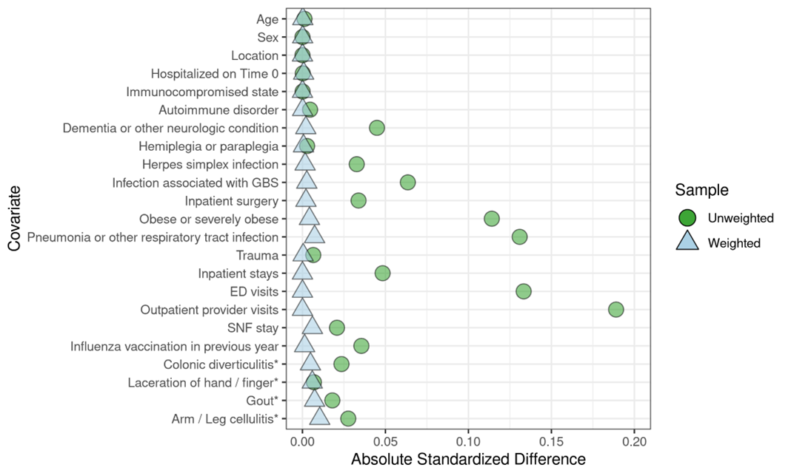

ii. Bell’s Palsy
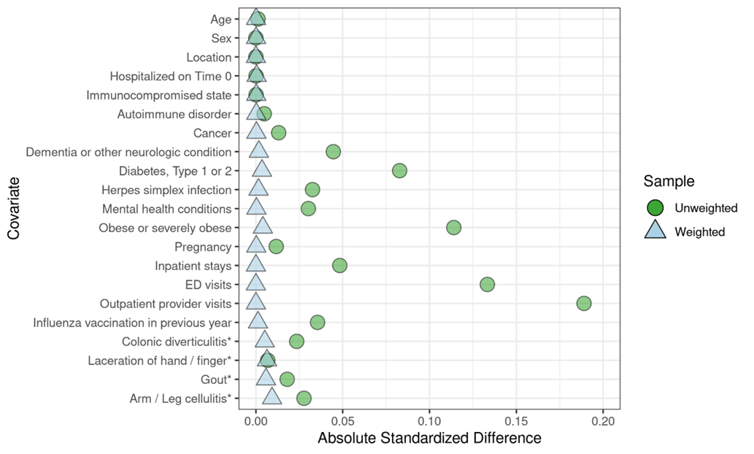

iii. Narcolepsy
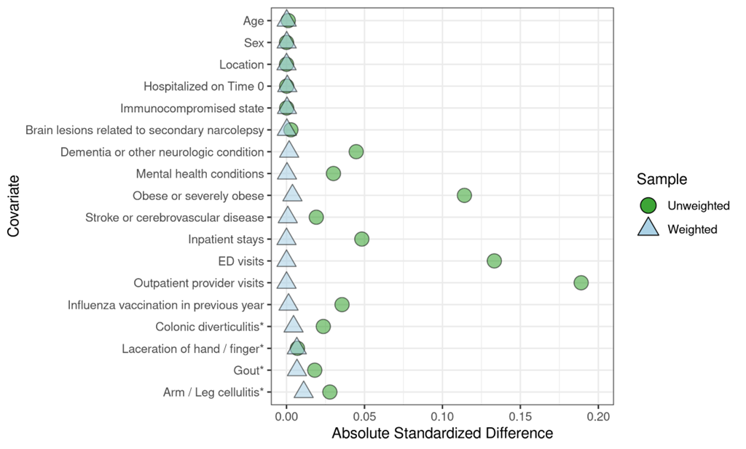

iv. Immune Thrombocytopenia
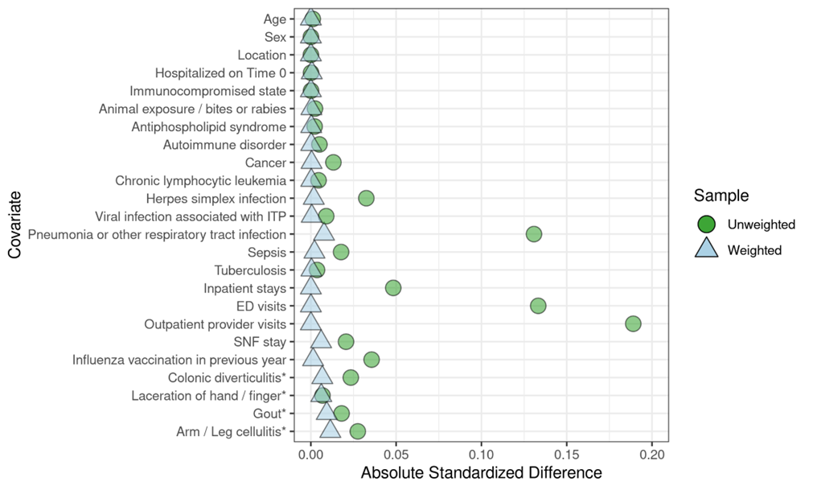

v. Transverse Myelitis
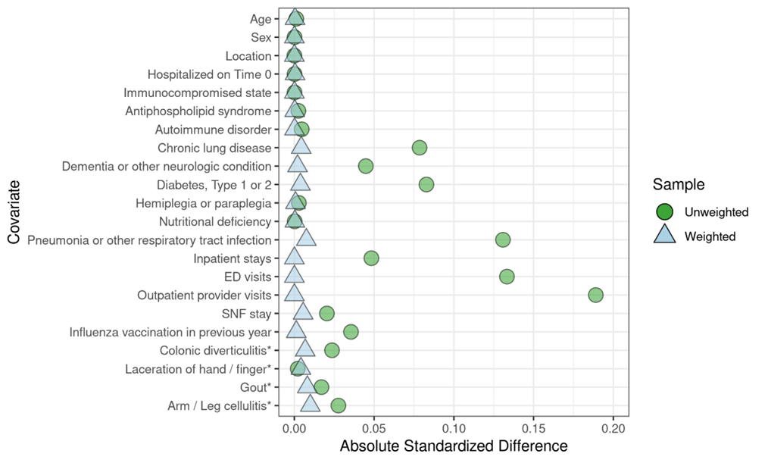

B. Medicare

i. Guillain-Barré Syndrome
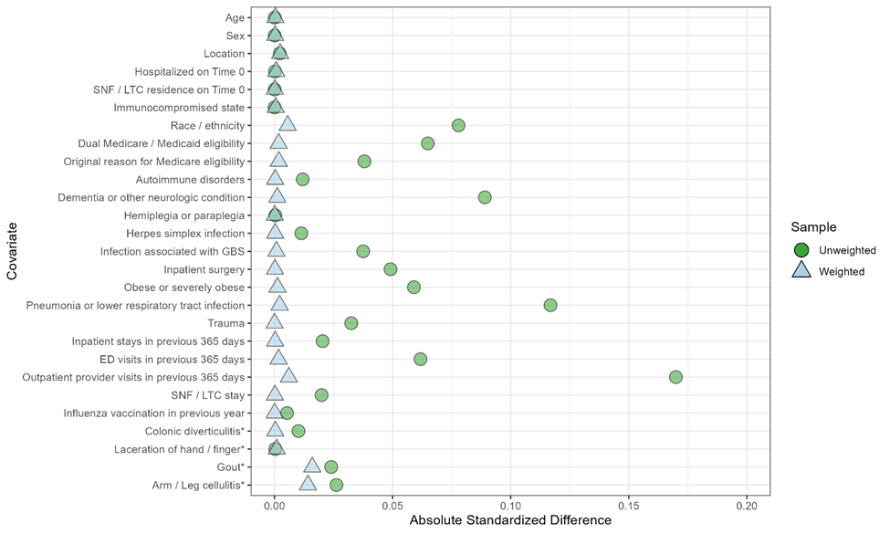

ii. Bell’s Palsy
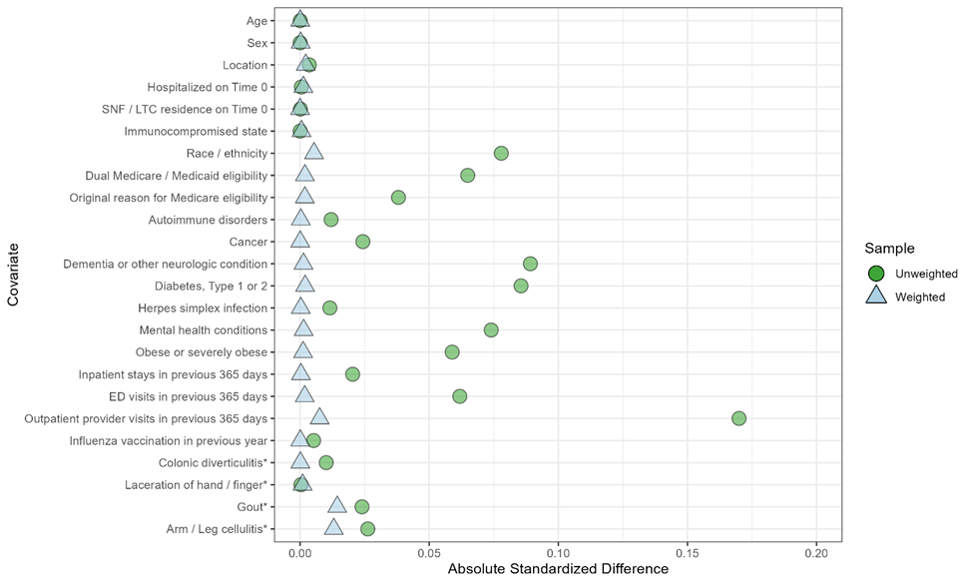

iii. Narcolepsy
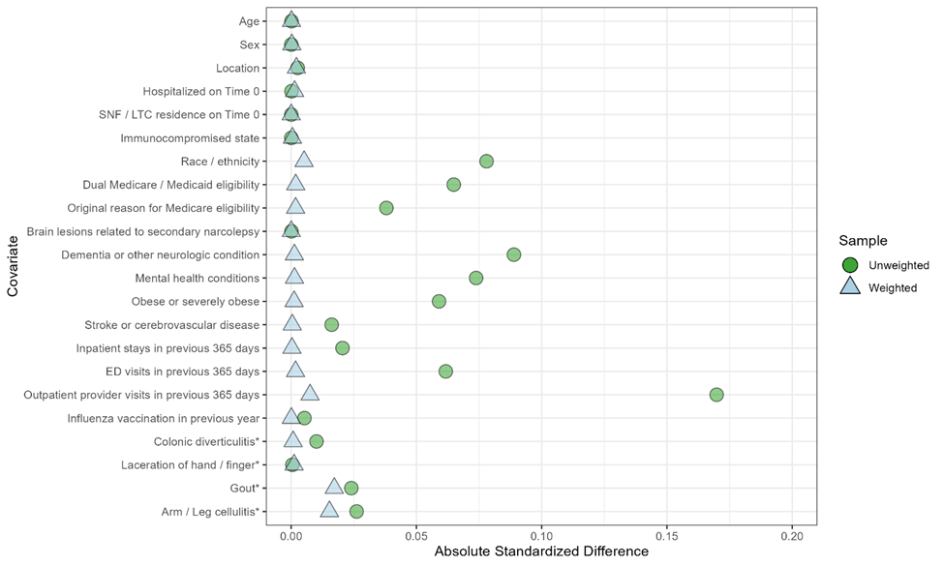

iv. Immune Thrombocytopenia
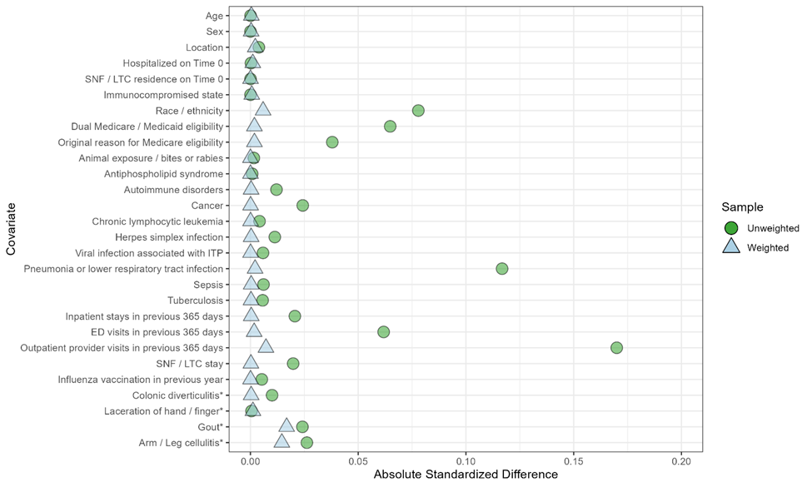

v. Transverse Myelitis
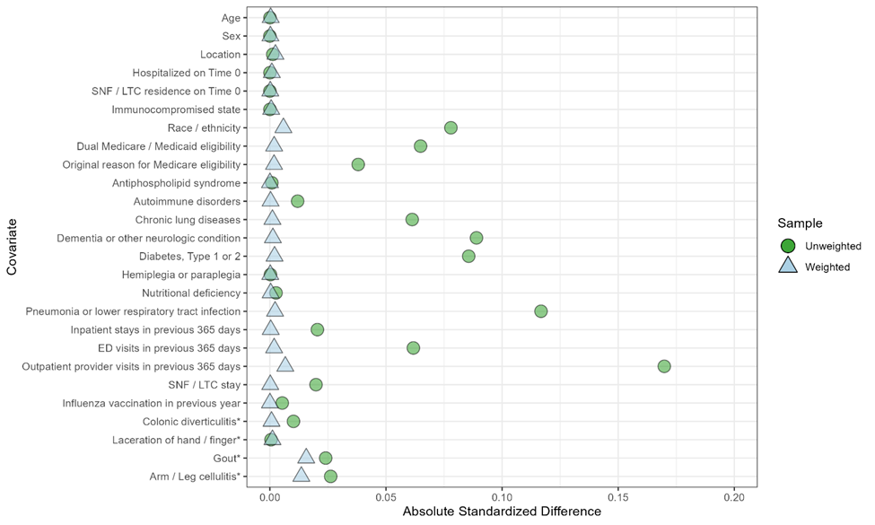

COVID 19 = coronavirus disease 2019; ED = emergency department; GBS = Guillain-Barré syndrome; ITP = immune thrombocytopenia; LTC = long-term care; SNF = skilled nursing facility.

