Supplementary materials

Risk of stroke for AMI treated with temporary mechanical circulatory support: Analysis of National Inpatient Sample

Authors: Jing Wu, PhDª, Chenguang Li, MD^{b}, Zheng Xu, MD^{c}, Baoguo Wang, MD^{c}, and Mingyou Zhang, MD^{c*}

Index
Supplementary Table 1. ICD9 and ICD10 diagnosis and procedure codes. Page 2
Supplementary Table 2: Univariate and multivariate regression for the risk of ischemic stroke.
Page 5
Supplementary Table 3: Univariate and multivariate regression for the risk of hemorrhagic stroke. Page 7

Supplementary Figure 1 study flow chart.
Page 9
Supplementary Figure 2 proportional Venn graph illustrating the proportion of hospitalizations with different modes of tMCS. Page 10

Supplementary Figure 3: Subgroup analysis of overall stroke risk comparing hospitalization treated with IABP only to those without tMCS devices. Page 11

Supplementary Figure 4: Subgroup analysis of overall stroke risk comparing hospitalization treated with Impella only to those without tMCS devices. Page 12

Supplementary Figure 5: Subgroup analysis of ischemic stroke risk comparing hospitalization treated with IABP only to those without tMCS devices. Page 13

Supplementary Figure 6: Subgroup analysis of ischemic stroke risk comparing hospitalization treated with Impella only to those without tMCS devices. Page 14

Supplementary Figure 7: Subgroup analysis of ischemic stroke risk comparing hospitalization treated with ECMO to those without tMCS devices. Page 15

Supplementary Figure 8: Subgroup analysis of hemorrhagic stroke risk comparing hospitalization treated with IABP only to those without tMCS devices. Page 16

Supplementary Figure 9: Subgroup analysis of hemorrhagic stroke risk comparing hospitalization treated with Impella only to those without tMCS devices. Page 17

Supplementary Figure 10: Subgroup analysis of hemorrhagic stroke risk comparing hospitalization treated with ECMO to those without tMCS devices. Page 18

Supplementary Table 1. ICD10 diagnosis and procedure codes

ICD9 | ICD10
ECMO

396.5 | 5A0920Z 5A15223 5A1522F 5A1522G 5A1522H
IABP  376.1 | 5A02110 5A02210
Impella  376.8 | 5A0221D 5A0211D
STEMI

410.00 410.01 410.02 410.10 410.11 410.12 410.20 410.21 410.22 410.30 410.31 410.32 410.40 410.41 410.42 410.50 410.51 410.52 410.60 410.61 410.62 410.80 410.81 410.82 410.90 410.91 410.92 | I21.01 I20.2 I20.9 I21.11 I21.19 I21.21 I21.29 I21.3
NSTEMI

410.70 410.71 410.72 | I21.4
COVID-19

Not applicable | U07.1
Atrial fibrillation

427.31 | I48.0 I48.1 I48.11 I48.19 I48.2 I48.20 I48.21 I48.91
Cardiac arrest

427.5 | 46.9 46.2 I46.8 I97.120 I97.121 I97.130 I97.710
Smoking status

V158.2 305.1 | Z87.891 F17.200 F17.201 F17.203 F17.208 F17.209 F17.210 F17.211 F17.213 F17.218 F17.219 F17.220 F17.221 F17.223 F17.228 F17.229 F17.290 F17.291 F17.293 F17.298 F17.299 Z72.0
Prior MI

412 | I25.2
Prior PCI

V458.2 | Z98.61 Z95.5
Prior CABG

V458.1 | Z95.1
Family history of CAD

V173 V174.9 | Z82.49 Z82.41
Prior Stroke

V125.4 | Z86.73
Left heart angiography

885.3 885.4 885.5 885.6 885.7 | B2060ZZ B2061ZZ B206YZZ B2160ZZ B2161ZZ B216YZZ B2000ZZ B2001ZZ B200YZZ B2010ZZ B2011ZZ B201YZZ B2100ZZ B2101ZZ B210YZZ B2110ZZ B2111ZZ  B211YZZ 4A023N7 4A023N8
PCI procedure

006.6 360.6 360.7 | 0210344 02103D4 0211344 02113D4 02123D4 0270346 027034Z 0270356 027035Z 0270366 027036Z 0270376 027037Z 02703D6 02703DZ 02703E6 02703EZ 02703F6 02703FZ 02703G6 02703GZ 02703T6 02703TZ 02703Z6 02703ZZ 0271346 027134Z 0271356 027135Z 0271366 027136Z 0271376 027137Z 02713D6 02713DZ 02713E6 02713EZ 02713F6 02713FZ 02713G6 02713GZ 02713T6 02713TZ 02713Z6 02713ZZ 0272346 027234Z 0272356 027235Z 0272366 027236Z 0272376 027237Z 02723D6 02723DZ 02723EZ 02723F6 02723FZ 02723G6 02723GZ 02723TZ 02723Z6 02723ZZ 0273346 027334Z 0273356 027335Z 0273366 027336Z 0273376 027337Z 02733D6 02733DZ 02733EZ 02733FZ 02733GZ 02733Z6 02733ZZ 02C03Z6 02C03ZZ 02C13Z6 02C13ZZ 02C23Z6 02C23ZZ 02C33Z6 02C33ZZ 02H03DZ 02H13DZ 02H23DZ 02Q03ZZ 02Q13ZZ 02Q23ZZ 02U03JZ 02U13JZ X2C0361 X2C1361 X2C2361 X2C3361
Cardiogenic shock

785.51 | R57.0
Pericardiocentesis

370 | 0W9D30Z 0W9D3ZX 0W9D3ZZ 0W9D40Z 0W9D4ZX 0W9D4ZZ 0W9D0ZX 0W9D0ZZ
Cardiac tamponade

423.3 | I31.4
Ischemic stroke
434.91 433.01 433.11 433.21 433.31 433.81 433.91 434.00 434.01 434.10 434.11 436 997.02 | G43.601 G43.609 G43.611 G43.619 I63.00 I63.011 I63.012 I63.013 I63.019 I63.02 I63.031 I63.032 I63.033 I63.039 I63.09 I63.10 I63.111 I63.112 I63.113 I63.119 I63.12 I63.131 I63.132 I63.133 I63.139 I63.19 I63.20 I63.211 I63.212 I63.213 I63.219 I63.22 I63.231 I63.232 I63.233 I63.239 I63.29 I63.30 I63.311 I63.312 I63.313 I63.319 I63.321 I63.322 I63.323 I63.329 I63.331 I63.332 I63.333 I63.339 I63.341 I63.342 I63.343 I63.349 I63.39 I63.40 I63.411 I63.412 I63.413 I63.419 I63.421 I63.422 I63.423 I63.429 I63.431 I63.432 I63.433 I63.439 I63.441 I63.442 I63.443 I63.449 I63.49 I63.50 I63.511 I63.512 I63.513 I63.519 I63.521 I63.522 I63.523 I63.529 I63.531 I63.532 I63.533 I63.539 I63.541 I63.542 I63.543 I63.549 I63.59 I63.6 I63.8 I63.81 I63.89 I63.9
Hemorrhagic stroke

430 431 432.0 432.1 432.9 | I60.00 I60.01 I60.02 I60.10 I60.11 I60.12 I60.2 I60.20 I60.21 I60.22 I60.30 I60.31 I60.32 I60.4 I60.50 I60.51 I60.52 I60.6 I60.7 I60.8 I60.9 I61.0 I61.1 I61.2 I61.3 I61.4 I61.5 I61.6 I61.8 I61.9 I62.00 I62.01 I62.02 I62.03 I62.1 I62.9

AMI: acute myocardial infarction; CABG: coronary artery bypass grafting; CAD: coronary artery disease; ECMO： extracorporeal membrane oxygenation; IABP: intra-aortic balloon pump; PCI: Percutaneous coronary intervention; STEMI: ST segment elevation myocardial infarction.

Supplementary Table 2: Univariate and multivariate regression f the risk of ischemic stroke
 | Univariate regression |  |  |  | Multivariate regression
Variables |  | Lower CI | Upper CI | p value | a | Lower CI | Upper CI | p value
ECMO | 3.61 | 3.13 | 4.17 | <0.001 | 2.67 | 2.30 | 3.10 | <0.001
age >75 Vs age<50 | 1.81 | 1.72 | 1.90 | <0.001 | 1.29 | 1.23 | 1.36 | <0.001
Atrial fibrillation | 1.68 | 1.63 | 1.72 | <0.001 | 1.42 | 1.38 | 1.46 | <0.001
Shock | 1.60 | 1.54 | 1.67 | <0.001 | 1.44 | 1.38 | 1.51 | <0.001
Female | 1.43 | 1.39 | 1.46 | <0.001 | 1.25 | 1.22 | 1.28 | <0.001
Impella only | 1.36 | 1.21 | 1.51 | <0.001 | 1.79 | 1.59 | 2.01 | <0.001
Prior stroke | 1.35 | 1.30 | 1.41 | <0.001 | 1.29 | 1.24 | 1.34 | <0.001
50≤ AGE ≤75 Vs age<50 | 1.32 | 1.28 | 1.35 | <0.001 | 1.23 | 1.17 | 1.30 | <0.001
Peripheral vascular disease | 1.28 | 1.24 | 1.33 | <0.001 | 1.25 | 1.21 | 1.29 | <0.001
IABP only | 1.08 | 0.99 | 1.15 | 0.06
Hypertension | 1.02 | 0.99 | 1.05 | 0.61 | 1.07 | 1.04 | 1.11 | <0.001
Diabetes mellitus | 1.01 | 0.99 | 1.04 | 0.44
Medicaid vs Medicare | 0.97 | 0.93 | 1.01 | <0.001 | 1.11 | 1.06 | 1.16 | <0.001
Hypothyroidism | 0.96 | 0.92 | 0.99 | <0.001 | 0.83 | 0.80 | 0.87 | <0.001
Rural/urban nonteaching | 0.95 | 0.90 | 1.01 | <0.001 | 0.86 | 0.81 | 0.91 | <0.001
Chronic lung disease | 0.81 | 0.79 | 0.83 | <0.001 | 0.72 | 0.70 | 0.75 | <0.001
White race | 0.78 | 0.76 | 0.80 | <0.001 | 0.83 | 0.81 | 0.85 | <0.001
Small bedsize of hospital/Large bedsize of hospital | 0.76 | 0.73 | 0.79 | <0.001 | 0.68 | 0.66 | 0.70 | <0.001
Prior CABG | 0.72 | 0.69 | 0.76 | <0.001 | 0.73 | 0.70 | 0.77 | <0.001
Rural/Urban teaching | 0.72 | 0.68 | 0.76 | <0.001 | 0.62 | 0.59 | 0.65 | <0.001
Obesity | 0.67 | 0.65 | 0.70 | <0.001 | 0.73 | 0.71 | 0.76 | <0.001
Prior MI | 0.66 | 0.63 | 0.68 | <0.001 | 0.79 | 0.76 | 0.82 | <0.001
Smoke | 0.65 | 0.64 | 0.67 | <0.001 | 0.74 | 0.72 | 0.77 | <0.001
Private insurance vs medicare | 0.61 | 0.59 | 0.63 | <0.001 | 0.82 | 0.79 | 0.85 | <0.001
Prior PCI | 0.57 | 0.55 | 0.60 | <0.001 | 0.66 | 0.63 | 0.69 | <0.001
Thrombectomy | 0.55 | 0.51 | 0.60 | <0.001
Family history of CAD | 0.40 | 0.38 | 0.42 | <0.001 | 0.51 | 0.48 | 0.54 | <0.001
PCI | 0.28 | 0.28 | 0.29 | <0.001 | 0.31 | 0.30 | 0.32 | <0.001
AMI: acute myocardial infarction; CABG: coronary artery bypass grafting; CAD: coronary artery disease; ECMO： extracorporeal membrane oxygenation; IABP: intra-aortic balloon pump; PCI: Percutaneous coronary intervention; STEMI: ST segment elevation myocardial infarction.

Supplementary Table 3: Univariate and multivariate regression for the risk of hem rhagic stroke
 | Univariate regression |  |  |  | Multivariate regression
Variables |  | Lower CI | Upper CI | P value | a | Lower CI | Upper CI | P value
ECMO | 7.12 | 5.82 | 8.72 | <0.001 | 2.86 | 2.31 | 3.55 | <0.001
Medicaid vs Medicare | 1.40 | 1.30 | 1.51 | <0.001
Atrial fibrillation | 1.28 | 1.21 | 1.35 | <0.001 | 1.16 | 1.1 | 1.23 | <0.001
Impella only | 1.25 | 0.99 | 1.58 | 0.06 | 1.55 | 1.22 | 1.99 | <0.001
Female | 1.24 | 1.18 | 1.30 | <0.001 | 1.13 | 1.07 | 1.19 | <0.001
age >75 Vs age<50 | 1.17 | 1.08 | 1.27 | <0.001 | 1.01 | 0.92 | 1.10 | <0.001
50≤ AGE ≤75 Vs age<50 | 1.15 | 1.06 | 1.26 | <0.001 | 1.22 | 1.11 | 1.36 | <0.001
Prior stroke | 1.07 | 0.98 | 1.17 | 0.12 | 1.16 | 1.06 | 1.27 | 0.001
peripheral vascular disease | 1.02 | 0.94 | 1.10 | <0.001
Private insurance vs medicare | 0.89 | 0.84 | 0.95 | <0.001
IABP only | 0.84 | 0.72 | 1.00 | 0.05 | 0.68 | 0.58 | 0.81 | <0.001
Hypertension | 0.80 | 0.76 | 0.85 | <0.001
Hypothyroidism | 0.79 | 0.73 | 0.86 | <0.001 | 0.81 | 0.75 | 0.88 | <0.001
Diabetes mellitus | 0.73 | 0.70 | 0.77 | <0.001 | 0.72 | 0.69 | 0.76 | <0.001
Rural/Urban nonteaching | 0.70 | 0.60 | 0.81 | <0.001 | 0.61 | 0.53 | 0.72 | <0.001
Chronic lung disease | 0.68 | 0.64 | 0.72 | <0.001 | 0.72 | 0.70 | 0.75 | <0.001
Obesity | 0.61 | 0.57 | 0.66 | <0.001 | 0.66 | 0.62 | 0.70 | <0.001
Smoke | 0.59 | 0.55 | 0.62 | <0.001 | 0.71 | 0.66 | 0.76 | <0.001
White race | 0.59 | 0.56 | 0.62 | <0.001 | 0.73 | 0.68 | 0.75 | <0.001
Prior CABG | 0.55 | 0.48 | 0.61 | <0.001 | 0.66 | 0.59 | 0.73 | <0.001
Prior MI | 0.53 | 0.48 | 0.57 | <0.001 | 0.68 | 0.62 | 0.75 | <0.001
Small bedsize of hospital/Large bedsize of hospital | 0.49 | 0.45 | 0.53 | <0.001 | 0.42 | 0.38 | 0.45 | <0.001
Thrombectomy | 0.49 | 0.41 | 0.59 | <0.001
Prior PCI | 0.48 | 0.44 | 0.53 | <0.001 | 0.61 | 0.56 | 0.67 | <0.001
Rural/Urban teaching | 0.34 | 0.29 | 0.39 | <0.001 | 0.29 | 0.25 | 0.33 | <0.001
Family history of CAD | 0.28 | 0.24 | 0.32 | <0.001 | 0.35 | 0.30 | 0.39 | <0.001
AMI: acute myocardial infarction; CABG: coronary artery bypass grafting; CAD: coronary artery disease; ECMO： extracorporeal membrane oxygenation; IABP: intra-aortic balloon pump; PCI: Percutaneous coronary intervention; STEMI: ST segment elevation myocardial infarction.

Supplementary Figure 1 Study flow chart

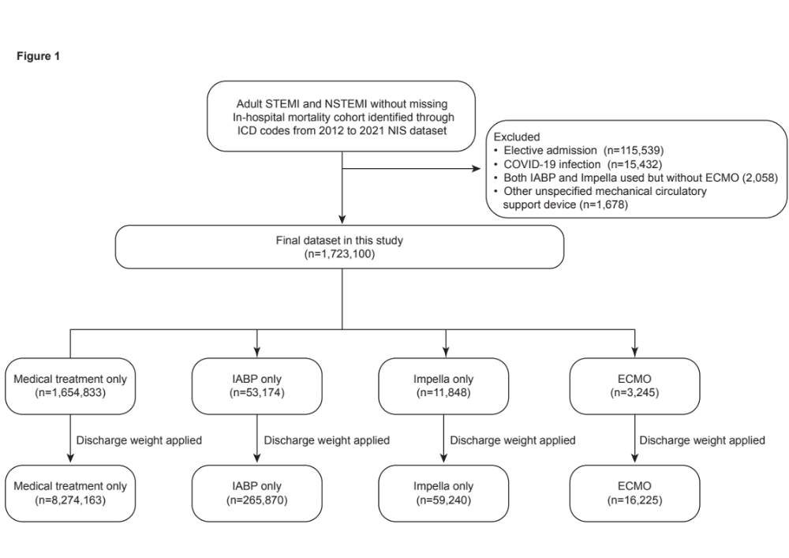

Supplementary Figure 2 proportional Venn graph illustrating the proportion of hospitalizations with different models of tMCS during the study period.

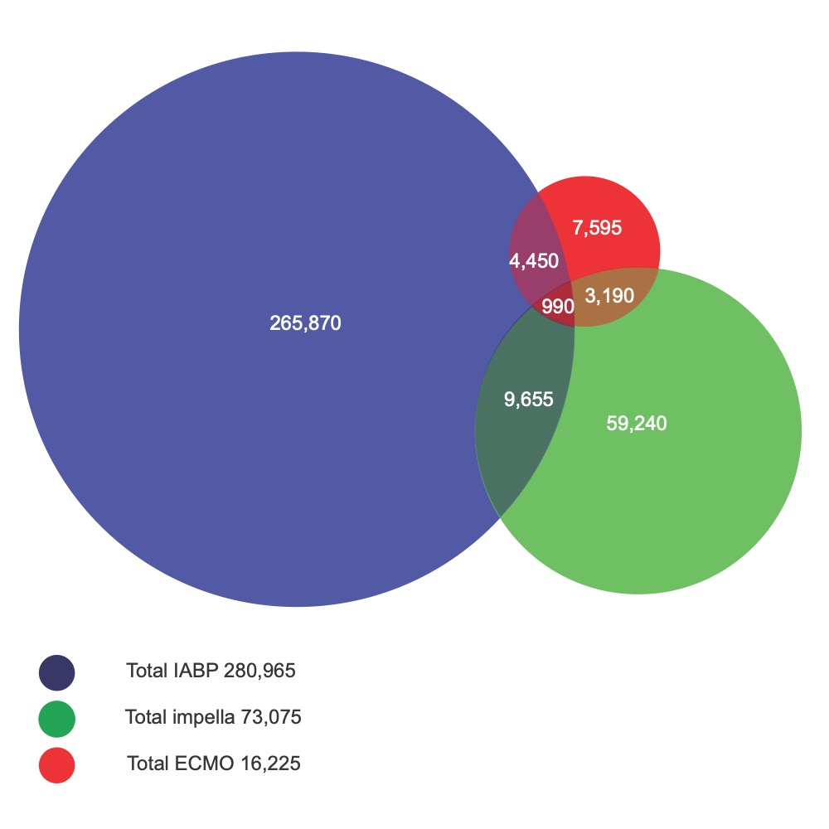

Supplementary Figure 3: Subgroup analysis of overall stroke risk comparing hospitalization treated with IABP only to those without tMCS devices.

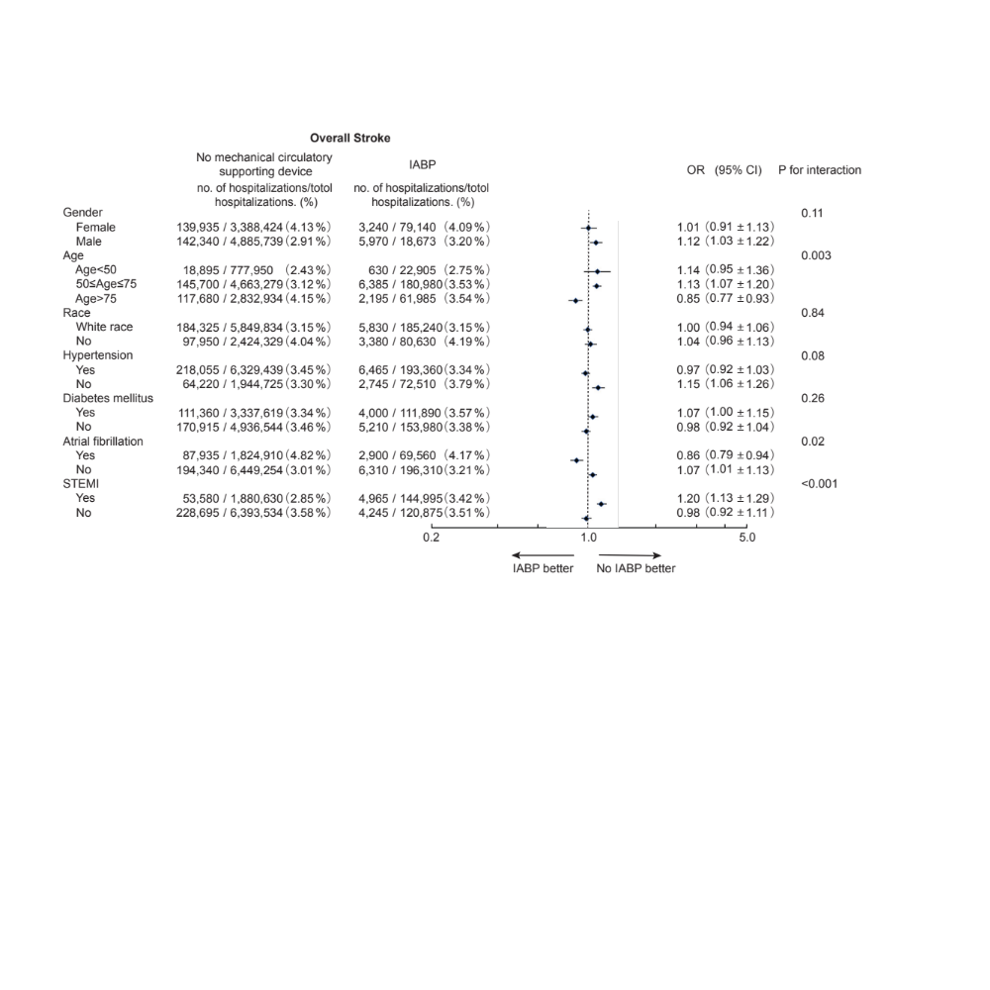

Supplementary Figure 4: Subgroup analysis of overall stroke risk comparing hospitalization treated with Impella only to those without tMCS devices.

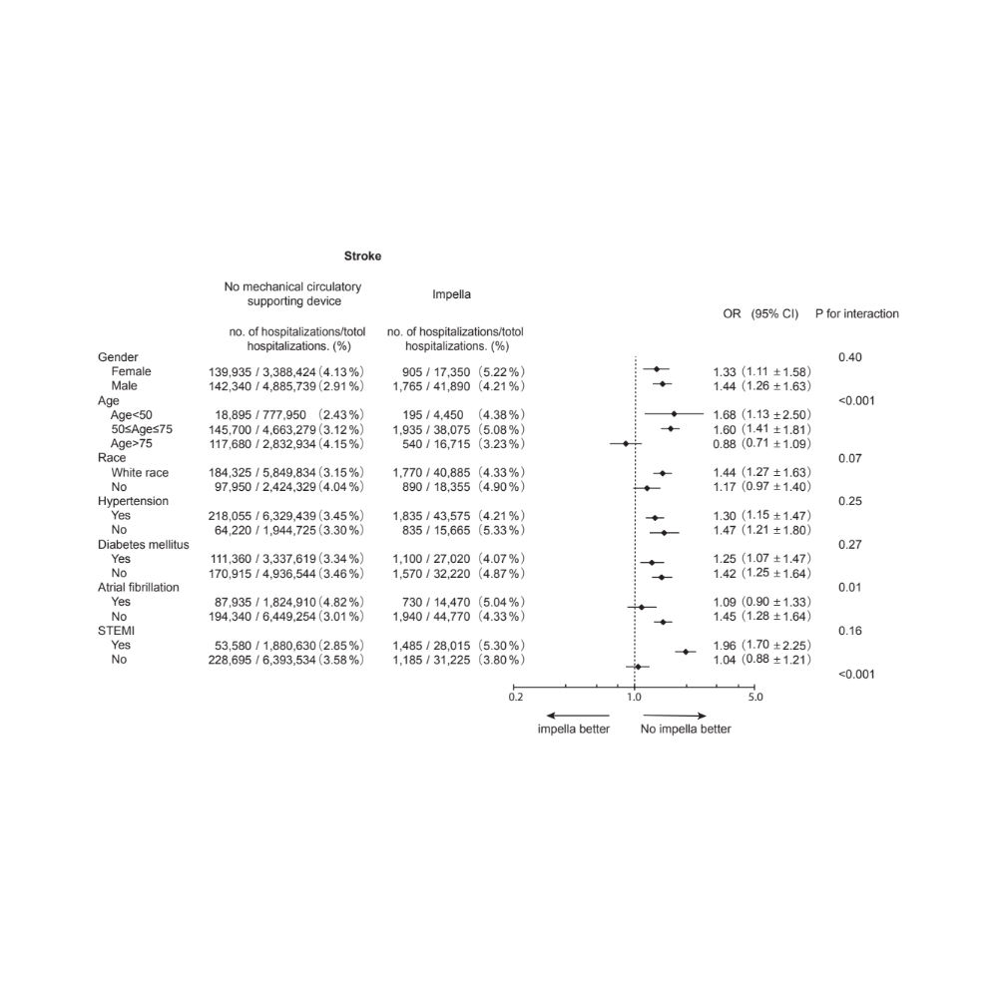

Supplementary Figure 5: Subgroup analysis of ischemic stroke risk comparing hospitalization treated with IABP only to those without tMCS devices.
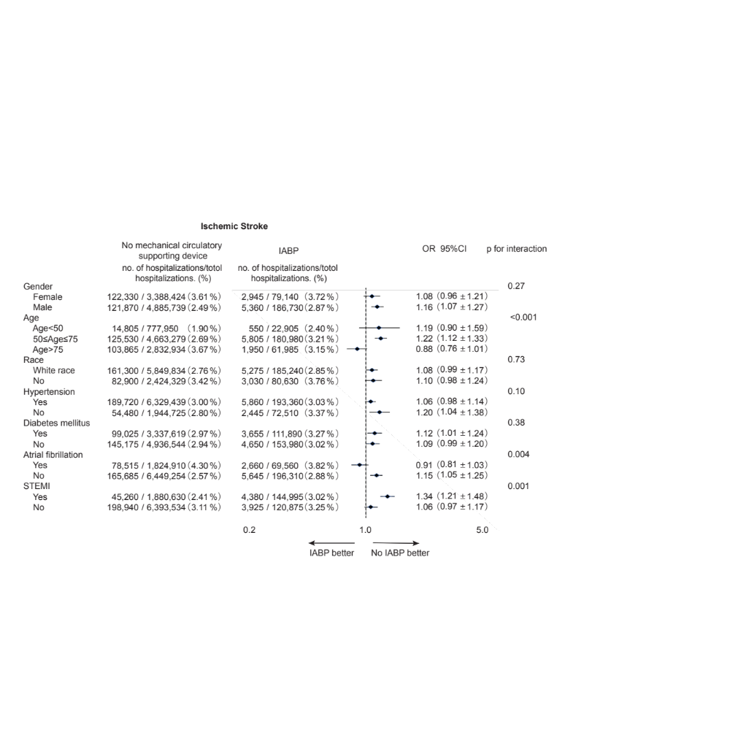

Supplementary Figure 6: Subgroup analysis of ischemic stroke risk comparing hospitalization treated with Impella only to those without tMCS devices.
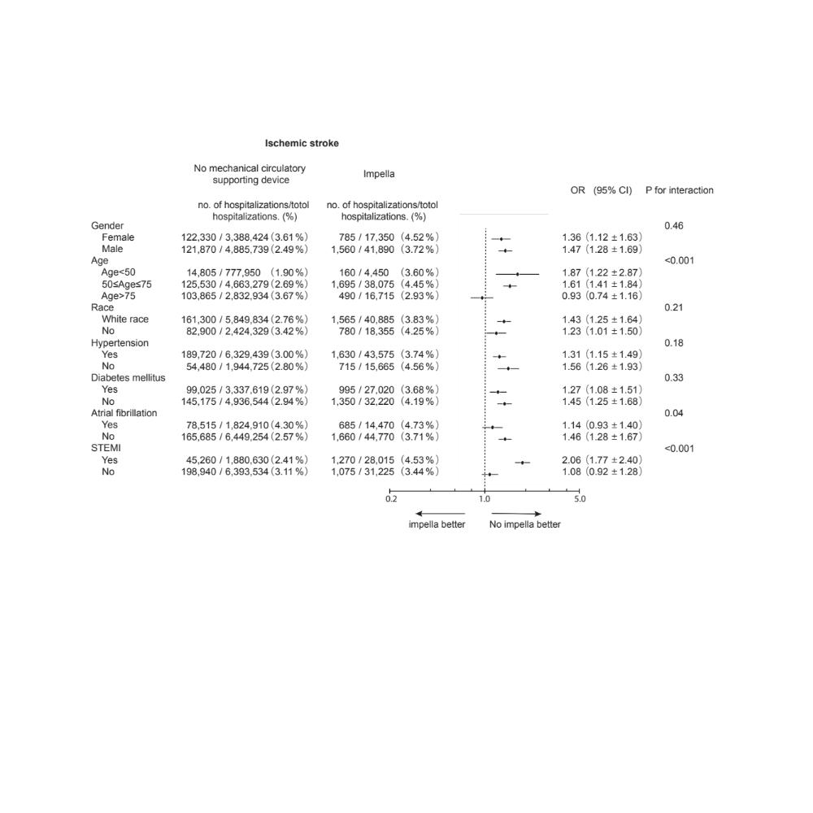

Supplementary Figure 7: Subgroup analysis of ischemic stroke risk comparing hospitalization treated with ECMO to those without tMCS devices.

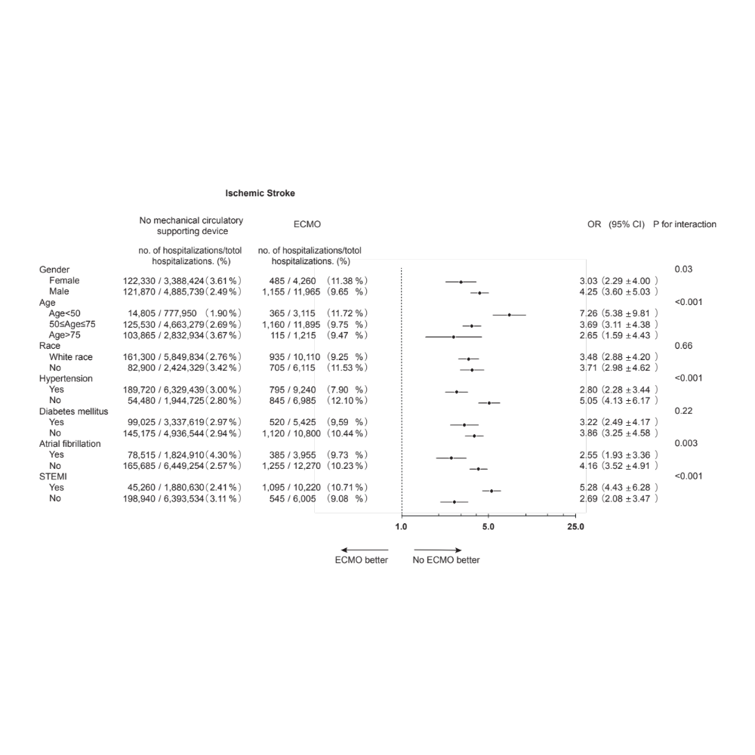

Supplementary Figure 8: Subgroup analysis of hemorrhagic stroke risk comparing hospitalization treated with IABP only to those without tMCS devices.

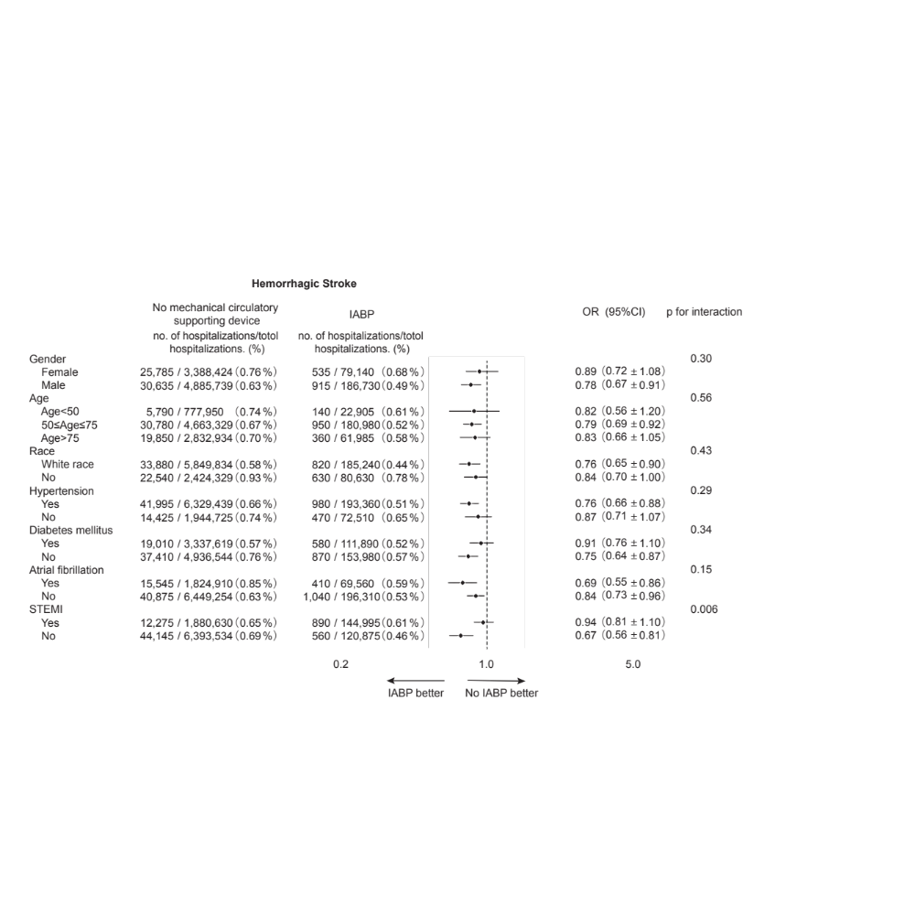

Supplementary Figure 9: Subgroup analysis of hemorrhagic stroke risk comparing hospitalization treated with Impella only to those without tMCS devices.

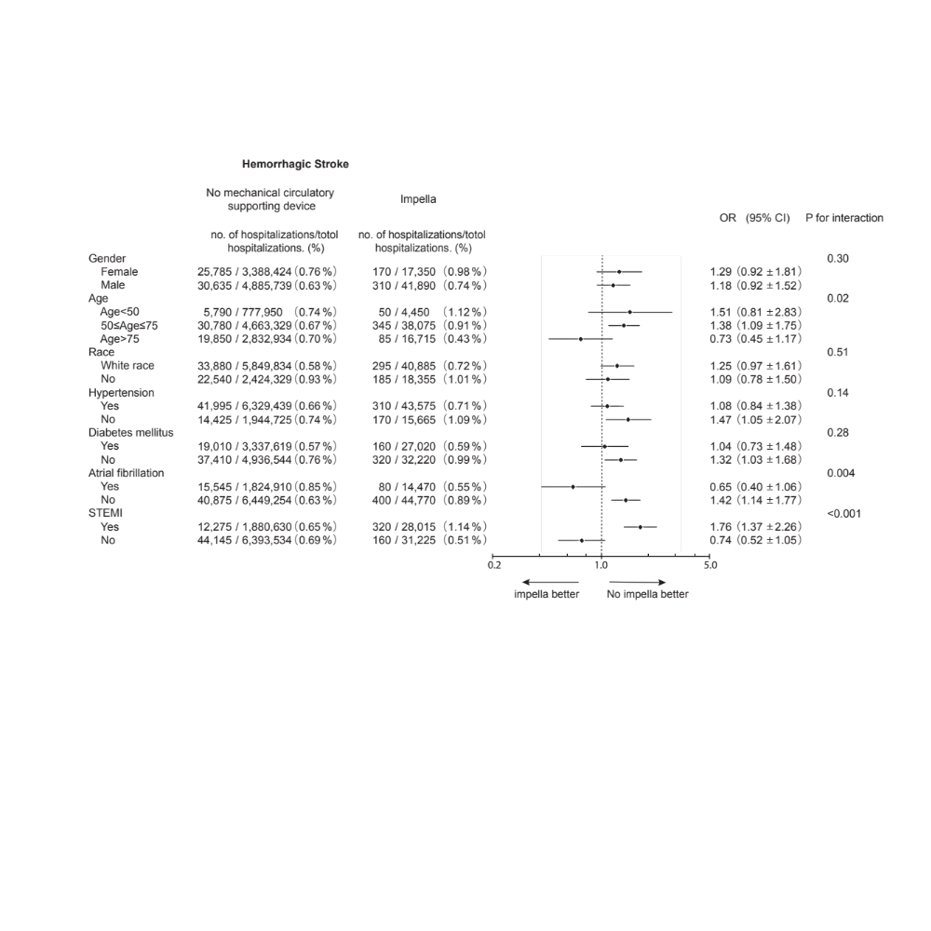

Supplementary Figure 10: Subgroup analysis of hemorrhagic stroke risk comparing hospitalization treated with ECMO to those without tMCS devices.

