Appendix A

Appendix A.1. Evaluation of the Received Operating Characteristic Curve of the Fitted Models
- ROC curves for resampling methods
- Comparison of resampling methods applied to complete cases datasets
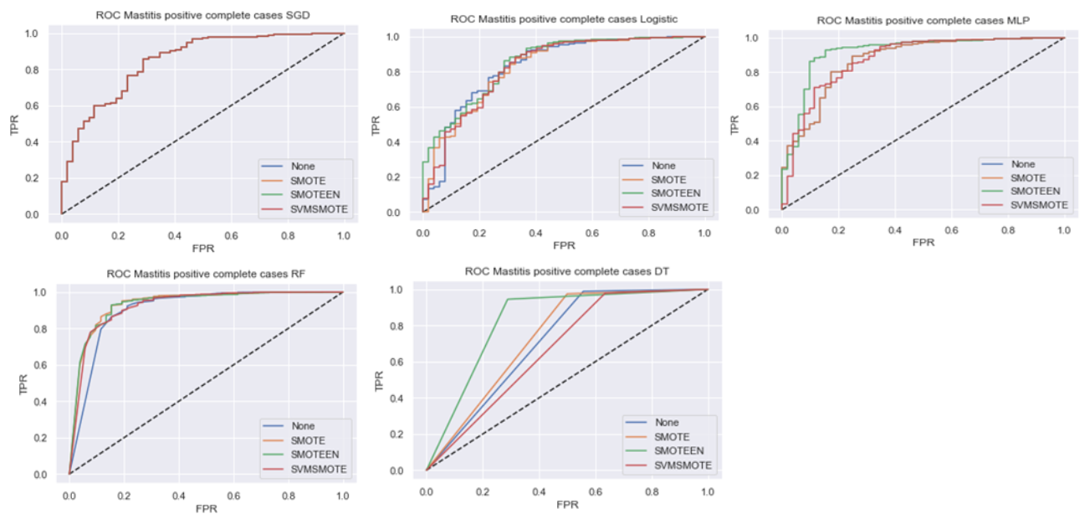
- Resampling methods applied to datasets with simple imputation of missing values
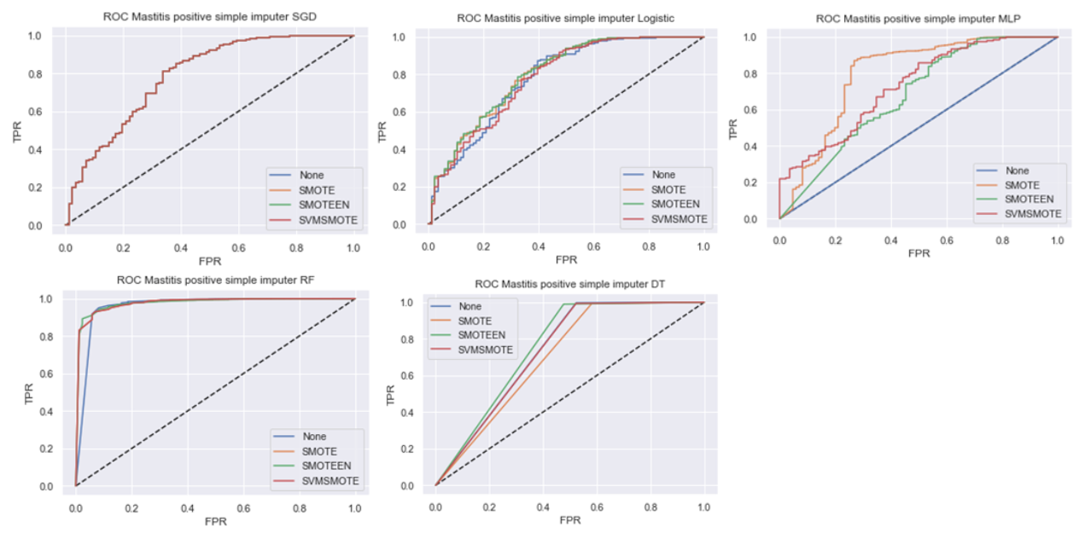
- Resampling methods applied to datasets with multiple imputation of missing values by chained equations
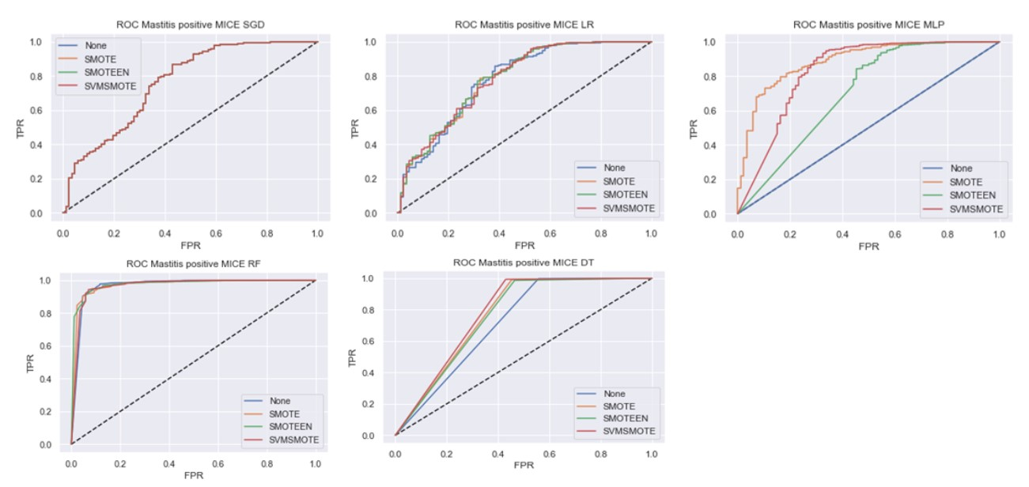
- Resampling methods applied to datasets with linear interpolation of missing values
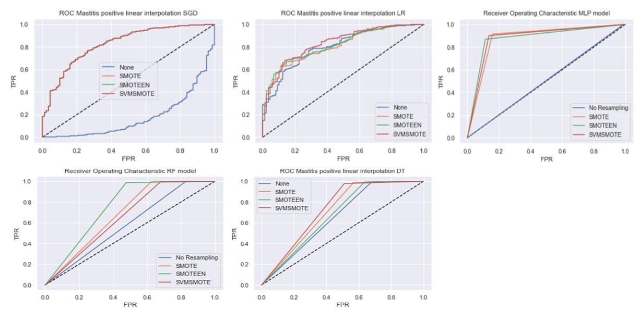
- ROC curves for the ML models performance with resampling methods
Logistic regression
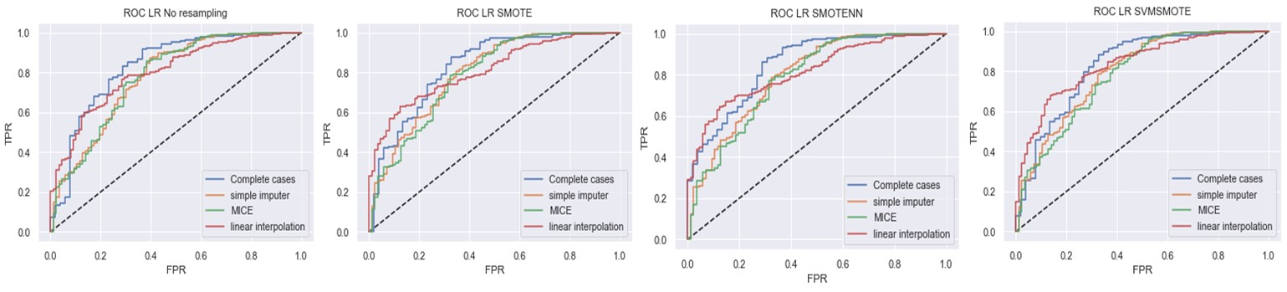
Decision tree
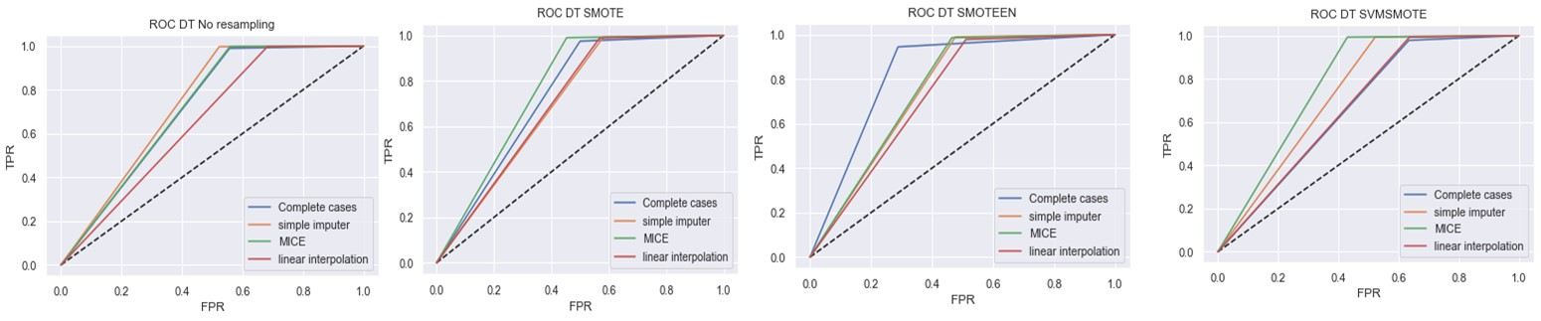
Random Forest
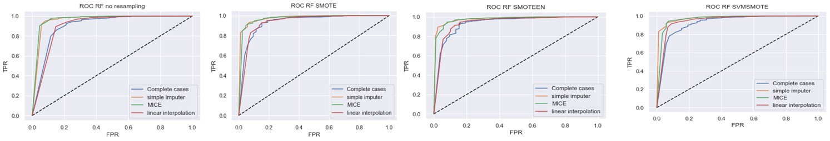
Multilayer perceptron
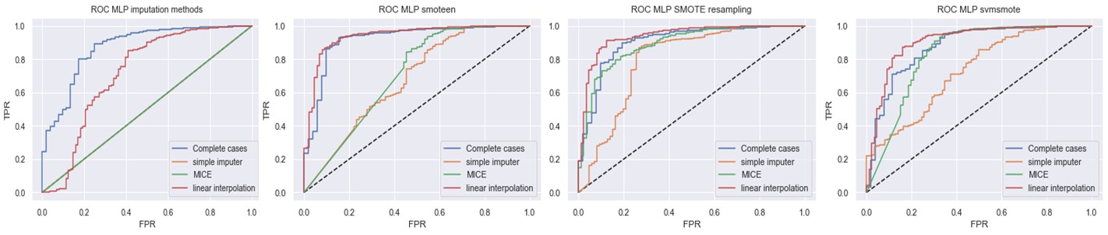

Appendix B
Rankings of the prediction scores of the fitted machine learning models with both resampling and imputation methods (kappa >0.20)
 | Model | Imputation | Resampling | Accuracy | F1Score | Precision | Recall | Kappa
1 | DT | SI | No Resampling | 0.994 | 0.997 | 0.997 | 0.997 | 0.465
2 | DT | MICE | No Resampling | 0.994 | 0.997 | 0.997 | 0.997 | 0.455
3 | RF | SI | SMOTE | 0.995 | 0.997 | 0.996 | 0.998 | 0.453
4 | RF | SI | SVMSMOTE | 0.995 | 0.997 | 0.996 | 0.998 | 0.453
5 | RF | MICE | SMOTE | 0.994 | 0.997 | 0.997 | 0.998 | 0.446
6 | RF | MICE | SVMSMOTE | 0.994 | 0.997 | 0.997 | 0.998 | 0.445
7 | RF | CC | No Resampling | 0.987 | 0.993 | 0.989 | 0.998 | 0.442
8 | RF | CC | SVMSMOTE | 0.980 | 0.990 | 0.991 | 0.989 | 0.426
9 | RF | SI | SMOTEEN | 0.993 | 0.997 | 0.997 | 0.996 | 0.417
10 | DT | CC | No Resampling | 0.980 | 0.981 | 0.981 | 0.980 | 0.416
11 | RF | SI | No Resampling | 0.996 | 0.998 | 0.996 | 1.000 | 0.409
12 | DT | MICE | SVMSMOTE | 0.991 | 0.995 | 0.998 | 0.993 | 0.404
13 | RF | MICE | SMOTEEN | 0.992 | 0.996 | 0.997 | 0.996 | 0.386
14 | RF | CC | SMOTE | 0.976 | 0.988 | 0.991 | 0.985 | 0.378
15 | DT | SI | SVMSMOTE | 0.991 | 0.995 | 0.997 | 0.994 | 0.367
16 | RF | CC | SMOTEEN | 0.963 | 0.981 | 0.995 | 0.968 | 0.366
17 | RF | MICE | No Resampling | 0.995 | 0.998 | 0.996 | 1.000 | 0.350
18 | DT | MICE | SMOTE | 0.988 | 0.994 | 0.997 | 0.990 | 0.333
19 | MLP | LI | SMOTE | 0.991 | 0.996 | 0.996 | 0.995 | 0.332
20 | RF | LI | SMOTE | 0.991 | 0.996 | 0.996 | 0.995 | 0.332
21 | DT | LI | No Resampling | 0.992 | 0.996 | 0.996 | 0.996 | 0.322
22 | MLP | LI | No Resampling | 0.992 | 0.996 | 0.996 | 0.996 | 0.322
23 | RF | LI | No Resampling | 0.992 | 0.996 | 0.996 | 0.996 | 0.322
24 | DT | CC | SMOTE | 0.967 | 0.972 | 0.979 | 0.967 | 0.316
25 | DT | SI | SMOTEEN | 0.987 | 0.994 | 0.997 | 0.990 | 0.313
26 | DT | SI | SMOTE | 0.990 | 0.995 | 0.997 | 0.993 | 0.309
27 | SGD | CC | No Resampling | 0.957 | 0.967 | 0.979 | 0.957 | 0.280
28 | DT | LI | SMOTEEN | 0.989 | 0.995 | 0.996 | 0.993 | 0.277
29 | MLP | LI | SMOTEEN | 0.984 | 0.992 | 0.997 | 0.986 | 0.265
30 | RF | LI | SMOTEEN | 0.984 | 0.992 | 0.997 | 0.986 | 0.265
31 | DT | MICE | SMOTEEN | 0.984 | 0.992 | 0.997 | 0.986 | 0.264
32 | DT | CC | SMOTEEN | 0.941 | 0.958 | 0.982 | 0.941 | 0.264
33 | MLP | CC | No Resampling | 0.954 | 0.976 | 0.992 | 0.961 | 0.261
34 | MLP | CC | SMOTE | 0.954 | 0.976 | 0.992 | 0.961 | 0.261
35 | DT | CC | SVMSMOTE | 0.968 | 0.972 | 0.977 | 0.968 | 0.258
36 | DT | LI | SMOTE | 0.985 | 0.993 | 0.997 | 0.989 | 0.251
37 | MLP | MICE | SVMSMOTE | 0.981 | 0.990 | 0.997 | 0.984 | 0.229
38 | SGD | CC | SVMSMOTE | 0.940 | 0.957 | 0.979 | 0.940 | 0.225
39 | LR | CC | SVMSMOTE | 0.944 | 0.959 | 0.978 | 0.944 | 0.218

