Discover Civil Engineering, Topical Collection "Advances in Sustainable Mining Waste Management”.

Supplementary Information
Phytostabilisation of arsenic contaminated gold mine waste using the native species Juncus usitatus L.A.S Johnson, Poa labillardieri Steud and Themeda triandra Forssk.
Julie A. Besedin ¹˒²˒³˒*, Leadin S. Khudur ¹˒², Pacian Netherway ³, Christian Krohn ¹˒², Albert L. Juhasz ⁴, Feizia Huslina ¹˒²˒⁵, Darislav A. Besedin ¹, Kraiwut Jansriphibul ¹˒², Kamrun Nahar ¹˒², Andrew S. Ball ¹˒².
¹ School of Science, Royal Melbourne Institute of Technology University, Bundoora, VIC 3083, Australia .
² Australian Research Council Training Centre for the Transformation of Australia’s Biosolids Resource, Royal
Melbourne Institute of Technology University, Bundoora, VIC 3083, Australia.
³ Environment Protection Authority Victoria, EPA Science, Centre for Applied Sciences, Ernest Jones Drive,
Macleod, Melbourne, VIC 3085, Australia.
⁴ Future Industries Institute, University of South Australia, Mawson Lakes Campus, Adelaide, SA 5095, Australia.
⁵ Department of Biology, Faculty of Science and Technology, State Islamic University of Ar-Raniry, Banda Aceh 23111, Indonesia.
* Correspondence: s3962676@student.rmit.edu.au (J.A.B).

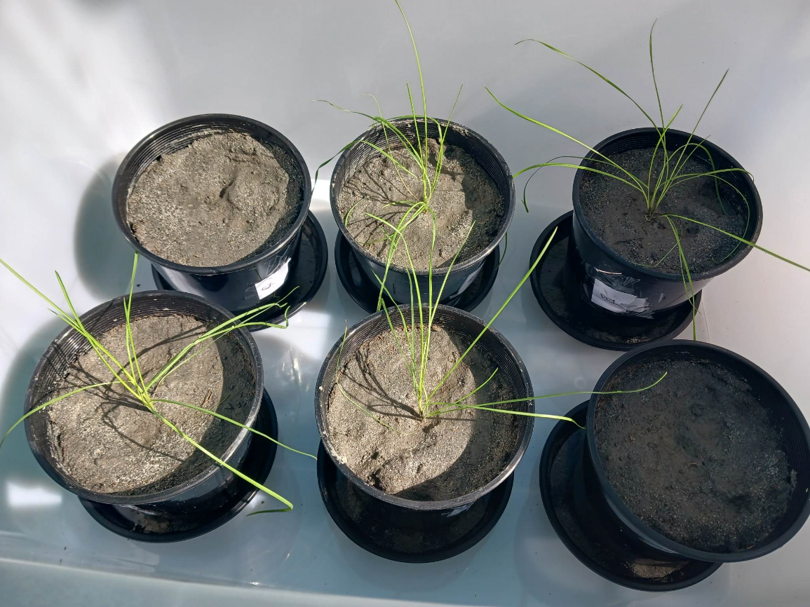
Figure S1: Poa labillardieri; no signs of discolouring and no curling of shoots.

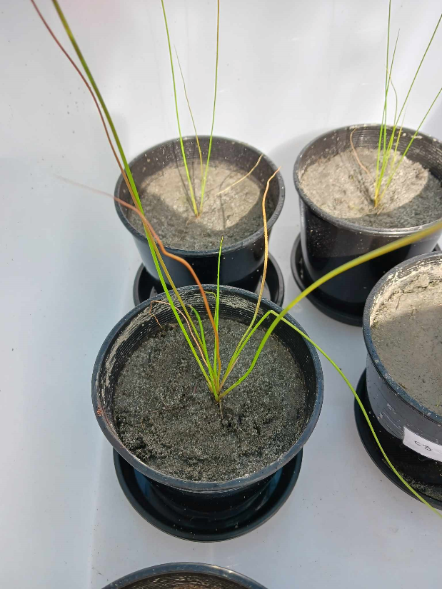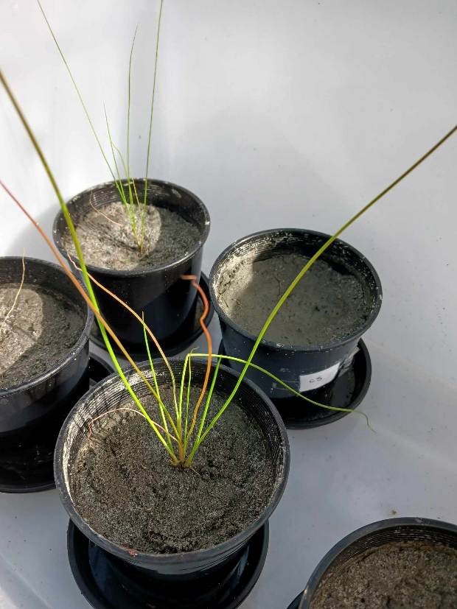
Figure S2: Juncus usitatus – orange discolouring and slight curling of some shoots.

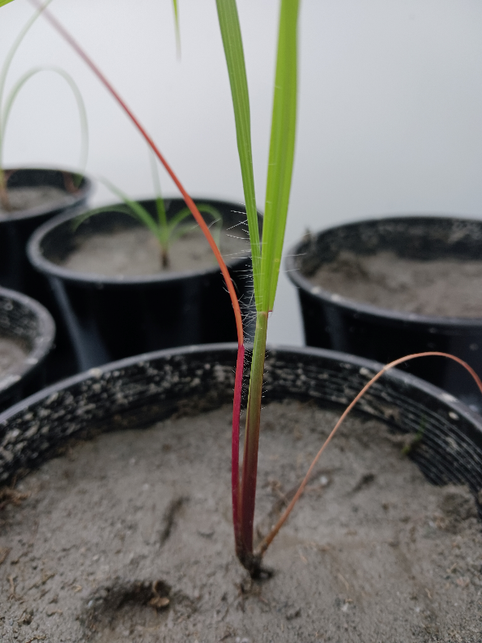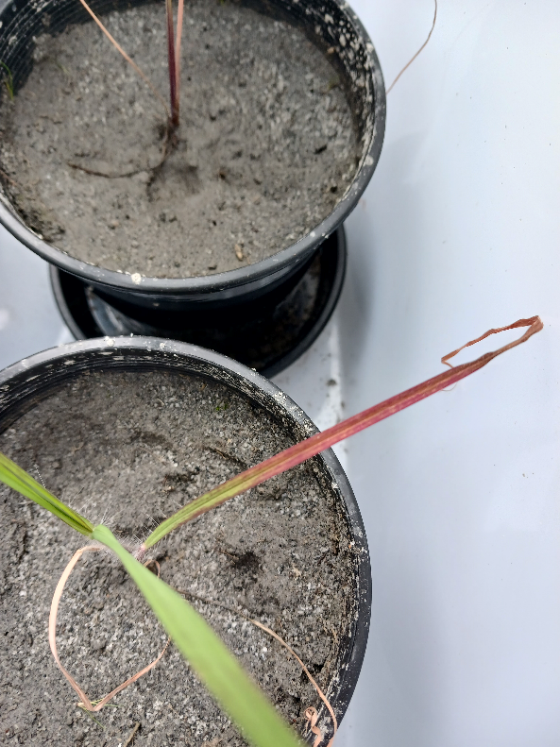
Figure S3: Themeda triandra; purple discolouring.

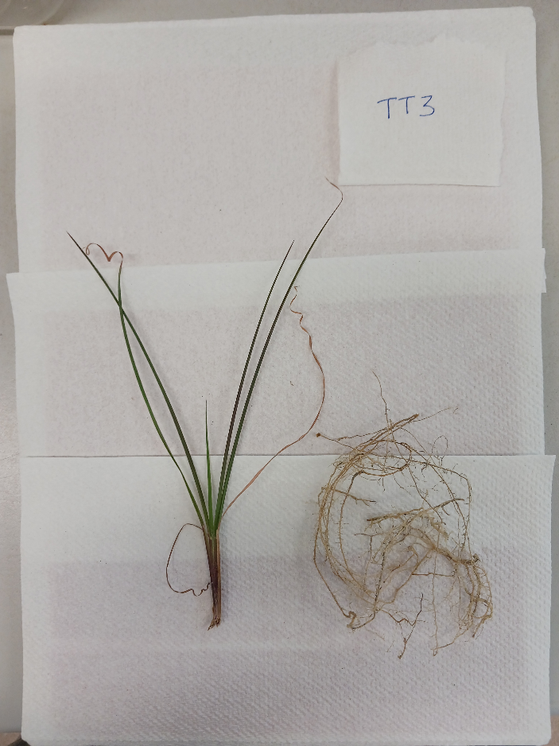
Figure S4: Themeda triandra; curling of shoot ends.
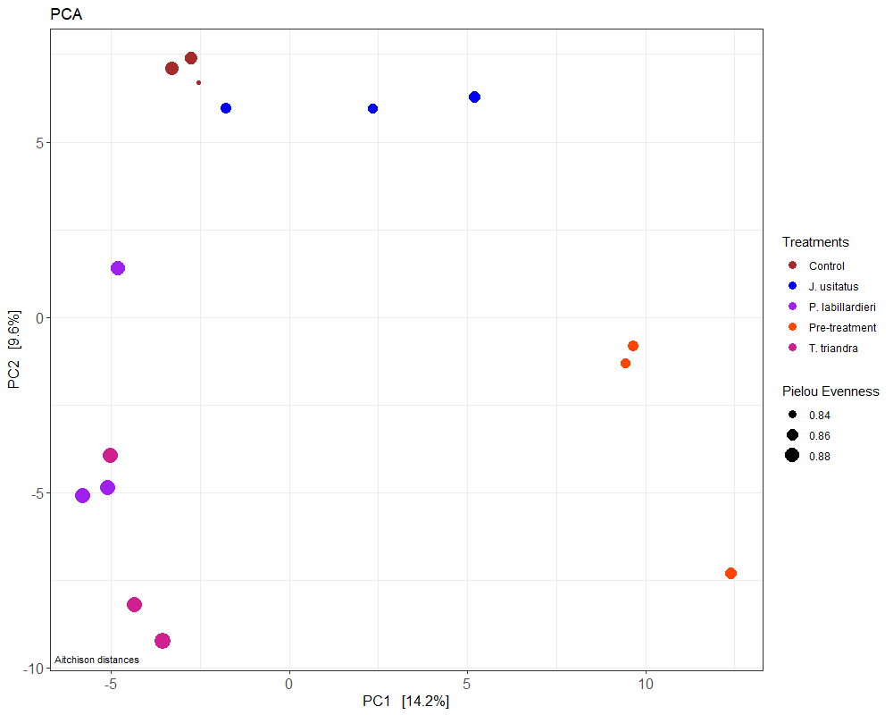
Figure S5: Principal component analysis (PCA) for pre- and post-treatments.

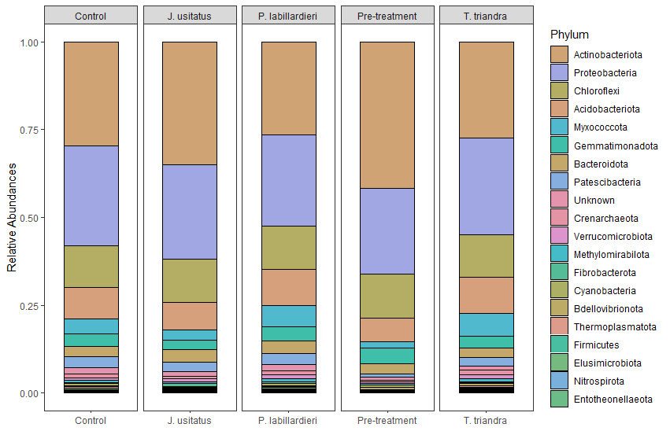
Figure S6: Phyla relative abundances for pre- and post-treatments.

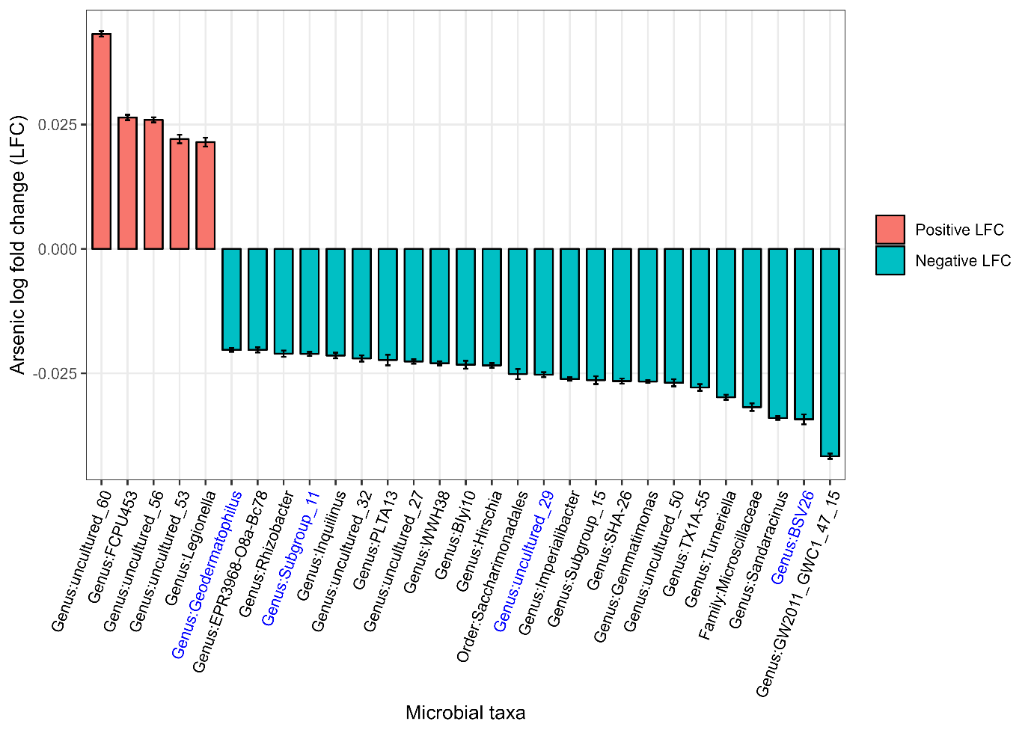
Figure S7: Analysis of Compositions of Microbiomes with Bias Correction 2 (ANCOM-BC2) analysis for microbial genera of rhizosphere soil for all plant species (n=9). Taxa not seen more than three times in at least 20% of the samples was removed to protect against OTUs with small mean. Waterfall plot with bars representing ANCOM-BC2 log fold change (LFC) that are > 0.02 and < -0.02, with error bars displaying standard error. Positive LFC and negative LFC indicates positive or negative relative association of microbial taxa as one unit (1 mg/kg) increase of As, Taxon highlighted in blue (x-axis) identifies successful passage of sensitivity test for zero counts.

