Appendix

Appendix A Implementation Strategy Function

Appendix B Core implementation strategies for brief smoking cessation intervention programmes based on the Proctor report specifications

Appendix C Clinical scenario: a typical middle-aged undiagnosed type 2 diabetes Unannounced Standardized Patient (USP)

Appendix D Quality assessment checklist: a typical middle-aged undiagnosed type 2 diabetes USP

Appendix E Questionnaire on the degree of implementation of regularization of BISC based on NPT

Appendix A Implementation Strategy Function
This process, guided by a scoping review(1), stakeholder consultations, and a Best-Worst Scaling (BWS) online survey(2), identified four key strategy functions to be included in the factorial trial: altering incentive/allowance structures, identifying and preparing champions, conducting educational meetings, and assessing readiness and identifying barriers and facilitators.. Based on ethical and logistical considerations, the " assessing readiness and identifying barriers and facilitators " strategy will be a constant component, while the other three will serve as the optional components to be tested for their main and interaction effects.
The optimization objectives for this study were definitively established, based on the specific implementation outcomes and constraints. The objective was to identify the most effective implementation strategy by balancing optimal outcomes with the established limitations, rather than solely maximizing outcomes. Through a stakeholder focus group, the barriers to BISC implementation were identified. These non-modifiable or difficult-to-modify barriers were then directly translated into the optimization constraints for the trial, with a specific focus on a cost constraint of 100 RMB and a time constraint of 3 minutes.
Reference
1. Siyuan L, Chen J. Using Consolidated Framework for Implementation Research to investigate facilitators and barriers of implementing Brief Intervention for Smoking Cessation among healthcare providers: a scoping review2025.
2. Chen J, Wang L. Stakeholder-Driven Priorities for Implementing Brief Smoking Cessation Interventions: A Best-Worst Scaling Approach2025.

Appendix B Core implementation strategies for brief smoking cessation intervention programmes based on the Proctor report specifications
Strategy | Action | Actor | Action Target | Temporality | Dose | Affected implementation outcomes | Reason
A.Assessing Readiness and Identifying Barriers and Facilitators | A1. Assessing readiness: Employ the validated, Chinese-translated Organisation Readiness for Evidence-Based Practice (ORIEBP) assessment tool (5 dimensions, 32 items, 5-point Likert scale plus 0/1 binary scoring). Collect data from all clinicians and managers within each organisation to calculate the institutional-level score (total item score divided by 32). | Project team assessors and institutional information officers working in pairs. | All medical staff in clinical departments, including doctors and nurses. | Completed within the first week of project commencement; Online questionnaire: 3 days; Paper-based follow-up: 2 days. | One-off comprehensive assessment for all staff; each institution must achieve a response rate of ≥80%. | The likelihood of brief smoking cessation interventions being adopted by organisations, implemented faithfully, and sustained over time to enhance institutional uptake, standardised implementation, and long-term execution. | Standardised measurement tools enable the swift acquisition of comparable data, allowing management to rapidly identify shortcomings and make resource allocation decisions.
 | A2. Identification of Barriers and Facilitating Factors: Establish a ‘Barriers-Facilitators Rapid Reporting Form’ mini-programme, enabling doctors and nurses to instantly tick boxes or upload text detailing implementation barriers (e.g., time conflicts, patient resistance) and facilitating conditions (e.g., departmental support, bonus incentives). Conduct monthly 30-minute online focus group discussions (6–8 participants per group) for in-depth interviews. | Medical Department or third-party assessment agency. | All medical staff in clinical departments, including doctors and nurses. | The intervention is ongoing throughout the entire process; data from the previous month is collected on the first working day of each month, with interviews completed during the second week. | One online questionnaire per month (2 minutes) + one focus group session per month (30 minutes). | Ensure real-time correction and optimisation of the intervention process to enhance long-term adherence. | Dynamic identification of obstacles and timely iteration of strategies can significantly enhance the sustainability of interventions.
B.Incentives | B1. Foundational Training: Training content includes the evidence-based medical rationale for brief smoking cessation interventions (e.g., the extent to which they reduce risk), case studies of successful outcomes (e.g., a clinician assisting a patient through brief cessation support), tobacco control policies and clinical guidelines, and concise operational procedures (e.g., the 2A+R and 4A+R models). | Third-party experts or project teams. | All medical staff in clinical departments, including doctors and nurses. | Within the first week of the project intervention commencing, prior to the issuance of administrative documents by B2. | A one-off training session lasting 45 minutes, followed by a 15-minute Q&A session, with a total duration not exceeding one hour. | Enhance healthcare professionals' readiness for compliance and acceptance of interventions. | Communicating the evidence-based value of interventions to healthcare professionals to alter their negative perceptions regarding low cost-effectiveness. This constitutes a low-cost, high-efficiency initial intervention capable of rapidly reaching a large number of medical staff.
B.Incentives | B2. Issue an Administrative Directive: Issue a notice entitled‘Promoting Brief Smoking Cessation Interventions by Clinicians During Outpatient Consultations’ in the form of an administrative directive. This notice shall clarify that brief smoking cessation interventions constitute an integral part of routine clinical practice and specify that compliance will be subject to random inspections and public disclosure. | Hospital administrators, middle management, department heads, etc. | All clinicians. | Issued within 24 hours of B1 training. | A formal, clear administrative document accompanied by operational guidelines. | Ensure the initiation rate and initial adherence to brief smoking cessation interventions. | By leveraging the coercive force of institutional mechanisms, interventions are transformed from optional measures into mandatory requirements, thereby fundamentally eliminating implementation barriers stemming from physicians' lack of external motivation. This approach incurs no additional costs, relying solely on hospitals' existing administrative management systems, rendering it highly feasible.
B.Incentives | B3. Assessment and Public Disclosure: Incorporated into existing grassroots healthcare service quality assessment programmes, this involves conducting regular telephone follow-ups with patients to gauge satisfaction levels and monitor outpatient clinicians' implementation of brief smoking cessation interventions. Performance metrics for randomly selected departments and clinicians shall be published periodically. | Medical Department or third-party assessment agency. | Departments and individual clinicians. | Following the issuance of B2 administrative documents, random inspections shall be conducted every Sunday, with results published on Mondays, concurrently with medical quality investigations. | Each week, the departments with medical records failing random inspections shall be publicly announced, and the department heads shall be provided with specific lists of non-compliant doctors. Each month, no more than three doctors demonstrating outstanding performance shall be selected for the title of ‘Smoking Control Pioneer’. | Ensure the continuity and integration of interventions. | By linking interventions to performance outcomes, this approach leverages external reinforcement and peer influence to motivate clinicians to sustain high-quality practice over the long term. Primarily utilising existing assessment frameworks, the measure incurs minimal costs while exerting a sustained positive influence on clinical behaviour, rendering it exceptionally cost-effective.
C.Identifying and Cultivating Champions | C1. Identification: Employing purposive sampling, formal recruitment notices for “Champions” shall be issued through internal management channels (such as the Medical Affairs Office and department heads), clearly outlining role responsibilities and professional development benefits. | Managers or middle-level leaders within healthcare institutions (such as directors of medical affairs departments or heads of departments). | All clinicians within the healthcare institution who possess the potential willingness and capability. | To be conducted within one week prior to the project commencement. | One champion per sample hospital, and one champion per department or primary healthcare facility. | Enhance the endogenous capacity for interventions within the organisation. | Through proactive recruitment, healthcare professionals demonstrating enthusiasm and potential for tobacco control work are systematically identified, laying the groundwork for subsequent training initiatives. This represents a highly cost-effective approach to talent discovery, requiring only the utilisation of existing internal communication channels.
C.Identifying and Cultivating Champions | C2. Selection: Conduct one-to-one motivational interviews with all candidates to explore their interests in depth and clarify the core responsibilities of the champion role. | Third-party experts or project teams, responsible for conducting professional interviews and assessments. | All candidates selected through the C1 stage. | Immediately following Phase C1, within the first week of the project. | Conduct one 20-minute one-to-one interview with each candidate. | Ensure high acceptance of the champion role and high adherence to intervention implementation. | Through one-to-one interviews, candidates' motivations and understanding are thoroughly assessed to ensure the final selection demonstrates a high degree of alignment. This approach offers cost control while significantly enhancing the success rate of interventions, thereby preventing resource wastage on unsuitable candidates.。
C.Identifying and Cultivating Champions | C3. Empowerment: Conferring authority and a sense of purpose upon champions through formal, public appointments. | Senior managers in healthcare institutions. | All selected champions. | Immediately following the C2 phase, within the first week of the project. | One formal letter of appointment, clearly outlining the core responsibilities of the promoter. | Enhance champions' sense of identity and acceptance of their role. | Through formal appointment, champions are provided with a clear identity and role, enabling them to work more effectively and gain recognition from colleagues. This initiative incurs no additional costs yet significantly boosts champions' intrinsic motivation and sense of responsibility.
C.Identifying and Cultivating Champions | C4. Cultivation: Deliver one core competency training session focusing on how champions can effectively provide peer support and overcome common obstacles encountered in grassroots practice. Provide ongoing online guidance centred on core responsibilities including demonstration, dissemination, support, coordination, advocacy and problem-solving, to continuously enhance champions' tobacco control knowledge and practical capabilities. | Third-party experts and project teams. | All selected champions. | Initiated immediately following Phase C3 and running throughout the entire project cycle. Core competency training commences in Week 1 of the project. During Weeks 2 to 12, champions enter the independent practice phase, with the project team providing weekly online guidance. | A intensive training session lasting 1–1.5 hours serves as the sole formal training for champions prior to commencing duties. Online guidance sessions, each lasting 10–15 minutes, are conducted to address critical issues encountered by champions during practical implementation. | Enhance champions' sense of self-efficacy and capacity for intervention implementation. | Through refined training and ongoing guidance, address technical challenges that champions may encounter while fulfilling their duties, ensuring they can effectively serve as role models and provide support. This model offers cost-effective solutions, particularly with online mentoring, which effectively supports promoters' continuous development and is well-suited to primary healthcare settings.
D.Education and Training | D1. Specialised Workshops: Conduct small-scale, highly interactive workshops. These sessions focus on specific challenges within brief smoking cessation interventions, such as: ‘How to skillfully initiate and broach the topic of tobacco control,’‘How to employ motivational interviewing techniques when encountering patient resistance,’ ‘How to assist patients in managing urges to relapse.’ | Project team members, or specially trained and experienced in-house smoking control specialists. | All healthcare professionals requiring in-depth training in tobacco control intervention techniques, particularly key practitioners from various departments. | From the first month of the project, this will be repeated periodically, occurring once per month. | Each session lasts 1.5 hours, comprising 30 minutes of theoretical instruction followed by 60 minutes of practical exercises (such as scenario simulations and role-playing). | Addressing specific technical challenges encountered by doctors during interventions to enhance their sense of self-efficacy. | Through small-scale, highly interactive practical exercises, this approach helps clinicians master communication techniques in complex scenarios, thereby addressing shortcomings in foundational training. Whilst requiring a certain level of organisational effort, it efficiently resolves specific operational challenges faced by medical staff, offering a favourable return on investment.
D.Education and Training | D2. Embedded Health Education: Continuously reinforce tobacco control knowledge within healthcare professionals' daily workflows through diverse bite-sized formats (e.g., electronic bulletins in work groups, morning meeting discussions, physical materials). Examples include: - Daily Tobacco Control Tips - Standard Responses to Patient Enquiries - Tobacco Control Conversation Cards - One-Minute Tobacco Control Flowchart | Public Health Department, project team, and heads of all departments. | All medical staff at the hospital. | Commencing from Week 1 of the project, this will be ongoing. | Fragmented channels shall convey a total of no fewer than 12 concise knowledge points. | Continuously instil and reinforce tobacco control concepts and techniques within the subconscious of healthcare professionals, transforming them into habitual thinking patterns thereby reducing the psychological burden in implementation. | Through fragmented, high-frequency communication, knowledge is integrated into daily workflows, ensuring healthcare professionals maintain continuous exposure to tobacco control information. This approach primarily leverages existing communication channels, incurring minimal costs while effectively reinforcing staff knowledge, rendering it highly feasible.
D.Education and Training | D3. Training Exchange: An informal case review session conducted as an open discussion forum. Physicians voluntarily share real-world challenges encountered in practice, with colleagues collectively deliberating and identifying solutions. | Department heads or trained key personnel, who serve as the organisers and facilitators of the activities. | Small groups of medical staff, such as those within the same department or voluntary interest groups. | Concentrated implementation during the mid-project phase, specifically in Week 8. | Conducted as a single session, lasting 1-2 hours. | Establish a mutual learning mechanism to provide doctors with channels for resolving individualised issues. | Implemented midway through the project, this initiative aims to promptly address common issues encountered by healthcare personnel during initial practice. Through informal, peer-to-peer collaborative learning, it effectively supplements formal training, thereby enhancing the internalisation and effectiveness of interventions.

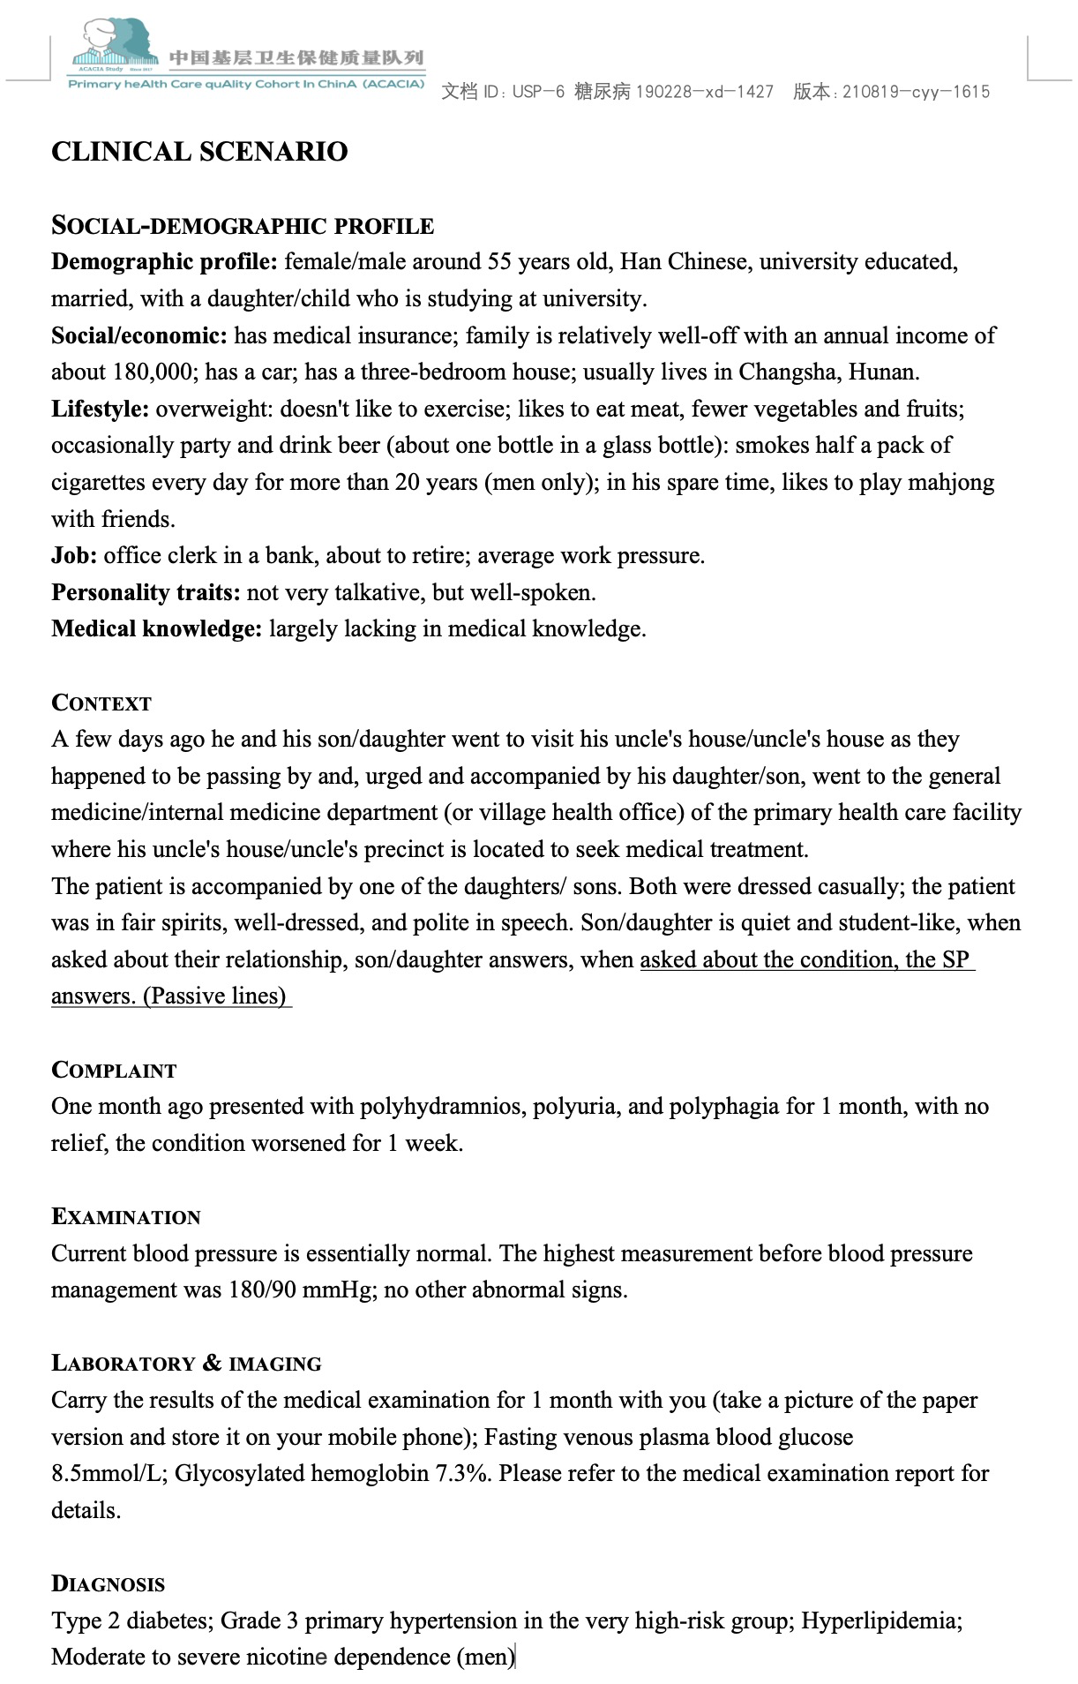

Appendix C Clinical scenario: a typical middle-aged undiagnosed type 2 diabetes Unannounced Standardized Patient (USP)

Appendix D Quality assessment checklist: a typical middle-aged undiagnosed type 2 diabetes USP
Item |  | Corresponding questions from doctors (Scoring points)
Quality of consultation and examination
Complaint &Current medical history | Drinking water (frequency, amount, etc.) | Approximately how much water can you drink per day? How much water did you drink in the previous day?
Complaint &Current medical history | Urination (frequency, volume, etc.) | Is the amount of urine about the same as the amount of water you drink or more? Number of the night starts?
Complaint &Current medical history | Remaining entries omitted
Relevant medical history | Past medical history | What previous illnesses have you had?
Relevant medical history | Smoking status (if, how much, when, etc.) | Do you smoke? How many cigarettes per day? How many years have you smoked?
Relevant medical history | Remaining entries omitted
Physical examination | Blood pressure | Need to record whether this test was performed and whether the test was performed in a standard way
Physical examination | Skin elasticity (to determine the presence of dehydration) | Need to record whether this test was performed and whether the test was performed in a standard way
Physical examination | Remaining entries omitted
Laboratory tests & imaging | Fasting blood glucose | Points will be deducted for tests that are not required or are harmful if prescribed by the doctor
Laboratory tests & imaging | Oral glucose tolerance test (OGTT) | Points will be deducted for tests that are not required or are harmful if prescribed by the doctor
Laboratory tests & imaging | Remaining entries omitted
Diagnostic quality
Correct diagnosis | Type 2 diabetes | Extra Credit
Correct diagnosis | Remaining entries omitted
Partially correct diagnosis | Diabetes or suspected diabetes | Extra Credit
Partially correct diagnosis | Remaining entries omitted
Incorrect diagnosis | not acclimatized | Deductions
Incorrect diagnosis | Urinary tract infections | Deductions
Incorrect diagnosis | Remaining entries omitted
Quality of treatment
Correct treatment measures | Low-salt, low-sodium diabetic diet | Extra credit, details omitted
Correct treatment measures | Telling about hazards of smoking, asking to quit smoking, making referrals and offering a quit line. | Points deducted if not implemented for male USP, details omitted
Correct treatment measures | Remaining entries omitted
Wrong treatment measures | Insulin | Deductions
Wrong treatment measures | Antibiotics | Deductions
Wrong treatment measures | Remaining entries omitted
USP, Unannounced standardized patient.

Appendix E Questionnaire on the degree of implementation of regularization of BISC based on NPT
Construct | Sub-Construct | Item
Coherence | Differentiation | 1. I can see how the brief smoking cessation intervention differs from usual ways of working
Coherence | Communal specification | 2. Staff in this organization have a shared understanding of the purpose of this brief smoking cessation intervention
Coherence | Individual specification | 3. I understand how the brief smoking cessation intervention affects the nature of my own work
Coherence | Internalization | 4. I can see the potential value of the brief smoking cessation intervention for my work
Cognitive  Participation | Initiation | 5. There are key people who drive the brief smoking cessation intervention forward and get others involved
Cognitive  Participation | Enrolment | 6. I’m open to working with colleagues in new ways to use the brief smoking cessation intervention
Cognitive  Participation | Legitimation | 7. I believe that participating in the brief smoking cessation intervention is a legitimate part of my role
Cognitive  Participation | Activation | 8. I will continue to support the brief smoking cessation intervention
Collective Action | Interactional workability | 9.I can easily integrate the brief smoking cessation intervention into my existing work
Collective Action | Relational integration | 10. The brief smoking cessation intervention disrupts working relationships (reverse scoring)
Collective Action | Relational integration | 11. I have confidence in other people’s ability to use the brief smoking cessation intervention
Collective Action | Skill set workability | 12 Work is assigned to those with skills appropriate to the brief smoking cessation intervention
Collective Action | Skill set workability | 13. Sufficient training is provided to enable staff to use the brief smoking cessation intervention
Collective Action | Contextual integration | 14. Sufficient resources are available to support the brief smoking cessation intervention
Collective Action | Contextual integration | 15. Management adequately support the brief smoking cessation intervention
Reflexive  Monitoring | Systemization | 16. I am aware of reports about the effects of the brief smoking cessation intervention
Reflexive  Monitoring | Communal appraisal | 17. The staff agree that the brief smoking cessation intervention is worthwhile
Reflexive  Monitoring | Individual appraisal | 18. I value the effects the brief smoking cessation intervention has had on my work
Reflexive  Monitoring | Reconfiguration | 19. Feedback about the brief smoking cessation intervention can be used to improve it in the future
Reflexive  Monitoring | Reconfiguration | 20. I can modify how I work with the brief smoking cessation intervention
BISC, Brief smoking cessation interventions; NPT, Normalization Process Theory.

