Supplementary Materials

Supplementary Figure S1 Three selected sample provinces on the map of China.

Supplementary Figure S2 Clinical scenario: a typical middle-aged undiagnosed type 2 diabetes Unannounced Standardized Patient (USP)

Supplementary Table S1 The top 15 CFIR-ERIC implementation techniques sets were matched in order of cumulative percentage

Supplementary Table S2 Quality assessment checklist: a typical middle-aged undiagnosed type 2 diabetes USP

Supplementary Table S3 Questionnaire on the degree of implementation of regularization of BISC based on NPT

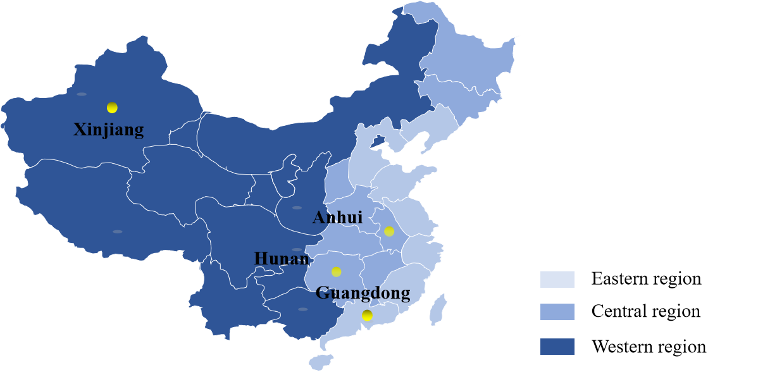

Supplementary Figure S1 Three selected sample provinces on the map of China.

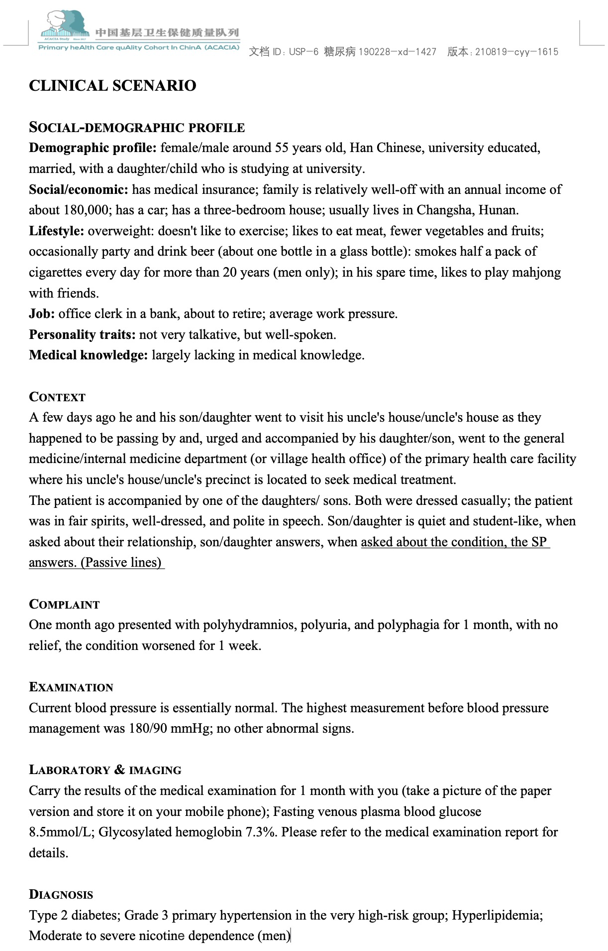

Supplementary Figure S2 Clinical scenario: a typical middle-aged undiagnosed type 2 diabetes Unannounced Standardized Patient (USP)

Supplementary Table S1 The top 15 CFIR-ERIC implementation techniques sets were matched in order of cumulative percentage
ERIC Strategies/Determinants | Cumulative Percent | Culture | Compatibility | Organizational Incentives & Rewards | Leadership Engagement | Access to knowledge & information | Knowledge & Beliefs about the Intervention | Self-efficacy
Identify and prepare champions | 232% | 52% | 21% | 25% | 41% | 24% | 40% | 30%
Conduct educational meetings | 192% | 22% | 10% | 0% | 9% | 79% | 56% | 15%
Create a learning collaborative | 151% | 30% | 14% | 13% | 5% | 45% | 16% | 30%
Alter incentive/allowance structures | 148% | 15% | 10% | 71% | 32% | 0% | 16% | 4%
Assess for readiness and identify barriers and facilitators | 139% | 41% | 34% | 13% | 14% | 7% | 20% | 11%
Facilitation | 129% | 30% | 24% | 4% | 18% | 10% | 20% | 22%
Capture and share local knowledge | 127% | 22% | 14% | 8% | 9% | 31% | 24% | 19%
Conduct local consensus discussions | 122% | 22% | 41% | 8% | 27% | 10% | 12% | 0%
Develop educational materials | 117% | 0% | 3% | 0% | 0% | 59% | 36% | 19%
Promote adaptability | 114% | 22% | 45% | 4% | 9% | 7% | 16% | 11%
Tailor strategies | 112% | 30% | 38% | 17% | 5% | 0% | 12% | 11%
Inform local opinion leaders | 99% | 22% | 3% | 17% | 18% | 7% | 28% | 4%
Provide ongoing consultation | 98% | 15% | 3% | 4% | 14% | 17% | 4% | 41%
Conduct educational outreach visits | 95% | 4% | 0% | 4% | 9% | 28% | 28% | 22%
Conduct ongoing training | 94% | 4% | 0% | 0% | 0% | 38% | 12% | 41%
Build a coalition | 94% | 19% | 21% | 17% | 18% | 3% | 16% | 0%
Conduct local needs assessment | 92% | 22% | 21% | 8% | 14% | 3% | 24% | 0%
Identify early adopters | 92% | 11% | 10% | 13% | 9% | 10% | 20% | 19%
Conduct cyclical small tests of change | 92% | 0% | 38% | 13% | 0% | 3% | 12% | 26%
Recruit, designate and train for leadership | 88% | 33% | 0% | 21% | 23% | 3% | 4% | 4%

Supplementary Table S2 Quality assessment checklist: a typical middle-aged undiagnosed type 2 diabetes USP
Item |  | Corresponding questions from doctors (Scoring points)
Quality of consultation and examination
Complaint &Current medical history | Drinking water (frequency, amount, etc.) | Approximately how much water can you drink per day? How much water did you drink in the previous day?
Complaint &Current medical history | Urination (frequency, volume, etc.) | Is the amount of urine about the same as the amount of water you drink or more? Number of the night starts?
Complaint &Current medical history | Remaining entries omitted
Relevant medical history | Past medical history | What previous illnesses have you had?
Relevant medical history | Smoking status (if, how much, when, etc.) | Do you smoke? How many cigarettes per day? How many years have you smoked?
Relevant medical history | Remaining entries omitted
Physical examination | Blood pressure | Need to record whether this test was performed and whether the test was performed in a standard way
Physical examination | Skin elasticity (to determine the presence of dehydration) | Need to record whether this test was performed and whether the test was performed in a standard way
Physical examination | Remaining entries omitted
Laboratory tests & imaging | Fasting blood glucose | Points will be deducted for tests that are not required or are harmful if prescribed by the doctor
Laboratory tests & imaging | Oral glucose tolerance test (OGTT) | Points will be deducted for tests that are not required or are harmful if prescribed by the doctor
Laboratory tests & imaging | Remaining entries omitted
Diagnostic quality
Correct diagnosis | Type 2 diabetes | Extra Credit
Correct diagnosis | Remaining entries omitted
Partially correct diagnosis | Diabetes or suspected diabetes | Extra Credit
Partially correct diagnosis | Remaining entries omitted
Incorrect diagnosis | not acclimatized | Deductions
Incorrect diagnosis | Urinary tract infections | Deductions
Incorrect diagnosis | Remaining entries omitted
Quality of treatment
Correct treatment measures | Low-salt, low-sodium diabetic diet | Extra credit, details omitted
Correct treatment measures | Telling about hazards of smoking, asking to quit smoking, making referrals and offering a quit line. | Points deducted if not implemented for male USP, details omitted
Correct treatment measures | Remaining entries omitted
Wrong treatment measures | Insulin | Deductions
Wrong treatment measures | Antibiotics | Deductions
Wrong treatment measures | Remaining entries omitted
USP, Unannounced standardized patient.

Supplementary Table S3 Questionnaire on the degree of implementation of regularization of BISC based on NPT
Construct | Sub-Construct | Item
Coherence | Differentiation | 1. I can see how the brief smoking cessation intervention differs from usual ways of working
Coherence | Communal specification | 2. Staff in this organization have a shared understanding of the purpose of this brief smoking cessation intervention
Coherence | Individual specification | 3. I understand how the brief smoking cessation intervention affects the nature of my own work
Coherence | Internalization | 4. I can see the potential value of the brief smoking cessation intervention for my work
Cognitive  Participation | Initiation | 5. There are key people who drive the brief smoking cessation intervention forward and get others involved
Cognitive  Participation | Enrolment | 6. I’m open to working with colleagues in new ways to use the brief smoking cessation intervention
Cognitive  Participation | Legitimation | 7. I believe that participating in the brief smoking cessation intervention is a legitimate part of my role
Cognitive  Participation | Activation | 8. I will continue to support the brief smoking cessation intervention
Collective Action | Interactional workability | 9.I can easily integrate the brief smoking cessation intervention into my existing work
Collective Action | Relational integration | 10. The brief smoking cessation intervention disrupts working relationships (reverse scoring)
Collective Action | Relational integration | 11. I have confidence in other people’s ability to use the brief smoking cessation intervention
Collective Action | Skill set workability | 12 Work is assigned to those with skills appropriate to the brief smoking cessation intervention
Collective Action | Skill set workability | 13. Sufficient training is provided to enable staff to use the brief smoking cessation intervention
Collective Action | Contextual integration | 14. Sufficient resources are available to support the brief smoking cessation intervention
Collective Action | Contextual integration | 15. Management adequately support the brief smoking cessation intervention
Reflexive  Monitoring | Systemization | 16. I am aware of reports about the effects of the brief smoking cessation intervention
Reflexive  Monitoring | Communal appraisal | 17. The staff agree that the brief smoking cessation intervention is worthwhile
Reflexive  Monitoring | Individual appraisal | 18. I value the effects the brief smoking cessation intervention has had on my work
Reflexive  Monitoring | Reconfiguration | 19. Feedback about the brief smoking cessation intervention can be used to improve it in the future
Reflexive  Monitoring | Reconfiguration | 20. I can modify how I work with the brief smoking cessation intervention
BISC, Brief smoking cessation interventions; NPT, Normalization Process Theory.

ERIC Strategies | Cumulative Percent | Patient Needs & Resources | Cosmopolitanism | Organizational Incentives & Rewards | Goals and Feedback | Readiness for Implementation | Available Resources | Access to knowledge & information | Planning | Champions | Reflecting & Evaluating
Identify and prepare champions | 747% | 5% | 15% | 25% | 12% | 19% | 4% | 24% | 31% | 67% | 8%
Assess for readiness and identify barriers and facilitators | 639% | 33% | 15% | 13% | 6% | 81% | 13% | 7% | 42% | 15% | 12%
Alter incentive/allowance structures | 511% | 10% | 0% | 71% | 15% | 23% | 17% | 0% | 12% | 7% | 0%
Build a coalition | 480% | 14% | 62% | 17% | 15% | 35% | 17% | 3% | 4% | 30% | 8%
Conduct educational meetings | 475% | 10% | 12% | 0% | 21% | 23% | 0% | 79% | 8% | 19% | 4%
Develop a formal implementation blueprint | 401% | 5% | 4% | 8% | 42% | 12% | 4% | 14% | 73% | 11% | 16%
Audit and provide feedback | 330% | 5% | 0% | 21% | 61% | 4% | 0% | 3% | 0% | 19% | 56%
Develop and implement tools for quality monitoring | 282% | 14% | 0% | 21% | 27% | 15% | 0% | 0% | 31% | 0% | 60%
Access new funding | 281% | 0% | 4% | 38% | 3% | 4% | 78% | 0% | 8% | 4% | 0%
Involve patients/consumers and family members | 245% | 71% | 4% | 4% | 9% | 8% | 0% | 3% | 4% | 4% | 4%
Obtain and use patients/consumers and family feedback | 229% | 76% | 0% | 13% | 9% | 8% | 0% | 0% | 4% | 4% | 28%

