
Lu Cai was born in Huanggang, Hubei, P.R. China, in 1984. She received the doctor's degree from Wuhan University of Technology, P.R. China. Now, she works in School of Management, Hubei University of Education. Her research interests include logistics and supply chain system optimization, innovation and knowledge Management.
E-mail: lydiacai@hue.edu.cn

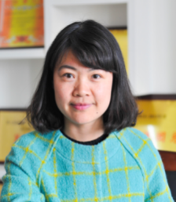
Aijun Liu was born in Zhongxiang, Hubei, P.R. China, in 1983. She received the doctor's degree from Wuhan University of Technology, P.R. China. Now, she works in School of Management, Hubei University of Education. Her research interests include technology innovation, information economy and complex system.
E-mail: laj@hue.edu.cn

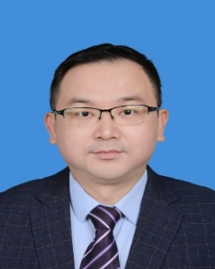
Yongcai Yan was born in Dawu, Hubei, P.R. China, in 1980. He received the doctor's degree from Wuhan University of Technology, P.R. China. Now, he works in School of Economics, Management & Low, Hubei Normal University. His research interests include logistics and supply chain management, technical economics and management.
E-mail: yanyc@hbnu.edu.cn

