Supplementary Material

Supplementary Figure S1.Incidence and trend of PTB and PTB-DM in Chongqing ,southwest China, 2016–2022.
Supplementary Figure S2.Number and trends of successful and unsuccessful treatment outcomes of PTB-DM patients registered for treatment in Chongqing ,southwest China, 2016–2022.

  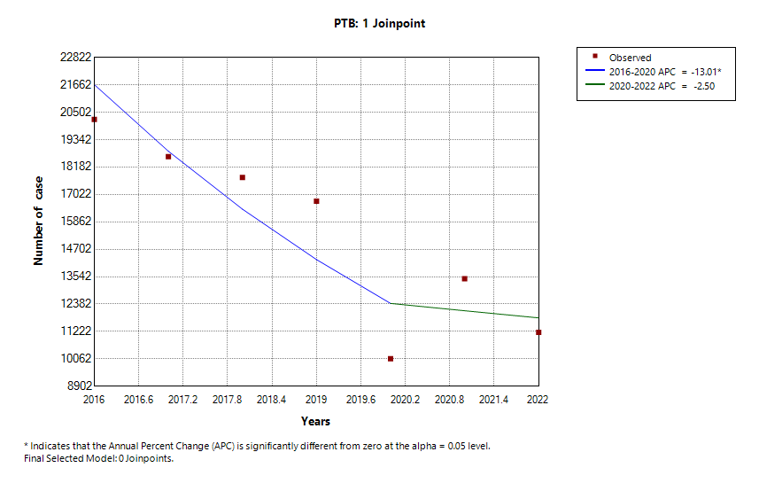 | 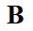  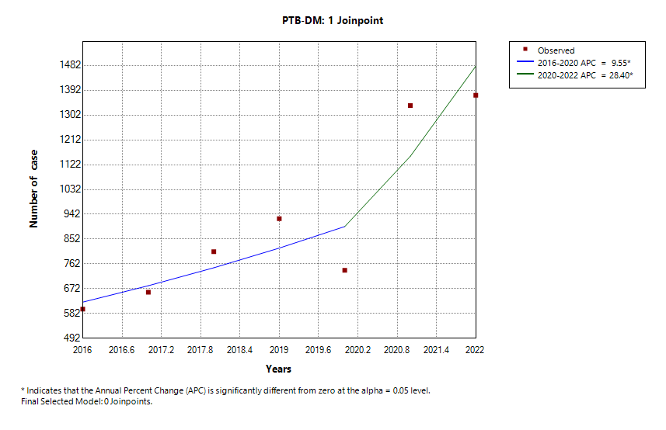
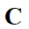  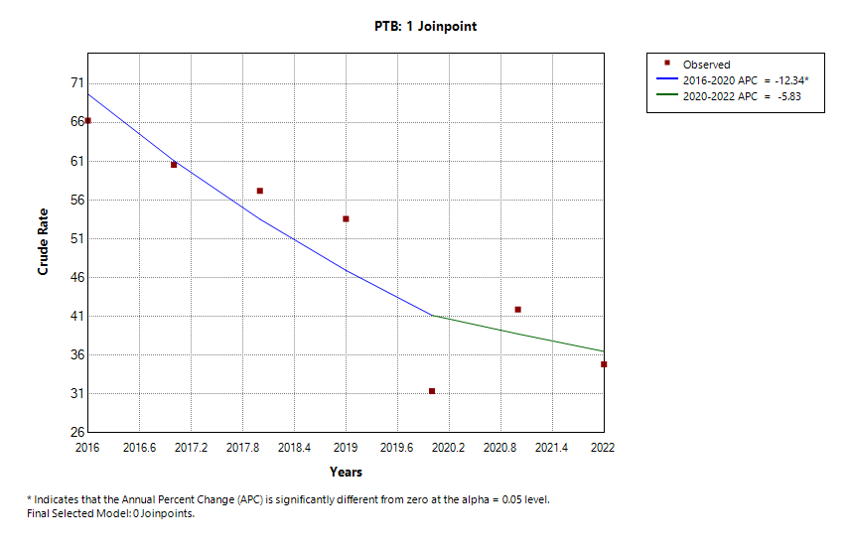 | 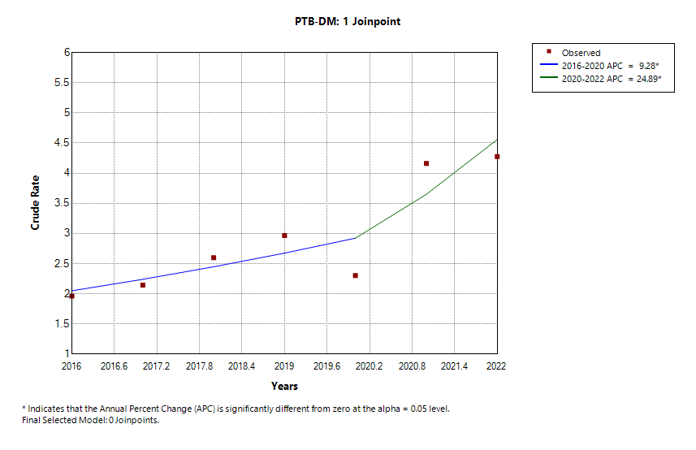  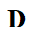
Supplementary Figure S1. Incidence and trend of PTB and PTB-DM in Chongqing ,southwest China, 2016–2022.(A) Number of cases of PTB; (B)Number of cases of PTB-DM; (C)Crude incidence rate of PTB; (D)Crude incidence rate of PTB-DM. *Indicate that the Annual Percent Change (APC) is significantly different from zero at the alpha = 0.05 level .

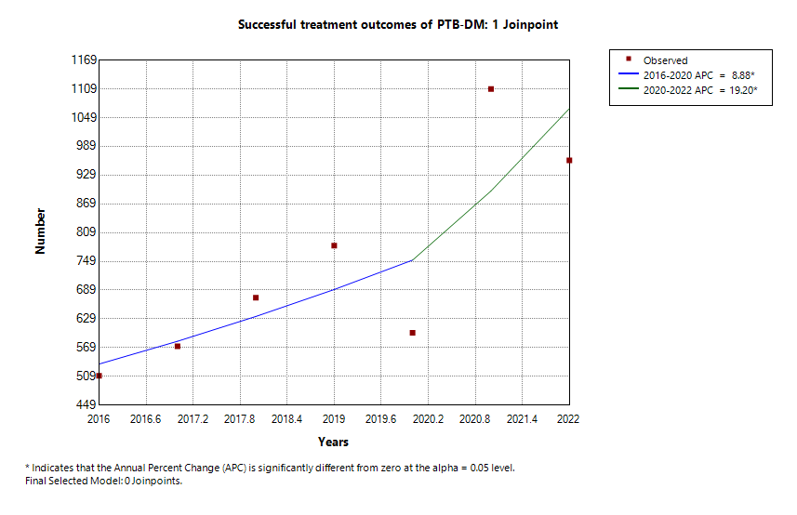 | 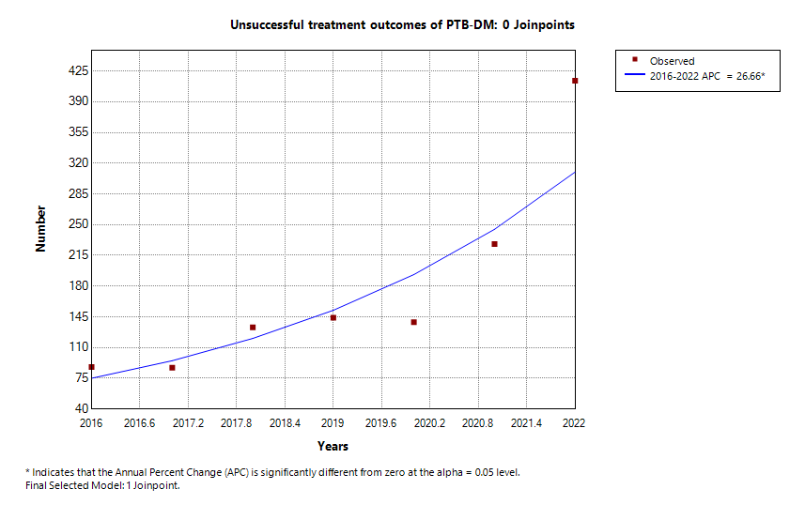
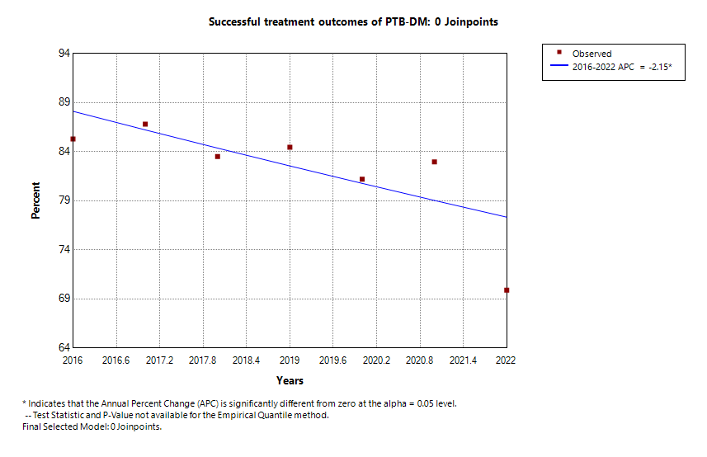 | 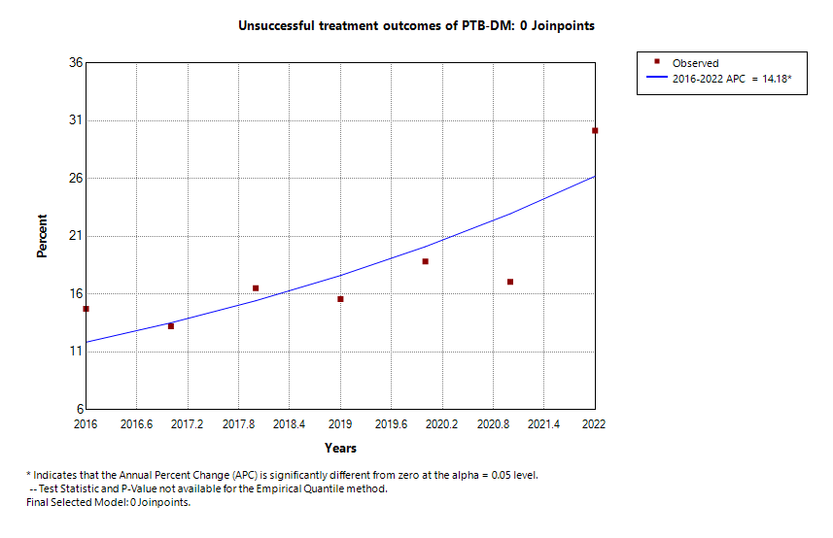

Supplementary Figure S2. Number and trends of successful and unsuccessful treatment outcomes of PTB-DM patients registered for treatment in Chongqing ,southwest China, 2016–2022.(A) Number of successful treatment outcomes; (B)Number of unsuccessful treatment outcomes; (C)Percentage of successful treatment outcomes; (D)Percentage of unsuccessful treatment outcomes. *Indicate that the Annual Percent Change (APC) is significantly different from zero at the alpha = 0.05 level .

