Supplementary information for “The effect of reward expectancy on different types of exploration in human reinforcement learning”

Journal name
Computational Brain and Behavior

Authors & Affiliations
Kanji Shimomura^{1,2}* & Kenji Morita^{1,3}
1 Graduate School of Education, The University of Tokyo, Tokyo, Japan
2 Japan Society for the Promotion of Science, Tokyo, Japan
3 International Research Center for Neurointelligence (WPI-IRCN), The University of Tokyo, Japan

*Corresponding author
Kanji Shimomura (skcpccp@gmail.com, ORCID: 0000-0003-4370-3710)

Supplementary method and results
Parameter recovery
As stated in main text, unlike previous studies, “novelty and uncertainty bias model” was selected as the best model in both high and low reward conditions in this study. Although model identifiability of all six candidate models in this study has been already confirmed in the previous studies (Cockburn et al., 2021; Nussenbaum et al., 2023), parameter identifiability of “novelty and uncertainty bias model” has not been examined. We therefore conducted parameter recovery with the model.
Specifically, first, we pseudo-randomly generated 300 parameter sets using uniform distribution and generated 100 data (each consisting of 300 trials) with each parameter set. The ranges (lower and upper bounds) of uniform distribution for generating each parameter were as follows: $η$: 0 to 1, $β$: 0 to 20, $N$: $-$2 to 2, $W_{I}$: $-$2 to 2, and $W_{T}$: $-$2 to 2. We then conducted model fitting in the same way as stated in the main text using the generated datasets and calculated PXP and estimated parameters for each parameter set.
The results of parameter recovery are summarized in Fig. S1. Out of 300 model fitting procedures, the true model (novelty and uncertainty bias model) was selected as the best model in 226 cases (75.3%). We calculated correlation coefficients between true (generative) parameters and estimated parameters using results when model selection was successful. As shown in Fig. S1, all five parameters showed high positive correlations ($η$: 0.99, $β$: 0.96, $N$: 0.98, $W_{I}$: 0.99, and $W_{T}$: 0.99), indicating that parameter identifiability of novelty and uncertainty bias model was sufficiently high.

Behavioral distinction between “novelty and uncertainty bias model” and “novelty-biased familiarity-gated uncertainty model”
To examine the reason why “novelty and uncertainty bias model”, but not “novelty-biased familiarity-gated uncertainty model”, was selected as the best model in this study, we conducted simulations using the two models. Specifically, we generated 198 data using the two models with the same parameter sets close to the group-level estimates in high reward condition ($η$=0.03, $β$=10, $N$=0.2, $W_{I}$=0, $W_{T}$=$-$0.2), and examined the behavioral difference between the two models.
As can be seen in Fig. S2, the two models differ in general level of and temporal change in preference for more novel options. While novelty-biased familiarity-gated uncertainty model showed relatively higher preference for novelty and such preference maintained high level throughout blocks, novelty and uncertainty bias model showed decrease in the preference for novelty in the latter half of the blocks. This is the critical difference between the behavior of the two models which stems from the presence/absence of familiarity-gating mechanism. When uncertainty bias is not modulated by familiarity, preference for novel options decrease as trial proceeds if $W_{T}$ is smaller than $W_{I}$ because tendency to avoid uncertainty increases. When there is familiarity gating mechanism, however, such decrease is suppressed because utility of completely novel stimuli become unaffected by uncertainty bias ($F\left(s_{i}\right)*w_{t}^{U}*U\left(s_{i}\right)$ becomes zero when $F\left(s_{i}\right)=0$).
Participants in our study showed weak but significant decreasing trend of preference for novelty (see 3.2 of main text and Fig. 4), which might be the main reason why the model without familiarity modulation was selected as the best model.

Relationship between W_{I} and performance in our task
To examine how performance changes depending on the value of $W_{I}$, we simulated how the average number of coins obtained over 300 trials varied when $W_{I}$ took 81 equally spaced values from $-$2 to 2 with the other parameters fixed ($η$=0.03, $β$=10, $N$=0.2 , $W_{T}$=$-$0.2).
As shown in Fig. S3, average number of coins had inverted U-shaped relation with $W_{I}$, taking maximal value when $W_{I}$ was close to 0. The group-level estimates of our participants were close to 0 (gray dotted and dashed lines of Fig. S3) in both conditions, which suggests that participants showed nearly optimal initial uncertainty bias in both conditions.

Comparison of memory test performance in the two conditions
To test whether memory test performance differed between high and low reward conditions, we conducted linear mixed modeling using memory test accuracy as a dependent variable and condition as an independent variable, assuming the random effect of participant. As stated in the main text, we found that there was no significant fixed effect of condition on performance ($b_{condition}=-0.002, p= .86$; see Fig. S4), suggesting that participants engaged in the two conditions with similar levels of motivation.

(See the following pages for supplementary figures)

Supplementary figures
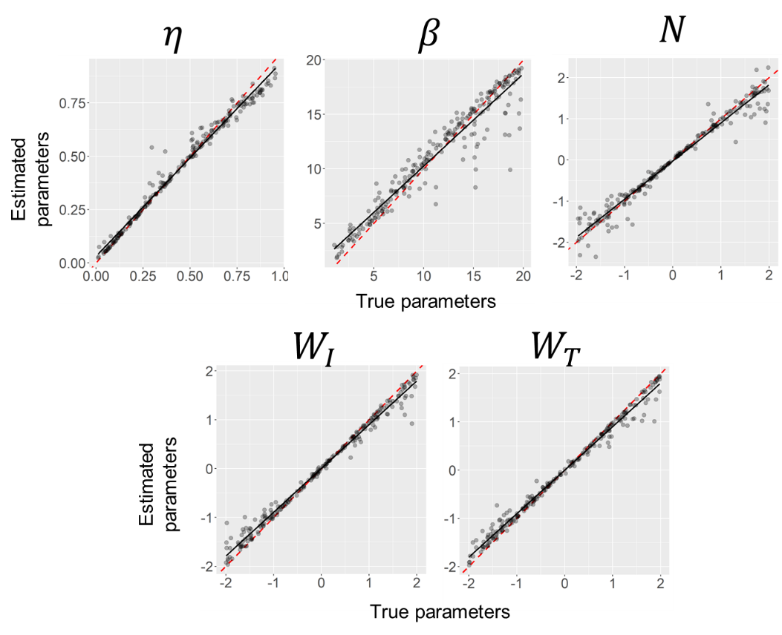
Fig. S1 Correlation between true (generative) parameters and estimated parameters of novelty and uncertainty bias model. Horizontal axis represents true values of each parameter and vertical axis shows estimated values of each parameter. Red dashed line represents identity line (i.e., y=x), and black line represents best fit linear regression line.

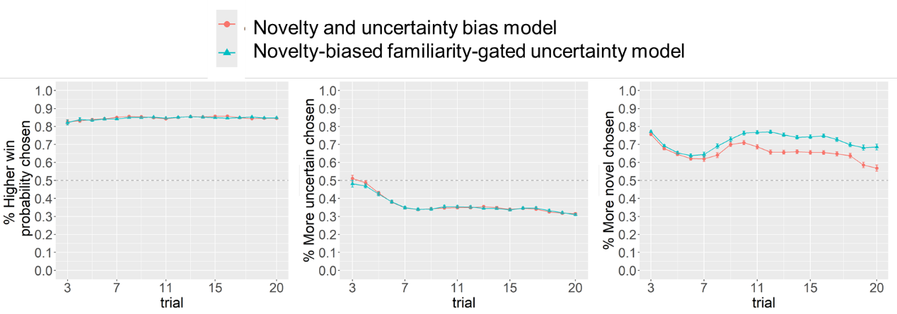
Fig. S2 The simulated interaction between task horizon and expected win probability (left), uncertainty (middle), and novelty (right) on choice of “novelty and uncertainty bias model” (red) and “novelty-biased familiarity-gated uncertainty model” (blue).

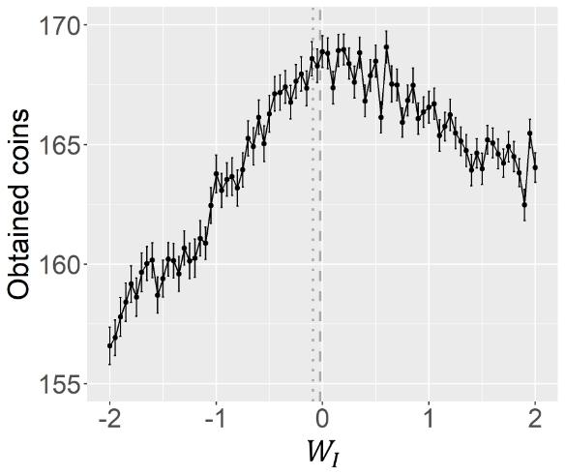
Fig. S3 The average total number of coins as a function of the initial uncertainty bias parameter ($W_{I}$). Error bars represent standard error of the mean. Gray dotted line and dashed line represents the group-level estimate of $W_{I}$ in high and low reward condition, respectively.

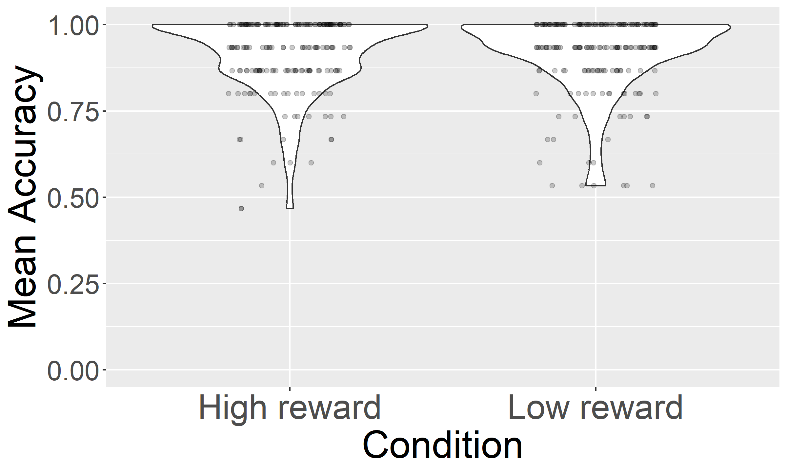
Fig. S4 Mean memory accuracy of the stimuli used in the high reward condition and low reward condition. There was no significant effect of condition on memory accuracy.

