Photoinduced Formal [4+2] Cycloaddition of Two Electron-deficient Olefins: Synthesis of Lucidumone

Supplementary Materials

Materials and Methods
Supplementary Text
Figures S1 to S8
Tables S1 to S3
Table of Contents
- General information 3
  - Materials and Methods
  - Description of the LED light source
  - Photoredox setup
- UV-Vis Absorption Spectra 5
- Mechanistic studies of the [4+2] photocycloaddition 6
- Optimization of the photocycloaddition in the synthesis application. 8
- Proposed mechanism for the photocatalytic alkoxymethylation 9
- Experimental procedures and spectral characterization of the products 10
- Reference 56
- Spectra data 57

1. General information.
1.1 Materials and methods.
All commercial reagents and solvents were purchased and used as received unless otherwise indicated. 2,4,6-Triphenylpyrylium tetrafluoroborate (TPP) was purchased from Alfa Aesar. Other reagents were purchased from Adamas, Energy Chemical and Bidepharm. The enones and dienes were prepared according to the known procedures. Acetonitrile was purified by a Vigor solvent purification system. All reactions were carried out under Argon atmosphere unless otherwise noted.
Column chromatography was generally performed on silica gel (300-400 mesh) and reactions were monitored by thin layer chromatography (TLC) using silica gel GF254 plates with UV light to visualize the course of reaction.
High-resolution mass spectra (HRMS) data were obtained on a Bruker APEXII mass spectrometer by means of the electrospray ionization (ESI) technique. High Performance Liquid Chromatography (HPLC) data were collected on Agilent 1260 (Column: Unisil 5-120 C18 Ultra, Dimensions: 4.6 × 150 mm, 5 μm, Eluent: water and acetonitrile). ¹H NMR spectra were recorded at 600 MHz or 400 MHz, ¹⁹F NMR were recorded at 564 MHz or 376 MHz, and ¹³C NMR spectra were recorded at 150 MHz or 100 MHz. ¹H NMR chemical shifts were determined relative to the signal of the residual protonated solvent: CDCl₃ at δ 7.26, CD₃OD at δ 3.31, d⁶-DMSO at δ 2.50, CD₃CN at δ 1.94. ¹³C NMR chemical shifts were determined relative to the signal of the residual protonated solvent: CDCl₃ at δ 77.16, CD₃OD at δ 49.00, d⁶-DMSO at δ 39.52, CD₃CN at δ 118.26. Data for ¹H NMR are reported as follows: chemical shift (δ ppm), multiplicity (s = singlet, d = doublet, t = triplet, m = multiplet, q = quartet, br = broad), coupling constant (Hz), integration. ¹³C NMR spectra were reported as chemical shifts in ppm and multiplicity where appropriate.
UV-Vis spectra were recorded on a Unico UV-4802 spectrophotometer.
Single crystal X-ray diffraction were collected on Agilent Supernova X-ray single crystal diffractometer.

1.2 Description of the LED light sources.
Two kinds of light sources appeared in this work. The 395 nm LEDs (emitting area: 450 × 15 mm) were assembled using 126 Model H45020-S chips (395 nm) in a compact fashion with three adjustable power output controller (0-100W). The 450 nm LED light (emitting area: 60 × 15 mm) were assembled using sixteen 450 nm (Model H6015-S) chips in a compact fashion with an adjustable power output controller (0-100W). Water cooling was enforced for effective thermal management to maintain luminous efficiency and life expectancy of LED lights. The emitting wavelength of 395 nm LEDs (380-420 nm) and 450 nm LEDs (430-485 nm) were recorded in Figure S1.
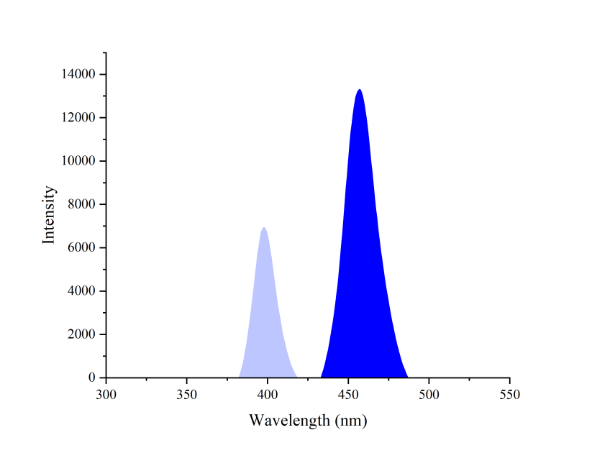
Figure S1. The spectrum of the LED lights.

1.3 Photoredox setup.
When setting up the batch photoreactions on 395 nm LEDs, 8 mL reaction vials are wrapped with parafilm right below the vial caps, and are placed at the center of a stir plate. The LEDs are placed perpendicular to the sidewall of reaction vials, so that the reactions vials can be equally exposed to the LEDs (at approximately 10 cm away from the light source, 14 W·cm⁻²). A clip fan (14-Inch fan) is put over the reaction vials and kept on during the reaction to maintain the reaction temperature below 35 ºC. The batch photoreactions on 450 nm LEDs was similar to that of the 395 nm LEDs.
When setting up the gram scale photoreactions on 395 nm LEDs, the reaction mixture is loaded into a 250 mL quartz glass apparatus under an argon atmosphere and then exposed to irradiation from one side (at approximately 10 cm away from the light source, 14 W·cm⁻²). The overhead electric fan is also necessary in order to offset the heat generated from the LED light and to stabilize reaction temperature (lower than 35 ºC) for reproducible results.
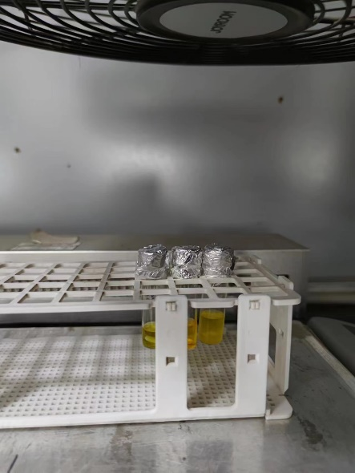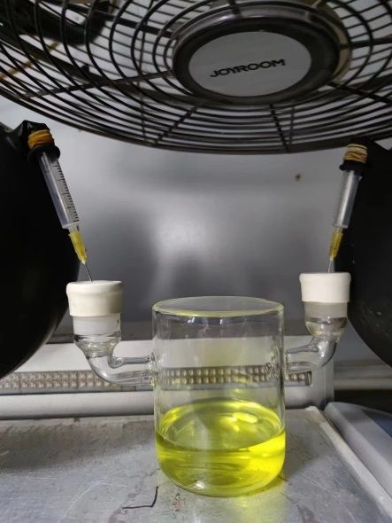
Figure S2. Details for the reaction setup.

2. UV-Vis Absorption Spectra.

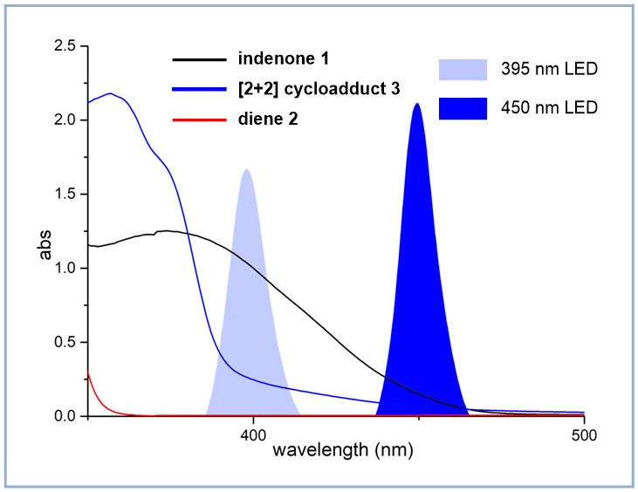
Figure S3. UV-Vis absorption of indenone 1, diene 2 and the [2+2] cycloadduct 3. The spectra of 1 and 2 are measured with the concentration of the corresponding material at 10⁻³ M in MeCN, while the concentration of 3 is 0.05 M in MeCN. The dienophile 1 and the overbred intermediate 3 can harvest photons from the 395 nm LEDs.
3. Mechanistic studies of the [4+2] photocycloaddition.
3.1 Verification of the intermediacy of a reversible [2+2] photocycloaddition.
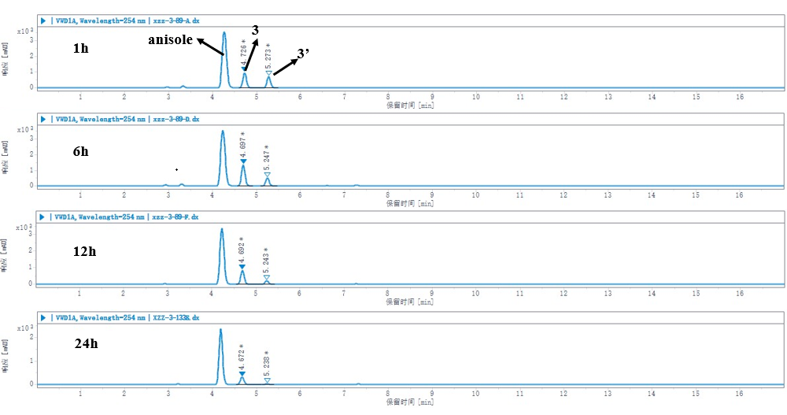
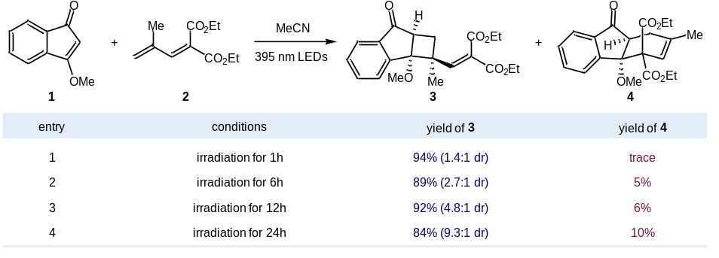
Figure S4. The reaction profile in the absence of Lewis acid. The diastereomeric ratio of 3 increased as the extension of reaction time, indicating a reversible [2+2] photocycloaddition.

3.2 Probe of the diversified path for the desired rearrangement.

Table S1. Control experiments ^{[a]}
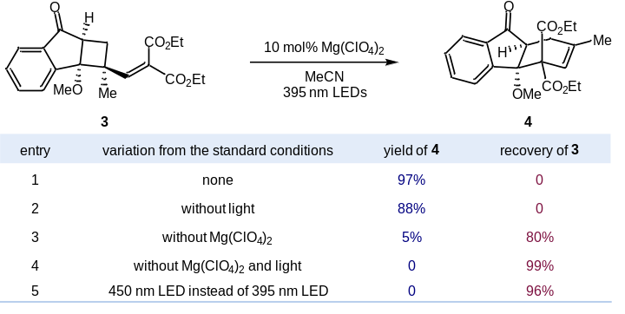
[a] Standard reaction conditions: 3 (0.2 mmol) and 10 mol% Mg(ClO₄)₂ in MeCN (2 mL) under irradiation of 395 nm LEDs at room temperature for 3 h.
3.3 Verification of the role of Lewis acid.
Since the introduction of the Lewis acid accelerate the photocycloaddition significantly, the possible role in enhancing the dr of overbred intermediate 3 is discussed. Control experiments using isomer mixture of 3 (1.3:1 dr) as substrate are designed. The results indicated that secondary excitation of 3, rather than the presence of Lewis acid, is responsible for its diastereomeric ratio change. Therefore, the Lewis acid participated dipolar path is irreversible.
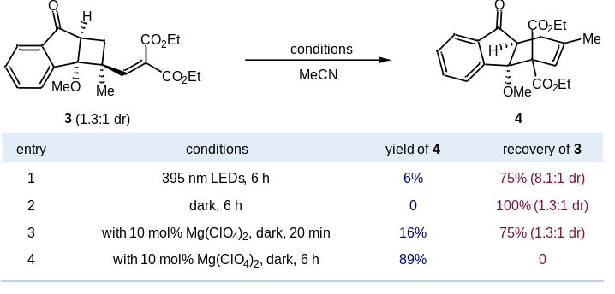
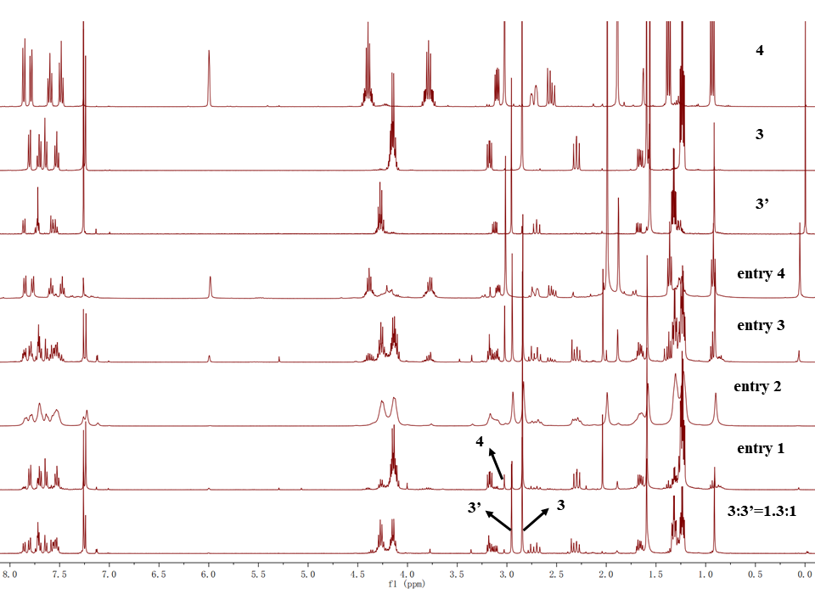
Figure S5. The reaction profile for the rearrangement of 3. and two different reaction pathways were involved in the rearrangement of the overbred intermediate 3.

3.4 Verification of a competitive path through cross experiment.
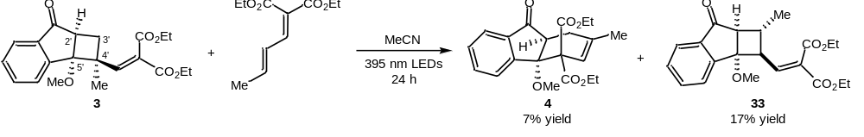
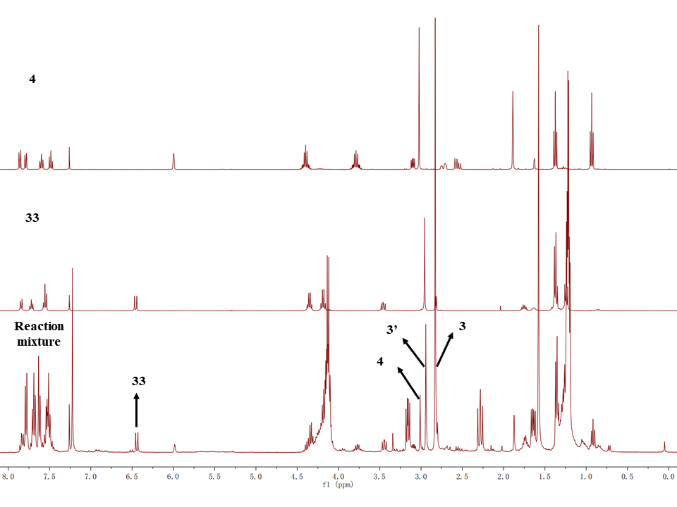
Figure S6. The cross experiment in the absence of Lewis acid. The cleavage of C2’−C3’ triggered by the diradical species was responsible for the formation of 33, thus providing a competitive path for the rearrangement.

4 Optimization of the photocycloaddition in the synthetic application.
Table S2. Evaluation of the reaction temperature
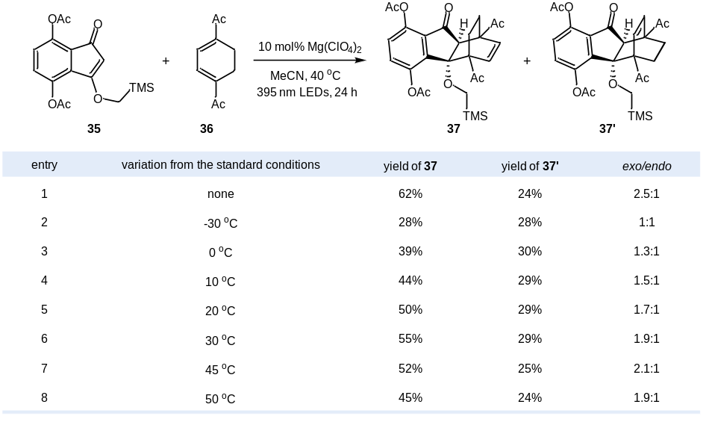

Table S3. Evaluation of the solvent
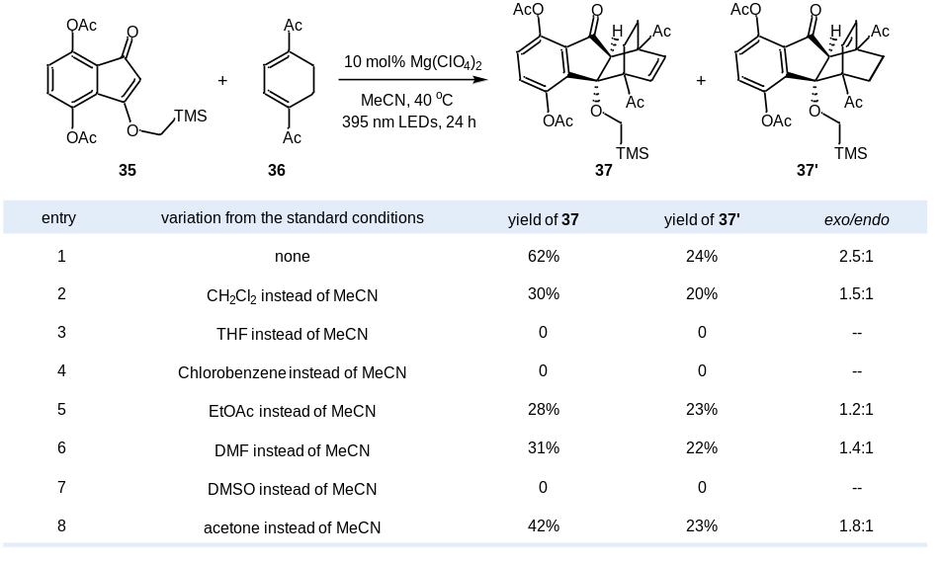

5 Proposed mechanism for the photocatalytic alkoxymethylation.
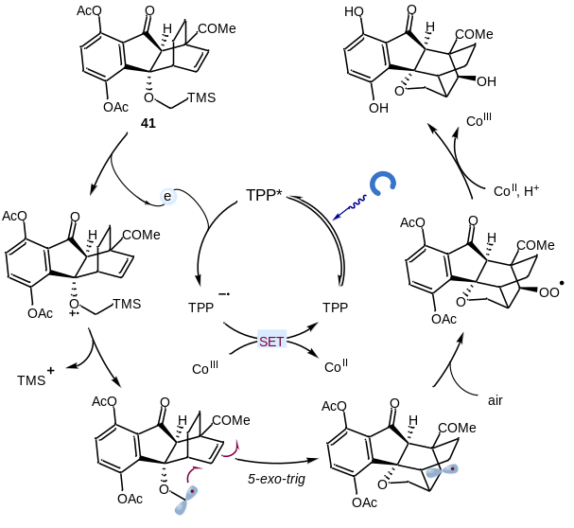
Figure S7. Proposed mechanism of the oxidative alkoxymethylation reaction. The excited photocatalyst was reductively quenched by 41, generating a C-centered radical that cyclized with the double bond in a 5-exo-trig form. The resultant radical species was captured by air to deliver a peroxide radical, which was reduced to alcohol via a Fenton-like process in the presence of Co(acac)₂ and Bronsted acid. Finally, the photocatalyst was regenerated to close the catalytic cycle through single electron transfer (SET) by Co(acac)₃ [E_{red} (Co^{III}/Co^{II}) = + 1.82 V vs SCE in MeCN] that was produced by oxidation of Co(acac)₂ in the air atmosphere. Deprotection in the acid media provided lucidumone.

6. Experimental procedures and spectral characterization of the products.
6.1 Synthesis of the enone and diene substrates.
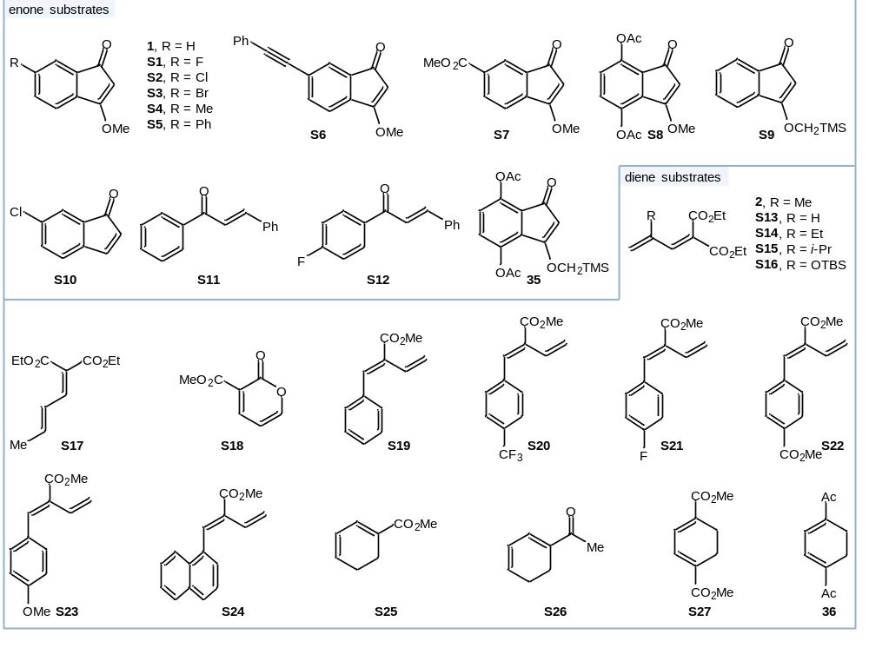
Figure S8. The list of enone and diene substrates. S11, S12 and S25 were purchased and used as received. Other substrates were prepared according to the known procedures.

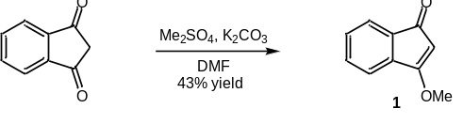
Synthesis of 3-methoxy-1H-inden-1-one (1): To an oven-dried flask charged with a stir bar was added 1,3-indandione (1.46 g, 10 mmol), K₂CO₃ (3.45g, 25 mmol) and Me₂SO₄ (2.52 g, 20 mmol) in 34 mL DMF. The mixture was stirred and heated at 40 °C for 12 h. The reaction mixture was quenched with aq. NH₄Cl and extracted with EtOAc. The combined organic phase was washed with brine and dried over anhydrous Na₂SO₄. The mixture was filtrated and the solvent was removed under vacuum. Purification by flash column chromatography (petroleum ether/EtOAc = 16:1) provided the product 1 as a yellow solid (0.69 g, 43%). ¹H NMR (400 MHz, CDCl₃) δ 7.44 - 7.42 (m, 1H), 7.38 - 7.29 (m, 2H), 7.22 - 7.21 (m, 1H), 5.06 (s, 1H), 4.00 (s, 3H); ¹³C NMR (100 MHz, CDCl₃) δ 194.8, 180.1, 139.6, 133.5, 132.3, 130.4, 121.3, 118.8, 96.5, 58.8; HRMS (ESI+): calcd for C₁₀H₉O₂⁺ (M+H) 161.0597, found 161.0599.

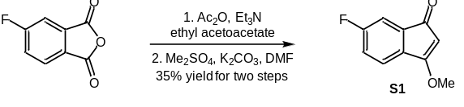
Synthesis of 6-fluoro-3-methoxy-1H-inden-1-one (S1)：To a solution of 4-fluorophthalic anhydride (3.32 g, 20 mmol) in acetic anhydride (20 mL) and triethylamine (10 mL) was added ethyl acetoacetate (2.84 mL, 22 mmol). The reaction mixture was stirred for 12 h before being poured into a mixture of concentrated HCl (24 g) and ice water (24 g). An additional aq. HCl (35.2 mL, 5M) was added into the mixture, then the mixture was heated to reflux for 2 h. After cooling to room temperature, the solution was diluted with water and extracted with CH₂Cl₂. The organic phase was washed with brine and dried over anhydrous Na₂SO₄. The solvent was removed under reduced pressure and the resultant crude product was used in the next step without further purification. To another flask was added the above crude 1,3-indanedione, K₂CO₃ (3.31 g, 24 mmol), Me₂SO₄ (3.32 mL, 24 mmol) and 60 mL DMF. The mixture was stirred for 24 h at room temperature before being quenched with saturated aq. NH₄Cl and diluted with EtOAc. The organic phase was dried over anhydrous Na₂SO₄. The solvent was removed under vacuum and the crude product was purified by flash column chromatography on silica gel (petroleum ether/EtOAc = 8:1) to give the product S1 as a yellow solid (1.25 g, 35%). ¹H NMR (600 MHz, CDCl₃) δ 7.41 - 7.39 (m, 1H), 6.97 - 6.93 (m, 2H), 5.11 (s, 1H), 4.00 (s, 3H); ¹⁹F NMR (564 MHz, CDCl₃) δ -106.5; ¹³C NMR (150 MHz, CDCl₃) δ 193.2, 177.9, 177.9, 166.6, 164.9, 142.6, 142.6, 129.1, 129.1, 123.1, 123.0, 116.0, 115.8, 108.0, 107.8, 97.7, 58.9; HRMS (ESI+): calcd for C₁₀H₈FO₂⁺ (M+H) 179.0503, found 179.0505.

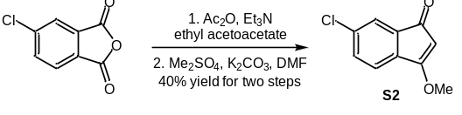
Synthesis of 6-chloro-3-methoxy-1H-inden-1-one (S2)：Using a similar procedure for synthesis of S1, 4-chlorophthalic anhydride (3.62 g, 20 mmol) was used instead. Purification by flash column chromatography (petroleum ether/EtOAc = 8:1) provided the product S2 as a yellow solid (1.56 g, 40%). ¹H NMR (400 MHz, CDCl₃) δ 7.39 (d, J = 1.6 Hz, 1H), 7.33 (dd, J = 8.0 Hz, 1.6 Hz, 1H), 7.15 (d, J = 8.0 Hz, 1H), 5.10 (s, 1H), 4.01 (s, 3H); ¹³C NMR (100 MHz, CDCl₃) δ 193.1, 179.7, 137.6, 136.7, 135.2, 131.7, 122.2, 119.8, 96.9, 59.0; HRMS (ESI+): calcd for C₁₀H₈ClO₂⁺ (M+H) 195.0207, found 195.0208.

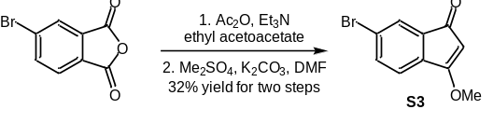
Synthesis of 6-bromo-3-methoxy-1H-inden-1-one (S3)：Using a similar procedure for synthesis of S1, 4-bromophthalic anhydride (4.54 g, 20 mmol) was used instead. Purification by flash column chromatography (petroleum ether/EtOAc = 8:1) provided the product S3 as a yellow solid (1.53 g, 32%). ¹H NMR (400 MHz, CDCl₃) δ 7.54 (d, J = 1.6 Hz, 1H), 7.51 (dd, J = 7.6 Hz, 1.6 Hz, 1H), 7.10 (d, J = 8.0 Hz, 1H), 5.08 (s, 1H), 4.01 (s, 3H); ¹³C NMR (100 MHz, CDCl₃) δ 193.1, 179.7, 138.1, 135.2, 134.7, 124.9, 124.7, 120.2, 96.8, 59.0; HRMS (ESI+): calcd for C₁₀H₈BrO₂⁺ (M+H) 238.9702, found 238.9705.

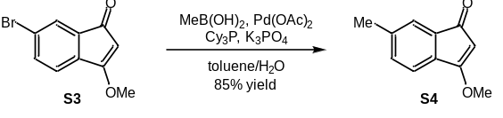
Synthesis of 3-methoxy-6-methyl-1H-inden-1-one (S4): To a solution of S3 (284.4 mg, 1.2 mmol) in toluene (5.0 mL) and water (0.5 mL) was added Pd(OAc)₂ (15.3 mg, 0.068 mol), Cy₃P (35.3 mg, 0.126 mmol), K₃PO₄ (0.81 g, 3.8 mmol) and MeB(OH)₂ (228.3 mg, 3.8 mmol). The mixture was stirred at 100 °C for 24 h before being quenched with water. The reaction mixture was extracted with ethyl acetate. The combined organic phase was washed successively with water and brine, then dried over anhydrous Na₂SO₄. Purification by flash column chromatography (petroleum ether/EtOAc = 8:1) provided the product S4 as a yellow solid (177.5 mg, 85%). ¹H NMR (400 MHz, CD₃CN) δ 7.23-7.20 (m, 2H), 7.12 (d, J = 7.6 Hz, 1H), 5.07 (s, 1H), 3.99 (s, 3H), 2.35 (s, 3H); ¹³C NMR (100 MHz, CD₃CN) δ 195.3, 181.4, 142.0, 137.6, 134.6, 133.1, 122.6, 119.4, 96.8, 59.8, 21.5; HRMS (ESI+): calcd for C₁₁H₁₁O₂⁺ (M+H) 175.0754, found 175.0755.

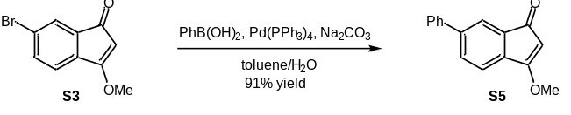
Synthesis of 3-methoxy-6-phenyl-1H-inden-1-one (S5): To a solution of S3 (238.2 mg, 1.0 mmol) in toluene (5.0 mL) and water (5.0 mL) was added phenylboronic acid (183.0 mg, 1.5 mmol), Pd(PPh₃)₄ (11.6 mg, 0.01 mmol), and Na₂CO₃ (210.2 mg, 2.0 mmol) and the mixture was allowed to reflux under Ar for 12 h. The mixture was cooled, and the aqueous layer was extracted with EtOAc. The combined extracts were washed with brine and dried over anhydrous Na₂SO₄. Purification by flash column chromatography (petroleum ether/EtOAc = 8:1) provided the product S5 as a yellow solid (215.1 mg, 91%). ¹H NMR (400 MHz, CDCl₃) δ 7.61 (s, 1H), 7.56 - 7.54 (m, 3H), 7.41 (t, J = 7.2 Hz, 2H), 7.34 (t, J = 7.2 Hz, 1H), 7.26 - 7.23 (m, 1H), 5.08 (s, 1H), 3.99 (s, 3H); ¹³C NMR (100 MHz, CDCl₃) δ 194.6, 180.2, 143.8, 140.2, 138.2, 134.4, 130.6, 129.1, 128.1, 127.0, 120.3, 119.2, 96.9, 58.8; HRMS (ESI+): calcd for C₁₆H₁₃O₂⁺ (M+H) 237.0910, found 237.0911.

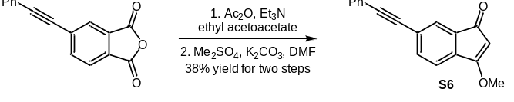
Synthesis of 3-methoxy-6-(phenylethynyl)-1H-inden-1-one (S6)：Using a similar procedure for synthesis of S1, 4-phenylethynylphthalic anhydride (4.96 g, 20 mmol) was used instead. Purification by flash column chromatography (petroleum ether/EtOAc = 8:1) provided the product S6 as a yellow solid (1.98 g, 38%). ¹H NMR (400 MHz, CDCl₃) δ 7.57 (br s, 1H), 7.55 - 7.51 (m, 3H), 7.36 - 7.35 (m, 3H), 7.22 (dd, J = 7.2 Hz, 0.4 Hz, 1H), 5.15 (s, 1H), 4.02 (s, 3H); ¹³C NMR (100 MHz, CDCl₃) δ 193.8, 179.7, 138.7, 135.4, 133.6, 131.8, 128.8, 128.6, 125.7, 124.4, 123.0, 118.8, 97.5, 91.7, 89.0, 58.9; HRMS (ESI+): calcd for C₁₈H₁₃O₂⁺ (M+H) 261.0910, found 261.0910.

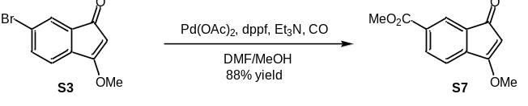
Synthesis of methyl 3-methoxy-1-oxo-1H-indene-6-carboxylate (S7): To a solution of S3 (72.5 mg, 0.3 mmol) in MeOH (3.0 mL) and DMF (3.0 mL) was added Pd(OAc)₂ (6.7 mg, 0.03 mmol), dppf (16.6 mg, 0.03 mmol) and Et₃N (104 μL, 0.75 mmol). The mixture was allowed to stir under carbon monoxide atmosphere at 60 °C for 12 h. After cooling, the reaction mixture was concentrated and the residue was purified by flash column chromatography on silica gel (petroleum ether/EtOAc = 4:1) to provide the product S7 as a yellow solid (57.6 mg, 88%). ¹H NMR (400 MHz, CDCl₃) δ 8.12 (dd, J = 7.2 Hz, 1.2 Hz, 1H), 8.06 (br s, 1H), 7.31 (d, J = 7.6 Hz, 1H), 5.22 (s, 1H), 4.03 (s, 3H), 3.92 (s, 3H); ¹³C NMR (100 MHz, CDCl₃) δ 193.3, 178.9, 166.2, 143.7, 134.5, 133.5, 132.4, 122.1, 118.7, 98.8, 59.0, 52.5; HRMS (ESI+): calcd for C₁₂H₁₁O₄⁺ (M+H) 219.0652, found 219.0655.

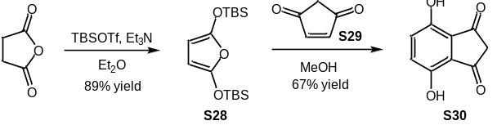
Synthesis of the 1,3-indandione intermediate S30: To an oven-dried flask charged with a stir bar was added succinic anhydride (5 g, 50 mmol, 1.0 equiv.) and 200 mL anhydrous Et₂O. The resulting suspension was cooled to 0 ºC before anhydrous triethylamine (21.1 mL, 150 mmol, 3.0 equiv.) was added. Then TBSOTf (25.2 mL, 110 mmol, 2.2 equiv.) was added dropwise and the reaction mixture was allowed to stir overnight at room temperature. The reaction mixture was filtered through phosphate buffered silica (pH = 7) and eluted with Et2O. The solvent was concentrated under reduced pressure. Purification by flash column chromatography [phosphate buffered silica (pH = 7), eluting with petroleum ether] provided the product S28 as a yellow oil (14.6 g, 89%). ¹H NMR (400 MHz, CDCl₃) δ 4.88 (s, 2H), 0.96 (s, 18H), 0.21 (s, 12H); ¹³C NMR (100 MHz, CDCl₃) δ 147.5, 84.0, 25.7, 18.2, -4.7; HRMS (ESI+): calcd for C₁₆H₃₃O₃Si₂⁺ (M+H) 329.1963, found 329.1959.
According to a similar procedure reported by the Newton group ^{[1]}, to a solution of S28 (4.92 g, 15 mmol, 1.5 equiv.) in MeOH (20.0 mL) was added S29 (0.96 g, 10 mmol, 1.0 equiv.) at 23 ºC. The reaction was stirred overnight and concentrated under reduced pressure. The residue was purified by flash column chromatography on silica gel (petroleum ether/EtOAc = 2:1→ EtOAc) to give 1,3-indandione S30 as a reddish solid (1.19 g, 67%). ¹H NMR (400 MHz, d⁶-DMSO) δ 9.94 (s, 2H), 7.13 (s, 2H), 3.19 (s, 2H); ¹³C NMR (100 MHz, d⁶-DMSO) δ 197.0, 148.0, 126.8, 125.8, 46.1; HRMS (ESI+): calcd for C₉H₇O₄⁺ (M+H) 179.0339, found 179.0337.

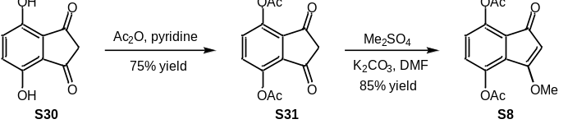
Synthesis of 3-methoxy-1-oxo-1H-indene-4,7-diyl diacetate (S8): To a flask equipped with a stir bar was added S30 (3.56 g, 20 mmol, 1.0 equiv.), pyridine (3.23 mL, 40 mmol, 2.0 equiv.), Ac₂O (5.63 mL, 60 mmol, 3.0 equiv.) and CH₂Cl₂ (100 mL). The mixture was stirred at room temperature for 12 h, then diluted with CH₂Cl₂ (100 mL). The solution was washed with saturated aq. CuSO₄ (30 mL) and brine (30 mL). The combined organic phase was dried over anhydrous Na₂SO₄. Purification by flash column chromatography (petroleum ether/EtOAc = 4:1) yielded compound S31 as a yellow solid (3.93 g, 75%). ¹H NMR (400 MHz, CDCl₃) δ 7.43 (s, 2H), 3.19 (s, 2H), 2.41 (s, 6H); ¹³C NMR (100 MHz, CDCl₃) δ 193.7, 168.8, 144.4, 135.0, 130.9, 45.5, 20.8; HRMS (ESI+): calcd for C₁₃H₁₀NaO₆⁺ (M+Na) 285.0370, found 285.0371.
To a solution of S31 (4.5 g, 20 mmol) in 66 mL DMF was added K₂CO₃ (3.31 g, 24 mmol) and Me₂SO₄ (3.32 mL, 24 mmol). The mixture was stirred for 24 h at room temperature and quenched with saturated aq. NH₄Cl. The combined organic layers were washed with brine and dried over anhydrous Na₂SO₄. The solvent was removed under vacuum and the crude product was purified by flash column chromatography on silica gel (petroleum ether/EtOAc = 4:1) to give the product S8 as a yellow solid (4.69 g, 85%). ¹H NMR (400 MHz, CDCl₃) δ 7.02 (d, J = 8.8 Hz, 1H), 6.98 (d, J = 8.8 Hz, 1H), 5.03 (s, 1H), 3.94 (s, 3H), 2.36 (s, 3H), 2.29 (s, 3H); ¹³C NMR (100 MHz, CDCl₃) δ 190.5, 178.2, 169.3, 168.9, 143.1, 141.1, 131.0, 129.2, 127.1, 124.2, 97.8, 59.4, 20.9, 20.8; HRMS (ESI+): calcd for C₁₄H₁₃O₆⁺ (M+H) 277.0707, found 277.0706.

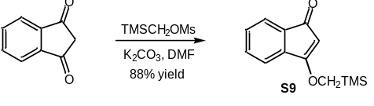
Synthesis of 3-((trimethylsilyl)methoxy)-1H-inden-1-one (S9): To a solution of 1,3-indanedione (320 mg, 2.0 mmol) in 6.0 mL DMF was added K₂CO₃ (331.2 mg, 2.4 mmol) and TMSCH₂OMs (436.8 mg, 2.4 mmol). The mixture was stirred for 24 h at room temperature and quenched with saturated aq. NH₄Cl. The combined organic phase was dried over anhydrous Na₂SO₄. The solvent was removed under vacuum and the crude product was purified by flash column chromatography on silica gel (petroleum ether/EtOAc = 8:1) to give the product S9 as a yellow solid (408.5 mg, 88%). ¹H NMR (600 MHz, CDCl₃) δ 7.43 (d, J = 7.2 Hz, 1H), 7.35 (t, J = 7.2 Hz, 1H), 7.31 (t, J = 7.2 Hz, 1H), 7.22 (d, J = 7.2 Hz, 1H), 5.09 (s, 1H), 3.86 (s, 2H), 0.19 (s, 9H); ¹³C NMR (150 MHz, CDCl₃) δ 195.0, 181.9, 139.9, 133.9, 132.1, 130.3, 121.1, 118.6, 96.5, 66.3, -3.0; HRMS (ESI+): calcd for C₁₃H₁₇O₂Si⁺ (M+H) 234.1071, found 234.1069.

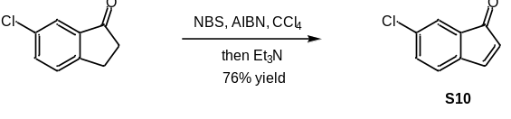
Synthesis of 6-chloro-1H-inden-1-one (S10): To a solution of 6-chloro-1-indanone (1.66 g, 10 mmol) in CCl₄ (4.0 mL) was added NBS (1.95 g, 11 mmol) and AIBN (20.2 mg, 0.11 mmol). The mixture was allowed to stir at 100 °C for 2.5 h. The crude mixture was filtered through a celite pad, and washed with CCl₄. The filtrate was cooled to 0 °C and treated with triethylamine (2.8 mL, 20 mmol). The mixture was concentrated in vacuo. Flash column chromatography on silica gel (petroleum ether/EtOAc = 8:1) gave product S10 as a yellow liquid (1.26 g, 76%). ¹H NMR (400 MHz, CDCl₃) δ 7.57 (dd, J = 6.0 Hz, 0.8 Hz, 1H), 7.38 (br s, 1H), 7.31 (dd, J = 7.6 Hz, 2.0 Hz, 1H), 7.00 (d, J = 7.6 Hz, 1H), 5.92 (d, J = 6.0 Hz, 1H); ¹³C NMR (100 MHz, CDCl₃) δ 197.0, 149.6, 142.7, 135.4, 133.0, 132.1, 127.6, 123.6, 123.2,; HRMS (ESI+): calcd for C₉H₆ClO⁺ (M+H) 167.0072, found 167.0076.

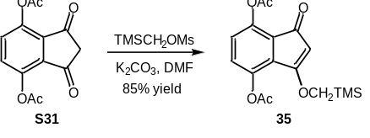
Synthesis of 1-oxo-3-((trimethylsilyl)methoxy)-1H-indene-4,7-diyl diacetate (35): To the solution of S31 (4.5 g, 20 mmol, 1.0 equiv.) in 66 mL DMF was added K₂CO₃ (3.31 g, 24 mmol, 1.2 equiv.) and TMSCH₂OMs (4.37 g, 24 mmol, 1.2 equiv.). The mixture was stirred for 48 h at room temperature, and quenched with saturated aq. NH₄Cl. The combined organic phase was washed with brine and dried over anhydrous Na₂SO₄. The solvent was removed and the crude product was purified by flash column chromatography on silica gel (petroleum ether/EtOAc = 4:1) to give the product 35 as a yellow solid (5.92 g, 85%). ¹H NMR (400 MHz, CDCl₃) δ 7.01 (d, J = 8.8 Hz, 1H), 6.96 (d, J = 8.8 Hz, 1H), 5.06 (s, 1H), 3.80 (s, 2H), 2.35 (s, 3H), 2.28 (s, 3H), 0.17 (s, 9H); ¹³C NMR (100 MHz, CDCl₃) δ 190.7, 180.4, 168.9, 168.8, 143.0, 140.9, 131.1, 129.2, 126.9, 124.6, 97.9, 67.4, 21.1, 20.8, -3.1; HRMS (ESI+): calcd for C₁₇H₂₁O₆Si⁺ (M+H) 349.1102, found 349.1103.

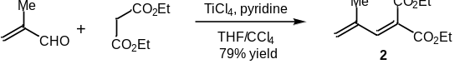
Synthesis of diethyl 2-(2-methylallylidene)malonate (2): According to the known method ^{[2]}, in a 200 mL oven-dried flask was added 60 mL THF and a solution of TiCl₄ (3.3 mL, 30 mmol) in CCl₄ (7.5 mL) at 0 °C. Then methacrolein (1.23 mL, 15 mmol) and diethyl malonate (1.14 mL, 7.5 mmol) were added dropwise. The reaction mixture was stirred for 30 min at 0 °C and pyridine (4.84 mL, 60 mmol) was added. The reaction mixture was diluted with EtOAc and water. The aqueous layer was extracted with EtOAc. The combined organic phase was washed sequentially with saturated aq. NaHCO₃ and brine, then dried over anhydrous Na₂SO₄. The solvent was removed under reduced pressure. Purification by flash chromatography on silica gel (petroleum ether/EtOAc = 16:1) provided the desired diene 2 (1.26 g, 79%). ¹H NMR (400 MHz, CDCl₃) δ 7.26 (s, 1H), 5.43 (s, 1H), 5.37 (s, 1H), 4.29 (q, J = 7.2 Hz, 2H), 4.24 (q, J =7.2 Hz, 2H), 1.88 (s, 3H), 1.32 (t, J = 7.2 Hz, 3H), 1.28 (t, J = 7.2 Hz, 3H); ¹³C NMR (100 MHz, CDCl₃) δ 166.8, 164.5, 143.9, 139.6, 127.5, 125.5, 61.7, 61.6, 19.2, 14.2, 14.1; HRMS (ESI+): calcd for C₁₁H₁₇O₄⁺ (M+H) 213.1121, found 213.1120.

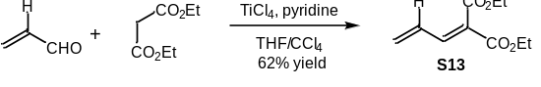
Synthesis of diethyl 2-allylidenemalonate (S13): Using a similar procedure for synthesis of 2, acrolein (1.0 mL, 15 mmol) was used instead. Purification by flash column chromatography (petroleum ether/EtOAc = 8:1) provided the diene S13 as an oil (0.92 g, 62%). ¹H NMR (400 MHz, CDCl₃) δ 7.31 (d, J = 11.2 Hz, 1H), 6.80 - 6.70 (m, 1H), 5.77 (d, J = 16.8 Hz, 1H), 5.67 - 5.65 (m, 1H), 4.32 (q, J = 7.2 Hz, 2H), 4.26 (q, J = 7.2 Hz, 2H), 1.34 (t, J = 7.2 Hz, 3H), 1.31 (t, J = 7.2 Hz, 3H); ¹³C NMR (100 MHz, CDCl₃) δ 165.2, 164.5, 144.4, 131.9, 129.6, 127.0, 61.6, 14.3, 14.3; HRMS (ESI+): calcd for C₁₀H₁₅O₄⁺ (M+H) 199.0965, found 199.0965.

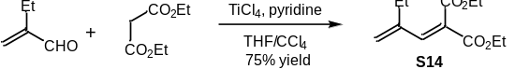
Synthesis of diethyl 2-(2-methylenebutylidene)malonate (S14): Using a similar procedure for synthesis of 2, TiCl₄ (13.2 mL, 60 mmol), ethylacrolein (2.93 mL, 30 mmol) and diethyl malonate (2.28 mL, 15 mmol) were used. Purification by flash column chromatography (petroleum ether/EtOAc = 8:1) provided the diene S14 as an oil (2.55 g, 75%). ¹H NMR (400 MHz, CDCl₃) δ 7.27 (s, 1H), 5.39 (s, 1H), 5.31 (d, J = 1.2 Hz, 1H), 4.31 - 4.22 (m, 4H), 2.21 (q, J = 7.2 Hz, 2H), 1.32 (t, J = 7.2 Hz, 3H), 1.30 (t, J = 7.2 Hz, 3H), 1.07 (t, J = 7.2 Hz, 3H); ¹³C NMR (100 MHz, CDCl₃) δ 166.8, 164.5, 145.3, 144.1, 126.0, 122.0, 61.7, 61.6, 26.2, 14.3, 14.1, 12.6; HRMS (ESI+): calcd for C₁₂H₁₉O₄⁺ (M+H) 227.1278, found 227.1275.

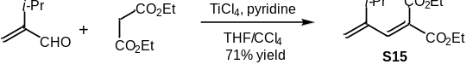
Synthesis of diethyl 2-(3-methyl-2-methylenebutylidene)malonate (S15): Using a similar procedure for synthesis of 2, 3-methyl-2-methylene-butyraldehyde (1.75 mL, 15 mmol) was used instead. Purification by flash column chromatography (petroleum ether/ethyl acetate = 8:1) provided the diene S15 as an oil (1.27 g, 71%). ¹H NMR (400 MHz, CDCl₃) δ 7.27 (s, 1H), 5.21 (s, 1H), 5.14 (s, 1H), 4.24 (q, J = 7.2 Hz, 4H), 2.46 - 2.39 (m, 1H), 1.31 - 1.26 (m, 6H), 1.06 (d, J = 6.8 Hz, 6H); ¹³C NMR (100 MHz, CDCl₃) δ 166.3, 164.1, 150.1, 143.9, 127.7, 116.0, 61.6, 61.5, 33.3, 21.8, 14.2, 14.0.; HRMS (ESI+): calcd for C₁₃H₂₁O₄⁺ (M+H) 241.1434, found 241.1433.

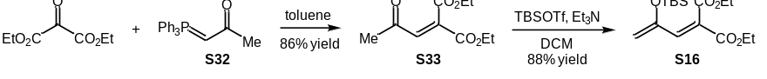
Synthesis of diethyl 2-(2-((tert-butyldimethylsilyl)oxy)allylidene)malonate (S16): Diethyl ketomalonate (3.48 g, 20 mmol) and ylide S32 (6.96 g, 20 mmol) were dissolved in toluene (120 mL). The mixture was stirred at room temperature for 3 h, and then diluted with CH₂Cl₂. The solution was washed with water and brine. The combined organic layers were dried over anhydrous Na₂SO₄, concentrated under reduced pressure and purified by flash column chromatography on silica gel (petroleum ether/EtOAc = 8:1) to give S33 as a colorless oil (3.65 g, 86%). ¹H NMR (400 MHz, CDCl₃) δ 7.11 (s, 1H), 4.35 (q, J = 7.2 Hz, 2H), 4.29 (q, J = 7.2 Hz, 2H), 2.34 (s, 3H), 1.33 (t, J = 7.2 Hz, 3H), 1.31 (t, J = 7.2 Hz, 3H); ¹³C NMR (100 MHz, CDCl₃) δ 196.3, 164.7, 162.9, 135.9, 135.6, 62.6, 62.2, 30.8, 14.1, 14.0; HRMS (ESI+): calcd for C₁₀H₁₅O₅⁺ (M+H) 215.0914, found 215.0915.
To a solution of S33 (1.0 g, 4.6 mmol) in CH₂Cl₂ (50 mL) was added TBSOTf (1.6 mL, 7.0 mmol) and Et₃N (1.28 mL, 9.2 mmol). The reaction mixture was stirred at room temperature for 1 h and quenched with saturated NH₄Cl. The combined organic layers were washed with brine, dried over anhydrous Na₂SO₄ and concentrated under reduced pressure. The residue was purified by flash column chromatography on silica gel (petroleum ether/EtOAc = 8:1) to give product S16 as a colorless oil (1.3 g, 88%). ¹H NMR (400 MHz, CDCl₃) δ 6.99 (s, 1H), 4.73 (d, J = 1.6 Hz, 1H), 4.69 (d, J = 1.6 Hz, 1H), 4.28 (q, J = 7.2 Hz, 2H), 4.23 (q, J = 7.2 Hz, 2H), 1.32 - 1.25 (m, 6H), 0.93 (s, 9H), 0.20 (s, 6H); ¹³C NMR (100 MHz, CDCl₃) δ 165.9, 164.4, 153.1, 139.2, 125.5, 104.4, 61.7, 61.4, 26.2, 19.2, 14.2, 14.1, -4.1; HRMS (ESI+): calcd for C₁₆H₂₉O₅Si⁺ (M+H) 329.1779, found 329.1777.

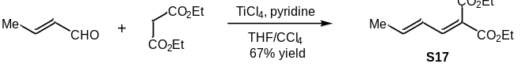
Synthesis of diethyl (E)-2-(but-2-en-1-ylidene)malonate (S17): Using a similar procedure for synthesis of 2, crotonaldehyde (1.23 mL, 15 mmol) was used instead. Purification by flash column chromatography (petroleum ether/EtOAc = 16:1) provided the diene S17 as an oil (1.07 g, 67%). ¹H NMR (400 MHz, CDCl₃) δ 7.32 (d, J = 11.2 Hz, 1H), 6.56 - 6.49 (m, 1H), 6.37 - 6.28 (m, 1H), 4.32 (q, J = 7.2 Hz, 2H), 4.24 (q, J = 7.2 Hz, 2H), 1.90 (dd, J = 6.8 Hz, 1.2 Hz, 3H), 1.34 (t, J = 7.2 Hz, 3H), 1.29 (t, J = 7.2 Hz, 3H); ¹³C NMR (100 MHz, CDCl₃) δ 165.6, 165.0, 145.4, 144.5, 127.3, 123.7, 61.4, 61.3, 19.2, 14.3, 14.3; HRMS (ESI+): calcd for C₁₁H₁₇O₄⁺ (M+H) 213.1121, found 213.1125.

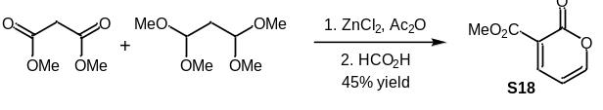
Synthesis of methyl 2-oxo-2H-pyran-3-carboxylate (S18): According to the known literature ^{[3]}, to a stirred mixture of 1,1,3,3-tetramethoxypropane (4.93 g, 30 mmol), anhydrous ZnCl₂ (27.2 mg, 0.2 mmol) and Ac₂O (10 mL) was added dimethyl malonate (3.96 g, 30 mmol) dropwise at room temperature. The reaction mixture was allowed to stir at reflux for 12 h. After that, Ac₂O was removed directly under reduced pressure. The residue was purified by flash column chromatography on silica gel (petroleum ether/EtOAc = 16:1). A solution of the above compound in formic acid (88% aq., 11 mL) was stirred at reflux for 1 h. Then formic acid was removed under reduced pressure. Purification by flash column chromatography (petroleum ether/EtOAc = 4:1) provided diene S18 as a yellow solid (2.08 g, 45%). ¹H NMR (400 MHz, CDCl₃) δ 8.19 (dd, J = 6.8 Hz, 2.0 Hz, 1H), 7.69 (dd, J = 4.8 Hz, 2.0 Hz, 1H), 6.39 - 6.36 (m, 1H), 3.88 (s, 3H); ¹³C NMR (150 MHz, CDCl₃) δ 163.8, 157.5, 156.6, 149.0, 117.8, 106.0, 52.9; HRMS (ESI+): calcd for C₇H₇O₄⁺ (M+H) 155.0339, found 155.0342.

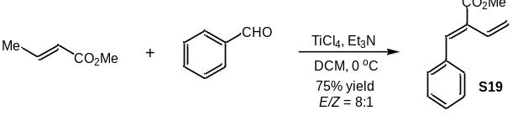
Synthesis of methyl (E)-2-benzylidenebut-3-enoate (S19): According to the known literature ^{[4]}, to a solution of methyl crotonate (1.1 mL, 10 mmol) and benzaldehyde (1.1 mL, 10 mmol) in CH₂Cl₂ (40 mL) was added Et₃N (4.2 mL, 30 mmol). The mixture was kept in ice bath for 5 min before the slow addition of TiCl₄ (2.2 mL, 20 mmol). The mixture was then allowed to stir at room temperature for 6 h. After that, the reaction mixture was diluted with brine and the organic layer was separated. The organic phase was then dried over anhydrous Na₂SO₄ and concentrated under reduced pressure. Purification by flash column chromatography on silica gel (petroleum ether/EtOAc = 16:1) provided diene S19 as a light yellow oil (1.4 g, 75%, E/Z = 8:1). The major isomer: ¹H NMR (600 MHz, CDCl₃) δ 7.55 (s, 1H), 7.42 (d, J = 7.2 Hz, 2H), 7.38 (t, J = 7.2 Hz, 2H), 7.33 (t, J = 7.2 Hz, 1H), 6.64 (dd, J = 17.4 Hz, 11.4 Hz, 1H), 5.85 (dd, J = 17.4 Hz, 1.8 Hz, 1H), 5.44 (d, J = 18.0 Hz, 1H), 3.85 (s, 3H); ¹³C NMR (150 MHz, CDCl₃) δ 168.0, 139.5, 135.4, 130.3, 130.2, 129.8, 128.9, 128.5, 121.2, 52.2; HRMS (ESI+): calcd for C₁₂H₁₃O₂⁺ (M+H) 189.0910, found 189.0913.

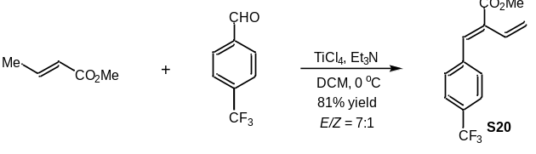
Synthesis of methyl (E)-2-(4-(trifluoromethyl)benzylidene)but-3-enoate (S20): Using a similar procedure for synthesis of S19, 4-(trifluoromethyl)benzaldehyde (1.3 mL, 10 mmol) was used instead. Purification by flash column chromatography (petroleum ether/EtOAc = 16:1) provided the diene S20 as a light yellow oil (2.07 g, 81%, E/Z = 7:1). The major isomer: ¹H NMR (400 MHz, CDCl₃) δ 7.63 (d, J = 8.4 Hz, 2H), 7.52-7.50 (m, 3H), 6.60 - 6.52 (m, 1H), 5.86 (dd, J = 17.6 Hz, 1.2 Hz, 1H), 5.50 - 5.46 (m, 1H), 3.86 (s, 3H); ¹⁹F NMR (564 MHz, CDCl₃) δ -62.8; ¹³C NMR (150 MHz, CDCl₃) δ 167.5, 138.9, 137.4, 132.2, 130.7, 130.4, 130.2, 129.1, 125.5, 125.4, 122.4, 52.4; HRMS (ESI+): calcd for C₁₃H₁₂F₃O₂⁺ (M+H) 257.0784, found 257.0787.

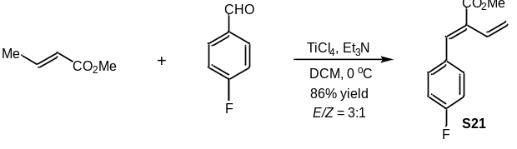
Synthesis of methyl (E)-2-(4-fluorobenzylidene)but-3-enoate (S21): Using a similar procedure for synthesis of S19, 4-fluorobenzaldehyde (1.07 mL, 10 mmol) was used instead. Purification by flash column chromatography (petroleum ether/EtOAc = 16:1) provided the diene S21 as a light yellow oil (1.77 g, 86%, E/Z = 3:1). The isomers were difficult to separate and thus two sets of NMR signals were recorded. ¹H NMR (600 MHz, CDCl₃) δ 7.51 (s, 1H), 7.43 - 7.41 (m, 2H), 7.28 - 7.26 (m, 0.69H), 7.09 - 7.06 (m, 2H), 7.03 - 7.00 (m, 0.65H), 6.61 - 6.56 (m, 1.32H), 6.47 - 6.43 (m, 0.36H), 5.85 (d, J = 18.0 Hz, 1H), 5.48 - 5.45 (m, 1H), 5.33 - 5.27 (m, 0.72H), 3.85 (br s, 3H), 3.79 (br s, 1.02H); ¹⁹F NMR (564 MHz, CDCl₃) δ -111.5, -112.4; ¹³C NMR (150 MHz, CDCl₃) δ 168.9, 167.8, 163.7, 163.5, 162.1, 161.9, 138.2, 135.2, 132.1, 132.0, 131.4, 130.1, 130.0, 129.5, 121.5, 116.7, 115.8, 115.7, 115.6, 115.5, 52.2, 52.2; HRMS (ESI+): calcd for C₁₂H₁₂FO₂⁺ (M+H) 207.0816, found 207.0817.

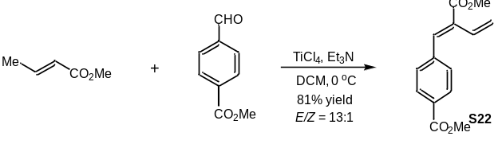
Synthesis of methyl (E)-4-(2-(methoxycarbonyl)buta-1,3-dien-1-yl)benzoate (S22): Using a similar procedure for synthesis of S19, methyl 4-formylbenzoate (1.37 mL, 10 mmol) was used instead. Purification by flash column chromatography (petroleum ether/EtOAc = 16:1) provided the diene S22 as a yellow solid (1.99 g, 81%, E/Z = 13:1). The major isomer: ¹H NMR (600 MHz, CDCl₃) δ 8.04 (d, J = 8.4 Hz, 2H), 7.53 (s, 1H), 7.48 (d, J = 8.4 Hz, 2H), 6.59 (dd, J = 17.4 Hz, 11.4 Hz, 1H), 5.85 (dd, J = 17.4 Hz, 12.0 Hz, 1H), 5.48 (d, J = 12.0 Hz, 1H), 3.93 (s, 3H), 3.86 (s, 3H); ¹³C NMR (150 MHz, CDCl₃) δ 167.7, 166.7, 139.9, 137.9, 132.0, 130.1, 130.0, 129.7, 129.3, 122.2, 52.4, 52.3; HRMS (ESI+): calcd for C₁₄H₁₅O₄⁺ (M+H) 247.0965, found 247.0965.

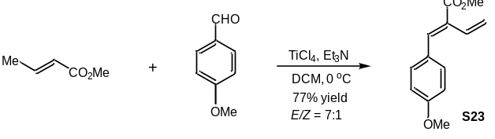
Synthesis of methyl (E)-2-(4-methoxybenzylidene)but-3-enoate (S23): Using a similar procedure for synthesis of S19, 4-methoxybenzaldehyde (1.21 mL, 10 mmol) was used instead. Purification by flash column chromatography (petroleum ether/EtOAc = 16:1) provided the diene S23 as a light yellow oil (1.68 g, 77%, E/Z = 7:1). The major isomer: ¹H NMR (600 MHz, CDCl₃) δ 7.53 (s, 1H), 7.43 - 7.39 (m, 2H), 6.92 - 6.88 (m, 2H), 6.67 - 6.60 (m, 1H), 5.83 (dd, J = 17.6 Hz, 1.6 Hz, 1H), 5.44 (dt, J = 11.6 Hz, 1.6 Hz, 1H), 3.83 (s, 6H); ¹³C NMR (100 MHz, CDCl₃) δ 168.1, 160.3, 139.4, 132.0, 130.1, 128.1, 127.9, 120.7, 114.0, 55.4, 52.1; HRMS (ESI+): calcd for C₁₃H₁₅O₃⁺ (M+H) 219.1016, found 219.1017.

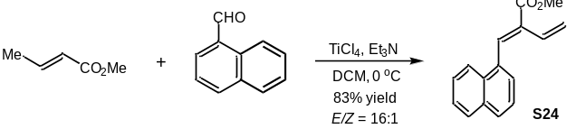
Synthesis of methyl (E)-2-(naphthalen-1-ylmethylene)but-3-enoate (S24): Using a similar procedure for synthesis of S19, 1-naphthaldehyde (1.34 mL, 10 mmol) was used instead. Purification by flash column chromatography (petroleum ether/EtOAc = 16:1) provided the diene S24 as a light yellow oil (1.98 g, 83%, E/Z = 16:1). The major isomer: ¹H NMR (400 MHz, CDCl₃) δ 8.07 (s, 1H), 7.95 - 7.94 (m, 1H),7.89 - 7.85 (m, 2H), 7.55 - 7.52 (m, 2H), 7.50 - 7.45 (m, 2H), 6.52 (dd, J = 17.4 Hz, 11.4 Hz, 1H), 5.90 (dd, J = 18.0 Hz, 1.2 Hz, 1H), 5.34 (dd, J = 17.4 Hz, 1.2 Hz, 1H), 3.93 (s, 3H); ¹³C NMR (150 MHz, CDCl₃) δ 167.8, 138.0, 133.6, 132.5, 132.2, 131.7, 129.8, 129.2, 128.7, 127.9, 126.7, 126.4, 125.2, 124.9, 120.7, 52.2; calcd for C₁₆H₁₅O₂⁺ (M+H) 239.1067, found 239.1068.

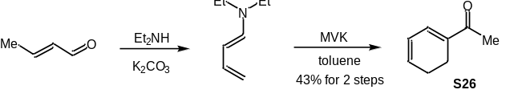
Synthesis of 1-(cyclohexa-1,3-dien-1-yl)ethan-1-one (S26): To a flask charged with diethylamine (32 mL, 0.309 mol) and K₂CO₃ (6 g, 0.043 mol) was added crotonaldehyde (10 g, 0.142 mol) in dry toluene (15 mL) between -5 and -10 ºC over 30 min. The mixture was kept in the dark for 1 h and allowed to stir overnight at room temperature. The unreacted K₂CO₃ was removed by filtration and the volatiles were removed in vacuo. The residue was used for the next step without further purification.
The aboved crude product was dissolved in toluene (60 mL), and methyl vinyl ketone (MVK, 21.2 g, 0.303 mol) was added. The mixture was stirred in the dark for 5 days. The reaction mixture was concentrated under reduced pressure. Purification by flash column chromatography on silica gel (petroleum ether/EtOAc = 32:1) provided S26 as a light yellow oil (7.32 g, 43%). ¹H NMR (400 MHz, CDCl₃) δ 6.87 (d, J = 5.2 Hz, 1H), 6.22 - 6.18 (m, 1H), 6.09 - 6.06 (m, 1H), 2.42 - 2.37 (m, 2H), 2.29 (s, 3H), 2.25-2.19 (m, 2H); ¹³C NMR (100 MHz, CDCl₃) δ 198.6, 136.2, 135.2, 134.1, 124.1, 25.1, 23.0, 19.5; HRMS (ESI+): calcd for C₈H₁₁O⁺ (M+H) 123.0806, found 123.0808.

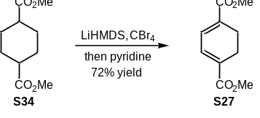
Synthesis of dimethyl cyclohexa-1,3-diene-1,4-dicarboxylate (S27): To a solution of dimethyl 1,4-cyclohexanedicarboxylate S34 (12 g, 60 mmol) in THF (100 mL) was added lithium bis(trimethylsilyl)amide solution (1.0 M in THF, 180 mL, 180 mmol) at -78 °C. After 10 min, CBr₄ (59.6 g, 180 mmol) in THF (50 mL) was added slowly and the reaction mixture was allowed to stir at room temperature for 12 h. The reaction was quenched with saturated aq. NH₄Cl. The organic layer was separated and the aqueous phase was extracted with EtOAc (100 mL × 2). The combined organic phase was dried over anhydrous Na₂SO₄, and concentrated under reduced pressure. The resultant brown solid was used directly without further purification. The above crude product was dissolved in pyridine (25 mL) and heated to reflux for 6 h. After that, the excess pyridine was removed under reduced pressure. Purification by flash column chromatography on silica gel (petroleum ether/EtOAc = 8:1) provided S27 as a white solid (8.64 g, 72%). ¹H NMR (400 MHz, CDCl₃) δ 7.08 (s, 2H), 3.78 (s, 6H), 2.55 (s, 4H); ¹³C NMR (100 MHz, CDCl₃) δ 167.2, 133.0, 131.9, 52.1, 21.8; HRMS (ESI+): calcd for C₁₀H₁₃O₄⁺ (M+H) 197.0808, found 197.0808.

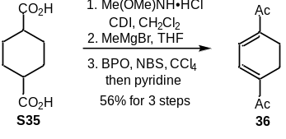
Synthesis of 1,1'-(cyclohexa-1,3-diene-1,4-diyl)bis(ethan-1-one) (36): To a solution of S35 (8.60 g, 50 mmol) in CH₂Cl₂ (120 mL) was added carbonyldiimidazole (CDI, 20.25 g, 125 mmol). The reaction mixture was stirred for 1 h at room temperature before N,O-dimethylhydroxylamine hydrochloride (14.63 g, 150 mmol) was added. After 16 h, aq. HCl (2 M, 100 mL) was added and the aqueous phase was extracted with CH₂Cl₂. The combined organic layers were washed with saturated aqueous NaHCO₃ and brine, dried over anhydrous Na₂SO₄ and the solvent was removed under reduced pressure. The crude Weinreb amide was used for the next step without further purification. To a solution of the above Weinreb amide in THF (100 mL) was added MeMgBr (3.0 M in THF, 50 mL) at 0 ºC. The mixture was stirred for 1 h and quenched with saturated aq. NH₄Cl. The aqueous phase was extracted with EtOAc (100 mL × 2). The combined organic phase was dried over anhydrous Na₂SO₄ and the solvent was concentrated in vacuo. To the solution of this crude product in CCl₄ (150 mL) was added BPO (580.8 mg, 2.4 mmol) and NBS (25.5 g, 144 mmol). The reaction mixture was heated to reflux for 12 h. After that, saturated aq. Na₂S₂O₄ was added, and the aqueous phase was extracted with CH₂Cl₂. The combined organic phase was dried over anhydrous Na₂SO₄, filtered and concentrated in vacuo. The obtained white solid was dissolved in pyridine (60 mL) and then refluxed for 6 h. The excess pyridine was removed under reduced pressure and the residue was purified by flash column chromatography on silica gel (petroleum ether/EtOAc = 8:1) to give diene 36 as a white solid (4.55 g, 56% for 3 steps). ¹H NMR (600 MHz, CDCl₃) δ 7.00 (s, 2H), 2.49 (s, 4H), 2.38 (s, 6H); ¹³C NMR (150 MHz, CDCl₃) δ 198.1, 141.8, 132.2, 25.7, 20.7; HRMS (ESI+): calcd for C₁₀H₁₃O₂⁺ (M+H) 165.0910, found 165.0911.

6.2 General procedure for [4+2] photocycloaddition reactions.
In a 8 mL vial, a solution of enone (0.2 mmol, 1.0 equiv.), diene (0.6 mmol, 3 equiv.) and Mg(ClO₄)₂ (0.02 mmol, 0.1 equiv.) in MeCN was degassed by Argon sparging for 10 min, then irradiated with 395 nm LED at approximately 10 cm away from the light source. After the enone substrate was fully consumed, the LED lamp was turned off and the reaction mixture was concentrated under reduced pressure. The residue was purified by flash column chromatography on silica gel to give the desired [4+2] cycloadducts.

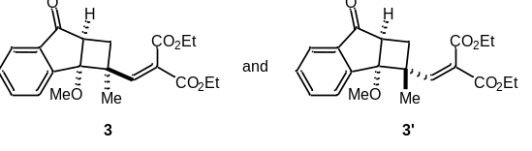
Diethyl-2-2a-methoxy-2-methyl-7-oxo-2,2a,7,7a-tetrahydro-1H-cyclobuta[a]inden-2-yl)methylene)malonate (3): According to the general procedure in section 6.2, enone 1 (16 mg, 0.1 mmol) and diene 2 (63.6 mg, 0.3 mmol) in CH₃CN (2.0 mL) was irradiated for 1 h in the absence of Mg(ClO₄)₂. Purification by flash chromatography on silica gel (petroleum ether/EtOAc = 8:1) provided a pair of diastereomers 3 and 3’ (35.0 mg, 94%, dr = 1.4:1). The major isomer 3: ¹H NMR (400 MHz, CDCl₃) δ 7.80 (d, J = 7.6 Hz, 1H), 7.71 (t, J = 7.6 Hz, 1H), 7.64 (d, J = 7.6 Hz, 1H), 7.53 (d, J = 7.6 Hz, 1H), 7.24 (s, 1H), 4.18 - 4.12 (m, 4H), 3.20 - 3.15 (m, 1H), 2.85 (s, 3H), 2.33 - 2.27 (m, 1H), 1.68 - 1.60 (m, 1H), 1.60 (s, 3H), 1.24 (t, J = 7.2 Hz, 3H), 1.23 (t, J = 7.2 Hz, 3H) ; ¹³C NMR (100 MHz, CDCl₃) δ 204.6, 165.6, 163.8, 151.3, 150.0, 138.1, 135.0, 130.3, 127.4, 126.7, 124.5, 85.9, 61.6, 61.5, 51.3, 45.7, 45.5, 32.2, 21.8, 14.1, 14.0; HRMS (ESI+): calcd for C₂₁H₂₅O₆⁺ (M+H) 373.1646, found 373.1649.
The minor isomer 3’: ¹H NMR (400 MHz, CDCl₃) δ 7.86 (d, J = 8.0 Hz, 1H), 7.75 -7.71 (m, 2H), 7.59 - 7.52 (m, 2H), 4.30 - 4.24 (m, 4H), 3.12 (dd, J = 11.6 Hz, 5.6 Hz, 1H), 2.96 (s, 3H), 2.70 (t, J = 12.8 Hz, 1H), 1.67 (dd, J = 12.8 Hz, 5.2 Hz, 1H), 1.34 - 1.30 (m, 6H), 0.91 (s, 3H) ; ¹³C NMR (100 MHz, CDCl₃) δ 204.9, 166.5, 164.5, 151.2, 150.9, 139.4, 135.0, 130.0, 127.6, 126.6, 124.4, 88.1, 61.6, 61.5, 51.8, 45.7, 44.4, 32.2, 24.5, 14.3, 14.2; HRMS (ESI+): calcd for C₂₁H₂₅O₆⁺ (M+H) 373.1646, found 373.1645.
X-ray crystal structure data for compound 3
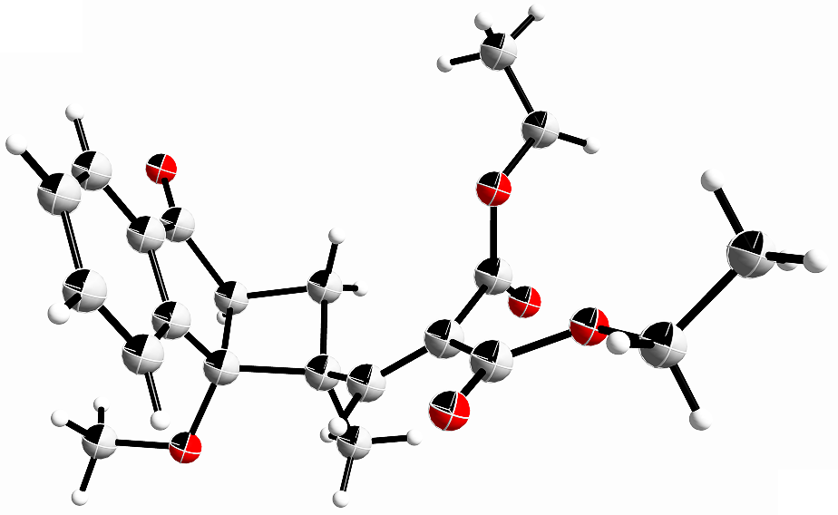
Identification code | xvzz_0715-2_auto
Empirical formula | C₂₁H₂₃O₆
Formula weight | 172.20
Temperature/K | 149.99(10)
Crystal system | monoclinic
Space group | P2₁/c
a/Å | 13.4616(2)
b/Å | 7.96974(11)
c/Å | 18.9118(3)
α/° | 90
β/° | 102.4216(15)
γ/° | 90
Volume/Å³ | 1981.47(5)
Z | 4
ρ_{calc}g/cm³ | 1.154
μ/mm⁻¹ | 0.594
F(000) | 728.0
Crystal size/mm³ | 0.06 × 0.05 × 0.03
Radiation | Cu Kα (λ = 1.54184)
2Θ range for data collection/° | 6.724 to 152.556
Index ranges | -16 ≤ h ≤ 16, -9 ≤ k ≤ 9, -23 ≤ l ≤ 23
Reflections collected | 14667
Independent reflections | 3984 [R_{int} = 0.0263, R_{sigma} = 0.0247]
Data/restraints/parameters | 3984/0/248
Goodness-of-fit on F² | 1.086
Final R indexes [I>=2σ (I)] | R₁ = 0.0542, wR₂ = 0.1410
Final R indexes [all data] | R₁ = 0.0597, wR₂ = 0.1460
Largest diff. peak/hole / e Å⁻³ | 0.71/-0.65

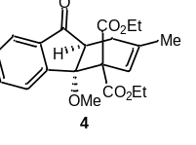
Diethyl-4a-methoxy-2-methyl-9-oxo-1,4a,9,9a-tetrahydro-4H-fluorene-4,4-dicarboxylate (4): According to the general procedure in section 6.2, enone 1 (16 mg, 0.1 mmol), diene 2 (63.6 mg, 0.3 mmol) and Mg(ClO₄)₂ (2.2 mg, 0.01 mmol) in CH₃CN (2.0 mL) were used. The reaction mixture was irradiated for 3 h. Purification by flash chromatography on silica gel (petroleum ether/EtOAc = 8:1) provided the product as a white solid (31.6 mg, 85%). ¹H NMR (400 MHz, CDCl₃) δ 7.86 (d, J = 7.6 Hz, 1H), 7.79 (d, J = 7.6 Hz, 1H), 7.60 (t, J = 7.6 Hz, 1H), 7.48 (t, J = 7.2 Hz, 1H), 6.00 (s, 1H), 4.44 - 4.35 (m, 2H), 3.83 - 3.74 (m, 2H), 3.12 - 3.08 (m, 1H), 3.02 (s, 3H), 2.71 - 2.70 (m, 1H), 2.59 - 2.52 (m, 1H), 1.89 (s, 3H), 1.37 (t, J = 7.2 Hz, 3H), 0.93 (t, J = 7.2 Hz, 3H); ¹³C NMR (100 MHz, CDCl₃) δ 202.6, 168.8, 167.3, 148.7, 139.2, 137.4, 133.1, 129.7, 128.2, 122.3, 118.5, 86.0, 63.4, 61.8, 61.4, 50.9, 48.1, 27.9, 23.8, 14.2, 13.7; HRMS (ESI+): calcd for C₂₁H₂₅O₆⁺ (M+H) 373.1646, found 373.1648.
X-ray crystal structure data for compound 4
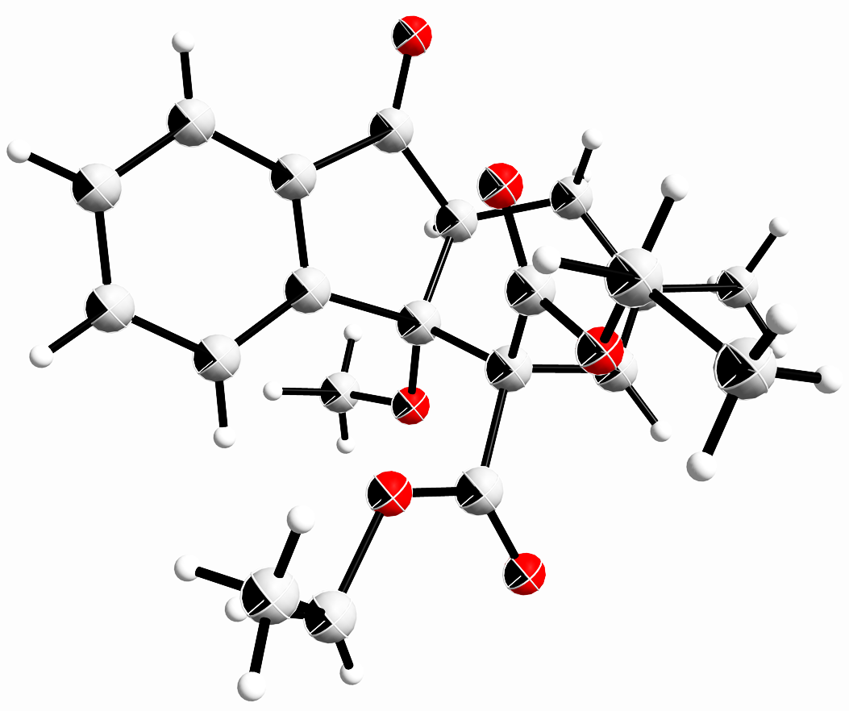
Identification code | cu_zzw_79_0m
Empirical formula | C₂₁H₂₄O₆
Formula weight | 372.40
Temperature/K | 150.0
Crystal system | triclinic
Space group | P-1
a/Å | 8.1425(2)
b/Å | 9.8472(3)
c/Å | 12.3143(4)
α/° | 81.8640(10)
β/° | 85.3040(10)
γ/° | 79.7390(10)
Volume/Å³ | 960.17(5)
Z | 2
ρcalcg/cm³ | 1.288
μ/mm⁻1 | 0.776
F(000) | 396.0
Crystal size/mm³ | 0.2 × 0.18 × 0.15
Radiation | CuKα (λ = 1.54178)
2Θ range for data collection/° | 7.264 to 157.444
Index ranges | -10 ≤ h ≤ 10, -12 ≤ k ≤ 12, -15 ≤ l ≤ 15
Reflections collected | 20009
Independent reflections | 4051 [R_{int} = 0.0399, R_{sigma} = 0.0352]
Data/restraints/parameters | 4051/0/269
Goodness-of-fit on F2 | 1.028
Final R indexes [I>=2σ (I)] | R₁ = 0.0401, wR₂ = 0.1023
Final R indexes [all data] | R₁ = 0.0423, wR₂ = 0.1042
Largest diff. peak/hole / e Å⁻³ | 0.31/-0.22

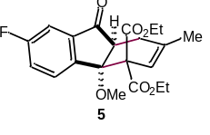
Diethyl-7-fluoro-4a-methoxy-2-methyl-9-oxo-1,4a,9,9a-tetrahydro-4H-fluorene-4,4-dicarboxylate (5): According to the general procedure in section 6.2, enone S1 (16.0 mg, 0.1 mmol), diene 2 (63.6 mg, 0.3 mmol) and Mg(ClO₄)₂ (2.2 mg, 0.01 mmol) in CH₃CN (2.0 mL) were used. The reaction mixture was irradiated for 3 h. Purification by flash chromatography on silica gel (petroleum ether/EtOAc = 8:1) provided the product as a white solid (34.7 mg, 89%). ¹H NMR (600 MHz, CDCl₃) δ 7.85 - 7.83 (m, 1H), 7.43 - 7.42 (m, 1H), 7.30 - 7.27 (m, 1H), 6.00 (br s, 1H), 4.44 - 4.34 (m, 2H), 3.85 - 3.77 (m, 2H), 3.13 - 3.11 (m, 1H), 3.03 (s, 3H), 2.74 - 2.71 (m, 1H), 2.57 - 2.53 (m, 1H), 1.89 (s, 3H), 1.37 (t, J = 7.8 Hz, 3H), 0.97 (t, J = 7.8 Hz, 3H); ¹³C NMR (150 MHz, CDCl₃) δ 201.2, 168.7, 167.3, 164.6, 162.9, 144.2, 141.4, 141.3, 137.4, 130.0, 120.6, 120.4, 118.3, 108.5, 108.3, 85.5 , 63.2, 61.9, 61.6, 50.9, 48.6, 27.9, 23.8, 14.2, 13.7; ⁹F NMR (376 MHz, CDCl₃) δ -111.1; HRMS (ESI+): calcd for C₂₁H₂₄FO₆⁺ (M+H) 391.1551, found 391.1554.

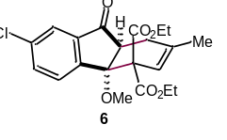
Diethyl-7-chloro-4a-methoxy-2-methyl-9-oxo-1,4a,9,9a-tetrahydro-4H-fluorene-4,4-dicarboxylate (6): According to the general procedure in section 6.2, enone S2 (18 mg, 0.1 mmol), diene 2 (63.6 mg, 0.3 mmol) and Mg(ClO₄)₂ (2.2 mg, 0.01 mmol) in CH₃CN (2.0 mL) were used. The reaction mixture was irradiated for 3 h. Purification by flash chromatography on silica gel (petroleum ether/EtOAc = 8:1) provided the product as a colorless oil (36.9 mg, 91%). ¹H NMR (600 MHz, CDCl₃) δ 7.79 (d, J = 8.4 Hz, 1H), 7.76 (d, J = 1.8 Hz, 1H), 7.54 (dd, J = 8.4 Hz, 1.8 Hz, 1H), 6.00 (br s, 1H), 4.43 - 4.35 (m, 2H), 3.86 - 3.79 (m, 2H), 3.12 - 3.09 (m, 1H), 3.03 (s, 3H), 2.74 - 2.69 (m, 1H), 2.57 - 2.52 (m, 1H), 1.89 (s, 3H), 1.37 (t, J = 7.2 Hz, 3H), 0.98 (t, J = 7.2 Hz, 3H); ¹³C NMR (150 MHz, CDCl₃) δ 201.0, 168.7, 167.2, 146.8, 140.8, 137.4, 136.3, 133.1, 129.5, 122.2, 118.3, 85.7, 63.1, 62.0, 61.6, 51.0, 48.4, 27.8, 23.8, 14.2, 13.7; HRMS (ESI+): calcd for C₂₁H₂₄ClO₆⁺ (M+H) 407.1256, found 407.1259.

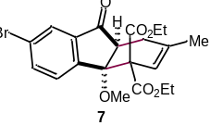
Diethyl-7-bromo-4a-methoxy-2-methyl-9-oxo-1,4a,9,9a-tetrahydro-4H-fluorene-4,4-dicarboxylate (7): According to the general procedure in section 6.2, enone S3 (23.9 mg, 0.1 mmol), diene 2 (63.6 mg, 0.3 mmol) and Mg(ClO₄)₂ (2.2 mg, 0.01 mmol) in CH₃CN (2.0 mL) were used. The reaction mixture was irradiated for 3 h. Purification by flash chromatography on silica gel (petroleum ether/EtOAc = 8:1) provided the product as colorless oil (39.2 mg, 87%). ¹H NMR (400 MHz, CDCl₃) δ 7.91 (d, J = 1.6 Hz, 1H), 7.73 - 7.68 (m, 2H), 5.99 (br s, 1H), 4.46 - 4.33 (m, 2H), 3.89 - 3.77 (m, 2H), 3.12 - 3.08 (m, 1H), 3.03 (s, 3H), 2.74 - 2.69 (m, 1H), 2.58 - 2.51 (m, 1H), 1.89 (s, 3H), 1.37 (t, J = 7.2 Hz, 3H), 0.98 (t, J = 7.2 Hz, 3H); ¹³C NMR (100 MHz, CDCl₃) δ 200.9, 168.7, 167.2, 147.3, 141.0, 137.4, 135.9, 129.8, 125.3, 124.4, 118.3, 85.8, 63.1, 62.0, 61.6, 51.0, 48.3, 27.8, 23.8, 14.2, 13.7; HRMS (ESI+): calcd for C₂₁H₂₄BrO₆⁺ (M+H) 451.0751, found 451.0754.

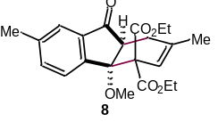
Diethyl-4a-methoxy-2,7-dimethyl-9-oxo-1,4a,9,9a-tetrahydro-4H-fluorene-4,4-dicarboxylate (8): According to the general procedure in section 6.2, enone S4 (17.4 mg, 0.1 mmol), diene 2 (63.6 mg, 0.3 mmol) and Mg(ClO₄)₂ (2.2 mg, 0.01 mmol) in CH₃CN (2.0 mL) were used. The reaction mixture was irradiated for 3 h. Purification by flash chromatography on silica gel (petroleum ether/EtOAc = 8:1) provided the product as a colorless oil (32.8 mg, 85%). ¹H NMR (600 MHz, CDCl₃) δ 7.73 (d, J = 7.8 Hz, 1H), 7.59 (s, 1H), 7.41 (d, J = 7.8 Hz, 1H), 6.00 (s, 1H), 4.43 - 4.36 (m, 2H), 3.85 - 3.76 (m, 2H), 3.10 - 3.07 (m, 1H), 3.01 (s, 3H), 2.72 - 2.69 (m, 1H), 2.57 - 2.53 (m, 1H), 2.43 (s, 3H), 1.88 (s, 3H), 1.37 (t, J = 7.2 Hz, 3H), 0.96 (t, J = 7.2 Hz, 3H); ¹³C NMR (150 MHz, CDCl₃) δ 202.8, 168.9, 167.4, 146.0, 140.0, 139.4, 137.5, 134.4, 127.9, 122.4, 118.6, 86.0, 63.4, 61.8, 61.4, 50.7, 48.4, 28.1, 23.8, 21.4, 14.2, 13.7; HRMS (ESI+): calcd for C₂₂H₂₇O₆⁺ (M+H) 387.1802, found 387.1805.

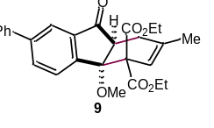
Diethyl-4a-methoxy-2-methyl-9-oxo-7-phenyl-1,4a,9,9a-tetrahydro-4H-fluorene-4,4-dicarboxylate (9): According to the general procedure in section 6.2, enone S5 (23.6 mg, 0.1 mmol), diene 2 (63.6 mg, 0.3 mmol) and Mg(ClO₄)₂ (2.2 mg, 0.01 mmol) in CH₃CN (2.0 mL) were used. The reaction mixture was irradiated for 3 h. Purification by flash chromatography on silica gel (petroleum ether/EtOAc = 8:1) provided the product as colorless oil (34.9 mg, 78%). ¹H NMR (400 MHz, CDCl₃) δ 8.01 (d, J = 1.2 Hz, 1H), 7.93 (d, J = 8.0 Hz, 1H), 7.85 (dd, J = 8.0, 1.6 Hz, 1H), 7.65 (d, J = 7.2 Hz, 2H), 7.47 (t, J = 7.2 Hz, 2H), 7.39 (t, J = 7.2 Hz, 1H), 6.03 (s, 1H), 4.46 - 4.39 (m, 2H), 3.86 - 3.77 (m, 2H), 3.18 - 3.14 (m, 1H), 3.08 (s, 3H), 2.79 - 2.74 (m, 1H), 2.62 - 2.55 (m, 1H), 1.91 (s, 3H), 1.40 (t, J = 7.2 Hz, 3H), 0.96 (t, J = 7.2 Hz, 3H); ¹³C NMR (100 MHz, CDCl₃) δ 202.6, 168.9, 167.4, 147.6, 142.8, 139.9, 139.8, 137.5, 132.1, 129.1, 128.6, 128.1, 127.4, 120.4, 118.5, 86.0, 63.5, 61.9, 61.5, 51.0, 48.6, 28.0, 23.8, 14.2, 13.7; HRMS (ESI+): calcd for C₂₇H₂₉O₆⁺ (M+H) 449.1959, found 449.1958.

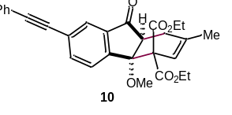
Diethyl-4a-methoxy-2-methyl-9-oxo-7-(phenylethynyl)-1,4a,9,9a-tetrahydro-4H-fluorene-4,4-dicarboxylate (10): According to the general procedure in section 6.2, enone S6 (26 mg, 0.1 mmol), diene 2 (63.6 mg, 0.3 mmol) and Mg(ClO₄)₂ (2.2 mg, 0.01 mmol) in CH₃CN (2.0 mL) were used. The reaction mixture was irradiated for 3 h. Purification by flash chromatography on silica gel (petroleum ether/EtOAc = 8:1) provided the product as colorless oil (38.2 mg, 81%). ¹H NMR (400 MHz, CDCl₃) δ 7.93 (s, 1H), 7.84 (d, J = 8.4 Hz, 1H), 7.73 (dd, J = 8.0 Hz, 1.6 Hz, 1H), 7.55 - 7.53 (m, 2H), 7.38 - 7.35 (m, 3H), 6.01 (s, 1H), 4.45 - 4.36 (m, 2H), 3.87 - 3.77 (m, 2H), 3.14 - 3.10 (m, 1H), 3.05 (s, 3H), 2.76 - 2.72 (m, 1H), 2.59 - 2.52 (m, 1H), 1.90 (s, 3H), 1.38 (t, J = 6.8 Hz, 3H), 0.97 (t, J = 6.8 Hz, 3H); ¹³C NMR (100 MHz, CDCl₃) δ 201.7, 168.7, 167.2, 148.2, 139.4, 137.4, 135.9, 131.9, 128.8, 128.6, 128.2, 125.2, 125.1, 122.9, 118.3, 91.2, 88.4, 85.9, 63.3, 61.9, 61.6, 51.0, 48.3, 27.9, 23.8, 14.2, 13.7; HRMS (ESI+): calcd for C₂₉H₂₉O₆⁺ (M+H) 473.1959, found 473.1964.

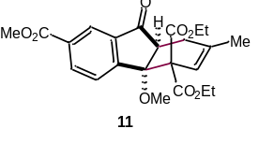
4,4-Diethyl 7-methyl (4aS,9aS)-4a-methoxy-2-methyl-9-oxo-1,4a,9,9a-tetrahydro-4H-fluorene-4,4,7-tricarboxylate (11): According to the general procedure in section 6.2, enone S7 (22 mg, 0.1 mmol), diene 2 (63.6 mg, 0.3 mmol) and Mg(ClO₄)₂ (2.2 mg, 0.01 mmol) in CH₃CN (2.0 mL) were used. The reaction mixture was irradiated for 3 h. Purification by flash chromatography on silica gel (petroleum ether/EtOAc = 8:1) provided the product as colorless oil (36.5 mg, 85%). ¹H NMR (400 MHz, CDCl₃) δ 8.44 (br s, 1H), 8.26 (dd, J = 8.0 Hz, 1.6 Hz, 1H), 7.92 (d, J = 8.0 Hz, 1H), 6.00 (s, 1H), 4.46 - 4.35 (m, 2H), 3.95 (s, 3H), 3.85 - 3.75 (m, 2H), 3.16 - 3.12 (m, 1H), 3.04 (s, 3H), 2.76 - 2.72 (m, 1H), 2.60 - 2.53 (m, 1H), 1.90 (s, 3H), 1.37 (t, J = 7.2 Hz, 3H), 0.95 (t, J = 7.2 Hz, 3H); ¹³C NMR (100 MHz, CDCl₃) δ 201.4, 168.6, 167.1, 166.3, 153.0, 139.6, 137.4, 133.8, 131.8, 128.3, 123.6, 118.3, 85.8, 63.2, 62.0, 61.6, 52.6, 51.2, 48.5, 27.8, 23.8, 14.2, 13.7; HRMS (ESI+): calcd for C₂₃H₂₇O₈⁺ (M+H) 431.1700, found 431.1703.

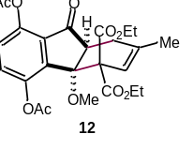
Diethyl-5,8-diacetoxy-4a-methoxy-2-methyl-9-oxo-1,4a,9,9a-tetrahydro-4H-fluorene-4,4-dicarboxylate (12): According to the general procedure in section 6.2, enone S8 (27.8 mg, 0.1 mmol), diene 2 (63.6 mg, 0.3 mmol) and Mg(ClO₄)₂ (2.2 mg, 0.01 mmol) in CH₃CN (2.0 mL) were used. The reaction mixture was irradiated for 3 h. Purification by flash chromatography on silica gel (petroleum ether/EtOAc = 8:1) provided the product as colorless oil (41 mg, 84%). ¹H NMR (400 MHz, CDCl₃) δ 7.27 (d, J =7.6 Hz, 1H), 7.14 (d, J = 8.4 Hz, 1H), 5.93 (br s, 1H), 4.51 - 4.45 (m, 1H), 4.12 - 4.09 (m, 1H), 3.96 - 3.90 (m, 2H), 3.22 - 3.18 (m, 1H), 3.03 (s, 3H), 2.57 - 2.52 (m, 1H), 2.47 - 2.45 (m, 1H), 2.40 (s, 3H), 2.27 (s, 3H), 1.86 (s, 3H), 1.18 (t, J = 7.2 Hz, 3H), 1.03 (t, J = 7.2 Hz, 3H); ¹³C NMR (150 MHz, CDCl₃) δ 197.5, 169.1, 169.1, 168.8, 166.6, 145.8, 143.9, 139.6, 136.6, 132.7, 129.5, 124.6, 119.9, 87.2, 61.8, 61.4, 61.3, 51.9, 48.1, 27.4, 23.4, 21.2, 21.0, 13.9, 13.9; HRMS (ESI+): calcd for C₂₅H₂₉O₁₀⁺ (M+H) 489.1755, found 489.1756.
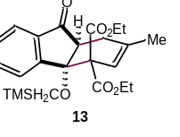
Diethyl-2-methyl-9-oxo-4a-((trimethylsilyl)methoxy)-1,4a,9,9a-tetrahydro-4H-fluorene-4,4-dicarboxylate (13): According to the general procedure in section 6.2, enone S9 (23.4 mg, 0.1 mmol), diene 2 (63.6 mg, 0.3 mmol) and Mg(ClO₄)₂ (2.2 mg, 0.01 mmol) in CH₃CN (2.0 mL) were used. The reaction mixture was irradiated for 3 h. Purification by flash chromatography on silica gel (petroleum ether/EtOAc = 8:1) provided the product as colorless oil (38.1 mg, 86%). ¹H NMR (600 MHz, CDCl₃) δ 7.81 (d, J =7.8 Hz, 1H), 7.76 (d, J = 7.2 Hz, 1H), 7.57 (t, J = 7.2 Hz, 1H), 7.45 (t, J = 7.2 Hz, 1H), 5.95 (s, 1H), 4.33 (q, J = 7.2 Hz, 2H), 3.82 - 3.74 (m, 2H), 3.15 - 3.12 (m, 1H), 2.73 - 2.69 (m, 2H), 2.50 - 2.46 (m, 2H), 1.85 (s, 3H), 1.36 (t, J = 7.2 Hz, 3H), 0.93 (t, J = 7.2 Hz, 3H), 0.04 (s, 9H); ¹³C NMR (100 MHz, CDCl₃) δ 203.2, 168.7, 167.7, 149.4, 139.4, 136.0, 132.9, 129.4, 128.3, 122.0, 118.9, 86.9, 63.7, 61.5, 61.3, 54.4, 47.7, 27.8, 23.6, 14.1, 13.7, -3.1; HRMS (ESI+): calcd for C₂₄H₃₃O₆Si⁺ (M+H) 445.2041, found 445.2042.

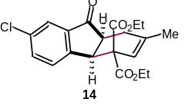
Diethyl-7-chloro-2-methyl-9-oxo-1,4a,9,9a-tetrahydro-4H-fluorene-4,4-dicarboxylate (14): According to the general procedure in section 6.2, enone S10 (16.4 mg, 0.1 mmol), diene 2 (63.6 mg, 0.3 mmol) and Mg(ClO₄)₂ (2.2 mg, 0.01 mmol) in CH₃CN (2.0 mL) were used. The reaction mixture was irradiated for 12 h. Purification by flash chromatography on silica gel (petroleum ether/EtOAc = 8:1) provided the product as a white solid (19.6 mg, 52%). ¹H NMR (600 MHz, CDCl₃) δ 7.67 (d, J = 1.8 Hz, 1H), 7.49 (dd, J = 8.4 Hz, 1.8 Hz, 1H), 7.37 (d, J = 7.8 Hz, 1H), 5.72 (s, 1H), 4.49 (d, J = 7.8 Hz, 1H), 4.31 - 4.26 (m, 1H), 4.23 - 4.18 (m, 1H), 4.15 - 4.10 (m, 1H), 4.09 - 4.03 (m, 1H), 3.15 (td, J = 7.8 Hz, 3.0 Hz, 1H), 2.64 (dd, J = 16.2 Hz, 3.0 Hz, 1H), 2.40 - 2.36 (m, 1H), 1.76 (s, 3H), 1.27 (t, J = 7.2 Hz, 3H), 1.19 (t, J = 7.2 Hz, 3H); ¹³C NMR (100 MHz, CDCl₃) δ 206.0, 169.6, 169.5, 151.1, 140.1, 139.5, 135.1, 134.5, 128.4, 123.4, 118.5, 62.1, 61.9, 59.4, 46.8, 42.9, 29.0, 24.1, 14.1, 13.9; HRMS (ESI+): calcd for C₂₀H₂₂ClO₅⁺ (M+H) 377.1150, found 377.1151.

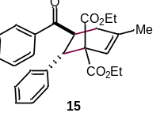
Diethyl-6-benzoyl-4-methyl-5,6-dihydro-[1,1'-biphenyl]-2,2(1H)-dicarboxylate (15): According to the general procedure in section 6.2, enone S11 (20.8 mg, 0.1 mmol), diene 2 (63.6 mg, 0.3 mmol) and Cu(ClO₄)₂ (3.7 mg, 0.01mmol) in CH₃CN (2.0 mL) were used. The reaction mixture was irradiated for 12 h. Purification by flash chromatography on silica gel (petroleum ether/EtOAc = 8:1) provided the product as a colorless oil (24.7 mg, 58%). ¹H NMR (400 MHz, CDCl₃) δ 7.90 (d, J = 7.2 Hz, 2H), 7.53 (t, J = 7.2 Hz, 1H), 7.43 (t, J = 7.2 Hz, 2H), 7.29 - 7.27 (m, 2H), 7.12 - 7.07 (m, 3H), 5.72 (d, J = 1.6 Hz, 1H), 4.56 - 4.50 (m, 1H), 4.16 - 4.09 (m, 3H), 3.97 - 3.89 (m, 1H), 3.70 - 3.62 (m, 1H), 2.30 (d, J = 7.2 Hz, 2H), 1.87 (s, 3H), 1.15 (t, J = 7.2 Hz, 3H), 0.85 (t, J = 7.2 Hz, 3H); ¹³C NMR (100 MHz, CDCl₃) δ 202.1, 170.4, 170.3, 140.3, 138.0, 137.1, 133.1, 129.2, 128.7, 128.3, 127.9, 126.9, 119.6, 61.6, 61.3, 60.9, 45.4, 43.4, 33.6, 23.9, 14.0, 13.6; HRMS (ESI+): calcd for C₂₆H₂₉O₅⁺ (M+H) 421.2010, found 421.2010.

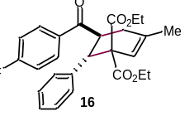
Diethyl-6-(4-fluorobenzoyl)-4-methyl-5,6-dihydro-[1,1'-biphenyl]-2,2(1H)-dicarboxylate (16): According to the general procedure in section 6.2, enone S12 (22.6 mg, 0.1 mmol), diene 2 (63.6 mg, 0.3 mmol) and Cu(ClO₄)₂ (3.7 mg, 0.01mmol) in CH₃CN (2.0 mL) were used. The reaction mixture was irradiated for 12 h. Purification by flash chromatography on silica gel (petroleum ether/EtOAc = 8:1) provided the product as a white solid (21.0 mg, 48%).¹H NMR (400 MHz, CDCl₃) δ 7.94 - 7.90 (m, 2H), 7.26 - 7.25 (m, 2H), 7.11 - 7.07 (m, 5H), 5.72 (d, J = 1.6 Hz, 1H), 4.49 - 4.43(m, 1H), 4.14 - 4.09 (m, 3H), 3.96 - 3.88 (m, 1H), 3.71 - 3.63 (m, 1H), 2.29 (d, J = 7.2 Hz, 2H), 1.87 (s, 3H), 1.15 (t, J = 7.2 Hz, 3H), 0.85 (t, J = 7.2 Hz, 3H); ¹⁹F NMR (376 MHz, CDCl₃) δ -105.5; ¹³C NMR (100 MHz, CDCl₃) δ 200.6, 170.4, 170.3, 167.0, 164.5, 140.2, 137.9, 133.5, 133.5, 131.0, 130.9, 129.1, 127.9, 127.0, 119.6, 115.9, 115.7, 61.6, 61.3, 60.7, 45.4, 43.4, 33.3, 23.9, 14.0, 13.6; HRMS (ESI+): calcd for C₂₆H₂₈FO₅⁺ (M+H) 439.1915, found 439.1913.
X-ray crystal structure data for compound 16
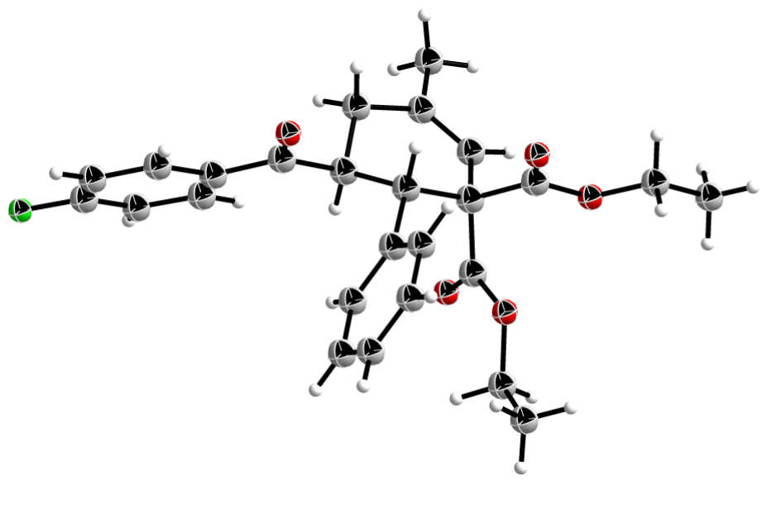
Identification code | xuzhezh_1208_auto
Empirical formula | C₂₆H₂₇FO₅
Formula weight | 438.47
Temperature/K | 300.2(2)
Crystal system | triclinic
Space group | P-1
a/Å | 8.4305(4)
b/Å | 11.5998(5)
c/Å | 12.7524(7)
α/° | 77.862(4)
β/° | 76.215(5)
γ/° | 82.863(4)
Volume/Å³ | 1180.48(10)
Z | 2
ρ_{calc}g/cm³ | 1.234
μ/mm⁻¹ | 0.090
F(000) | 464.0
Crystal size/mm³ | 0.15 × 0.13 × 0.12
Radiation | Mo Kα (λ = 0.71073)
2Θ range for data collection/° | 3.602 to 62.054
Index ranges | -10 ≤ h ≤ 10, -16 ≤ k ≤ 15, -17 ≤ l ≤ 15
Reflections collected | 16032
Independent reflections | 5788 [R_{int} = 0.0216, R_{sigma} = 0.0277]
Data/restraints/parameters | 5788/0/292
Goodness-of-fit on F² | 1.127
Final R indexes [I>=2σ (I)] | R₁ = 0.0470, wR₂ = 0.1376
Final R indexes [all data] | R₁ = 0.0717, wR₂ = 0.1496
Largest diff. peak/hole / e Å⁻³ | 0.18/-0.16

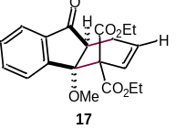
Diethyl-4a-methoxy-9-oxo-1,4a,9,9a-tetrahydro-4H-fluorene-4,4-dicarboxylate (17): According to the general procedure in section 6.2, enone 1 (16 mg, 0.1 mmol), diene S13 (59.4 mg, 0.3 mmol) and Mg(ClO₄)₂ (2.2 mg, 0.01 mmol) in CH₃CN (2.0 mL) were used. The reaction mixture was irradiated for 3 h. Purification by flash chromatography on silica gel (petroleum ether/EtOAc = 8:1) provided the product as a colorless oil (25.1 mg, 70%). ¹H NMR (400 MHz, CDCl₃) δ 7.87 (d, J = 7.6 Hz, 1H), 7.80 (d, J = 7.6 Hz, 1H), 7.61 (td, J = 7.6 Hz, 1.2 Hz, 1H), 7,49 (td, J = 7.6 Hz, 0.8 Hz, 1H), 6.33 - 6.30 (m, 1H), 6.18 - 6.13 (m, 1H), 4.46 - 4.35 (m, 2H), 3.83 - 3.74 (m, 2H), 3.08 - 3.06 (m, 1H), 3.04 (s, 3H), 2.77 - 2.73 (m, 2H), 1.37 (t, J = 7.2 Hz, 3H), 0.94 (t, J = 7.2 Hz, 3H); ¹³C NMR (150 MHz, CDCl₃) δ 202.4, 168.5, 167.1, 148.7, 139.3, 133.1, 129.8, 128.9, 128.2, 124.7, 122.3, 86.4, 63.1, 61.9, 61.6, 51.0, 47.3, 23.0, 14.1, 13.6; HRMS (ESI+): calcd for C₂₀H₂₃O₆⁺ (M+H) 359.1489, found 359.1495.
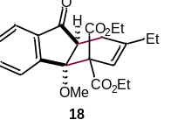
Diethyl-2-ethyl-4a-methoxy-1-methyl-9-oxo-1,4a,9,9a-tetrahydro-4H-fluorene-4,4-dicarboxylate (18): According to the general procedure in section 6.2, enone 1 (16 mg, 0.1 mmol), diene S14 (67.8 mg, 0.3 mmol) and Mg(ClO₄)₂ (2.2 mg, 0.01 mmol) in CH₃CN (2.0 mL) were used. The reaction mixture was irradiated for 3 h. Purification by flash chromatography on silica gel (petroleum ether/EtOAc = 8:1) provided the product as a colorless oil (30.1 mg, 78%). ¹HNMR (400 MHz, CDCl₃) δ 7.84 (d, J = 7.6 Hz, 1H), 7.77 (d, J = 7.6 Hz, 1H), 7.59 (t, J = 7.6 Hz, 1H), 7.47 (t, J = 7.6 Hz, 1H), 5.99 (s, 1H), 4.41 - 4.35 (m, 2H), 3.82 - 3.76 (m, 2H), 3.08 - 3.04 (m, 1H), 2.99 (s, 3H), 2.72 - 2.66 (m, 1H), 2.61 - 2.54 (m, 1H), 2.23 - 2.13 (m, 2H), 1.36 (t, J = 7.2 Hz, 3H), 1.06 (t, J = 7.2 Hz, 3H), 0.93 (t, J = 7.2 Hz, 3H); ¹³C NMR (100 MHz, CDCl₃) δ 203.0, 168.8, 167.2, 149.0, 142.7, 139.1, 133.2, 129.7, 128.0, 122.3, 117.3, 86.4, 63.2, 61.8, 61.3, 50.9, 48.2, 30.5, 26.8, 14.1, 13.6, 12.0; HRMS (ESI+): calcd for C₂₂H₂₇O₆⁺ (M+H) 387.1802, found 387.1802.

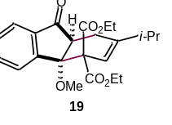
Diethyl-2-isopropyl-4a-methoxy-9-oxo-1,4a,9,9a-tetrahydro-4H-fluorene-4,4-dicarboxylate (19): According to the general procedure in section 6.2, enone 1 (16 mg, 0.1 mmol), diene S15 (72.0 mg, 0.3 mmol) and Mg(ClO₄)₂ (2.2 mg, 0.01 mmol) in CH₃CN (2.0 mL) were used. The reaction mixture was irradiated for 3 h. Purification by flash chromatography on silica gel (petroleum ether/EtOAc = 8:1) provided the product as a colorless oil (30.0 mg, 75%). ¹H NMR (400 MHz, CDCl₃) δ 7.83 (d, J = 8.0 Hz, 1H), 7.79 (d, J = 7.6 Hz, 1H), 7.60 (td, J = 7.6 Hz, 1.2 Hz, 1H), 7.49 (td, J = 7.6 Hz, 1.2 Hz, 1H), 6.04 - 6.03 (m, 1H), 4.45 - 4.35 (m, 2H), 3.86 - 3.80 (m, 2H), 3.05 - 3.01 (dd, J = 9.6 Hz, 6.4 Hz, 1H), 2.98 (s, 3H), 2.73 - 2.67 (m, 1H), 2.62 - 2.55 (m, 1H), 2.47 - 2.40 (m, 1H), 1.36 (t, J = 7.2 Hz, 3H), 1.08 (d, J = 4.8 Hz, 3H), 1.07 (d, J = 4.8 Hz, 3H), 0.97 (t, J = 7.2 Hz, 3H); ¹³C NMR (100 MHz, CDCl3) δ 203.5, 168.8, 167.2, 149.6, 146.6, 139.1, 133.4, 129.7, 128.0, 122.4, 117.2, 86.8, 63.2, 61.8, 61.3, 51.2, 48.7, 35.2, 25.1, 21.0, 20.9, 14.1, 13.8; HRMS (ESI+): calcd for C₂₃H₂₉O₆⁺ (M+H) 401.1959, found 401.1964.

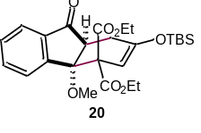
Diethyl-2-((tert-butyldimethylsilyl)oxy)-4a-methoxy-9-oxo-1,4a,9,9a-tetrahydro-4H-fluorene-4,4-dicarboxylate (20): According to the general procedure in section 6.2, enone 1 (16 mg, 0.1 mmol), diene S16 (98.4 mg, 0.3mmol) and Mg(ClO₄)₂ (2.2 mg, 0.01 mmol) in CH₃CN (2.0 mL) were used. The reaction mixture was irradiated for 3 h. Purification by flash chromatography on silica gel (petroleum ether/EtOAc = 8:1) provided the product as a colorless oil (34.2 mg, 70%). ¹H NMR (400 MHz, CDCl₃) δ 7.86 (d, J = 8.0 Hz, 1H), 7.78 (d, J = 7.6 Hz, 1H), 7.60 (td, J = 7.6 Hz, 1.2 Hz, 1H), 7.48 (t, J = 7.6 Hz, 1H), 5.42 (d, J = 2.4 Hz, 1H), 4.44 - 4.32 (m, 2H), 3.83 - 3.73 (m, 2H), 3.25 - 3.21 (m, 1H), 3.08 (s, 3H), 2.88 - 2.82 (m, 1H), 2.61 - 2.53 (m, 1H), 1.36 (t, J = 7.2 Hz, 3H), 0.96 (t, J = 7.2 Hz, 3H), 0.93 (s, 9H), 0.19 (s, 3H), 0.14 (s, 3H); ¹³C NMR (100 MHz, CDCl₃) δ 202.0, 168.6, 168.0, 152.7, 148.6, 138.9, 133.2, 129.8, 128.3, 122.2, 101.9, 85.8, 63.0, 61.8, 61.5, 51.1, 49.1, 27.7, 25.7, 18.2, 14.1, 13.8, -4.1, -4.5; HRMS (ESI+): calcd for C₂₆H₃₇O₇Si⁺ (M+H) 489.2307, found 489.2303.

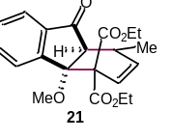
Diethyl-4a-methoxy-1-methyl-9-oxo-1,4a,9,9a-tetrahydro-4H-fluorene-4,4-dicarboxylate (21): According to the general procedure in section 6.2, enone 1 (16 mg, 0.1 mmol), diene S17 (63.6 mg, 0.3 mmol) and Mg(ClO₄)₂ (2.2 mg, 0.01 mmol) in CH₃CN (2.0 mL) were used. The reaction mixture was irradiated for 3 h. Purification by flash chromatography on silica gel (petroleum ether/EtOAc = 8:1) provided the product as a white solid (27.2 mg, 73%). ¹H NMR (400 MHz, CDCl₃) δ 7.82-7.79 (m, 2H), 7.60 (td, J = 7.6 Hz, 1.2 Hz, 1H), 7.49 (td, J = 7.6 Hz, 1.2 Hz, 1H), 6.31 (dd, J = 9.6 Hz, 3.2 Hz, 1H), 5.94 (dd, J = 9.6 Hz, 2.4 Hz, 1H), 4.47 - 4.35 (m, 2H), 3.83 - 3.77 (m, 2H), 3.01 (s, 3H), 2.90 - 2.85 (m, 1H), 2.62 (d, J = 5.6 Hz, 1H), 1.42 (d, J = 7.2 Hz, 3H), 1.37 (t, J = 7.2 Hz, 3H), 0.95 (t, J = 7.2 Hz, 3H); ¹³C NMR (100 MHz, CDCl₃) δ 202.3, 168.6, 166.7, 148.2, 139.5, 136.0, 133.0, 129.8, 128.1, 123.9, 122.3, 86.8, 62.8, 61.9, 61.6, 55.5, 50.8, 29.5, 23.2, 14.2, 13.7; HRMS (ESI+): calcd for C₂₁H₂₅O₆⁺ (M+H) 373.1646, found 373.1649.

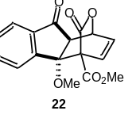
Methyl-4a-methoxy-9,10-dioxo-1,4a,9,9a-tetrahydro-4H-1,4-(epoxymethano)fluorene-4-carboxylate (22): According to the general procedure in section 6.2, enone 1 (16 mg, 0.1 mmol), S18 (46.2 mg, 0.3 mmol) and Mg(ClO₄)₂ (2.2 mg, 0.01 mmol) in CH₃CN (2.0 mL) were used. The reaction mixture was irradiated for 12 h. Purification by flash chromatography on silica gel (petroleum ether/EtOAc = 8:1) provided the product as a white solid (20.4 mg, 65%). ¹H NMR (600 MHz, CDCl₃) δ 8.24 (d, J = 8.4 Hz, 1H), 7.79 (d, J = 7.8 Hz, 1H), 7.75 (t, J = 7.8 Hz, 1H), 7.57 (t, J = 7.8 Hz, 1H), 6.97 (d, J = 7.8 Hz, 1H), 6.74 - 6.72 (m, 1H), 5.63 - 5.62 (m, 1H), 3.95 (s, 3H), 3.02 (br s, 1H), 2.95 (s, 3H); ¹³C NMR (100 MHz, CDCl₃) δ 198.1, 166.8, 166.1, 148.5, 139.2, 135.5, 133.9, 131.3, 130.2, 129.7, 123.7, 87.1, 75.3, 64.3, 55.5, 53.1, 52.1; HRMS (ESI+): calcd for C₁₇H₁₄O₆Na⁺ (M+Na) 337.0683, found 337.0682.
X-ray crystal structure data for compound 22
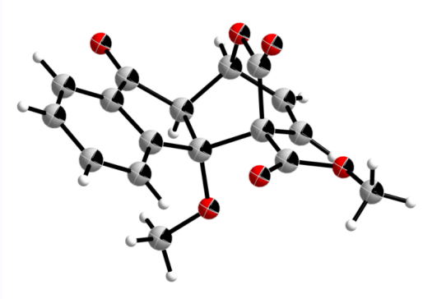

Identification code | xuzhezhe-hah_0719_auto
Empirical formula | C₁₇H₁₄O₆
Formula weight | 314.28
Temperature/K | 275.57(10)
Crystal system | orthorhombic
Space group | Pbca
a/Å | 14.1022(2)
b/Å | 13.5905(2)
c/Å | 15.1955(2)
α/° | 90
β/° | 90
γ/° | 90
Volume/Å³ | 2912.31(7)
Z | 8
ρ_{calc}g/cm³ | 1.434
μ/mm⁻¹ | 0.923
F(000) | 1312.0
Crystal size/mm³ | 0.15 × 0.12 × 0.08
Radiation | Cu Kα (λ = 1.54184)
2Θ range for data collection/° | 10.754 to 153.984
Index ranges | -17 ≤ h ≤ 8, -16 ≤ k ≤ 14, -18 ≤ l ≤ 18
Reflections collected | 9424
Independent reflections | 2898 [R_{int} = 0.0250, R_{sigma} = 0.0213]
Data/restraints/parameters | 2898/0/210
Goodness-of-fit on F² | 1.036
Final R indexes [I>=2σ (I)] | R₁ = 0.0460, wR₂ = 0.1250
Final R indexes [all data] | R₁ = 0.0499, wR₂ = 0.1293
Largest diff. peak/hole / e Å⁻³ | 0.22/-0.27

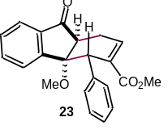
Methyl-4a-methoxy-9-oxo-4-phenyl-4,4a,9,9a-tetrahydro-1H-fluorene-3-carboxylate (23): According to the general procedure in section 6.2, enone 1 (16 mg, 0.1 mmol), S19 (60.6 mg, 0.3 mmol) and Mg(ClO₄)₂ (2.2 mg, 0.01 mmol) in CH₃CN (2.0 mL) were used. The reaction mixture was irradiated for 12 h. Purification by flash chromatography on silica gel (petroleum ether/EtOAc = 8:1) provided the product as a white solid (27.2 mg, 78%). ¹H NMR (400 MHz, CDCl₃) δ 7.78 - 7.74 (m, 2H), 7.70 (td, J = 7.6 Hz, 0.8 Hz, 1H), 7.50 (td, J = 7.6 Hz, 1.2 Hz, 1H), 7.43 - 7.41 (m, 2H), 7.34 - 7.30 (m, 2H), 7.27 - 7.25 (m, 1H), 6.95 - 6.93 (m, 1H), 5.00 (s, 1H), 3.60 (s, 3H), 3.24 - 3.21 (m, 1H), 3.07 - 2.99 (m, 1H), 2.89 (s, 3H), 2.73 - 2.66 (m, 1H); ¹³C NMR (100 MHz, CDCl₃) δ 206.0, 166.1, 154.1, 138.7, 138.2, 137.5, 135.3, 133.8, 129.9, 129.5, 128.2, 126.9, 124.8, 124.0, 84.0, 52.0, 51.1, 50.3, 45.9, 27.6; HRMS (ESI+): calcd for C₂₂H₂₁O₄⁺ (M+H) 349.1439, found 349.1434.
X-ray crystal structure data for compound 23
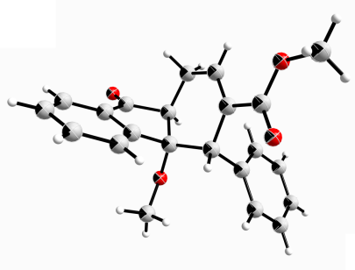
Identification code | xuzhezhe_1102_auto
Empirical formula | C₂₂H₂₀O₄
Formula weight | 348.38
Temperature/K | 300.20(10)
Crystal system | orthorhombic
Space group | Pbca
a/Å | 7.97520(10)
b/Å | 20.1364(3)
c/Å | 21.7081(4)
α/° | 90
β/° | 90
γ/° | 90
Volume/Å3 | 3486.14(9)
Z | 8
ρcalcg/cm3 | 1.328
μ/mm-1 | 0.736
F(000) | 1472.0
Crystal size/mm3 | 0.13 × 0.11 × 0.02
Radiation | Cu Kα (λ = 1.54184)
2Θ range for data collection/° | 8.146 to 156.308
Index ranges | -10 ≤ h ≤ 6, -25 ≤ k ≤ 20, -26 ≤ l ≤ 26
Reflections collected | 12943
Independent reflections | 3523 [Rint = 0.0617, Rsigma = 0.0493]
Data/restraints/parameters | 3523/0/237
Goodness-of-fit on F2 | 1.043
Final R indexes [I>=2σ (I)] | R1 = 0.0531, wR2 = 0.1455
Final R indexes [all data] | R1 = 0.0612, wR2 = 0.1513
Largest diff. peak/hole / e Å-3 | 0.18/-0.21

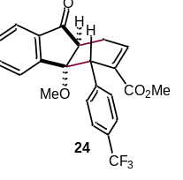
Methyl-4a-methoxy-9-oxo-4-(4-(trifluoromethyl)phenyl)-4,4a,9,9a-tetrahydro-1H-fluorene-3-carboxylate (24): According to the general procedure in section 6.2, enone 1 (16 mg, 0.1 mmol), S20 (76.8 mg, 0.3 mmol) and Mg(ClO₄)₂ (2.2 mg, 0.01 mmol) in CH₃CN (2.0 mL) were used. The reaction mixture was irradiated for 12 h. Purification by flash chromatography on silica gel (petroleum ether/EtOAc = 4:1) provided the product as a white solid (25.6 mg, 70%). ¹H NMR (400 MHz, CDCl₃) δ 7.78 (d, J = 7.6 Hz, 1H), 7.72 (d, J = 3.6 Hz, 2H), 7.58 - 7.51 (m, 5H), 7.02 - 6.99 (m, 1H), 4.99 (s, 1H), 3.60 (s, 3H), 3.22 - 3.19 (m, 1H), 2.99 - 2.92 (m, 1H), 2.88 (s, 3H), 2.81 - 2.74 (m, 1H); ¹⁹F NMR (376 MHz, CDCl₃) δ -62.5; ¹³C NMR (100 MHz, CDCl₃) δ 205.3, 165.9, 153.8, 142.3, 139.4, 137.5, 135.5, 133.2, 130.1, 130.1, 129.9, 129.9, 129.3, 128.9, 125.1, 125.0, 124.8, 124.0, 83.8, 52.1, 51.2, 49.7, 46.6, 27.2; HRMS (ESI+): calcd for C₂₃H₂₀F₃O₄⁺ (M+H) 417.1308, found 417.1313.

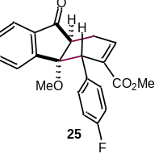
Methyl-4-(4-fluorophenyl)-4a-methoxy-9-oxo-4,4a,9,9a-tetrahydro-1H-fluorene-3-carboxylate (25): According to the general procedure in section 6.2, enone 1 (16 mg, 0.1 mmol), S21 (61.8 mg, 0.3 mmol) and Mg(ClO₄)₂ (2.2 mg, 0.01 mmol) in CH₃CN (2.0 mL) were used. The reaction mixture was irradiated for 12 h. Purification by flash chromatography on silica gel (petroleum ether/EtOAc = 4:1) provided the product as a white solid (27.0 mg, 65%). ¹H NMR (600 MHz, CDCl₃) δ 7.77 (d, J = 7.8 Hz, 1H), 7.70 (br s, 2H), 7.50 (br s, 1H), 7.38 - 7.36 (m, 2H), 7.00 (t, J = 8.4 Hz, 2H), 6.96 - 6.95 (m, 1H), 4.92 (s, 1H), 3.60 (s, 3H), 3.18 (d, J = 9.6 Hz, 1H), 2.98 - 2.93 (m, 1H), 2.88 (s, 3H), 2.75 - 2.70 (m, 1H); ¹⁹F NMR (564 MHz, CDCl₃) δ -116.2; ¹³C NMR (150 MHz, CDCl₃) δ 205.6, 166.1, 162.7, 161.1, 154.0, 138.8, 137.5, 135.3, 133.8, 133.7, 133.7, 131.1, 131.0, 129.9, 124.8, 124.0, 115.1, 114.9, 83.8, 52.1, 51.1, 49.9, 45.7, 27.3; HRMS (ESI+): calcd for C₂₂H₂₀FO₄⁺ (M+H) 367.1337, found 367.1340.

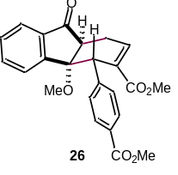
Dimethyl-1'-benzoyl-7-oxo-6-oxaspiro[bicyclo[3.2.1]octane-3,4'-piperidine]-8,8-dicarboxylate (26): According to the general procedure in section 6.2, enone 1 (16 mg, 0.1 mmol), S22 (73.8 mg, 0.3 mmol) and Mg(ClO₄)₂ (2.2 mg, 0.01 mmol) in CH₃CN (2.0 mL) were used. The reaction mixture was irradiated for 12 h. Purification by flash chromatography on silica gel (petroleum ether/EtOAc = 4:1) provided the product as a white solid (31.7 mg, 78%). ¹H NMR (600 MHz, CDCl₃) δ 7.98 (d, J = 8.4 Hz, 2H), 7.78 (d, J = 7.2 Hz, 1H), 7.71 (d, J = 2.4 Hz, 2H), 7.52 - 7.50 (m, 1H), 7.48 (d, J = 7.8 Hz, 2H), 6.99 (d, J = 6.6 Hz, 1H), 4.97 (s, 1H), 3.91 (s, 3H), 3.60 (s, 3H), 3.21 (d, J = 9.6 Hz, 1H), 3.00 - 2.95 (m, 1H), 2.88 (s, 3H), 2.79 - 2.74 (m, 1H); ¹³C NMR (150 MHz, CDCl₃) δ 205.4, 167.1, 166.0, 153.9, 143.6, 139.2, 137.5, 135.4, 133.3, 130.0, 129.6, 129.4, 128.8, 124.8, 124.0, 83.9, 52.2, 52.1, 51.1, 49.8, 46.8, 27.2; HRMS (ESI+): calcd for C₂₄H₂₃O₆⁺ (M+H) 407.1489, found 407.1494.

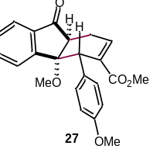
Methyl-4a-methoxy-4-(4-methoxyphenyl)-9-oxo-4,4a,9,9a-tetrahydro-1H-fluorene-3-carboxylate (27): According to the general procedure in section 6.2, enone 1 (16 mg, 0.1 mmol), S23 (65.4 mg, 0.3 mmol) and Mg(ClO₄)₂ (2.2 mg, 0.01 mmol) in CH₃CN (2.0 mL) were used. The reaction mixture was irradiated for 12 h. Purification by flash chromatography on silica gel (petroleum ether/EtOAc = 4:1) provided the product as a white solid (27.2 mg, 72%). ¹H NMR (600 MHz, CDCl₃) δ 7.77 (d, J = 7.2 Hz, 1H), 7.73 (d, J = 7.2 Hz, 1H), 7.69 (t, J = 7.2 Hz, 1H), 7.49 (t, J = 7.2 Hz, 1H), 7.33 (d, J = 9.0 Hz, 2H), 6.93 - 6.92 (m, 1H), 6.86 (d, J = 9.0 Hz, 2H), 4.93 (s, 1H), 3.80 (s, 3H), 3.60 (s, 3H), 3.19 - 3.17 (m, 1H), 3.03 - 2.97 (m, 1H), 2.89 (s, 3H), 2.70 - 2.66 (m, 1H); ¹³C NMR (100 MHz, CDCl₃) δ 206.1, 166.2, 158.5, 154.3, 138.4, 137.5, 135.2, 134.0, 130.5, 130.0, 129.8, 124.9, 124.0, 113.6, 84.0, 55.3, 52.0, 51.1, 50.2, 45.2, 27.5; HRMS (ESI+): calcd for C₂₃H₂₃O₅⁺ (M+H) 379.1540, found 379.1545.

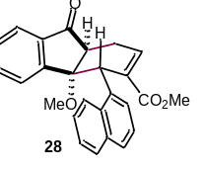
Methyl-4a-methoxy-4-(naphthalen-1-yl)-9-oxo-4,4a,9,9a-tetrahydro-1H-fluorene-3-carboxylate (28): According to the general procedure in section 6.2, enone 1 (16 mg, 0.1 mmol), S24 (71.4 mg, 0.3 mmol) and Mg(ClO₄)₂ (2.2 mg, 0.01 mmol) in CH₃CN (2.0 mL) were used. The reaction mixture was irradiated for 12 h. Purification by flash chromatography on silica gel (petroleum ether/EtOAc = 4:1) provided the product as a yellow solid (24.7 mg, 62%). ¹H NMR (600 MHz, CDCl₃) δ 8.47 (d, J = 9.0 Hz, 1H), 7.86 (d, J = 7.8 Hz, 2H), 7.82 (d, J = 7.8 Hz, 1H), 7.78 (d, J = 7.8 Hz, 1H), 7.73 (t, J = 7.2 Hz, 1H), 7.56 - 7.52 (m, 2H), 7.48 (t, J = 7.2 Hz, 1H), 7.43 (t, J = 7.8 Hz, 1H), 7.39 (d, J = 7.2 Hz, 1H), 7.11 - 7.10 (m, 1H), 5.69 (s, 1H), 3.47 (s, 3H), 3.25 - 3.20 (m, 2H), 2.85 - 2.81 (m, 1H), 2.70 (s, 3H); ¹³C NMR (150 MHz, CDCl₃) δ 205.4, 166.5, 154.6, 138.4, 137.3, 135.3, 134.7, 134.3, 134.2, 134.0, 129.9, 128.9, 128.0, 126.0, 125.8, 125.3, 125.1, 125.0, 124.8, 124.0, 84.4, 52.0, 51.3, 49.8, 42.4, 26.9; HRMS (ESI+): calcd for C₂₆H₂₃O₄⁺ (M+H) 399.1591, found 399.1596.

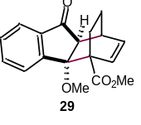
Methyl-4a-methoxy-9-oxo-1,4a,9,9a-tetrahydro-4H-1,4-ethano-fluorene-4-carboxylate (29): According to the general procedure in section 6.2, enone 1 (16 mg, 0.1 mmol), S25 (41.4 mg, 0.3 mmol) and Mg(ClO₄)₂ (2.2 mg, 0.01 mmol) in CH₃CN (2.0 mL) were used. The reaction mixture was irradiated for 12 h. Purification by flash chromatography on silica gel (petroleum ether/EtOAc = 8:1) provided the product as a white solid (26.5 mg, 89%). ¹H NMR (400 MHz, CDCl₃) δ 7.72 (d, J = 7.2 Hz, 1H), 7.64 (t, J = 7.2 Hz, 1H), 7.51 - 7.47 (m, 2H), 6.67 (d, J = 8.0 Hz, 1H), 6.45 (t, J = 7.2 Hz, 1H), 3.85 (s, 3H), 3.19 (s, 1H), 2.76 (s, 3H), 2.59 (s, 1H), 1.39 - 1.30 (m, 2H), 1.25 - 1.19 (m, 1H), 1.13 - 1.08 (m, 1H); ¹³C NMR (100 MHz, CDCl₃) δ 204.7, 173.5, 151.1, 138.5, 134.6, 133.2, 132.6, 130.2, 127.3, 123.1, 90.6, 54.3, 52.7, 52.2, 50.7, 34.2, 25.1, 20.6; HRMS (ESI+): calcd for C₁₈H₁₉O₄⁺ (M+H) 299.1278, found 299.1278.

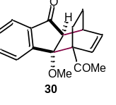
4-Acetyl-4a-methoxy-1,4,4a,9a-tetrahydro-9H-1,4-ethanofluoren-9-one (30): According to the general procedure in section 6.2, enone 1 (16 mg, 0.1 mmol), S26 (36.6 mg, 0.3 mmol) and Mg(ClO₄)₂ (2.2 mg, 0.01 mmol) in CH₃CN (2.0 mL) were used. The reaction mixture was irradiated for 12 h. Purification by flash chromatography on silica gel (petroleum ether/EtOAc = 8:1) provided the product as a white solid (17.8 mg, 63%). ¹H NMR (400 MHz, CDCl₃) δ 7.74 (d, J = 8.0 Hz, 1H), 7.63 (td, J = 7.6 Hz, 1.2 Hz, 1H), 7.50 (td, J = 8.0 Hz, 1.2 Hz, 1H), 7.27 - 7.25 (m, 1H), 6.60 - 6.54 (m, 2H), 3.24 - 3.23 (m, 1H), 2.79 (s, 3H), 2.62 (s, 3H), 2.61 - 2.60 (m, 1H), 1.42 - 1.36 (m, 1H), 1.26 - 1.21 (m, 1H), 1.11 - 1.07 (m, 2H); ¹³C NMR (100 MHz, CDCl₃) δ 211.5, 204.9, 151.0, 138.5, 135.0, 133.6, 132.9, 130.3, 126.5, 123.4, 91.1, 58.2, 54.1, 50.4, 34.6, 31.0, 23.9, 20.8; HRMS (ESI+): calcd for C₁₈H₁₉O₃⁺ (M+H) 283.1329, found 283.1330.

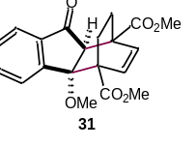
Dimethyl-4a-methoxy-9-oxo-9,9a-dihydro-1H-1,4-ethanofluorene-1,4(4aH)-dicarboxylate (31): According to the general procedure in section 6.2, enone 1 (16 mg, 0.1 mmol), S27 (58.8 mg, 0.3 mmol) and Mg(ClO₄)₂ (2.2 mg, 0.01 mmol) in CH₃CN (2.0 mL) were used. The reaction mixture was irradiated for 12 h. Purification by flash chromatography on silica gel (petroleum ether/EtOAc = 8:1) provided the product as a white solid (26.4 mg, 63%). ¹H NMR (400 MHz, CDCl₃) δ 7.75 (d, J = 7.6 Hz, 1H), 7.69 (td, J = 7.6 Hz, 1.2 Hz, 1H), 7.56 - 7.49 (m, 2H), 6.78 (d, J = 8.4 Hz, 1H), 6.34 (d, J = 8.0 Hz, 1H), 3.89 (s, 3H), 3.88 (s, 3H), 3.13 (d, J = 2.4 Hz, 1H), 2.85 (s, 3H), 1.73 - 1.66 (m, 1H), 1.55 - 1.47 (m, 1H), 1.44 - 1.29 (m, 2H); ¹³C NMR (100 MHz, CDCl₃) δ 202.2, 174.5, 172.9, 150.3, 138.3, 135.0, 133.3, 132.5, 130.6, 127.3, 123.4, 90.9, 56.6, 53.3, 52.6, 52.5, 51.0, 49.3, 25.0, 23.1; HRMS (ESI+): calcd for C₂₀H₂₁O₆⁺ (M+H) 357.1333, found 357.1329.

6.3 Compounds in the mechanistic experiments.
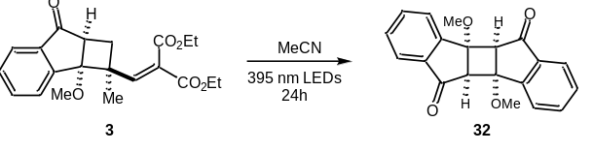
Synthesis of the dimer 32: the [2+2] cycloadduct 3 (74.4 mg, 0.2 mmol) in CH₃CN (4.0 mL) was irradiated under 395 nm LEDs for 24 h. The reaction mixture was concentrated under reduced pressure. Purification by flash chromatography on silica gel (petroleum ether/EtOAc = 8:1) provided 32 as a white solid (1.7 mg, 5%). ¹H NMR (400 MHz, CDCl₃) δ 7.56 - 7.55 (m, 4H), 7.30 - 7.22 (m, 4H), 3.77 (s, 2H), 3.18 (s, 6H); ¹³C NMR (100 MHz, CDCl₃) δ 200.3, 149.1, 139.6, 135.4, 130.1, 126.8, 123.1, 79.2, 57.0, 52.5; HRMS (ESI+): calcd for C₂₀H₁₇O₄⁺ (M+H) 321.1121, found 321.1120.
X-ray crystal structure data for compound 32
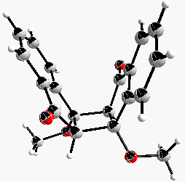
Identification code | xuzhezhe_0916-1_auto
Empirical formula | C₂₀H₁₆O₄
Formula weight | 320.33
Temperature/K | 274.2(5)
Crystal system | monoclinic
Space group | P2₁/n
a/Å | 12.65673(18)
b/Å | 9.85863(14)
c/Å | 12.96444(19)
α/° | 90
β/° | 99.3403(13)
γ/° | 90
Volume/Å³ | 1596.23(4)
Z | 4
ρ_{calc}g/cm³ | 1.333
μ/mm⁻¹ | 0.758
F(000) | 672.0
Crystal size/mm³ | 0.09 × 0.07 × 0.05
Radiation | Cu Kα (λ = 1.54184)
2Θ range for data collection/° | 9.058 to 151.844
Index ranges | -15 ≤ h ≤ 15, -12 ≤ k ≤ 10, -16 ≤ l ≤ 15
Reflections collected | 10525
Independent reflections | 3164 [R_{int} = 0.0257, R_{sigma} = 0.0221]
Data/restraints/parameters | 3164/0/219
Goodness-of-fit on F² | 1.046
Final R indexes [I>=2σ (I)] | R₁ = 0.0411, wR₂ = 0.1127
Final R indexes [all data] | R₁ = 0.0451, wR₂ = 0.1161
Largest diff. peak/hole / e Å⁻³ | 0.18/-0.17
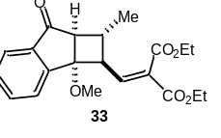
Synthesis of the cycloadduct 33: The [2+2] cycloadduct 3 (37.2 mg, 0.1 mmol) and S17 (21.2 mg, 0.1 mmol) in CH₃CN (2.0 mL) was irradiated under 395 nm LEDs for 24 h. The reaction mixture was concentrated under reduced pressure. Purification by flash chromatography on silica gel (petroleum ether/EtOAc = 8:1) provided 33 as a colorless oil (6.5 mg, 17%). ¹H NMR (400 MHz, CDCl₃) δ 7.84 (d, J = 7.2 Hz, 1H), 7.72 (t, J = 7.2 Hz, 1H), 7.57 - 7.54 (m, 2H), 6.46 (d, J = 10.4 Hz, 1H), 4.35 (q, J = 7.2 Hz, 2H), 4.19 (q, J = 7.2 Hz, 2H), 3.48 - 3.44 (m, 1H), 2.96 (s, 3H), 2.82 (d, J = 6.0 Hz, 1H), 1.80 - 1.71 (m, 1H), 1.39 - 1.35 (m, 6H), 1.24 (t, J = 7.2 Hz, 3H); ¹³C NMR (100 MHz, CDCl₃) δ 203.7, 165.2, 163.7, 149.4, 145.5, 138.8, 135.2, 130.3, 129.8, 127.2, 124.5, 82.3, 61.7, 61.6, 55.0, 51.5, 48.9, 34.4, 20.3, 14.3, 14.2; HRMS (ESI+): calcd for C₂₁H₂₅O₆⁺ (M+H) 373.1646, found 373.1649.

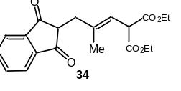
Synthesis of diethyl (E)-2-(3-(1,3-dioxo-2,3-dihydro-1H-inden-2-yl)-2-methylprop-1-en-1-yl)malonate (34): The [2+2] cycloadduct 3 (37.2 mg, 0.1 mmol), Mg(ClO₄)₂ (2.2 mg, 0.01 mmol) and p-TsOH•H₂O (0.4 mg, 0.02 mmol) in CH₃CN (2.0 mL) was stirred in dark for 3 h. The reaction mixture was concentrated under reduced pressure. Purification by flash chromatography on silica gel (petroleum ether/EtOAc = 8:1) provided 34 as a colorless oil (7.3 mg, 20%). ¹H NMR (400 MHz, CDCl₃) δ 7.94 - 7.92 (m, 2H), 7.83 - 7.80 (m, 2H), 5.55 (dd, J = 9.2 Hz, 1.2 Hz, 1H), 4.17 (s, 1H), 4.13 (q, J = 6.8 Hz, 4H), 3.16 (t, J = 6.4 Hz, 1H), 2.68 (d, J = 6.4 Hz, 2H), 1.70 (d, J = 1.2 Hz, 3H), 1.22 (t, J = 6.8 Hz, 6H); ¹³C NMR (100 MHz, CDCl₃) δ 199.7, 168.2, 142.3, 137.4, 135.7, 123.3, 119.7, 61.6, 52.3, 51.7, 36.5, 17.3, 14.1; HRMS (ESI+): calcd for C₂₀H₂₃O₆⁺ (M+H) 359.1489, found 359.1493.

6.4 Intermediates in the synthesis of lucidumone.

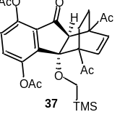
1,4-Diacetyl-9-oxo-4a-((trimethylsilyl)methoxy)-4,4a,9,9a-tetrahydro-1H-1,4-ethanofluorene-5,8-diyl diacetate (37): According to the general procedure in section 6.2, enone 35 (69.6 mg, 0.2 mmol), diene 36 (98.4 mg, 0.6 mmol) and Mg(ClO₄)₂ (4.4 mg, 0.02 mmol) in CH₃CN (4.0 mL) were used. The reaction mixture was irradiated for 24 h. Purification by flash chromatography on silica gel (petroleum ether/EtOAc = 4:1) provided the product as a white solid (84.1 mg, 86%, 2.5:1 dr). When scaled up, 35 (1.74 g, 5 mmol), diene 36 (2.43 g, 15 mmol), Mg(ClO₄)₂ (110 mg, 0.5 mmol) and CH₃CN (100 mL) was added to a 250 mL quartz glass apparatus. Then two balloons with argon were equipped and the reaction system was purged three times. The mixture was irradiated for 30 h before poured into a 250 mL flask. The solvent was removed in vacuo and the residue was further purified by flash chromatography to give the product (2.1 g, 82%, 2.3:1 dr).
The major isomer 37: ¹H NMR (400 MHz, CDCl₃) δ 7.44 (d, J = 8.4 Hz, 1H), 7.14 (d, J = 8.4 Hz, 1H), 6.59 (d, J = 8.4 Hz, 1H), 6.23 (d, J = 8.4 Hz, 1H), 3.11 - 3.09 (m, 1H), 2.68 (d, J = 12.4 Hz, 1H), 2.64 (s, 3H), 2.45 (d, J = 12.4 Hz, 1H), 2.36 (s, 6H), 2.33 (s, 3H), 1.77 - 1.70 (m, 1H), 1.52 - 1.42 (m, 2H), 1.33 - 1.29 (m, 1H), 0.01 (s, 9H). ¹³C NMR (100 MHz, CDCl₃) δ 209.5, 209.4, 199.1, 168.9, 168.5, 145.5, 144.5, 141.0, 133.7, 132.6, 131.3, 131.2, 124.9, 93.5, 58.8, 57.3, 55.3, 55.3, 31.2, 28.0, 24.0, 23.6, 21.9, 20.9, -2.9; HRMS (ESI+): calcd for C₂₇H₃₃O₈Si⁺ (M+H) 513.1939, found 513.1940.
The minor isomer 37’: ¹H NMR (400 MHz, CDCl₃) δ 7.44 (d, J = 8.4 Hz, 1H), 7.15 (d, J = 8.4 Hz, 1H), 6.60 (d, J = 10.4 Hz, 1H), 5.91 (d, J = 10.4 Hz, 1H), 3.63 (s, 1H), 2.84 (d, J = 12.0 Hz, 1H), 2.82-2.75 (m, 1H), 2.66 (d, J = 12.0 Hz, 1H), 2.49 (s, 3H), 2.39 (s, 3H), 2.35 (s, 3H), 2.08 (s, 3H), 2.07 - 2.02 (m, 1H), 1.56 - 1.44 (m, 2H), -0.03 (s, 9H); ¹³C NMR (100 MHz, CDCl₃) δ 211.1, 206.6, 200.5, 168.8, 168.5, 145.6, 145.6, 144.5, 131.6, 131.4, 129.7, 127.3, 124.5, 78.2, 58.2, 58.1, 56.6, 52.1, 29.6, 27.5, 27.2, 23.1, 21.3, 20.9, -3.1; HRMS (ESI+): calcd for C₂₇H₃₃O₈Si⁺ (M+H) 513.1939, found 513.1939.
X-ray crystal structure data for compound 37
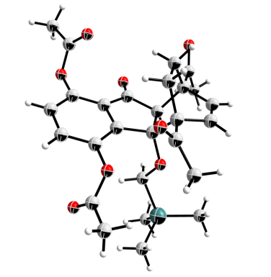
Identification code | xuzhezhe-hah_0606_auto
Empirical formula | C₂₇H₃₂O₈Si
Formula weight | 512.61
Temperature/K | 280.6(10)
Crystal system | monoclinic
Space group | P2₁/n
a/Å | 12.7149(2)
b/Å | 9.85080(10)
c/Å | 21.5836(2)
α/° | 90
β/° | 102.7190(10)
γ/° | 90
Volume/Å³ | 2637.05(6)
Z | 4
ρ_{calc}g/cm³ | 1.291
μ/mm⁻¹ | 1.191
F(000) | 1088.0
Crystal size/mm³ | 0.12 × 0.11 × 0.08
Radiation | Cu Kα (λ = 1.54184)
2Θ range for data collection/° | 7.434 to 151.868
Index ranges | -15 ≤ h ≤ 15, -12 ≤ k ≤ 4, -26 ≤ l ≤ 25
Reflections collected | 18156
Independent reflections | 5222 [R_{int} = 0.0207, R_{sigma} = 0.0186]
Data/restraints/parameters | 5222/0/332
Goodness-of-fit on F² | 1.063
Final R indexes [I>=2σ (I)] | R₁ = 0.0387, wR₂ = 0.1099
Final R indexes [all data] | R₁ = 0.0429, wR₂ = 0.1132
Largest diff. peak/hole / e Å⁻³ | 0.20/-0.17
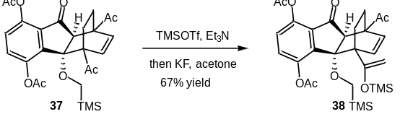
Synthesis of 1-acetyl-9-oxo-4a-((trimethylsilyl)methoxy)-4-(1-((trimethylsilyl)oxy)vinyl)-4,4a,9,9a-tetrahydro-1H-1,4-ethanofluorene-5,8-diyl diacetate (38): To a solution of ketone 37 (256 mg, 0.5 mmol) and Et₃N (0.21 mL, 1.5 mmol, 3.0 equiv.) in CH₂Cl₂ (10 mL) was added TMSOTf (0.28 mL, 1.5 mmol, 3.0 equiv.) at room temperature. The reaction mixture was stirred at room temperature for 1 h. The solvent was concentrated under reduced pressure. The resultant crude dienolsilyl ether was dissolved in acetone (5 mL) and KF (34.8 mg, 0.6 mmol, 1.2 equiv.) was added at room temperature. After stirring for 6 h, the reaction mixture was quenched with saturated aq. NH₄Cl and extracted with CH₂Cl₂. The combined organic layers were dried over anhydrous Na₂SO₄ and concentrated in vacuo. The residue was purified by flash column chromatography on silica gel (petroleum ether/EtOAc = 4:1) to afford enolsilyl ether 38 as a white solid (196 mg, 67%). ¹H NMR (400 MHz, CDCl₃) δ 7.52 (d, J = 8.8 Hz, 1H), 7.08 (d, J = 8.4 Hz, 1H), 6.40 (d, J = 8.4 Hz, 1H), 6.03 (d, J = 8.4 Hz, 1H), 4.47 (s, 1H), 4.37 (s, 1H), 3.15 (d, J = 2.4 Hz, 1H), 2.63 (d, J = 12.0 Hz, 1H), 2.49 (d, J = 12.0 Hz, 1H), 2.36 (s, 3H), 2.35 (s, 3H), 2.29 (s, 3H), 1.82 - 1.76 (m, 1H), 1.49 - 1.44 (m, 1H), 1.41 - 1.33 (m, 1H), 1.15 - 1.08 (m, 1H), 0.11 (s, 9H), -0.02 (s, 9H); ¹³C NMR (100 MHz, CDCl₃) δ 210.0, 200.0, 169.1, 168.9, 159.4, 146.7, 143.9, 142.4, 137.3, 131.2, 130.2, 130.0, 123.8, 93.9, 93.0, 56.7, 54.7, 54.4, 52.2, 27.7, 25.1, 25.0, 22.2, 21.0, 0.4, -2.9; HRMS (ESI+): calcd for C₃₀H₄₁O₈Si₂⁺ (M+H) 585.2334, found 585.2335.

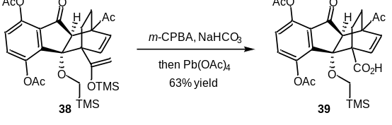
Synthesis of 5,8-diacetoxy-1-acetyl-9-oxo-4a-((trimethylsilyl)methoxy)-1,4a,9,9a-tetrahydro-4H-1,4-ethanofluorene-4-carboxylic acid (39): To a solution of enolsilyl ether 38 (117 mg, 0.2 mmol, 1.0 equiv.) in CH₂Cl₂ (4.0 mL) was added m-CPBA (48.5 mg, 0.24 mmol, 1.2 equiv.) and NaHCO₃ (42 mg, 0.5 mmol, 2.5 equiv.) at 0 °C. The reaction mixture was stirred at 0 °C for 2 h before p-TsOH•H₂O (1.0 M in MeOH, 0.3 mL, 0.3 mmol, 1.5 equiv.) was added, and the resultant mixture was stirred for 30 min. The solvent was removed under reduced pressure and the residue was dissolved in toluene, which was then added to a suspension of Pb(OAc)₄ (265.8 mg, 0.6 mmol, 3.0. equiv.) and K₂CO₃ (165.6 mg, 1.2 mmol, 6.0 equiv.) in toluene (4.0 mL) at 0 °C. The resultant mixture was warmed to room temperature and stirred for 6 h. The mixture was concentrated under reduced pressure and further purified by flash column chromatography on silica gel (petroleum ether/EtOAc = 4:1 to EtOAc) to give acid 39 as a white solid (65 mg, 63%). ¹H NMR (600 MHz, CDCl₃) δ 10.45 (br s, 1H), 7.50 (d, J = 8.4 Hz, 1H), 7.22 (d, J = 8.4 Hz, 1H), 6.39 (d, J = 8.4 Hz, 1H), 6.34 (d, J = 8.4 Hz, 1H), 2.94 (s, 1H), 2.82 (d, J = 12,6 Hz, 1H), 2.60 (d, J = 12.6 Hz, 1H), 2.46 (s, 3H), 2.37 (s, 3H), 2.35 (s, 3H), 1.86 - 1.81 (m, 1H), 1.60 - 1.52 (m, 2H), 1.41 - 1.37 (m, 1H), 0.03 (s, 9H); ¹³C NMR (150 MHz, CDCl₃) δ 208.7, 198.1, 173.6, 169.3, 168.8, 145.6, 144.7, 140.2, 134.2, 133.6, 131.8, 131.3, 125.9, 91.5, 58.8, 56.8, 55.0, 52.7, 28.1, 24.5, 22.1, 21.6, 20.9, -3.2.; HRMS (ESI+): calcd for C₂₆H₃₁O₉Si⁺ (M+H) 515.1732, found 515.1732.

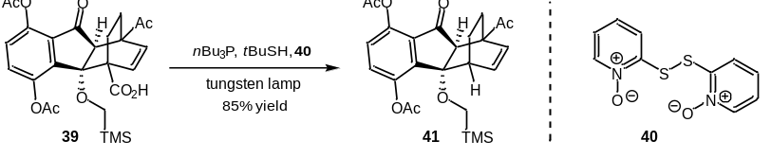
Synthesis of 1-acetyl-9-oxo-4a-((trimethylsilyl)methoxy)-4,4a,9,9a-tetrahydro-1H-1,4-ethanofluorene-5,8-diyl diacetate (40): To a solution of acid 39 (52 mg, 0.1 mmol, 1.0 equiv.) and 2,2′-dithiobis(pyridine 1-oxide) 40 (51 mg, 0.2 mmol, 2.0 equiv.) in dry THF (2.0 mL) was added tributylphosphane (54.8 μL, 0.22 mmol, 2.2 equiv.) dropwise at 0 °C in dark. The solution was stirred at room temperature for 2 h, forming a characteristic lemon-yellow color of the thiohydroxamic esters. Freshly distilled tert-butanethiol (57 μL, 0.5 mmol, 5.0 equiv.) was added to the solution, which was irradiated with a 100 W tungsten lamp for 30 min. Then CH₂Cl₂ was added (20 mL), and the solution was successively washed with saturated aq. NaHCO₃, water and brine. The combined organic layers were dried over anhydrous Na₂SO₄ and concentrated in vacuo. The residue was purified by flash column chromatography on silica gel (petroleum ether/EtOAc = 4:1) to afford decarboxylated product 41 as a white solid (40 mg, 85%). ¹H NMR (400 MHz, CDCl₃) δ 7.37 (d, J = 8.4 Hz, 1H), 7.12 (d, J = 8.4 Hz, 1H), 6.49 (dd, J = 8.4, 6.4 Hz, 1H), 6.07 (d, J = 8.4 Hz, 1H), 3.28 (br s, 1H), 2.92 (s, 1H), 2.62 (d, J = 12.0 Hz, 1H), 2.39 - 2.36 (m, 10H), 1.43 - 1.40 (m, 2H), 1.25 - 1.23 (m, 1H), 1.14 - 1.09 (m, 1H), -0.05 (s, 9H); ¹³C NMR (100 MHz, CDCl₃) δ 210.0, 200.4, 168.9, 168.9, 145.7, 145.5, 144.6, 135.5, 131.1, 131.1, 130.6, 124.4, 89.1, 57.4, 55.3, 54.7, 39.3, 27.8, 21.7, 21.5, 21.2, 20.9, -3.2; HRMS (ESI+): calcd for C₂₅H₃₁O₇Si⁺ (M+H) 471.1834, found 471.1834.

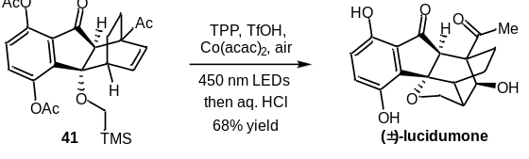
Synthesis of lucidumone: A solution of compound 41 (24 mg, 0.05 mmol, 1.0 equiv.), TPP (2.0 mg, 0.005 mmol, 0.1 equiv.), Co(acac)₂ (34 mg, 0.15 mmol, 3.0 equiv.) and CF₃SO₃H (13 μL, 0.15 mmol, 3.0 equiv.) in CH₃CN (1.0 mL) was irradiated with 450 nm blue LEDs (50 W, at approximately 10 cm away from the light source) under air atmosphere for 12 h. The LED was turned off and the reaction mixture was diluted with MeOH (2.0 mL). Then, aq. HCl (6.0 M solution, 33.3 μL) was added slowly into the solution. The reaction was stirred at 60 ºC for 3 h. The mixture was concentrated under reduced pressure and further purified by flash column chromatography on silica gel (petroleum ether/EtOAc = 1:1 to EtOAc) to afford the natural product (12 mg, 68%). ¹H NMR (600 MHz, CD₃OD) δ 7.01 (d, J = 8.4 Hz, 1H), 6.75 (d, J = 8.4 Hz, 1H), 4.25 (dd, J = 8.4 Hz, 4.8 Hz, 1H), 3.90 (s, 1H), 3.77 (d, J = 7.8 Hz, 1H), 2.88 (d, J = 1.8 Hz, 1H), 2.69 (q, J = 3.6 Hz, 1H), 2.35 (t, J = 4.2 Hz, 1H), 2.28 (s, 3H), 2.20 - 2.16 (m, 1H), 1.89 - 1.83 (m, 1H), 1.36 - 1.31 (m, 1H), 1.08 - 1.04 (m, 1H); ¹³C NMR (150 MHz, CD₃OD) δ 214.8, 204.2, 150.8, 149.5, 135.4, 126.4, 125.4, 118.6, 87.4, 79.5, 74.3, 62.3, 52.7, 49.1, 39.1, 28.5, 16.2, 15.8; HRMS (ESI+): calcd for C₁₈H₁₉O₆⁺ (M+H) 331.1174, found 331.1176.
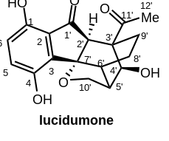

no. | ¹H NMR [δ (ppm), mult, J (Hz)] in MeOD |  |  | ¹³C NMR (δ, ppm) in MeOD
no. | Isolated  (600 MHz) | Synthesized  (600 MHz) | Δδ | Isolated  (150 MHz) | Synthesized  (150MHz) | Δδ
1 |  |  |  | 150.8  (misassigned,149.5) | 149.5 | 0.0
2 |  |  |  | 125.4 | 125.4 | 0.0
3 |  |  |  | 135.4 | 135.4 | 0.0
4 |  |  |  | 149.5  (misassigned,  150.8) | 150.8 | 0.0
5 | 7.01 d (8.7) | 7.01 d (8.4) | 0.00 | 126.4 | 126.4 | 0.0
6 | 6.75 d (8.7) | 6.75 d (8.4) | 0.00 | 118.6 | 118.6 | 0.0
1' |  |  |  | 204.2 | 204.2 | 0.0
2' | 2.88 d (2.2) | 2.88 d (1.8) | 0.00 | 62.3 | 62.3 | 0.0
3' |  |  |  | 52.7 | 52.7 | 0.0
4' | 3.90 brs | 3.90 s | 0.00 | 79.5 | 79.5 | 0.0
5' | 2.35 t-like (4.5) | 2.35 t (4.2) | 0.00 | 48.7 | 49.1 | 0.4
6' | 2.69 q-like (3.4) | 2.69 q (3.6) | 0.00 | 39.1 | 39.1 | 0.0
7' |  |  |  | 87.4 | 87.4 | 0.0
8' | Ha 1.86 m  Hb 1.06 m | Ha 1.89-1.83 m  Hb 1.08-1.04 m | 0.00  0.00 | 16.2 | 16.2 | 0.0
9' | Ha 2.17 m  Hb 1.33 m | Ha 2.20-2.16 m  Hb 1.36-1.31 m | 0.00  0.00 | 15.8 | 15.8 | 0.0
10' | Ha 4.25 dd (8.3, 4.9)  Hb 3.77 d (8.3) | Ha 4.25 dd (8.4, 4.8)  Hb 3.77 d (7.8) | 0.00  0.00 | 74.3 | 74.3 | 0.0
11' |  |  |  | 214.8 | 214.8 | 0.0
12' | 2.26 s | 2.28 s | 0.02 | 28.5 | 28.5 | 0.0
7 References
- I. Dissanayake, J. D. Hart, E. C. Becroft, C. J. Sumby, C. G. Newton, J. Am. Chem. Soc. 2020, 142, 13328-13333.
- O. Rousseau, T. Delaunay, R. Robiette, Synlett 2014, 25, 519-522.
- X.-W. Liang, Y. Zhao, X.-G. Si, M.-M. Xu, J.-H. Tan, Z.-M. Zhang, C.-G. Zheng, C. Zheng, Q. Cai, Angew. Chem. Int. Ed. 2019, 58, 14562-14567.
- R. Sun, W. Song, C. Ma, H. Zhang, X. Yu, Adv. Synth. Catal. 2016, 358, 3977-3982.

8 Spectra data

