Supplemental Material
Table S1. Sources of the antibodies used in this study.
Target of antibody | Source | Application | Dilution | Identifier
ALOX15 | Abcam | IB,IF,IP | 1:1000  1:100  1:50 | ab244205
PEBPE | Santa | IB,IP | 1:1000  1:50 | Sc-133085
P-PEBPE | Santa | IB,IP | 1:1000  1:50 | Sc-135779
β-actin | Cell Signaling Technology | IB | 1:1000 | 4967
ACSL4 | Zenbio | IB | 1:1000 | R24265
CD163 | Abcam | IF | 1:100 | ab182422
CD86 | Cell Signaling Technology | IF | 1:100 | 19589
LPCAT3 | Proteintech | IB | 1:1000 | 67822-1-lg
P53 | Zenbio | IB | 1:1000 | 345567
GPX4 | Zenbio | IB | 1:1000 | 381958
GAPDH | Cell Signaling Technology | IF | 1:1000 | 2118
SAT1 | Proteintech | IB | 1:1000 | 10708-1-AP
IL-4 | Proteintech | IB | 1:1000 | 66142-1-lg
PerCP/Cyanine 5.5 anti-mouse/human CD11b | Biolegend | F | 1:100 | 101227
APC anti-mouse Ly-6G | Biolegend | F | 1:100 | 127613
Brilliant Violet 605TM anti-mouse Ly-6C | Biolegend | F | 1:100 | 128035
IB: immunoblotting; IF: immunofluorescence;F:Flow Cytometry.

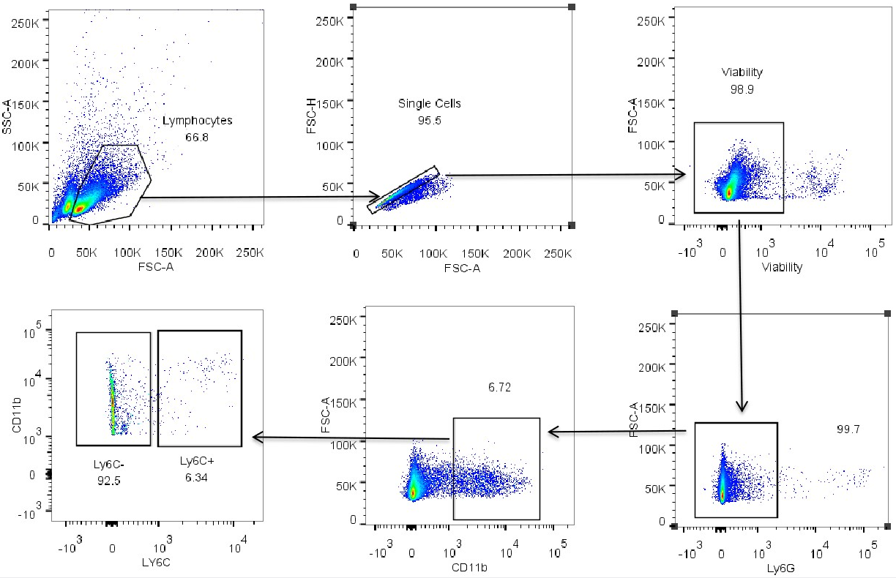
Fig. S1 Flow cytometry gating strategy was used to define inflammatory monocytes subset Ly6c+ in the spleen. The blood and bone marrow strategy is also the same.
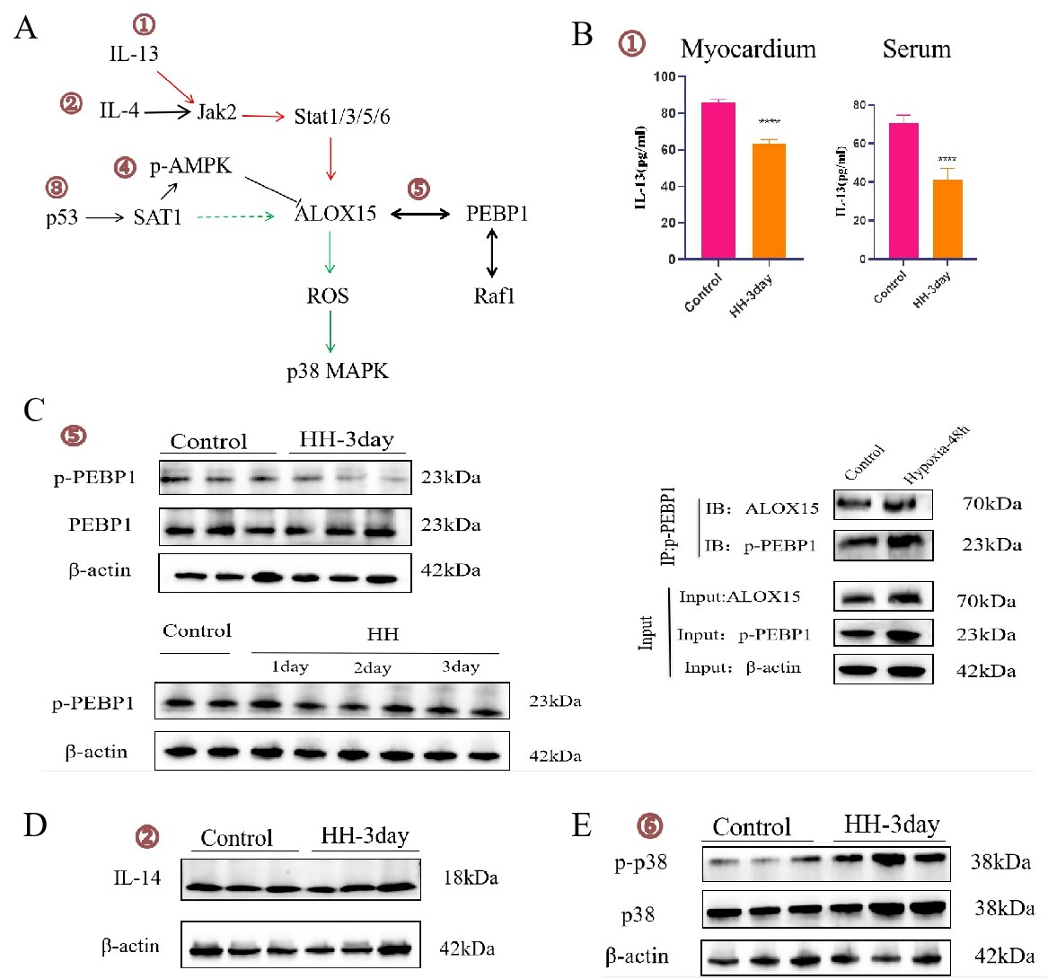
Fig. S2 A Upstream and downstream of ALOX15-related pathway diagrams. B The level of IL-13 in serum and myocardium. C p-PEBPE expression in HH1-3day and The binding of p-PEBP1 with ALOX15 that was examined by co-IP in HUVE cells after hypoxia exposure for 24. D and E Western blotting analysis of IL-4, p-38 and P38 expression in myocardium.

