Habitat use by nomadic ibis and spoonbills post-dispersal from breeding sites - Supplementary Information

Heather M. McGinness^{1*}, Luke R. Lloyd-Jones^{2*}, Freya Robinson³, Art Langston¹, Louis G. O’Neill¹, Shoshana Rapley^{1,9}, Micha V. Jackson¹, Jessica Hodgson¹, Melissa Piper⁴, Micah Davies¹, John M. Martin⁵, Richard Kingsford⁶, Kate Brandis⁶, Veronica Doerr¹, Ralph Mac Nally^{7,8}
*These authors are equal contributors to this work and designated as co-first authors.
¹CSIRO Environment, Canberra ACT 2601, Australia
²CSIRO Data61, Brisbane QLD 4102, Australia
³CSIRO Health and Biosecurity, Canberra ACT 2601, Australia
⁴CSIRO Agriculture, Canberra ACT 2601, Australia
⁵Royal Botanic Gardens Sydney NSW 2000, Australia
⁶ University of New South Wales, Sydney NSW 2052, Australia
⁷University of Canberra, Canberra ACT 2615, Australia
⁸ School of Biosciences, The University of Melbourne, Parkville 3052, Australia (http-//orcid.org/0000-0002-4473-1636)
⁹ Fenner School of Environment and Society, the Australian National University, Canberra ACT 2600

Supplementary Figures
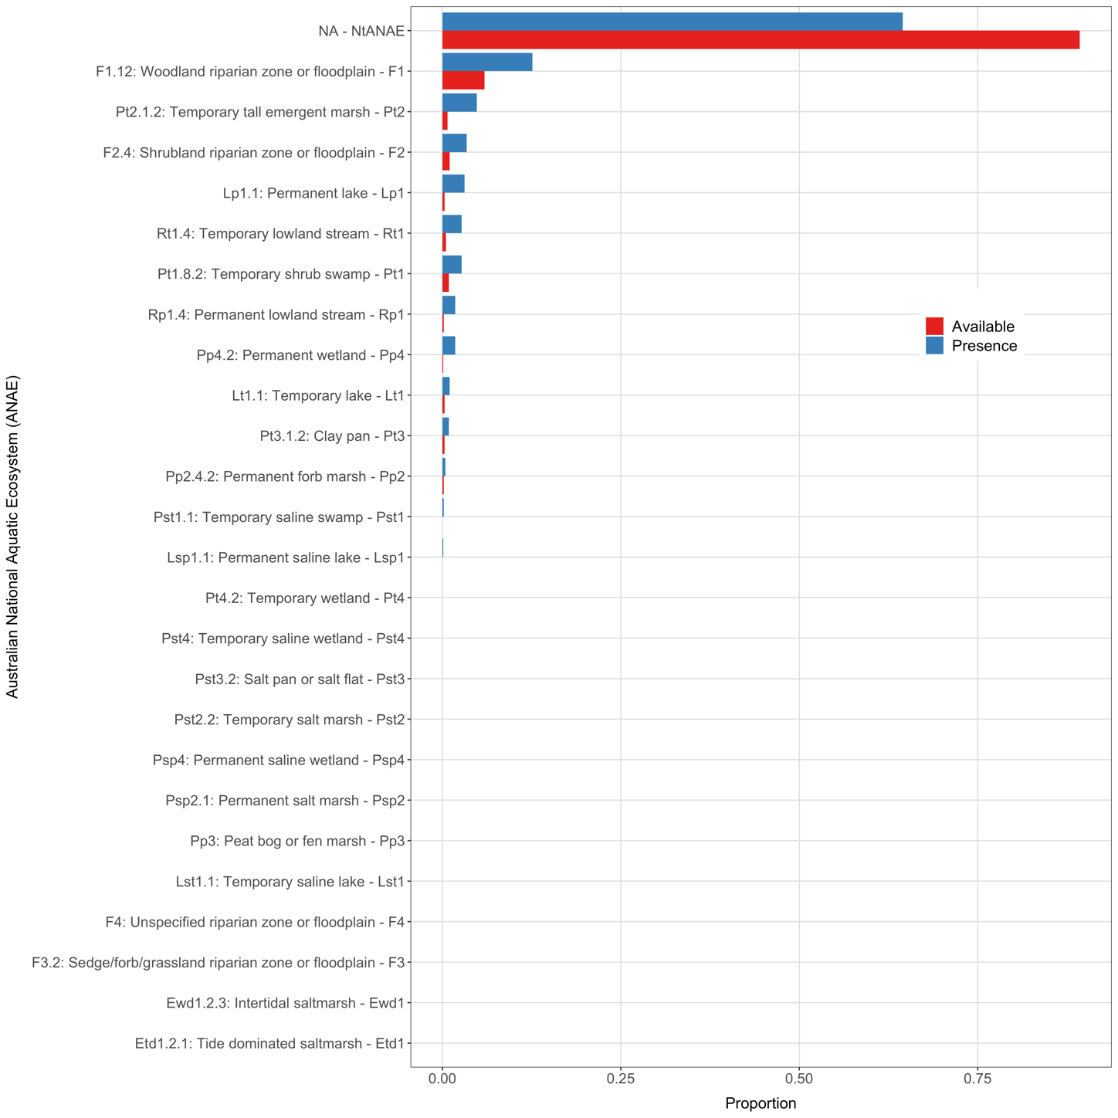
Supplementary Figure 1 Raw available and presence proportions for levels of ANAE covariate for straw-necked ibis.

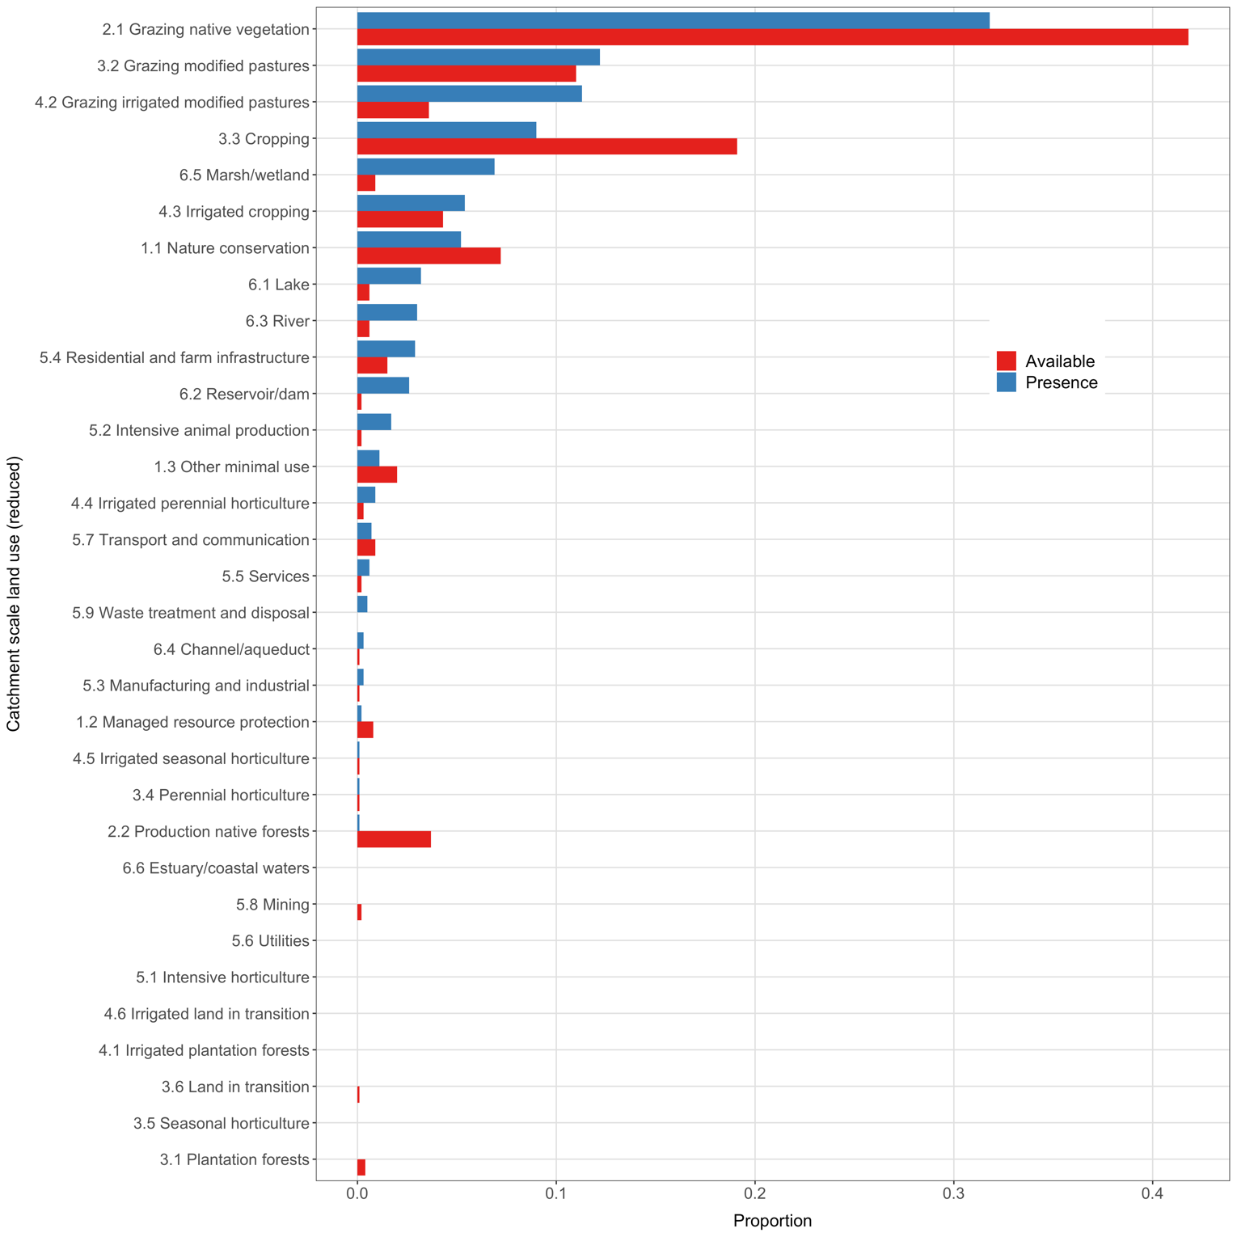
Supplementary Figure 2 Raw available and presence proportions for levels of CLUM covariate for straw-necked ibis.

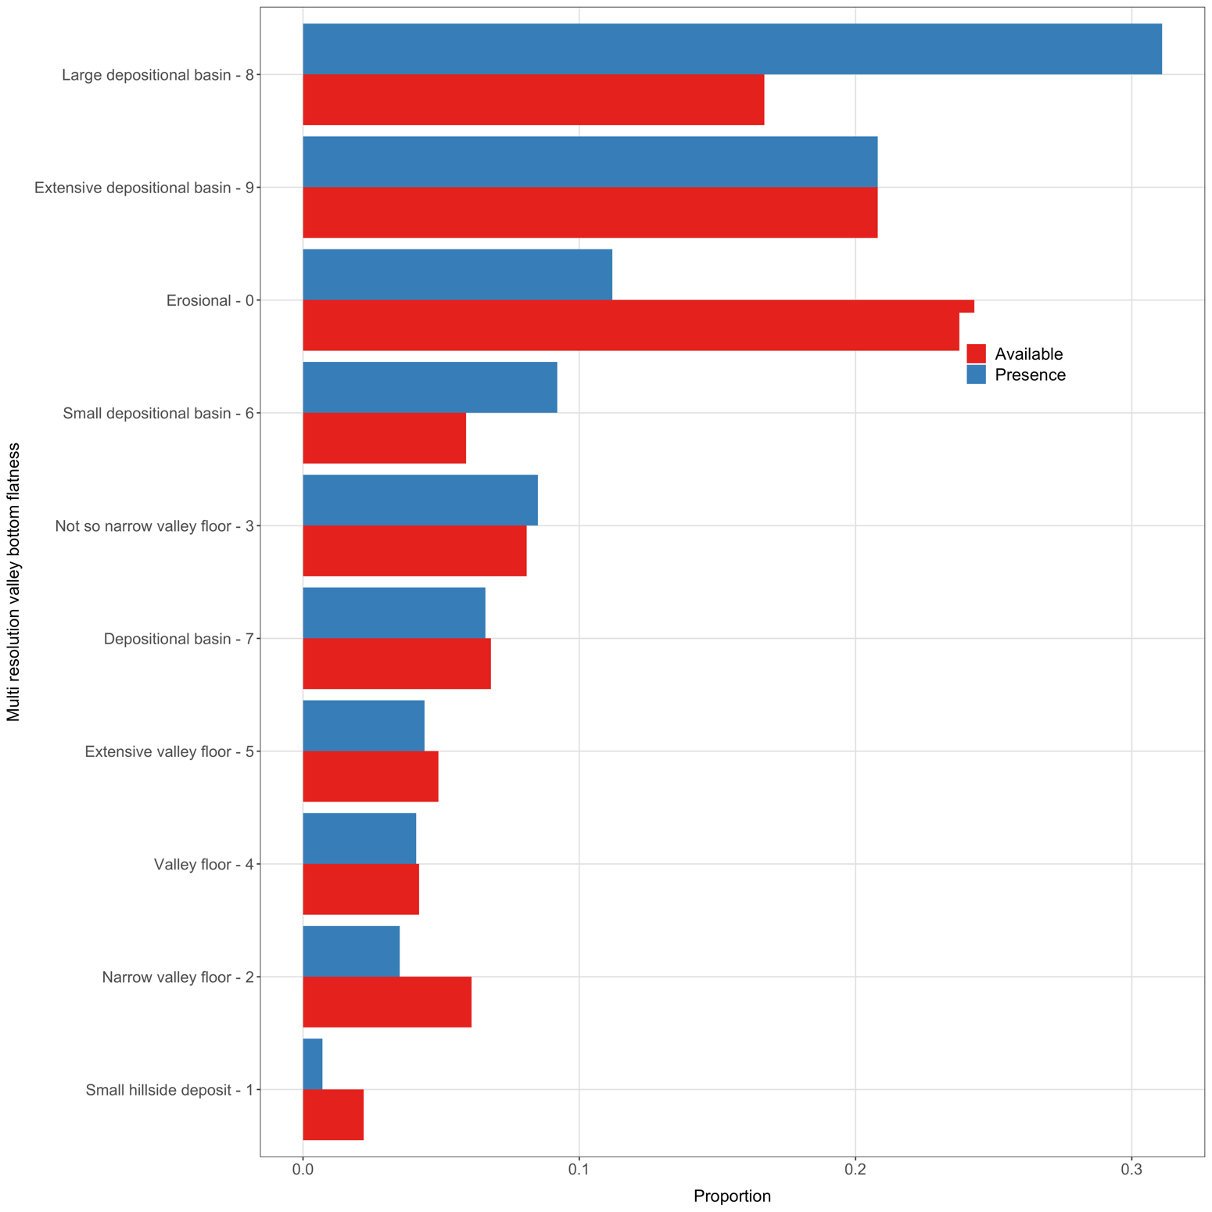
Supplementary Figure 3 Raw available and presence proportions for levels of MRVBF covariate for straw-necked ibis.

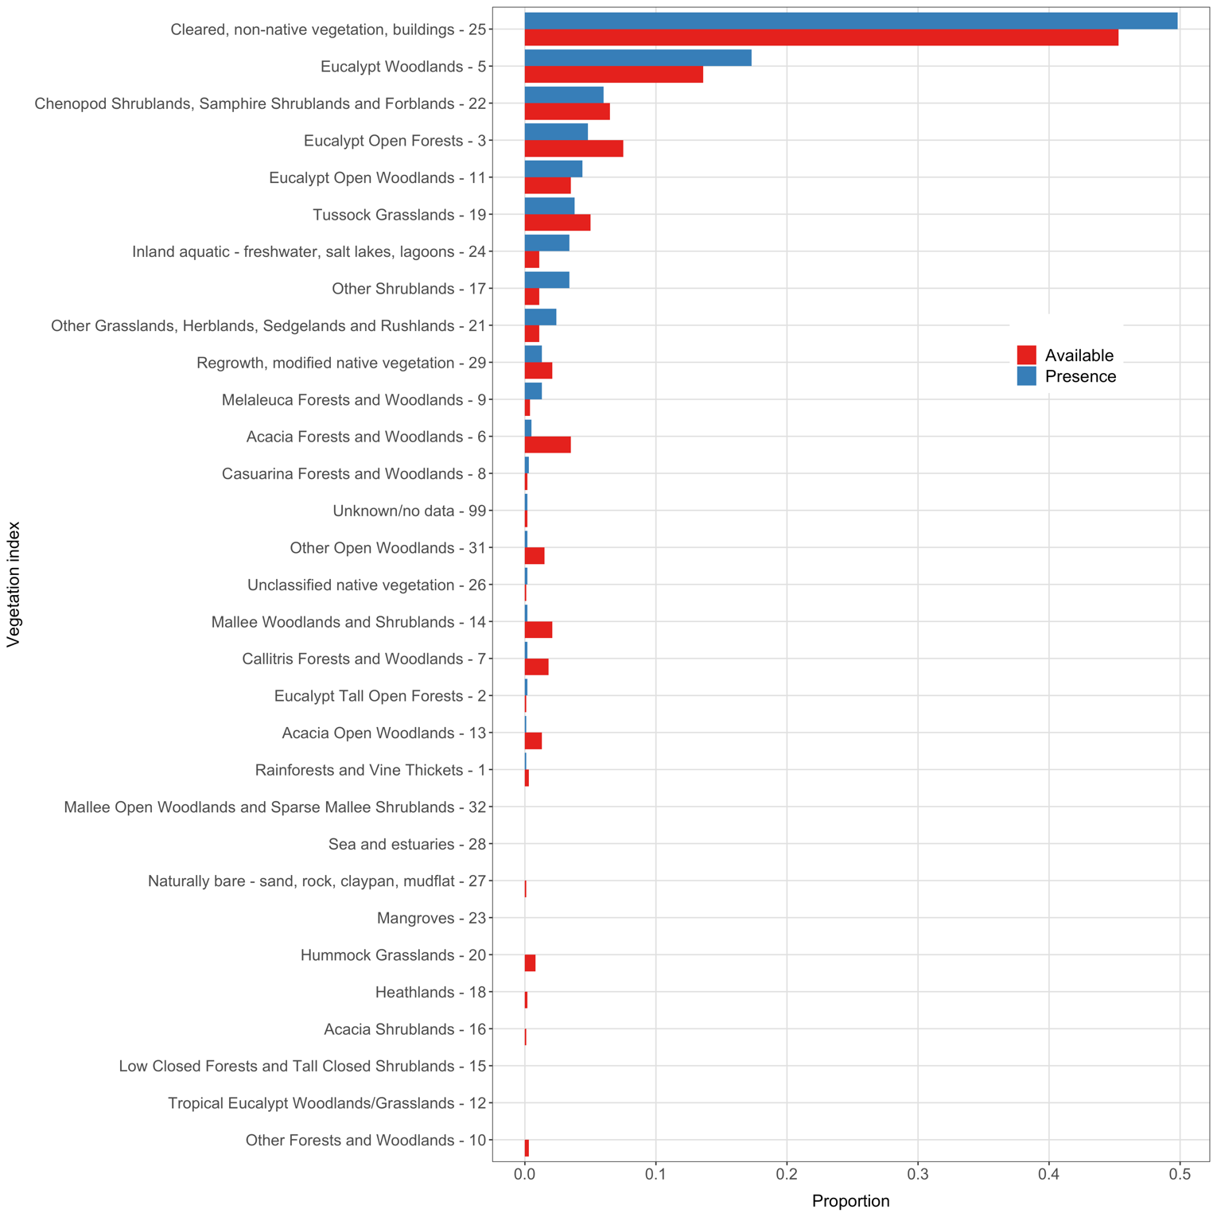
Supplementary Figure 4 Raw available and presence proportions for levels of NVIS covariate for straw-necked ibis.

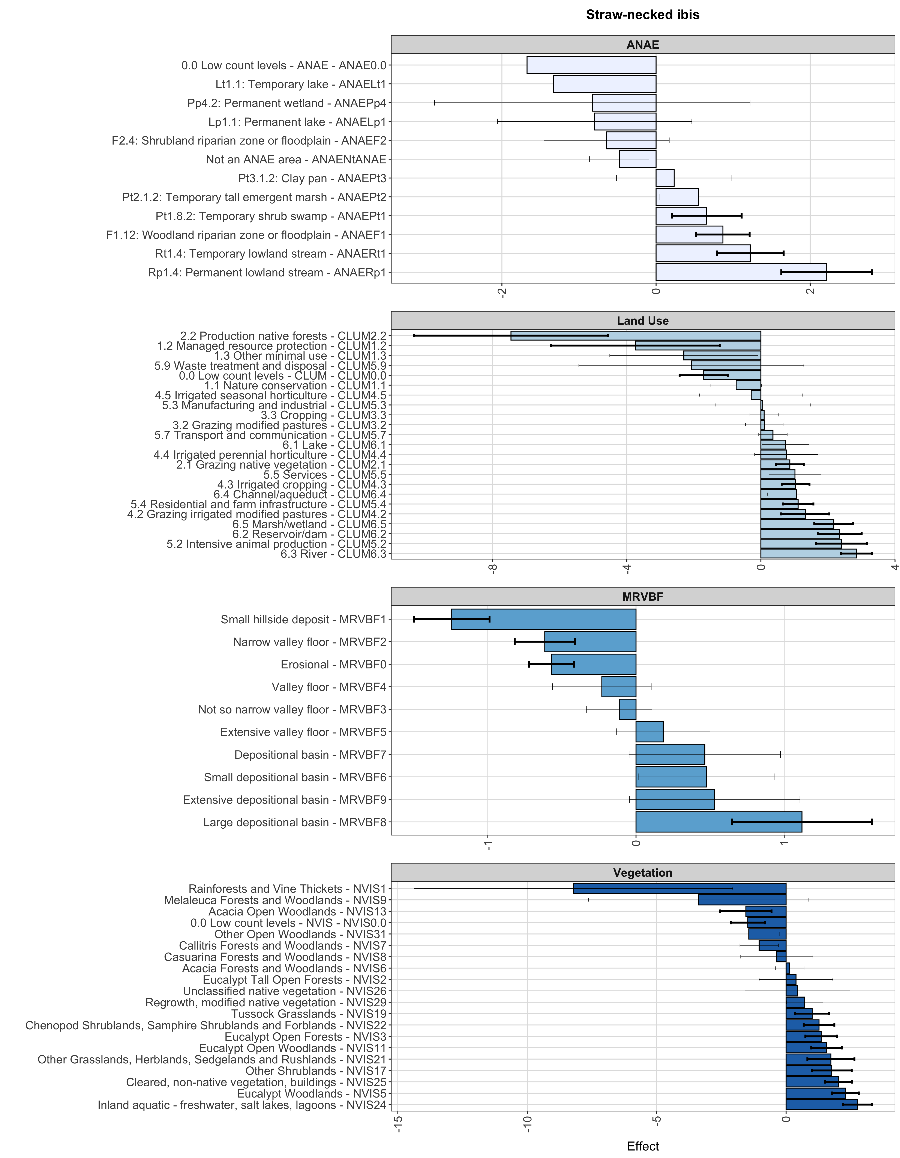
Supplementary Figure 5 Modelled habitat selection coefficients for satellite-tracked adult straw-necked ibis from random slope and intercept by individual models. Bar width indicates effect size and whisker lines the 95% interval on the effect. Bold whisker lines indicate covariate levels significance after multiple testing correction.

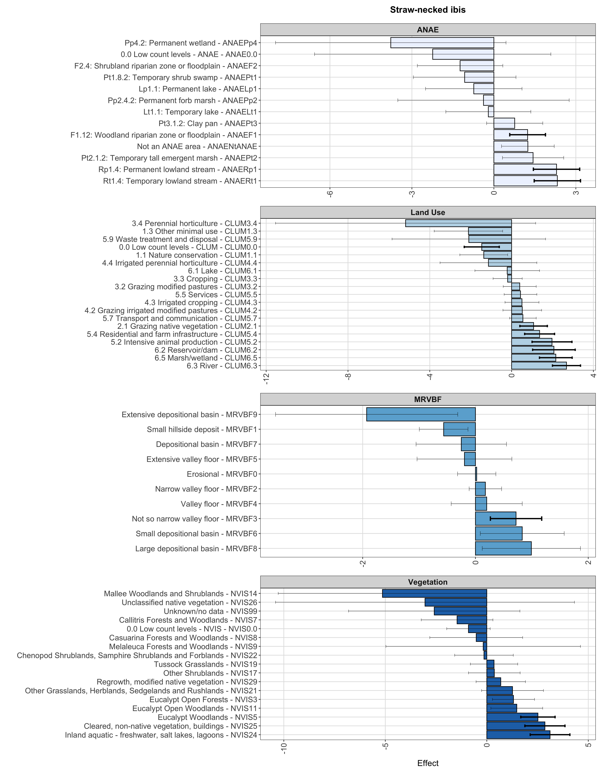
Supplementary Figure 6 Modelled habitat selection coefficients for satellite-tracked juvenile straw-necked ibis from random slope and intercept by individual models. Bar width indicates effect size and whisker lines the 95% interval on the effect. Bold whisker lines indicate covariate levels significance after multiple testing correction.

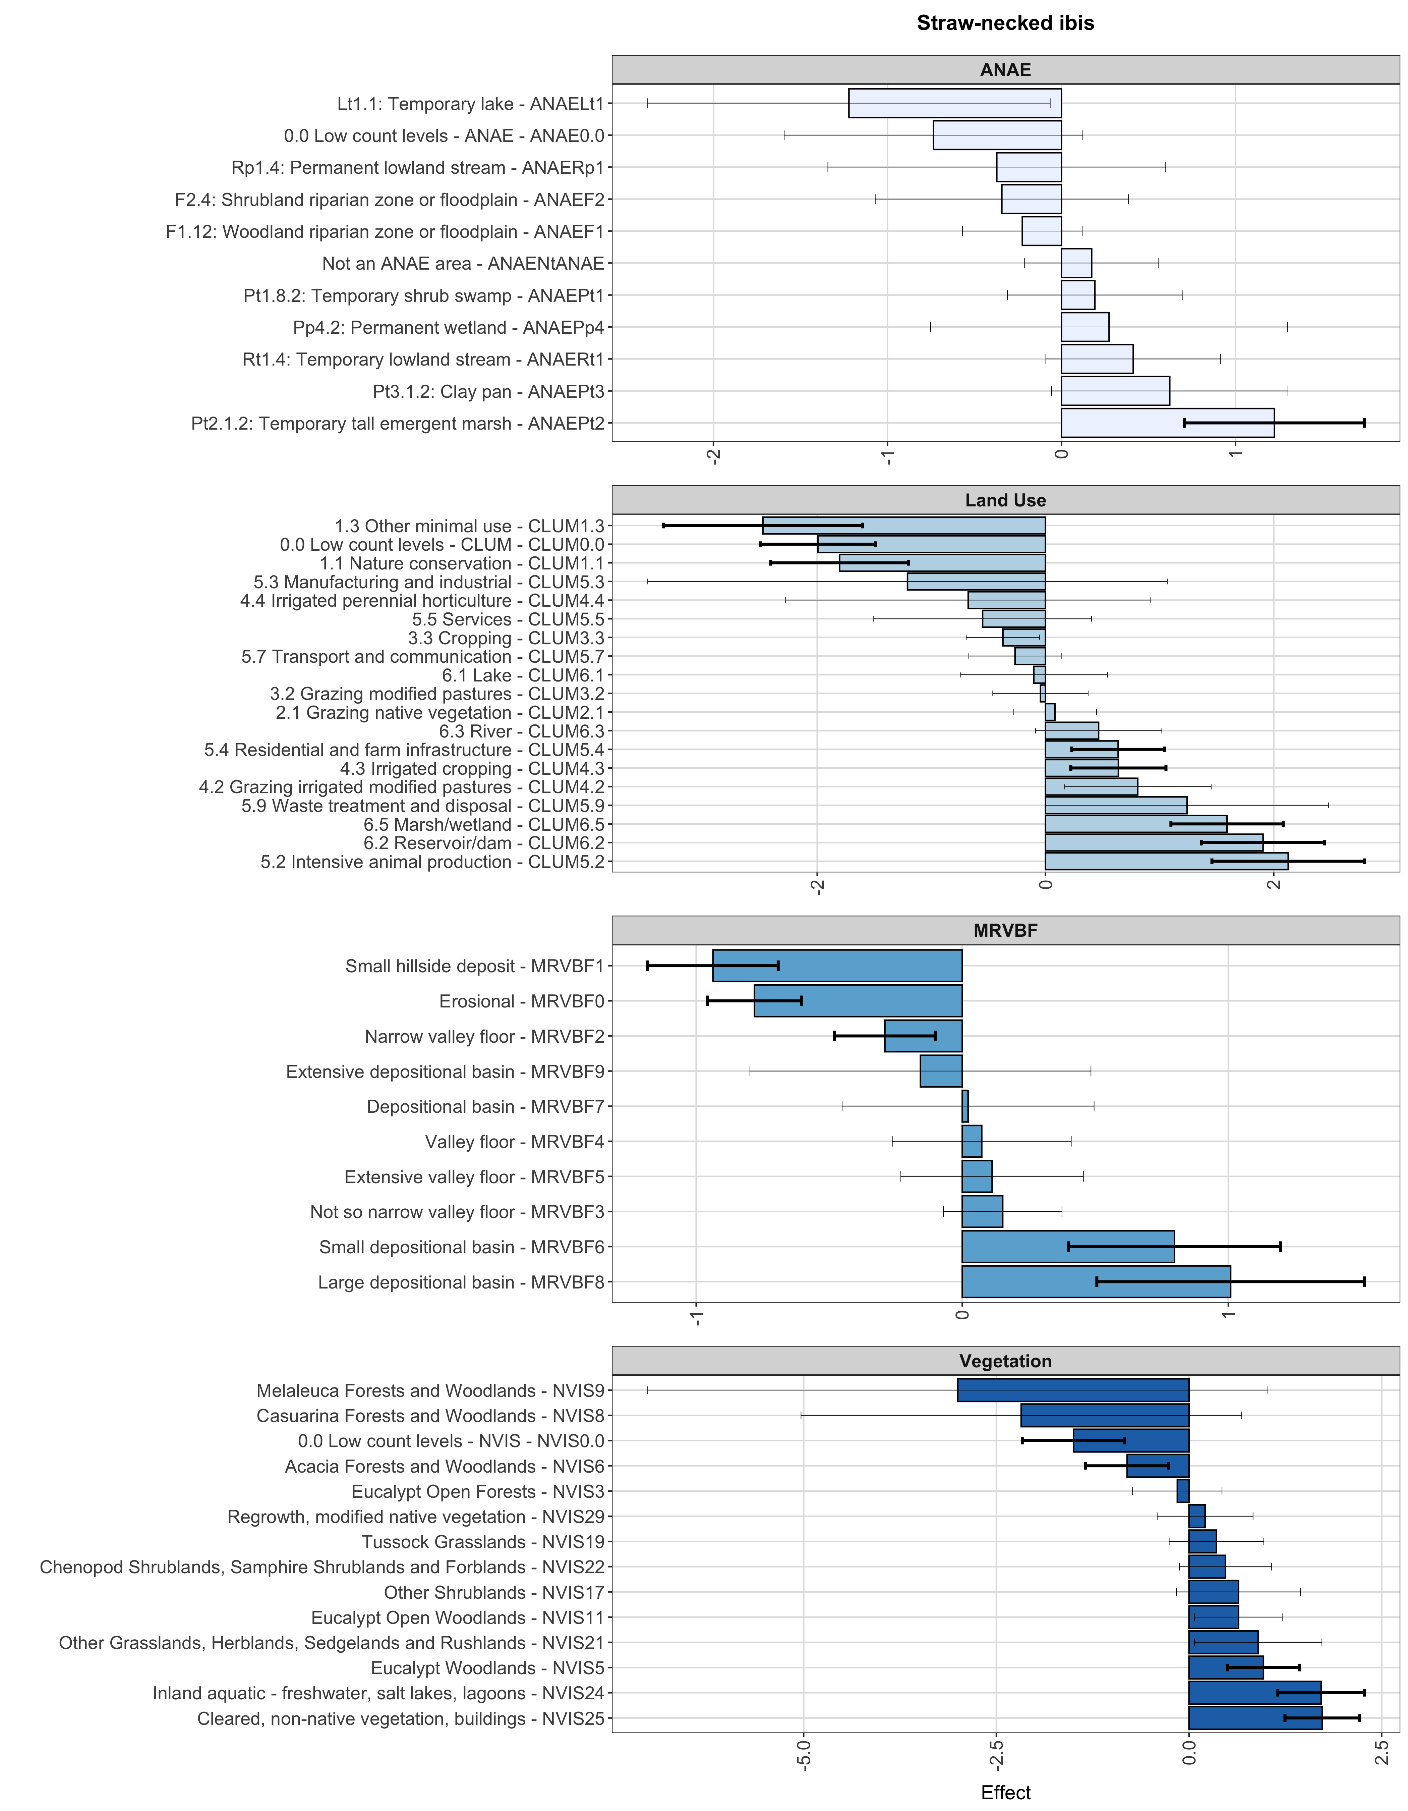
Supplementary Figure 7 Modelled habitat selection coefficients for satellite-tracked midday points from straw-necked ibis from random slope and intercept by individual models. Bar width indicates effect size and whisker lines the 95% interval on the effect. Bold whisker lines indicate covariate levels significance after multiple testing correction.

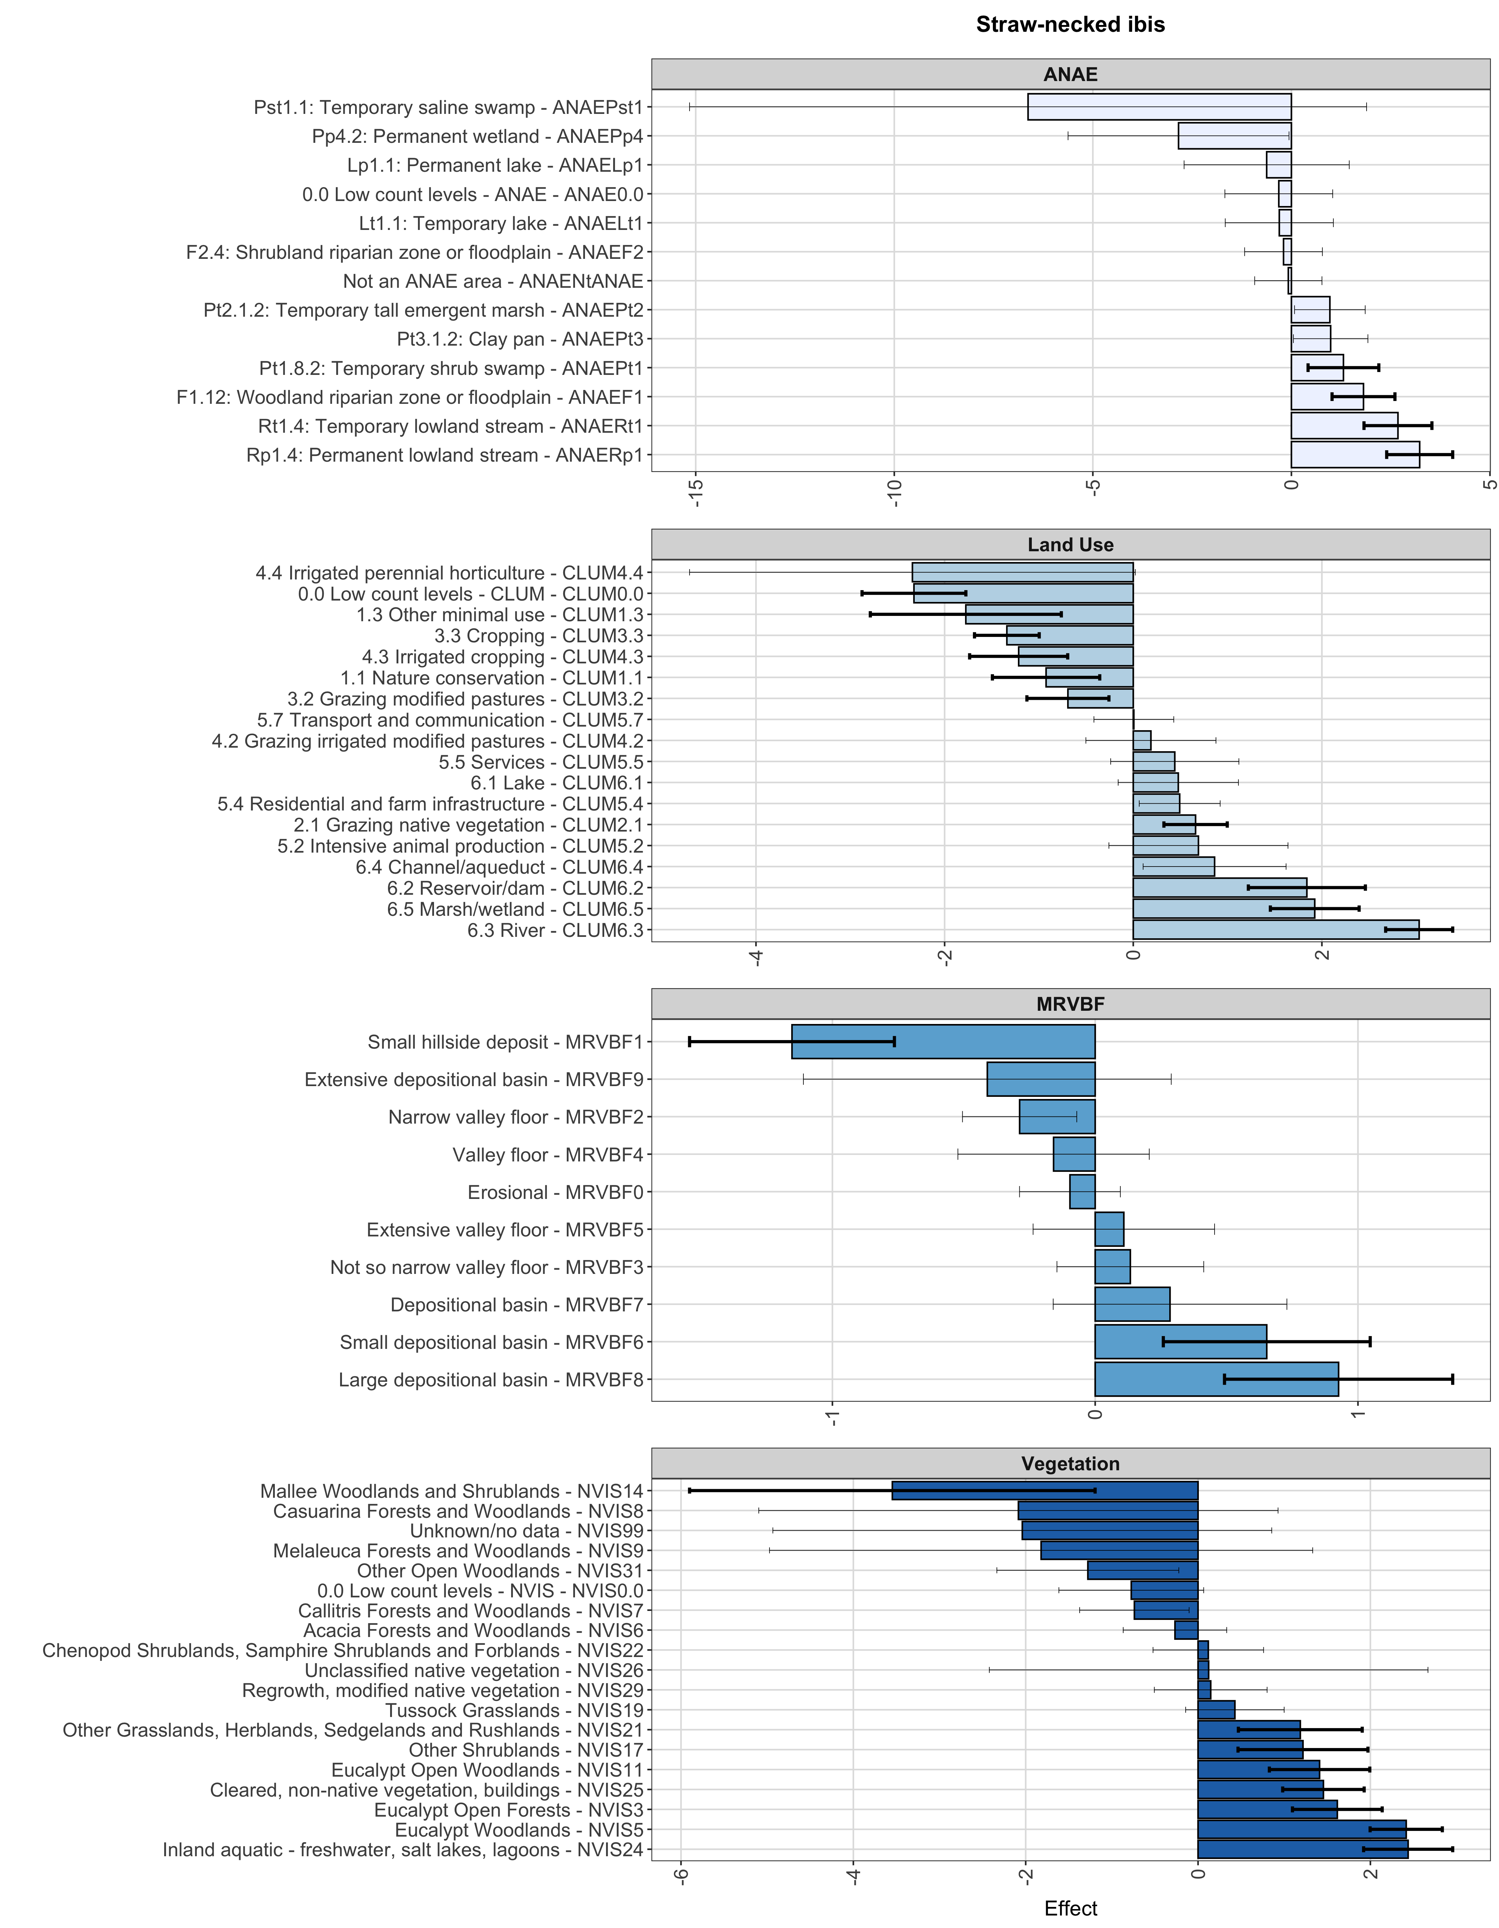
Supplementary Figure 8 Modelled habitat selection coefficients for satellite-tracked midnight points from straw-necked ibis from random slope and intercept by individual models. Bar width indicates effect size and whisker lines the 95% interval on the effect. Bold whisker lines indicate covariate levels significance after multiple testing correction.

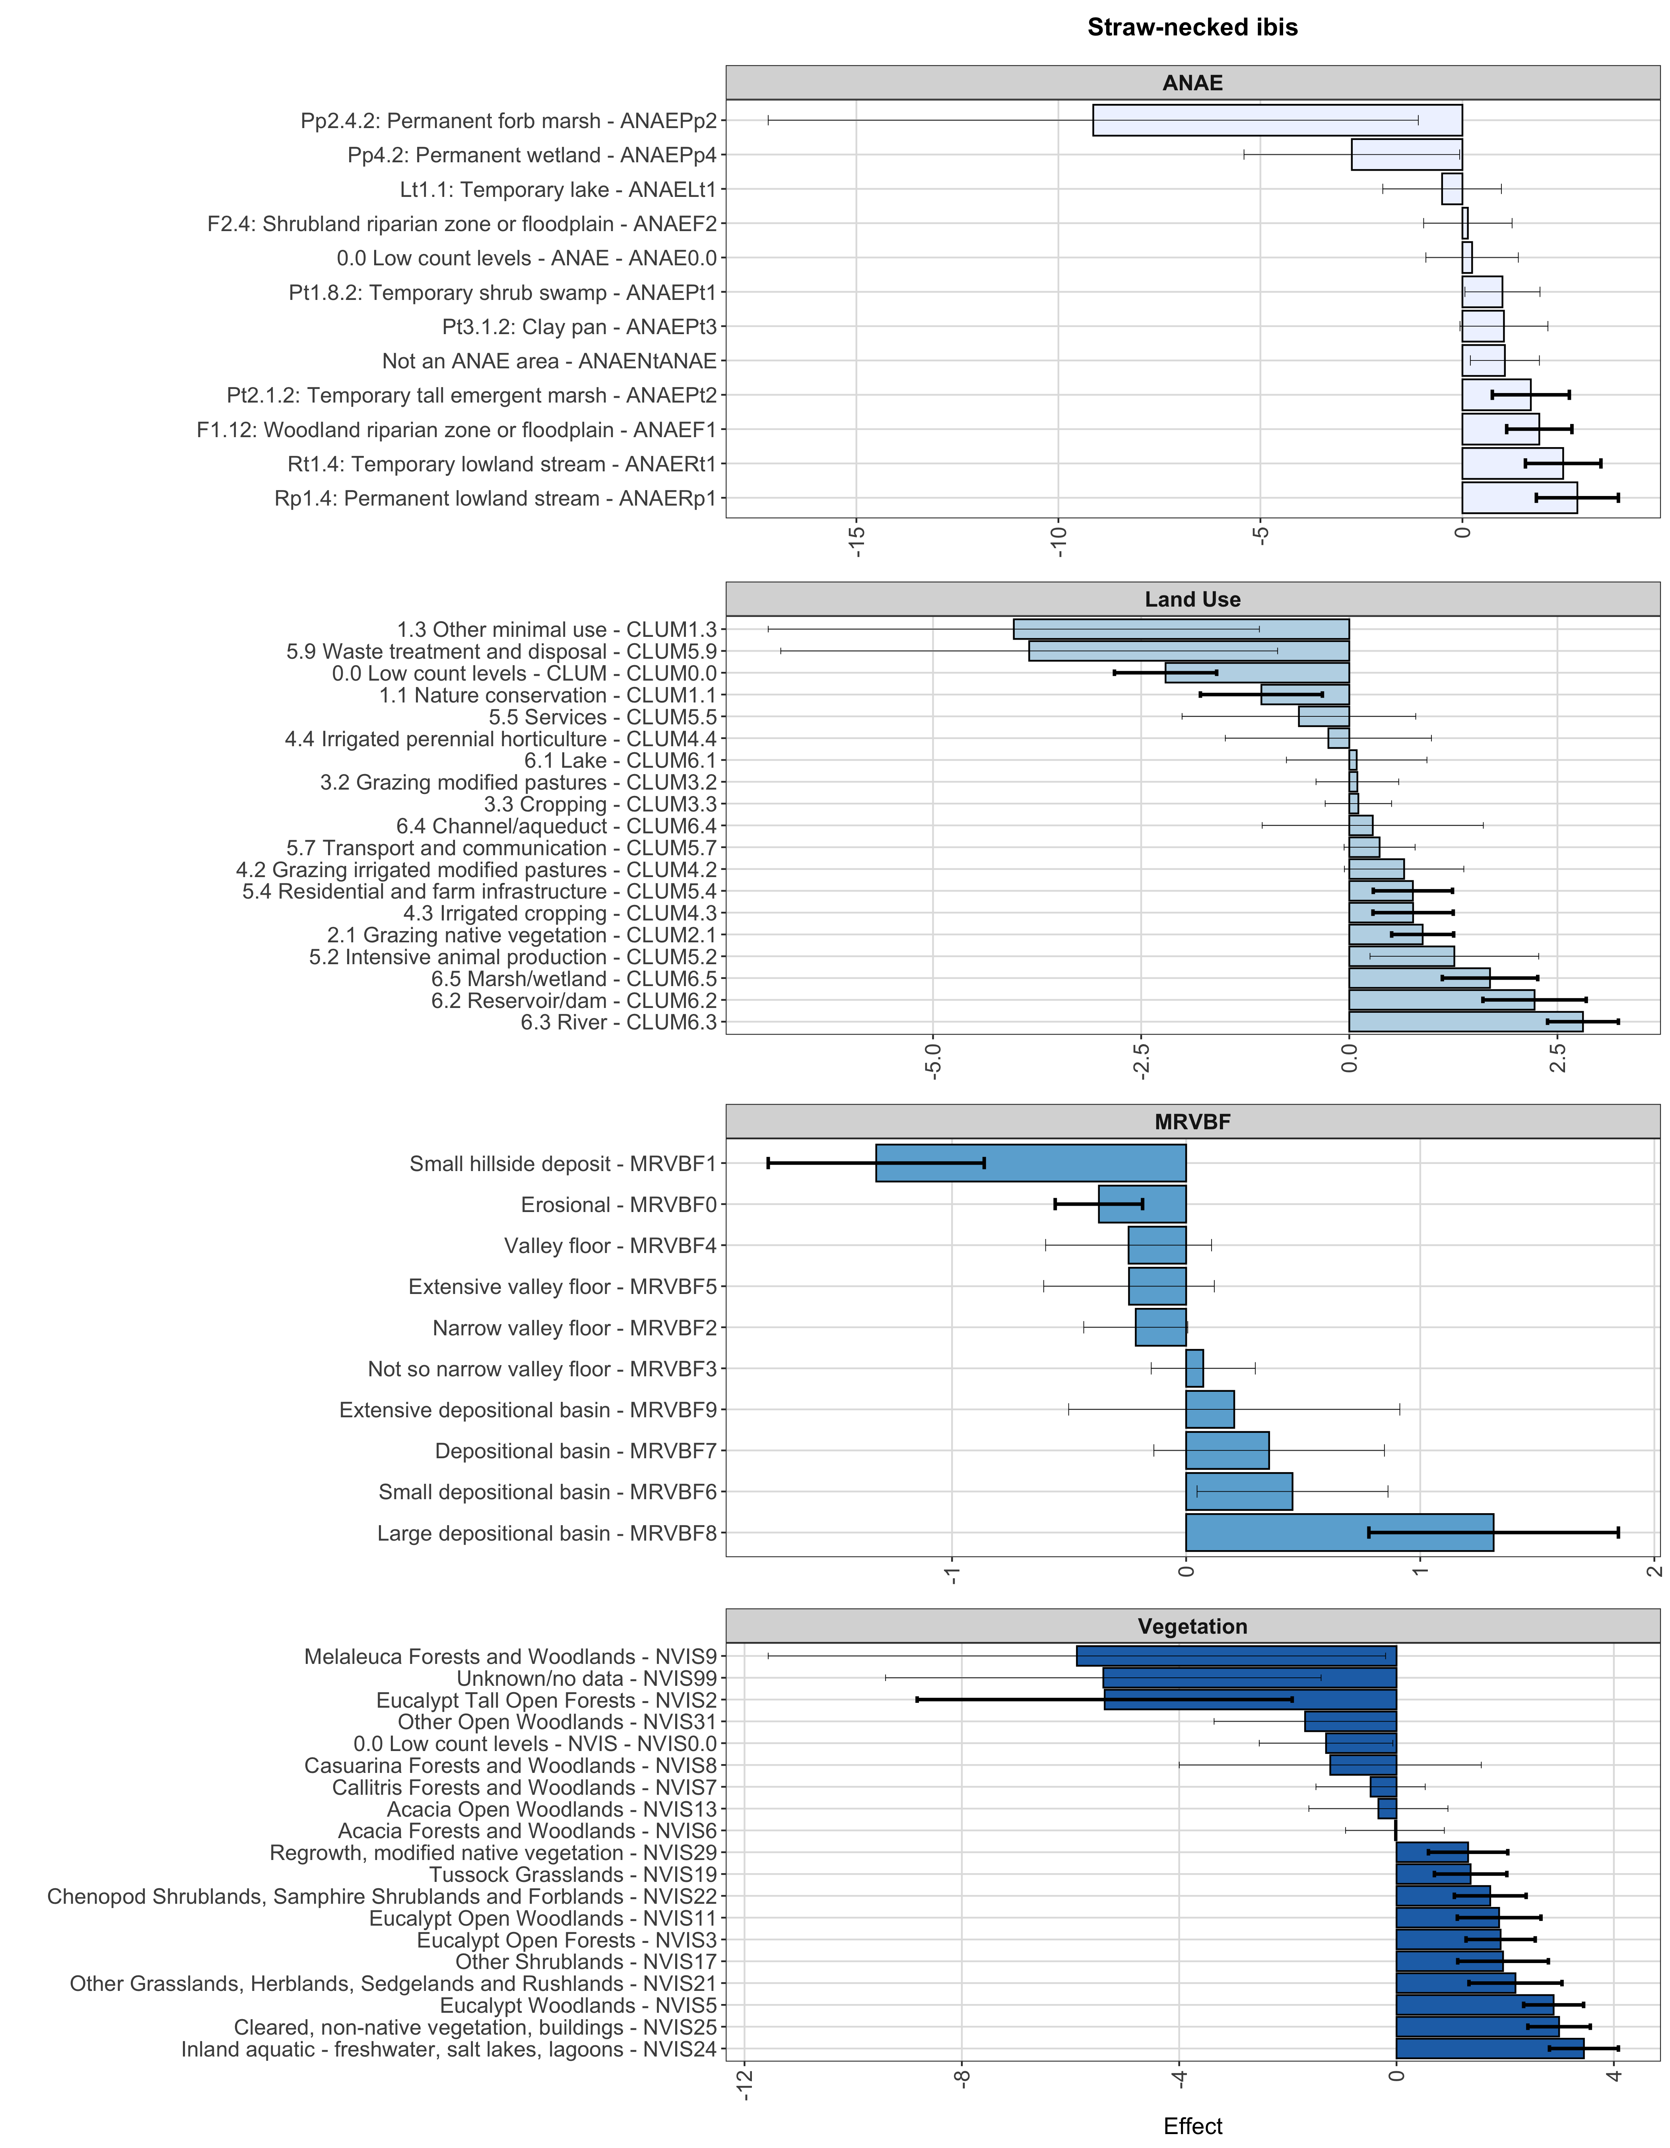
Supplementary Figure 9 Modelled habitat selection coefficients for satellite-tracked summer points from straw-necked ibis from random slope and intercept by individual models. Bar width indicates effect size and whisker lines the 95% interval on the effect. Bold whisker lines indicate covariate levels significance after multiple testing correction.

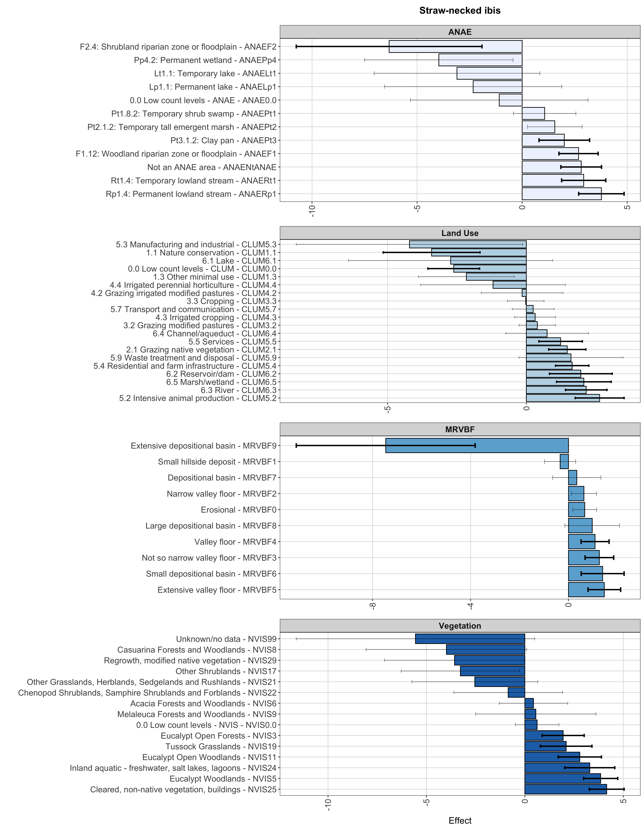
Supplementary Figure 10 Modelled habitat selection coefficients for satellite-tracked autumn points from straw-necked ibis from random slope and intercept by individual models. Bar width indicates effect size and whisker lines the 95% interval on the effect. Bold whisker lines indicate covariate levels significance after multiple testing correction.

Supplementary Figure 11 Modelled habitat selection coefficients for satellite-tracked winter points from straw-necked ibis from random slope and intercept by individual models. Bar width indicates effect size and whisker lines the 95% interval on the effect. Bold whisker lines indicate covariate levels significance after multiple testing correction.

Supplementary Figure 12 Modelled habitat selection coefficients for satellite-tracked spring points from straw-necked ibis from random slope and intercept by individual models. Bar width indicates effect size and whisker lines the 95% interval on the effect. Bold whisker lines indicate covariate levels significance after multiple testing correction.

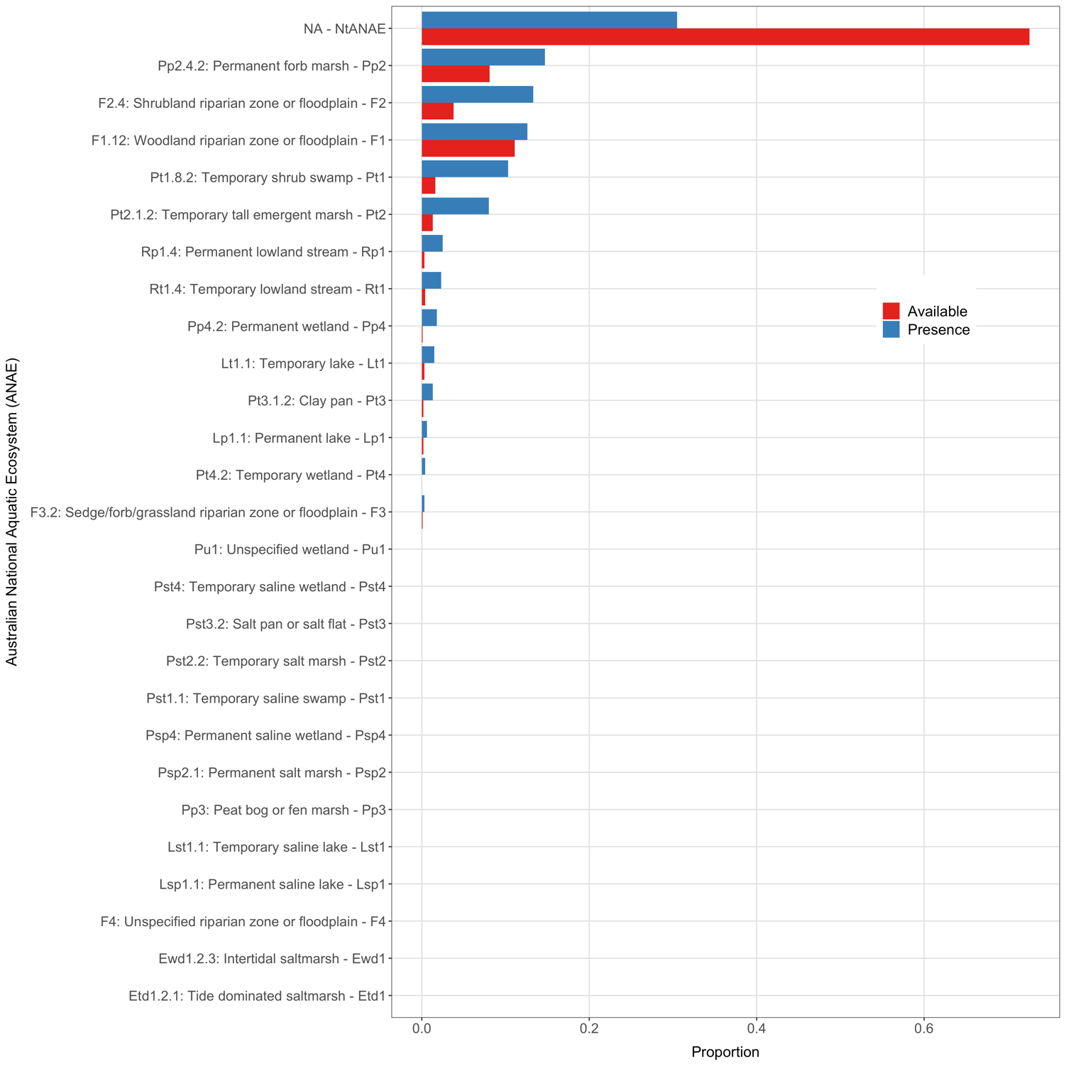
Supplementary Figure 13 Raw available and presence proportions for levels of ANAE covariate for royal spoonbill.

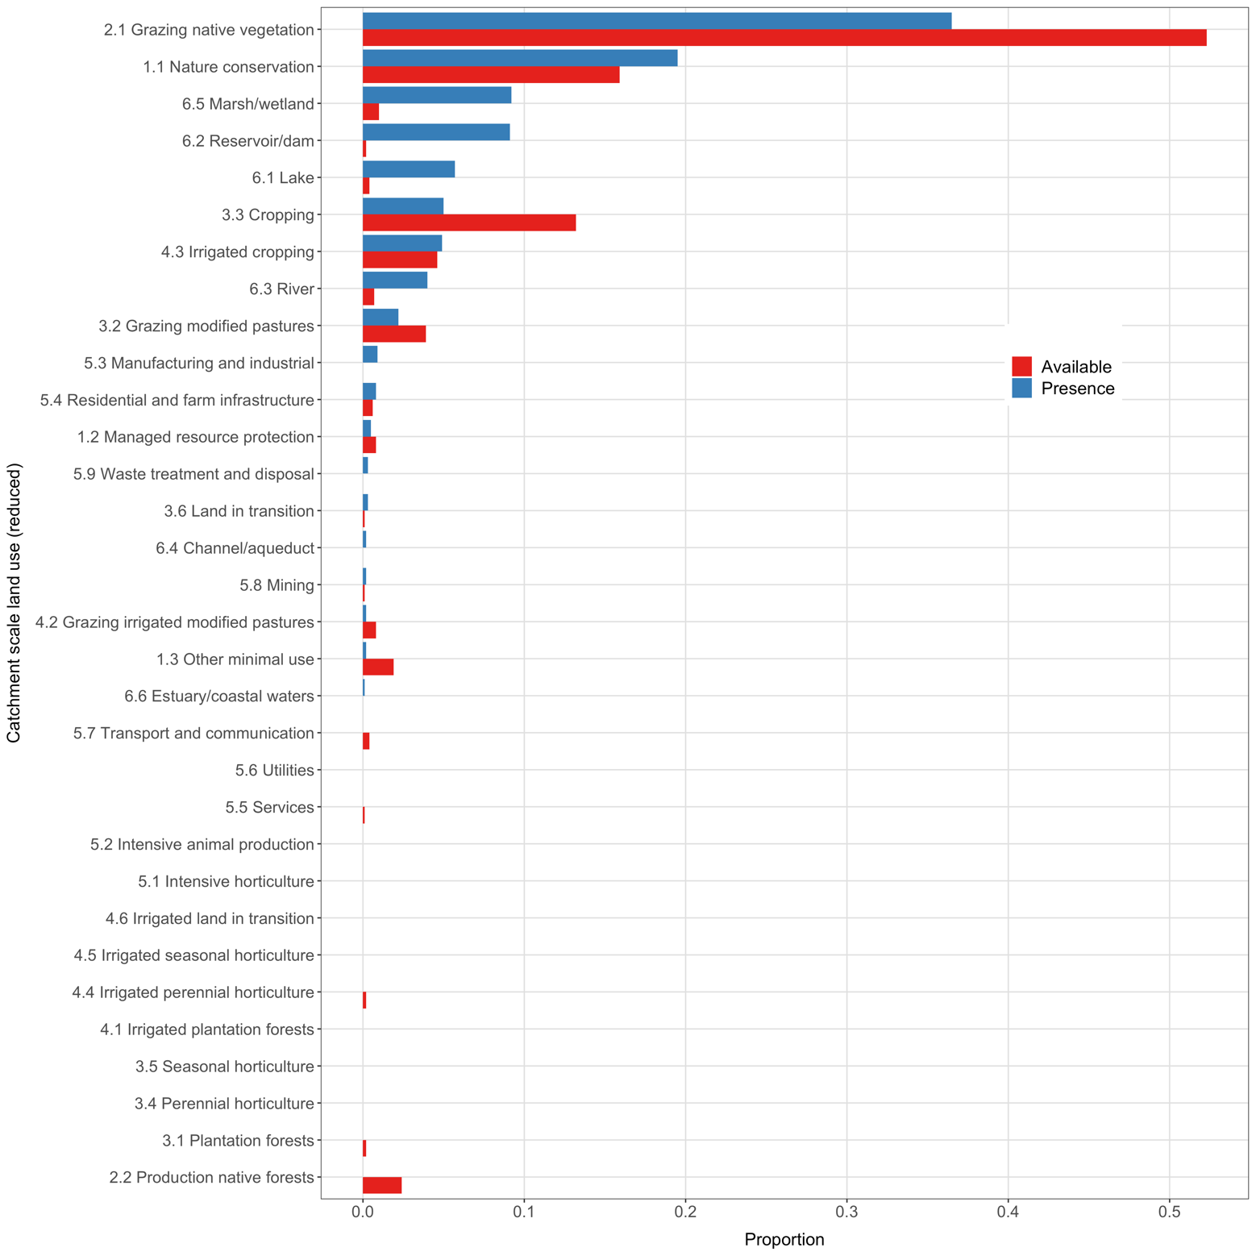
Supplementary Figure 14 Raw available and presence proportions for levels of CLUM covariate for royal spoonbill.

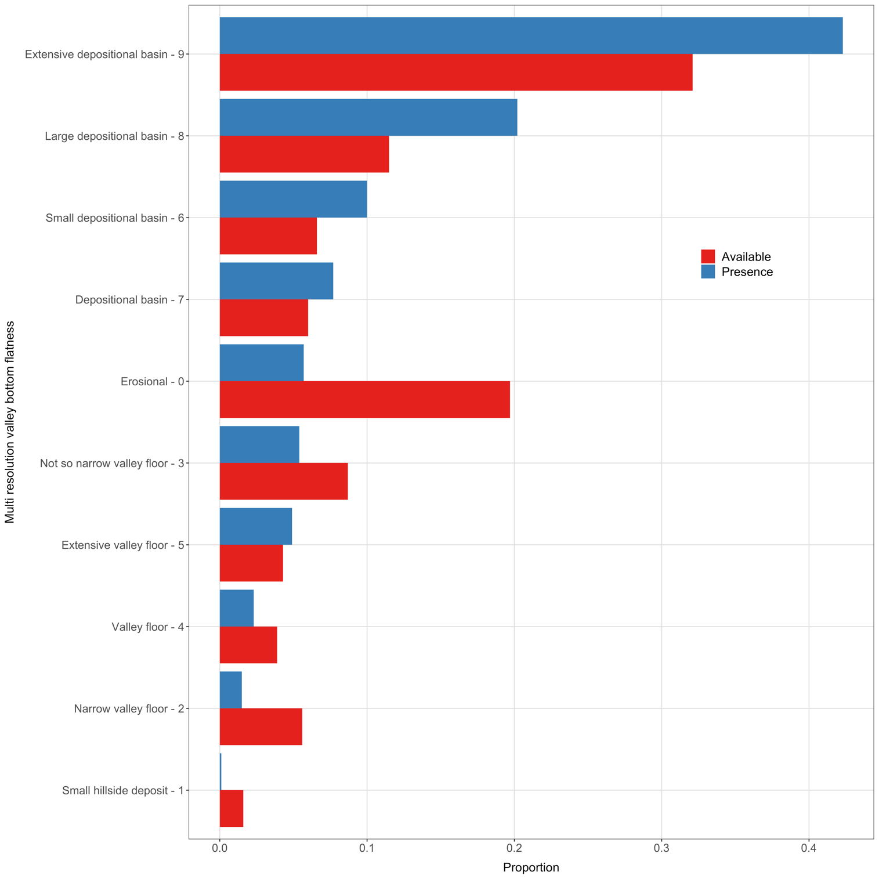
Supplementary Figure 15 Raw available and presence proportions for levels of MRVBF covariate for royal spoonbill.

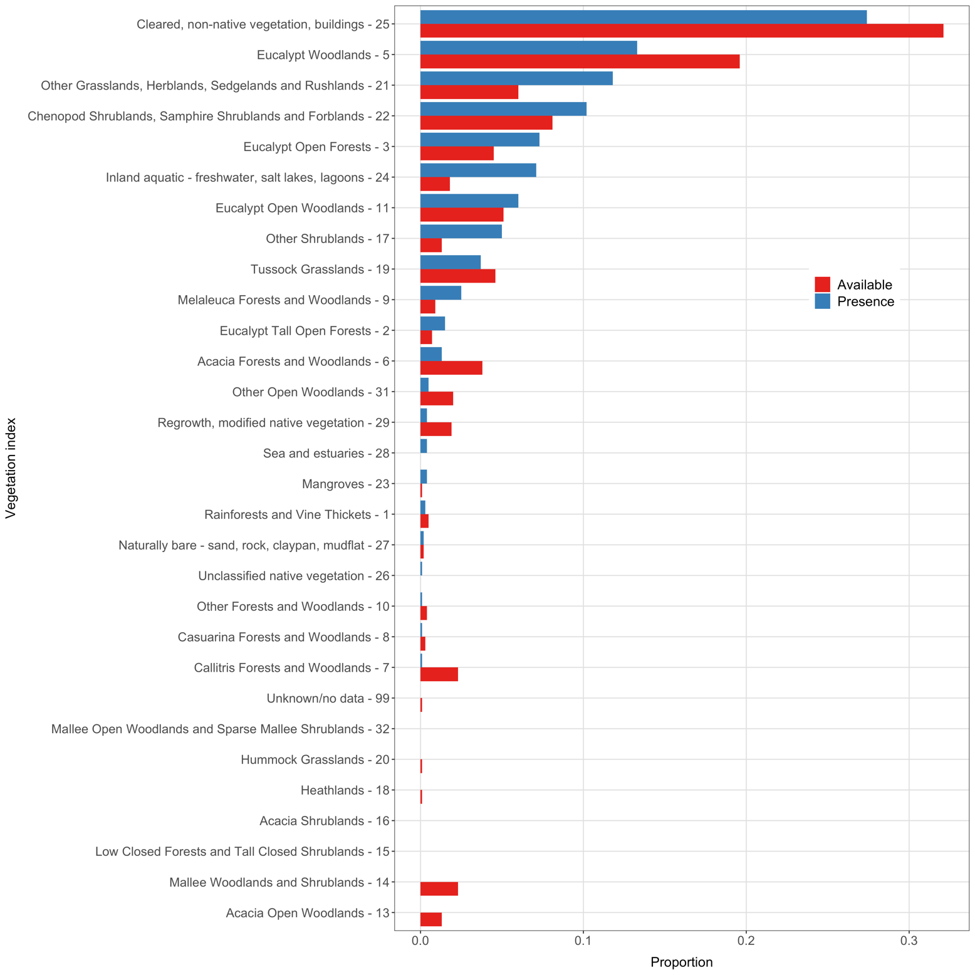
Supplementary Figure 16 Raw available and presence proportions for levels of MRVBF covariate for royal spoonbill.

Supplementary Figure 17 Modelled habitat selection coefficients for satellite-tracked midnight points from royal spoonbill from random slope and intercept by individual models. Bar width indicates effect size and whisker lines the 95% interval on the effect. Bold whisker lines indicate covariate levels significance after multiple testing correction.

Supplementary Figure 18 Modelled habitat selection coefficients for satellite-tracked midday points from royal spoonbill from random slope and intercept by individual models. Bar width indicates effect size and whisker lines the 95% interval on the effect. Bold whisker lines indicate covariate levels significance after multiple testing correction.

Supplementary Figure 19 Summary of GAM MIMs smooth for local water depth for straw neck ibis all individuals a), adults b) and juveniles c); and royal spoonbills all individuals d), adults e) and juveniles f). Data density is indicated by tick marks inside the x-axes.

Supplementary Figure 20 Summary of availability and presence data proportions for water depth cut to 0.5 m increments for straw-necked ibis. Bottom panel shows zoom for lower proportions as ~ 85% of the data are within 0-1 m.

Supplementary Figure 21 Summary of availability and presence data proportions for water depth cut to 0.5 m increments for royal spoonbills. Bottom panel shows zoom for lower proportions as ~ 85% of the data are within 0-1 m.

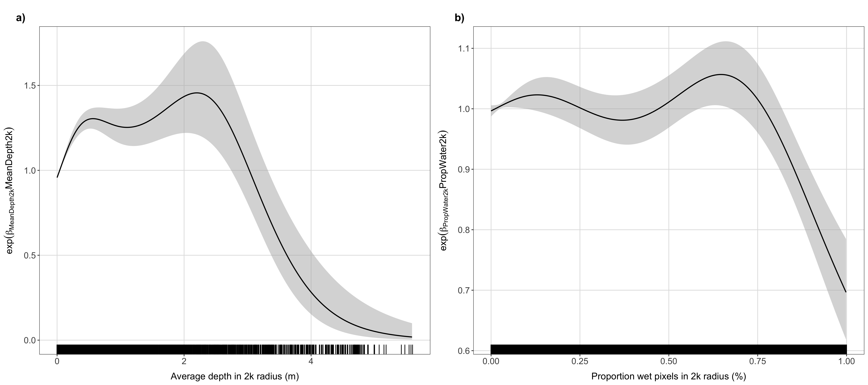
Supplementary Figure 22 Straw-necked ibis GAM MIMs smooth 2 km radii curves for average depth and proportion wet for all individuals (a and b), adult individuals (c and d) and juvenile individuals (e and f).

Supplementary Figure 23 Royal spoonbill GAM MIMs smooth 2 km radii curves for all individuals for average depth (left) and water proportion (right).

Supplementary Tables
Supplementary Table 1 Summary of the estimated fixed effects from the IWGLMM for straw-necked ibis from the random intercepts and random slopes model.
Variable | Estimate | Std. Error | Z value | P-value
ANAERp1 | 3.21385441 | 0.3586366 | 8.96131183 | 3.21E-19
ANAERt1 | 2.70206343 | 0.34344106 | 7.86761898 | 3.61E-15
ANAEF1 | 1.98337896 | 0.31370947 | 6.32234326 | 2.58E-10
ANAEPt2 | 1.85485485 | 0.36710865 | 5.05260463 | 4.36E-07
ANAEPt1 | 1.40132561 | 0.36707127 | 3.81758461 | 0.00013476
ANAEPt3 | 1.41115036 | 0.40787758 | 3.45973997 | 0.0005407
ANAEPp2 | -6.4989032 | 1.96801717 | -3.3022594 | 0.00095909
ANAENtANAE | 1.12343946 | 0.34569191 | 3.24982863 | 0.00115475
ANAEPst1 | -5.4565961 | 2.96953445 | -1.8375258 | 0.06613231
ANAE0.0 | -1.2715417 | 0.94224778 | -1.3494771 | 0.17718379
ANAEPp4 | -0.8709997 | 1.27264889 | -0.6843991 | 0.4937232
ANAEF2 | 0.21428278 | 0.45637611 | 0.4695311 | 0.63869006
ANAELp1 | 0.22373065 | 0.58792906 | 0.38054021 | 0.70354445
ANAELt1 | -0.0303253 | 0.52939954 | -0.0572824 | 0.95432024
Intercept | -0.0220666 | 117.856914 | -0.0001872 | 0.99985061
CLUM6.3 | 3.05996018 | 0.19051656 | 16.0613872 | 4.76E-58
CLUM6.5 | 2.43265301 | 0.23612371 | 10.3024512 | 6.87E-25
CLUM6.2 | 2.53235815 | 0.27556267 | 9.18977211 | 3.94E-20
CLUM5.2 | 2.50638334 | 0.30316055 | 8.26751156 | 1.37E-16
CLUM5.4 | 1.46852371 | 0.19857739 | 7.39522094 | 1.41E-13
CLUM2.1 | 1.21364976 | 0.17717235 | 6.85010801 | 7.38E-12
CLUM2.2 | -7.8246712 | 1.22666371 | -6.3788234 | 1.78E-10
CLUM4.3 | 1.11807816 | 0.19753561 | 5.66013474 | 1.51E-08
CLUM0.0 | -1.7731972 | 0.33288112 | -5.3268183 | 9.99E-08
CLUM4.2 | 1.25921994 | 0.2939438 | 4.28387987 | 1.84E-05
CLUM5.7 | 0.686718 | 0.1826977 | 3.75876645 | 0.00017075
CLUM1.2 | -2.6589726 | 0.73963447 | -3.594982 | 0.00032441
CLUM5.5 | 0.93252983 | 0.31020449 | 3.00617775 | 0.00264554
CLUM6.4 | 1.02534883 | 0.38553763 | 2.65952986 | 0.00782498
CLUM1.3 | -1.7707882 | 0.79221049 | -2.2352497 | 0.02540096
CLUM1.1 | -0.6956501 | 0.31879322 | -2.1821357 | 0.02909952
CLUM3.2 | 0.47295894 | 0.23465289 | 2.01556835 | 0.04384513
CLUM6.1 | 0.68200571 | 0.34052028 | 2.00283432 | 0.04519507
CLUM3.4 | -1.8731484 | 1.09956567 | -1.7035348 | 0.08846803
CLUM5.9 | -1.9565941 | 1.24345617 | -1.5735127 | 0.11560015
CLUM3.3 | 0.26847086 | 0.18373317 | 1.4611997 | 0.14396064
CLUM4.5 | -1.2244773 | 0.95552206 | -1.2814747 | 0.20002699
CLUM4.4 | 0.44181378 | 0.44475871 | 0.99337859 | 0.32052549
CLUM5.3 | -0.3233513 | 0.72368588 | -0.4468117 | 0.65501104
Intercept | -0.0131407 | 117.264374 | -0.0001121 | 0.99991059
MRVBF1 | -1.0616717 | 0.12486973 | -8.5022338 | 1.86E-17
MRVBF0 | -0.3721909 | 0.07837835 | -4.748645 | 2.05E-06
MRVBF8 | 1.04325596 | 0.22190044 | 4.70145954 | 2.58E-06
MRVBF2 | -0.3344634 | 0.08370536 | -3.9957228 | 6.45E-05
MRVBF6 | 0.5996676 | 0.19632772 | 3.05442142 | 0.00225495
MRVBF3 | 0.17830194 | 0.11370283 | 1.56813985 | 0.1168485
MRVBF7 | 0.18575349 | 0.22856924 | 0.8126793 | 0.41640195
MRVBF9 | -0.261839 | 0.33122641 | -0.7905137 | 0.42922784
MRVBF5 | 0.10009281 | 0.16608682 | 0.60265354 | 0.5467392
MRVBF4 | -0.0763576 | 0.15173012 | -0.5032463 | 0.61479112
Intercept | -0.0010644 | 117.041206 | -9.09E-06 | 0.99999274
NVIS24 | 3.44819935 | 0.25309786 | 13.623977 | 2.88E-42
NVIS5 | 2.94270435 | 0.22389698 | 13.1431176 | 1.86E-39
NVIS25 | 2.8914911 | 0.24225164 | 11.9358992 | 7.69E-33
NVIS11 | 2.18689043 | 0.28023669 | 7.80372629 | 6.01E-15
NVIS3 | 1.92340235 | 0.26776629 | 7.18313857 | 6.81E-13
NVIS21 | 2.14595317 | 0.38742523 | 5.5390124 | 3.04E-08
NVIS17 | 1.81368301 | 0.34781198 | 5.21455019 | 1.84E-07
NVIS22 | 1.49730181 | 0.28757566 | 5.2066361 | 1.92E-07
NVIS19 | 1.37809428 | 0.29261105 | 4.7096454 | 2.48E-06
NVIS29 | 1.27229224 | 0.31140245 | 4.08568478 | 4.39E-05
NVIS14 | -2.4577957 | 0.67403505 | -3.6463916 | 0.00026595
NVIS1 | -6.7498336 | 2.24124812 | -3.0116405 | 0.0025984
NVIS2 | -4.2584551 | 1.45664576 | -2.9234665 | 0.00346157
NVIS31 | -1.3802822 | 0.59068715 | -2.3367398 | 0.01945272
NVIS0.0 | -1.1182319 | 0.50653805 | -2.207597 | 0.02727238
NVIS13 | -1.137039 | 0.56958356 | -1.9962638 | 0.04590522
NVIS7 | -0.5991172 | 0.373334 | -1.6047752 | 0.10854328
NVIS99 | -1.8072837 | 1.21148444 | -1.4917928 | 0.13575348
NVIS9 | -2.1243295 | 1.78829265 | -1.1879093 | 0.23486914
NVIS6 | 0.15060875 | 0.31749885 | 0.47436 | 0.63524321
NVIS8 | 0.14160555 | 0.60871589 | 0.23262995 | 0.81604877
NVIS26 | -0.1513418 | 1.35528609 | -0.1116678 | 0.91108682
Intercept | -0.0196371 | 117.041594 | -0.0001678 | 0.99986613
(Intercept) | -0.0031594 | 117.050939 | -2.70E-05 | 0.99997846
WOFS | 1.67670896 | 0.21818296 | 7.68487589 | 1.53E-14
I(WOFS^2) | -0.6055803 | 0.17720107 | -3.4174754 | 0.00063205

Supplementary Table 2 Summary of the estimated fixed effects from the IWGLMM for royal spoonbills from the random intercepts and random slopes model.
Variable | Estimate | Std. Error | Z value |  | P-value
ANAEPp4 | 2.8953244 | 0.50761655 | 5.70376284 |  | 1.17E-08
ANAERt1 | 1.70079145 | 0.40415527 | 4.2082625 |  | 2.57E-05
ANAEPt1 | 1.66225983 | 0.48661009 | 3.41599949 |  | 0.00063548
ANAEPt2 | 1.69732322 | 0.5021146 | 3.38035027 |  | 0.00072394
ANAERp1 | 2.03790662 | 0.61006483 | 3.34047548 |  | 0.00083635
ANAE0.0 | -6.3876927 | 2.15335215 | -2.9663948 |  | 0.00301313
ANAEPt3 | -6.054507 | 2.14195758 | -2.8266232 |  | 0.00470416
ANAEPp2 | 5.18556666 | 1.96836084 | 2.63445937 |  | 0.00842714
ANAEF1 | 0.83879337 | 0.38464514 | 2.18069408 |  | 0.02920605
ANAEF2 | 0.95007057 | 0.49139985 | 1.93339611 |  | 0.05318742
ANAENtANAE | -0.7627656 | 0.41068419 | -1.8573044 |  | 0.06326785
ANAELt1 | -2.1103706 | 1.32737608 | -1.5898815 |  | 0.11186152
ANAEF3 | -2.2772775 | 2.02021352 | -1.127246 |  | 0.2596385
ANAELp1 | 0.62391605 | 0.63221079 | 0.9868798 |  | 0.32370157
Intercept | -0.0159565 | 154.315777 | -0.0001034 |  | 0.9999175
CLUM6.2 | 5.06507057 | 0.41482408 | 12.2101653 |  | 2.74E-34
CLUM6.5 | 3.60800663 | 0.41925343 | 8.60578921 |  | 7.58E-18
CLUM6.3 | 3.31421799 | 0.42642163 | 7.77216197 |  | 7.72E-15
CLUM6.1 | 2.71938753 | 0.61821102 | 4.39880145 |  | 1.09E-05
CLUM2.1 | 1.55438004 | 0.38041438 | 4.0860181 |  | 4.39E-05
CLUM1.1 | 1.60715036 | 0.47859556 | 3.3580553 |  | 0.00078493
CLUM6.4 | 2.08160532 | 0.72817433 | 2.85866342 |  | 0.0042543
CLUM1.3 | -1.4533785 | 0.55706084 | -2.6090122 |  | 0.0090804
CLUM1.2 | -7.35975 | 2.88738667 | -2.5489312 |  | 0.01080536
CLUM0.0 | -1.3965859 | 0.55339924 | -2.5236499 |  | 0.01161435
CLUM4.3 | 1.16196015 | 0.48371963 | 2.40213561 |  | 0.01629966
CLUM3.2 | -1.2747656 | 0.68207739 | -1.8689457 |  | 0.06163037
CLUM5.3 | -4.7497306 | 2.56858924 | -1.8491593 |  | 0.06443482
CLUM5.8 | -2.6391722 | 2.261074 | -1.1672206 |  | 0.24312129
CLUM3.6 | -2.0764204 | 2.43689955 | -0.8520747 |  | 0.39417265
CLUM3.3 | -0.4135698 | 0.51523472 | -0.8026824 |  | 0.42215834
CLUM5.4 | 0.25140035 | 0.68369097 | 0.3677105 |  | 0.71308911
Intercept | -0.0147542 | 154.49468 | -9.55E-05 |  | 0.9999238
MRVBF9 | 1.31190555 | 0.22056358 | 5.9479699 |  | 2.71E-09
MRVBF1 | -2.3019083 | 0.52030393 | -4.4241609 |  | 9.68E-06
MRVBF7 | 0.9043713 | 0.21847776 | 4.13942039 |  | 3.48E-05
MRVBF2 | -1.1225261 | 0.29173156 | -3.8478049 |  | 0.00011918
MRVBF6 | 0.67738438 | 0.27198043 | 2.49056293 |  | 0.01275409
MRVBF8 | 0.8141636 | 0.40050796 | 2.0328275 |  | 0.04206995
MRVBF5 | 0.39089994 | 0.25209601 | 1.55059951 |  | 0.12099769
MRVBF4 | -0.3370067 | 0.23367711 | -1.4421896 |  | 0.14924889
MRVBF0 | -0.2237746 | 0.2719619 | -0.8228158 |  | 0.41061273
MRVBF3 | -0.1135326 | 0.21822016 | -0.5202665 |  | 0.60287786
Intercept | -0.0026949 | 154.30611 | -1.75E-05 |  | 0.99998607
NVIS24 | 3.47850984 | 0.48660276 | 7.1485616 |  | 8.77E-13
NVIS21 | 3.2726278 | 0.49355237 | 6.63076105 |  | 3.34E-11
NVIS2 | 3.06140208 | 0.59444798 | 5.14999158 |  | 2.60E-07
NVIS25 | 1.86449997 | 0.38442588 | 4.85008959 |  | 1.23E-06
NVIS3 | 2.00293466 | 0.4535651 | 4.4159805 |  | 1.01E-05
NVIS5 | 1.54212983 | 0.40436175 | 3.81373812 |  | 0.00013688
NVIS31 | -8.6178814 | 3.07913917 | -2.7987957 |  | 0.00512936
NVIS0.0 | -2.614858 | 1.01026715 | -2.5882837 |  | 0.00964555
NVIS1 | -6.3879745 | 2.689178 | -2.3754376 |  | 0.01752816
NVIS11 | 1.23096203 | 0.62820734 | 1.95948368 |  | 0.05005617
NVIS22 | 0.99796222 | 0.53921627 | 1.85076429 |  | 0.06420347
NVIS27 | 0.9748946 | 0.59158404 | 1.64793932 |  | 0.09936512
NVIS29 | -2.6751011 | 1.79700339 | -1.4886456 |  | 0.13658073
NVIS9 | 1.0971859 | 1.01580014 | 1.08011985 |  | 0.28008881
NVIS17 | 0.86679959 | 0.8101051 | 1.06998411 |  | 0.28462646
NVIS28 | 0.84059071 | 1.18040595 | 0.71212002 |  | 0.47639046
NVIS23 | -1.1412498 | 2.16224175 | -0.5278086 |  | 0.59763219
NVIS6 | 0.12229013 | 0.54430266 | 0.22467303 |  | 0.82223364
NVIS19 | 0.08547586 | 0.51624403 | 0.16557259 |  | 0.86849332
Intercept | -0.0196918 | 154.311665 | -0.0001276 |  | 0.99989818
(Intercept) | -0.0024416 | 154.248775 | -1.58E-05 |  | 0.99998737
WOFS | 2.38969766 | 0.25088543 | 9.52505546 |  | 1.65E-21
I(WOFS^2) | -0.5619843 | 0.12909218 | -4.3533568 |  | 1.34E-05

Supplementary Table 3 GAM model summary output from water depth at pixel scale model for straw-necked ibis (all individuals).
Family: binomial
Link function: logit

Formula:
PRESENT_PABSENT ~ s(WaterDepth) + s(BirdID, k = 5, bs = "re")

Parametric coefficients:
Estimate Std. Error z value Pr(>|z|)
(Intercept) -13.144691 0.008141 -1615 <2e-16 ***
---
Signif. codes: 0 ‘***’ 0.001 ‘**’ 0.01 ‘*’ 0.05 ‘.’ 0.1 ‘ ’ 1

Approximate significance of smooth terms:
edf Ref.df Chi.sq p-value
s(WaterDepth) 8.907 8.997 6722.12 <2e-16 ***
s(BirdID) 27.897 59.000 80.44 <2e-16 ***
---
Signif. codes: 0 ‘***’ 0.001 ‘**’ 0.01 ‘*’ 0.05 ‘.’ 0.1 ‘ ’ 1

R-sq.(adj) = -0.000127 Deviance explained = 0.32%
-REML = 6.7686e+05 Scale est. = 1 n = 288466
Supplementary Table 4 GAM model summary output from water depth at pixel scale model for royal spoonbills (all individuals).
Family: binomial
Link function: logit

Formula:
PRESENT_PABSENT ~ s(WaterDepth, k = 5) + s(BirdID, bs = "re")

Parametric coefficients:
Estimate Std. Error z value Pr(>|z|)
(Intercept) -13.22851 0.05938 -222.8 <2e-16 ***
---
Signif. codes: 0 ‘***’ 0.001 ‘**’ 0.01 ‘*’ 0.05 ‘.’ 0.1 ‘ ’ 1

Approximate significance of smooth terms:
edf Ref.df Chi.sq p-value
s(WaterDepth) 3.989 4 7314.6 <2e-16 ***
s(BirdID) 26.797 29 611.8 <2e-16 ***
---
Signif. codes: 0 ‘***’ 0.001 ‘**’ 0.01 ‘*’ 0.05 ‘.’ 0.1 ‘ ’ 1

R-sq.(adj) = -0.0006 Deviance explained = 2.05%
-REML = 1.182e+05 Scale est. = 1 n = 51233

Supplementary Table 5 GAM model summary output from 2 km radii model for straw-necked ibis.
Family: binomial
Link function: logit

Formula:
PRESENT_PABSENT ~ s(WaterDepth2kMean, k = 5) + s(WaterDepth2kProp,
k = 5) + s(BirdID, bs = "re")

Parametric coefficients:
Estimate Std. Error z value Pr(>|z|)
(Intercept) -13.126276 0.005694 -2305 <2e-16 ***
---
Signif. codes: 0 ‘***’ 0.001 ‘**’ 0.01 ‘*’ 0.05 ‘.’ 0.1 ‘ ’ 1

Approximate significance of smooth terms:
edf Ref.df Chi.sq p-value
s(WaterDepth2kMean) 3.882 3.991 172.88 < 2e-16 ***
s(WaterDepth2kProp) 3.799 3.973 40.27 2.58e-07 ***
s(BirdID) 10.741 59.000 15.28 0.048 *
---
Signif. codes: 0 ‘***’ 0.001 ‘**’ 0.01 ‘*’ 0.05 ‘.’ 0.1 ‘ ’ 1

R-sq.(adj) = -6.38e-05 Deviance explained = 0.0279%
-REML = 6.7887e+05 Scale est. = 1 n = 288486

Supplementary Table 6 GAM model summary output from 2 km radii model for royal spoonbills.
Family: binomial
Link function: logit

Formula:
PRESENT_PABSENT ~ s(WaterDepth2kMean, k = 5) +
s(WaterDepth2kProp, k = 5) + s(BirdID, bs = "re")

Parametric coefficients:
Estimate Std. Error z value Pr(>|z|)
(Intercept) -13.14170 0.02047 -642.1 <2e-16 ***
---
Signif. codes: 0 ‘***’ 0.001 ‘**’ 0.01 ‘*’ 0.05 ‘.’ 0.1 ‘ ’ 1

Approximate significance of smooth terms:
edf Ref.df Chi.sq p-value
s(WaterDepth2kMean) 3.712 3.947 21.66 0.000533 ***
s(WaterDepth2kProp) 3.847 3.981 178.74 < 2e-16 ***
s(BirdID) 14.875 29.000 37.38 5.56e-05 ***
---
Signif. codes: 0 ‘***’ 0.001 ‘**’ 0.01 ‘*’ 0.05 ‘.’ 0.1 ‘ ’ 1

R-sq.(adj) = -0.000438 Deviance explained = 0.112%
-REML = 1.205e+05 Scale est. = 1 n = 51234

Supplementary Table 7 GAM model summary output from 20 km radii model for straw-necked ibis.
Family: binomial
Link function: logit

Formula:
PRESENT_PABSENT ~ s(WaterDepth20kMean, k = 5) +
s(WaterDepth20kProp, k = 5) + s(BirdID, bs = "re")

Parametric coefficients:
Estimate Std. Error z value Pr(>|z|)
(Intercept) -13.122360 0.004613 -2844 <2e-16 ***
---
Signif. codes: 0 ‘***’ 0.001 ‘**’ 0.01 ‘*’ 0.05 ‘.’ 0.1 ‘ ’ 1

Approximate significance of smooth terms:
edf Ref.df Chi.sq p-value
s(WaterDepth20kMean) 1.845 2.279 1.335 0.502
s(WaterDepth20kProp) 1.202 1.373 0.021 0.986
s(BirdID) 0.513 59.000 0.009 1.000

R-sq.(adj) = -1.23e-05 Deviance explained = 0.000208%
-REML = 6.7903e+05 Scale est. = 1 n = 288486

Supplementary Table 8 GAM model summary output from 20 km radii model for royal spoonbills.
Family: binomial
Link function: logit

Formula:
PRESENT_PABSENT ~ s(WaterDepth20kMean, k = 5) +
s(WaterDepth20kProp, k = 5) + s(BirdID, bs = "re")

Parametric coefficients:
Estimate Std. Error z value Pr(>|z|)
(Intercept) -13.12236 0.01087 -1207 <2e-16 ***
---
Signif. codes: 0 ‘***’ 0.001 ‘**’ 0.01 ‘*’ 0.05 ‘.’ 0.1 ‘ ’ 1

Approximate significance of smooth terms:
edf Ref.df Chi.sq p-value
s(WaterDepth20kMean) 1.01317 1.026 0.004 0.980
s(WaterDepth20kProp) 1.00433 1.009 0.003 0.978
s(BirdID) 0.08918 29.000 0.000 1.000

R-sq.(adj) = -4.11e-05 Deviance explained = 1.79e-05%
-REML = 1.206e+05 Scale est. = 1 n = 51234

