figure 7A
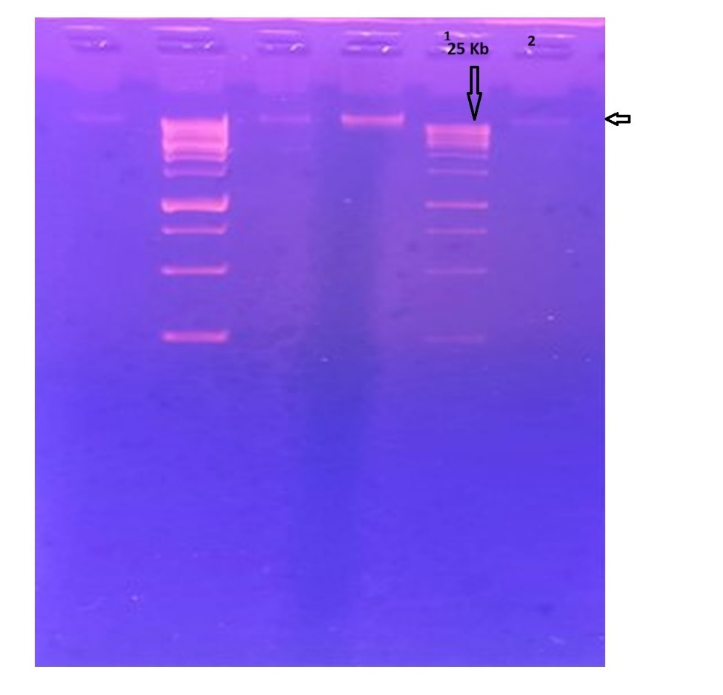
Figure 7A. Results of agarose gel electrophoresis and sodium dodecyl sulfate‒polyacrylamide gel electrophoresis; the ɸEcM-vB1 phage genome, as detected by agarose (0.7%) gel electrophoresis. Lane 1 shows the XLarge DNA ladder (Gene DireX) and lane 2 shows a band of phage DNA with a size of approximately 30-40 kb

Figure 7B
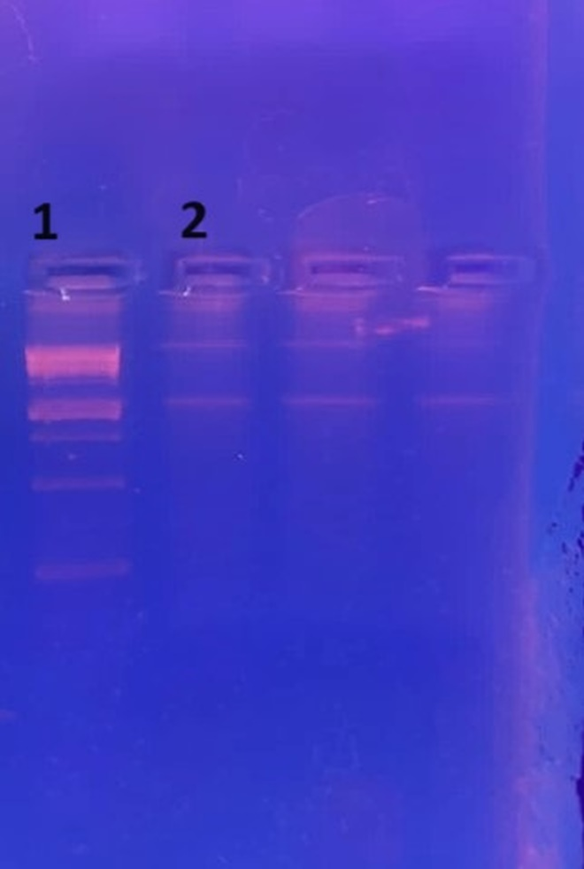
Figure 7B: Results of agarose gel electrophoresis and sodium dodecyl sulfate‒polyacrylamide gel electrophoresis Lane 1 shows a 1 kb DNA ladder (New England Biolabs) and lane 2 shows the ɸEcM-vB1 phage DNA restriction analysis with EcoR1;
Figure 7C
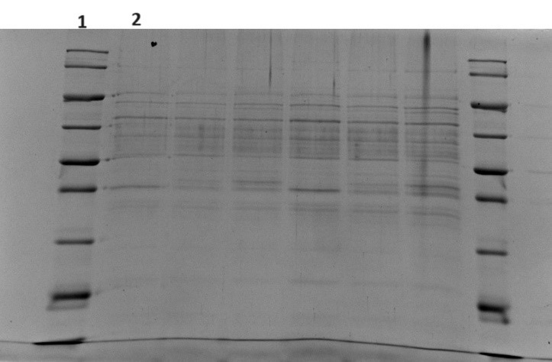
Figure 7B: The Image shows the SDS-PAGE analysis of the ɸEcM-vB1 phage structural proteins; lane 1 shows broad range protein molecular weight markers (The Novex™️ sharp pre-stained protein standard,Life Technologies) and lane 2 shows the ɸEcM-vB1 phage proteins

