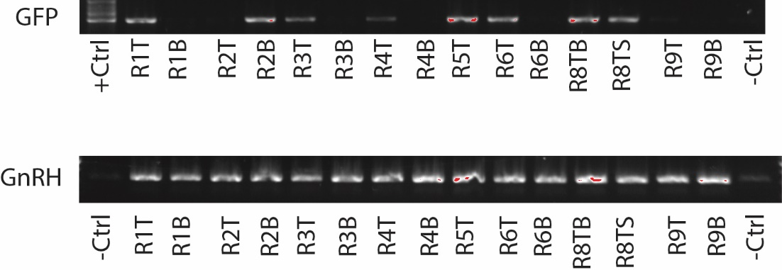
Supplementary Figure.1 Genotyping of 8/15 GFP+ individuals (top) and GnRH control (bottom)
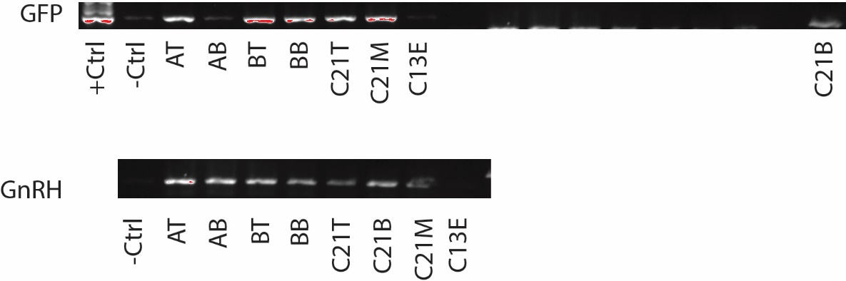
Supplementary Figure. 2 Genotyping of GFP+ F1 individuals (excluding AB and C13E) (top) and GnRH control
(bottom)

