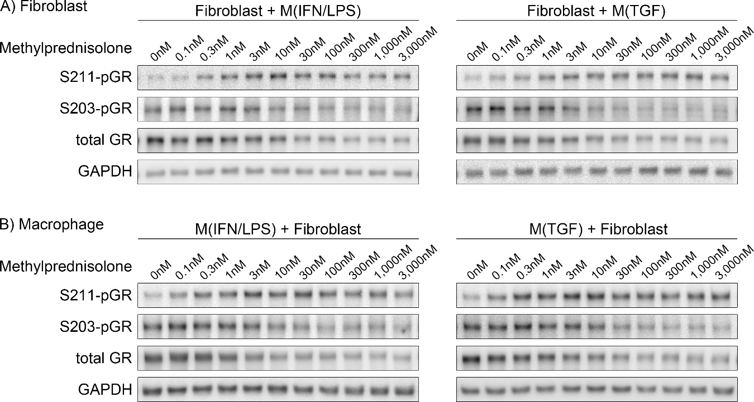

Figure S1. Western blots for S211-pGR, S203-pGR, and tGR in indirectly co-cultured human VF fibroblasts and macrophages. Human VF fibroblasts were indirectly co-cultured with M(IFN/LPS) or M(TGF) macrophages ± 0.1–3,000nM methylprednisolone for 24 hours. Protein from fibroblasts (A) and macrophages (B) was extracted separately after co-culture.

