SUPPLEMENTARY INFORMATION
Title
Time for Managed Wildfire in Europe: The Pioneering Integrated Fire Management Plan of the Aran, Pyrenees

Authors
Jordi Oliveres* ^{1,2}. Email: itbop317@gencat.cat
Marc Castellnou ^{2,3}
Xavi Castellarnau ²
Martí Rosas-Casals ¹
Lluís Brotons ^{4,5,6}
Andrea Duane ^{3,4}

Affiliations
¹ Institute for Sustainability Science and Technology, Universitat Politècnica de Catalunya – Barcelona Tech, Jordi Girona 31, Barcelona, 08034, Barcelona, Spain.
² Catalan Fire and Rescue Service (CFRS), GRAF Team. Avinguda de Serra Galliners, s/n (Universitat Autònoma de Barcelona), 08193 Cerdanyola del Vallès, Spain.
³ Department of Agricultural and Forest Engineering, Universitat de Lleida, Alcalde Rovira Roure 191, 25198 Lleida, Spain.
⁴ Forest Science Centre of Catalonia (CTFC), Carretera vella de Sant Llorenç de Morunys km 2, 25280 Solsona, Lleida, Spain.
⁵ Ecological and Forestry Applications Research Center (CREAF), Campus de Bellaterra (UAB) Edifici C. 08193 Cerdanyola del Vallès, Spain.
⁶ The Spanish National Research Council (CSIC), 08193 Cerdanyola del Vallès, Spain.

Supplementary Information

Environmental Fire Flow (EFF)

As a novel concept, the EFF has been inspired by the field of water management, more specifically by the environmental flow concept (Tickner et al., 2017; Scanlon. 2003). We have designed and established two paths for implementing prescribed fire. On the one hand, prescribed burns represent the conventional way. On the other hand, we have managed wildfires, a counterintuitive strategy that represents the innovative framework. Modulating fire suppression efforts in mild weather conditions is an appealing but hotly debated strategy to use unplanned ignitions and associated fuel reduction to create opportunities to suppress large fires in future adverse weather conditions (Regos et al. 2014). Thus, changing responses to unplanned/aleatory ignitions provides a largely unexplored but vital opportunity to restore landscape conditions and reduce future risk. However, from the generic idea of "let a fire burn" to defining a concrete resolution that is viable and safe in its practical implementation, there is a remarkable qualitative leap and, simultaneously, the recognition of a differentiated creative niche for emergency managers. Effectuating this change in fire management is challenging because ambiguity and incomplete information surround issues of responder safety, suppression effectiveness, and performance measurement (Thompson et al., 2018). In this strategic leap, the tactical ability is capital, and thus, the concretion of the Where, the When, the Quantity, the How, and the Who.

In the main manuscript, we have defined Environmental Fire Flow as «the quantity, quality, and timing of fire flow required to guarantee self-organizing processes at the landscape level to preserve the common goods of a specific socioecological system, » which implies that to be applicable in management, EFF must be translatable to specific actions, must have traceability in space and time, and must be monitorable. Also, regarding the case study, «common goods» deals with socioecological resilience against severe wildfire events, active conservation of biodiversity richness, and conciliation of interests and reciprocity between social agents represented in the Aran community.

Proposed as a standard for fire management and to support decision-making, the EFF arises from five geo-referenced variables that, in its practical sense, should be easy to understand and follow for the community of fire experts. These five proposed variables are capacity, power, fire behavior, seasonality, and recurrence. Altogether, they constitute the way to characterize the quantity and quality of fire flows.

- The Quantity has an area connotation and is measured in hectares. We make two sub-differentiations:
- Capacity (CA): it is a proxy for spread potential and refers to the accumulated manageable area when considering prescribed fire in a specific sector.
- Power (P): the maximum area burned in a single episode, measured in hectares/day or episode. Thus, it includes the variable of time upon the area burned. It refers to the maximum burned area when considering prescribed fires in a specific area (prescribed power).

- The Quality has a standard connotation, and it arises from three different variables:
- Behavior (B), in this case, as a proxy of intensity.
- Seasonality (S)
- Recurrence (R).

We do not detail these three variables intrinsic to quality since all three are widely described in the bibliography (Arno. 1994; Agee. 1998) and are well-known among fire professionals.

The primary motivation for implementing an EFF policy in the case of the Aran deals with the regeneration of pastures and extensive control of scrub populations. This action counterposes the landscape homogenization trend, significantly reducing high-intensity fire behavior and severity at a landscape scale. Hence, the EFF standard of the Aran does not include management within dense forests, apart from isolated wooded patches within the dominant matrix of scrub and pastures. Relating to these wooded patches in the fire management areas, the prescription is limited to low/medium-intensity surface fires, preventing fire from consuming deep organic soil as much as possible and tolerating occasional torching in dense tree patches.

To better understand the EFF policy in its practical sense, it is necessary to focus on the scope of action of the FMP. It includes the whole of the Aran, identifying the areas susceptible to management with prescribed fire and the areas where conventional suppression will be systematically applied. The planned period of the FMP covers ten years from its approval. However, the modeling considers 20 years, a broader timeframe for a better understanding of collateral effects and landscape dynamics.

In parallel to modeling, the analysis provided by emergency experts has been crucial to determining the sizing of respective management areas, following a conservative criterion to choose limits of confinement based on natural boundaries/anchorages as much as possible. This analysis follows the methodology inherent to fire polygons (Arilla et al. 2023), a preliminary approach to the methodology of Potential Operational Delineations proposed by Thompson et al., 2022. This expert’s analysis provides certainty about the ability to control the fire within the expected propagation limits. In practice, prescribed fire experts affirm that depending on environmental conditions and field decision-making (snow level, time lag fuel classes, among others), the executed EFF must fall significantly below the maximum stage (around 250 hectares per year). This magnitude is a friendlier target compared to the 400 hectares per year (maximum scenario) proposed by the modeling).

Twelve fire management areas (FMA) and their respective specific management units (FMU) exist. Each FMA has a technical sheet in which the EFF parameter is specified together with other relevant aspects. Basic information also exists in geodata format to easily integrate into geographical information systems. Hence, the critical geodata can be searchable, monitorable, and adaptable for managers and operative teams from online and offline platforms in a user-friendly way. In terms of contents, each FMA follows the structure listed below:

- Name and general geophysical characteristics.
- Goals of management.
- General map.
- Vegetation types and structures.
- Safety aspects.
- Limits of confinement and types.
- Details of the burning units included (FMUs).
- Operational recommendations.
- Prescription details such as environmental conditionings, fire-specific goals, favorable and unfavorable management scenarios, range of acceptable results, the pertinent EFF, or the framework window, among others.
The following figures illustrate information gathered within FMA technical sheets. In this case, the FMU A and B were partially managed during the Canejan Fire (2023/03/16), representing the first register of managed wildfires formally implemented in Europe (Canejan fire movie, additional file).

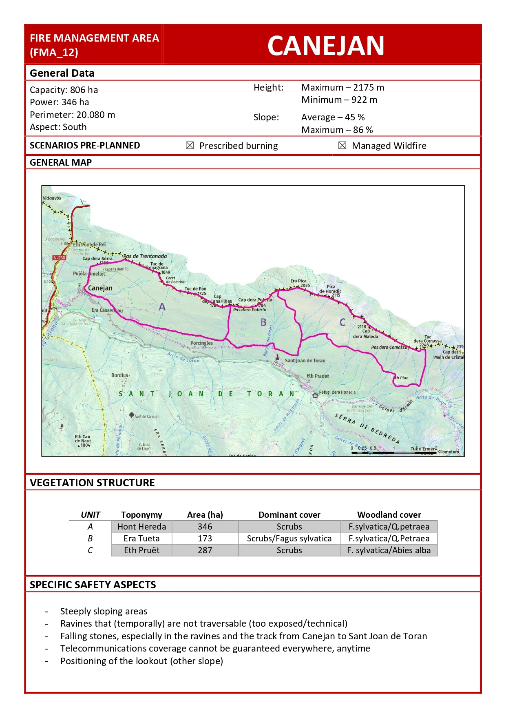
Supplementary Figure 1. Illustration of common general data linked to FMA technical sheets and, specifically, the FMA of Canejan. It defines the approved pre-planned scenarios, differentiating between prescribed burning, managed wildfire, or both ways in a compatible manner, among other information. Source: FMP of the Aran.
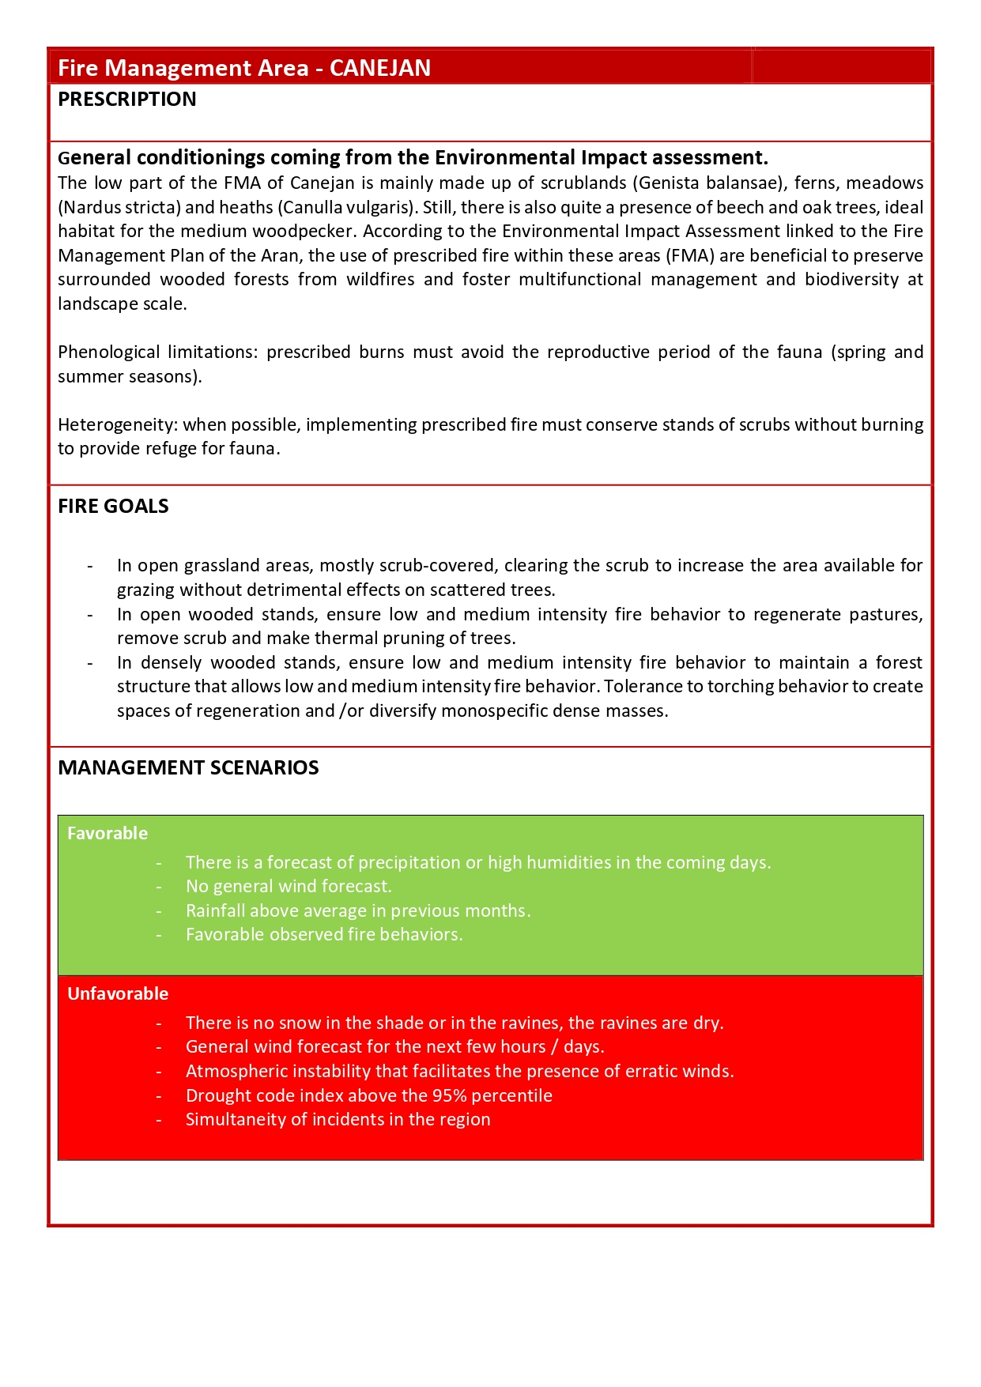
Supplementary Figure 2. Illustration of general prescriptions and favorable/unfavorable management scenarios linked to the FMA of Canejan. Source: FMP of the Aran.
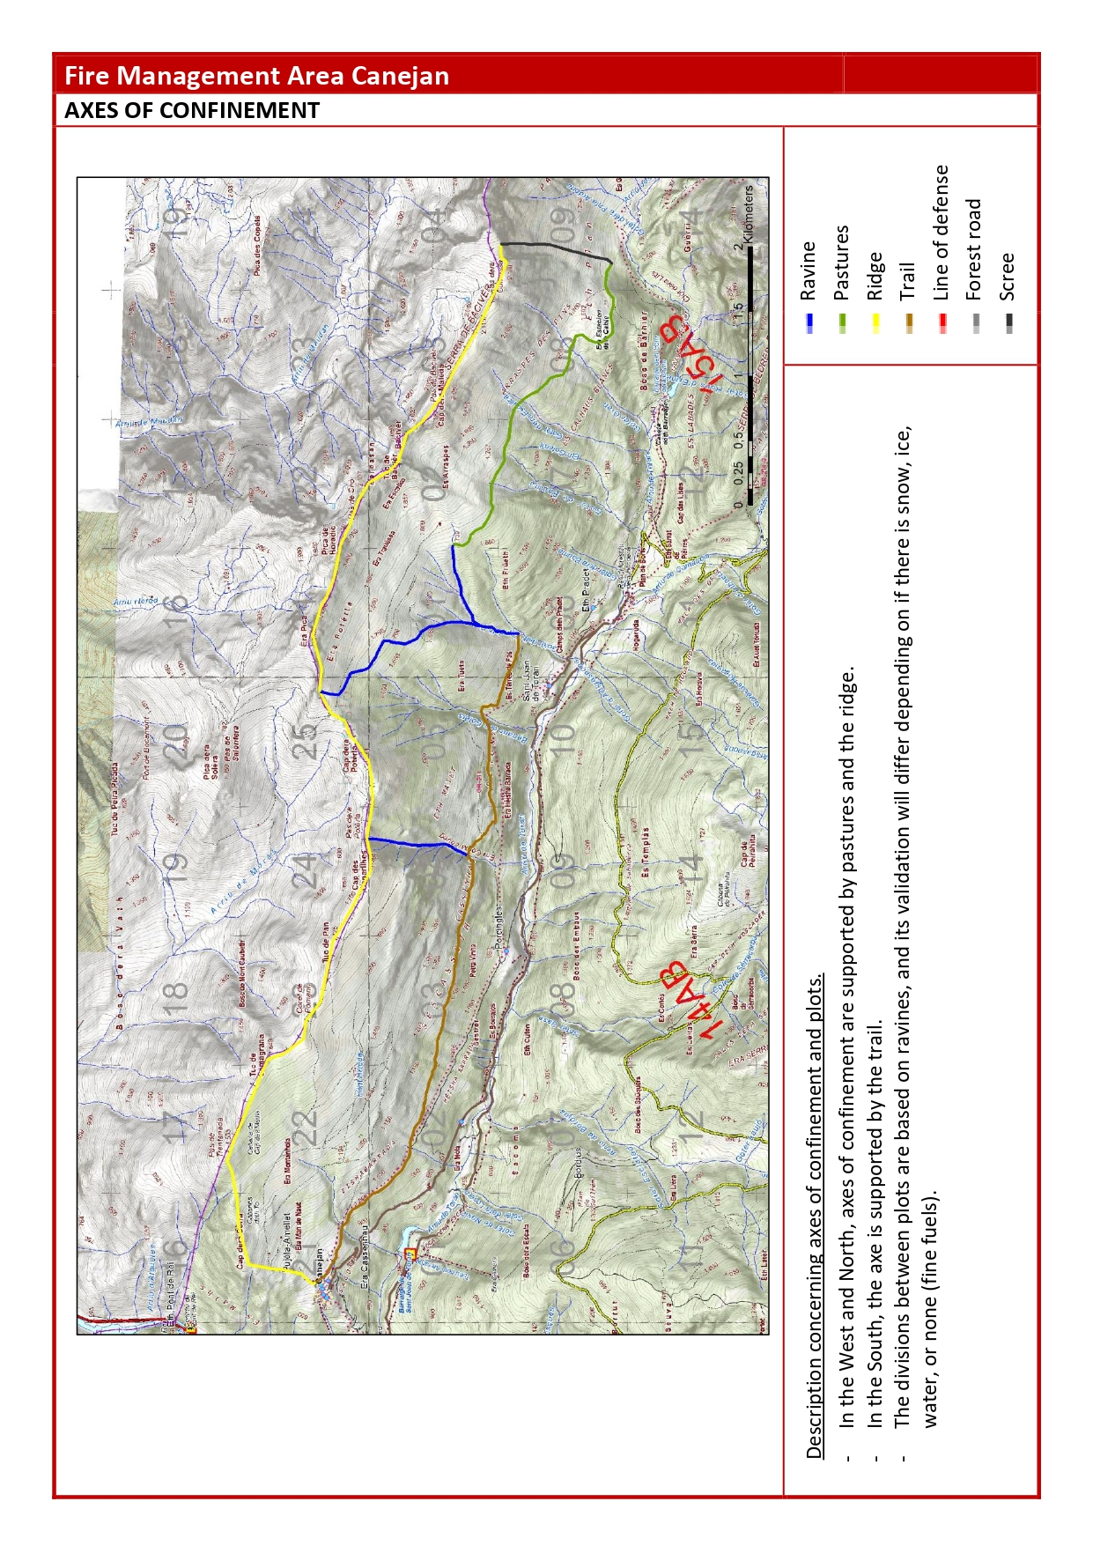
Supplementary Figure 3. Illustration of axes of confinement linked to the FMA of Canejan. Source: FMP of the Aran.
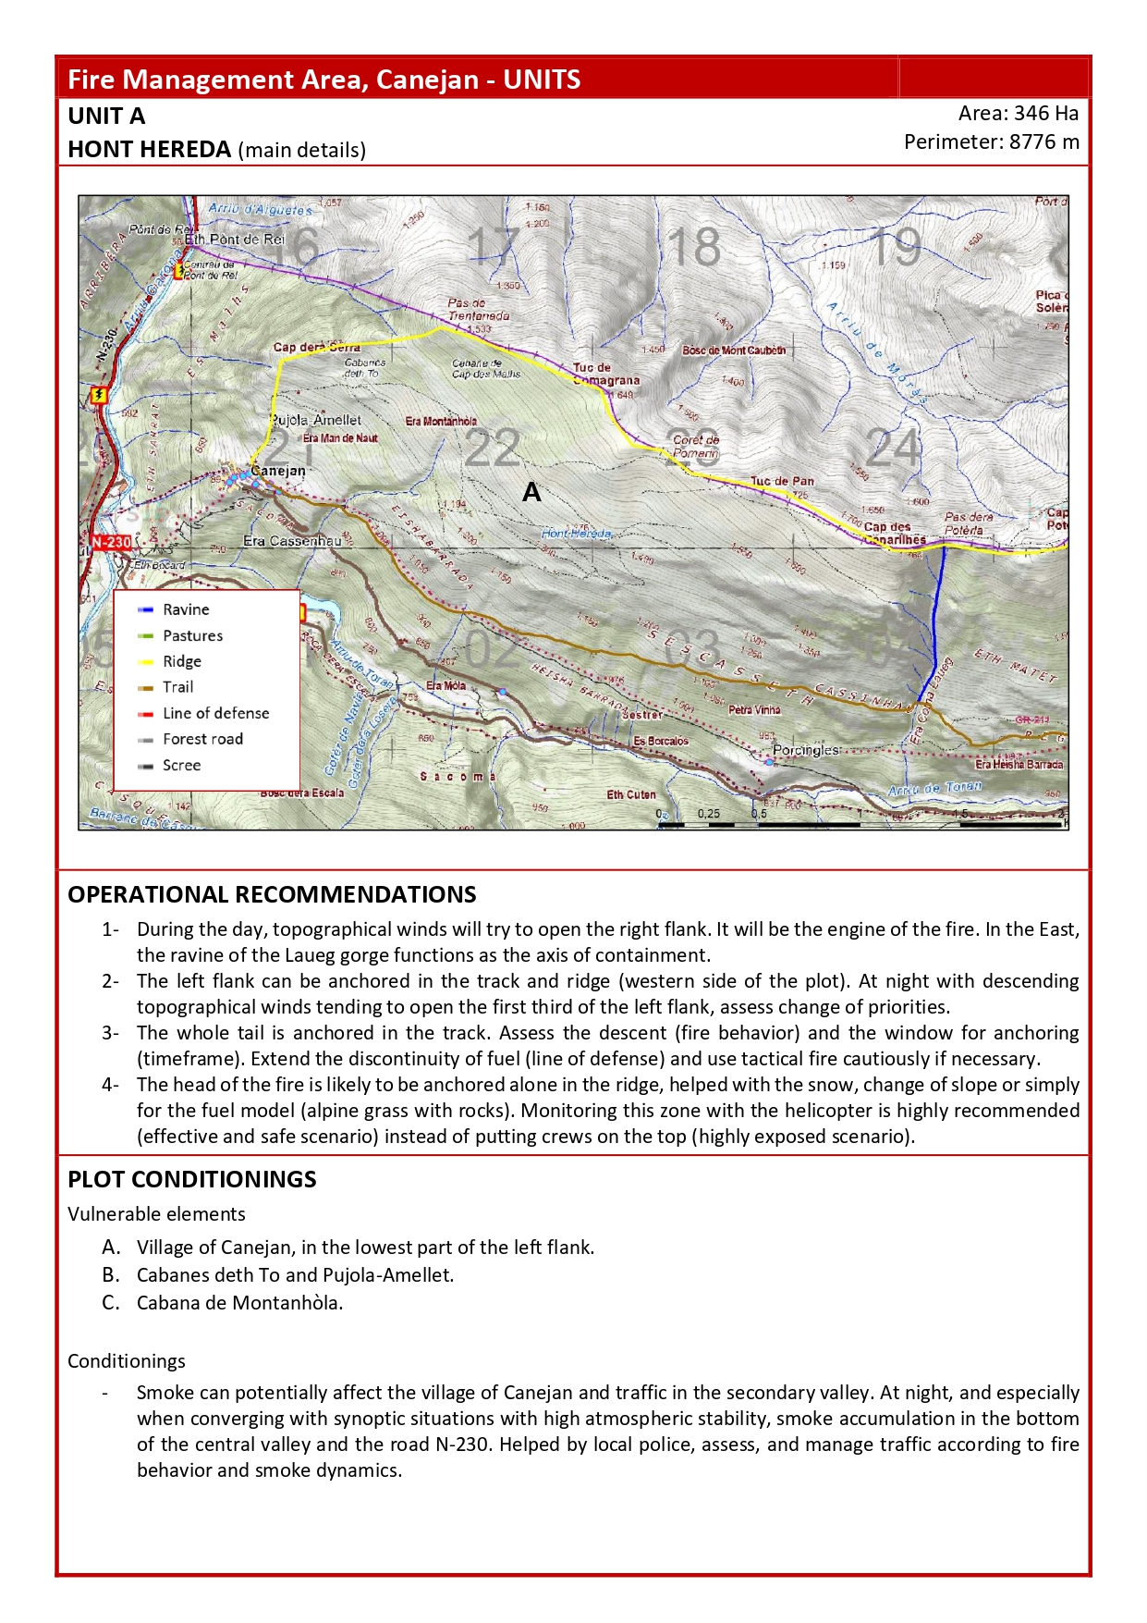
Supplementary Figure 4. Illustration of operational recommendations and plot conditionings linked to the FMA of Canejan and, specifically, to the FMU known as Hont Hereda. Source: FMP of the Aran.
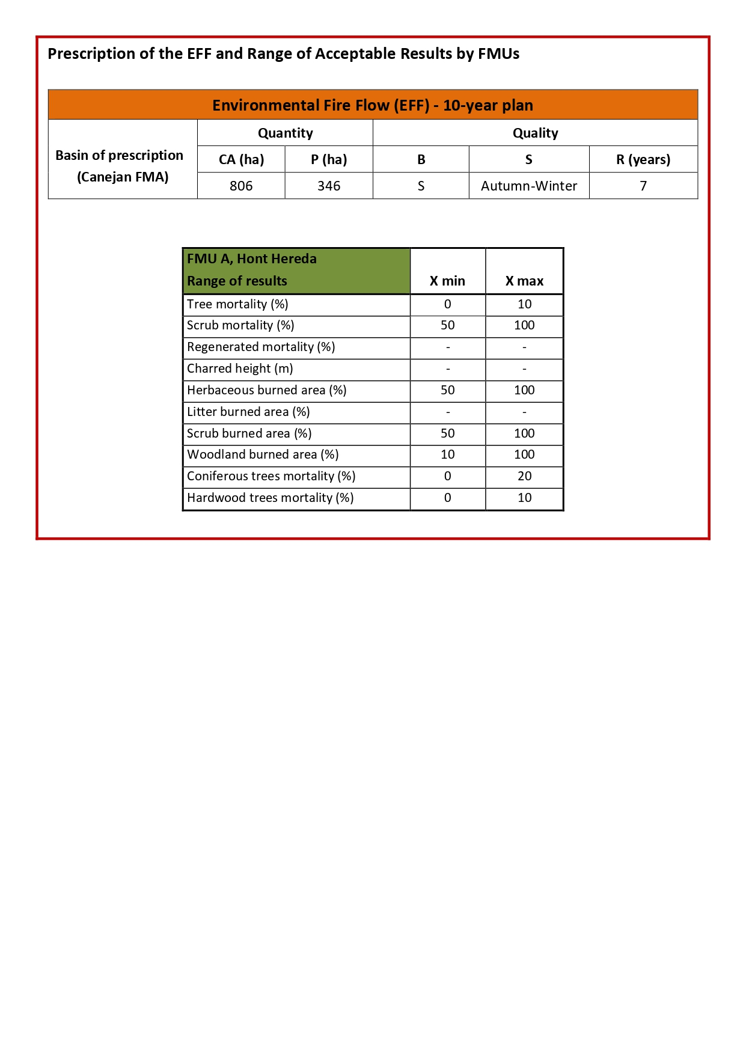
Supplementary Figure 5. Illustration of EFF prescription explicitly defined at a level of FMU, in this case, corresponding to the FMU Hont Hereda located within the FMA of Canejan. Additionally, it shows the range of acceptable results for this unit, the FMU Hont Hereda. Source: FMP of the Aran.

The MEDFIRE ARAN model
The model aims to reproduce the Aran fire regime (spatial and temporal fire patterns) based on the relationship between wildfires, climate, and landscapes (Duane et al. 2020). The final goal is to assess changing fire regimes and their impacts because of spatial interactions between climate and management (including landscape management and fire suppression strategies). The model works for the whole Aran territory. Spatial resolution is 100 meters, and temporal resolution is one year. Within a year, a sequential order of events arises scheduled (more details in the Description section). Two state variables define each pixel and may change over the years:

- LCFM: Land cover and forest map. For each pixel, the main cover typology is described, and if the cover is a forest, it includes the main forest tree species (mixed stands are not included).
- Age: It captures the number of years since the last disturbance. If no disturbance has been reported, it describes vegetation age for vegetated pixels or a large, unmeaningful number for artificial lands.

Other spatial constant variables also influence some of MEDFIRE Aran's processes:

- DEM: Digital elevation model in meters
- Aspect: four categories of pixels aspect (N, S, W, and E)
- Slope: the maximum slope of each pixel according to maximum elevation differences in degrees.
- Summer radiation: average summer radiation for June-July-August months, in kKJ·m⁻²·day·micrometer
- Ignition probability: ignition probability in the area calibrated according to the official ignitions database and landscape variables. Probability between 0 and 1 (see below for details about the calibration of the layer)

Two main processes are implemented in the MEDFIRE Aran model: the fire submodule and the vegetation dynamics submodule.

- Fire submodule.
  - Wildfires: The fire regime is modeled by a top-down approach, where both the target annual burnt area and the fire size distributions depend on synoptic weather conditions and landscape features. Both distributions (annual burnt area and fire size) are calibrated with historical data in the Aran. In this region, three different synoptic weather conditions are related to wildfire activity: winter windy fires, winter topographic fires, and summer topographic fires. Past drought conditions also influence annual burnt areas and fire sizes: drought can be mild or severe in winter and summer. Thus, for every year and season, the model first selects the type of summer or winter (mild or severe) from a distribution. This distribution is calibrated from historical data and can change in the future. Then, the model simulates fires in the three synoptic weather conditions each year (first winter windy fires, then winter topographic fires, and finally summer topographic fires). The annual target burnt area is selected from a distribution calibrated with historical data for each synoptic weather condition. A maximum area of 5000 hectares per year is chosen to avoid unrealistic values that could arise from a statistical distribution. Wildfires are simulated once an annual target burnt area is selected in synoptic weather conditions until the total potential burnt area is reached. First, an ignition point is selected for each wildfire according to the ignition probability map. A potential fire size is selected from the historical distribution in each synoptic weather condition. Fire spreads from the ignition point until the selected fire size according to windy or topographic fire spread patterns. Four factors affect the spread: vegetation combustibility, slope, aspect, and wind direction, with different weights according to the type of spread pattern (Duane et al., 2016). The current work has re-calibrated the combustibility of vegetation (more details in the Initialization section). Wind direction is randomly chosen for each fire according to the following criteria: in topographic fires, wind direction is equally probable in all eight directions (N, NE, E, SE, S, SW, W, and NW). For windy fires, 33% are Northern wind, 33% Northwestern and 33% western winds (related to historical weather data). Wildfires can burn in high intensity or low intensity as a function of 1) the type of weather year (severe drought years always burn in high intensity) and 2) the rate of spread, which depends on the values of the four factors affecting propagation. The threshold for low or high-intensity burning is 0.35 [0-1], corresponding to the value that simulates 85% of high-intensity fires in the whole of Catalonia. Pixel age always becomes 0, regardless of whether it burns high or low intensity.

  - Controlled burns. Controlled burns are simulated every year after wildfires, mimicking autumn burns. The number and location of controlled burns are emergent in the model, but the total amount burnt every year is a parameter in the model. The amount burnt every year is calculated according to an EFF selected by the user: according to the total burnt area in the previous seven years (both in controlled burns and wildfires), the model burns as much as necessary to reach the EFF. The burns’ initial location follows the same criteria as wildfires (ignition probability map), and they follow a topographical spread, always burning in low intensity. The pixel age becomes 0.

  - Fire suppression. Wildfires stop when they reach their potential fire size: this mimics a situation where conditions have ameliorated (weather, topography, etc.) so the fire suppression bodies can stop the fire. However, fires can also be stopped before reaching the potential burnt area if they reach a low-fuel area, meaning pixels with less than seven years since the last disturbance. These areas suppose opportunities for fire suppression according to previous fire activity, and the final effective fire size becomes smaller.

- Vegetation dynamics submodule
  - Post-fire establishment. After a wildfire, vegetation in each burnt pixel can remain the same or change. The probability that a burnt species persists in the same pixel depends on its functional traits (serotiny, fire-stimulated germination, resprouting, or none). If it cannot persist, another species is chosen, according to a transition matrix calibrated for the Aran valley. However, since within the same fire, successional paths are similar due to local covariates, 40% of postfire establishment is done by spatial contagion (we want to avoid a salt-and-pepper effect within the same burnt area).
  - Afforestation grassland-shrubland. The probability of a grassland pixel becoming a shrubland (mimicking the natural succession with the lignification of plants) is simulated according to a probabilistic logistic function (probability of becoming a shrubland (1) instead of remaining a grassland (0)) calibrated in the Aran Valley with landscape data.
  - Afforestation shrubland-forest. The probability of a shrubland pixel becoming a tree-type forest (mimicking the natural succession) is simulated according to a probabilistic logistic function (probability of becoming a forest (1) instead of remaining shrubland (0)) calibrated in the whole of Catalonia using landscape data.

Initialization

State variables and constant spatial variables.
- Land Cover and Forest Map. The map is based on the Land Cover Map of Catalonia 2009. Original classes have been reclassified to broader classes (defined in Table S3.1.), and a spatial generalization to match the 100-meter pixel has been made using the Mode criteria (source in 30-meter resolution). The dominant tree species for forest areas has been elected using data from the Spanish National Inventory 3rd edition, more specifically, using the basal area.

Code | Description | Land Cover | Burnability | Dynamism
1 | Ps | Forests | Burnable | Dynamic  (it can change within MEDFIRE Aran)
2 | Pu | Forests | Burnable | Dynamic  (it can change within MEDFIRE Aran)
3 | Aa | Forests | Burnable | Dynamic  (it can change within MEDFIRE Aran)
4 | Qh | Forests | Burnable | Dynamic  (it can change within MEDFIRE Aran)
5 | Fs | Forests | Burnable | Dynamic  (it can change within MEDFIRE Aran)
6 | Other threes * | Forests | Burnable | Dynamic  (it can change within MEDFIRE Aran)
7 | Shrublands | Shrublands | Burnable | Dynamic  (it can change within MEDFIRE Aran)
8 | Grasslands | Grasslands | Burnable | Dynamic  (it can change within MEDFIRE Aran)
9 | Harvesting pastures | Harvesting pastures | Burnable | Static (always the same)
10 | Bare soil | Bare soil | Non-burnable | Static (always the same)
11 | Water | Water | Non-burnable | Static (always the same)
12 | Urban | Urban | Non-burnable | Static (always the same)

Supplementary Table 1. Land Cover and Forest Map Categories. (* Other trees category represents typical broadleaf stands such as Betula pendula or Quercus robur).

- Age Map. The initialization of the forest pixels is based on the maximum height per pixel according to a Lidar flight in the area in 2005. The age has been calculated according to the regressions proposed by Gil-Tena et al. 2016 based on stand height. For the burnt areas in the last 20 years, years since the last fire have been selected. For unburnt grass and shrub pixels, we have selected the age of 20 years, which is the period in which we have data of fire activity at least.
- Probability of ignition map. The probability of ignition has been calculated as a function of elevation, slope, and solar radiation (a good proxy of average vegetation dryness). We used ignition localization data from 1987 to 2017 and adjusted a logistic model, choosing non-fire ignition locations as zero. The resulting model and map are displayed in Supplementary Figure 6.

logitPigni|non-igni= -11.155 - 0.003·Elevation + 0.059·Slope -0.006·SolarRadiation

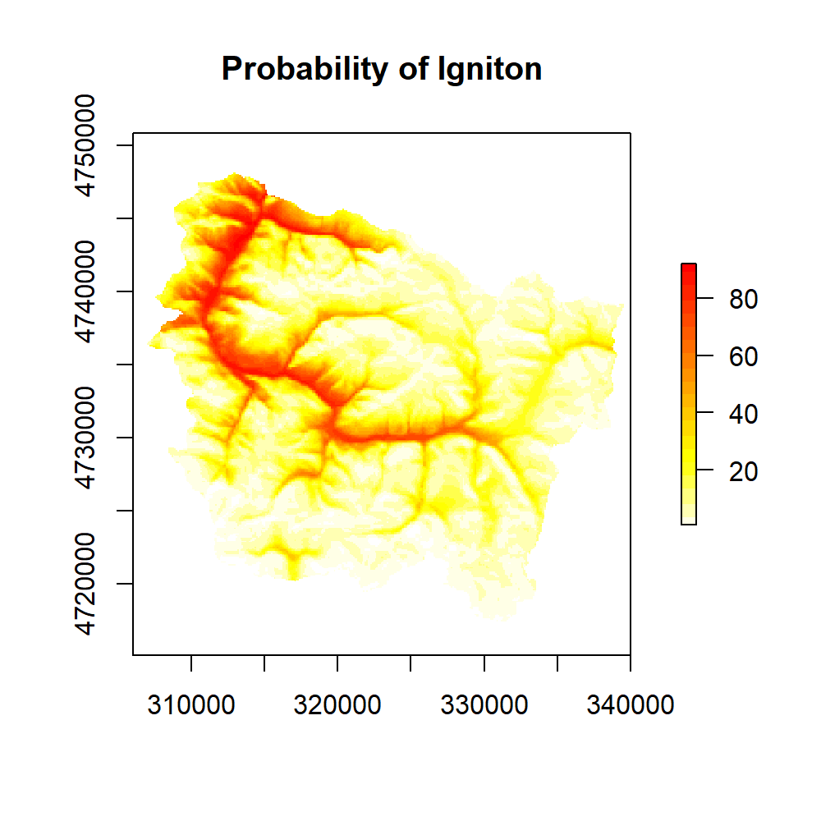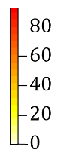
Supplementary Figure 6. Ignition model and probability map according to elevation, slope, and solar radiation. Values represent probability between 0 and 100.

We have applied a mask to restrict the fire activity to realistic areas in winter (and avoid model unprovable decisions in remote locations) so wildfires can only be initiated in grass and shrubland pixels below 1500 meters. In contrast, in summer, we have applied a mask where fires can only be initiated in forest pixels above 1500 meters (lighting fires typical in summer).

Fire submodule.
Mild or severe drought years
- Summer fires. We have selected the same criteria for the rest of Catalonia in the summer season (Duane et al. 2019). In this work, the SPEI (Standardized Precipitation Evapotranspiration Index) calculates the water deficit in all of Catalonia in spring. This index was related to wildfire activity in the whole region, obtaining a threshold from which the summer can be considered mild or severe. In this case, we have considered that predominant conditions in the region are representative of summer conditions in the Aran. Historical data shows that 45% of years are severe and 55% are mild. With climate change projections used in Duane et al. 2019, the percentage of severe years upscales to 66% in the middle of the 21st century.
- Winter fires. We have used the average temperature in the Aran for the January-February-March months each year, corresponding to the peak fire activity. Temperature data has been retrieved from the reanalysis data of the MESCAN-SURFEX-UERRA model available in the Copernicus Data Store. We have used the region's four pixels of 5.5 km falling and the local noon temperature. Using a Petit test methodology relating mean temperature and burnt area, we have obtained a threshold from which years can be considered severe or dry. According to the historical data, we obtained a threshold of 0.410C with a significant effect (p<0.05), which leads to 26% of years being severe (Supplementary Figure 7. With climate change projections, in which we evaluate the mean temperature of the three months in the Aran according to the CNRM model with the CCLM4-8-17 regionalization, we obtained that 49% of the years are severe (see Supplementary Figure 8).

- 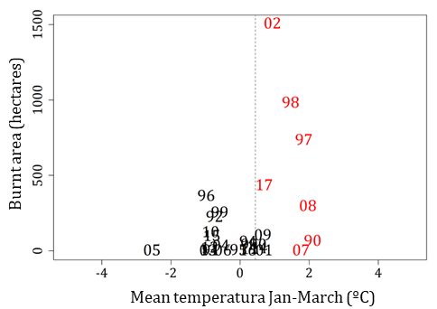

Supplementary Figure 7. The split of the years (numbers inside the plot) as a function of the mean temperature January-February-March and total burnt area each year. The vertical dashed line shows the threshold for separating mil years (black) from severe years (Red) and corresponds to 0.41⁰C.

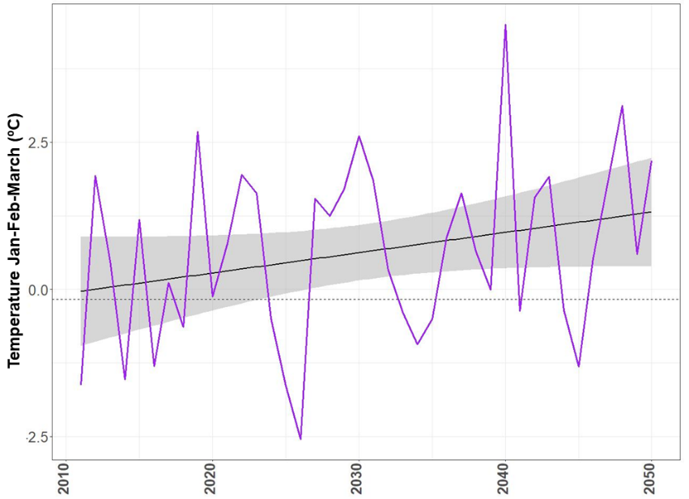

Supplementary Figure 8. Temperature evolution from 2010 to 2050 according to the CNRM CCLM4-8-17 model in the Aran valley. The black solid line shows the trend, and the horizontal dashed line shows the threshold from which a winter is considered severe (above the line).

- Annual burnt area. Annual burnt area distribution is calibrated per each synoptic weather condition and type of year (mild or severe drought). Since historical summer fires in Aran are scarce, we have used the database to cover the Catalan Pyrenean area for summer wildfires. Since the predictions project increased burnt area in summer, we wanted to include summer fires in the model using contextual data. We calibrated functions for the whole Pyrenean area and readjusted to the percentage of the burnt area the Aran represents in this region (the total annual area in a vast territory is not the same as in a portion of it). For winter fires, we have used historical fire perimeter (see the main manuscript for more details) classified according to the synoptic weather conditions in which they occurred. Once the historical annual area is obtained, we fitted a lognormal distribution for the six resulting combinations (three synoptic weather conditions and two-year types). These types of distribution have two parameters (Table 2), Lognormal parameters, for the six synoptic weather combinations. However, we have data for the simulation's first seven years, and since the model started in 2010, we have imposed the quantities specified in Table 3 corresponding to the actual burnt area in Aran.

Drought | Synoptic condition | mean log | Sd log
Mild | Winter-wind | 1.06 | 1.92
Mild | Winter-topo | 2.15 | 2.06
Mild | Summer-topo | 0.71 | 0.99
Severe | Winter-wind | 3.16 | 2.82
Severe | Winter-topo | 3.59 | 3.14
Severe | Summer-topo | 1.39 | 1.43

Supplementary Table 2. Lognormal parameters for six synoptic weather combinations.

Year | Burnt Area
2011 | 11
2012 | 19
2013 | 0
2014 | 14
2015 | 96
2016 | 0
2017 | 432

Supplementary Table 3. Actual burnt area between 2011 and 2017

- Fire size distributions. Once the potential burnt area is fixed, wildfires are simulated until reaching that burnt area. Each wildfire has a size selected from a distribution that follows a power-law shape. This function relates the fire size logarithm with the logarithm of the number of times that size is surpassed, and they are negatively related linearly (Supplementary Figure 9). Parameters of the fitter distributions are displayed in Table 4.

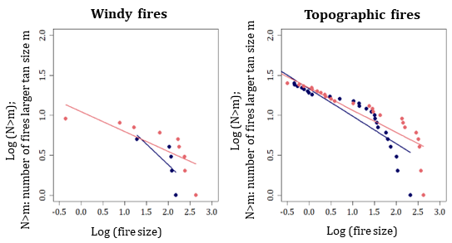

Supplementary Figure 9. Fire size distributions follow a heavy-tailed distribution according to drought conditions (blue – mild, red – severe).

Type of year | Type of spread pattern | intercept | slope
Mild | Winter-wind | 1.42 | -0.52
Mild | Winter-topo | 1.33 | -0.34
Mild | Summer-topo | 1.70 | -0.69
Severe | Winter-wind | 1.05 | -0.25
Severe | Winter-topo | 1.34 | -0.28
Severe | Summer-topo | 1.61 | -0.50

Supplementary Table 4. Power law distribution parameters for the six weather combinations.

- Vegetation flammability. The effect of vegetation characteristics on wildfire spread is a whole research world. Although Rothermel, Scott, and Burgan's models are usually used, their effectiveness is often questioned because of their lack of relation with reality. In addition, this classification is based on physical parameters of spread, which is not the case in this work. Here, thus, we used an approach to fuel flammability according to the main tree species, which acts as an indicator of species flammability, structure, average humidity, etc., based on the values obtained in Duane et al. 2016, the values for the current tree species have been assigned according to expert criteria with official firefighters in the area (Table 5).

Cover | Spread in mild years | Spread in severe years
Pinus sylvestris | 0.5 | 0.6
Pinus uncinata | 0.4 | 0.5
Abies alba | 0.4 | 0.5
Quercus humilis | 0.5 | 0.6
Fagus sylvatica | 0.4 | 0.5
Other threes * | 0.4 | 0.5
Shrublands | 0.9 | 0.9
Grasslands | 0.8 | 0.8
Harvesting pastures | 0.7 | 0.7
Bare soil | 0 | 0
Water | 0 | 0
Urban | 0 | 0
Supplementary Table 5. Flammability of main covers in MEDFIRE Aran.

- Prescribed fire sizes. As mentioned in the description section, the controlled burn number and location emerge in the model according to the annual burnt area and the probability map. However, each prescribed burn (PB) has a size chosen from a distribution. We have adjusted a lognormal distribution using the official PB dataset (Supplementary Figure 10) but only burns above p90 (above 11.5 hectares) since these are the typical sizes in the Pyrenees (in contrast to more metropolitan burns). The mean is 3.13, and the standard deviation is 0.48.

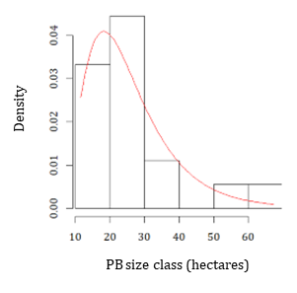

Supplementary Figure 10. Prescribed fire size class distribution

Vegetation submodule
- Postfire transition matrix. After a wildfire, the capacity of a species to persist is evaluated according to the species' functional traits. If the species cannot persist, another species is chosen based on the most common transitions in the Aran (Table 6). Values in Table 6 are based on the transitions described in Brotons et al. 2013 derived from Rodrigo et al. 2004 and adapted to the Aran according to expert criteria. If a wildfire is to happen in a short period, this matrix can be altered. For a short period, we refer to 15 years for forest stands (shrublands and grasslands are not considered affected since they always transition to grasslands). If a fire occurs within 15 years, the pixel will become a shrubland since we consider that species do not have either the seeds or the carbon reserves to persist.

Post-fire  Pre-fire | Ps | Pu | Aa | Qh | Fs | Other trees | Shrublands | Grasslands | Total
Ps | 0.130 |  |  | 0.335 |  | 0.335 | 0.200 |  | 1
Pu |  | 0.130 |  | 0.335 |  | 0.335 | 0.200 |  | 1
Aa |  |  | 0.130 | 0.335 |  | 0.335 | 0.200 |  | 1
Qh |  |  |  | 0.930 |  |  | 0.070 |  | 1
Fs |  |  |  |  | 0.930 |  | 0.070 |  | 1
Other trees |  |  |  |  |  | 0.930 | 0.070 |  | 1
Shrublands |  |  |  |  |  |  |  | 1 | 1
Grasslands |  |  |  |  |  |  |  | 1 | 1
Supplementary Table 6. Persistence and post-fire transitions matrix. Ps (Pinus sylvestris), Pu (Pinus uncinata), Aa (Avies alba), Fs (Fagus sylvatica)

- Afforestation from grassland to shrubland and shrubland to forest. Forest succession from shrubland was already calculated by Gil-Tena et al. 2016, in which they calculated a logistic regression for a shrubland to become a forest (1) or stay as a shrubland (0) according to shrubland age, slope, solar radiation, and amount of mature forest around the evaluated pixel. Mature forests are considered 15 years for conifer species and four years for Fagaceae. The area around the evaluated pixel is considered 500 meters. The type of tree species selected in this pixel will be based on the proportion of the different species around the evaluated pixel but doubling the colonization effect of conifers. The probability of becoming a shrubland from a grassland was not evaluated before. We have sampled 30 spots in the Aran, which the 2009 land cover map determined to be grasslands. In 2019, we visited the spots and checked whether they were still grasslands or shrublands that had colonized them. Then, we have fitted a logistic model calculating the probability of becoming a shrubland (1) or staying a grassland (0). Predictors are elevation, slope, summer radiation, grassland age, and the amount of forest or shrublands around the evaluated pixel (150-meter radius) (Table 7). Grassland’s age was derived from historical fire perimeters.

Predictor | Units | Source
Elevation | m | DEM
Slope | ⁰C | DEM
Summer Solar Radiation | 10 kJ / (m2·day·micrometer) | DCAC
Mature vegetation 150 m around | 0 to 8 pixels | LCMC 2010
Age | Years | Fire perimeters

Supplementary Table 7. Logistic model predictors of the probability of evolving to a shrubland.

The logistic resulting model is the following:

logit (P_{shrubland}|_{grassland}) = 16.048 – 0.007·Elevation – 0.092·Slope – 0.006·SolarRadiation + 0.676·matureVegetation + 0.168·Age

Validation
The model was validated through a spatial overlap of the observed data with the model results to evaluate whether the model closely simulates spatial fire distribution: we used the probability of burning outcome of the model in the BAU no Climate change simulations. Since observed wildfires burned 5% of the landscape in 28 years, we searched for the pixels above the percentile 95 of the probability of burning in the simulation results (Supplementary Figure 11). We obtained a matched spatial overlap between observed and simulated data of about 35% of the area, which is lower than expected but within a range found in the literature evaluating spatial overlapping in wildfires (Duane et al. 2016; Cardil et al. 2023).

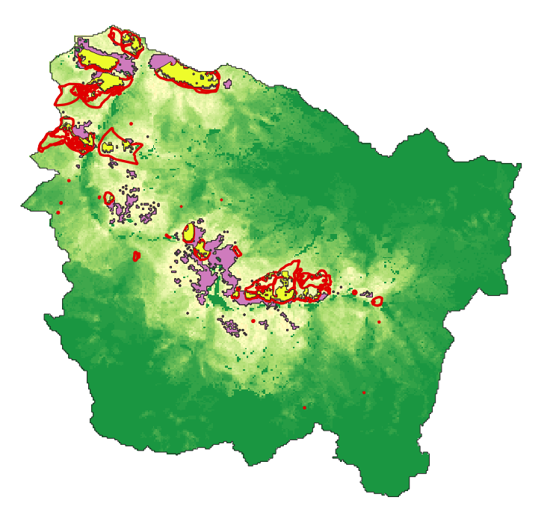
Supplementary Figure 11. Model validation. Pink polygons represent percentil95 areas of the model outputs. Red-line polygons represent the observed fires from 1990 to 2017. Yellow areas represent overlapping zones in the validation.

