Supplementary Materials
Bian X et al., Berberine-inspired ionizable lipid for self-structure stabilization and potent brain targeting delivery of nucleic acid therapeutics

Contents:
Supplementary Figures S1 to S14 pp 2-14
Supplementary Tables S1 to S5 pp 15-19

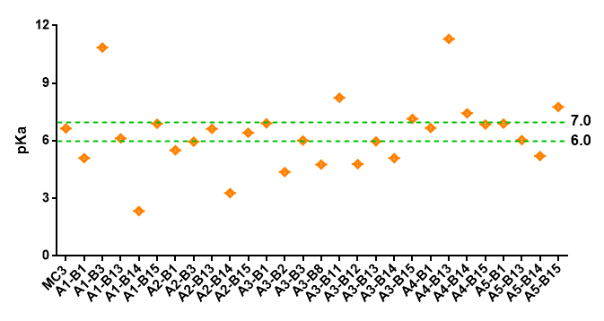
Supplementary Figure 1. pKa characterization of the size of BE <100 nm. Data are presented as means ± SD (n = 3 biologically independent experiments).

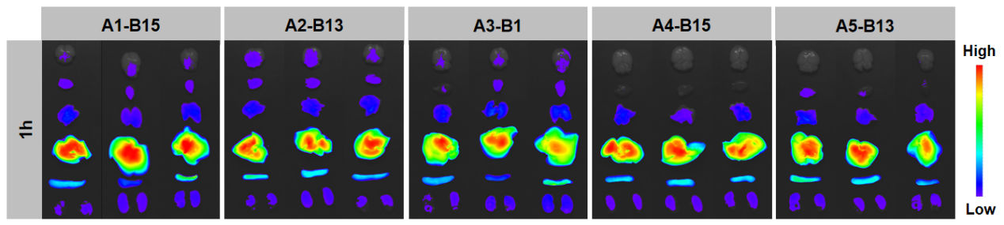
Supplementary Figure 2. Ex vivo fluorescence images of LNP@DiR after 1 h injected into mice. (n = 3 biologically independent samples).

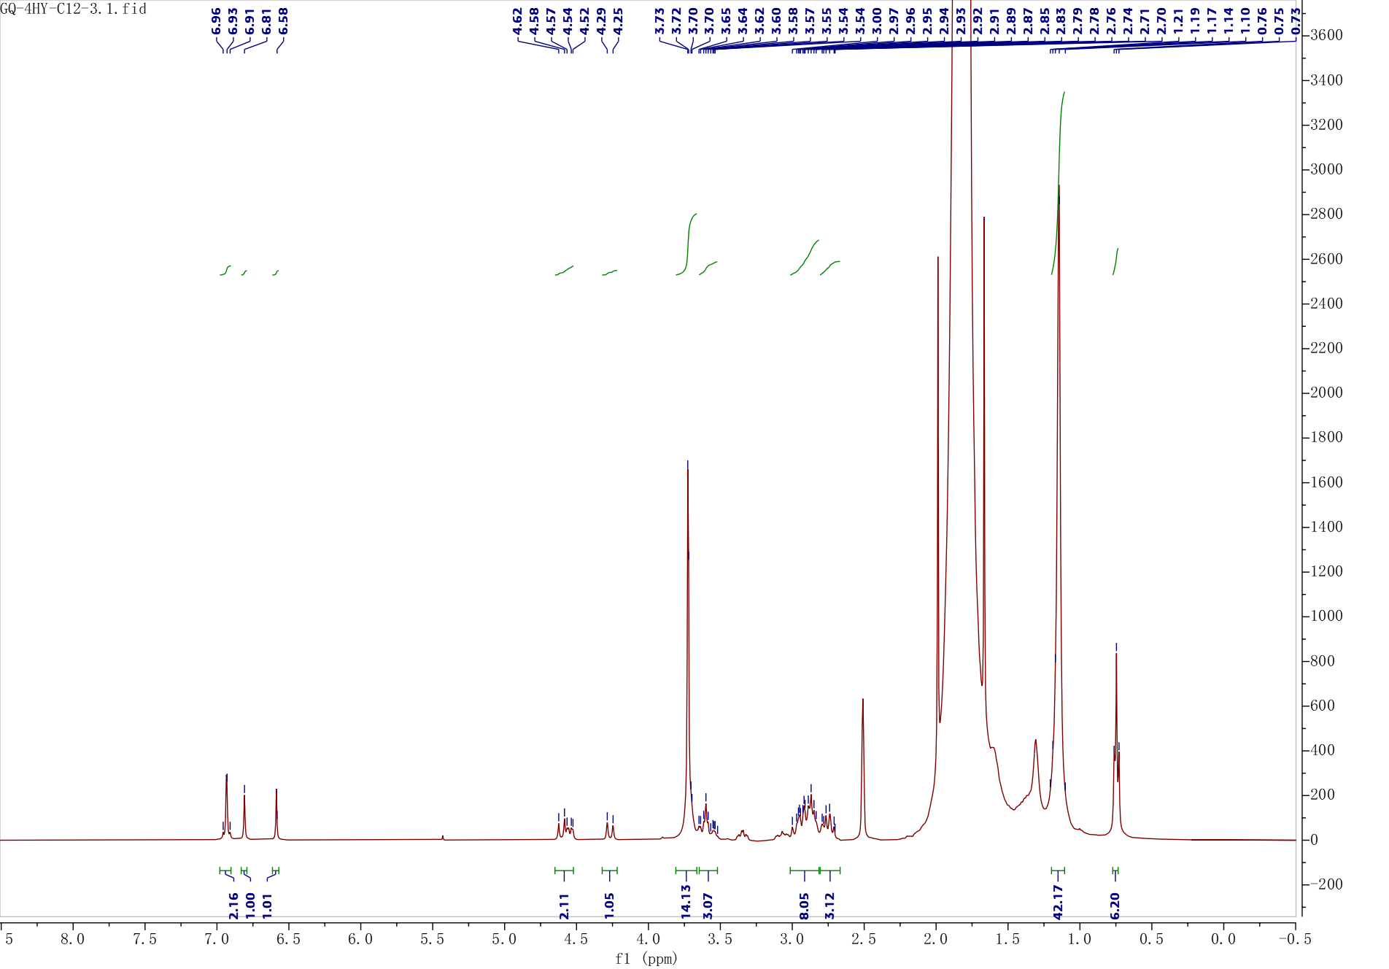Supplementary Figure 3.The compound structures were confirmed by ¹H nuclear magnetic resonance (NMR).

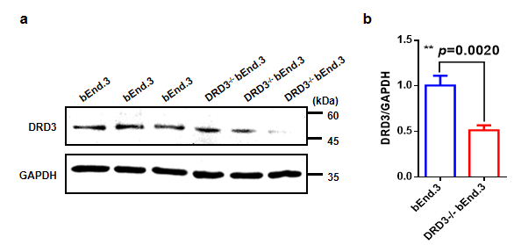
Supplementary Figure 4. Quantification of western blotting analysis of DRD3 protein expression is shown relative to GAPDH. Data are presented as means ± SD (n = 3 biologically independent samples). **P < 0.01. Statistical significance was calculated with two-tailed unpaired t-tests.

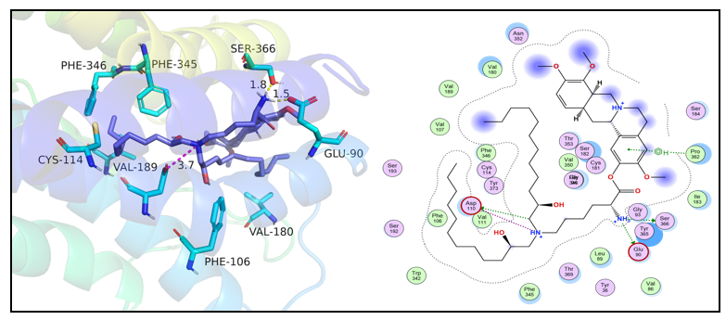
Supplementary Figure 5. Three-dimensional ligand-protein interaction mode for the binding site of DRD3 (PDB ID: 3PBL) with the leading compound A2-B13. The active site residues are shown as cyan sticks; the compound is blue, and the hydrogen-bond network with protein residues is represented as yellow dotted lines.
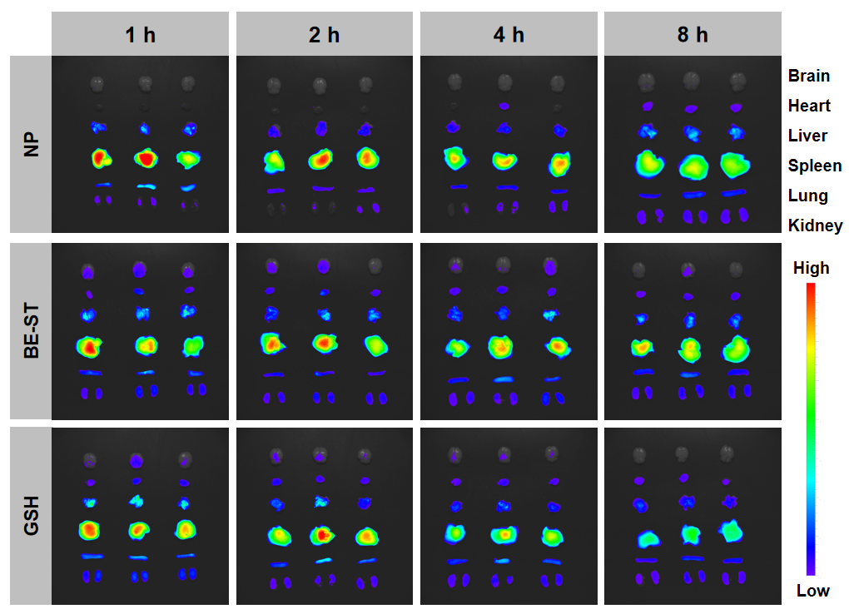
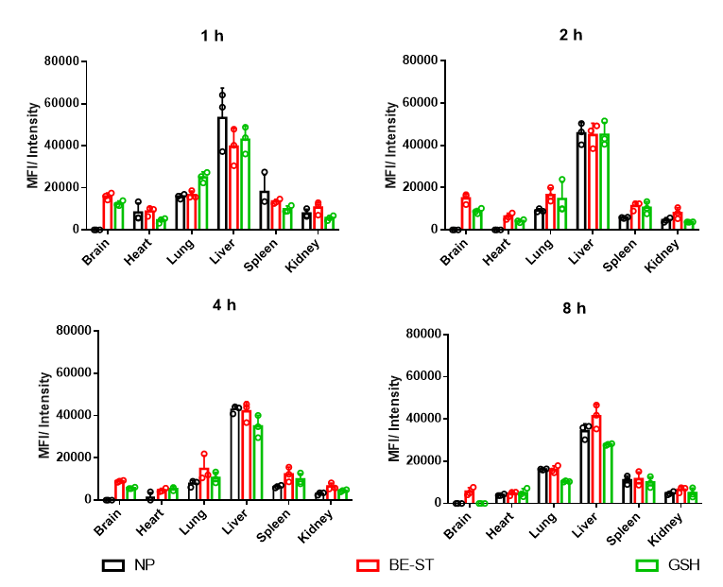
Supplementary Figure 6. Ex vivo fluorescence images of LNP@DiR after 1 h, 2 h, 4 h, 8 h injected into mice and semi‒quantitative analysis of fluorescence intensity. Data are presented as means ± SD (n = 3 biologically independent samples).
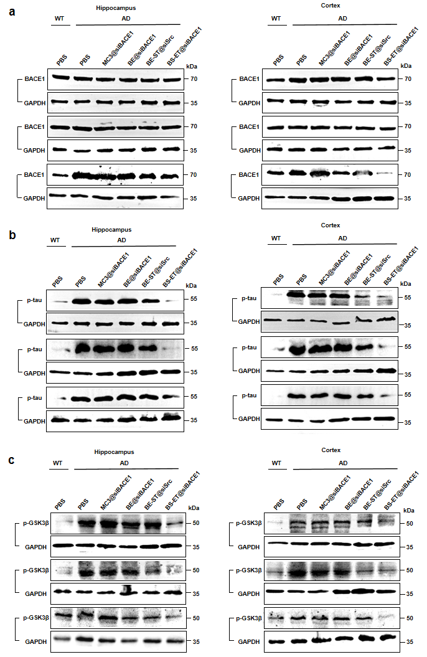
Supplementary Figure 7. Western blot data for BACE1, p-tau, and p-GSK3β protein expression quantification in the hippocampus and cortex for LNP@siBACE1-treated APP/PS1 mice, control APP/PS1 groups and WT mice. Data are presented as means ± SD (n = 3 biologically independent samples).
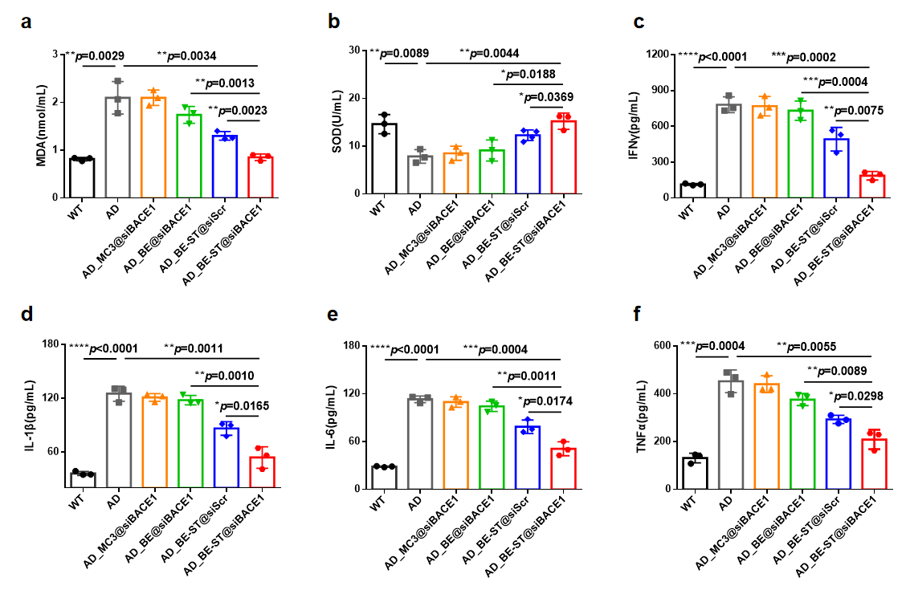 Supplementary Figure 8. (a-b) Oxidative stress markers (such as SOD and MDA) in serum were assessed. (c-f) Proinflammatory cytokines (such as IL-1β, IL-6, IFN-γ, and TNF-α) in serum were assessed. Data are presented as means ± SD (n = 3 biologically independent samples). *P<0.05, **P<0.01, ***P<0.001, ****P < 0.0001. Statistical significance was calculated with two-tailed unpaired t-tests.

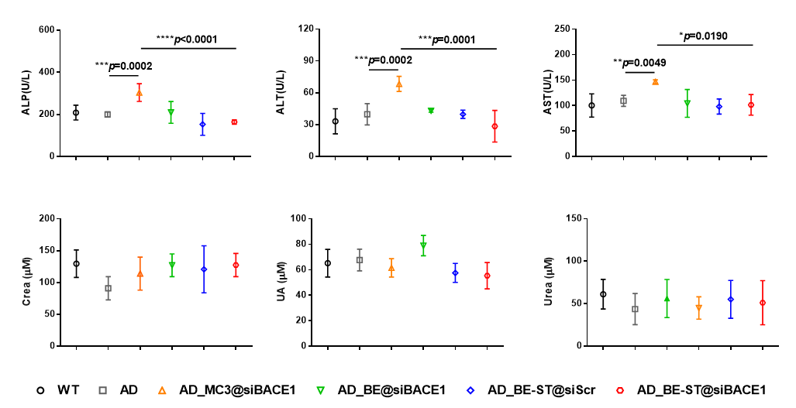
Supplementary Figure 9. Blood chemistry examinations. Assessment of plasma alanine aminotransferase (ALT), aspartate aminotransferase (AST), alkaline phosphatase (ALP), plasma urea (Urea), creatinine (Crea), and uric acid (UA) levels. Data are presented as means ± SD (n = 3 biologically independent samples). *P<0.05, **P<0.01, ***P<0.001, ****P < 0.0001. Statistical significance was calculated with two-tailed unpaired t-tests.

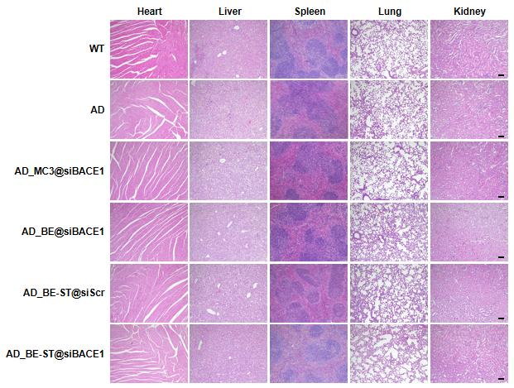
Supplementary Figure 10. Representative data for hematoxylin and eosin staining in major organs from APP/PS1 mice treated with LNP@siBACE1 or PBS.(Scale bar: 100 µm)

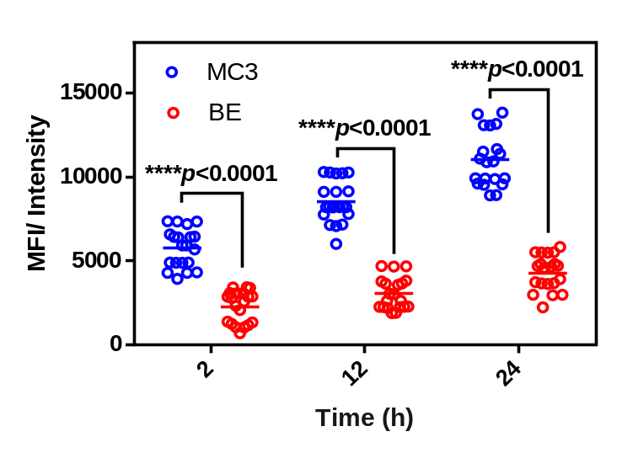
Supplementary Figure 11. Reactive oxygen species production in bEnd.3 cells after administration for 2 h, 12 h, 24 h. Data are presented as means ± SD (n = 20 biologically independent samples). ****P < 0.0001. Statistical significance was calculated with two-tailed unpaired t-tests.

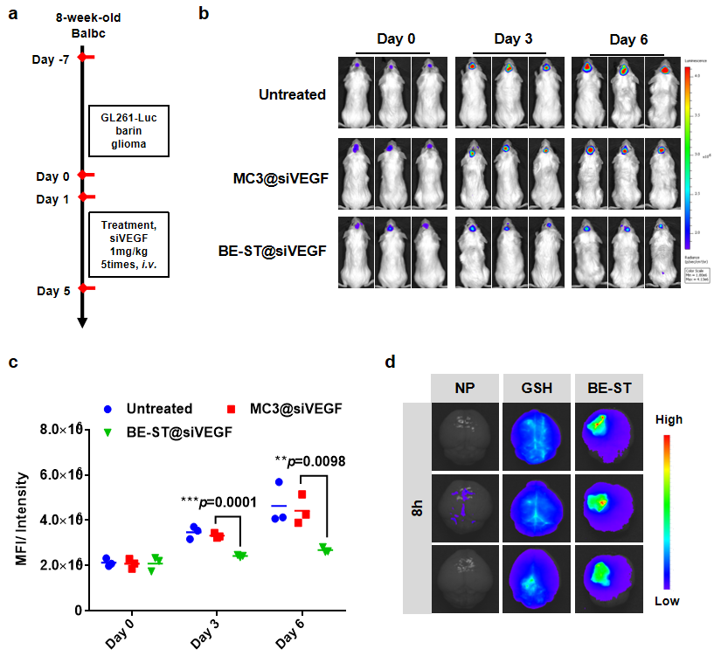
Supplementary Figure 12. (a) Schematic diagram of the experimental timeline. Mice were treated with LNP@siVEGF or PBS via tail vein injection every day (5 cycles). (b-c) Fluorescence images and quantitative analysis of live imaging. (d) Ex vivo fluorescence images of LNP@DiR after 8 h injected into mice to evaluated precise targeted to location of the lesion in the brain tumor model. Data are presented as means ± SD，n =3 biologically independent samples, **P<0.01, ***P<0.001. Statistical significances were calculated by multiple t test.

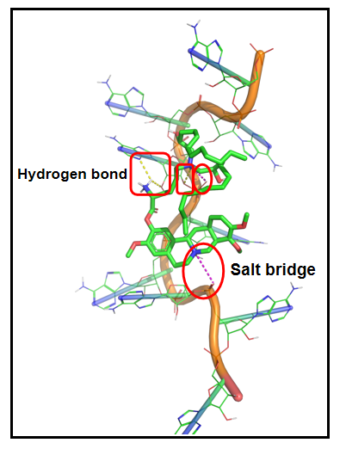
Supplementary Figure 13. Three-dimensional ligand-RNA interaction mode for the binding site of polyA with the leading compound A2-B13. The polyA chain is shown as orange, the compound is green, and the hydrogen-bond network and salt bridge are represented as yellow and pink dotted lines, respectively.

Supplementary Table 1: The molar ratios of each component in BE formulations tested in this study.
Name | Molar Ratio
Name | Ionizable  lipidoid | Helper lipid |  |  | Cholesterol | PEG -DMG
Name | Ionizable  lipidoid | DOPE | DOPC | DSPC | Cholesterol | PEG -DMG
1 | 49 | 30 | - | - | 20 | 1
2 | 49 | 20 | - | - | 29.5 | 1.5
3 | 49 | 10 | - | - | 39 | 2
4 | 49 | - | 30 | - | 20 | 1
5 | 49 | - | 20 | - | 29.5 | 1.5
6 | 49 | - | 10 | - | 39 | 2
7 | 49 | - | - | 30 | 20 | 1
8 | 49 | - | - | 20 | 29.5 | 1.5
9 | 49 | - | - | 10 | 39 | 2
10 | 39 | 30 | - | - | 30 | 1
11 | 39 | 20 | - | - | 39.5 | 1.5
12 | 39 | 10 | - | - | 49 | 2
13 | 39 | - | 30 | - | 30 | 1
14 | 39 | - | 20 | - | 39.5 | 1.5
15 | 39 | - | 10 | - | 49 | 2
16 | 39 | - | - | 30 | 30 | 1
17 | 39 | - | - | 20 | 39.5 | 1.5
18 | 39 | - | - | 10 | 49 | 2
19 | 29 | 30 | - | - | 40 | 1
20 | 29 | 20 | - | - | 49.5 | 1.5
21 | 29 | 10 | - | - | 59 | 2
22 | 29 | - | 30 | - | 40 | 1
23 | 29 | - | 20 | - | 49.5 | 1.5
24 | 29 | - | 10 | - | 59 | 2
25 | 29 | - | - | 30 | 40 | 1
26 | 29 | - | - | 20 | 49.5 | 1.5
27 | 29 | - | - | 10 | 59 | 2

Supplementary Table 2: Physiochemical characterizations of BE based on A3-B1, including the particle size and polydispersity index (PDI).
Name | Size (nm) | PDI
A2-B13-1 | 176.9 | 0.613
A2-B13-2 | 144.7 | 0.557
A2-B13-3 | 118.1 | 0.377
A2-B13-4 | 138.6 | 0.313
A2-B13-5 | 98.11 | 0.572
A2-B13-6 | 92.85 | 0.496
A2-B13-7 | 173.8 | 0.267
A2-B13-8 | 154.6 | 0.486
A2-B13-9 | 175.6 | 0.279
A2-B13-10 | 63.94 | 0.201
A2-B13-11 | 98.93 | 0.478
A2-B13-12 | 128.1 | 0.237
A2-B13-13 | 159.2 | 0.246
A2-B13-14 | 179.1 | 0.286
A2-B13-15 | 147.3 | 0.456
A2-B13-16 | 161.3 | 0.456
A2-B13-17 | 166.9 | 0.276
A2-B13-18 | 122.4 | 0.505
A2-B13-19 | 124.3 | 0.293
A2-B13-20 | 99.27 | 0.266
A2-B13-21 | 114 | 0.438
A2-B13-22 | 154.8 | 0.256
A2-B13-23 | 98.91 | 0.524
A2-B13-24 | 155.8 | 0.162
A2-B13-25 | 187.1 | 0.419
A2-B13-26 | 156 | 0.343
A2-B13-27 | 235.9 | 0.269

Supplementary Table 3: Physiochemical characterizations of BE based on formulation 10, including the particle size, polydispersity index (PDI).
Name | Size (nm) | PDI | Name | Size (nm) | PDI
A1-B1 | 67.64 | 0.294 | A3-B9 | 124.3 | 0.556
A1-B2 | 134 | 0.547 | A3-B10 | 139.7 | 0.295
A1-B3 | 72.09 | 0.577 | A3-B11 | 93.97 | 0.306
A1-B4 | 122 | 0.437 | A3-B12 | 67.06 | 0.46
A1-B5 | 112.7 | 0.197 | A3-B13 | 97.68 | 0.394
A1-B6 | 132.1 | 0.603 | A3-B14 | 65.97 | 0.347
A1-B7 | 218.6 | 0.264 | A3-B15 | 90.77 | 0.401
A1-B8 | 136.6 | 0.468 | A4-B1 | 73.82 | 0.32
A1-B9 | 183.6 | 0.326 | A4-B2 | 252.2 | 0.278
A1-B10 | 111 | 0.63 | A4-B3 | 118.5 | 0.198
A1-B11 | 135.6 | 0.279 | A4-B4 | 165.9 | 0.289
A1-B12 | 140.9 | 0.292 | A4-B5 | 136.4 | 0.232
A1-B13 | 70.71 | 0.278 | A4-B6 | 129.9 | 0.464
A1-B14 | 73.61 | 0.996 | A4-B7 | 210.5 | 0.358
A1-B15 | 69.97 | 0.292 | A4-B8 | 137.6 | 0.331
A2-B1 | 77.21 | 0.383 | A4-B9 | 122.7 | 0.429
A2-B2 | 273.6 | 0.669 | A4-B10 | 161.7 | 0.295
A2-B3 | 73.47 | 0.447 | A4-B11 | 230.8 | 0.367
A2-B4 | 250.2 | 0.547 | A4-B12 | 148 | 0.417
A2-B5 | 174.5 | 0.332 | A4-B13 | 79.62 | 0.35
A2-B6 | 192.3 | 0.894 | A4-B14 | 91.54 | 0.593
A2-B7 | 139.8 | 0.417 | A4-B15 | 70.17 | 0.362
A2-B8 | 210.8 | 0.322 | A5-B1 | 98.1 | 0.398
A2-B9 | 262 | 0.55 | A5-B2 | 254.7 | 0.239
A2-B10 | 103.4 | 0.363 | A5-B3 | 125.6 | 0.203
A2-B11 | 141.1 | 0.213 | A5-B4 | 146.3 | 0.272
A2-B12 | 109.4 | 0.394 | A5-B5 | 229.7 | 0.343
A2-B13 | 63.94 | 0.201 | A5-B6 | 127.9 | 0.254
A2-B14 | 84.4 | 0.418 | A5-B7 | 153.8 | 0.272
A2-B15 | 83.5 | 0.305 | A5-B8 | 183.7 | 0.255
A3-B1 | 80.08 | 0.307 | A5-B9 | 139.8 | 0.18
A3-B2 | 73.55 | 0.358 | A5-B10 | 115.6 | 0.299
A3-B3 | 71.36 | 0.45 | A5-B11 | 116.4 | 0.394
A3-B4 | 142.8 | 0.431 | A5-B12 | 164.1 | 0.292
A3-B5 | 123.8 | 0.338 | A5-B13 | 91.86 | 0.521
A3-B6 | 171.2 | 0.205 | A5-B14 | 90.35 | 0.466
A3-B7 | 151.9 | 0.346 | A5-B15 | 73.05 | 0.462
A3-B8 | 74.26 | 0.423

Supplementary Table 4: The simulative binding affinity between compound and DRD3 (PDB ID: 3PBL) protein by molecular docking.
DRD3 | K_{D} (M)
Berberine | 0.34×10⁻⁶
A2-B13 | 1.59×10⁻⁶

Supplementary Table 5: The simulative binding affinity between compound and polyA (PDB ID: 3GIB) by molecular docking.
polyA | K_{D} (M)
Berberine | 3.71×10⁻⁶
A2-B13 | 3.13×10⁻⁶

