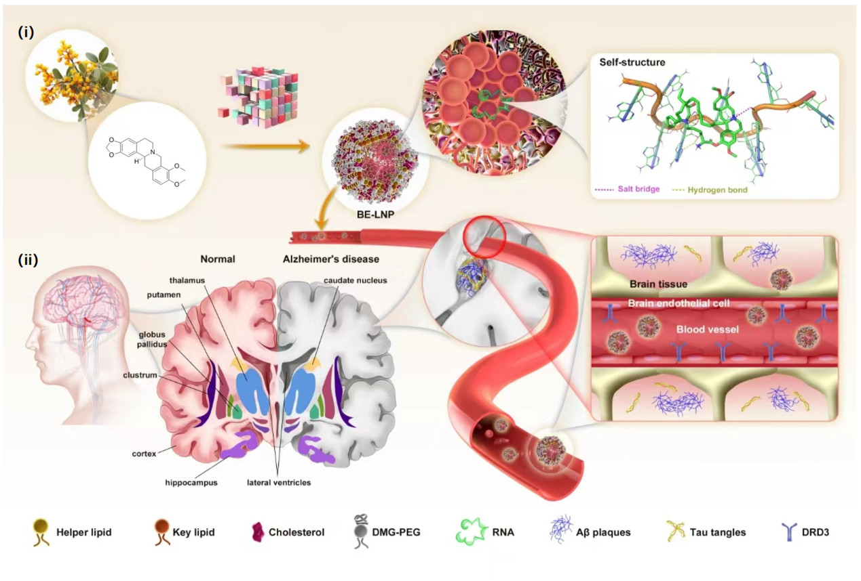
Scheme 1. Development of a berberine-inspired lipidoid nanoparticle (BE) for synergistic, targeted brain drug delivery. (i) Illustration of the construction of a three-dimensional combinatorial synthesis library and the BE@RNA complex, leveraging the high affinity and self-assembling properties of a berberine derivate and polyA. (ii) Depiction of how BE penetrates the blood-brain barrier via mediation by the dopamine D3 receptor (D3R), demonstrating the potential for targeted delivery of therapeutics for neurodegenerative disorders such as Alzheimer’s disease (AD).

