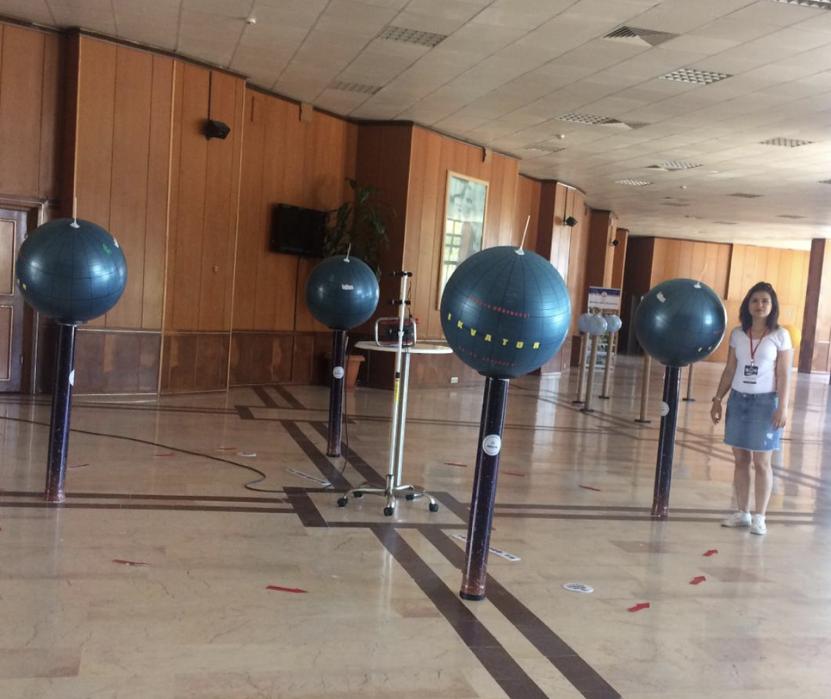

Pic 1. Model regarding the effect of the Earth's rotation and rotation on the formation of the seasons

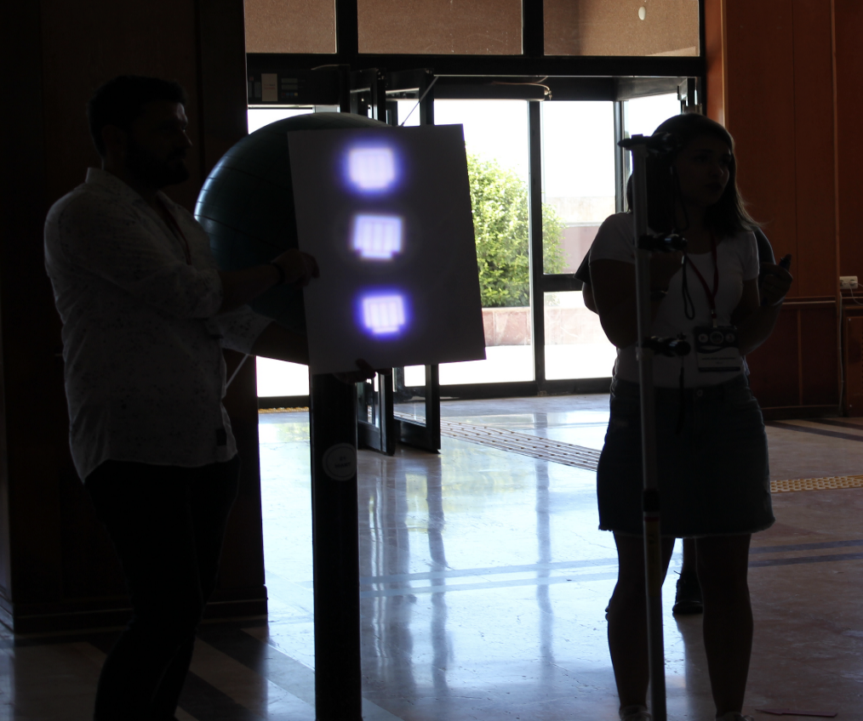

Pic 2. Model regarding the effect of the amount of energy per unit surface depending on the global structure of the Earth

