Table 6 ROC curves and learning curves of five different algorithm models
Algorithm | ROC Curves | Learning Curves
LR | 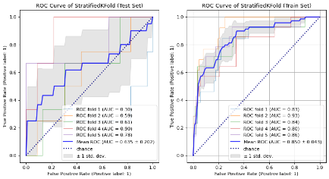 | 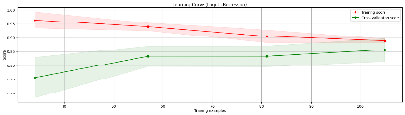
SVM | 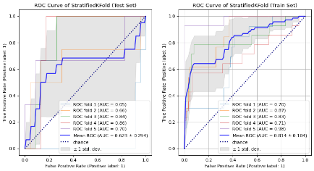 | 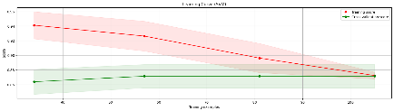
DT | 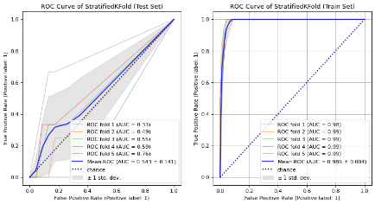 | 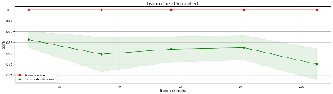
RF | 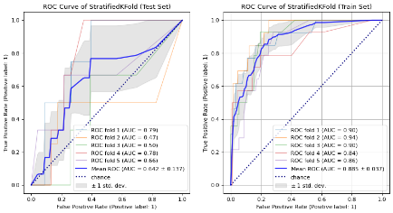 | 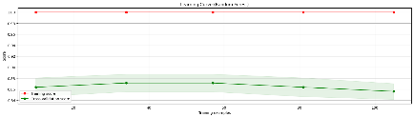
XGBoost | 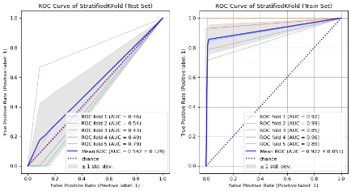 | 