Supplementary Information

Supplemental Figure 1.
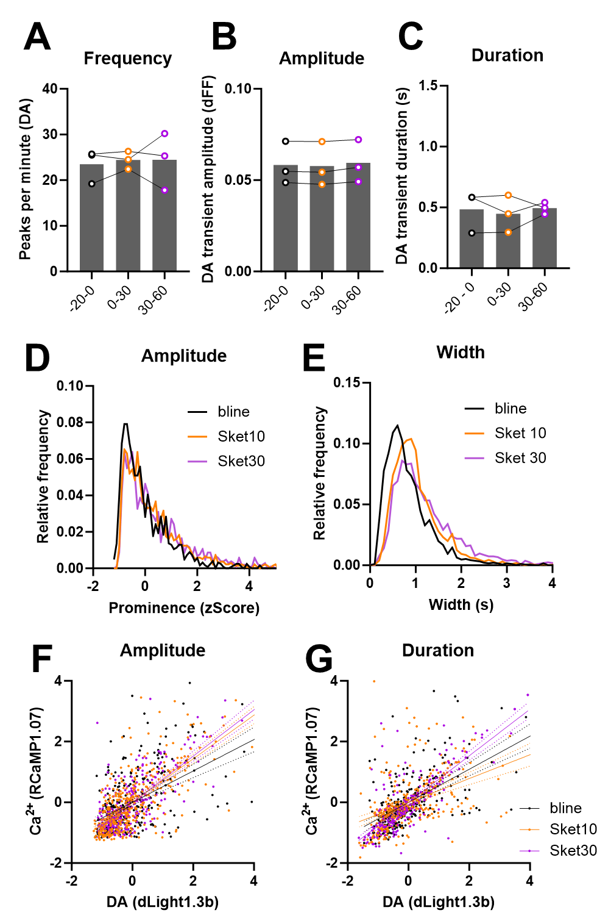
Supplemental Figure 1. (A-C) The awake Dlight1.3b photometry data was represented and normalized respect to a baseline period of 20 minutes before the first esketamine injection. Animals were previously habituated to the room, the arena and the fiber tethering, however, there could still be an effect of time in the different parameters calculated on the dopamine signal. To account for this, we ran a control experiment where vehicle (saline) was injected instead of esketamine. No effects of time were observed in frequency of the peaks (RM ANOVA: F (1.039, 2.078) = 0.1275), p = 0.76), nor their amplitude (RM ANOVA: F (1.272, 2.544) = 8.465, p = 0.07) or their duration (RM ANOVA: F (1.612, 3.224) = 0.2591, p = 0.74). (D-E) In the main text’s Figure 2, peak amplitude and duration data was summarized as the mean of each parameter per animal. Here, we report the same data as histograms of all events (dopamine transients) and confirming a shift to higher duration transients when the animals were treated with esketamine, while no change was observed in their amplitude distribution. Peak duration is represented in seconds and amplitude is represented as a z-score to be able to normalize within different magnitudes of the signal between animals (mostly due to changes in biosensor expression). (F-G) Correlation between extracellular dopamine and intracellular calcium from terminals from VTA neurons in the NAc. All correlations were statistically significant with p < 0.001 and esketamine treatment did not alter Pearson’s r coefficients on amplitude (p = 0.52) nor duration (p = 0.58).

Supplemental Figure 2.
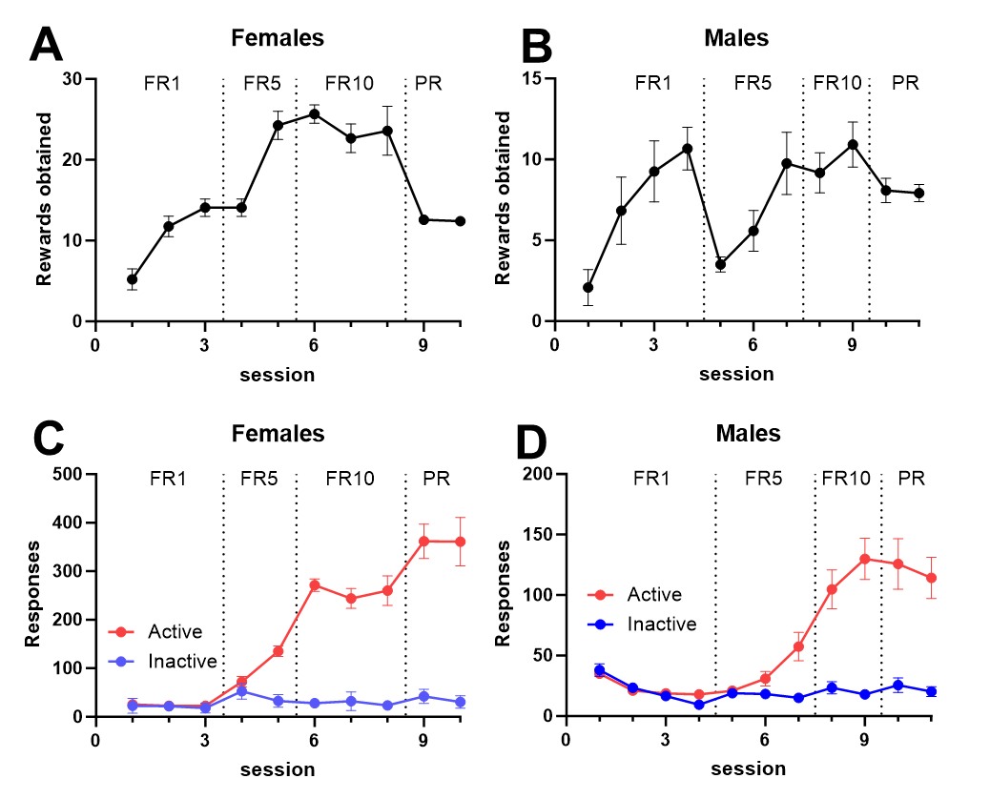
Supplemental Figure 2. Sucrose self-administration training data segregated by sex. Data is shown as mean ± SEM (error bars smaller that the data points are not shown) of the 12 males and 12 females used in this experiment (Figure 5) before any drug administration. Mice were trained on a sequence of 3 fixed ratio (FR1, FR5 and FR10) schedules before they were moved to a progressive ratio schedule (PR).

