Supplementary figures
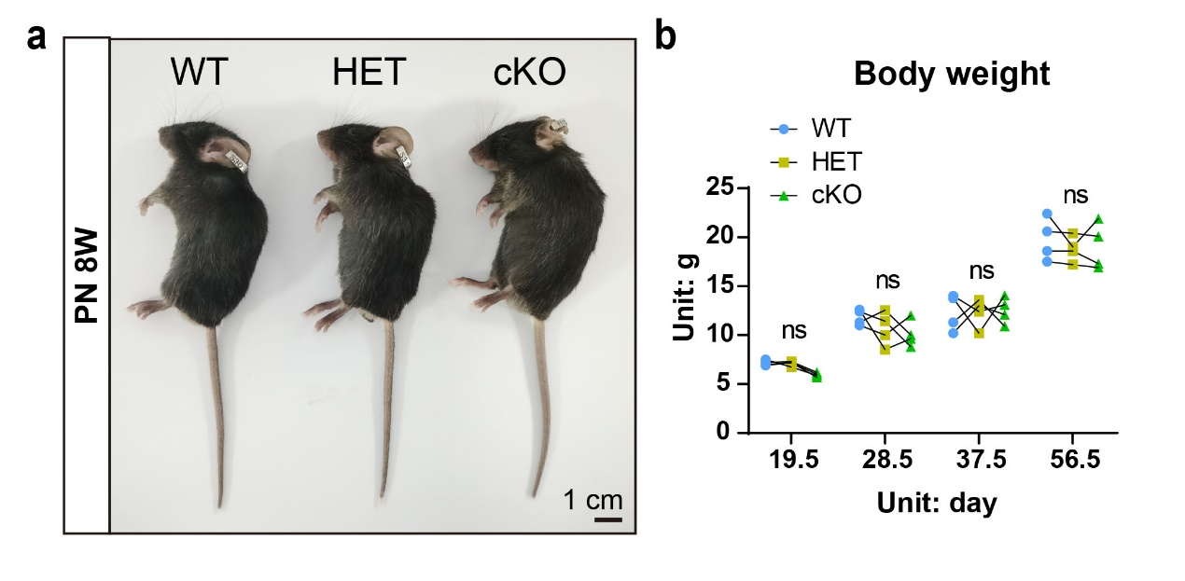
Fig. S1 No significant differences in body size or weight were observed among WT, heterozygous mice (HET), and cKO mice. n = 4. ns, not significant, p > 0.05.

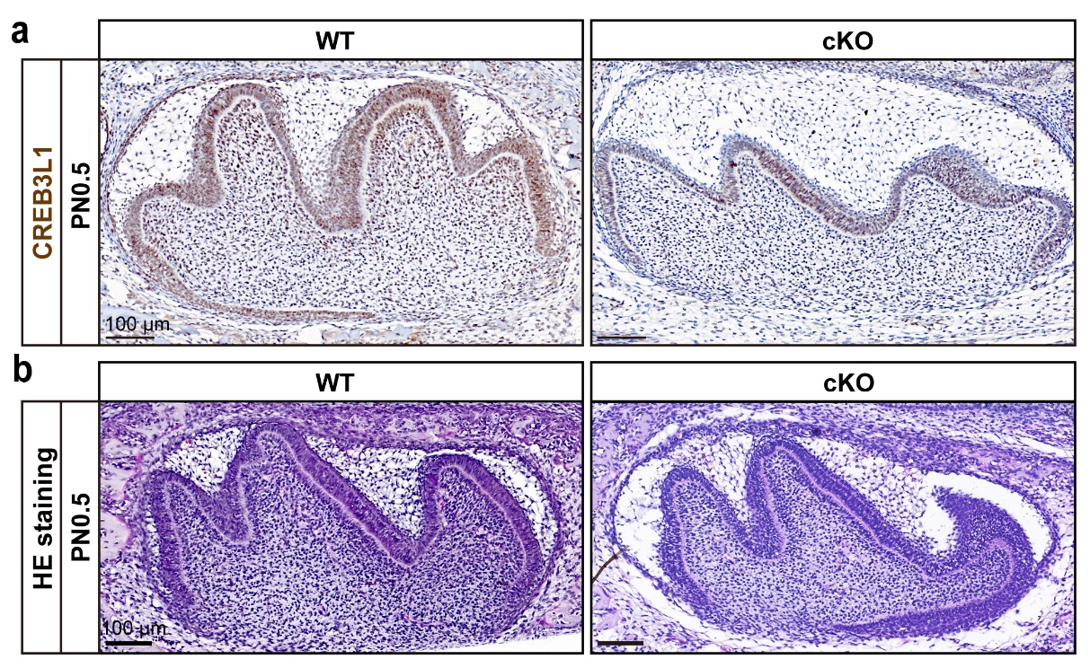
Fig. S2 Conditional deletion of Creb3l1 in the neural crest lineage revealed no difference in the first molar of PN0.5 mice. a The absence of CREB3L1 in cKO mice odontoblasts was validated by IHC staining in mandibular first molar sections of PN0.5 mice. Scale bar = 100 μm. b HE staining was performed on the first molar of PN0.5 WT and conditional knockout mice. Scale bar = 100 μm.

Fig. S3 The height of the mandible below the root furcation of the first molar was slightly decreased in cKO mice compared to WT mice. a The schematic diagram depicts the measurement site for the height of the mandible below the root furcation of the first molar. The vertical distance from the root furcation alveolar ridge to the outermost part of the mandibular bone cortex was quantified in the same section by adjusting the mandible to the same orientation. The red and yellow solid lines illustrate the height of the mandible below the first molar root furcation in WT and cKO mice, respectively. Scale bar = 1 mm. b The quantitative data for the height of the mandible below the root furcation of the first molar in WT and cKO mice at PN 3W. c The quantitative data for the height of the mandible below the root furcation of the first molar in WT and cKO mice at PN 8W. n ≥ 6. *p < 0.05; ****p < 0.0001.

Fig. S4 Micro-CT analysis of mandibular alveolar bone (MAB) from PN 3W and PN 8W conditional knockout (cKO) and wild-type (WT) mice. a The schematic diagram of the measurement sites for MAB1. The red 3D area (MAB1) represents the mandibular alveolar bone in the region between the two roots of the first molar. The green 3D area (MAB2) represents the mandibular alveolar bone between the first and second molars. b Micro-CT sections of MAB1 from WT and cKO mice at PN 3W and PN 8W. Scale bar = 1 mm. c The quantitative data of the bone volume (BV) to tissue volume (TV) from WT and cKO mice MAB1 at PN 3W. d The quantitative data of the trabecular thickness (Tb.Th) from WT and cKO mice MAB1 at PN 3W. e The quantitative data of the trabecular number (Tb.N) from WT and cKO mice MAB1 at PN 3W. f The quantitative data of the trabecular separation (Tb.Sp) from WT and cKO mice MAB1 at PN 3W. g–j The quantitative data of the BV/TV (g), Tb.Th (h), Tb.N (i), Tb.Sp (j) from WT and cKO mice MAB1 at PN 8W. n ≥ 6. ns, not significant, p > 0.05; *p < 0.05; ****p < 0.0001.
Fig. S5 Micro-CT analysis of MAB2 from WT and cKO mice at PN 3W and PN 8W. a The schematic diagram of the measurement sites for MAB. The red 3D area (MAB1) represents the mandibular alveolar bone in the region between the two roots of the first molar. The green 3D area (MAB2) represents the mandibular alveolar bone between the first and second molars. b Micro-CT sections of MAB2 from WT and cKO mice at PN 3W and PN 8W. Scale bar = 1 mm. c The quantitative data of the bone volume (BV) to tissue volume (TV) from WT and cKO mice MAB2 at PN 3W. d The quantitative data of the trabecular thickness (Tb.Th) from WT and cKO mice MAB2 at PN 3W. e The quantitative data of the trabecular number (Tb.N) from WT and cKO mice MAB2 at PN 3W. f The quantitative data of the trabecular separation (Tb.Sp) from WT and cKO mice MAB2 at PN 3W. g–j The quantitative data of the BV/TV (g), Tb.Th (h), Tb.N (i), Tb.Sp (j) from WT and cKO mice MAB2 at PN 8W. n ≥ 6. ns, not significant, p > 0.05; ***p < 0.001.
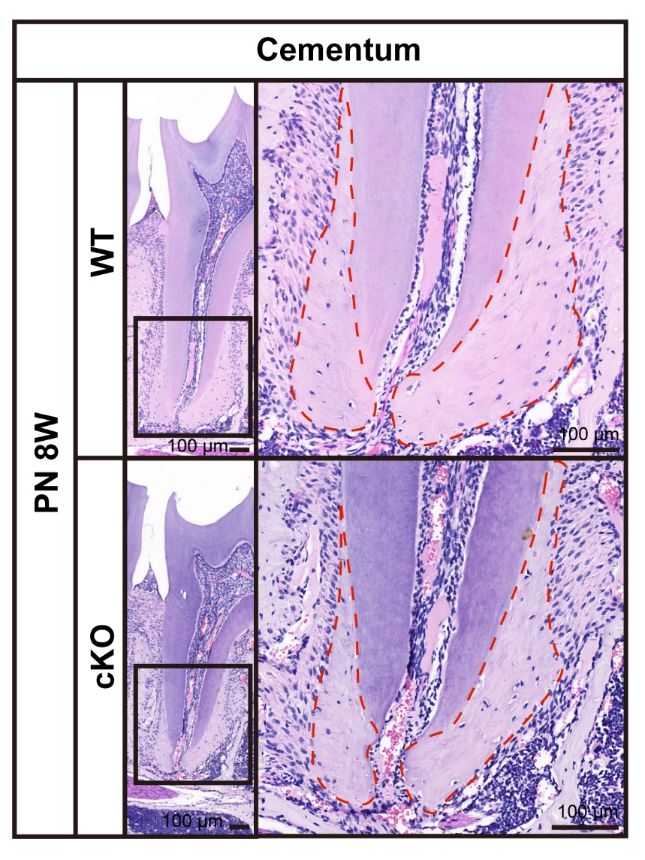
Fig. S6 The area of cementum in the first molar of cKO mice was slightly decreased compared to the WT mice at PN 8W. The HE staining of first molar roots in WT and cKO mice at PN 8W. The area delineated by the red dotted line represents the cementum. Scale bar = 100 μm.

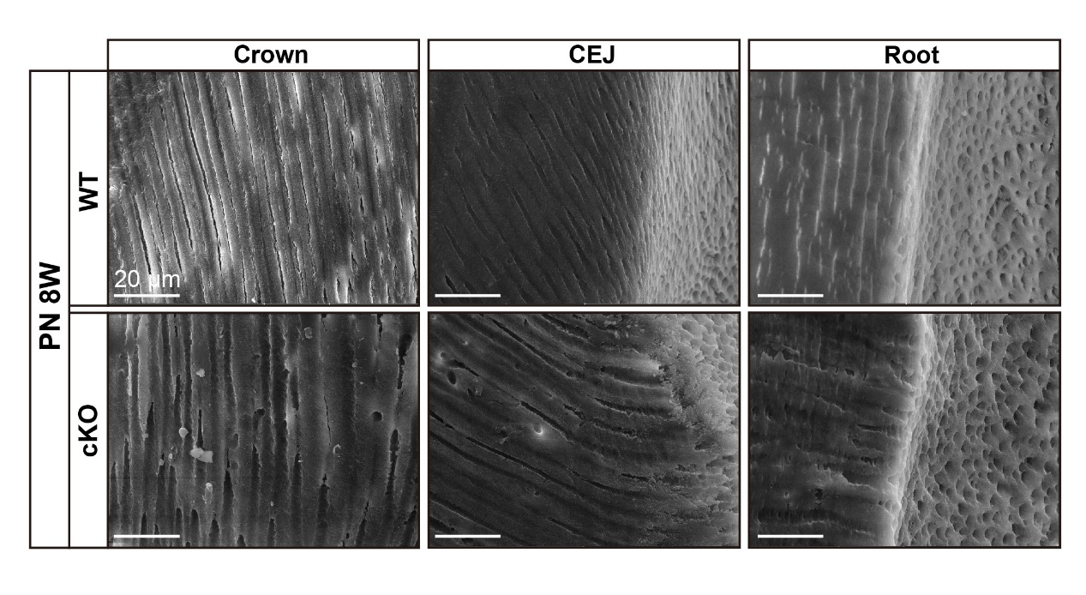
Fig. S7 No significant difference in dentinal tubule between WT and cKO. Scanning electron microscope (SEM) of dentin revealed no significant difference in dentinal tubule between WT and cKO. Scale bar = 20 μm. CEJ, cementoenamel junction.

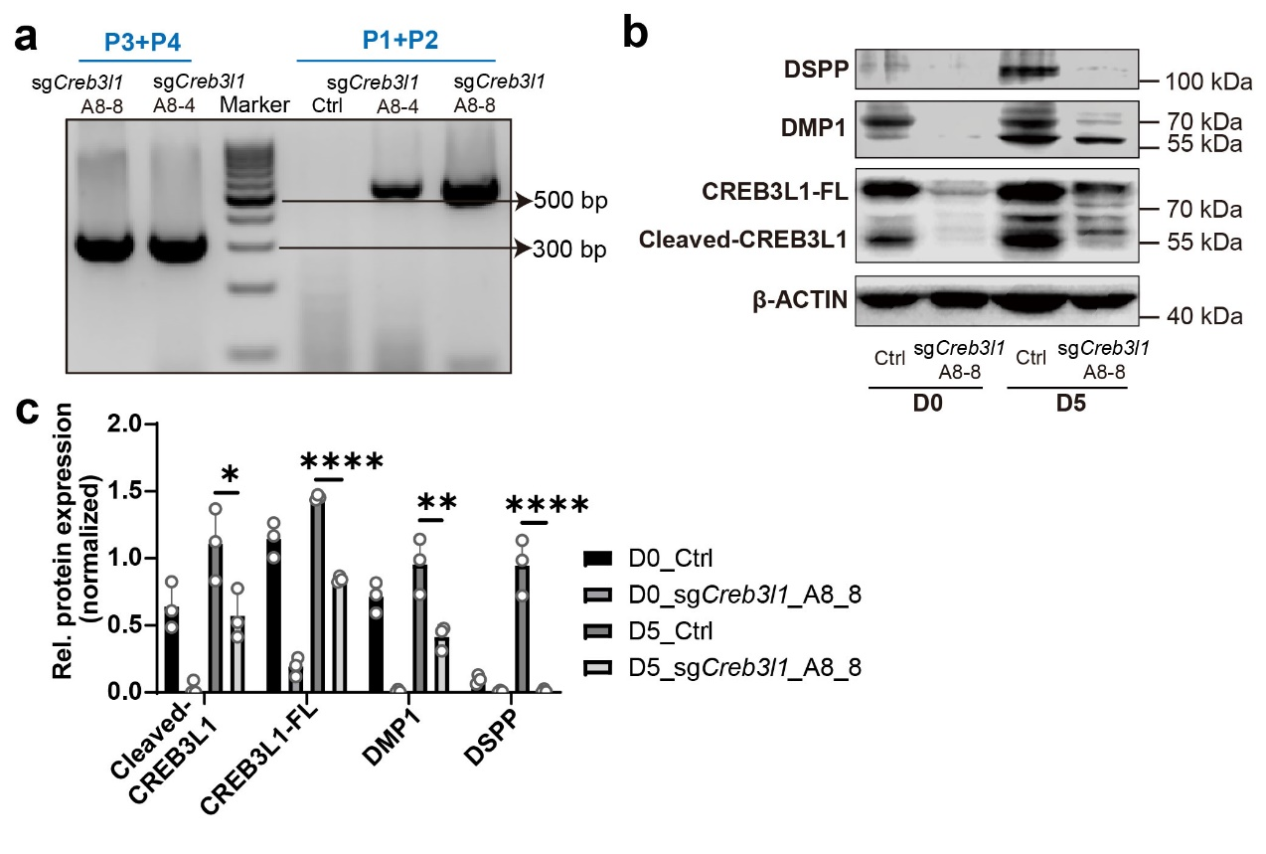
Fig. S8 Downregulation of Creb3l1 impaired the odontoblastic differentiation ability of mDPCs. a Genotyping results for two heterozygote monoclonal cell lines with Creb3l1 knockdown, sgCreb3l1_A8-4 and sgCreb3l1_A8_8. b The expression of the full length of CREB3L1 (CREB3L1-FL), Cleaved-CREB3L1, DMP1, and DSPP were decreased in sgCreb3l1_A8-8 during differentiation induction. c Quantification of the relative protein expression levels of (b). n = 3. *p < 0.05; **p < 0.01; ****p < 0.0001.

Fig. S9 Effects of two cycloheximide (CHX) concentrations on cell status after treatment for 24 h. Cells treated with CHX at a concentration of 1 ug/mL for 24 h exhibited less cell death than cells treated with CHX at a concentration of 5 ug/mL.

Fig. S10 The expression of TMEM30B was detected in cells expressing CREB3L1. The expression of TMEM30B and CREB3L1 in the first molar of PN 3W WT mice. Scale bar = 50 μm.

Fig. S11 Deficiency of Tmem30b impaired the odontoblastic differentiation capability of mDPCs. a During the induction of differentiation, the mRNA of Tmem30b and Dspp was decreased by Tmem30b deficiency (sgTmem30b_60) compared to the Ctrl group. b During the induction of differentiation, the expression of DMP1 and DSPP was decreased in the sgTmem30b_60 group compared to the Ctrl group. c Quantification of the relative levels of protein expression in (b). d Alizarin red S staining was performed to visualize the calcium nodules in Ctrl and sgTmem30b_60 after 14 days of differentiation induction. Scale bar = 1 cm, scale bar = 200 μm. n = 3. **p < 0.01; ***p < 0.001; ****p < 0.0001.

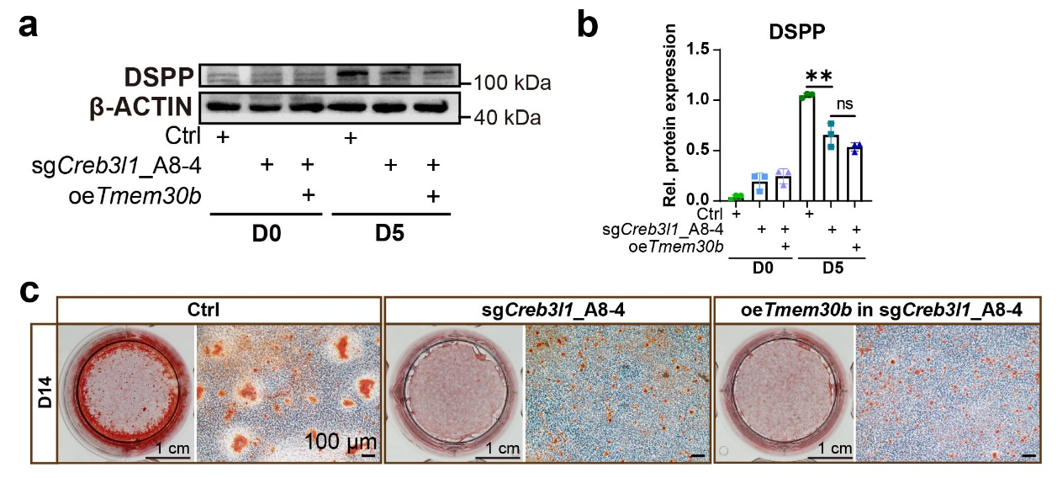
Fig. S12 The attenuated odontoblastic differentiation capability caused by CREB3L1 deficiency cannot be rescued by overexpression of TMEM30B. a The level of DSPP remained unchanged between the sgCreb3l1_A8-4 group and the sgCreb3l1_A8-4 group treated with oeTmem30b after 5 days of differentiation induction. b Quantification of the relative levels of protein expression in (a). c Alizarin red S staining was performed to visualize the calcium nodules in Ctrl, sgCreb3l1_A8-4, and sgCreb3l1_A8-4 treated with oeTmem30b group after 14 days of differentiation induction. Scale bar = 1 cm, scale bar = 100 μm. n = 3. ns, not significant, p > 0.05; **p < 0.01.

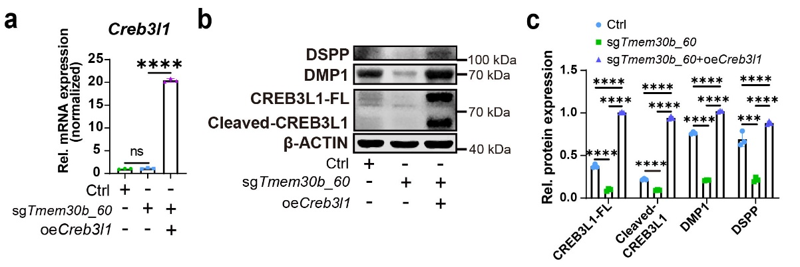
Fig. S13 Overexpression of CREB3L1 in TMEM30B-deficient mDPCs elevated the expression of DMP1 and DSPP. a The mRNA level of Creb3l1 was increased in the sgTmem30b_60 treated with Creb3l1 overexpression lentivirus (oeCreb3l1) group compared to sgTmem30b_60 group. b The levels of CREB3L1-FL, Cleaved-CREB3L1, DMP1, and DSPP proteins were all upregulated in sgTmem30b_60 treated with oeCreb3l1 group compared to Ctrl and sgTmem30b_60 groups. c Quantification of the relative levels of protein expression in (b). n = 3. ns, not significant, p > 0.05; ***p < 0.001; ****p < 0.0001.

