Table S1. Results of sensitivity analyses for severe pressure ulcer after inverse probability of treatment weighting
 | Early rehabilitation  (N=3,434) | Non-early rehabilitation  (N=1,728) | Odds ratio | 95% CI | P
Diagnosed with ICD-10 codes^{*1} | 2.2% | 2.6% | 0.95 | (0.64–1.39) | 0.776
Requiring medication^{*2} | 2.4% | 2.9% | 0.86 | (0.75–0.99) | 0.034
CI, confidence interval
^{*1}Diagnosed with ICD-10 code L890–899 (pressure ulcers) as complications during hospitalization
^{*2}Requires medication for pressure ulcers on the fourth day after admission

Figure S1. Balance plot in the early and non-early rehabilitation groups in the unweighted and weighted cohort by inverse probability of treatment weighting analyses
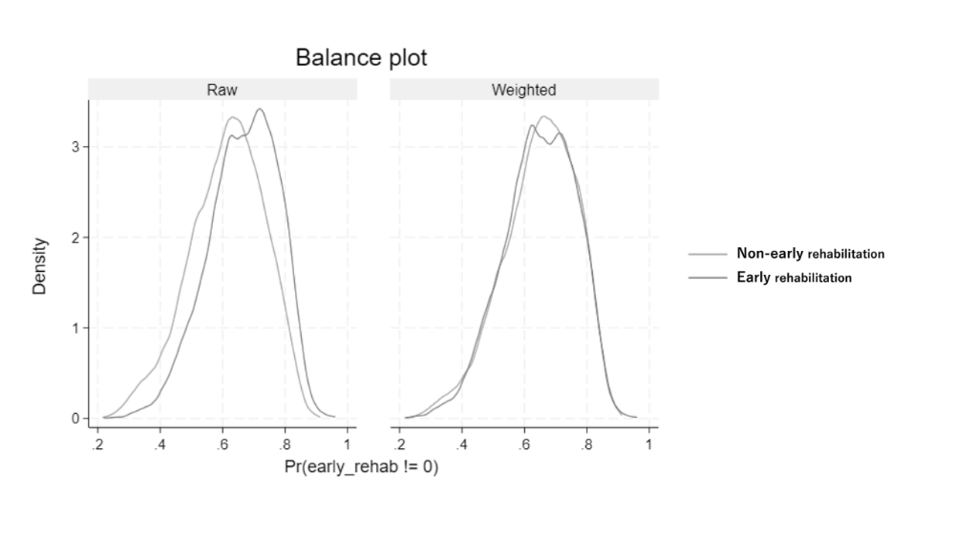
Figure S2. Distribution of the propensity scores in the early and non-early rehabilitation
groups in the weighted cohort by inverse probability of treatment weighting analyses

