SUPPLEMENTAL MATERIAL

Table 1. Selection of variables.
Table 2. Descriptive statistics for the full sample.
Table 3. Results of the baseline regression analysis.
Table 4. Eterogeneity regression results.
Table 5. Balance test.
Table 6. Regression results after propensity score matching.
Table 7. Regression results with replacement of explanatory variables.
Table 8. Changing sample regression results.
Table 9. Intermediation effect regression results.
Figure 1 .Placebo test results

Table 1
Selection of variables.
Variable type | Variable name | Variable symbol | Variable Definition
Explanatory variable | Physical activity participation of the population | activity | 1-5, the larger the value, the more frequent the participation of residents in physical activity
Explanatory variable | Smart City Policy | post_treat | Interaction term between experimental group dummy variable and policy time dummy variable
Intermediary variables | Built environment | envir | 1-5 Assignment of values, with higher values indicating greater environmental accessibility
Intermediary variables | Information channel | internet | 1-5 Assignment of values, with higher values indicating more efficient dissemination of information
Intermediary variables | Consumption for enjoyment | cons | Sum of the five consumption categories of living goods and services, transportation and communications, education, culture and recreation, health care, and other goods and services + 1, taking logarithms
Individual-level control variables | Genders | gender | Males are assigned a value of 1 and females are assigned a value of 0
Individual-level control variables | Age | age | Actual age of respondents
Individual-level control variables | Place of residence | urb | Towns are assigned a value of 1 and villages are assigned a value of 0
Individual-level control variables | Self-assessed health | health | 1-5, the higher the score, the better the health status
Individual-level control variables | educational attainment | eduyear | Conversion of no schooling, elementary school, junior high school, high school (junior college), junior college, undergraduate, master's degree and doctoral degree into years of education: 0, 6, 9, 12, 15, 16, 19, 22 years
Household-level control variables | Number of family members | familysize | Number of family members
Household-level control variables | Number of children in the family | child | Number of children in the family
Household-level control variables | Net monthly household income | fincome | Net monthly household income + 1, logarithmic value
City-level control variables | Urban GDP per capita | lngdp | Urban GDP per capita, logarithmic

Table 2
Descriptive statistics for the full sample.
Variable name | Variable symbol | Average value | Standard deviation | Minimum value | Maximum values | Sample size
Physical activity participation of the population | activity | 1.696 | 1.391 | 1.000 | 5.000 | 22277
Smart City Policy | post_treat | 0.364 | 0.481 | 0.000 | 1.000 | 22277
Built environment | envir | 3.297 | 0.735 | 1.000 | 5.000 | 22277
Information channel | internet | 2.347 | 1.092 | 1.000 | 5.000 | 22277
Consumption for enjoyment | cons | 9.427 | 0.903 | 0.000 | 15.326 | 22277
Genders | gender | 0.507 | 0.500 | 0.000 | 1.000 | 22277
Age | age | 48.232 | 13.799 | 16.000 | 95.000 | 22277
Current address | urb | 0.494 | 0.500 | 0.000 | 1.000 | 22277
Self-assessed health | health | 2.905 | 1.192 | 1.000 | 5.000 | 22277
Educational attainment | eduyear | 7.799 | 4.781 | 0.000 | 22.000 | 22277
Number of family members | familysize | 3.794 | 1.796 | 1.000 | 17.000 | 22277
Number of children in the family | child | 1.782 | 1.084 | 0.000 | 10.000 | 22277
Net monthly household income | fincome | 8.26 | 1.14 | 0.000 | 13.763 | 22277
Urban GDP per capita | lngdp | 10.756 | 0.602 | 9.227 | 12.068 | 22277
Urban population size | lnsize | 6.204 | 0.641 | 4.556 | 8.136 | 22277
Urban sports system practitioners | lntysize | 8.29 | 1.291 | 3.555 | 12.156 | 22277

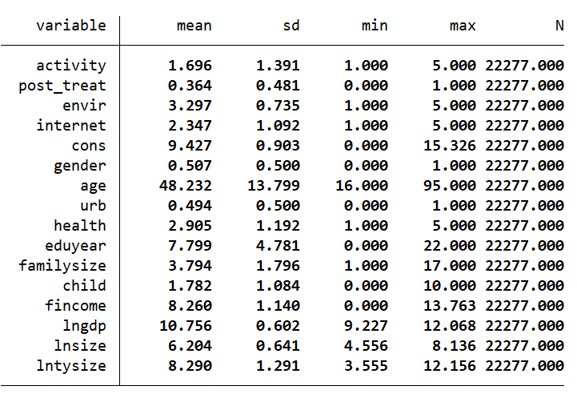

Table 3
Results of the baseline regression analysis.
 | (1) | (2) | (3) | (4)
 | activity | activity | activity | activity
post_treat | 1.236*** | 1.224*** | 1.238*** | 1.347***
 | (0.318) | (0.316) | (0.316) | (0.348)
gender |  | -0.015 | -0.020 | -0.019
 |  | (0.026) | (0.026) | (0.026)
age |  | 0.016*** | 0.019*** | 0.019***
 |  | (0.001) | (0.002) | (0.002)
urb |  | 0.010 | 0.012 | 0.009
 |  | (0.045) | (0.045) | (0.045)
health |  | 0.005 | 0.005 | 0.005
 |  | (0.007) | (0.007) | (0.007)
eduyear |  | 0.001 | 0.000 | -0.000
 |  | (0.004) | (0.004) | (0.004)
familysize |  |  | -0.012 | -0.012
 |  |  | (0.008) | (0.008)
child |  |  | -0.081*** | -0.081***
 |  |  | (0.020) | (0.020)
fincome |  |  | -0.000 | -0.000
 |  |  | (0.009) | (0.009)
lngdp |  |  |  | 0.076
 |  |  |  | (0.051)
lnsize |  |  |  | -0.095
 |  |  |  | (0.153)
lntysize |  |  |  | -0.033**
 |  |  |  | (0.015)
_cons | 1.246*** | 0.473*** | 0.524*** | 0.532
 | (0.116) | (0.151) | (0.170) | (1.004)
Individual | Yes | Yes | Yes | Yes
Year | Yes | Yes | Yes | Yes
N | 22277 | 22277 | 22277 | 22277
R² | 0.859 | 0.861 | 0.861 | 0.861
Note: (1)*, ** and *** represent 10%, 5% and 1% significance levels. (2)Robust standard error for statistics in parentheses.

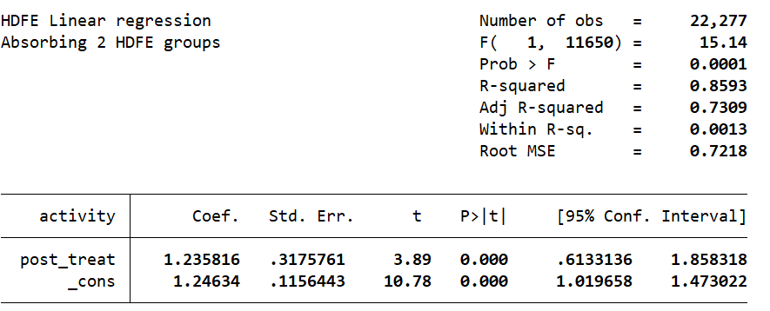
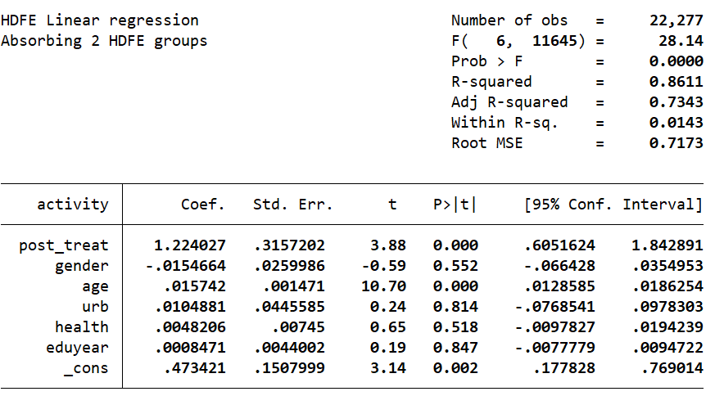
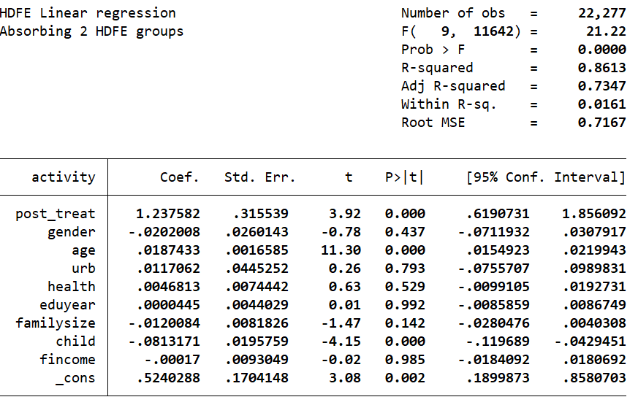
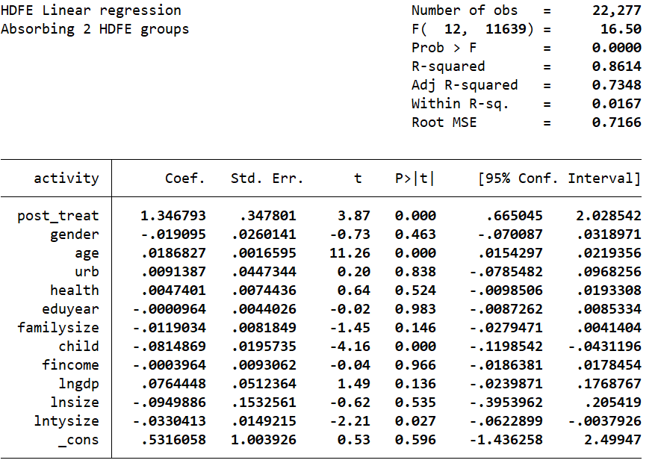

Table 4
Eterogeneity regression results.
 | (1) | (2) | (3) | (4) | (5) | (6) | (7) | (8)
 | Towns | villages | East Central Region | western region | low education | high educated | Low  age | advanced age
post_treat | 3.806*** | 2.415** | 1.295*** | 1.309 | 0.148 | 1.439*** | 1.061*** | 4.130***
 | (1.021) | (1.008) | (0.400) | (1.100) | (0.941) | (0.388) | (0.407) | (0.513)
gender | -0.004 | -0.054 | -0.014 | -0.016 | -0.084* | -0.072* | -0.002 | 0.038
 | (0.039) | (0.036) | (0.028) | (0.062) | (0.045) | (0.042) | (0.031) | (0.045)
age | 0.029*** | 0.010*** | 0.019*** | 0.017*** | 0.012*** | 0.030*** | - | -
 | (0.003) | (0.002) | (0.002) | (0.004) | (0.003) | (0.003) | - | -
health | 0.006 | 0.003 | 0.007 | -0.004 | -0.002 | 0.004 | 0.001 | 0.003
 | (0.012) | (0.010) | (0.008) | (0.018) | (0.010) | (0.012) | (0.009) | (0.009)
eduyear | -0.000 | 0.003 | -0.001 | -0.000 | - | - | -0.011** | -0.006
 | (0.007) | (0.006) | (0.005) | (0.009) | - | - | (0.005) | (0.009)
familysize | -0.009 | -0.010 | -0.006 | -0.030 | -0.007 | -0.012 | -0.025** | 0.005
 | (0.014) | (0.011) | (0.009) | (0.019) | (0.011) | (0.013) | (0.011) | (0.009)
child | -0.129*** | -0.031 | -0.076*** | -0.102** | -0.058 | -0.126*** | 0.002 | -0.051*
 | (0.033) | (0.025) | (0.022) | (0.044) | (0.036) | (0.032) | (0.024) | (0.027)
fincome | 0.003 | -0.003 | -0.003 | 0.008 | -0.007 | 0.009 | 0.003 | -0.008
 | (0.014) | (0.012) | (0.010) | (0.023) | (0.013) | (0.014) | (0.012) | (0.011)
lngdp | 0.038 | 0.135* | 0.006 | 0.145 | 0.062 | 0.100 | 0.086 | 0.074
 | (0.079) | (0.076) | (0.053) | (0.176) | (0.077) | (0.072) | (0.062) | (0.071)
lnsize | 0.244 | -0.563* | -0.003 | -0.911* | -0.027 | -0.051 | -0.042 | 0.401
 | (0.247) | (0.331) | (0.163) | (0.480) | (0.325) | (0.195) | (0.179) | (0.347)
lntysize | -0.013 | -0.051*** | -0.001 | -0.189*** | -0.023 | -0.039* | -0.048*** | 0.004
 | (0.026) | (0.019) | (0.015) | (0.043) | (0.021) | (0.022) | (0.018) | (0.019)
urb | - | - | 0.043 | -0.119 | -0.039 | 0.040 | -0.020 | 0.020
 | - | - | (0.048) | (0.106) | (0.063) | (0.067) | (0.054) | (0.060)
_cons | -2.713 | 2.791 | 0.422 | 5.955* | 0.843 | -0.409 | 1.062 | -2.358
 | (1.770) | (2.034) | (1.076) | (3.364) | (2.052) | (1.277) | (1.163) | (2.268)
Individual | Yes | Yes | Yes | Yes | Yes | Yes | Yes | Yes
Year | Yes | Yes | Yes | Yes | Yes | Yes | Yes | Yes
N | 10999 | 11278 | 17081 | 5196 | 9347 | 12930 | 17367 | 4910
R² | 0.888 | 0.833 | 0.877 | 0.819 | 0.891 | 0.864 | 0.798 | 0.983
Note: (1)*, ** and *** represent 10%, 5% and 1% significance levels. (2)Robust standard error for statistics in parentheses.

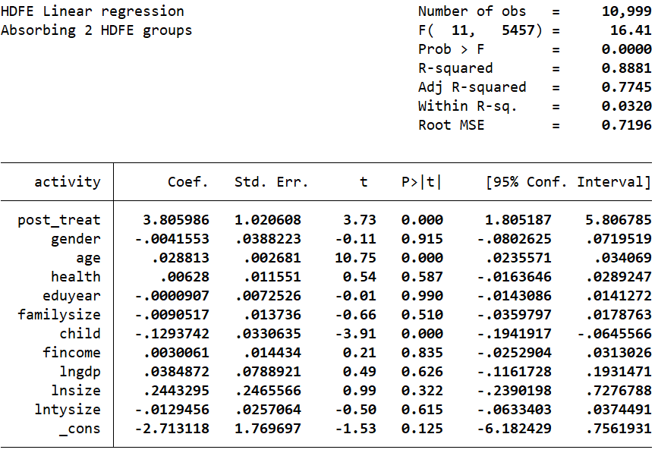
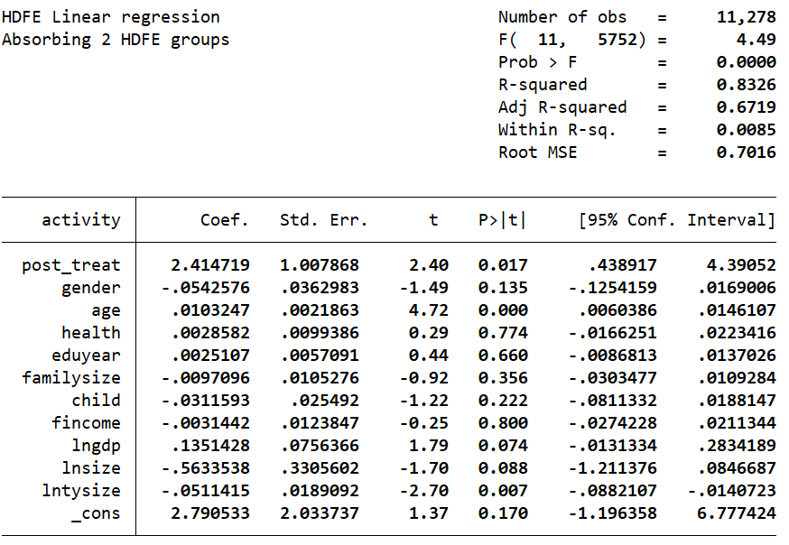
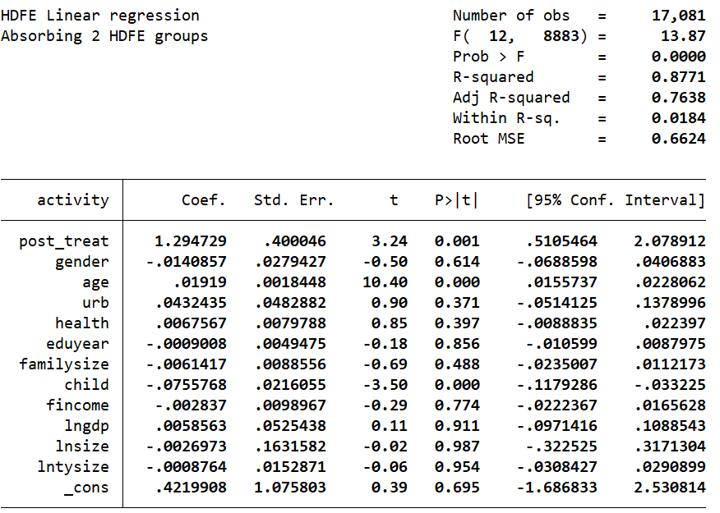
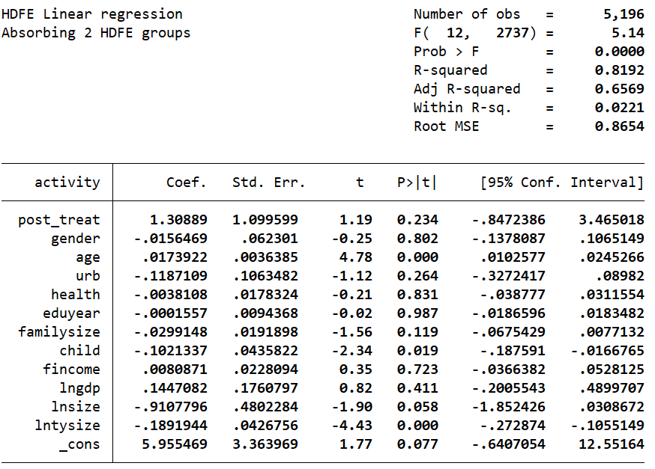
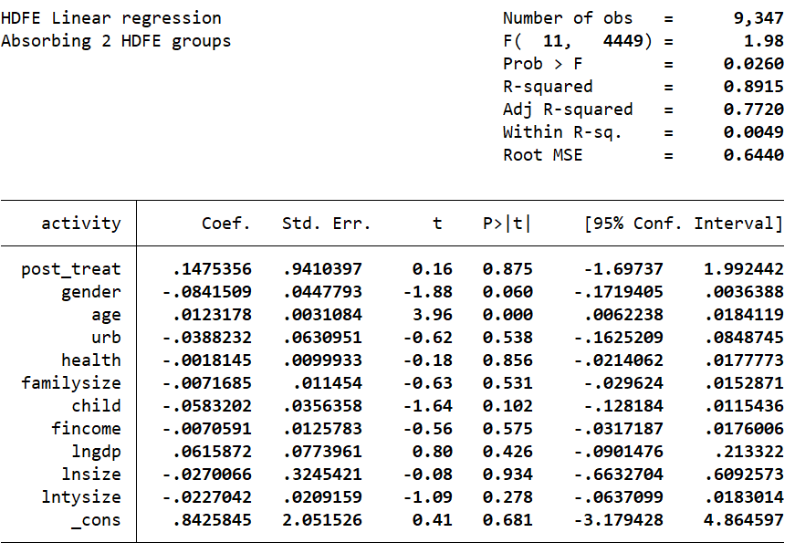
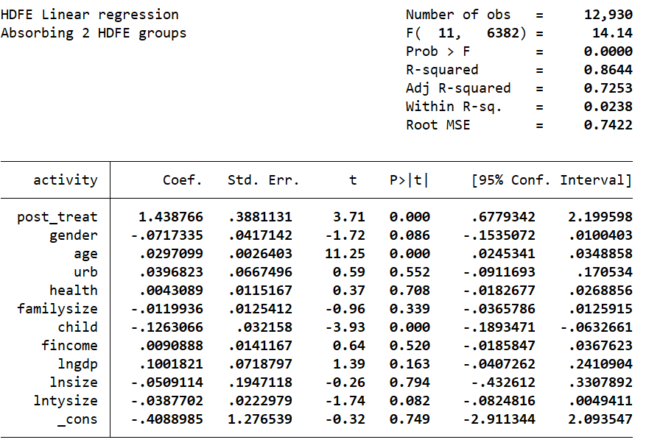
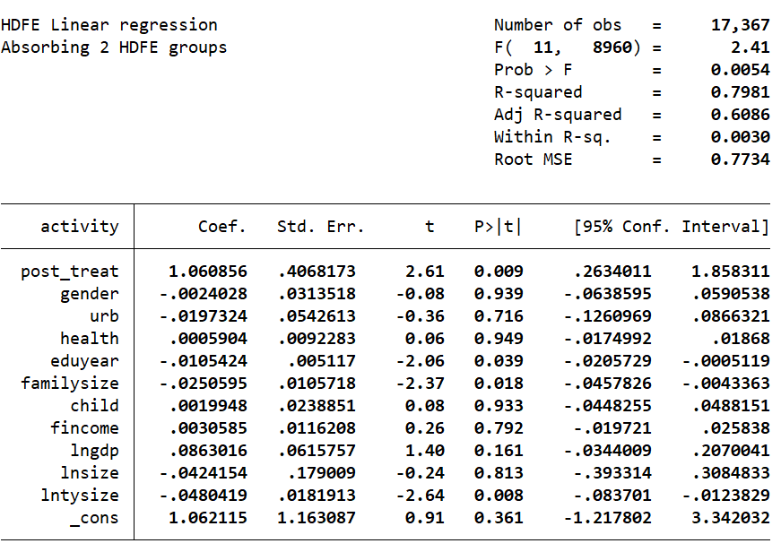
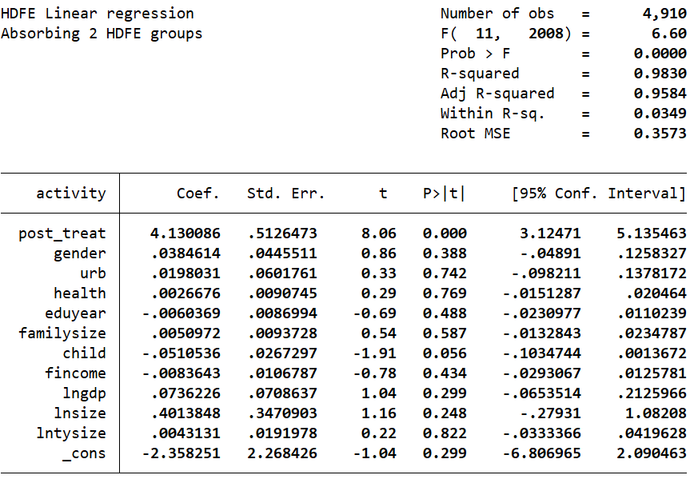

Table 5
Balance test.
Variable name | Matching situation | Experimental group mean | Control group group mean | Deviation rate | Deviation reduction rate | T-value | P-value
gender | Before matching | 0.51289 | 0.50416 | 1.7 | 60.9 | 1.25 | 0.21
gender | After matching | 0.51347 | 0.51005 | 0.7 | 60.9 | 0.43 | 0.665
age | Before matching | 46.723 | 49.094 | -17.2 | 50.2 | -12.38 | 0
age | After matching | 46.717 | 45.536 | 8.6 | 50.2 | 5.46 | 0
urb | Before matching | 0.56767 | 0.45145 | 23.4 | 84 | 16.8 | 0
urb | After matching | 0.5651 | 0.58372 | -3.7 | 84 | -2.39 | 0.017
health | Before matching | 2.9677 | 2.8699 | 8.3 | 72.8 | 5.9 | 0
health | After matching | 2.967 | 2.9936 | -2.3 | 72.8 | -1.46 | 0.144
eduyear | Beforematching | 8.6132 | 7.3329 | 27 | 98.6 | 19.39 | 0
eduyear | After matching | 8.5917 | 8.6092 | -0.4 | 98.6 | -0.23 | 0.816
familysize | Before matching | 3.7426 | 3.8237 | -4.6 | 94.1 | -3.24 | 0.001
familysize | After matching | 3.7447 | 3.7495 | -0.3 | 94.1 | -0.18 | 0.86
child | Before matching | 1.5882 | 1.8921 | -29 | 88.2 | -20.32 | 0
child | After matching | 1.5915 | 1.5557 | 3.4 | 88.2 | 2.32 | 0.021
fincome | Before matching | 8.4903 | 8.1276 | 32.3 | 96.5 | 23.12 | 0
fincome | After matching | 8.485 | 8.4725 | 1.1 | 96.5 | 0.72 | 0.474
lngdp | Before matching | 10.908 | 10.669 | 39 | 91.2 | 29.16 | 0
lngdp | After matching | 10.904 | 10.925 | -3.4 | 91.2 | -2.04 | 0.041
lnsize | Before matching | 6.3681 | 6.1099 | 39.3 | 70.8 | 29.47 | 0
lnsize | After matching | 6.363 | 6.2877 | 11.5 | 70.8 | 7.1 | 0
lntysize | Before matching | 8.8871 | 7.9487 | 73.7 | 95.7 | 55.69 | 0
lntysize | After matching | 8.8678 | 8.8278 | 3.1 | 95.7 | 1.83 | 0.067

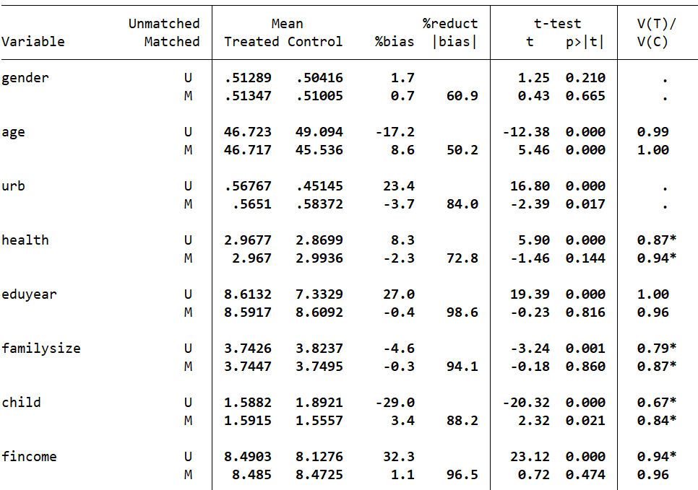
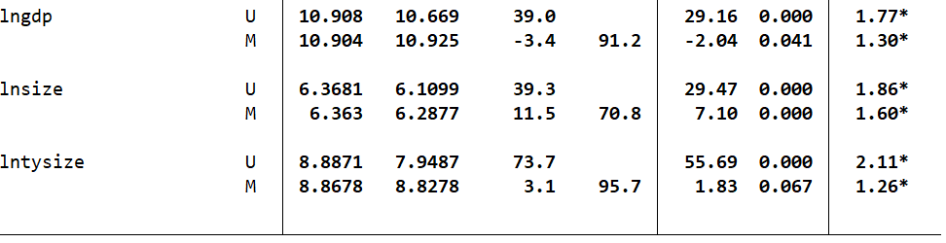
Table 6
Regression results after propensity score matching.
 | (1) | (2) | (3) | (4)
 | activity | activity | activity | activity
post_treat | 1.304*** | 1.320*** | 1.342*** | 1.259**
 | (0.458) | (0.457) | (0.456) | (0.520)
gender |  | -0.031 | -0.038 | -0.034
 |  | (0.048) | (0.048) | (0.048)
age |  | 0.020*** | 0.024*** | 0.024***
 |  | (0.003) | (0.003) | (0.003)
urb |  | -0.079 | -0.076 | -0.075
 |  | (0.087) | (0.087) | (0.087)
health |  | 0.009 | 0.010 | 0.010
 |  | (0.014) | (0.014) | (0.014)
eduyear |  | -0.002 | -0.003 | -0.003
 |  | (0.008) | (0.008) | (0.008)
familysize |  |  | -0.027* | -0.029*
 |  |  | (0.016) | (0.016)
child |  |  | -0.104*** | -0.104***
 |  |  | (0.038) | (0.038)
fincome |  |  | 0.008 | 0.008
 |  |  | (0.018) | (0.018)
lngdp |  |  |  | 0.021
 |  |  |  | (0.094)
lnsize |  |  |  | 0.174
 |  |  |  | (0.270)
lntysize |  |  |  | -0.080**
 |  |  |  | (0.037)
_cons | 1.260*** | 0.346 | 0.371 | -0.201
 | (0.210) | (0.275) | (0.312) | (1.671)
Individual | Yes | Yes | Yes | Yes
Year | Yes | Yes | Yes | Yes
N | 13529 | 13529 | 13529 | 13529
R² | 0.860 | 0.862 | 0.863 | 0.863
Note: (1)*, ** and *** represent 10%, 5% and 1% significance levels. (2)Robust standard error for statistics in parentheses.

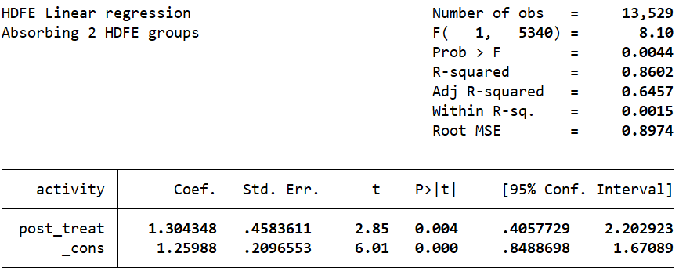
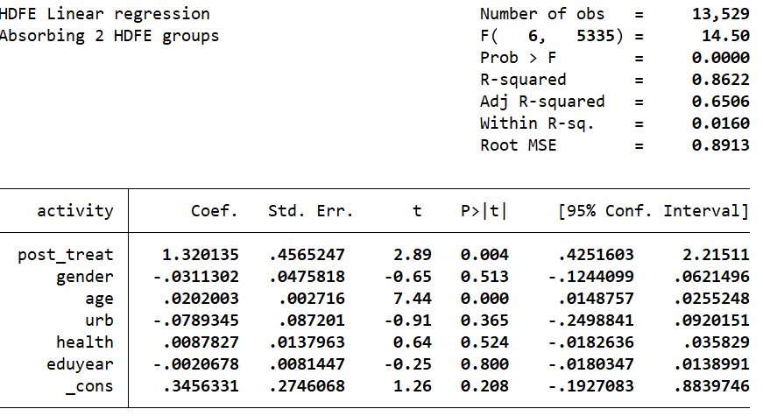
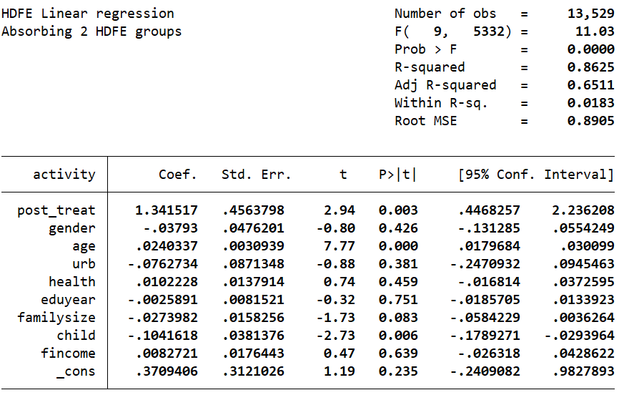

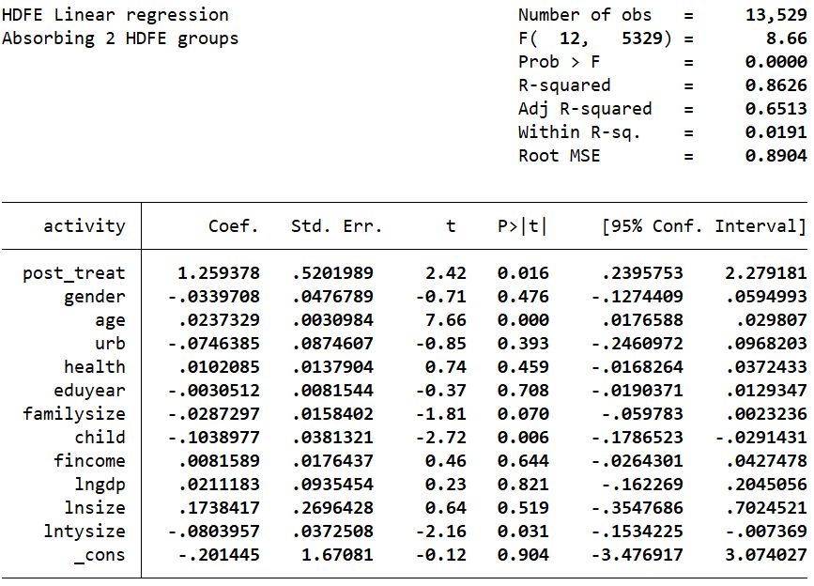

Table 7
Regression results with replacement of explanatory variables.
 | (1) | (2) | (3) | (4)
 | exercise | exercise | exercise | exercise
post_treat | 2.718* | 2.665* | 2.678* | 3.776**
 | (1.564) | (1.563) | (1.563) | (1.723)
gender |  | 0.026 | 0.022 | 0.026
 |  | (0.129) | (0.129) | (0.129)
age |  | 0.035*** | 0.039*** | 0.038***
 |  | (0.007) | (0.008) | (0.008)
urb |  | 0.068 | 0.072 | 0.126
 |  | (0.221) | (0.221) | (0.222)
health |  | 0.045 | 0.045 | 0.045
 |  | (0.037) | (0.037) | (0.037)
eduyear |  | -0.009 | -0.009 | -0.010
 |  | (0.022) | (0.022) | (0.022)
familysize |  |  | -0.021 | -0.024
 |  |  | (0.041) | (0.041)
child |  |  | -0.130 | -0.128
 |  |  | (0.097) | (0.097)
fincome |  |  | -0.045 | -0.043
 |  |  | (0.046) | (0.046)
lngdp |  |  |  | -0.334
 |  |  |  | (0.254)
lnsize |  |  |  | -0.591
 |  |  |  | (0.759)
lntysize |  |  |  | -0.208***
 |  |  |  | (0.074)
_cons | 0.556 | -1.209 | -0.736 | 7.873
 | (0.570) | (0.747) | (0.844) | (4.973)
Individual | Yes | Yes | Yes | Yes
Year | Yes | Yes | Yes | Yes
N | 22277 | 22277 | 22277 | 22277
R² | 0.717 | 0.717 | 0.717 | 0.718
Note: (1)*, ** and *** represent 10%, 5% and 1% significance levels. (2)Robust standard error for statistics in parentheses.
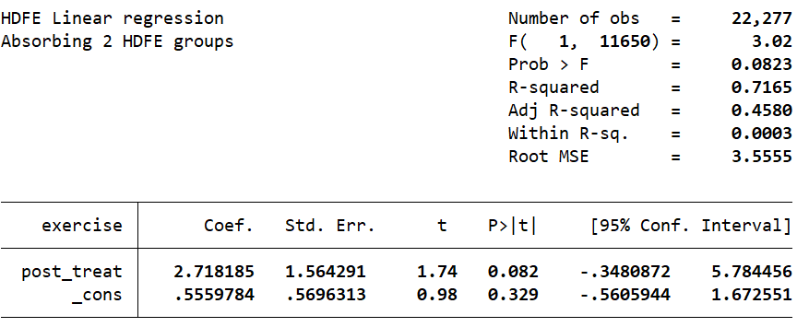
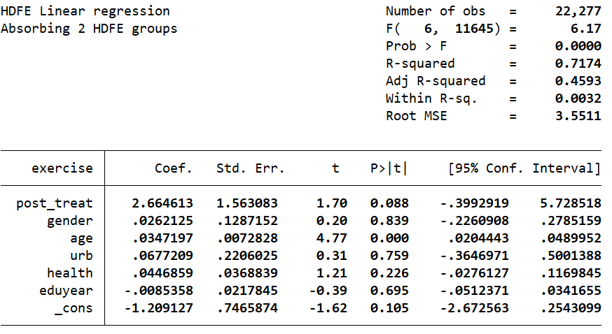
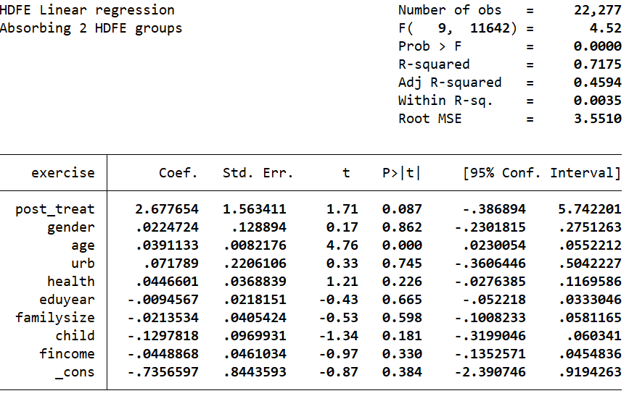
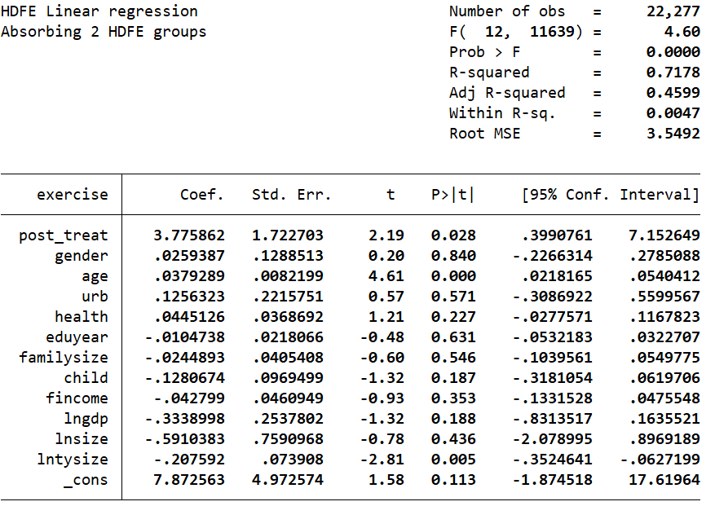

Table 8
Changing sample regression results.
 | (1) | (2) | (3) | (4)
 | activity | activity | activity | activity
post_treat | 1.866*** | 1.871*** | 1.885*** | 2.037***
 | (0.426) | (0.423) | (0.423) | (0.450)
gender |  | -0.042 | -0.048 | -0.047
 |  | (0.029) | (0.029) | (0.029)
age |  | 0.015*** | 0.019*** | 0.018***
 |  | (0.002) | (0.002) | (0.002)
urb |  | -0.032 | -0.033 | -0.028
 |  | (0.059) | (0.059) | (0.060)
health |  | 0.007 | 0.007 | 0.007
 |  | (0.010) | (0.010) | (0.010)
eduyear |  | 0.003 | 0.002 | 0.002
 |  | (0.005) | (0.005) | (0.005)
familysize |  |  | -0.016 | -0.016
 |  |  | (0.011) | (0.011)
child |  |  | -0.089*** | -0.089***
 |  |  | (0.023) | (0.023)
fincome |  |  | 0.005 | 0.005
 |  |  | (0.013) | (0.013)
lngdp |  |  |  | 0.006
 |  |  |  | (0.070)
lnsize |  |  |  | -0.146
 |  |  |  | (0.198)
lntysize |  |  |  | -0.027
 |  |  |  | (0.017)
_cons | 1.024*** | 0.281 | 0.305 | 1.322
 | (0.156) | (0.192) | (0.222) | (1.323)
Individual | Yes | Yes | Yes | Yes
Year | Yes | Yes | Yes | Yes
N | 17659 | 17659 | 17659 | 17659
R² | 0.884 | 0.885 | 0.886 | 0.886
Note: (1)*, ** and *** represent 10%, 5% and 1% significance levels. (2)Robust standard error for statistics in parentheses.

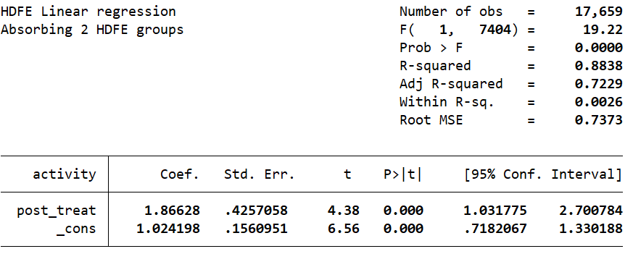
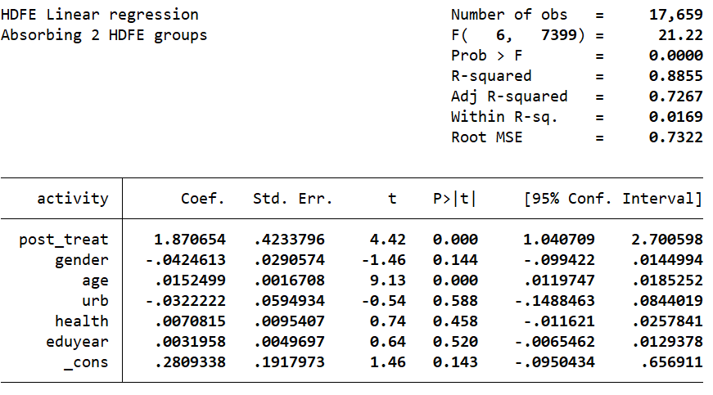
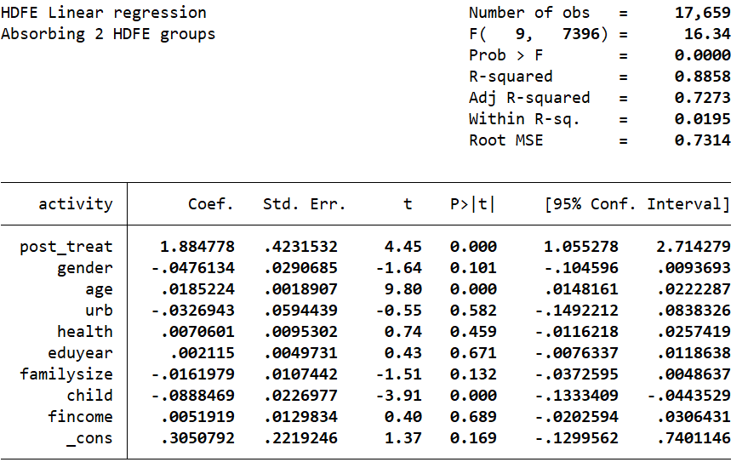
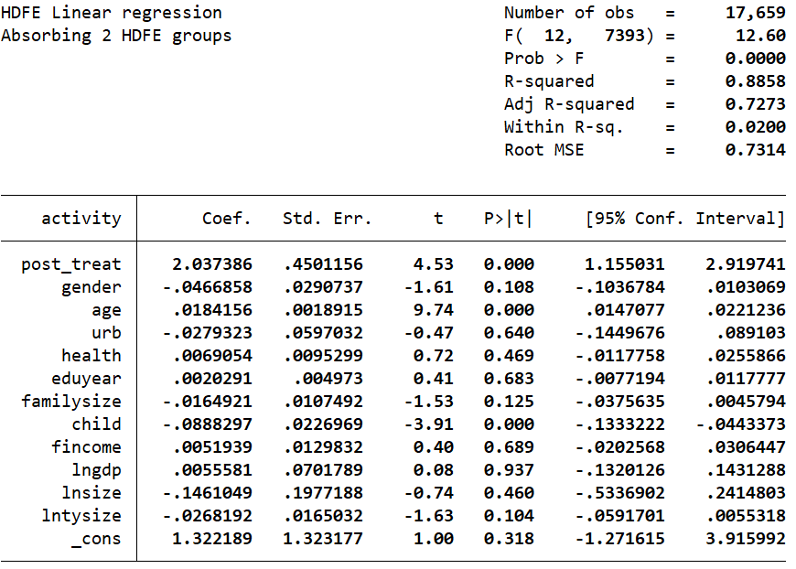

Figure 1 .Placebo test results

Table 9
Intermediation effect regression results.
 | (1) | (2) | (3) | (4) | (5) | (6)
 | envir | activity | internet | activity | cons | activity
post_treat | 0.484** | 1.309*** | 0.564* | 1.216*** | 0.632*** | 1.279***
 | (0.237) | (0.347) | (0.341) | (0.339) | (0.245) | (0.347)
envir |  | 0.078***
 |  | (0.014)
internet |  |  |  | 0.231***
 |  |  |  | (0.009)
cons |  |  |  |  |  | 0.107***
 |  |  |  |  |  | (0.013)
gender | 0.028 | -0.021 | 0.080*** | -0.038 | 0.034* | -0.023
 | (0.018) | (0.026) | (0.026) | (0.025) | (0.018) | (0.026)
age | 0.008*** | 0.018*** | -0.028*** | 0.025*** | -0.005*** | 0.019***
 | (0.001) | (0.002) | (0.002) | (0.002) | (0.001) | (0.002)
urb | 0.038 | 0.006 | -0.008 | 0.011 | 0.022 | 0.007
 | (0.030) | (0.045) | (0.044) | (0.044) | (0.032) | (0.045)
health | 0.027*** | 0.003 | 0.013* | 0.002 | -0.032*** | 0.008
 | (0.005) | (0.007) | (0.007) | (0.007) | (0.005) | (0.007)
eduyear | -0.010*** | 0.001 | 0.016*** | -0.004 | 0.007** | -0.001
 | (0.003) | (0.004) | (0.004) | (0.004) | (0.003) | (0.004)
familysize | -0.005 | -0.011 | -0.005 | -0.011 | 0.068*** | -0.019**
 | (0.006) | (0.008) | (0.008) | (0.008) | (0.006) | (0.008)
child | 0.011 | -0.082*** | -0.061*** | -0.067*** | -0.031** | -0.078***
 | (0.013) | (0.020) | (0.019) | (0.019) | (0.014) | (0.020)
fincome | 0.012* | -0.001 | 0.013 | -0.003 | 0.069*** | -0.008
 | (0.006) | (0.009) | (0.009) | (0.009) | (0.007) | (0.009)
lngdp | -0.036 | 0.079 | 0.039 | 0.067 | 0.006 | 0.076
 | (0.035) | (0.051) | (0.050) | (0.050) | (0.036) | (0.051)
lnsize | -0.053 | -0.091 | -0.479*** | 0.016 | 0.020 | -0.097
 | (0.104) | (0.153) | (0.150) | (0.149) | (0.108) | (0.153)
lntysize | 0.012 | -0.034** | -0.007 | -0.032** | -0.004 | -0.033**
 | (0.010) | (0.015) | (0.015) | (0.015) | (0.011) | (0.015)
_cons | 3.234*** | 0.279 | 5.912*** | -0.837 | 8.528*** | -0.378
 | (0.684) | (1.004) | (0.984) | (0.979) | (0.708) | (1.007)
Individual | Yes | Yes | Yes | Yes | Yes | Yes
Year | Yes | Yes | Yes | Yes | Yes | Yes
N | 22277 | 22277 | 22277 | 22277 | 22277 | 22277
R² | 0.769 | 0.862 | 0.784 | 0.869 | 0.836 | 0.862
Sobel test | 6.588***（0.000） |  | 29.600***（0.000） |  | 20.480***（0.000）
Note: (1)*, ** and *** represent 10%, 5% and 1% significance levels. (2)Robust standard error for statistics in parentheses.

