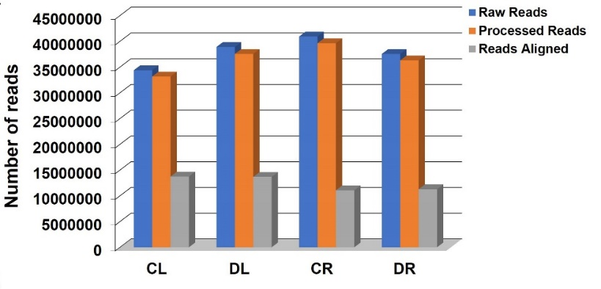
Fig. S1 Graphical representation of transcript abundance in cowpea under control and drought stress. Total number of reads for transcripts further categorized into processed and aligned reads, obtained from four RNA-Seq libraries in cowpea, under control and drought stress. Control Leaf, CL; Control Root, CR; Drought Stressed Leaf, DL; Drought Stressed Root, DR

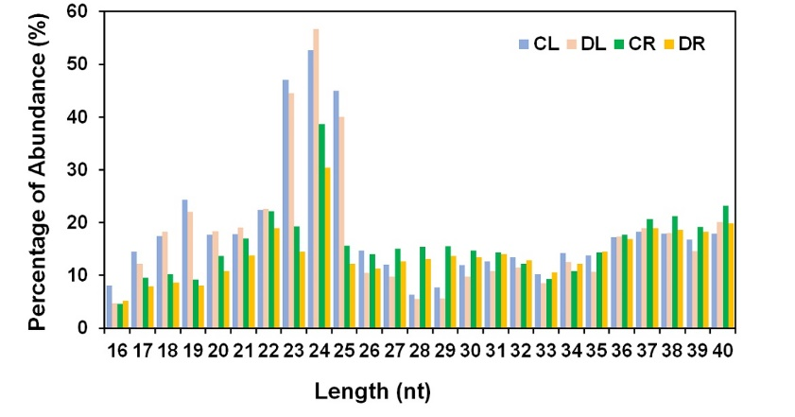

Fig. S2 miRNA abundance in control and drought stressed small RNAs (sRNA) libraries of cowpea. Percentage of sRNA abundance across the length distribution range of 16-40 nt in control and drought stressed libraries of cowpea. Control Leaf, CL; Control Root, CR; Drought Stressed Leaf, DL; Drought Stressed Root, DR

Fig. S3 Known and novel miRNAs in control and drought stressed sRNA libraries of cowpea. (A) Total number of miRNAs identified in leaf and root libraries in cowpea. (B) Conserved miRNA family with highest members identified in cowpea. Venn diagram showing number of conserved (C) and novel (D) miRNAs present in each library. Control Leaf, CL; Control Root, CR; Drought Stressed Leaf, DL; Drought Stressed Root, DR

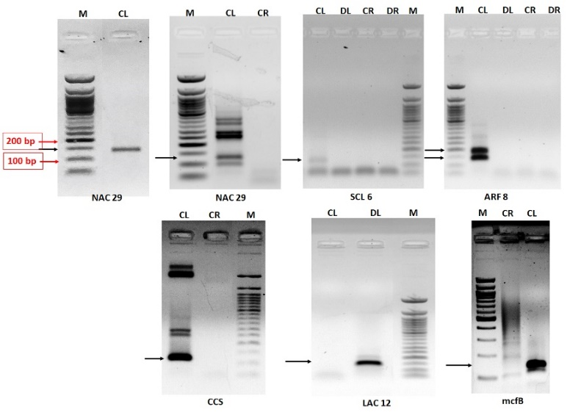

Fig. S4 Validation of candidate target genes cleaved by selected DE in cowpea by 5’ RNA ligase mediated rapid amplification of cDNA ends (5’ RLM-RACE). The target genes NAC 29, SCL 6, ARF 8, CCS, LAC 12, and mcfB were obtained as amplified nested PCR products using RACE inner primer and gene specific primers from the outer race products obtained using outer RACE primer and gene specific primers and cDNA obtained from RNA ligase mediated 5’-adapter-RNA templates, following manufacturer’s instructions

