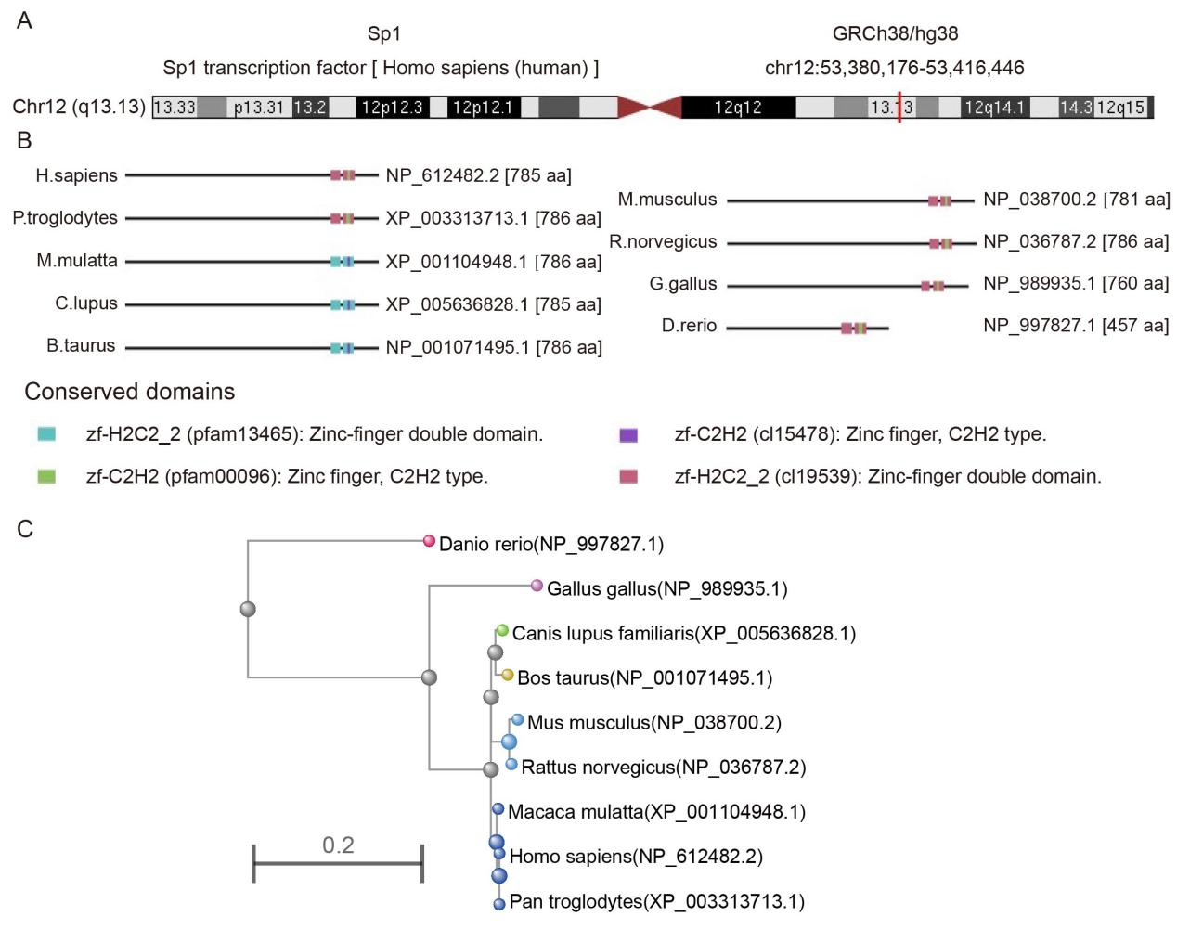
Supplementary Figure 1. The structure characteristics of Sp1. (A) Genomic location of human Sp1; (B) Conserved domains of Sp1 among different species; (C) the phylogenetic tree of Sp1 in different species.

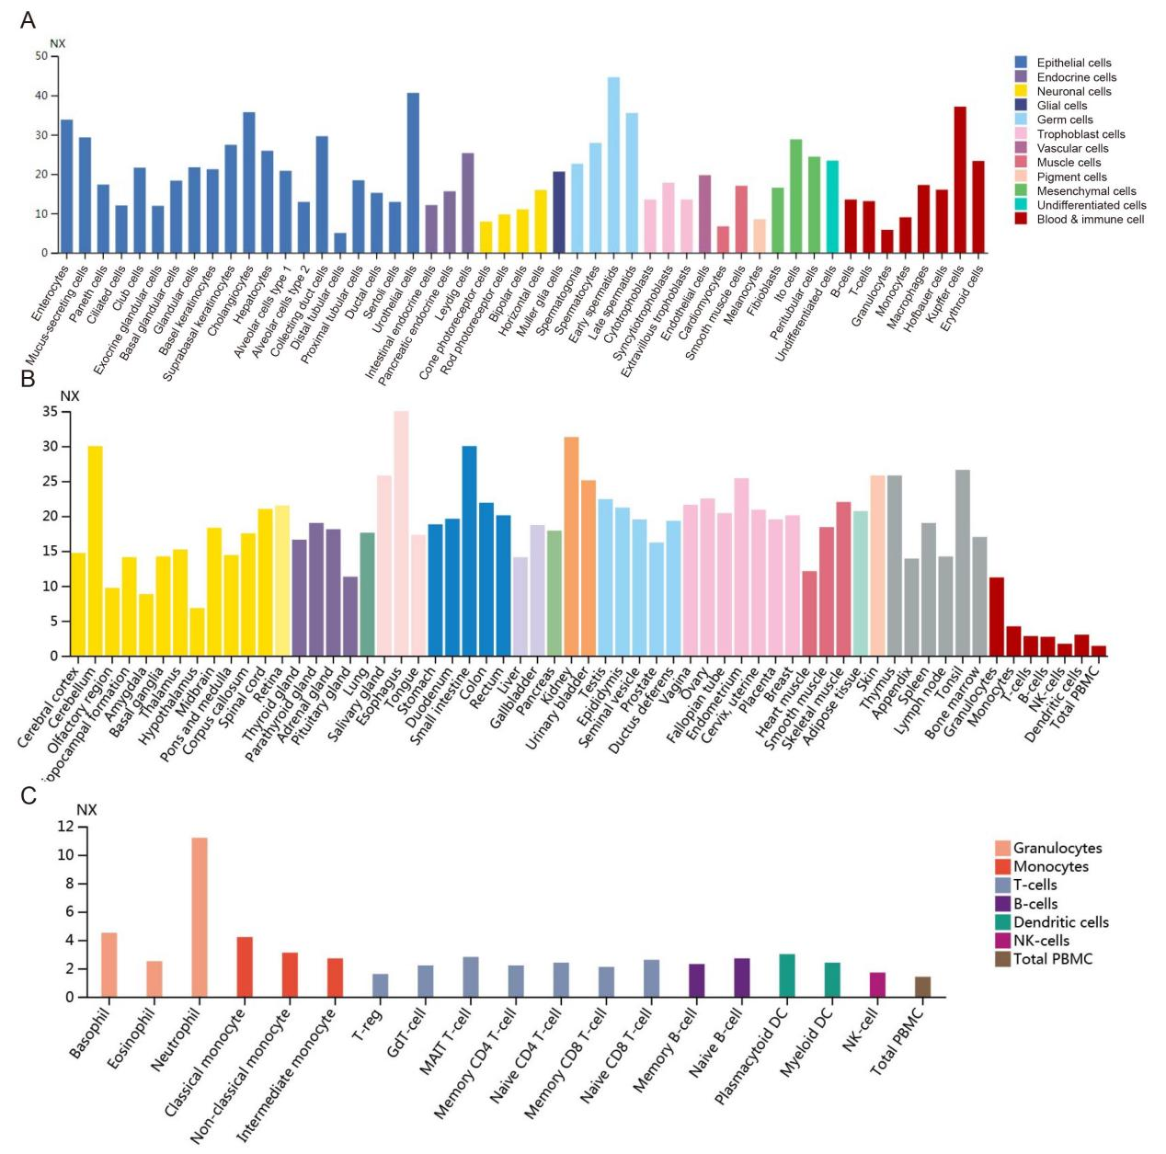
Supplementary Figure 2. A comprehensive analysis of Sp1 expression patterns across various cell lines (A), normal tissues (B), and blood cells (C).

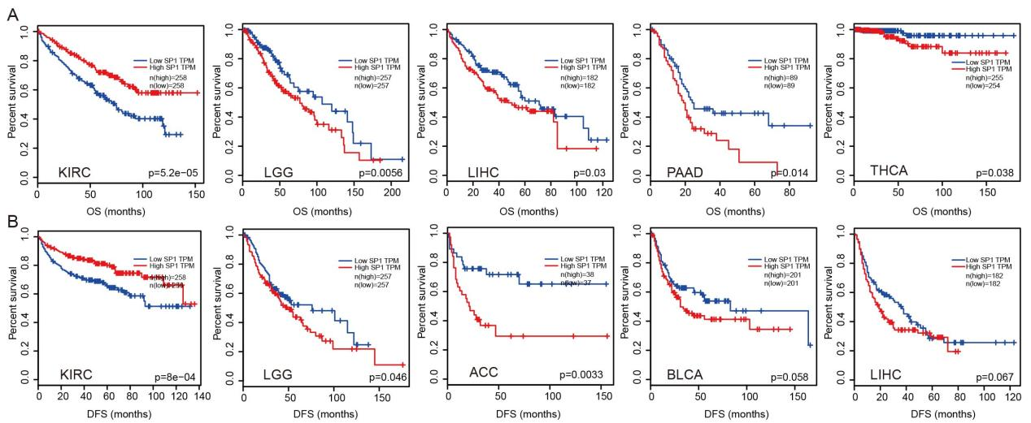

Supplementary Figure 3. Correlations between the DFS, OS and Sp1 expression using the GEPIA2. We used the GEPIA2 to perform survival analyses, including OS and DFS, via the level of Sp1 in different types of cancers.

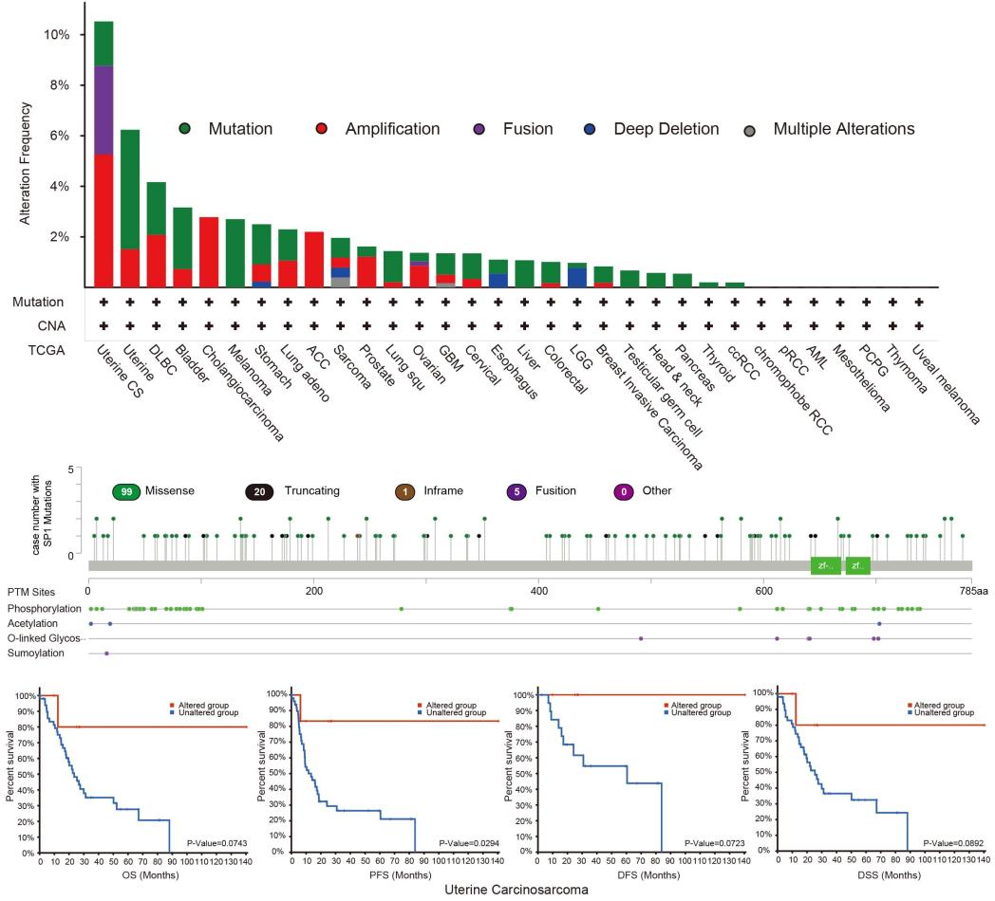
Supplementary Figure 4. The genetic alteration of Sp1 in different types of cancers using the TCGA database. The alteration frequency and mutation type of Sp1 were displayed in different cancers (A). The sites and types of Sp1 genetic alterations, along with post-translational modifications were displayed (B). We display the correlations between the alteration status of Sp1 and clinical survival prognosis, including OS, PFS, DFS, and DSS, in uterine carcinosarcoma (C).

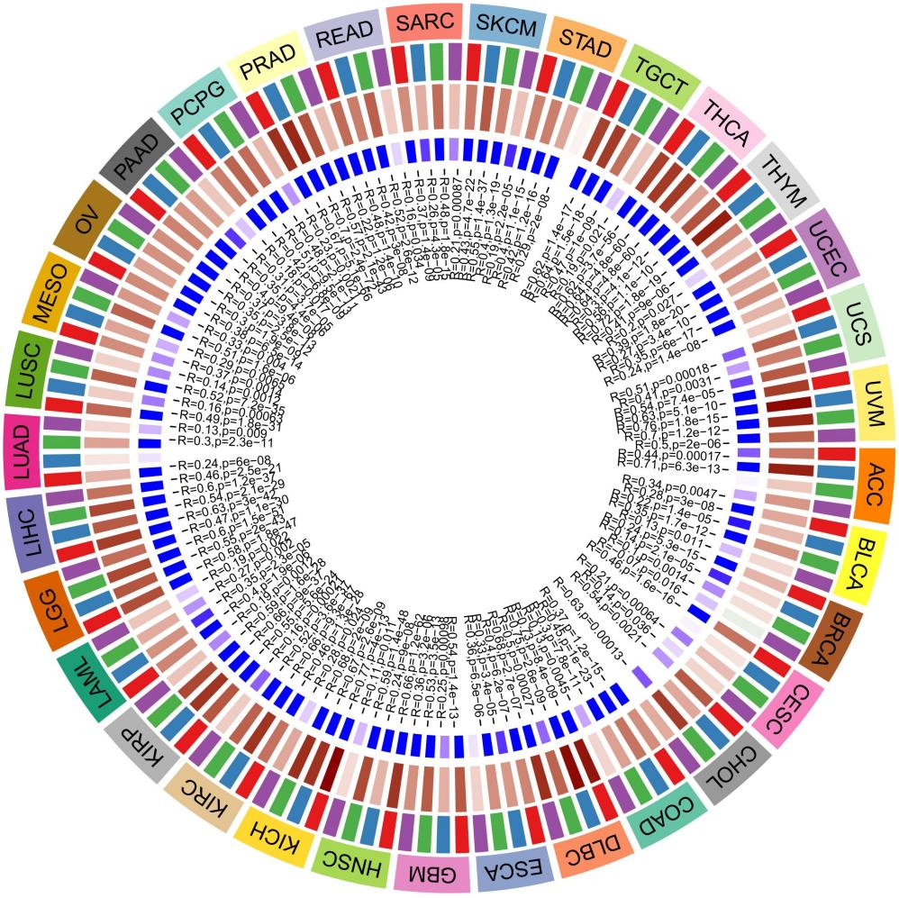
Supplementary Figure 5. The correlation between the Sp1 expression and four classical DNA methyltransferase including DNMT1, DNMT2, DNMT3A, and DNMT3B.

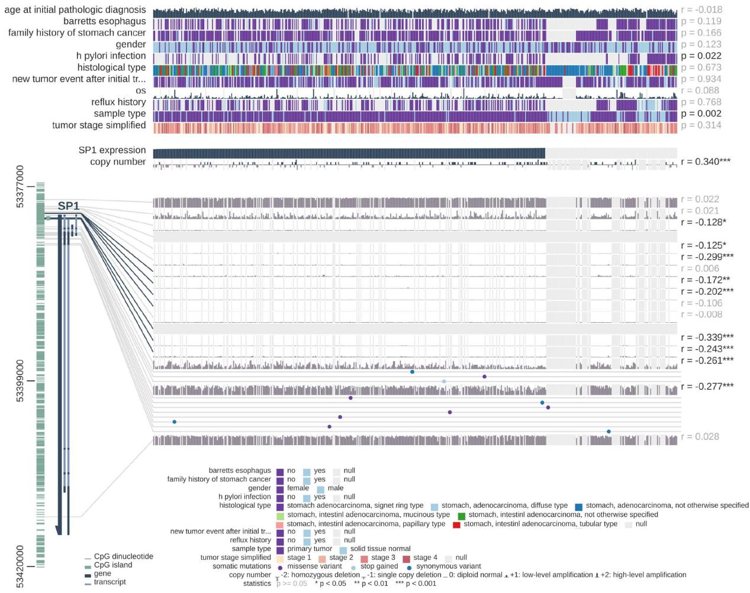
Supplementary Figure 6. The association between Sp1 DNA methylation and the pathogenesis of gastric cancer.

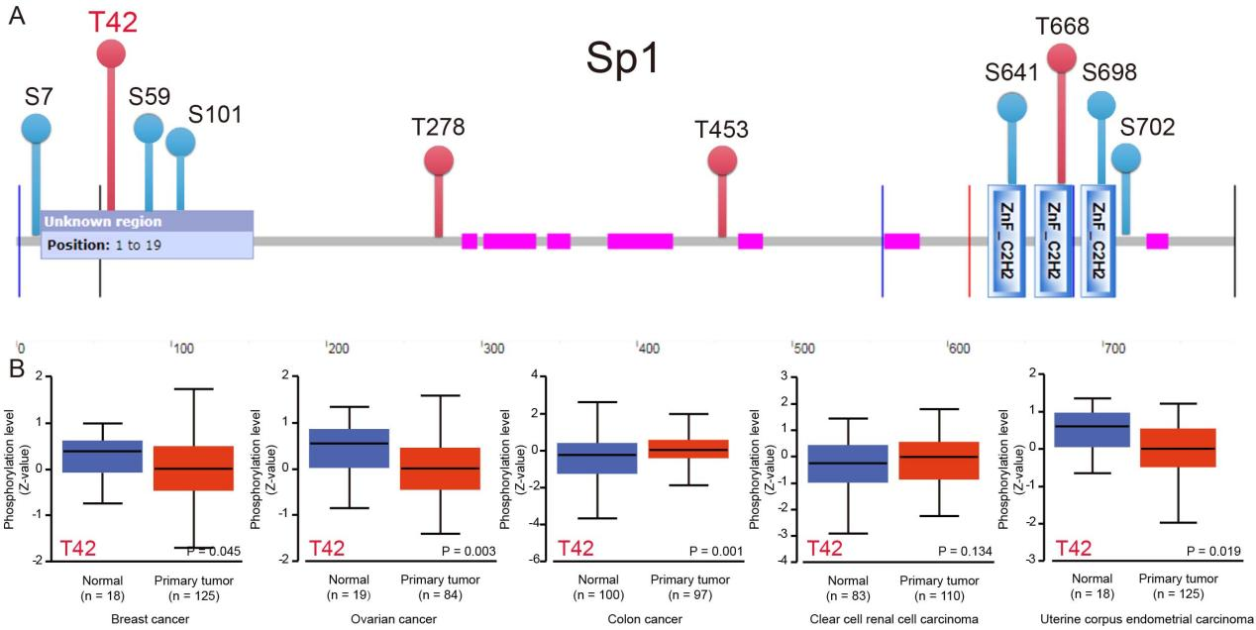
Supplementary Figure 7. Phosphorylation analysis of Sp1 in different tumors of CPTAC dataset. We analyzed the expression level of Sp1 phosphoprotein in different sites (A) between normal tissue and several tumors via the UALCAN (B).
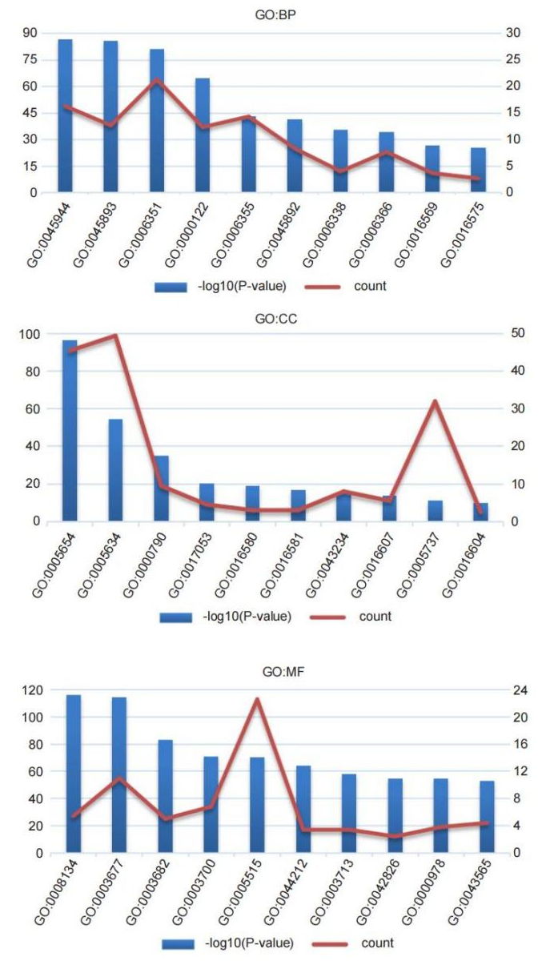
Supplementary Figure 8. The GO enrichment analysis based on Sp1-binding proteins and related genes.

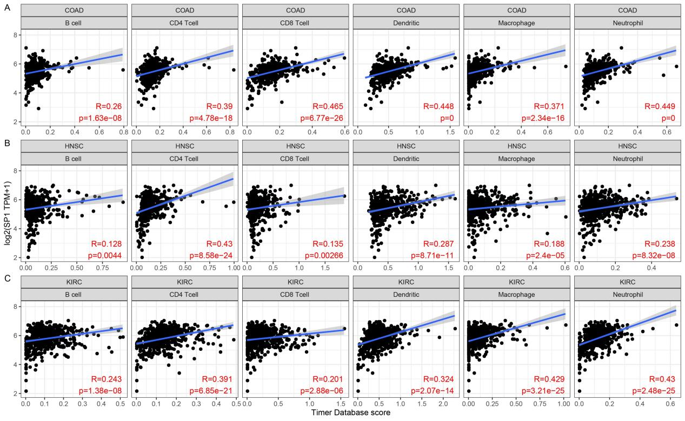
Supplementary Figure 9. The correlations between Sp1 expression and immune cells in patients with COAD (A), HNSC (B), and KIRC (C).

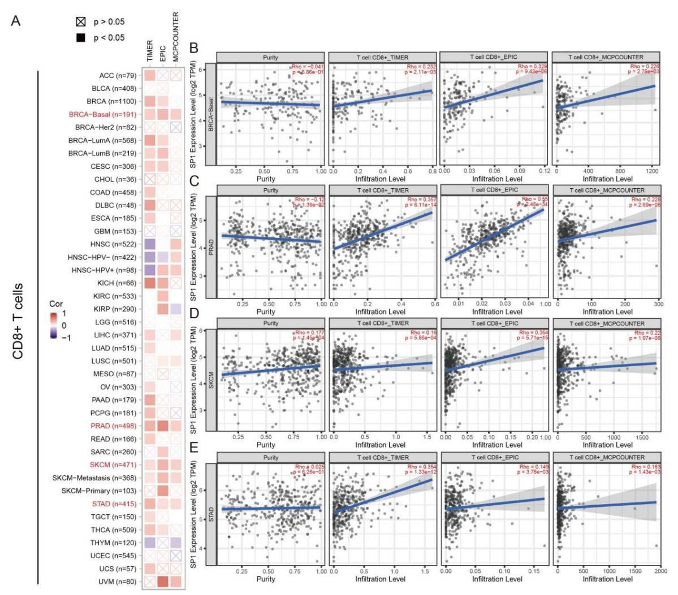
Supplementary Figure 10. Correlations between Sp1 expression and immune infiltration of CD8+ T cells. The EPIC, MCPCOUNTER, and TIMER algorithms were used to explore the potential correlations between the expression of Sp1 and the infiltration level of CD8+ T cells across all types of cancer in TCGA (A). The correlations between Sp1 expression and CD8⁺ T cells in patients with STAD, BRCA-Basal, SKCM, and PRAD using all three algorithms (B).

