Extended Data
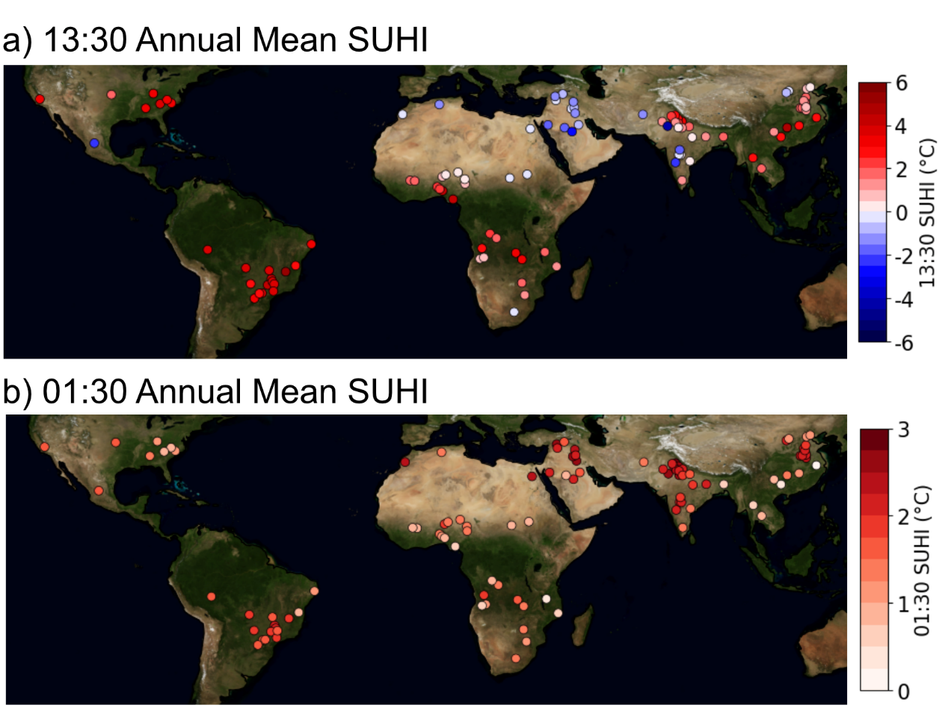
Extended Data Figure 1 Current 18-year annual mean SUHIs, a) at 13:30 (daytime) and b) at 01:30 (nighttime). The city annual SUHIs range from -4.0 °C to 5.4 °C for the 13:30 overpass and from 0.3 °C to 2.8 °C for the 01:30.
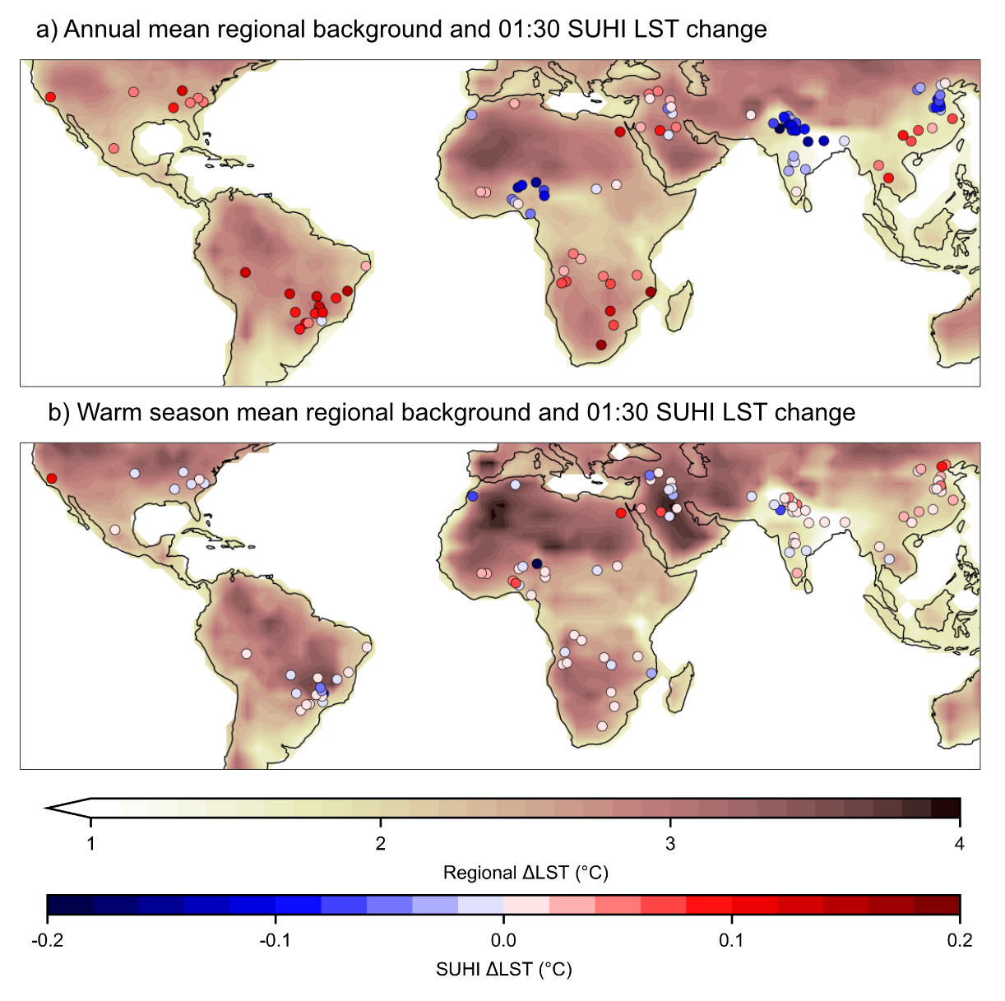
Extended Data Figure 2 A global view of the projected LST changes for the nighttime SUHI, maps show a) regional changes in annual mean LST predicted by the ESMs, with the additional 01:30 LST changes in the city. 58 % of the 01:30 SUHIs are projected to increase in their annual mean in the median ESM based changes and b) regional changes in warm season mean LST predicted by the ESMs, with the additional 01:30 LST changes in the city. 63% of the 01:30 SUHIs are projected to increase in the warm season mean LST changes. Note the different colour bar range from 13:30 figures. There is much less variation in the 01:30 SUHI, and this reflected in the test statistics of 0.65 R-squared and 0.49 °C RMSE.

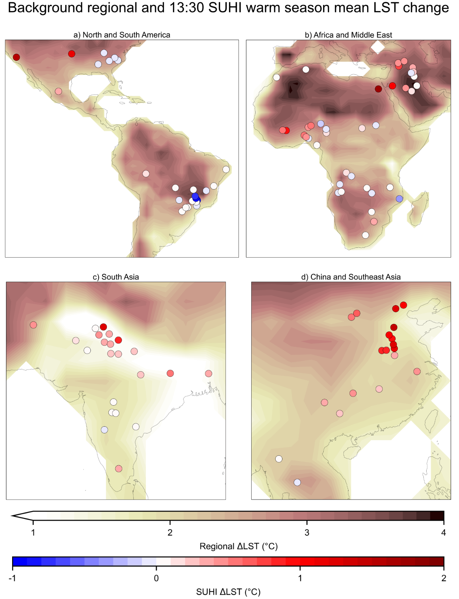
Extended Data Figure 3 A closer view of the projected warm season mean LST changes for the background regional area and the additional SUHI driven changes. The map in Figure 1b is split into regions showing a) North and South America, b) Africa and Middle East, c) South Asia, d) China and Southeast Asia.
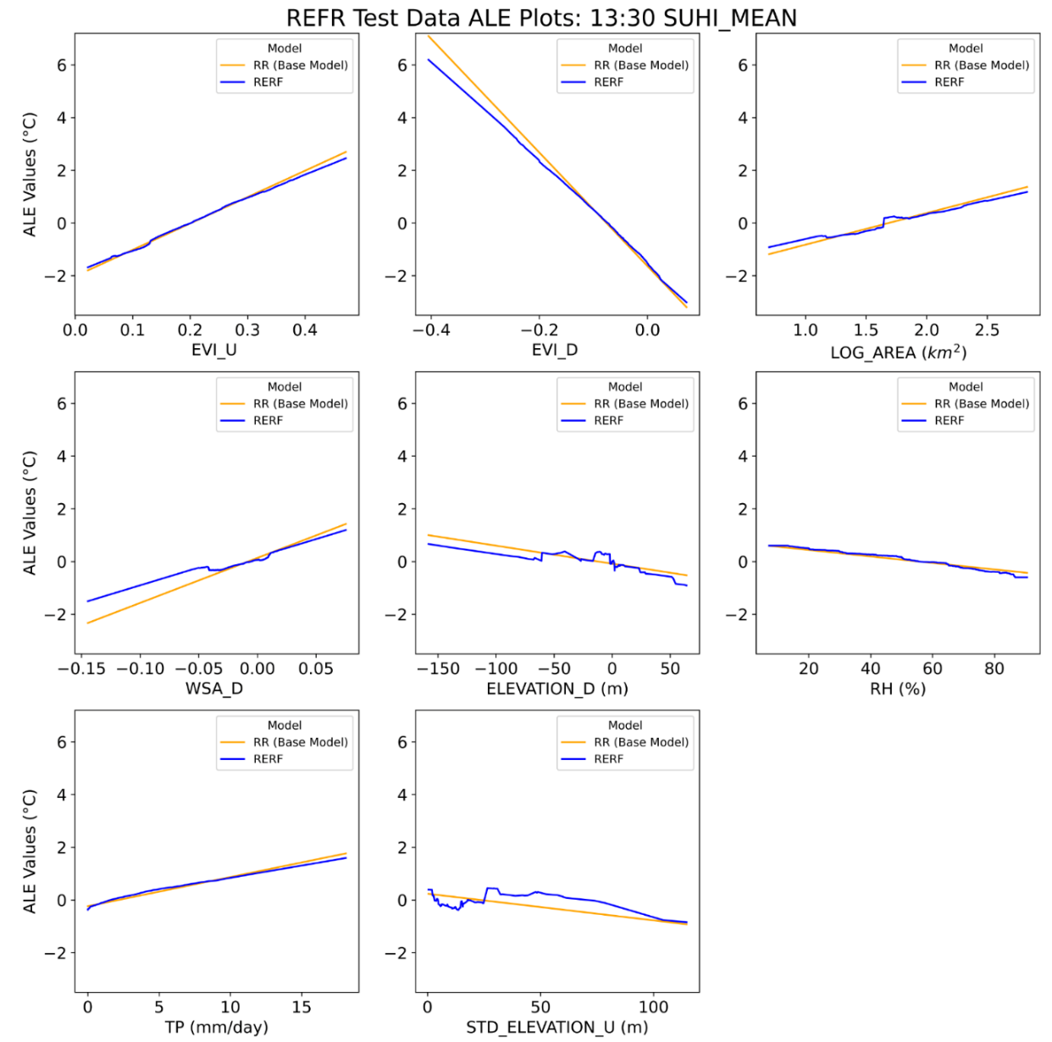
Extended Data Figure 4 13:30 SUHI Accumulated Local Effects²⁰ (ALE) plots for the REFR (blue), with the base Ridge Regression model included (in orange), to show the differences between the two. ALE plots show how a predictor variable (on the x-axis) influences a prediction, shown on the y-axis. A positive slope means increasing the predictor variable increases the prediction and a negative slope indicates an increase in the predictor variable decreasing the prediction made. Here, changes in the EVI_D (urban minus rural EVI) variable is seen to have a strong influence on the prediction made. More rural vegetation leads to a more positive predicted SUHI, and more urban vegetation has a negative influence on the prediction. The ALE plots were generated using test data. Training data ALE plots show the same relationships.

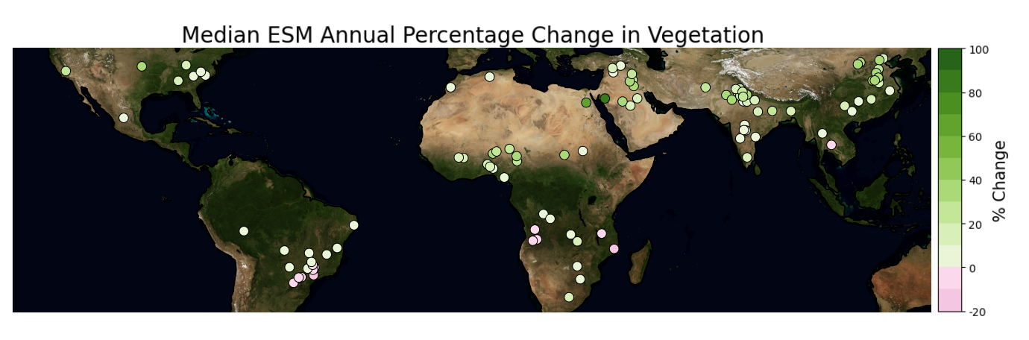
Extended Data Figure 5 The median ESM projected percentage change in vegetation. Comparison of this plot to changes in projected SUHI show areas with increasing vegetation abundance correspond to those with larger projected increases in SUHI magnitude.

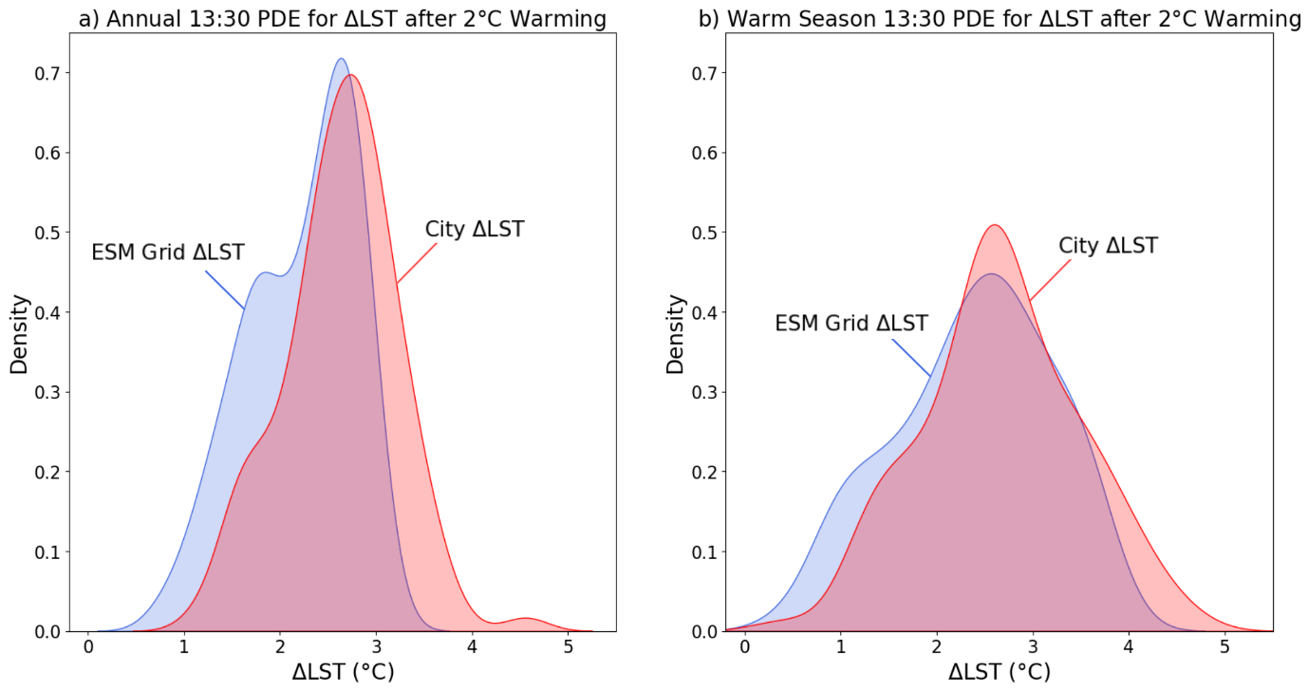
Extended Data Figure 6 Probability distributions generated by kernel density estimation to show the changes in LST for the entire region versus the changes in LST for the city. Generated for a) the annual mean LST change, b) the warm season LST change.

