Revolutionizing antimicrobial treatment: Unprecedented synergy of ZnO quantum dots/Ag NPs/Nitazoxanide Triumphs composite NPs over multidrug-resistant human pathogens

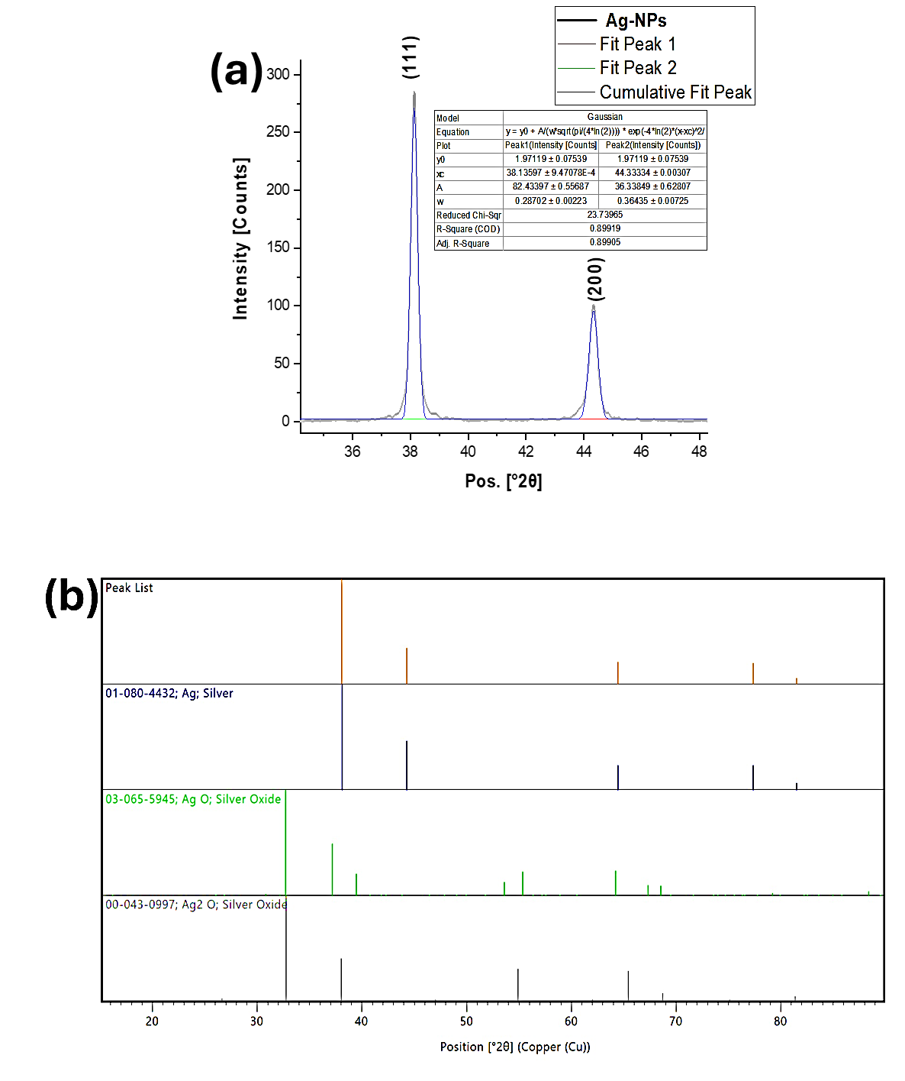
Figure S1. X-ray Powder Diffraction Investigation of Silver Nanoparticles: (a) Elucidation of [111] and [002] as Predominant Peaks through Fitting Analysis; (b) Comparative Assessment of Diffraction Peaks vis-à-vis Various Reference Cards from the International Centre for Diffraction Data (ICDD).
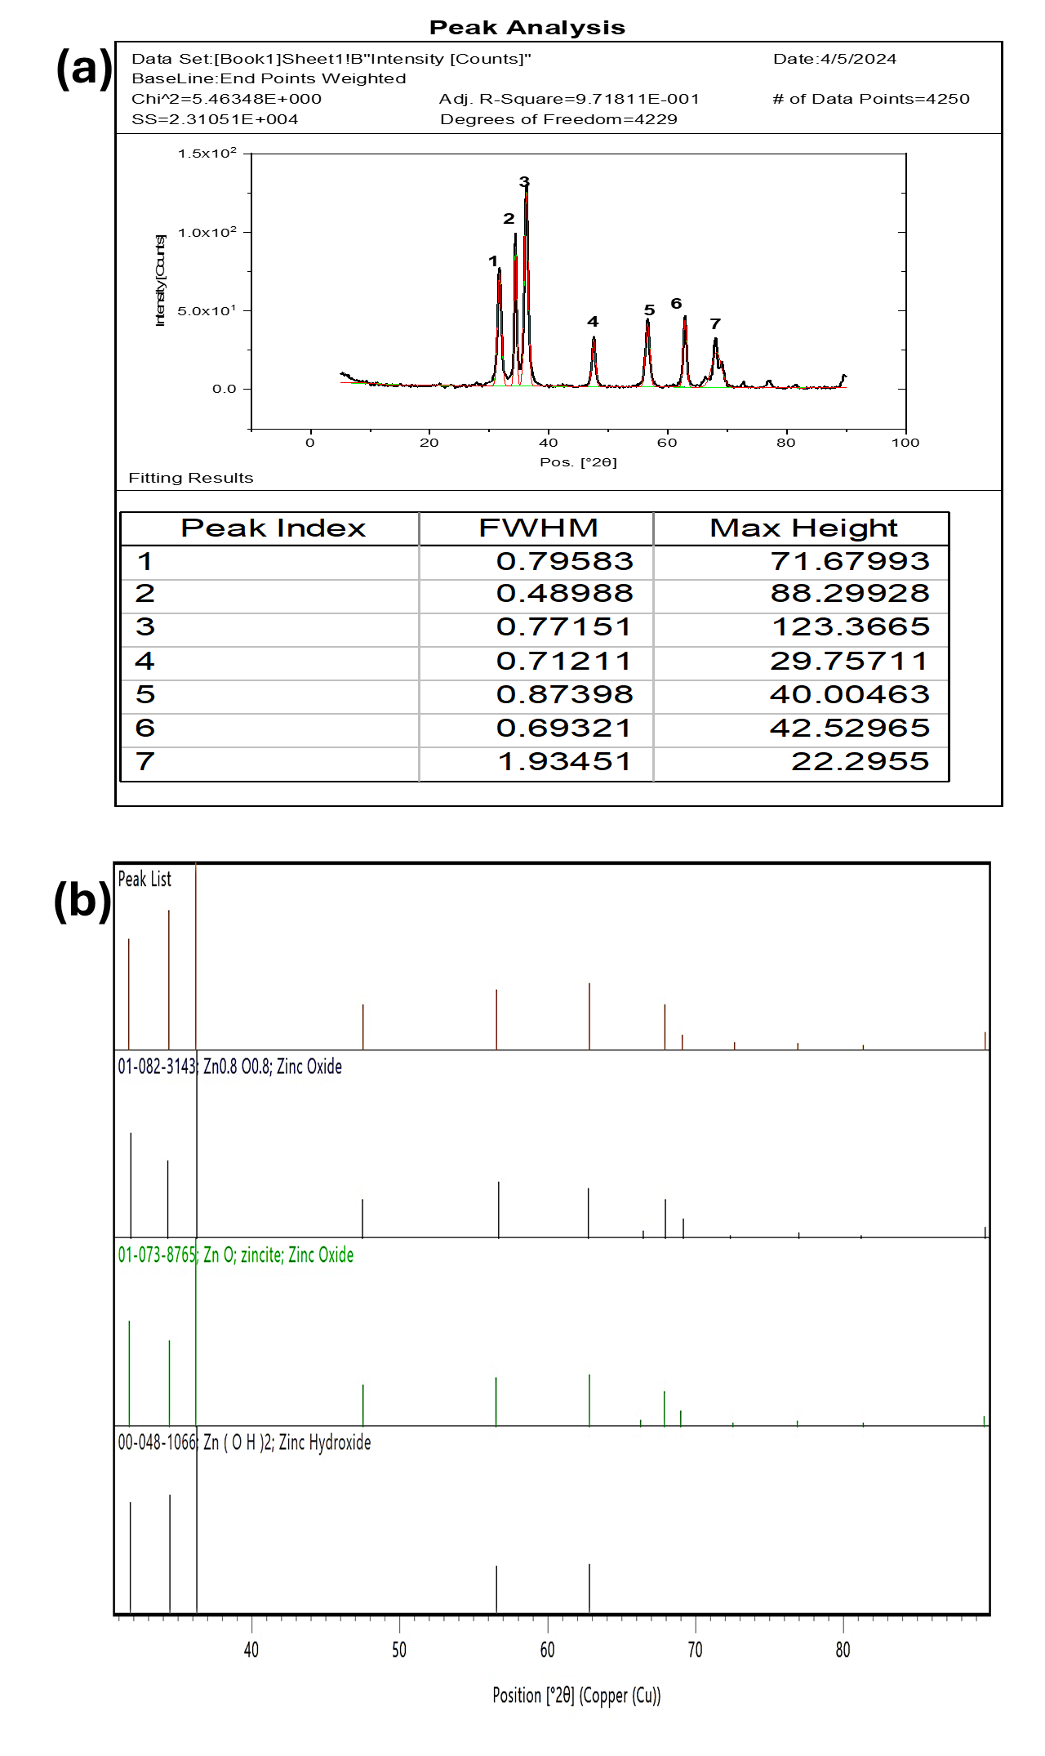
Fig. S2. X-ray Powder Diffraction Investigation of ZnO-QDs: (a) Elucidation of all prominent Peaks through Fitting Analysis; (b) Comparative Assessment of Diffraction Peaks vis-à-vis Various Reference Cards from the International Centre for Diffraction Data (ICDD).

S1, PDF
Name and formula
Reference code: 01-082-3143
Compound name: Zinc Oxide
Empirical formula: O0.8Zn0.8
Chemical formula: Zn0.8O0.8
Crystallographic parameters
Crystal system: Hexagonal
Space group: P63mc
Space group number: 186
a (Å): 3.2450
b (Å): 3.2450
c (Å): 5.2200
Alpha (°): 90.0000
Beta (°): 90.0000
Gamma (°): 120.0000
Volume of cell (106 pm3): 47.60
Z: 2.00
RIR: 4.21
Subfiles and quality
Subfiles: Alloy, metal or intermetalic, Ceramic, Ceramic - Semiconductor, Common Phase, Excipient, Forensic, ICSD
Pattern, Inorganic, Pharmaceutical, Thermoelectric Material
Quality: Indexed (I)
Comments
ANX: AX
ICSD collection code: 236216
Creation Date: 9/1/2014
Cross-References: ICSD:236216, ICDD:04-015-4060 (related phase)
ANX: AX
Analysis: O0.8 Zn0.8
Formula from original source: Zn0.8 O0.8
ICSD Collection Code: 236216
Minor Warning: No e.s.d reported/abstracted on the cell dimension. No R factors reported/abstracted
Wyckoff Sequence: b2 (P63MC)
Unit Cell Data Source: Powder Diffraction.
References
Primary reference: Ekicibil, A., Solid State Sci., 14, 1486, (2012)
Structure: Ekicibil, A., Solid State Sci., 14, 1486, (2012)
Peak list
No. h k l d [Å] 2θ [°] I [%]
1 1 0 0 2.81025 31.817 55.9
2 0 0 2 2.61000 34.331 41.2
3 1 0 1 2.47445 36.275 100.0
4 1 0 2 1.91243 47.505 20.8
5 1 1 0 1.62250 56.688 29.8
6 1 0 3 1.47939 62.757 26.5
7 2 0 0 1.40513 66.488 3.8
8 1 1 2 1.37795 67.976 20.4
9 2 0 1 1.35683 69.183 10.1
10 0 0 4 1.30500 72.352 1.6
11 2 0 2 1.23722 77.013 3.0
12 1 0 4 1.18361 81.205 1.5
13 2 0 3 1.09318 89.601 6.1
14 2 1 0 1.06218 92.972 2.0
15 2 1 1 1.04085 95.474 5.8
16 1 1 4 1.01689 98.489 3.1
17 2 1 2 0.98383 103.065 2.1
18 1 0 5 0.97865 103.831 3.9
19 2 0 4 0.95621 107.331 0.6
20 3 0 0 0.93675 110.633 2.4
21 2 1 3 0.90660 116.348 5.8
22 3 0 2 0.88168 121.776 2.9
23 0 0 6 0.87000 124.602 0.4
24 2 0 5 0.83801 133.619 2.4
25 1 0 6 0.83109 135.901 0.6
26 2 1 4 0.82379 138.477 0.8
27 2 2 0 0.81125 143.435 1.6
Stick Pattern

