Supplementary Information

Room-temperature waveguide-integrated photodetector using bolometric effect for mid-infrared spectroscopy applications
Joonsup Shim¹, Jinha Lim¹, Inki Kim¹, Jaeyong Jeong¹, Bong Ho Kim¹, Seong Kwang Kim¹, Dae-Myeong Geum², and SangHyeon Kim^{1*}
¹ School of Electrical Engineering, Korea Advanced Institute of Science and Technology (KAIST), 291 Daehak-Ro, Yuseong-Gu, Daejeon 34141, Republic of Korea
² School of Electronics Engineering, Chungbuk National University, 1 Chungdae-ro, Seowon-Gu, Cheongju, Chungbuk 28644, Republic of Korea
*Corresponding Author: SangHyeon Kim (shkim.ee@kaist.ac.kr)

Contents
Note 1. Free-carrier absorption (FCA) in Ge
Note 2. Optimizing device geometries
Note 3. Fabrication process flow
Note 4. Device characterization
Note 5. Low-frequency noise analysis
Note 6. Electrical breakdown characteristics
Note 7. Simulation of mode converters
Note 8. Performance comparison
Note 9. References

Supplementary Note 1. Free-carrier absorption (FCA) in Ge

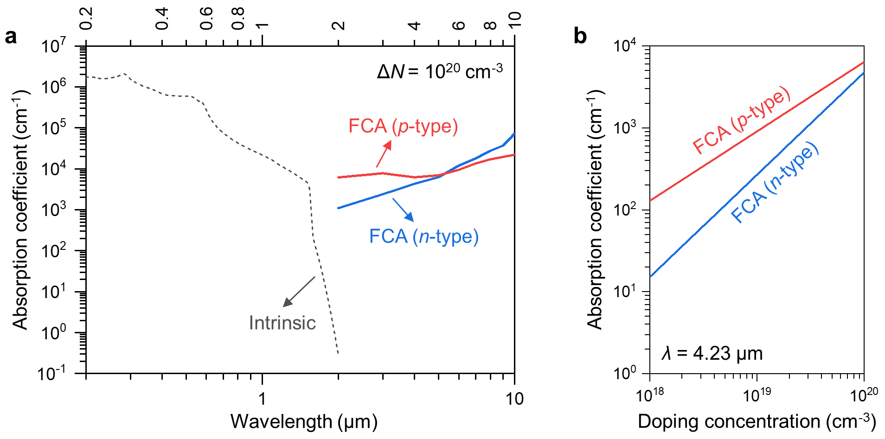
Fig. S1. FCA in Ge. a Absorption coefficients in Ge for intrinsic absorption and for FCA in both n- and p-type Ge with a doping (impurity) concentration (ΔN) of 10²⁰ cm⁻³ depending on the wavelengths. b Comparison of the calculated FCA coefficients as a function of the doping concentration for n- and p-type Ge at a wavelength (λ) of 4.23 μm. The absorption coefficients for FCA in Ge are calculated based on the literature¹.

The free-carrier absorption (FCA) is a process where free carriers, i.e., free electrons and free holes, absorb the incoming photon energy, leading to non-radiative carrier transition with the thermalization process^{1,2}. There are two types of FCA in Ge: FCA in n-type Ge and FCA in p-type Ge, each corresponding to the absorption attributed to the free electrons and free holes, respectively. The absorption coefficients in Ge for intrinsic absorption (band-to-band absorption) and FCA are plotted in Fig. S1a. The doping (impurity) concentration (ΔN) is assumed to be 10²⁰ cm⁻³. The intrinsic absorption of Ge is negligible beyond the wavelength of ~1.9 μm; however, FCA becomes increasingly significant beyond the bandgap energies. Furthermore, FCA in Ge shows a clear trend of increase with the wavelength of light, highlighting the importance of our approach for broadband mid-infrared (MIR) photodetection – even much higher photoresponse at longer wavelengths – within the waveguide structures on the Ge-on-insulator (Ge-OI) platform. Figure S1b represents the absorption coefficients of FCA for n- and p-type Ge depending on the doping concentration at the wavelength of 4.23 μm, chosen for the carbon dioxide (CO₂) gas sensing demonstration in this work. As shown in Fig. S1b, FCA is more pronounced in p-type doped Ge compared to n-type. Consequently, we selected p-type doping to maximize the FCA-induced heating process in our detector.

Supplementary Note 2. Optimizing device geometries

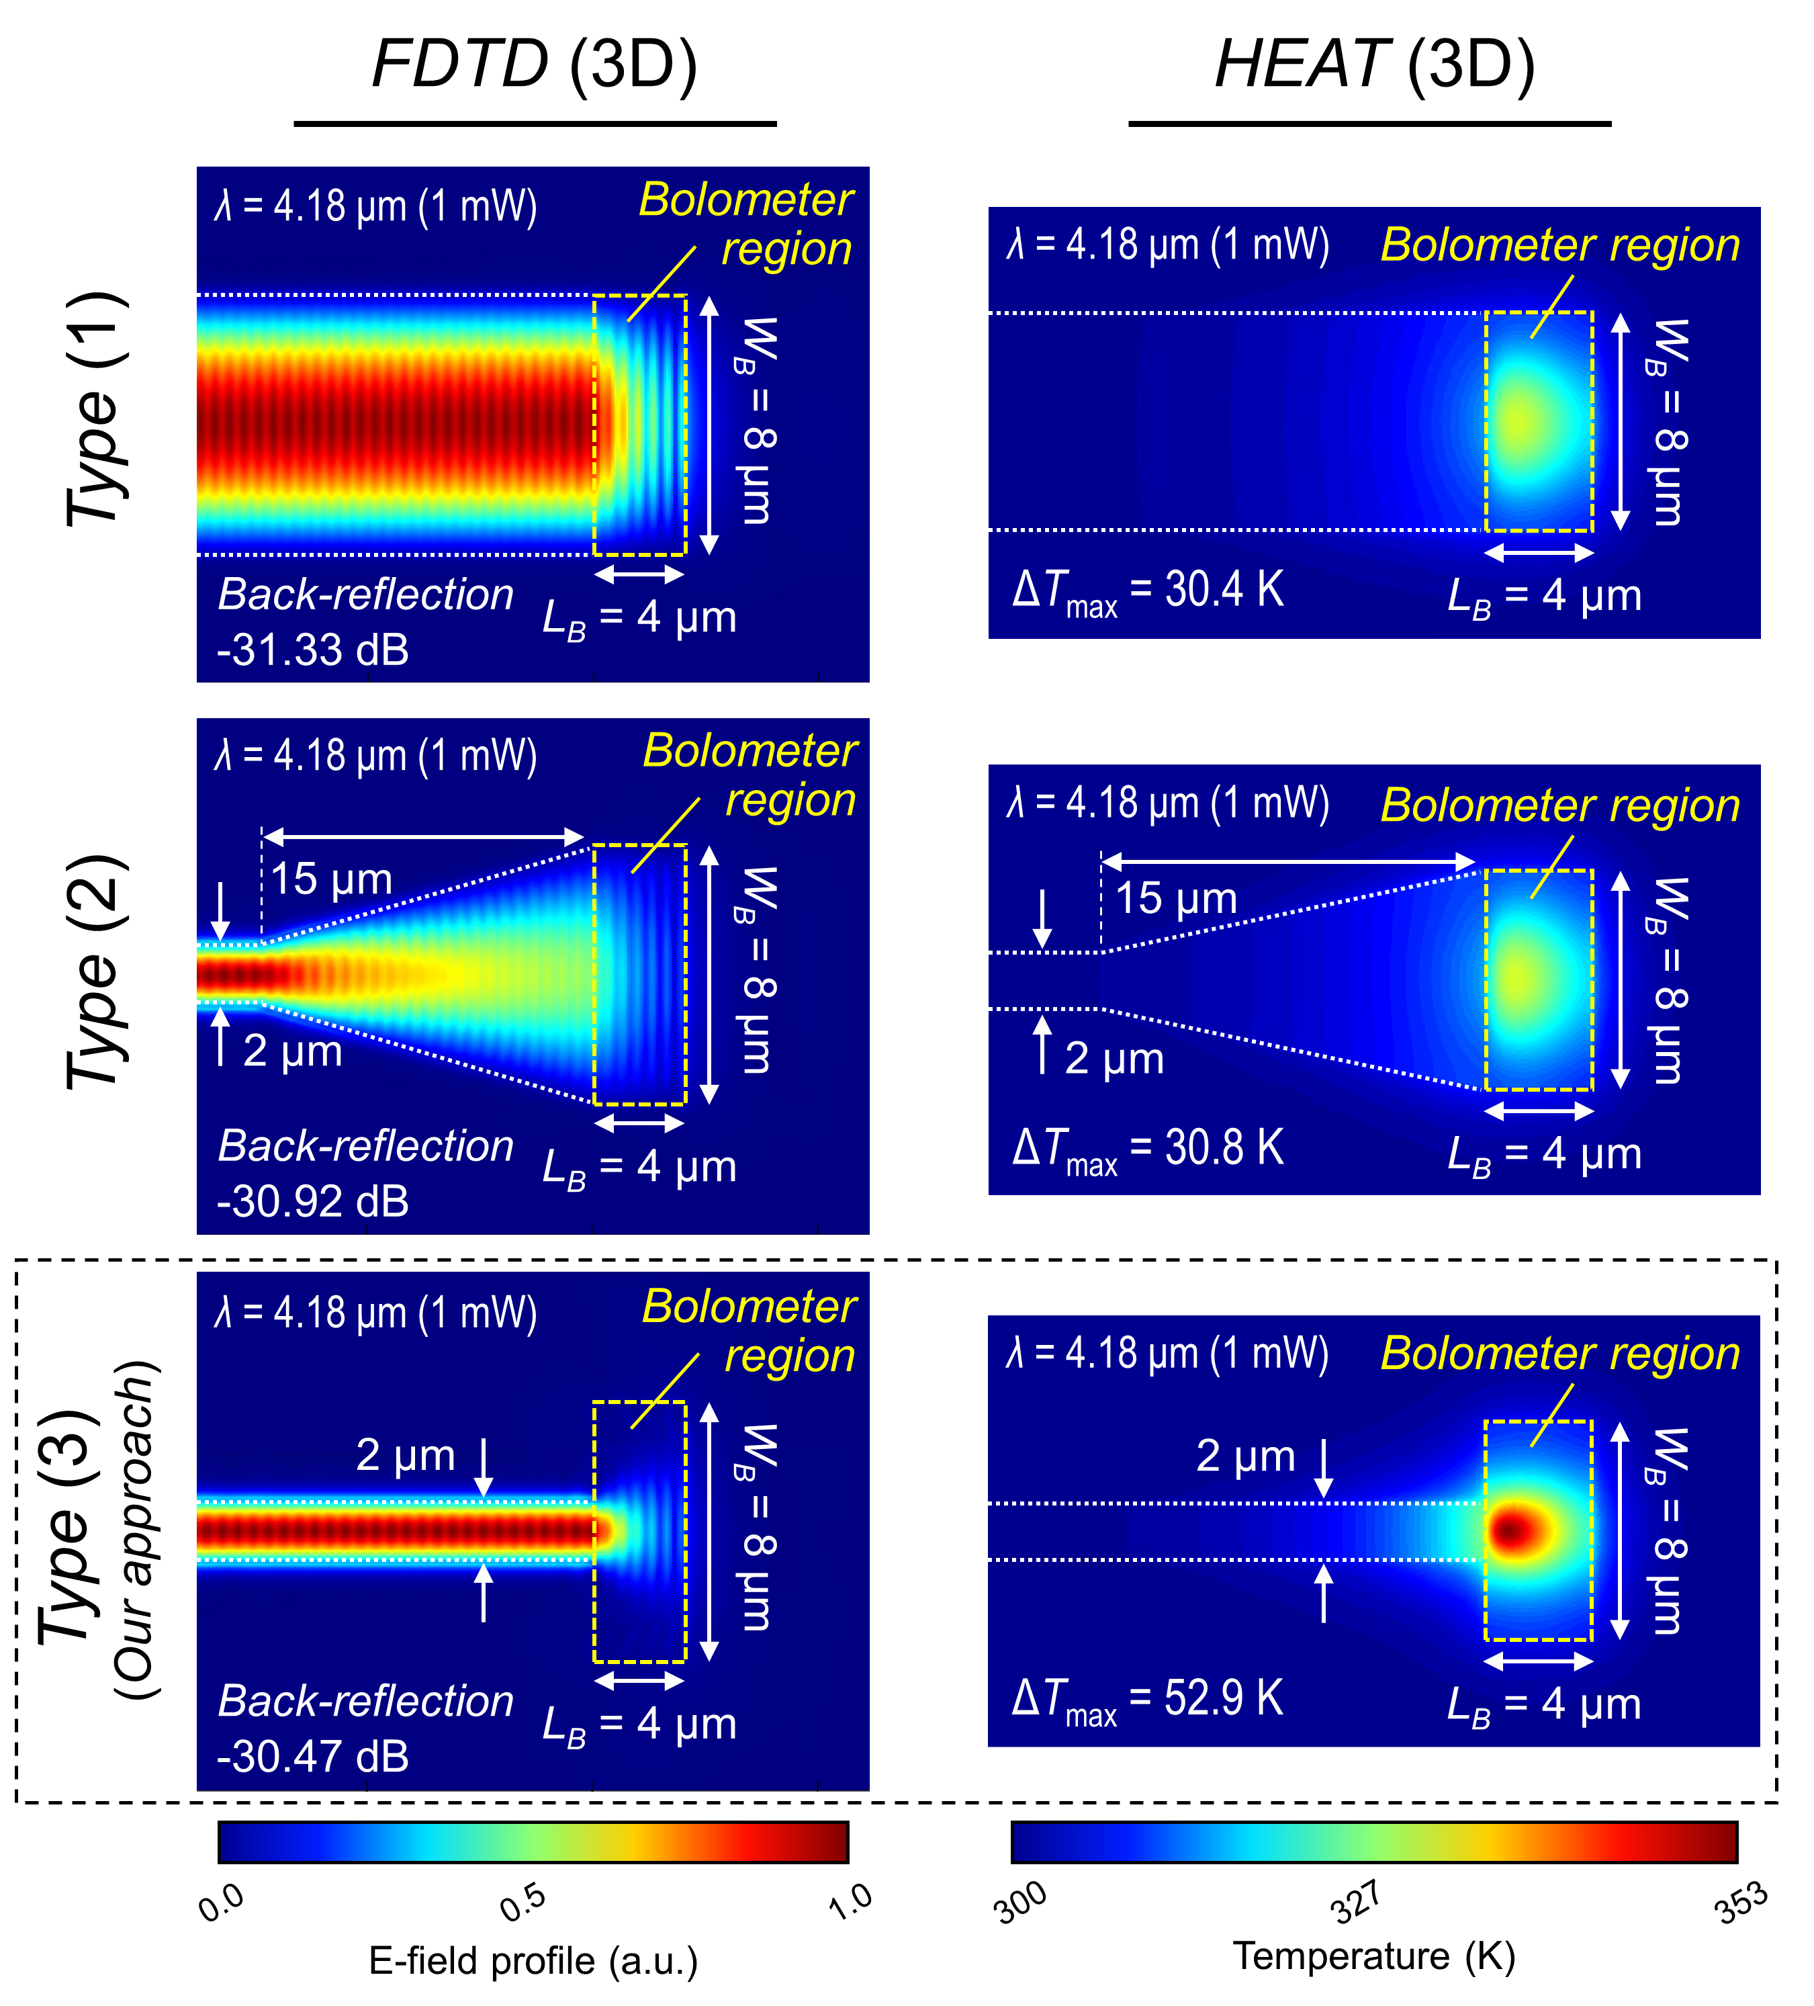
Fig. S2. Optimization of waveguide-to-bolometer interfacing geometries. The amount of back-reflection and FCA-induced heating efficiency was obtained through numerical simulations based on different interfacing geometries. Three device configurations were evaluated: Type (1) features a conventional structure, Type (2) incorporates a tapered structure, and Type (3) – our approach – utilizes an abrupt structure.

The optimization process of device geometries was conducted by numerical simulations of 3D-FDTD and HEAT solvers (Ansys Lumerical). We first introduced a terminated-waveguide structure, in which the input waveguide is terminated after the bolometer region (p⁺ Ge region). Furthermore, we carefully considered the waveguide-to-bolometer interfacing geometry. Figure S2 describes a comparative analysis of three device configurations depending on the interfacing geometries: type (1) – conventional structure, type (2) – tapered structure, and type (3) – abrupt structure (our approach). An input light of 1 mW at 4.18 μm was assumed to support only the fundamental transverse-electric (TE) mode. Here, we primarily considered the amount of back-reflection and the FCA-induced heating efficiency. Type (1) illustrates a conventional waveguide with a uniform width leading directly into the bolometer region, which shows a back-reflection of -31.33 dB and a maximum temperature increase (ΔT_{max}) of 30.4 K. Type (2) depicts a tapered waveguide structure that gradually widens towards the bolometer region, resulting in a back-reflection of -30.92 dB and a ΔT_{max} of 30.8 K. Type (3) represents an abrupt transition design with a narrow waveguide expanding suddenly to the relatively wider bolometer region, producing a similar lower back-reflection of -30.47 dB and a notably higher ΔT_{max} of 52.9 K compared with other approaches. Consequently, we opted for the type (3) – abrupt structure – as our approach for enhanced FCA-induced heating performance with reasonable amount of back-reflection.

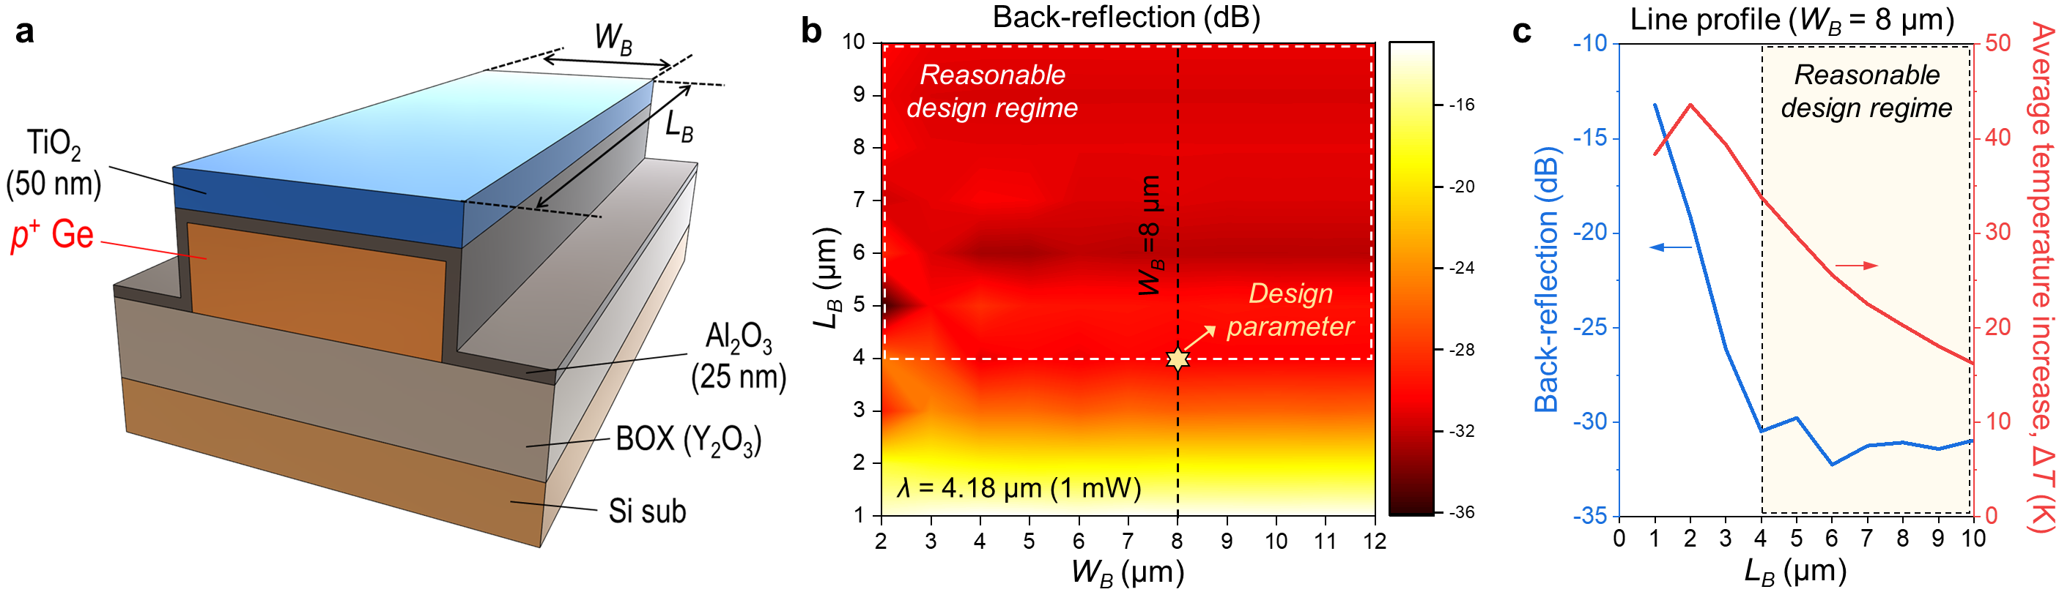
Fig. S3. Optimization of geometrical parameters of the bolometer region. a Schematic of the device structure for simulations. b Simulated contour map showing geometry-dependent back-reflection across varying L_{B} and W_{B} of the bolometer region. c Line profiles of both back-reflection and average temperature increase (ΔT) within the bolometer region as L_{B} varies for a fixed W_{B} of 8 μm.

Figure S3 presents the simulation results used to determine the optimal geometrical parameters of the bolometer region. A schematic of the simulated device structure is illustrated in Fig. S3a. For these simulations, we explored a wide range of lengths (L_{B}) and widths (W_{B}) for the bolometer region, while the width of an input waveguide (W_{in}) leading to the bolometer region was fixed at 2 μm. We first evaluated back-reflection, which can cause unwanted ripples that deteriorate the overall noise characteristics of the sensing system. Figure S3b represents a simulated contour map that shows the geometry-dependent back-reflection. At smaller L_{B} values, relatively higher back-reflection occurs due to insufficient light absorption in the bolometer region, while changes in W_{B} have little impact. As shown in Fig. S3b, an L_{B} greater than 4 μm is preferable, as it ensures back-reflection remains below approximately -30 dB, indicated by a white dotted line and considered within a reasonable design regime. Figure S3c depicts the line profiles of both back-reflection and average temperature increase (ΔT) within the bolometer region, as L_{B} varies for a W_{B} of 8 μm. Although smaller W_{B} could potentially enhance heat confinement, a width of 8 μm was chosen due to alignment tolerance constraints in subsequent in-house fabrication steps. Additionally, ΔT was calculated within the bolometer region for a central width of 2 μm, corresponding to the spacing of electrodes, due to the minor amount of transfer length between the prepared bolometric material and electrode stack. As shown in Fig. S3c, we finally selected an L_{B} of 4 μm and a W_{B} of 8 μm to achieve the highest ΔT within the reasonable design regime. It is important to note that the geometrical parameters of the bolometer region can be tailored based on the specific application requirements.

Supplementary Note 3. Fabrication process flow

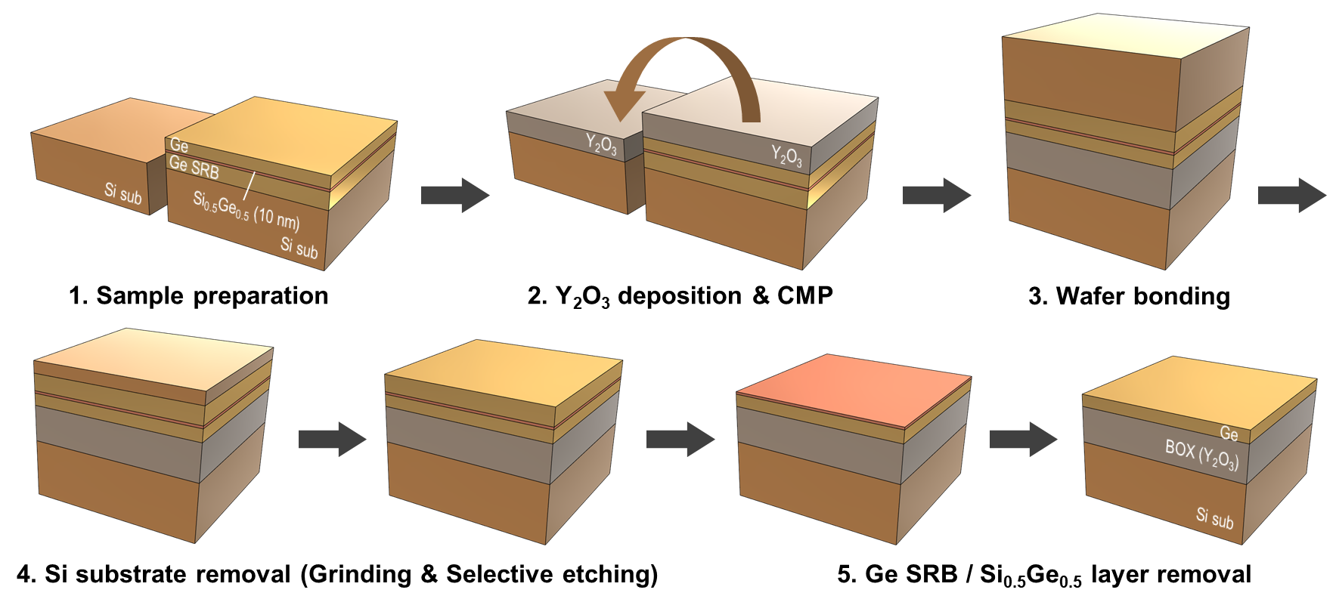
Fig. S4. Fabrication process flow of the Ge-OI photonic platform using direct wafer bonding (DWB) technique. SRB, strain relaxed buffer; BOX, buried oxide; CMP, chemical mechanical polishing.

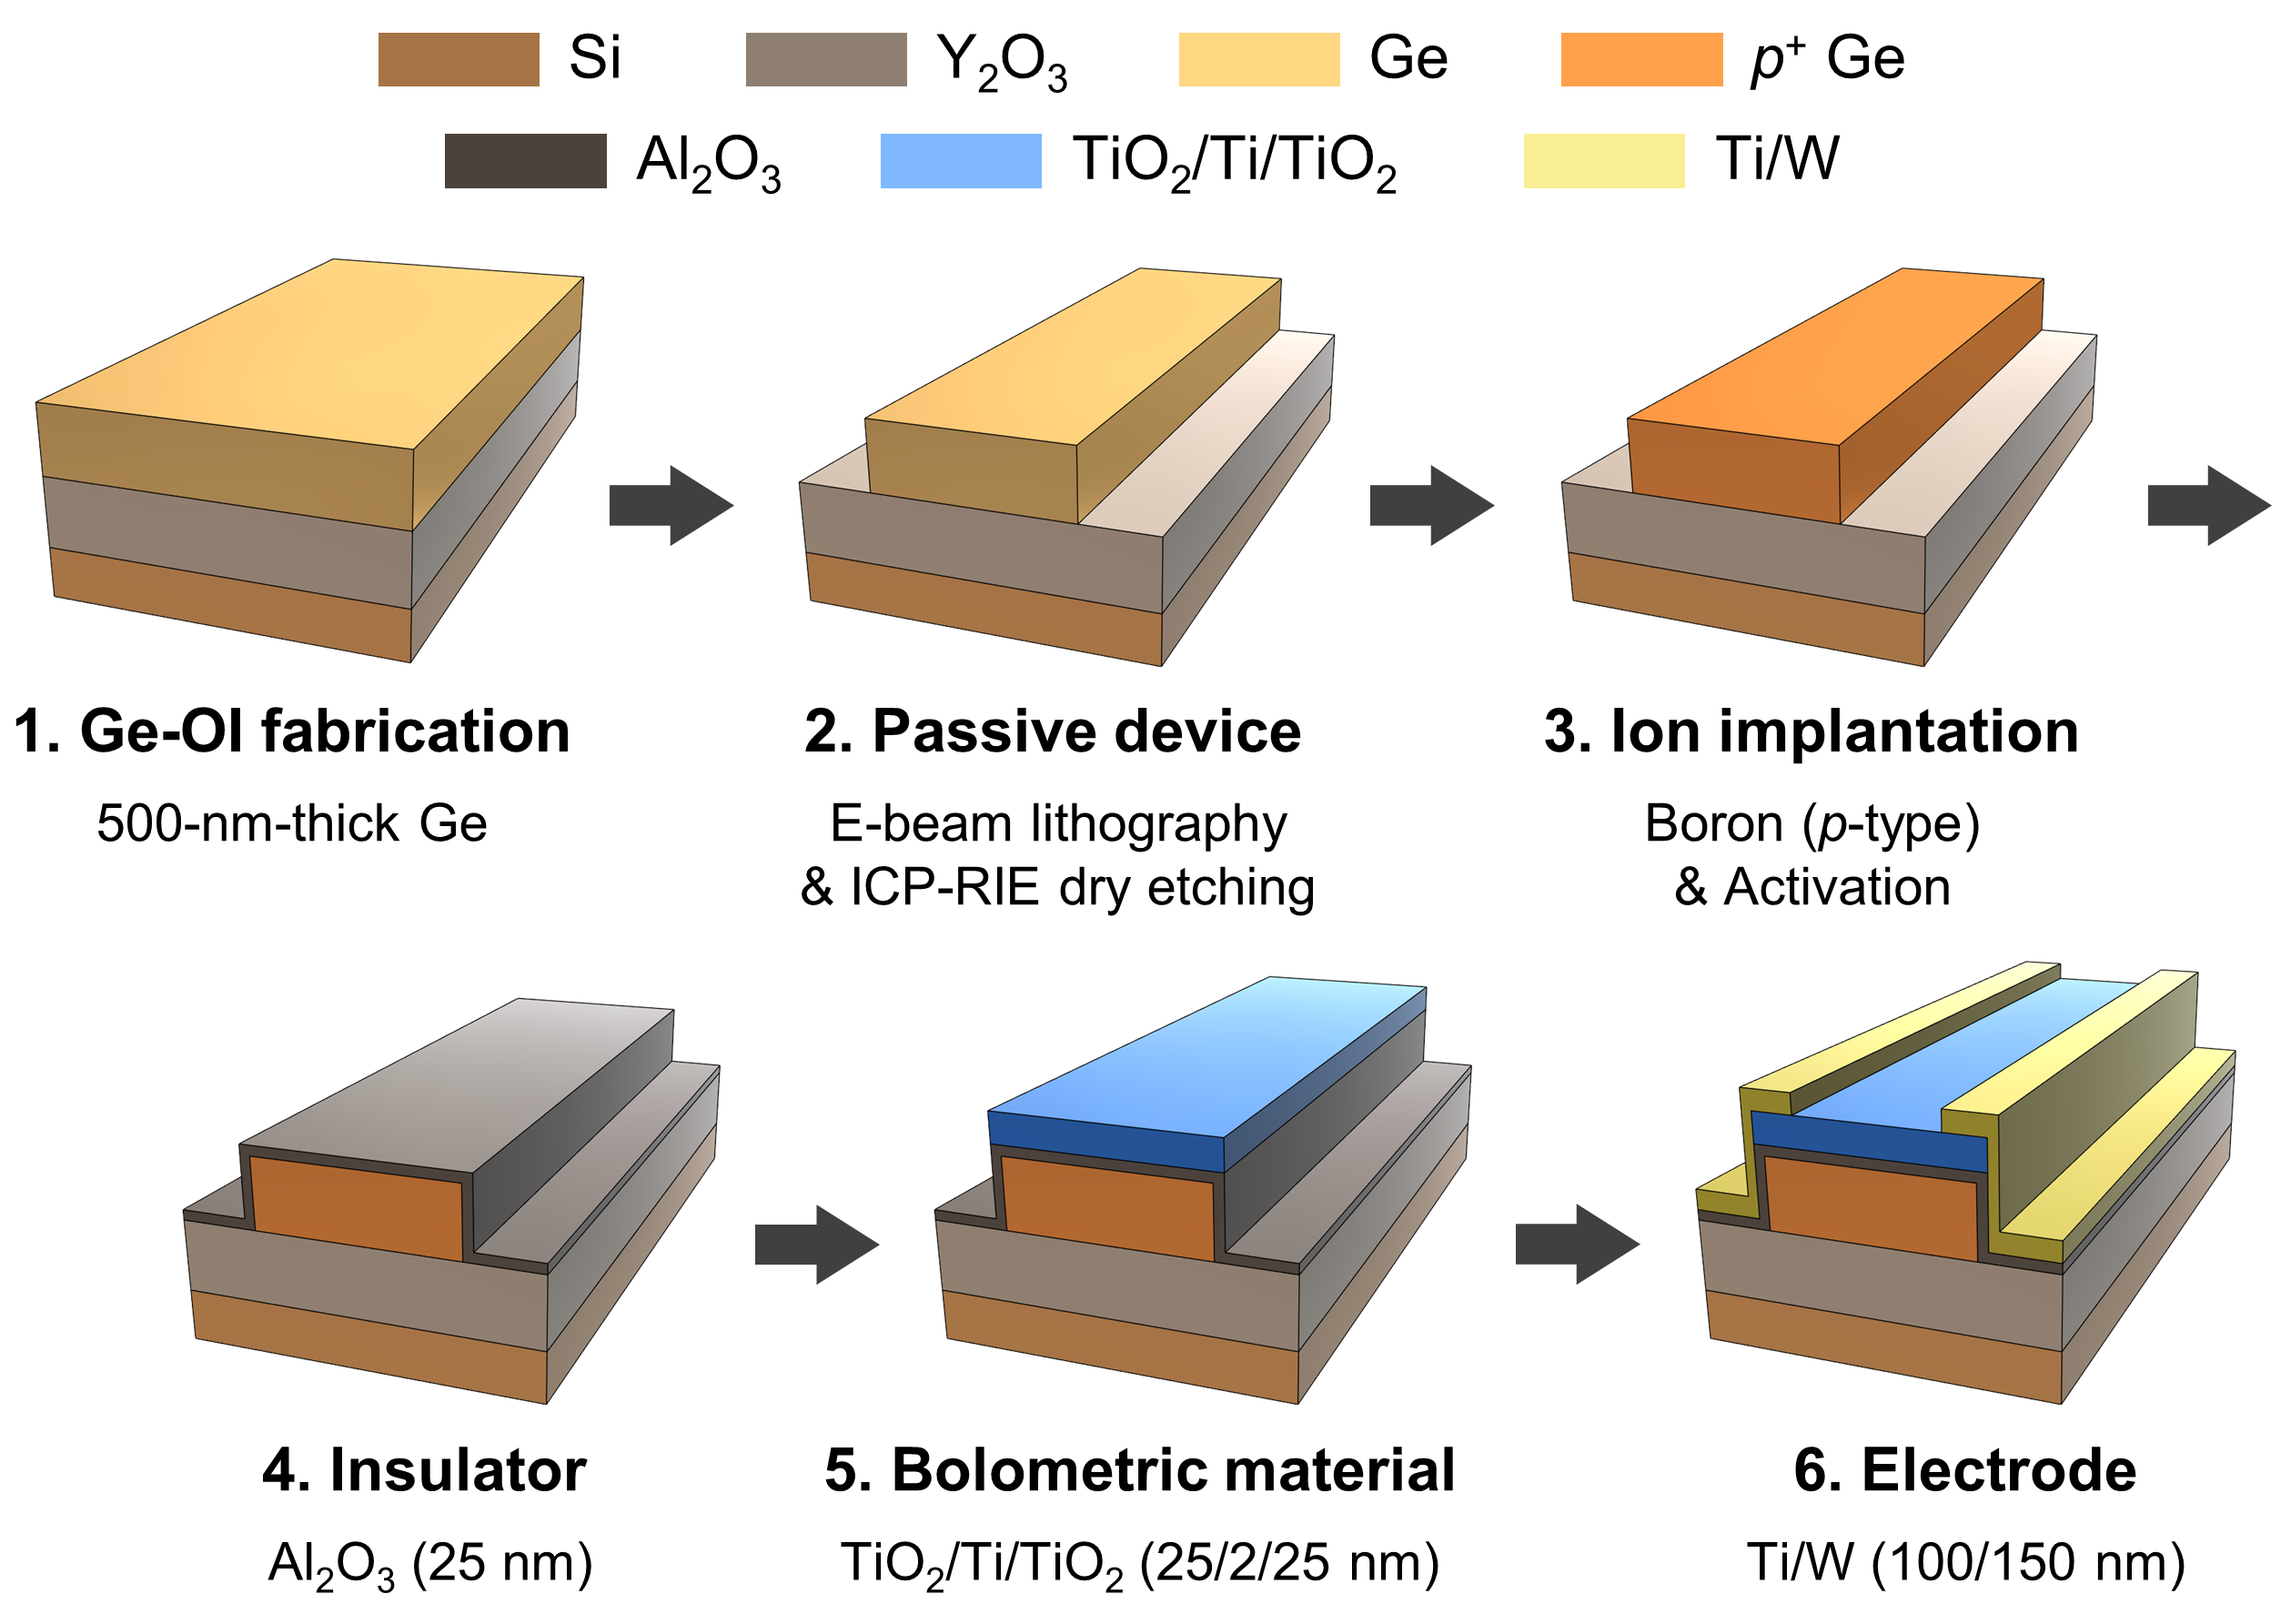
Fig. S5. Fabrication process flow of the proposed MIR waveguide-integrated PD on a Ge-OI platform. ICP-RIE, inductively coupled plasma reactive ion etching.

Figures S4 and S5 summarize the fabrication process flow of the proposed MIR waveguide-integrated photodetector (PD) on the Ge-OI platform using the bolometric effect with FCA process.

Supplementary Note 4. Device characterization

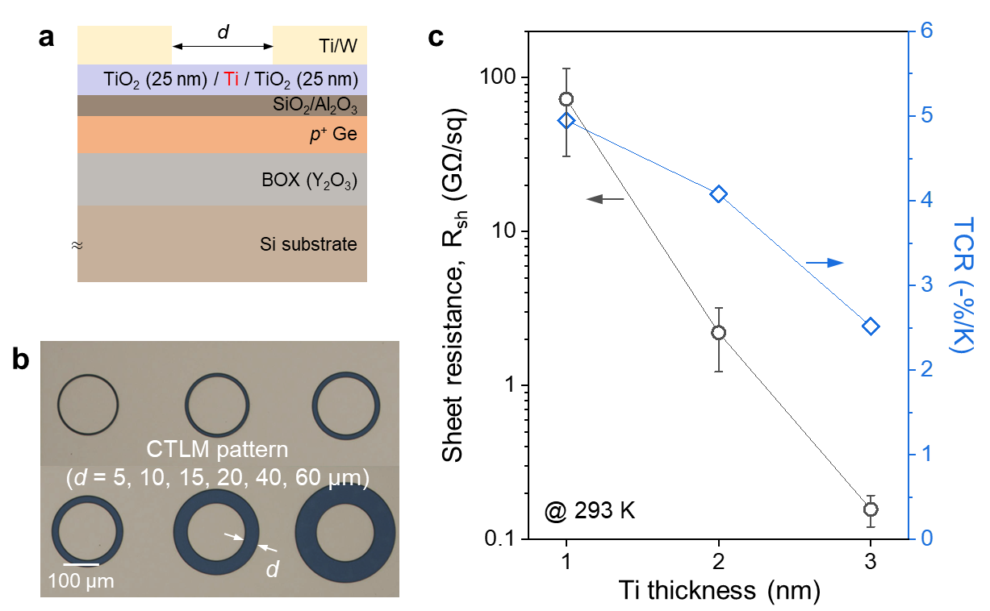
Fig. S6. Optimization of bolometric material. a Schematic of the device structure for the CTLM patterns. b Optical microscope image of the fabricated CTLM patterns. c Variation in sheet resistance (Ω/sq) and TCR (-%/K) depending on the thickness of the metallic Ti layer.

To optimize the thermo-electrical properties of the bolometric material in the TiO₂/Ti/TiO₂ tri-layer film, we fabricated the test devices with varying thickness of the metallic Ti layer. Figure S6a illustrates the schematic of these devices, which feature circular transmission line method (CTLM) patterns with spacings (d) of 5, 10, 15, 20, 40, and 60 μm, as depicted in the optical microscope image in Fig. S6b. For simplicity, the thickness of the upper and lower TiO₂ film was maintained at 25 nm, while the thickness of metallic Ti layer varied from 1 to 3 nm. The thickness of the other layers was kept consistent with those used in our waveguide-integrated photodetector. As demonstrated in Fig. S6c, the extracted sheet resistance (R_{sh}) values from the CTLM patterns at 293 K exhibit a clear downward trend as the thickness of the metallic Ti layer increases. Moreover, the temperature-coefficient of resistance (TCR) values, calculated from the temperature-dependent R_{sh} values, show a correlation with the R_{sh} values. Further detailed analysis can be found in our previous work³. It is important to note that this approach allows us to tailor the thermo-electrical properties of the bolometric material to meet specific application requirements. Here, we selected a 2 nm thickness for the metallic Ti layer to achieve an optimal balance of electrical resistance and high TCR value in our waveguide-integrated photodetector.

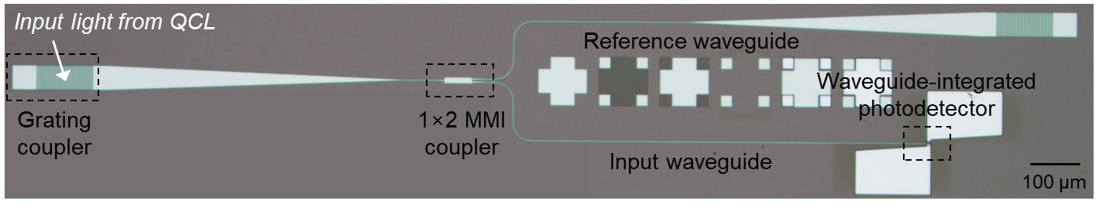
Fig. S7. Optical microscope image of the fabricated device with the reference waveguide pattern. QCL, quantum cascade lasers; MMI, multi-mode interference.

Figure S7 shows an optical microscope image of the fabricated waveguide-integrated photodetector with the reference waveguide structure, which was utilized to assist the optical alignment of fiber-optic coupling and to precisely calculate the optical power coupled into the bolometer region.

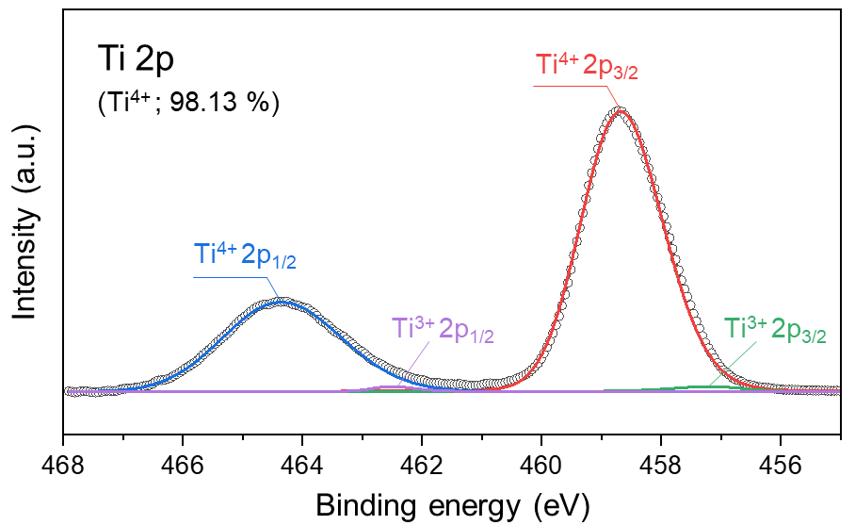
Fig. S8. XPS analysis of the TiO₂ thin film. The 25 nm-thick TiO₂ thin film predominantly consists of Ti⁴⁺ states.

To obtain comprehensive insights into the chemical bonding states and composition of the bolometric material, X-ray photoelectron spectroscopy (XPS) analysis was performed using the Thermo Scientific K-Alpha model at KAIST Analysis Center for Research Advancement (KARA). This analysis employed a monochromatic Al Kα X-ray source to identify the chemical states. Calibration of the energy axis was achieved using the C 1s reference peak. Prior to analysis, the surface of the 25 nm TiO₂ thin film was cleaned by sputter-cleaning with an Ar⁺ ion beam (~5 nm depth) to prevent the effects of surface contaminants on the XPS results. Figure S8 shows the detailed Ti 2p XPS spectra. Deconvolution of these spectra was performed with reference⁴ to determine the relative proportions of each valence state. The analysis, as shown in Figure S8, indicated that the TiO₂ thin film predominantly consists of Ti⁴⁺ states (98.13%), with a minor presence of Ti³⁺ states.

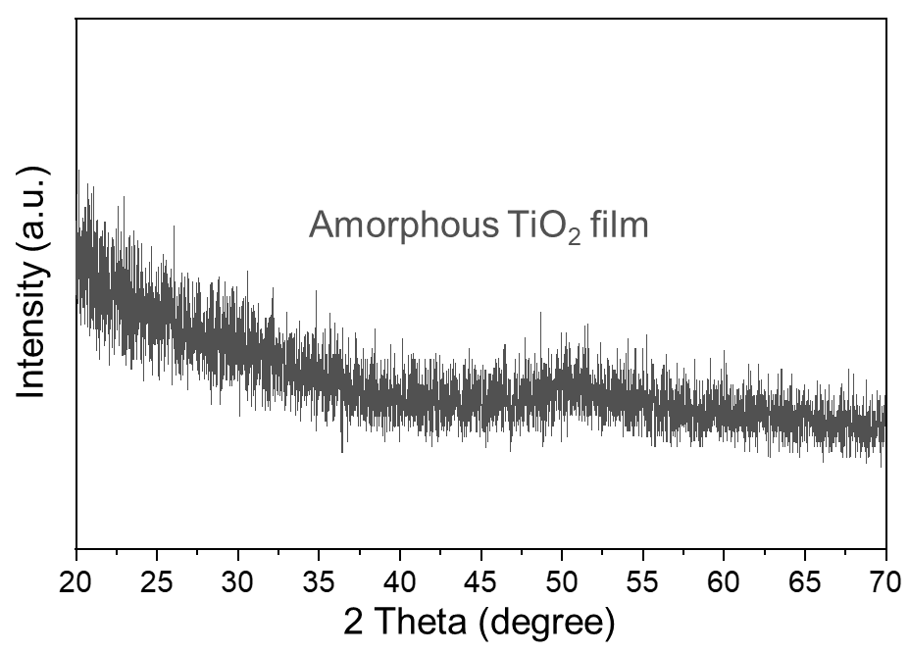
Fig. S9. XRD analysis of the TiO₂ thin film. The 25 nm-thick TiO₂ thin film shows amorphous state.

To investigate the crystalline properties of the bolometric material, we performed X-ray diffraction (XRD) analysis on a 25 nm TiO₂ thin film using a Cu Kα source in 2-theta scan mode (Rigaku D/MAX-2500 model at KAIST Analysis Center for Research Advancement, KARA). As depicted in Fig. S9, the diffraction pattern clearly indicated an amorphous state with no sharp peaks, attributed to the insufficient thermal energy required to achieve crystalline phases.

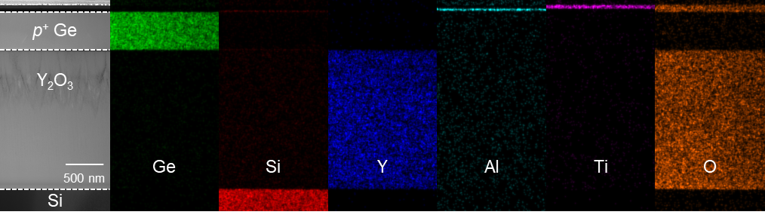
Fig. S10. TEM with EDS analysis. Cross-sectional transmission electron microscopy (TEM) image of the fabricated device with energy-dispersive X-ray spectroscopy (EDS) elemental mapping patterns of Ge, Si, Y, Al, Ti, and O atoms.

Supplementary Note 5. Low-frequency noise analysis

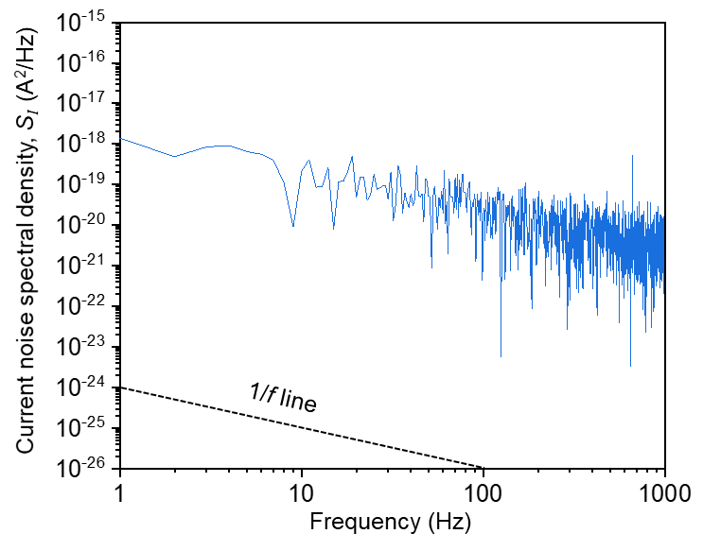
Fig. S11. Low frequency noise (LFN) characteristics. Current noise spectral density, S_{I} (A²/Hz) of the fabricated device as a function of frequency.

Noise characteristics are critical performance metrics for photonic sensing systems. To estimate the noise-equivalent power (NEP) of our device, we examined the low-frequency noise (LFN) features, i.e., current noise spectral density (A²/Hz), without light coupling (dark state). As shown in Fig. S11, the noise characteristic predominantly follows the 1/f line (dashed line), indicating that the measured noise primarily arises from flicker noise, also known as 1/f noise.

Supplementary Note 6. Electrical breakdown characteristics

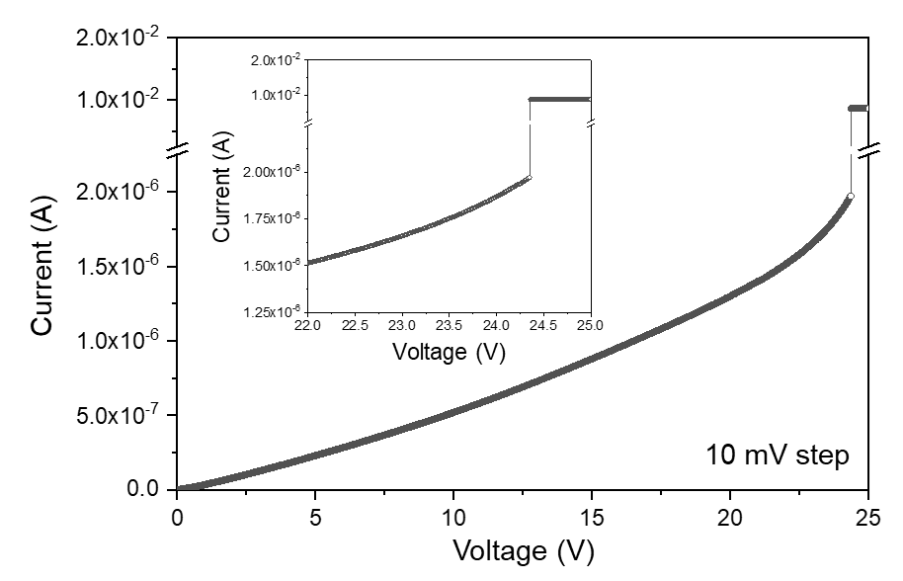
Fig. S12. Electrical breakdown. Current-voltage (I-V) curve of the fabricated device up to 25 V measured at room temperature with a 10-mV interval, indicating the breakdown voltage of ~23.8 V.

Figure S12 presents the current-voltage (I-V) characteristics of our device, which were assessed up to a high voltage range of 25 V at room temperature with a voltage step of 10 mV. It was found that the electrical breakdown occurs at ~23.8 V, characterized by a rapid change in the slope of the I-V curve. Beyond this voltage range, the device becomes highly conductive, indicating a transition into the breakdown regime where the device exhibits operational failure.

Supplementary Note 7. Propagation loss of waveguides

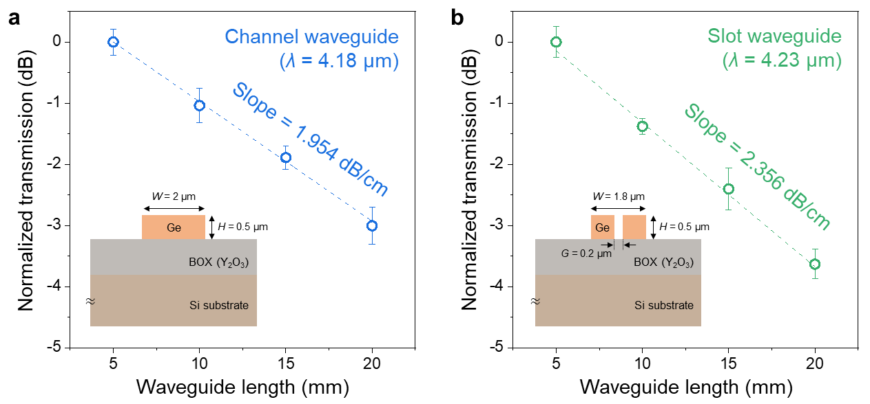
Fig. S13. Propagation losses. a Channel waveguide at a wavelength of 4.18 µm. b Slot waveguide at a wavelength of 4.23 µm.

Figure S13a and S13b show the propagation losses for channel and slot waveguides on the Ge-OI platform, respectively, as depicted in each inset. These losses were characterized using the cut-back method under an N₂ gas purging environment. The results indicate propagation losses of 1.954 dB/cm for the channel waveguide at a wavelength of 4.18 µm and 2.356 dB/cm for slot waveguide at 4.23 µm.

Supplementary Note 8. Simulation of mode converters

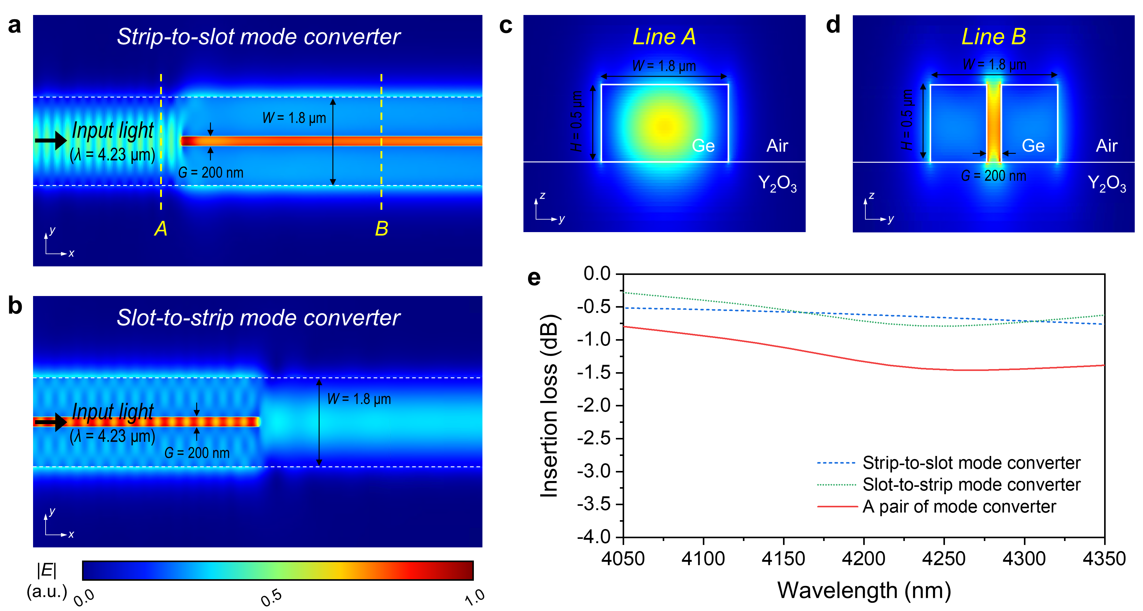
Fig. S14. Mode converters on Ge-OI platform. a-b Electric-field distribution for strip-to-slot and slot-to-strip mode converters at a wavelength of 4.23 µm. c-d Cross-sectional field distribution along lines A and B for the channel and slot waveguide regions, respectively. e Simulated mode conversion efficiencies for individual converters and a pair of mode converter.

Figures S14a and S14b depict the electric-field distribution of strip-to-slot and slot-to-strip mode converters on the Ge-OI platform at a wavelength of 4.23 µm in fundamental transverse-electric (TE) mode, respectively. The conversion efficiencies between strip and slot modes⁵ were calculated by a 3D-FDTD solver (Ansys Lumerical). Figure S14c and S14d show the cross-sectional field distribution along lines A and B in the strip and slot regions, respectively, representing well-confined modal fields. The simulated mode conversion efficiencies for the wavelength range from 4050 to 4350 nm are plotted in Fig. S14e. The insertion of a pair of mode converter at 4.23 µm was estimated to be 1.43 dB.

Supplementary Note 9. Performance comparison
Table S1. The overall performance characteristics of the reported MIR waveguide-integrated thermal-type PDs. ChG, chalcogenide glass; BOL, bolometric; PTE, photothermoelectric; TCR, temperature-coefficient of resistance; NEP, noise-equivalent power.
Reference, Year | Ref ⁶, 2019 | Ref ⁷, 2021 | Ref ⁸, 2022 | This work
Operation wavelength | 3.72 – 3.88 μm | 3.72 – 3.88 μm | 5.2 μm | 4.03 – 4.36 μm
Photonic platform | Suspended-Si  (c-Si) | Suspended-Si  (a-Si) | ChG-on-CaF₂  (Ge₂₈Sb₁₂Se₆₀-on-CaF₂) | Ge-OI  (Ge-on-insulator)
Operation mechanism | BOL | BOL | PTE | BOL
Absorption material | Au | Au | Graphene | p⁺ Ge
Bolometric material | a-Si | a-Si | - | TiO₂/Ti/TiO₂
TCR (-%/K) | 0.9 | 1.9 | - | 4.262 (@293 K)
Responsivity | 2.26×10⁻⁴ mA/W  (@15 V, 3.8 μm) | 2.95×10⁻³ mA/W  (@10 V, 3.8 μm) | 10 mA/W  (@0 V) | 12.19 mA/W  (@3 V, 4.18 μm)
Dark current (nA) | 20 (@ 5 V) | 12 (@10 V) | Not stated | 127.5 (@3 V)
NEP | 66 μW/Hz^{0.5} | 10.4 μW/Hz^{0.5} | 1.1 nW/Hz^{0.5} | 3.4 nW/Hz^{0.5}
CMOS-compatibility | Low | Low | Low | High

References
1. Zhang, L. et al. The Franz-Keldysh effect and free carrier dispersion effect in germanium. Optik 159, 202–210 (2018).
2. Nedeljkovic, M. et al. G. Z. Predictions of free-carrier electroabsorption and electrorefraction in germanium. IEEE Photonics J. 7, 1–14 (2015).
3. Shim, J. et al. Tailoring bolometric properties of a TiO_{x}/Ti/TiO_{x} tri-layer film for integrated optical gas sensors. Opt. Express 29, 18037 (2021).
4. Biesinger, M. C. et al. Resolving surface chemical states in XPS analysis of first row transition metals, oxides and hydroxides: Sc, Ti, V, Cu and Zn. Appl. Surf. Sci. 257, 887–898 (2010).
5. Lim, J. et al. Low-loss and high-confinement photonic platform based on germanium-on-insulator at mid-infrared range for optical sensing. J. Light. Technol. 1–11 (2023).
6. Wu, Y. et al. Mid-infrared nanometallic antenna assisted silicon waveguide based bolometers. ACS Photonics 6, 3253–3260 (2019).
7. Wu, Y. et al. Nanometallic antenna-assisted amorphous silicon waveguide integrated bolometer for mid-infrared. Opt. Lett. 46, 677 (2021).
8. Goldstein, J. et al. Waveguide-integrated mid-infrared photodetection using graphene on a scalable chalcogenide glass platform. Nat. Commun. 13, 3915 (2022).

