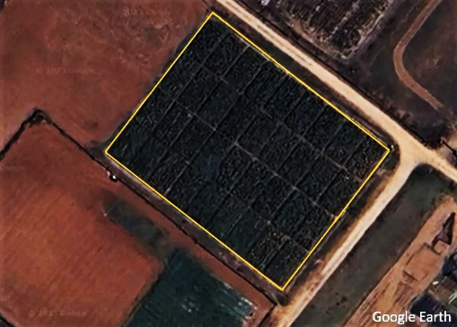
Figure supplementary 1: Satellite view of the experimental field (36 plots inside demarcated with yellow line).

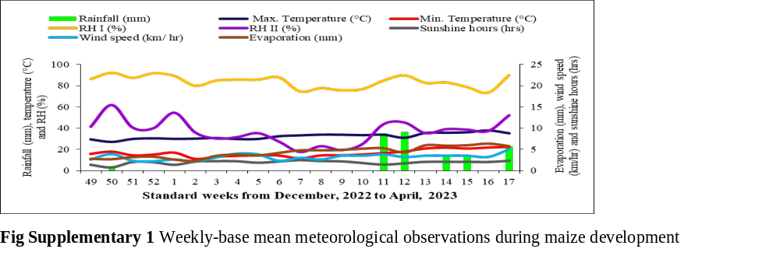
Figure supplementary 2: Weekly-base mean meteorological observations during maize development.

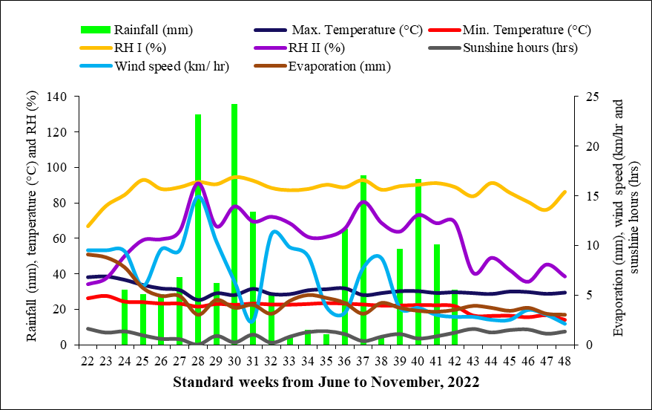
Figure supplementary 3: Weekly-base mean meteorological observations during cotton development

