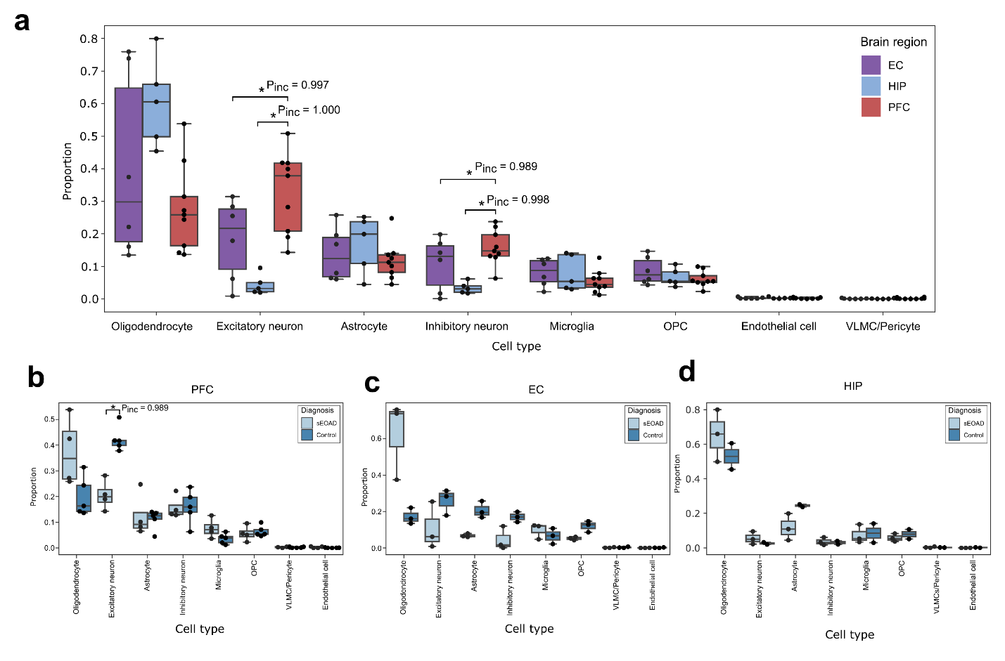
Extended Data Fig. 1: Differential cell type composition across brain regions and conditions.
a, Major cell type compositional changes comparing samples from the entorhinal cortex (EC), hippocampus (HIP), and prefrontal cortex (PFC). b-d, Major cell type compositional changes between sEOAD and control samples in (b) PFC, (c) EC, and (d) HIP. Box boundaries and lines in box plots correspond to the interquartile range (IQR) and median, respectively. Statistically credible changes in cell types, as tested with scCODA, are marked with *Pinc (posterior inclusion probability), indicating the significance of these changes.

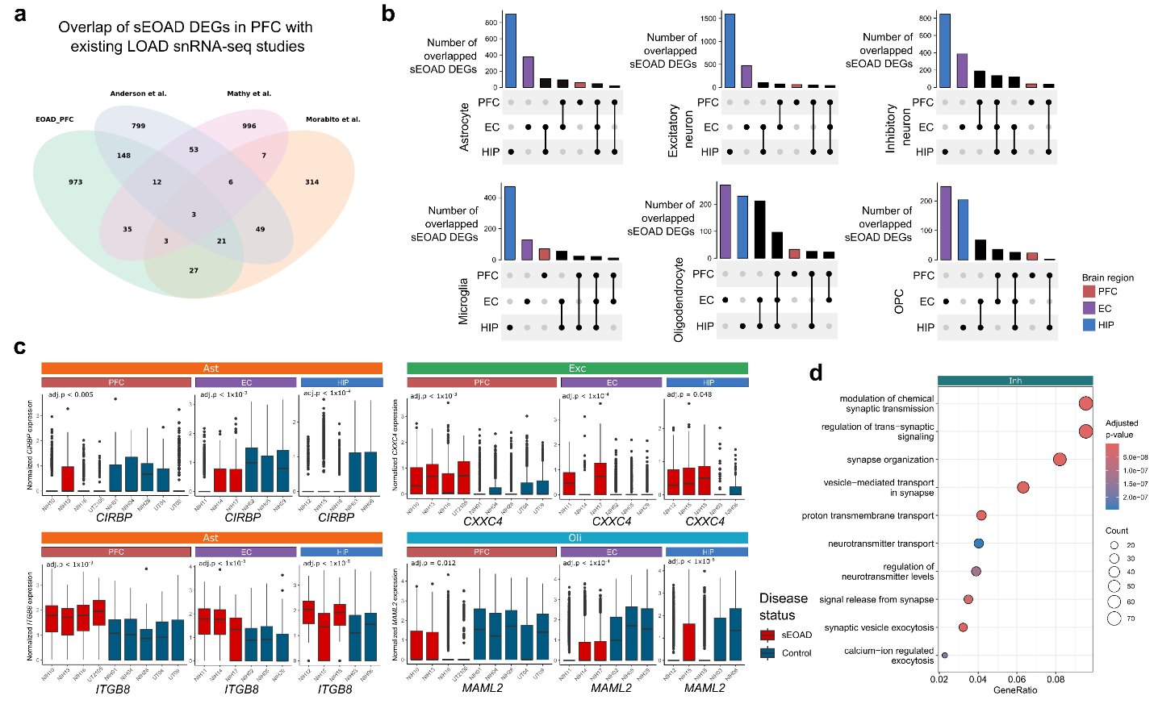 Extended Data Fig. 2: Overlap of cell type-specific sEOAD DEGs across brain regions and studies.
a, Venn diagram showing the overlap of sEOAD DEGs in the prefrontal cortex (PFC) identified in current study with signals reported by existing late-onset Alzheimer’s Disease (LOAD) single-nuclei RNA-sequencing studies. Three DEGs were consistent across all studies, including MRAS in astrocytes and CNORDC1 and TP53TG3 in oligodendrocytes. b, The number of overlapped sEOAD differential expression genes (sEOAD DEGs) in each cell type across brain regions with colors indicating brain regions. c, sEOAD DEGs consistently identified in all three brain regions associated with specific pathways: circadian clock regulation (top left, CIRBP in astrocyte), extracellular matrix organization (top right, ITGB8 in astrocyte), Wnt-signaling pathway (bottom left, CXXC4 in excitatory neurons), NOTCH signaling pathway (bottom right, MAML2 in oligodendrocytes). The x-axis indicates sample identification, and the color of the box indicates the diagnosis label. Box boundaries and lines correspond to the interquartile range (IQR) and median, respectively. d, The top 10 enriched Gene Ontology biological processes (GO BP) terms for consistently downregulated sEOAD DEGs in inhibitory neurons (number of genes = 110) across brain regions.
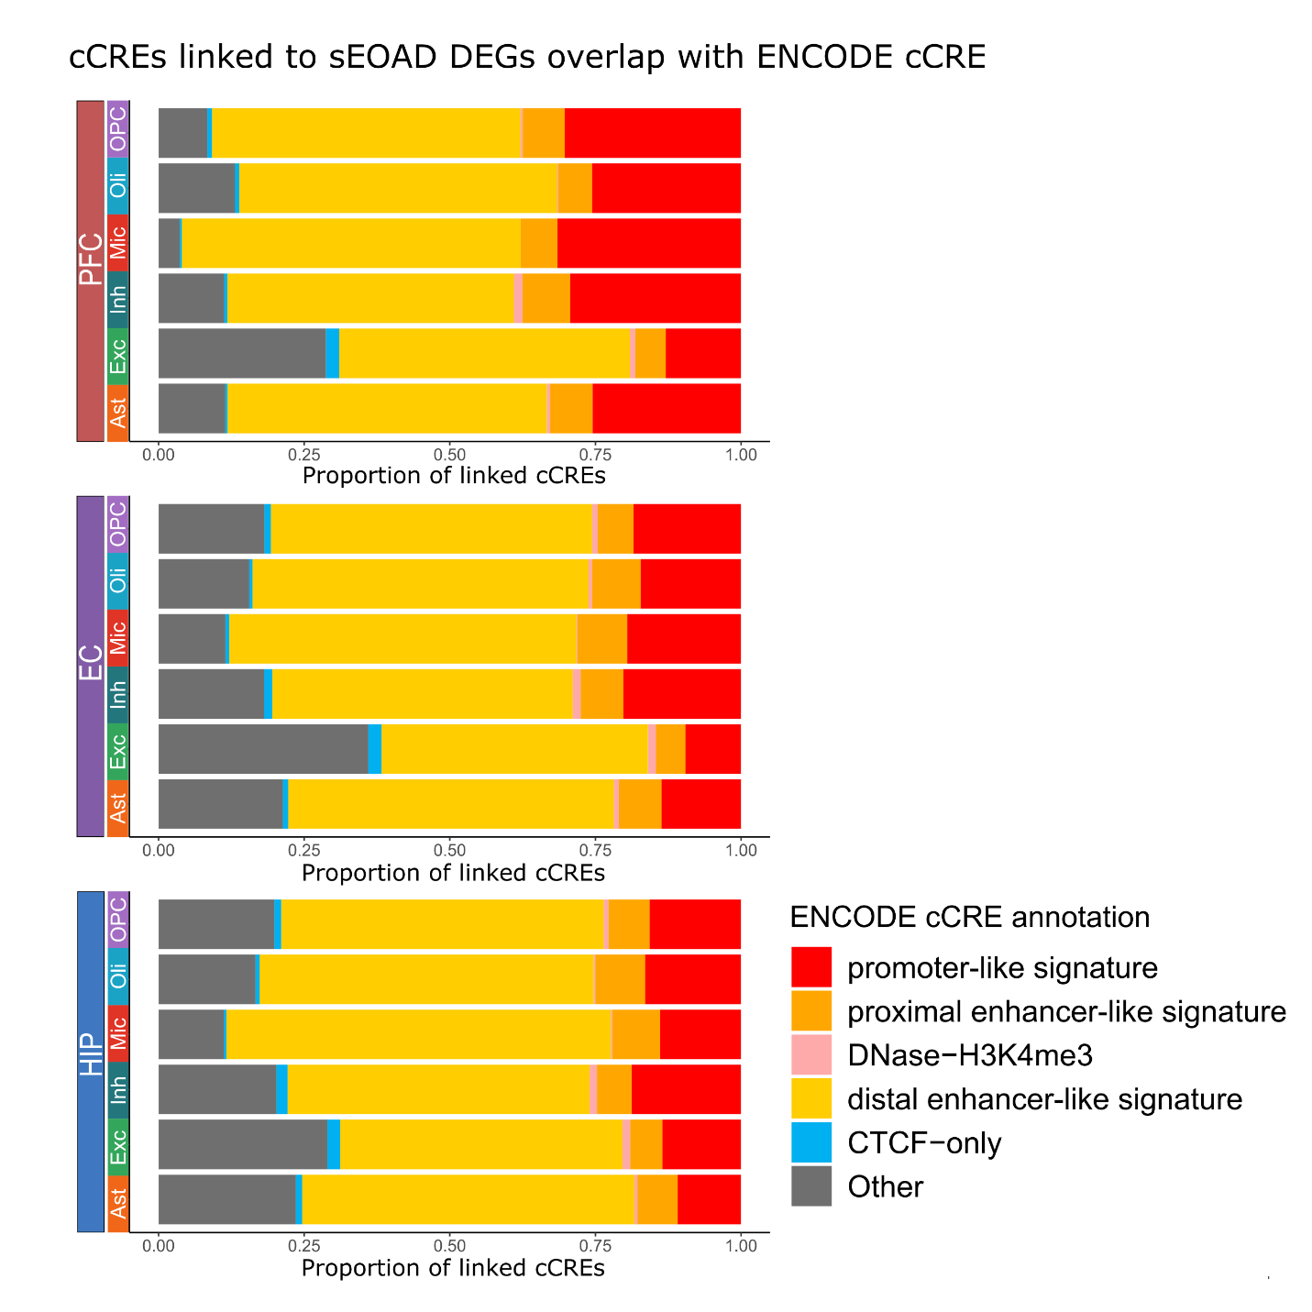
Extended Data Fig. 3: ENCODE annotation of cis-regulatory elements linked to sEOAD DEGs by cell type and brain region.
Stacked bar plots displaying the percentage of candidate cis-regulatory elements linked to sEOAD differential expression genes (DEGs) in each cell type and region that overlapped with ENCODE cCREs annotated promoters and enhancers.
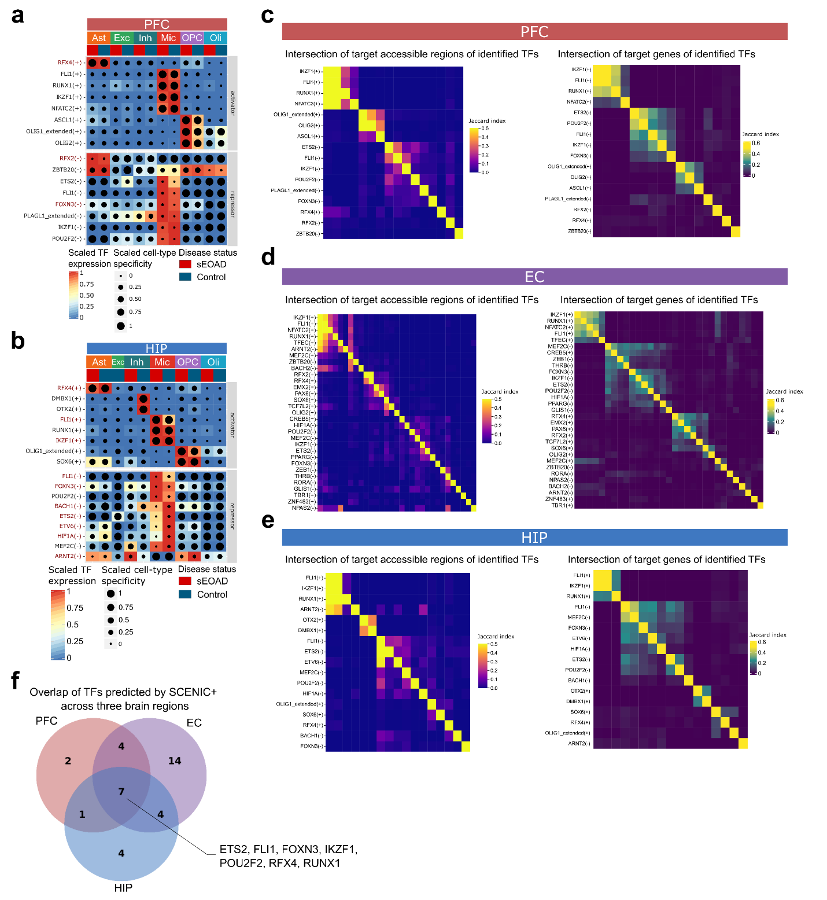 Extended Data Fig. 4: Cell type-specific transcription factor regulatory circuities in the prefrontal cortex and hippocampus of sEOAD
a,b, Heatmap/dot plot showing SCENIC+ analysis results for (a) the prefrontal cortex (PFC) or (b) the hippocampus (HIP), categorized by cell type and diagnosis label (x-axis). The gene expression of identified transcription factors (TFs) is presented on a color scale, while the cell type-specificity of the regulon is presented by dot size. c-e, Jaccard heat maps showing the intersection of target regions (left) and target genes (right) of the identified TFs in (c) PFC, (d) EC, and (e) HIP. f, Venn diagram depicting the number of overlaps of transcription factors in the PFC, EC, and HIP.
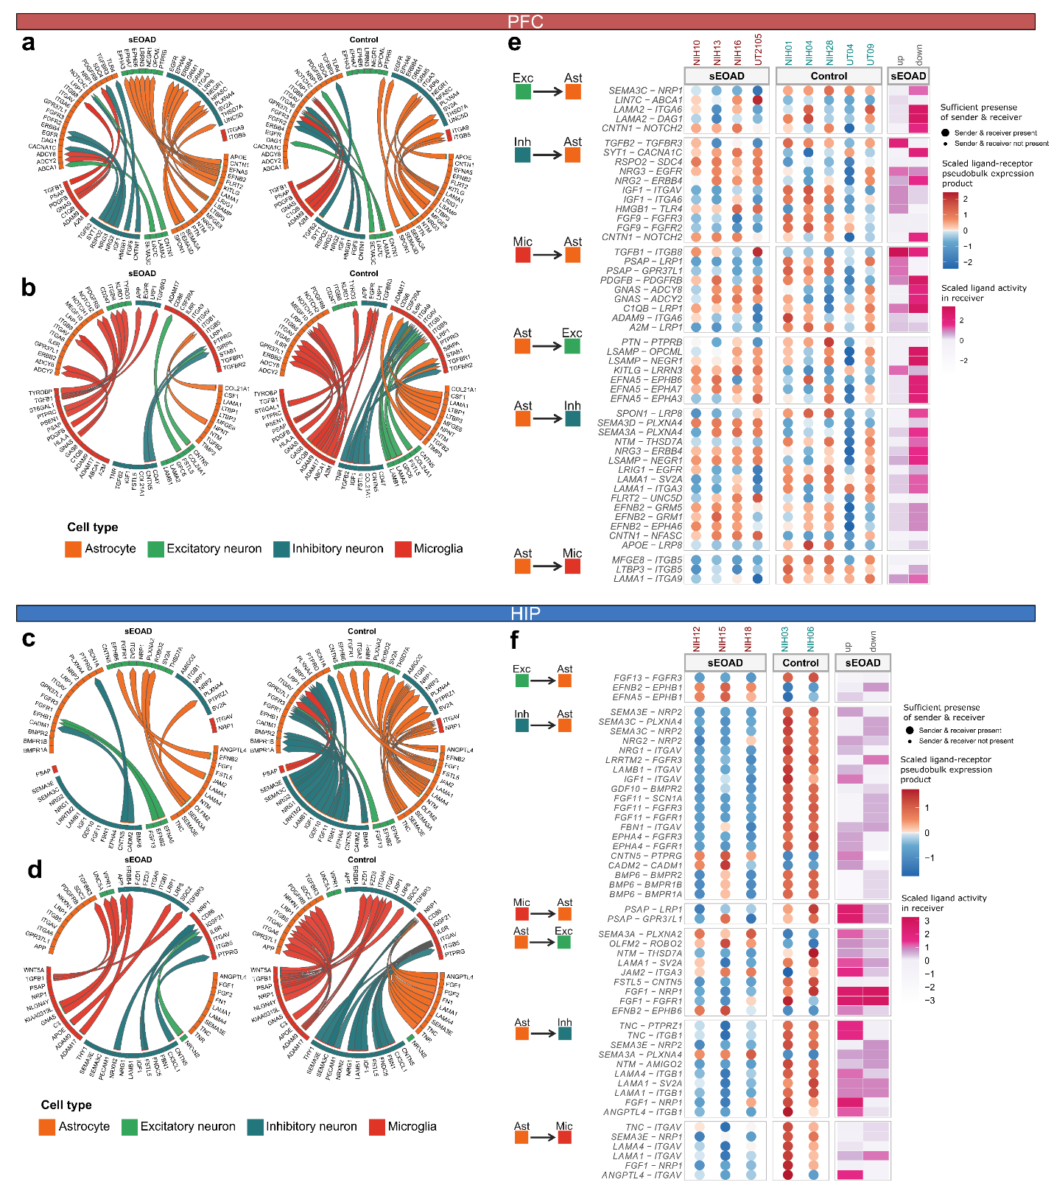
Extended Data Fig. 5: Comparative analysis of dysregulated cell-cell communication in PFC and HIP between sEOAD and controls.
a, Top 25 differential ligand-receptor signals received and sent by astrocytes in the prefrontal cortex (PFC) between sEOAD and control groups. b, Top 25 differential ligand-receptor signals received and sent by microglia in the PFC between sEOAD and control groups. c, Top 25 differential ligand-receptor signals received and sent by astrocytes in the hippocampus (HIP) between sEOAD and control groups. d, Top 25 differential ligand-receptor signals received and sent by microglia in the HIP between sEOAD and control groups. The arrowhead represents the direction of the signal from the sender cell type to the receiver cell type. e-f, The heatmap depicting the regulatory potential scores (purple) of selected dysregulated ligand-receptor pairs in receiver cell types within (e) PFC or (f) HIP. The dot plots show the scaled ligand-receptor pseudobulk expression in each sample, with dot size indicating whether a sample had at least ten cells for astrocytes.
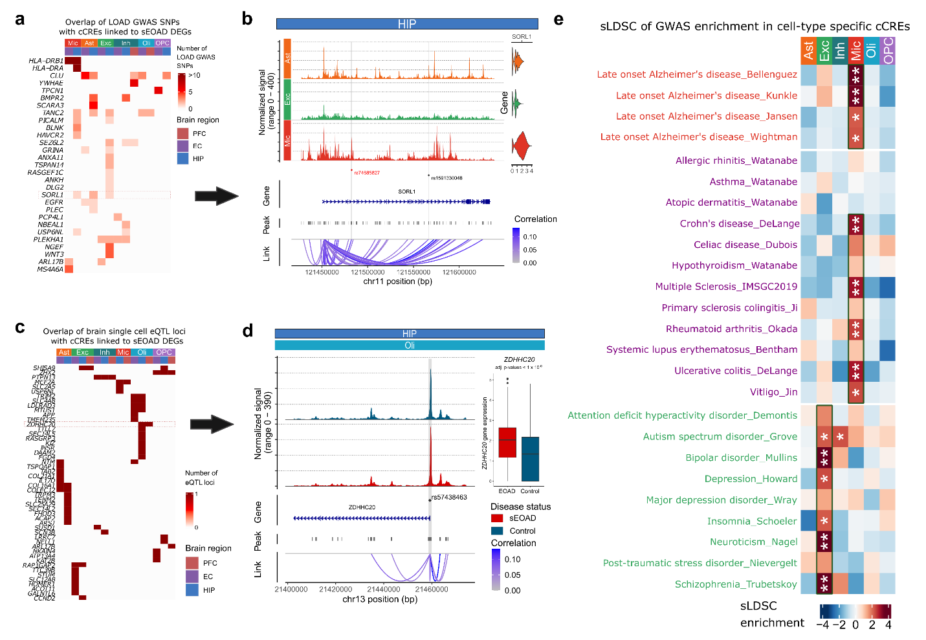 Extended Data Fig. 6: GWAS enrichment in cell type specific cCREs and variants prioritization
a, Heatmap displaying the sEOAD differentially expressed genes (DEGs) with associated candidate cis-regulatory elements(cCREs) containing LOAD GWAS loci. b, SNP rs74685827, as reported in Bellenguez et al., overlaps with a microglia-specific cCRE linked to dysregulated SORL1 gene expression in hippocampus (HIP). Its associated SNP, rs1591330048, overlaps with a cCRE linked to dysregulated SORL1 gene expression in astrocytes in HIP. The cCREs linked to sEOAD DEG contain LOAD GWAS loci and are highlighted in gray. c, Heatmap shows the cCRE linked to sEOAD DEGs containing single-cell expression quantitative trait loci (eQTL). d, The promoter region of ZDHHC20 in oligodendrocytes contains the single-cell eQTL SNP rs57438463. The box plot depicts that the ZDHHC20 gene was significantly upregulated in oligodendrocytes in HIP samples of sEOAD patients. e, Heatmap showing the enrichment of risk variants associated with LOAD, immune-mediated traits, and psychiatry disorders from GWAS in cell type specific peaks (*FDR < 0.05, **FDR < 0.01).

