Supplementary Figures
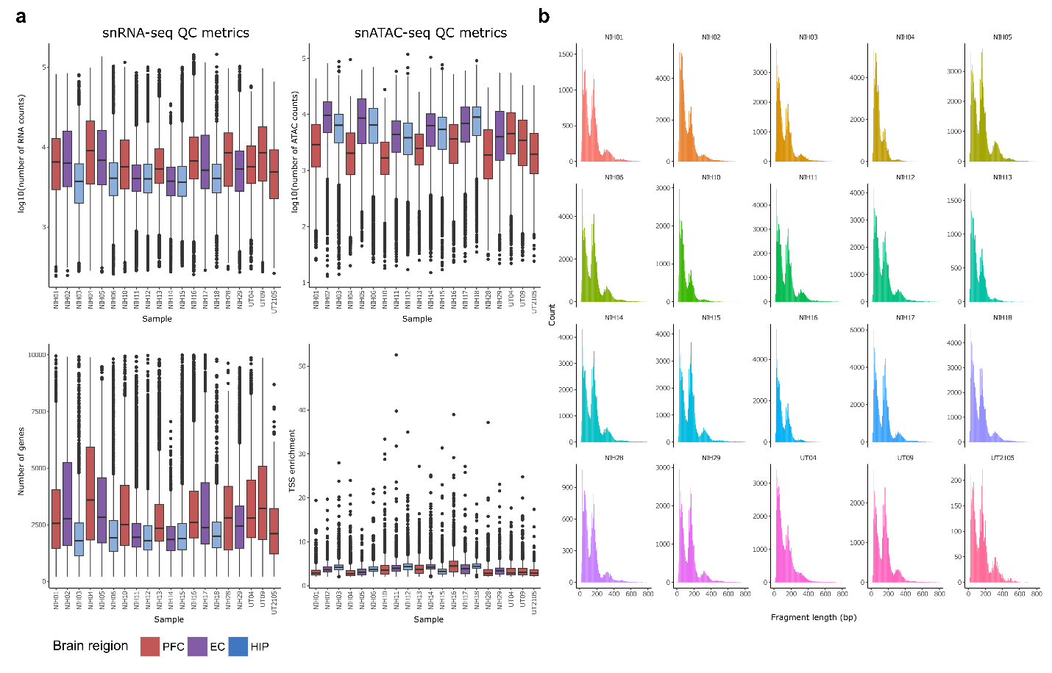
Supplementary Fig. 1: Quality control of snRNA-seq and snATAC-seq libraries.
a, Box plots showing the distribution of several snRNA-seq (left) and snATAC-seq (right) quality metrics for each sample. The snRNA-seq metrics include the total number of RNA counts and total number of genes detected. The snATAC-seq metrics include total number of ATAC counts, and transcription start site (TSS) enrichment. b, Density plots showing the distribution of fragment size for each sample.

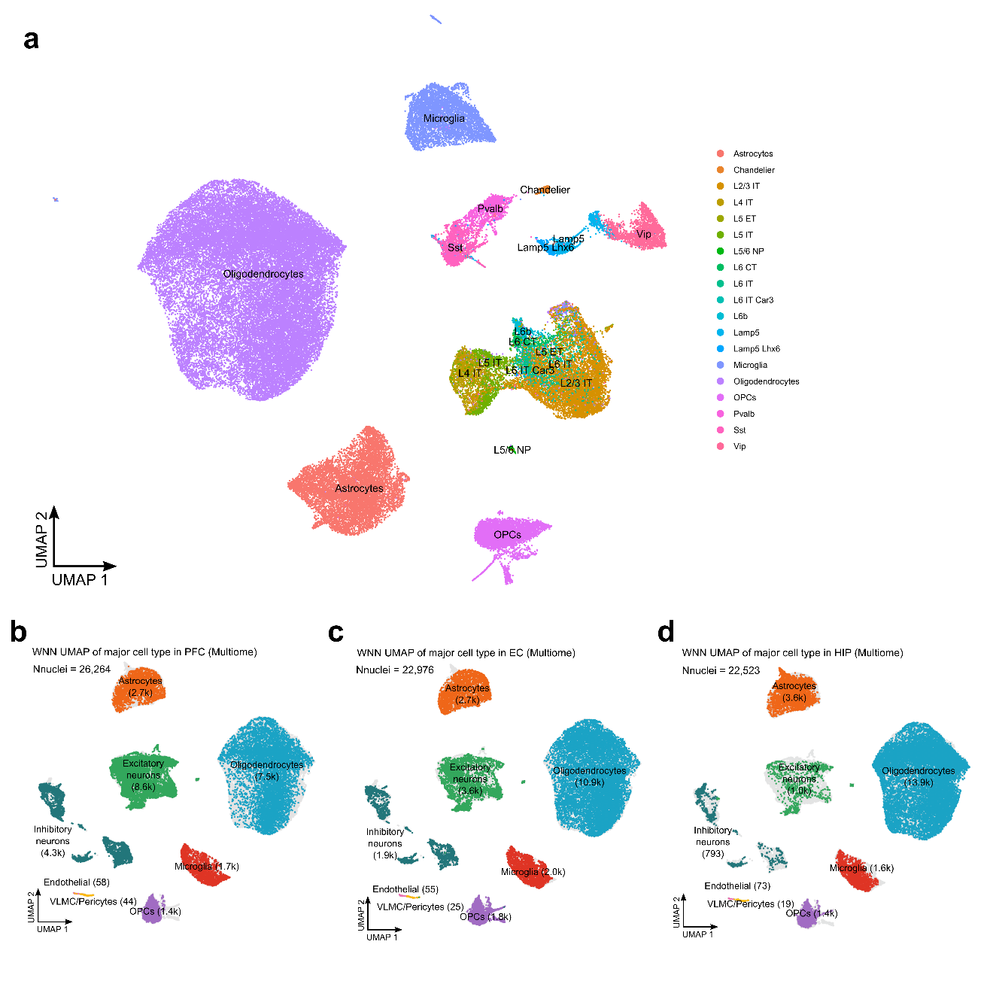
Supplementary Fig. 2: Sub cell type annotation and major cell type annotation across brain regions.
a, Uniform manifold approximation and projection (UMAP) visualization of 71,763 nuclei based on weighted nearest neighbor (WNN) clustering, labeled by cell subclass. Cell subclasses were annotated independently based on a reference snRNA-seq dataset from postmortem brain samples. b-d, UMAP visualization of WNN clustering based on major cell types in (b) prefrontal cortex (PFC), (c) entorhinal cortex (EC), and (d) hippocampus (HIP).
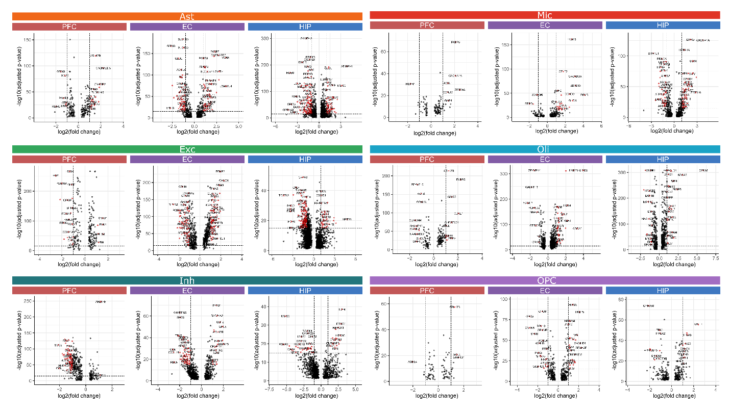
Supplementary Fig. 3: Cell type-specific differentially expressed genes across brain regions.
Volcano plots highlighting the top sEOAD DEGs of each major cell type across prefrontal cortex (PFC), entorhinal cortex (EC), and hippocampus (HIP). Gray vertical dashed lines represent the absolute log2FC =1, and the gray horizontal dashed line represents the –log10 (adjusted p-value) =16.

Supplementary Tables & Data
Supplementary Table 1: Sample information.
Supplementary Table 2: Cell type proportional analysis.
Supplementary Table 3: Description of GWAS datasets used in sLDSC analysis.
Supplementary Table 4: Power analysis of differentially expressed gene.
Supplementary Data 1: Differentially expressed genes between sEOAD and control within each cell type.
Supplementary Data 2: cCREs linked to sEOAD DEGs in each cell type in each brain region.
Supplementary Data 3: Transcription factor motif enrichment of cCREs linked to sEOAD DEGs.
Supplementary Data 4: SCENIC+ gene regulatory network analysis in each brain region.
Supplementary Data 5: sLDSC analysis of cCRES linked to sEOAD DEGs and cell type-specific cCREs.

