SUPPLEMENTARY MATERIAL
Efficient removal of Congo red and cytotoxicity evaluation of biosorbents prepared from chitosan-added watermelon pulp
Mehmet Semih Bingöl*
*East Anatolia High Technology Application and Research
Center (DAYTAM), Ataturk University, 25240 Erzurum,Turkey
e-mail: semih.bingol@atauni.edu.tr

This supplementary material contains 6 pages, including 5 figures.

Adsorption Studies
The percent dye removal and adsorption capacity were calculated from the concentration changes using the following equations:
$q_{e}=\left(c_{0}-c_{e}\right)×\frac{V}{W}$ (1)
Removal, % $= \frac{(C_{0}-C_{e})}{C_{0}}×100$ (2)
Where C₀, C_{e}, and C_{t} denote the initial equilibrium Congo red concentrations, and the concentration at time t, respectively, qe and qt adsorption capacity equilibrium and at time, V is the volume of Congo red solution, and W is the adsorbent mass.
Adsorption Isotherm Studies
The isotherm describes the relationship between the amount of Congo red adsorbed during adsorption and the remaining Congo red concentration in the solution after adsorption. The isotherm data can be analyzed in order to estimate the adsorbent’s adsorption capacity, which is one of the most critical parameters to consider when designing an adsorption system (Kumar et al., 2013).
However, Langmuir isotherm is the most fundamental description of the adsorption process. The Langmuir isotherm measures the adsorbate surface’s maximal monolayer adsorption capacity. This model assumes the adsorbate surface is homogeneous and uniformly bound. The following is the mathematical expression for the Langmuir isotherm (Langmuir, 1918):
$\frac{C_{e}}{q_{e}}=\frac{1}{q_{max}K_{C}}+\frac{C_{e}}{q_{max}}$ (3)
A non-ideal and reversible adsorption of a heterogeneous system is described by the Freundlich isotherm. It takes into account multilayer adsorption with heterogeneous active site energy distributions and interactions between adsorbed molecules (Freundlich, 1906; Ng et al., 2003). The following is the mathematical expression for the Freundlich isotherm:
$\ln{q_{e}=\ln{K_{F}+(\frac{1}{n})\ln{C_{e}}}}$ (4)
qmax: Maximum adsorption capacity (mg/g). KF, n: Freundlich constant
Kinetic Studies
Kinetic models are used to explain experimental data in adsorption processes in order to determine the rate-controlling phases and adsorption mechanisms that are present (B. Wang et al., 2019). The CR adsorption mechanism on Ch-PVA-Gd surfaces was investigated using two diferent kinetic models. These models are pseudo-frst-order kinetic models (PFO) and pseudo-second-order kinetic models (PSO), respectively.
The PFO is given in Eq. 5 (Lagergren, 1898).
$\log\left(q_{e}-q_{t}\right)=\ln{q_{e}-\frac{K_{1}t}{2,303}}$ (5)
The PSO is given in Eq. 6 (Ho & McKay, 1999).
$\frac{t}{q_{t}}=\frac{1}{k_{2}{q_{e}}^{2}}+\frac{t}{q_{e}}$ (6)

Figure 1s. Calibration curve of Congo red
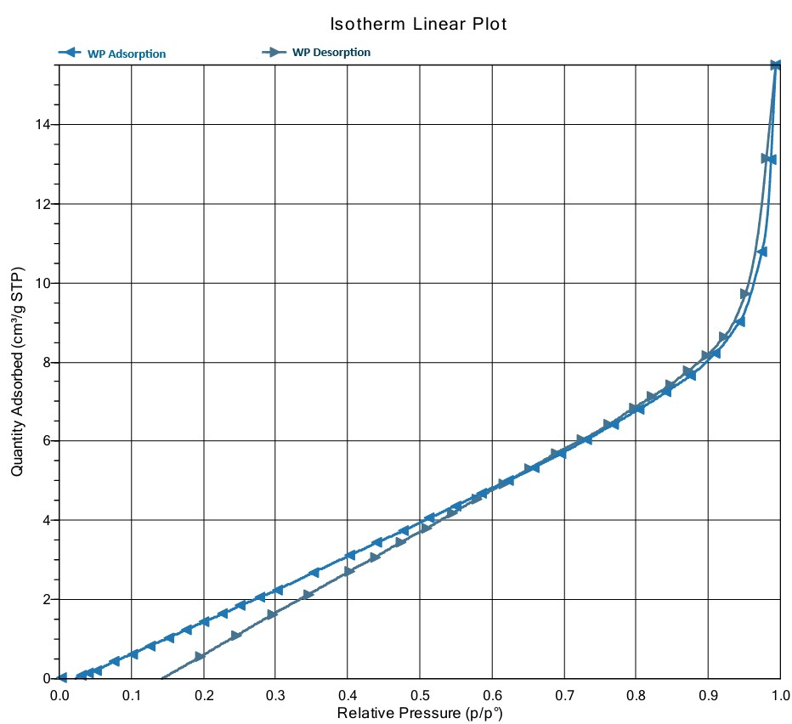
Figure 2s. WP of BET analysis isotherm
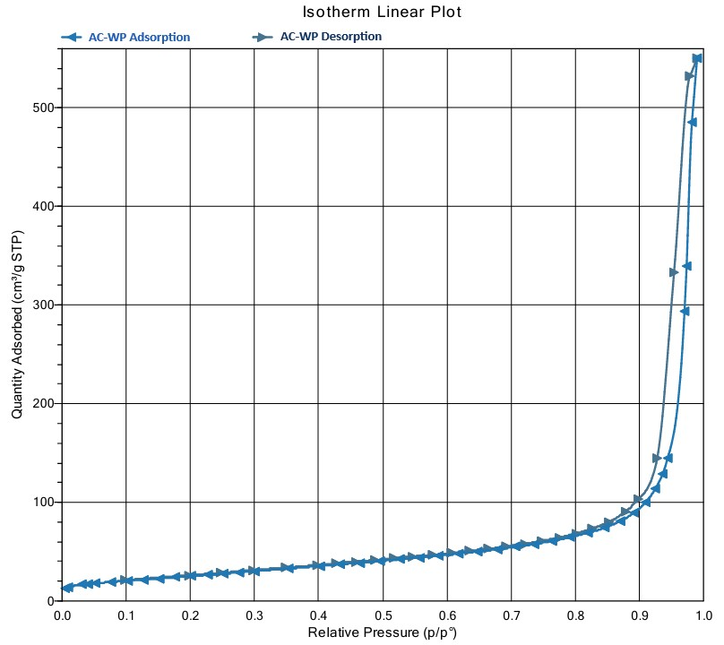
Figure 3s. AC-WP of BET analysis isotherm
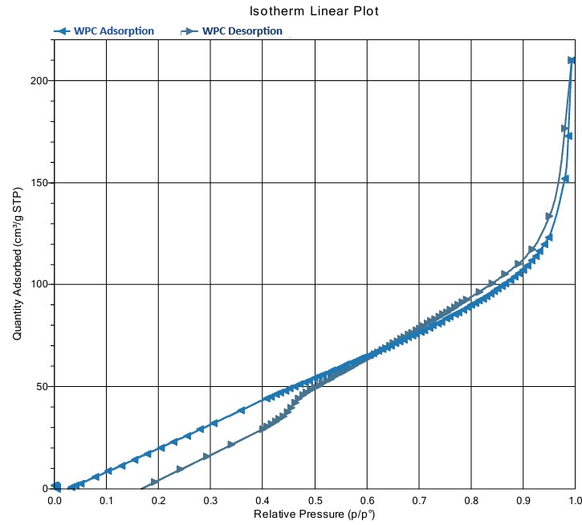
Figure 4s. WPC of BET analysis isotherm
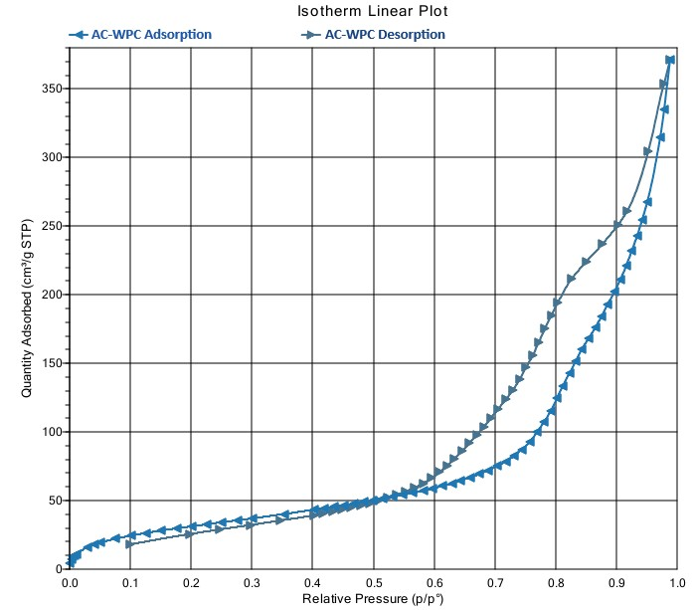
Figure 5s. AC-WPC of BET analysis isotherm

