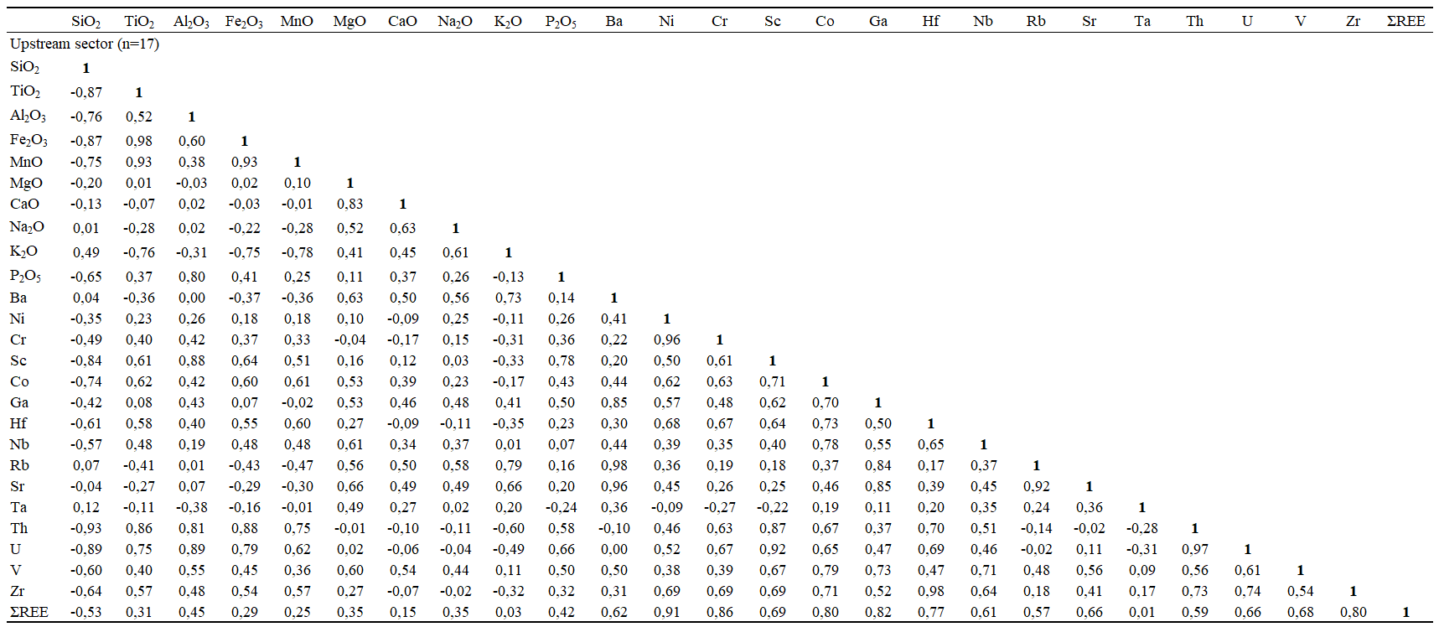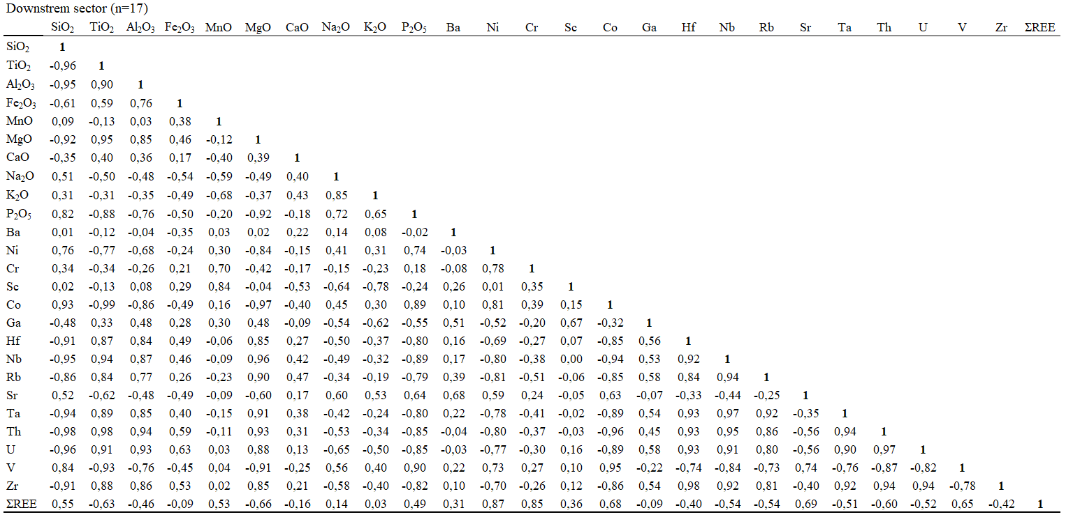
Table 6 Correlation matrix of geochemical data from the Ouaka river sediments. Pearson’s correlation coefficients calculated using the XLSTAT software (level of statistical significance: p ˂ 0.05)

