Supplemental Information for:

Enhancing the Accuracy of Reference-Guided Genomic Assemblies: Implementing Ragtag Correction for Reference-Guided Scaffolds

Table of Contents:
Table S1. Comparison of Megalobrama amblycephala Genome Assemblies Using Various Reference-Guided and Error-Corrected Strategies | Page 1
Figure S1. Dot Plot Comparison of Reference-Guided Assembly with Megalobrama amblycephala Genome Using Ragtag Versus the Chromosome-Level Genome of M. amblycephala | Page 2
Figure S2. Comparative Dot Plot Analysis of Genomes Assembled Using Combined in Silico Library Strategies with Ragout, Ragtag, and Abyss-Sealer versus de novo Assembly of Megalobrama amblycephala | Page 3
Figure S3. Dot Plot Comparison of Reference-Guided Assembly and Error Correction Using Chanodichthys erythropterus Genome with Multi-reference Assembly Versus the Chromosome-Level Genome of M. amblycephala | Page 4
Figure S4. Dot Plot Comparison of Reference-Guided Assembly and Error Correction Using Culter alburnus Genome with Multi-reference Assembly Versus the Chromosome-Level Genome of M. amblycephala | Page 5
Figure S5. Dot Plot Comparison of Reference-Guided Assembly and Error Correction Using Megalobrama amblycephala Genome with Multi-reference Assembly Versus the Chromosome-Level Genome of M. amblycephala | Page 6
Figure S6. Dot Plot Comparison of Megalobrama amblycephala Genomes: Comparison Between Reference-Guided Assembly and Error Correction Using Chanodichthys erythropterus Versus the Chromosome-Level Genome of M. amblycephala | Page 7
Figure S7. Dot Plot Comparison of Megalobrama amblycephala Genomes: Comparison Between Reference-Guided Assembly and Error Correction Using Culter alburnus Versus the Chromosome-Level Genome of M. amblycephala | Page 8
Figure S8. Dot Plot Comparison of Megalobrama amblycephala Genomes: Comparison Between Reference-Guided Assembly and Error Correction Using M. amblycephala Genome (GCA_018812025.1) Versus the Chromosome-Level Genome of M. amblycephala (GCA_018812025.1) | Page 9
Figure S9. Dot Plot Comparison of Reference-Guided Assembly of Culter alburnus Genome (GCA_009869775.1) with Multi-reference Genomes Using Ragout and Ragtag Versus the Chromosome-Level Genome of C. alburnus | Page 10
Figure S10. Dot Plot Comparison of Reference-Guided Assembly of Culter alburnus Genome (GCA_028476615.1) with Multi-reference Genomes Using Ragout and Ragtag Versus the Chromosome-Level Genome of C. alburnus | Page 11
Figure S11. Dot Plot Comparison of Culter alburnus Genomes: Comparison Between Reference-Guided Assembly of C. alburnus Genome (GCA_009869775.1) and Error Correction Using C. alburnus Genome Versus the Chromosome-Level Genome of C. alburnus | Page 12
Figure S12. Dot Plot Comparison of Culter alburnus Genomes: Comparison Between Reference-Guided Assembly of C. alburnus Genome (GCA_028476615.1) and Error Correction Using C. alburnus Genome Versus the Chromosome-Level Genome of C. alburnus | Page 13

Table S1. Comparison of Megalobrama amblycephala Genome Assemblies Using Various Reference-Guided and Error-Corrected Strategies analyzed by BBmap (Bushnell 2014)
n_scaffolds | n_contigs | scaf_bp | contig_bp | gap_pct | scaf_L50 | scaf_N50 | ctg_L50 | ctg_N50 | scaf_max | ctg_max | assembly name
242 | 1333 | 1109871993 | 1107958225 | 0.172 | 11 | 42265598 | 109 | 2576065 | 75861420 | 17436821 | ma
18243 | 24986 | 1087899576 | 1075211507 | 1.166 | 206 | 1403021 | 882 | 322872 | 8320830 | 3163465 | maSCA
15615 | 24986 | 1115588511 | 1075211507 | 3.619 | 11 | 43676718 | 882 | 322872 | 67341102 | 3163465 | raw_ma
16999 | 27226 | 1189584584 | 1075211507 | 9.615 | 11 | 41172990 | 1127 | 248498 | 109013519 | 2065989 | meta_assembled
15353 | 27039 | 1206890640 | 1075053579 | 10.924 | 8 | 52507027 | 1118 | 249913 | 113397247 | 2065989 | ma_gc
18541 | 32601 | 1226075422 | 1075053579 | 12.318 | 139 | 2211850 | 2208 | 125727 | 16407952 | 1472995 | merge_cor_1
21717 | 35437 | 1223245969 | 1075053579 | 12.115 | 368 | 567428 | 3173 | 100004 | 16998945 | 1593552 | merge_cor_2
22769 | 34340 | 1216254905 | 1075053579 | 11.61 | 148 | 1281000 | 2171 | 100700 | 15890183 | 2065989 | merge_cor_3
16432 | 32601 | 1255834409 | 1075053579 | 14.395 | 12 | 41858733 | 2208 | 125727 | 94763749 | 1472995 | cor_1_out_1
16671 | 35437 | 1263510685 | 1075053579 | 14.915 | 12 | 41931747 | 3173 | 100004 | 86435588 | 1593552 | cor_2_out_2
16501 | 34340 | 1246492700 | 1075053579 | 13.754 | 11 | 44871173 | 2171 | 100700 | 96270106 | 2065989 | cor_3_out_3
The de novo assembly of the Megalobrama amblycephala chromosome-level genome (GCA_018812025.1), referred to as "ma," and the de novo assembly of the M. amblycephala draft genome (GCA_009869865.1), designated as "maSCA" were developed. The genome labeled "raw_ma" was assembled using Ragtag with M. amblycephala (GCA_018812025.1) as a reference. Subsequently, the "meta_assembled" genome was assembled using Ragout, guided by multiple reference genomes. This approach was also employed for the "ma_gc" genome, which underwent additional refinement through Ragtag using M. amblycephala (GCA_018812025.1) as the reference.
Furthermore, three rounds of misassembly correction were implemented, employing different reference genomes to guide the Ragtag assembly, resulting in the creation of the "merge_cor_1," "merge_cor_2," and "merge_cor_3" genomes. Specifically, "merge_cor_1" was refined using the Chanodichthys erythropterus (GCA_024489055.1) genome for error correction, while "merge_cor_2" and "merge_cor_3" utilized the Culter alburnus (GWHBOSX00000000) and M. amblycephala (GCA_018812025.1) genomes, respectively.
In targeted reassembly efforts, the "cor_1_out_1" genome was assembled with C. erythropterus (GCA_024489055.1) as the source of error correction and the guiding reference. Similarly, "cor_2_out_2" was reassembled post-error correction with C. alburnus (GWHBOSX00000000) as the reference, and "cor_3_out_3" was processed using M. amblycephala (GCA_018812025.1) as the reference. Bushnell B (2014) BBMap: A Fast, Accurate, Splice-Aware Aligner. https://sourceforge.net/projects/bbmap/. Accessed December 10th, 2021

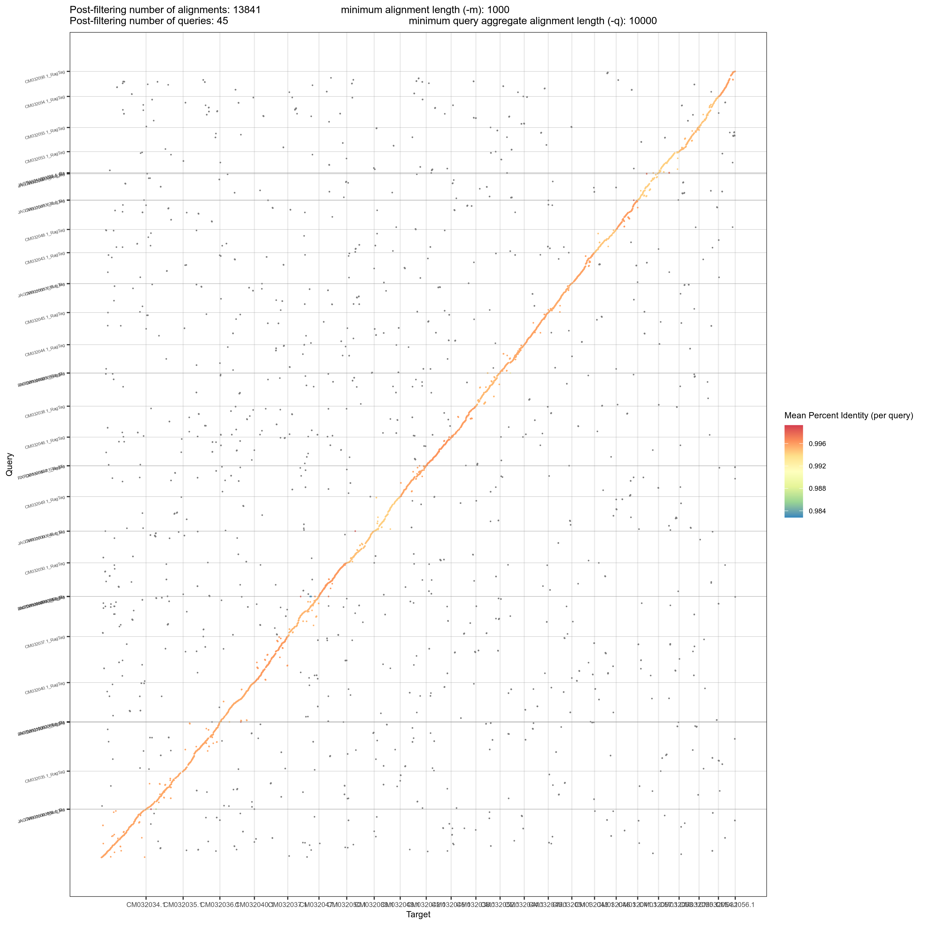
Figure S1. Dot Plot Comparison of Reference-Guided Assembly of Megalobrama amblycephala Genome (GCA_009869865.1) with M. amblycephala Genome (GCA_018812025.1) Using Ragtag Versus the Chromosome-Level Genome of M. amblycephala (GCA_018812025.1)
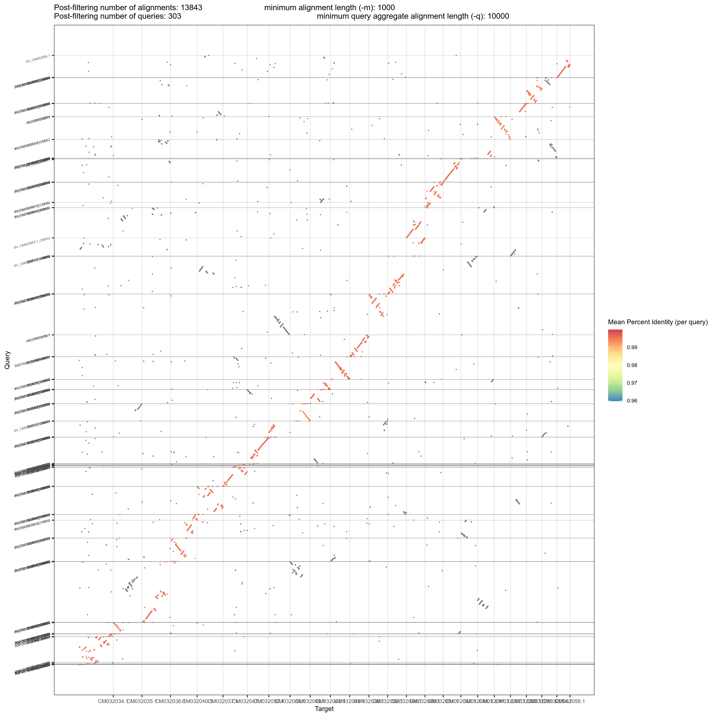
Figure S2. Dot Plot Comparison of Reference-Guided Assembly of Megalobrama amblycephala Genome (GCA_009869865.1) with Multi-reference Genomes Using Ragout Versus the Chromosome-Level Genome of M. amblycephala (GCA_018812025.1)
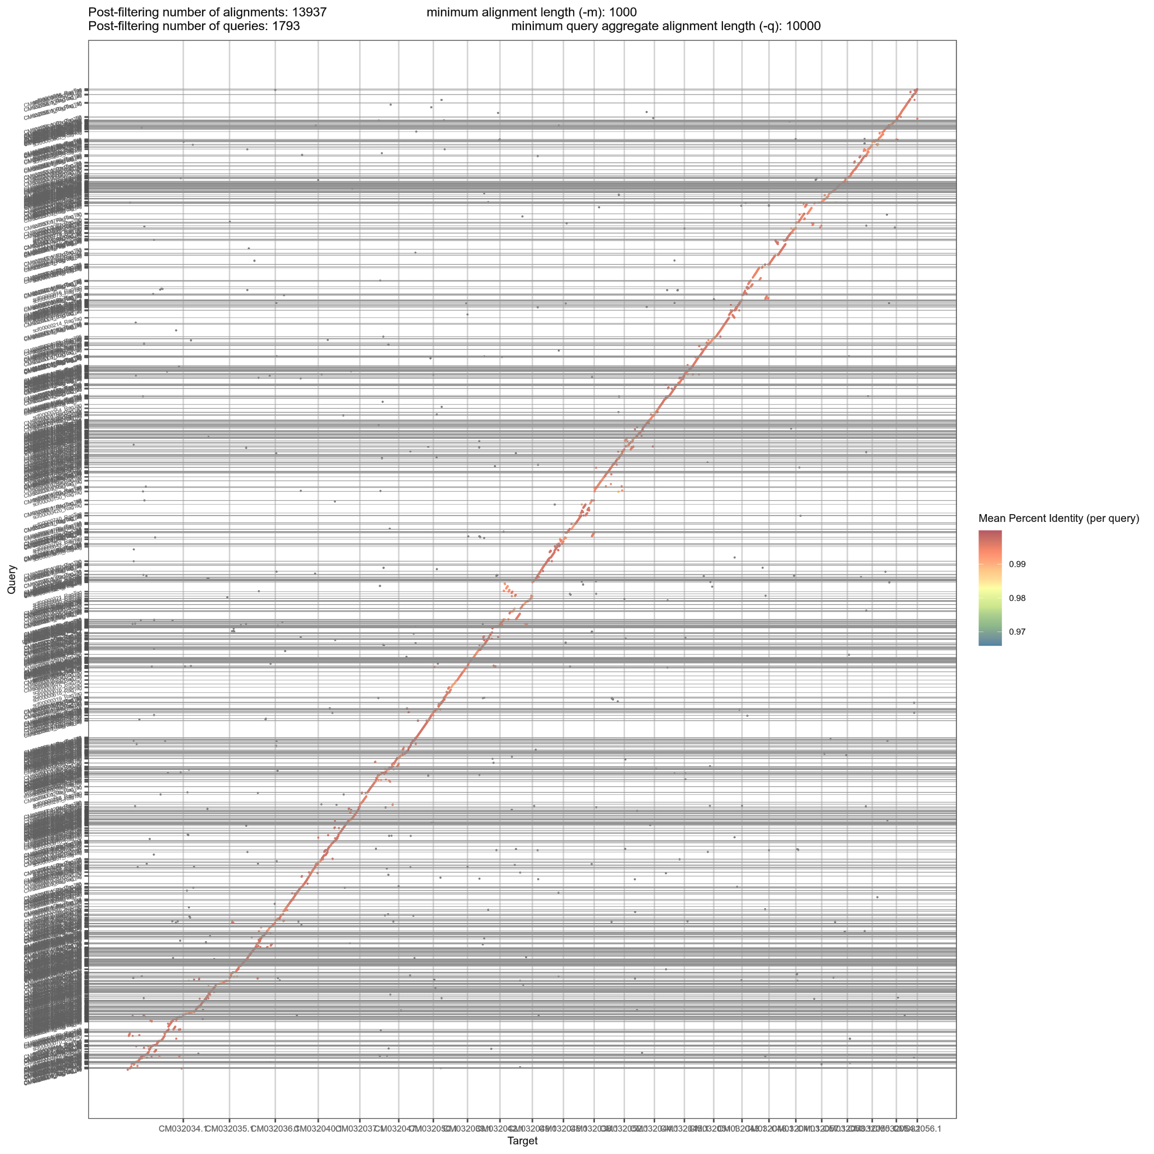
Figure S3. Dot Plot Comparison of Reference-Guided Assembly of Megalobrama amblycephala Genome (GCA_009869865.1) and Error Correction Using Chanodichthys erythropterus Genome (GCA_024489055.1) with Multi-reference Assembly by Ragtag's Merge function Versus the Chromosome-Level Genome of M. amblycephala (GCA_018812025.1)
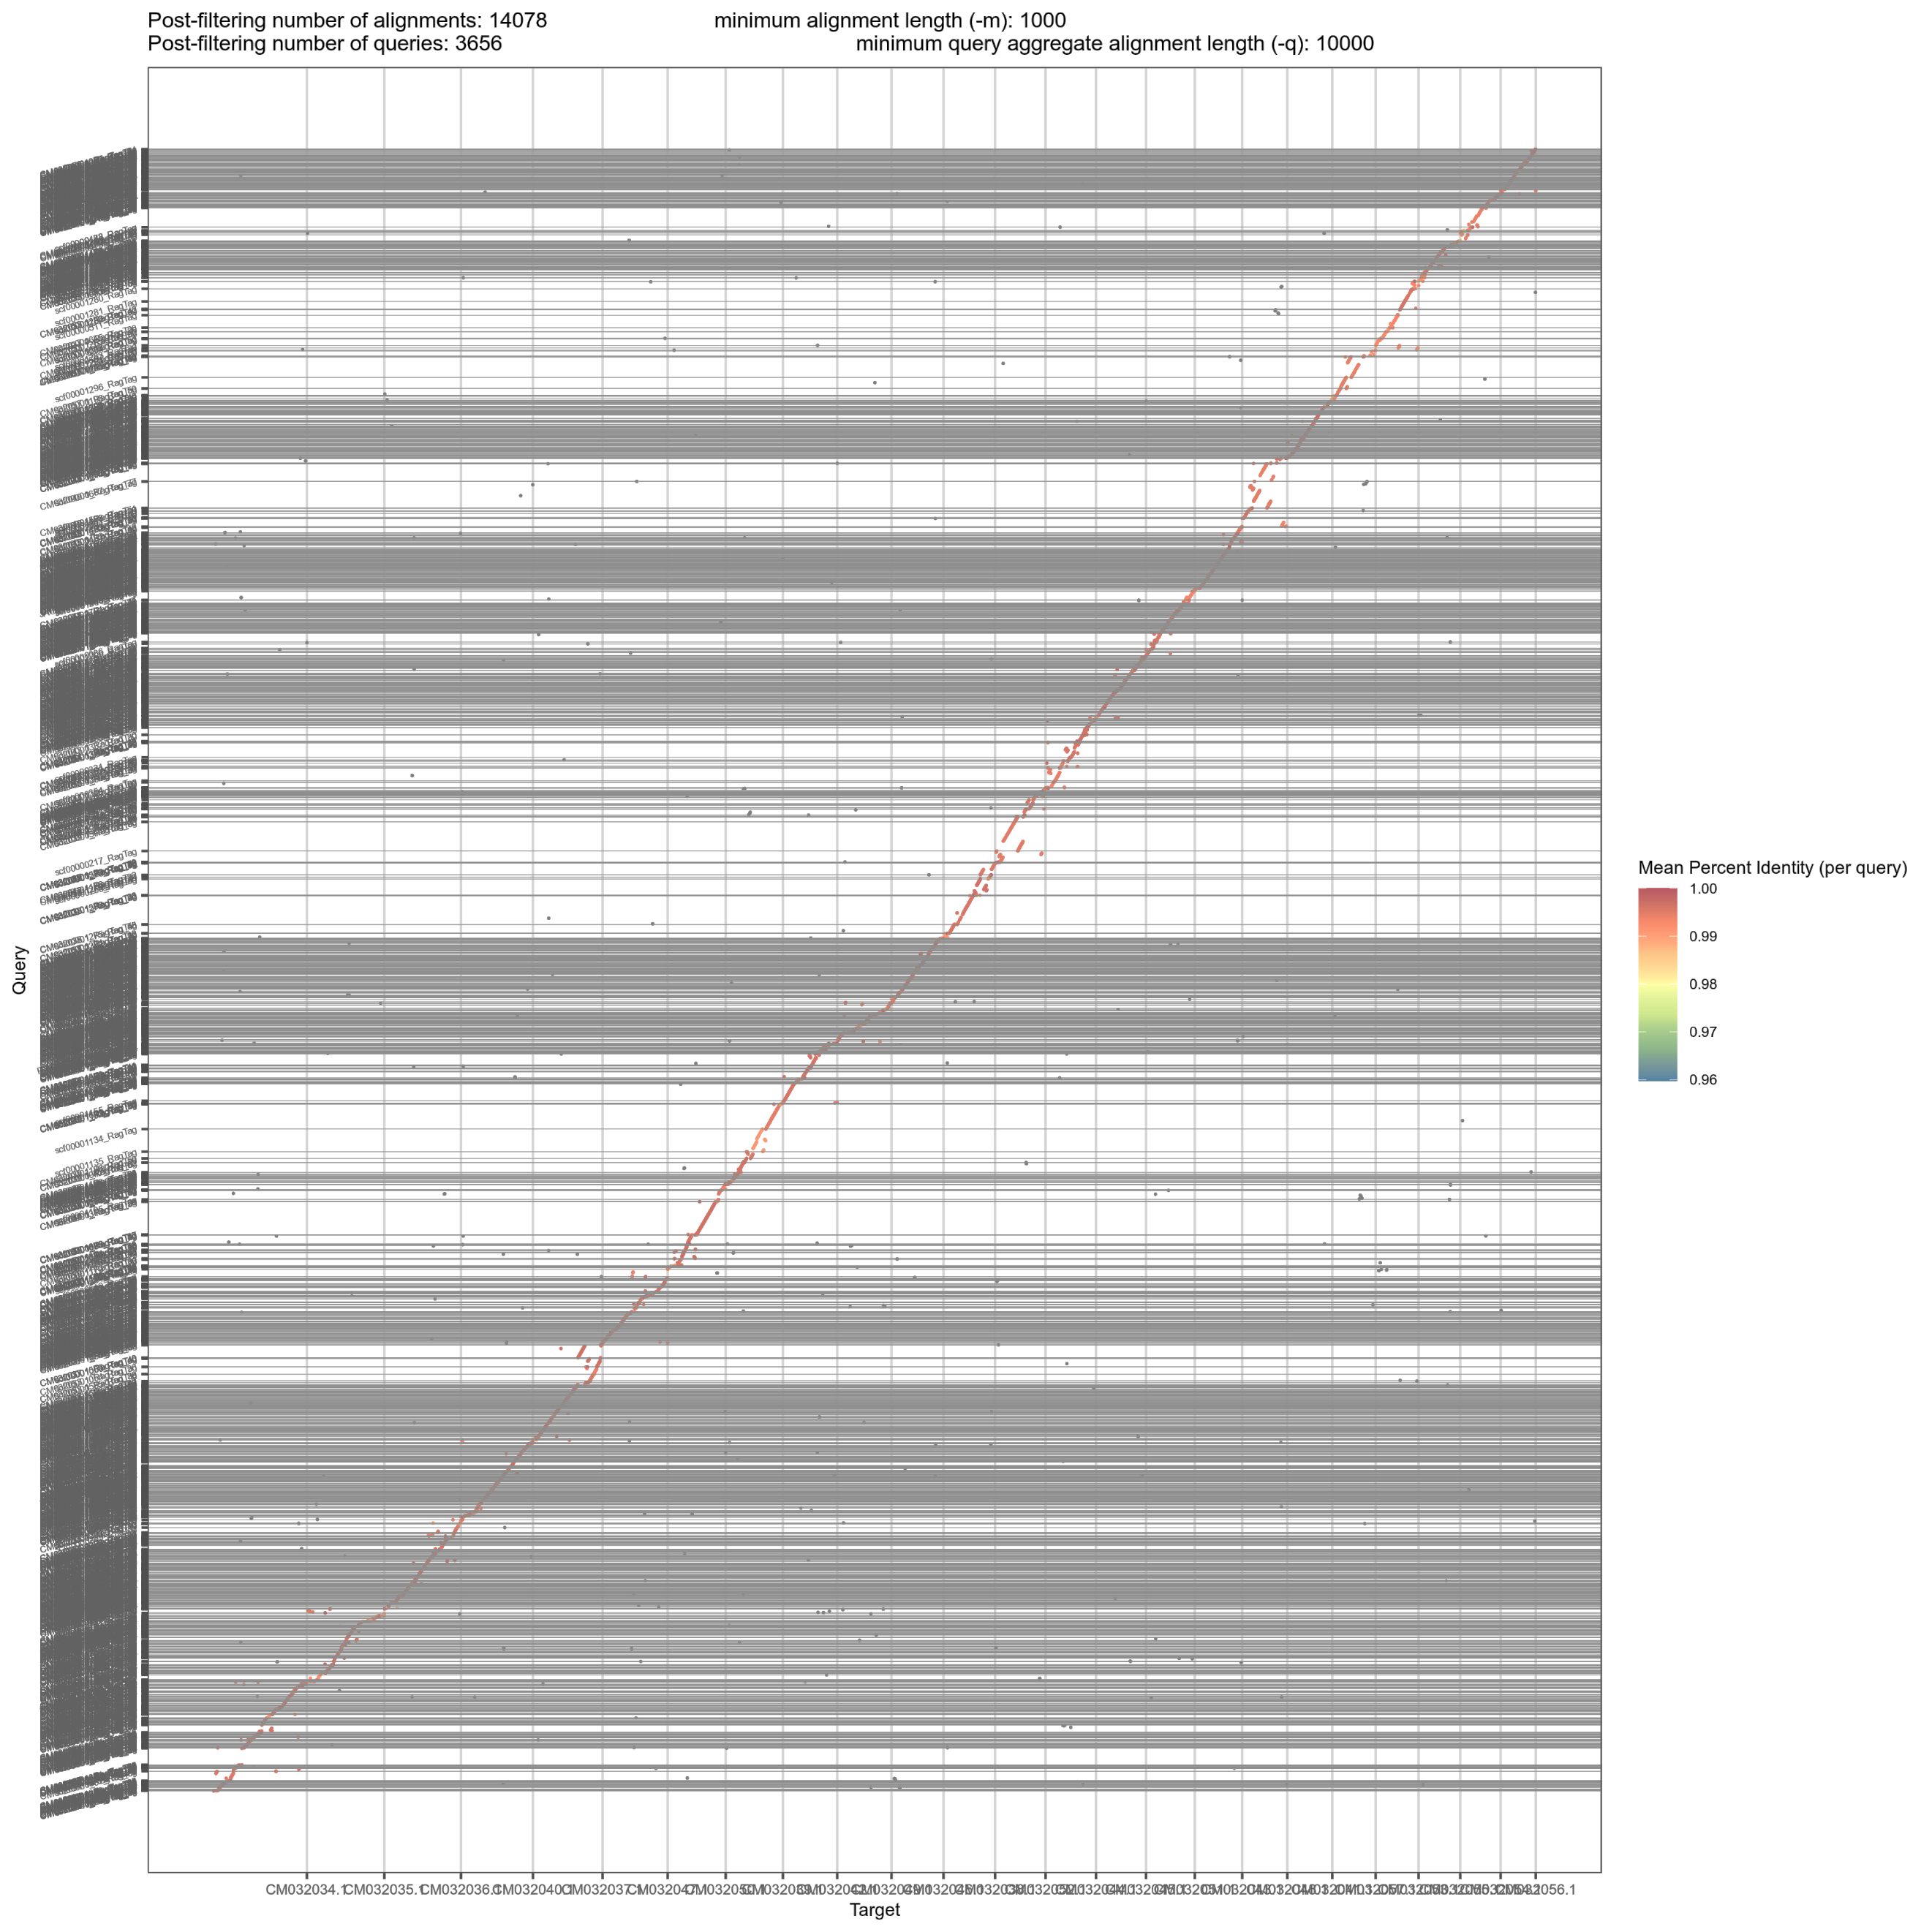
Figure S4. Dot Plot Comparison of Reference-Guided Assembly of Megalobrama amblycephala Genome (GCA_009869865.1) and Error Correction Using Culter alburnus Genome (GWHBOSX00000000) with Multi-reference Assembly by Ragtag's Merge function Versus the Chromosome-Level Genome of M. amblycephala (GCA_018812025.1)
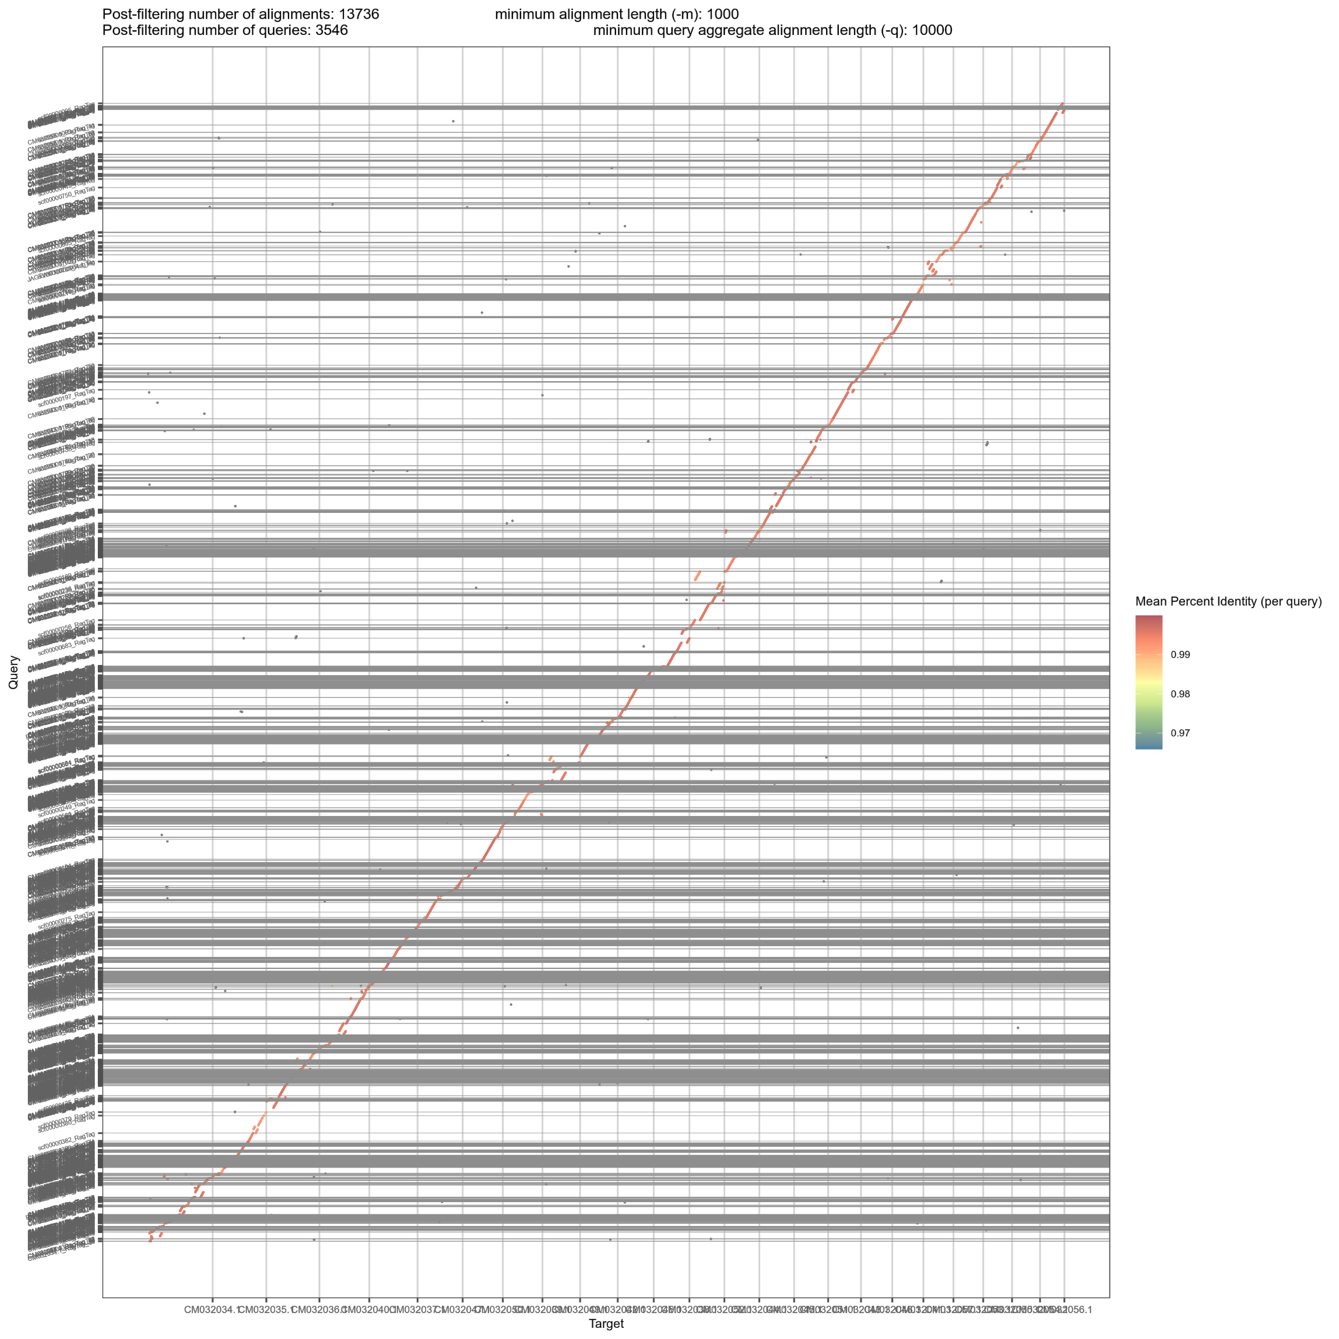
Figure S5. Dot Plot Comparison of Reference-Guided Assembly of Megalobrama amblycephala Genome (GCA_009869865.1) and Error Correction Using M. amblycephala Genome (GCA_018812025.1) with Multi-reference Assembly by Ragtag's Merge function Versus the Chromosome-Level Genome of M. amblycephala (GCA_018812025.1)
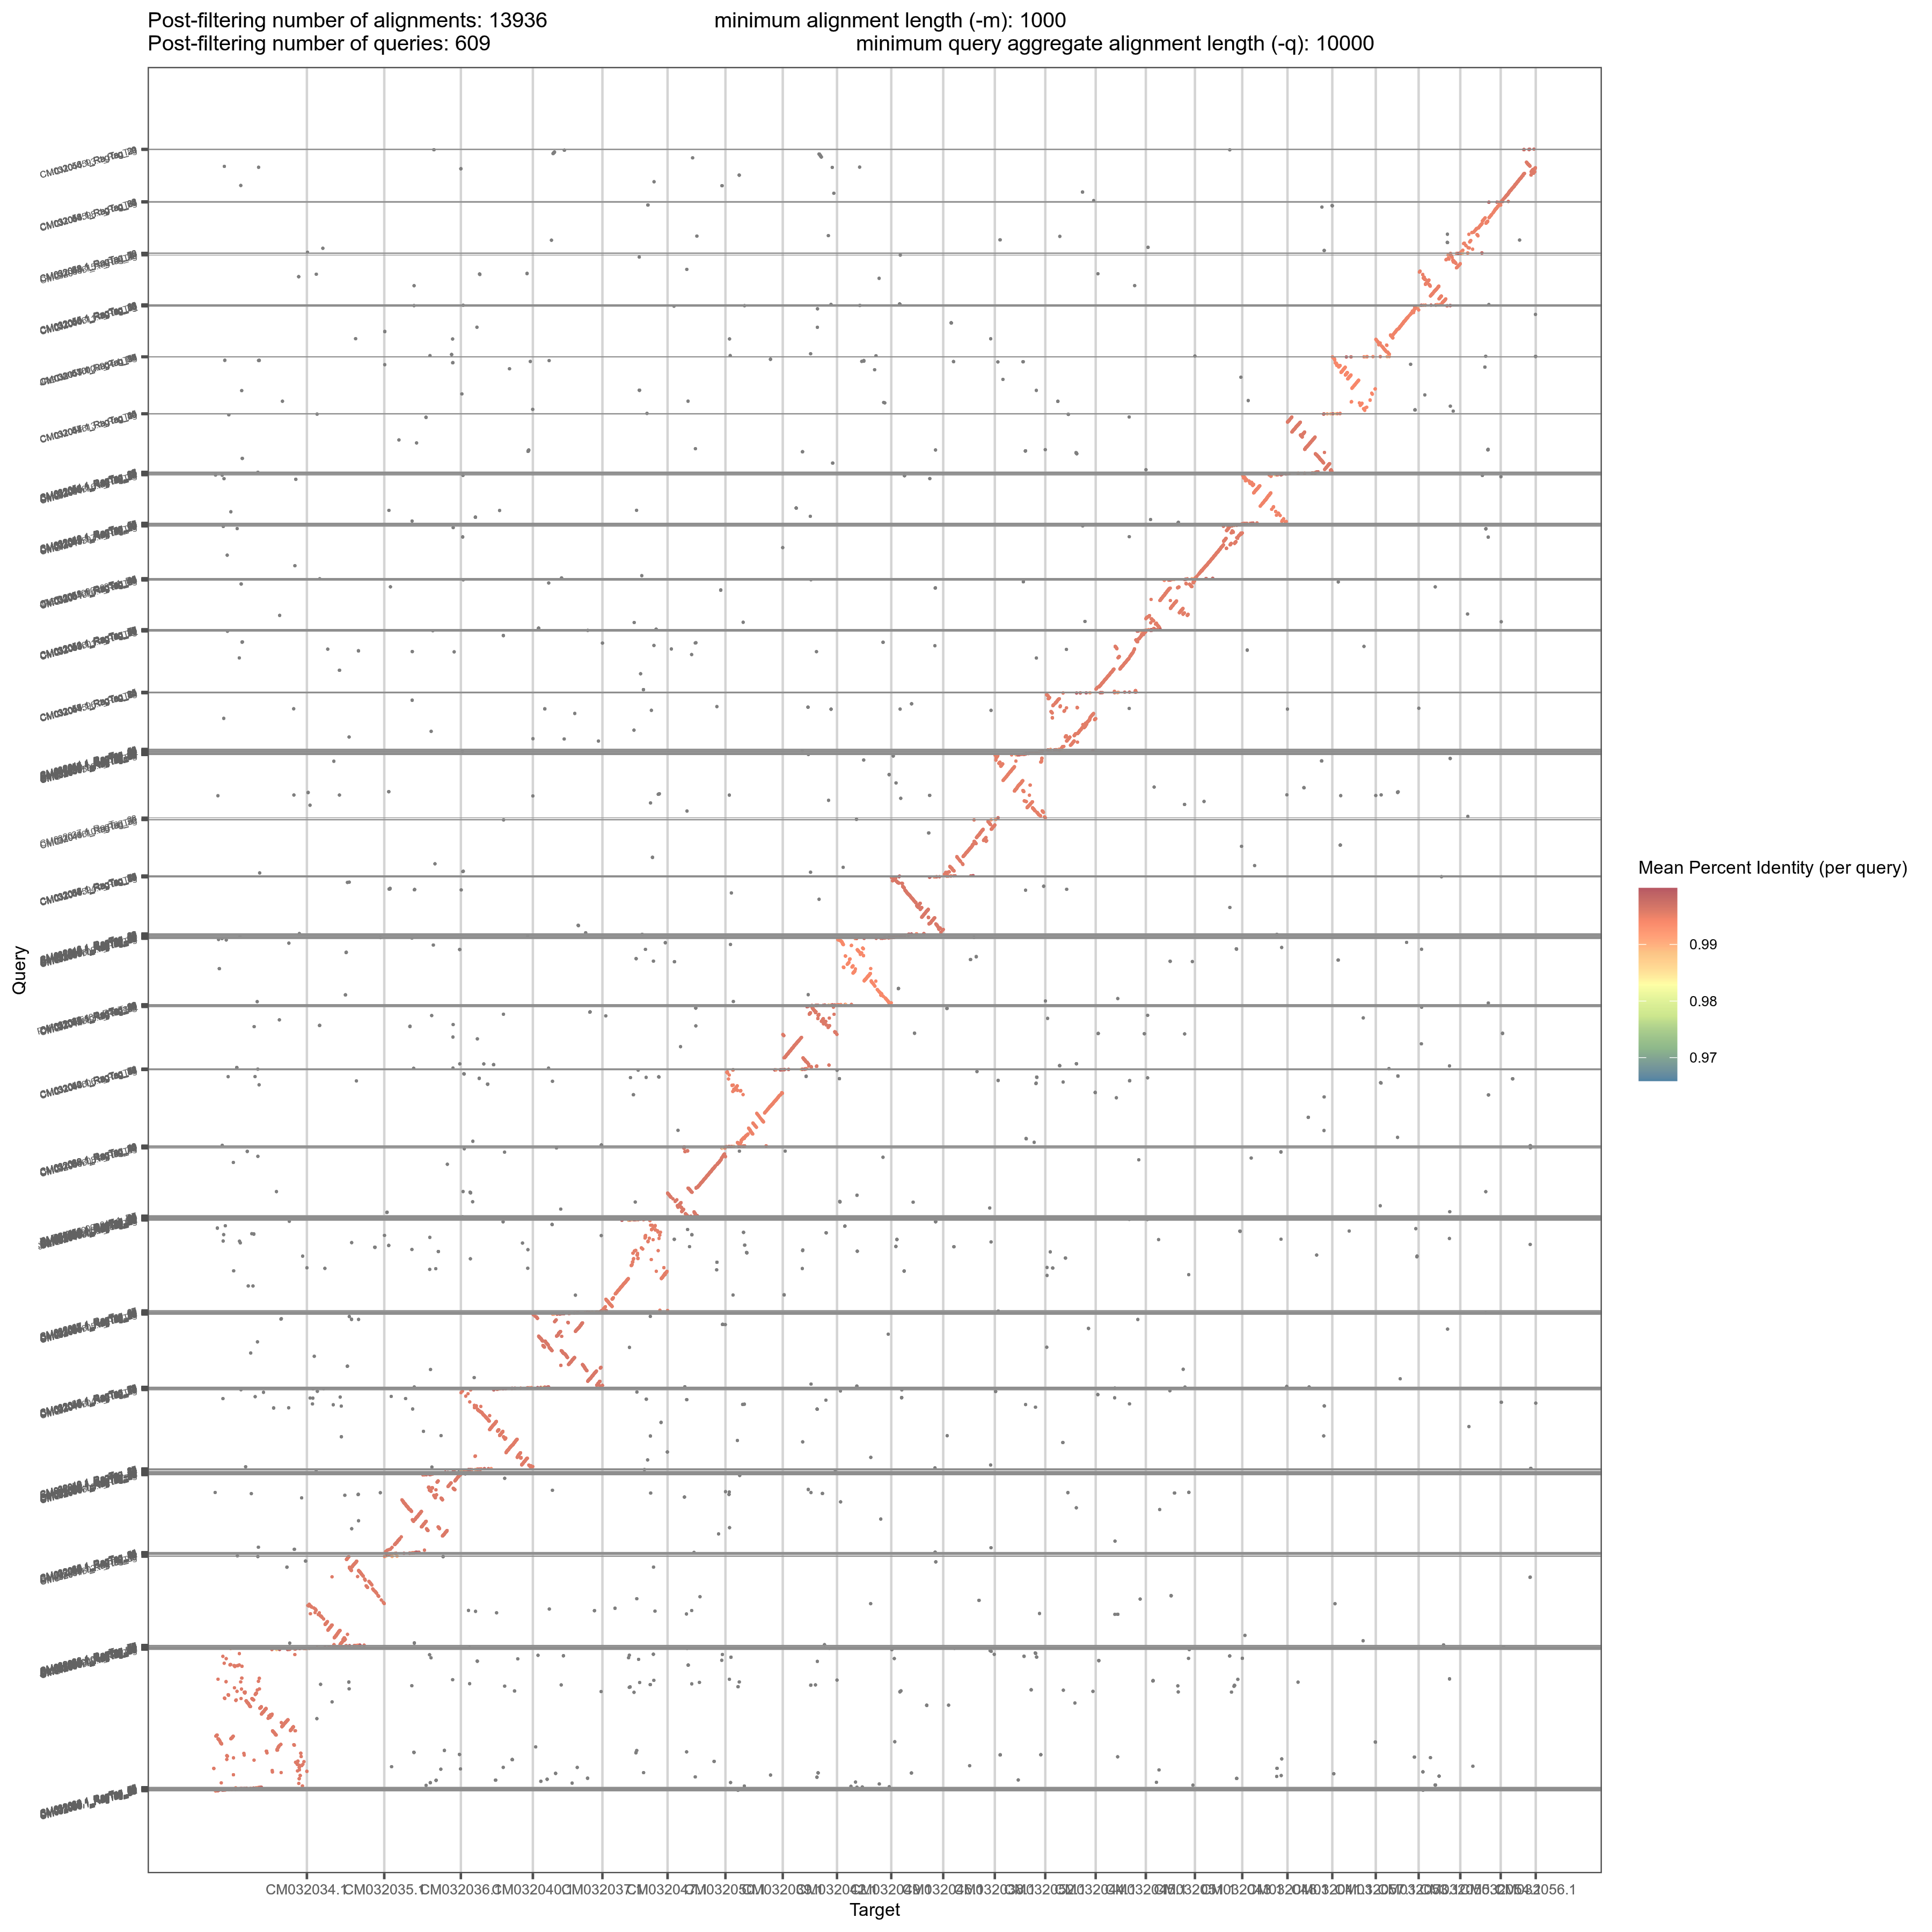
Figure S6. Dot Plot Comparison of Megalobrama amblycephala Genomes: Comparison Between Reference-Guided Assembly and Error Correction Using Chanodichthys erythropterus Genome (GCA_024489055.1) Versus the Chromosome-Level Genome of M. amblycephala (GCA_018812025.1)
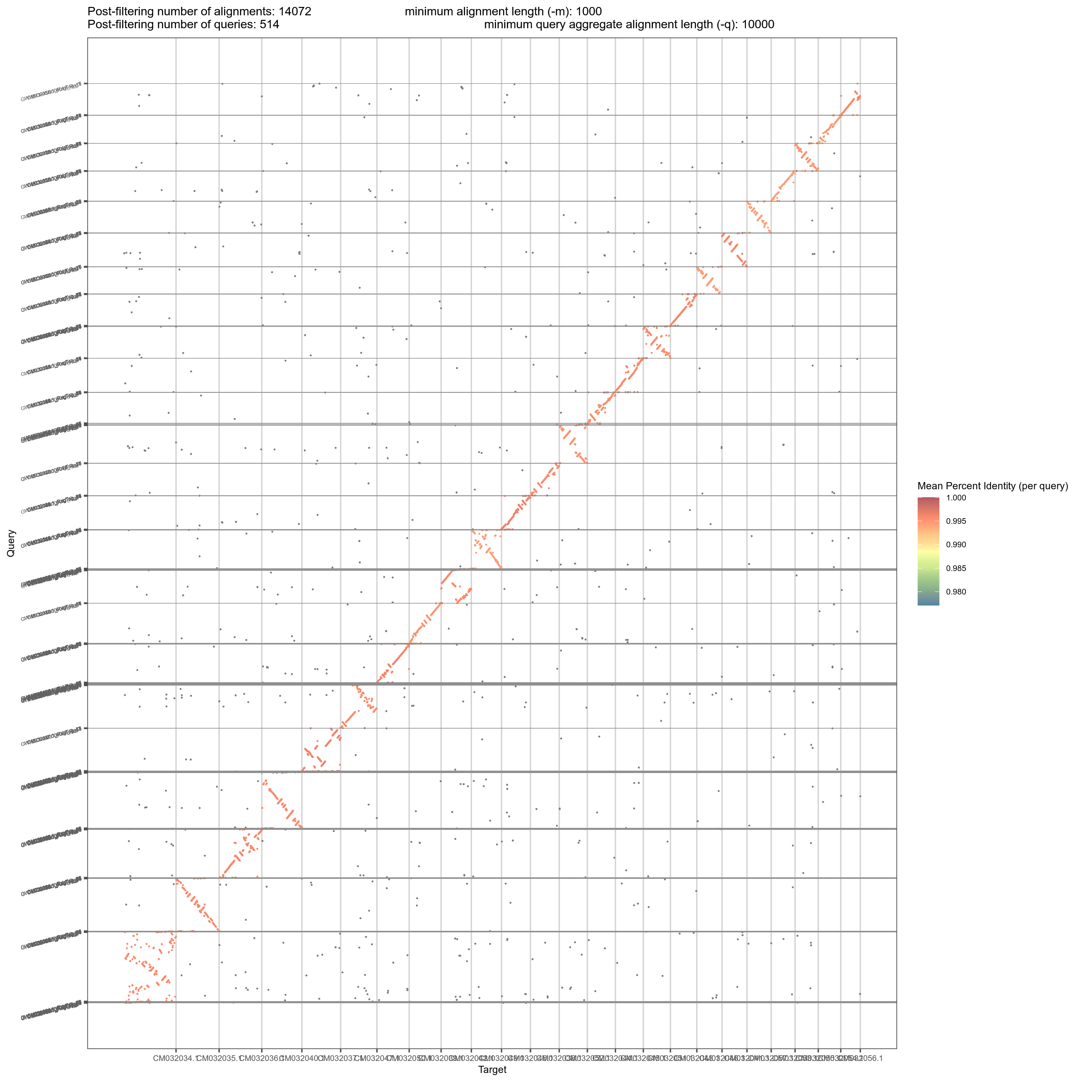
Figure S7. Dot Plot Comparison of Megalobrama amblycephala Genomes: Comparison Between Reference-Guided Assembly and Error Correction Using Culter alburnus Genome (GWHBOSX00000000) Versus the Chromosome-Level Genome of M. amblycephala (GCA_018812025.1)
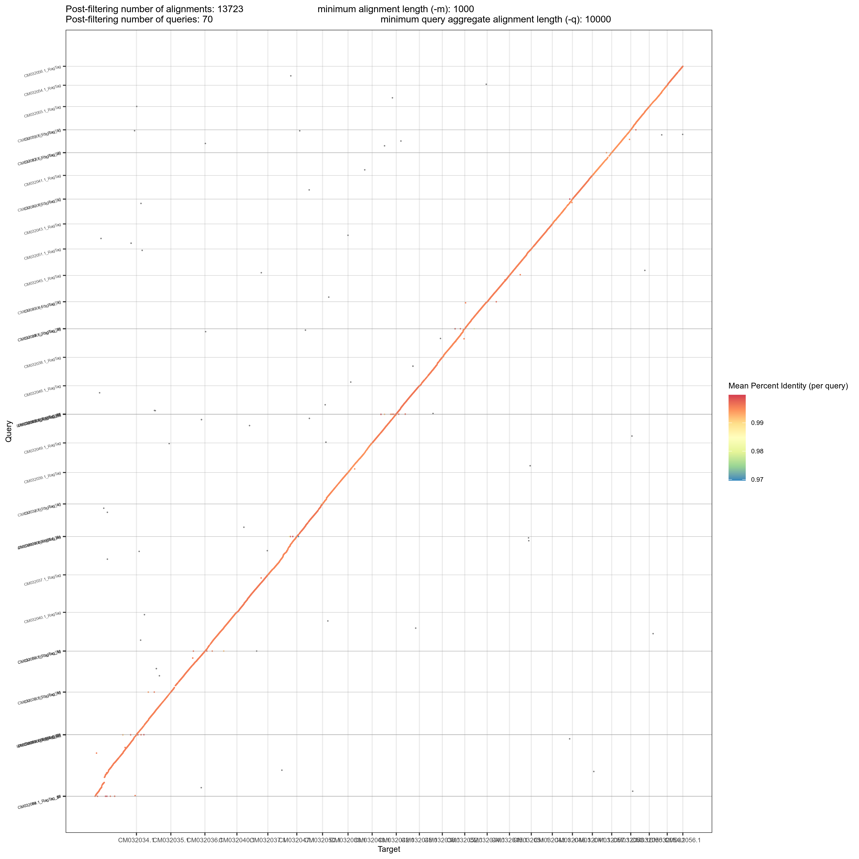
Figure S8. Dot Plot Comparison of Megalobrama amblycephala Genomes: Comparison Between Reference-Guided Assembly and Error Correction Using M. amblycephala Genome (GCA_018812025.1) Versus the Chromosome-Level Genome of M. amblycephala (GCA_018812025.1)
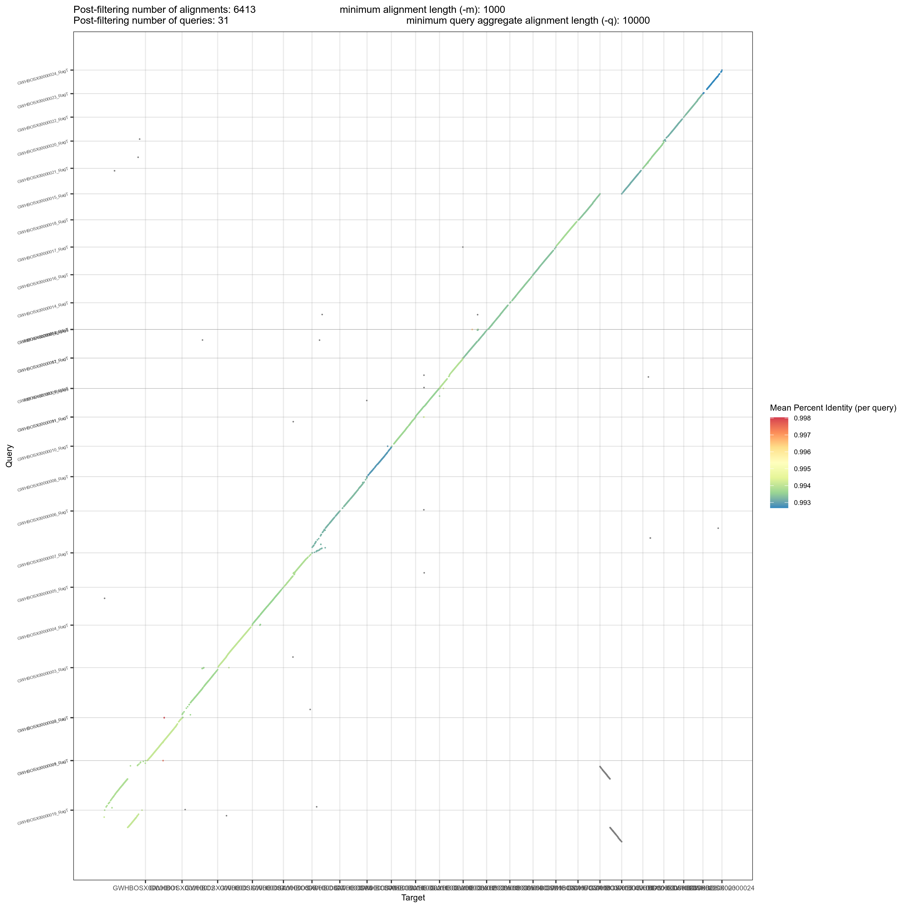
Figure S9. Dot Plot Comparison of Reference-Guided Assembly of Culter alburnus Genome (GCA_009869775.1) with Multi-reference Genomes Using Ragout and Ragtag Versus the Chromosome-Level Genome of C. alburnus (GWHBOSX00000000)
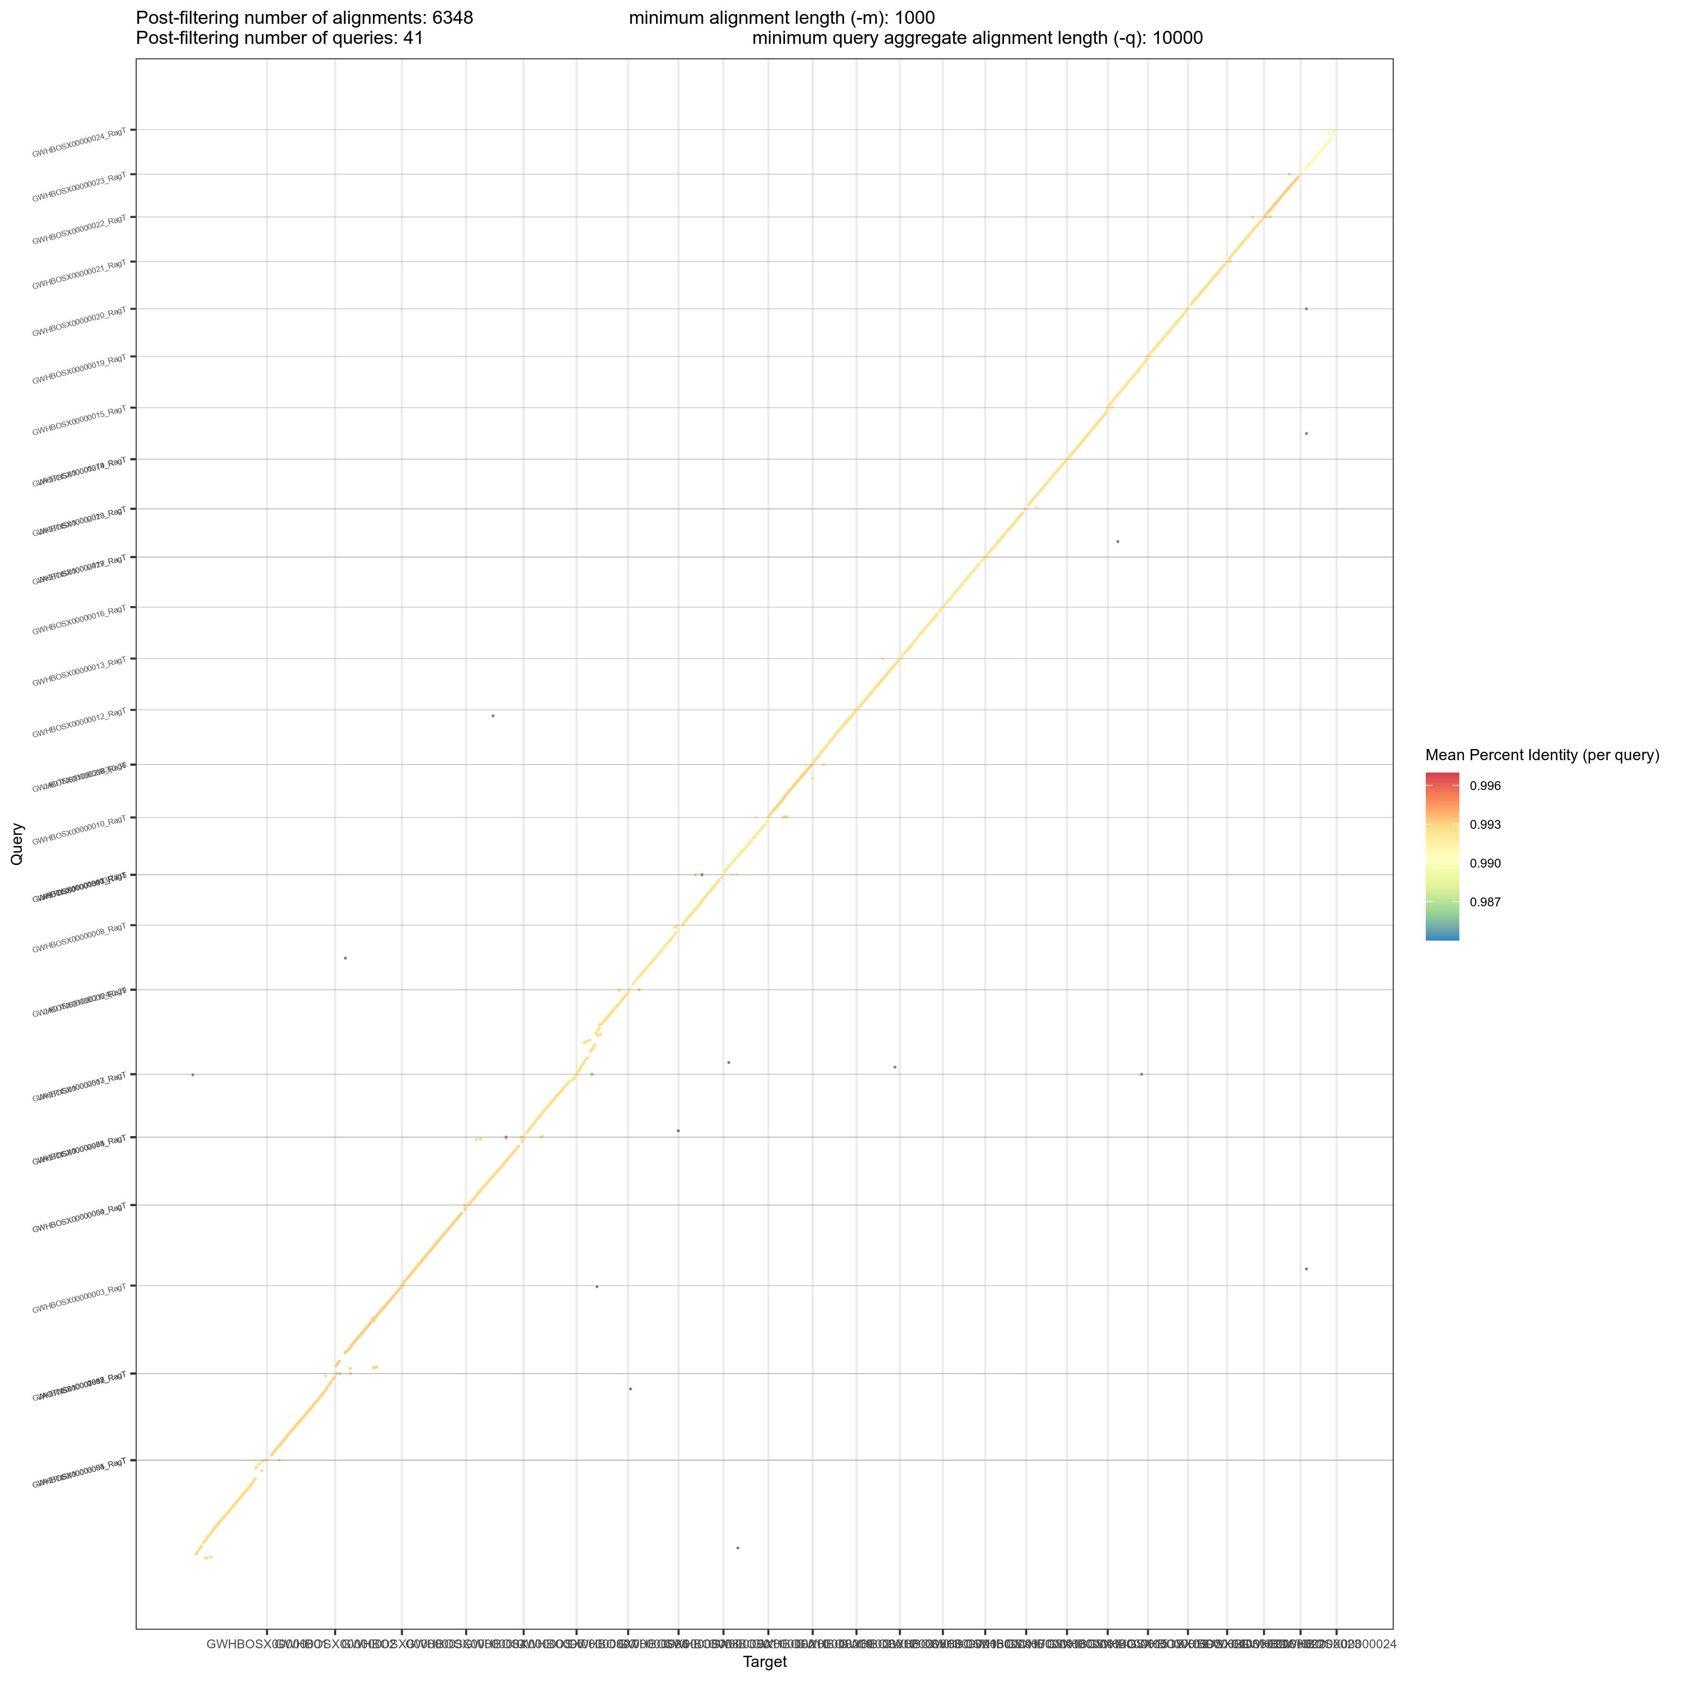
Figure S10. Dot Plot Comparison of Reference-Guided Assembly of Culter alburnus Genome (GCA_028476615.1) with Multi-reference Genomes Using Ragout and Ragtag Versus the Chromosome-Level Genome of C. alburnus (GWHBOSX00000000)
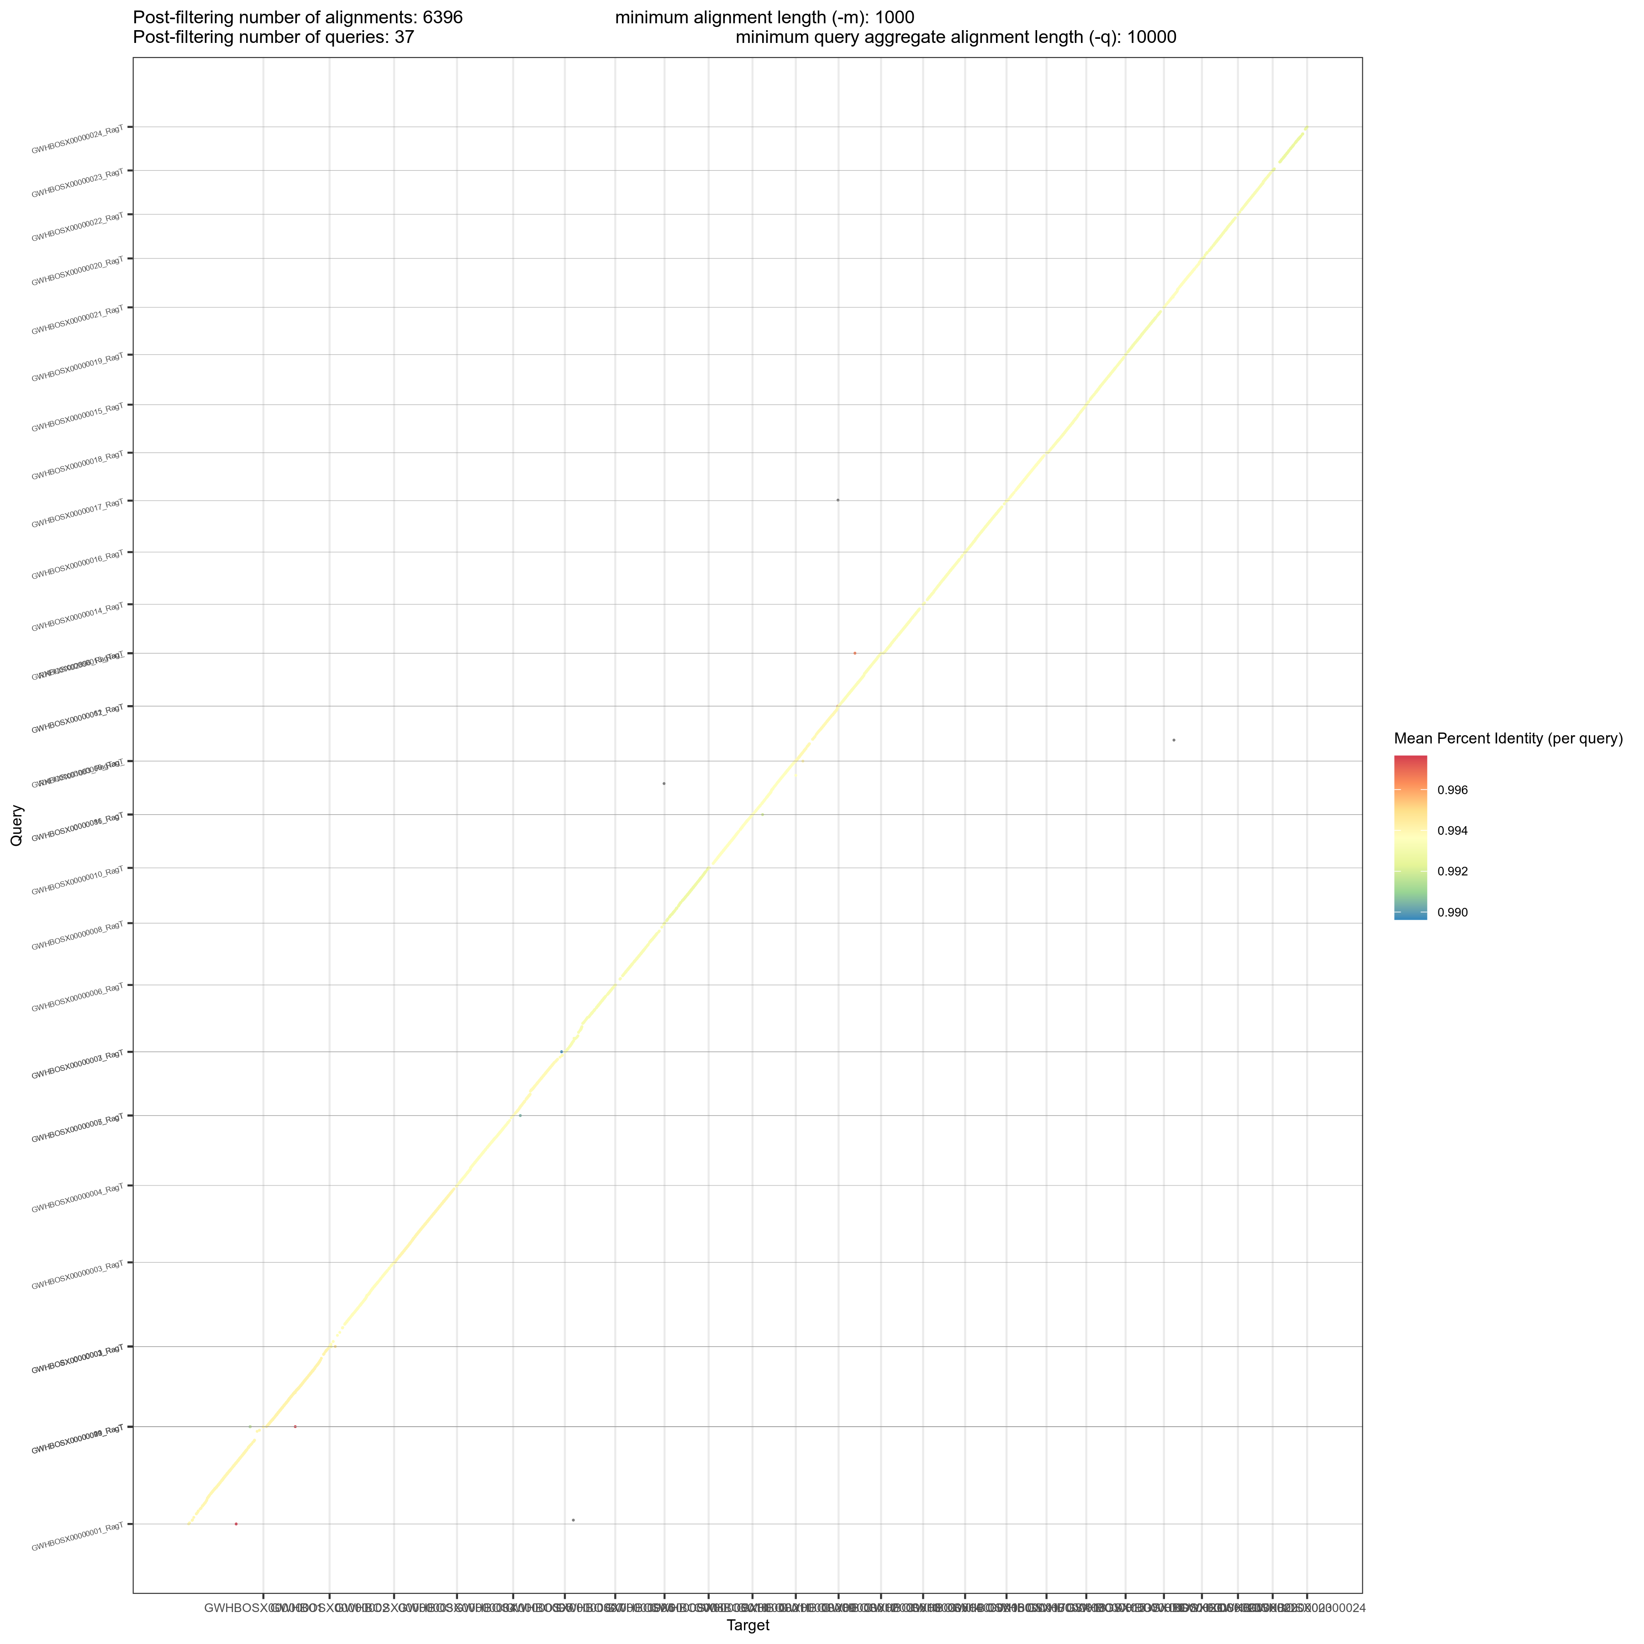
Figure S11. Dot Plot Comparison of Culter alburnus Genomes: Comparison Between Reference-Guided Assembly of Culter alburnus Genome (GCA_009869775.1) and Error Correction Using C. alburnus Genome (GWHBOSX00000000) Versus the Chromosome-Level Genome of C. alburnus (GWHBOSX00000000)
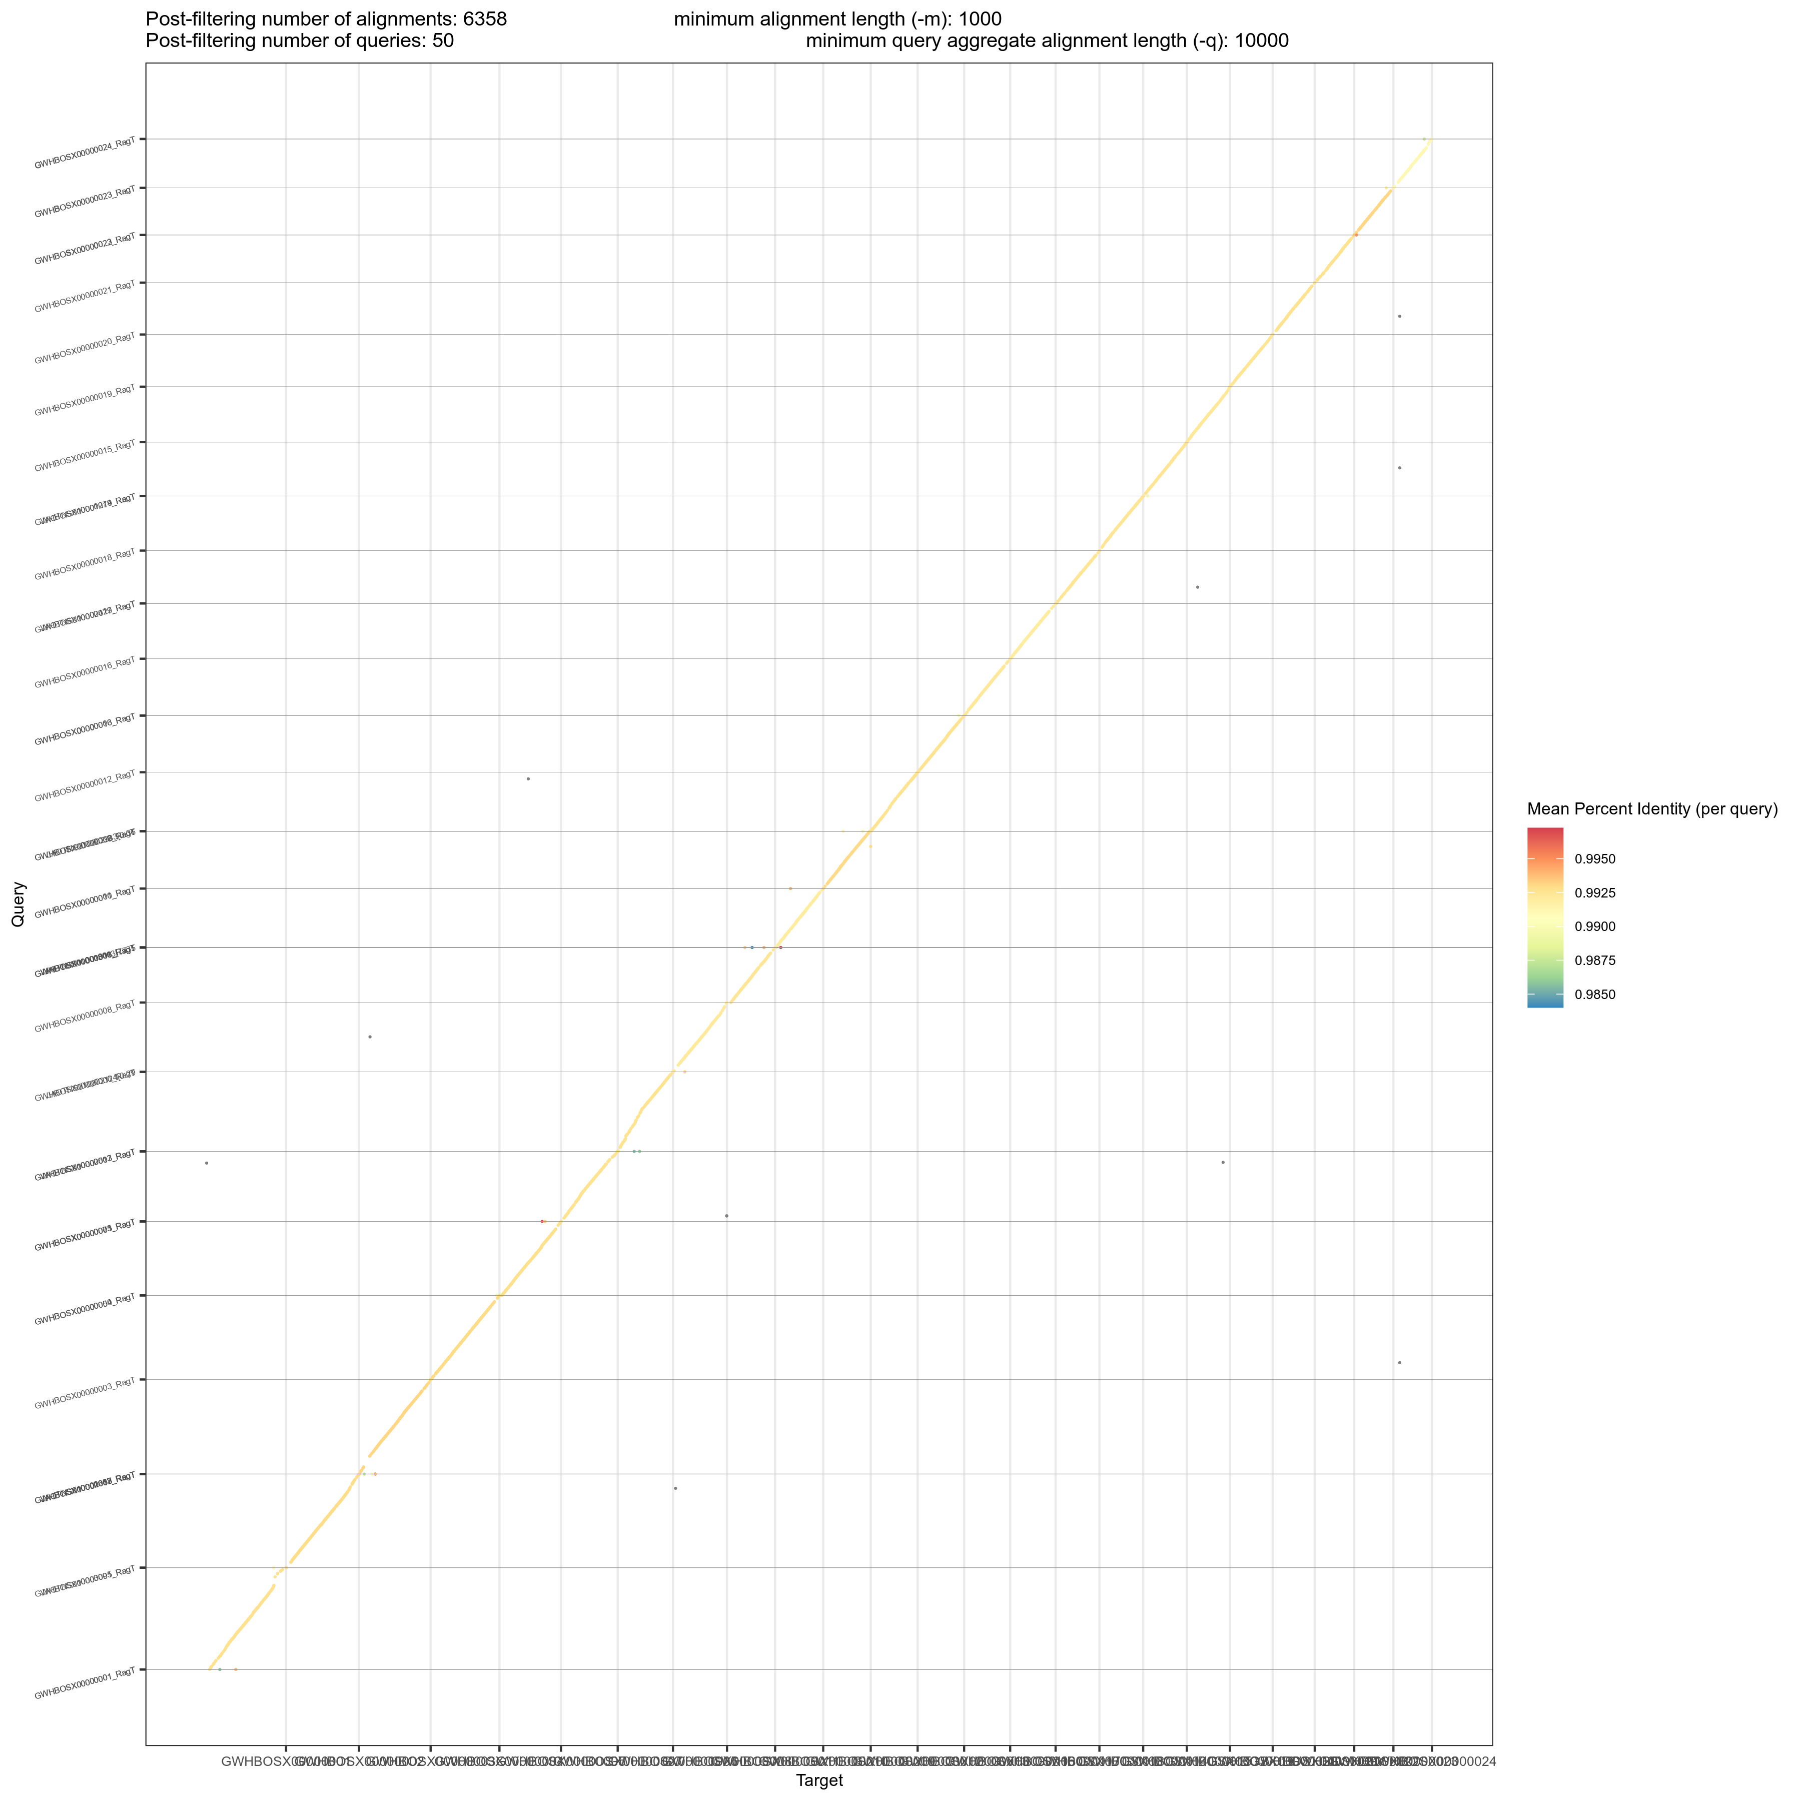
Figure S12. Dot Plot Comparison of Megalobrama amblycephala Genomes: Comparison Between Reference-Guided Assembly of Culter alburnus Genome (GCA_028476615.1) and Error Correction Using C. alburnus Genome (GWHBOSX00000000) Versus the Chromosome-Level Genome of C. alburnus (GWHBOSX00000000)

