Supporting Information
Pd doped tin oxide nanostructured catalysts for electrochemical reduction of carbon dioxide

1 Experimental

Electrochemical test methods
Electrocatalytic CO₂ reduction experiments were conducted using an electrochemical workstation to test the performance of the catalyst for CO₂ reduction.All electrochemical characterization and electrocatalytic reduction experiments were controlled through a CHI-660e workstation.A three-electrode system was used in all experiments, with the platinum sheet electrode as the counter electrode, the catalyst-loaded gas diffusion electrode as the working electrode, and the Ag/AgCl electrode as a reference electrode, placed in the Ag/AgCl electrode as the reference electrode, placed near the working electrode. The electrolyte was 1 mol.L⁻¹ KOH solution.
The electrocatalytic reduction of CO₂ performance test was carried out by constant potential electrolysis, where the electrolysis potential was adjusted so that the reaction was carried out at a specific potential and the change of the reaction current with time was recorded in order to measure the Faraday efficiency of different catalysts at different applied potentials for specific products. Liquid and gas sampling were carried out separately after an interval to ensure that a steady state was reached.The flow rate of CO₂ was set at 20 mL.min⁻¹.

CO₂RR products analysis
The gas phase products were passed into a Gas Chromatograph (GC) for detection. A Thermal Conductivity Detector (TCD) was used to detect hydrogen, and a Flame Ionization Detector (FID) was used to detect some of the gas-phase products in the product, such as carbon monoxide, hydrogen and methane. The carrier gas used in the experiment is high purity argon (purity of 99.999%), and the standard curves of different products are calibrated using the external standard method, and the gas used for the external standard needs to be precisely customized. The gas used for the external standard needs to be customized accurately. Before starting the experiment, the error of the system needs to be detected. The test is performed by feeding a known concentration of an accurately customized gas into the detector, and if the gas concentration detected by the detector agrees with the actual concentration, the formal test can begin. The relationship between concentration and Faraday efficiency is(take CO for example）：
 | $$j_{CO}=\frac{peak area}{α}×flow rates×\frac{ZEP}{RT}$$ | Eq.S1
 | $${FE}_{CO}=\frac{j_{CO}}{j_{Total}}$$ | Eq.S2
where peak area indicates the peak area of the corresponding product detected in the detector and α is the corresponding gas chromatography standard curve conversion relation. The flow rate corresponds to the flow rate of CO₂ through the electrolysis cell, Z denotes the number of transferred electrons in the reaction, P denotes the atmospheric pressure of 1.013 bar, T denotes the temperature at which the experiment was carried out, which was 273.15 K, and F was 96500 C. After a period of electrolytic enrichment,The liquid phase products were collected and tested and analyzed by a liquid phase NMR spectrometer(Bruker AV400,400MHz).The Faraday efficiency of the liquid phase product is calculated as:
 | $$FE=\frac{Q_{Product}}{Q}×100\%=\frac{nN_{product}F}{Q}×100\%$$ | Eq.S3
where n denotes the number of electrons transferred in the production of a particular product, and the number of electrons transferred in the production of formic acid and CO from CO₂ is 2; N_{product} is the amount of material of the product (mol); Q_{product} is the amount of charge required to produce the product in CO₂RR (C); Q is the total charge passing through the surface of the working electrode in the reduction reaction (C); and F denotes the Faraday's constant (96485 C.mol⁻¹ )

DFT calculations
Spin-polarized density functional theory (DFT) calculations were performed using the Vienna ab-initio Simulation Package (VASP)^{[1]}, employing the generalized gradient approximation (GGA) with the Perdew-Burke-Ernzerhof (PBE) exchange–correlation functional^{[2]} to account for the exchange and correlation effects. The cut-off energy was set to 450 eV, while the convergence threshold was set to 10-4 and 0.02 eV/Å for energy and force, respectively. The SnO2 (110) surface was modelled by a three-layer slab with a (3×2) unit cell, where the top two layers were relaxed, and the bottom layer was fixed during the calculation. Brillouin-zone integrations were sampled using a (3 × 3 × 1) Monkhorst-Pack k-points. A vacuum space around 15 Å was adopted to avoid the interaction between two images. van der Waals (vdW) interactions were considered using the Grimme’s D3-type of the semiempirical method between the catalysts and intermediates^{[3]}. Based on computational hydrogen electrode (CHE) model^{[4]}, the Gibbs free energies for various adsorbates were calculated via the equation
 | ∆G = ∆E + ∆E_{ZPE} − T∆S | Eq.S4
where ∆E is the adsorption energy of the adsorbates, and ∆E_{ZPE} and ∆S are the difference in the zero-point energy and the change in entropy before and after adsorption of various intermediates, respectively.
The electronic structure energies, zero-point energies, entropies, and Gibbs free energies for the formation of formic acid, CO, and H₂ on the catalyst surface at room temperature are shown in Tables S2 and S3.
a 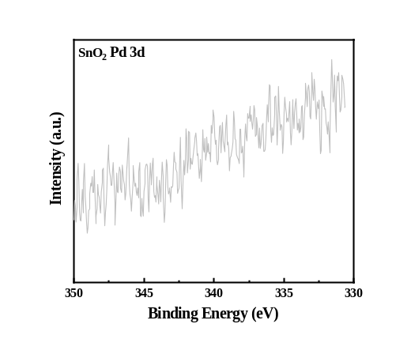b 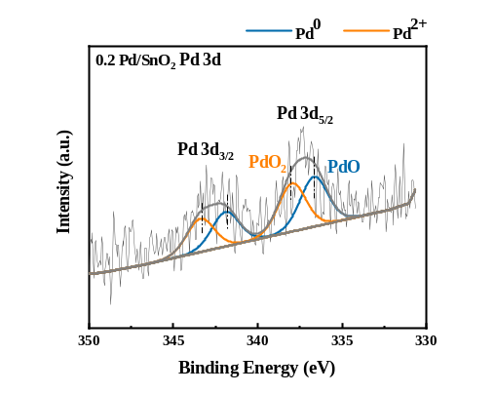
c 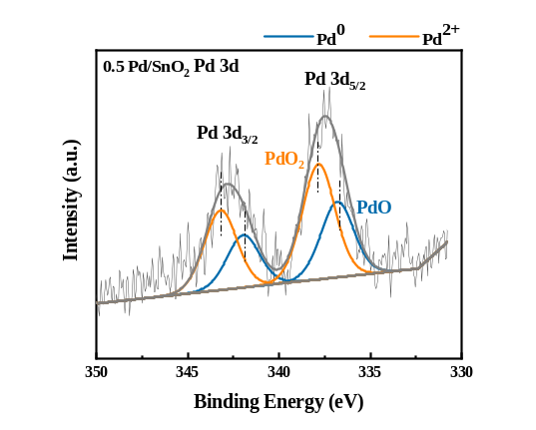d 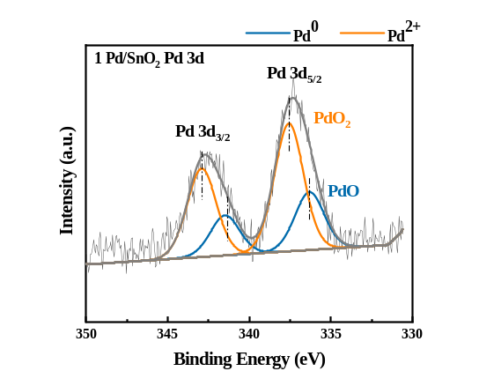
Figure S1. XPS Pd 3dimages of Pd/SnO₂ (a)SnO₂ (b)0.2Pd/SnO₂ (c)0.5Pd/SnO₂ (d)1.0Pd/SnO₂

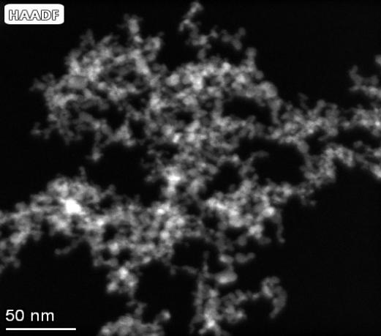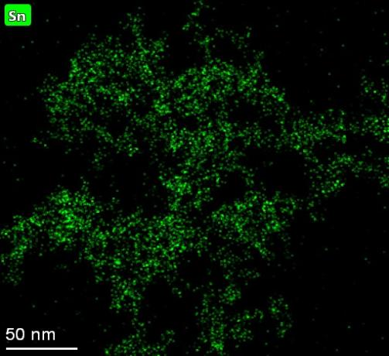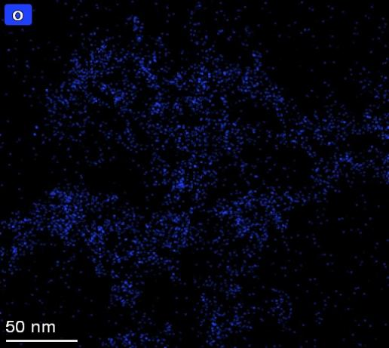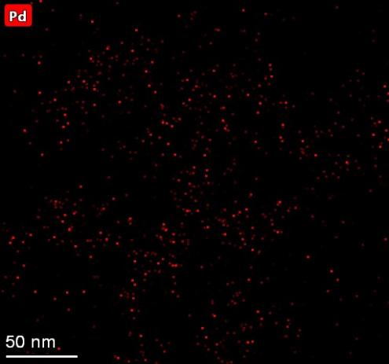
Figure S2. EDS images of Sn, O and Pd elements in 0.5Pd/SnO₂

a 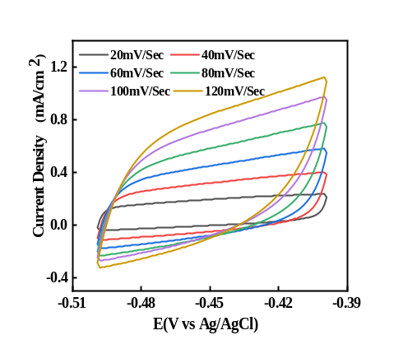b 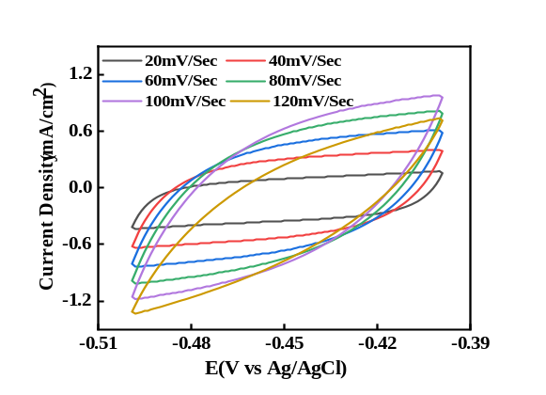
c 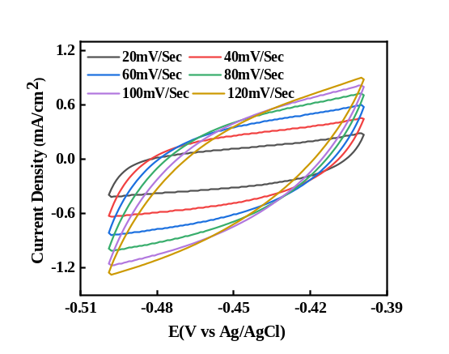d 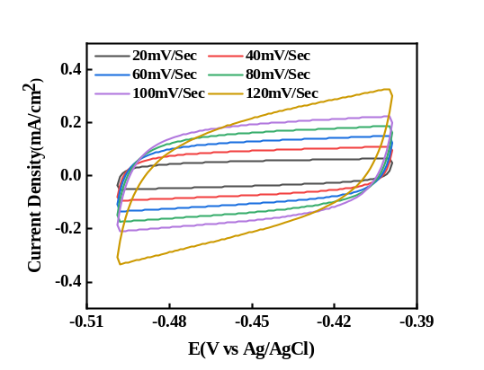
Figure S3. CV curves at different scan rates in the capacitive region of the bilayer (a) SnO₂ (b) 0.2 Pd/SnO₂ (c) 0.5 Pd/SnO₂ (d) 1.0 Pd/SnO₂

a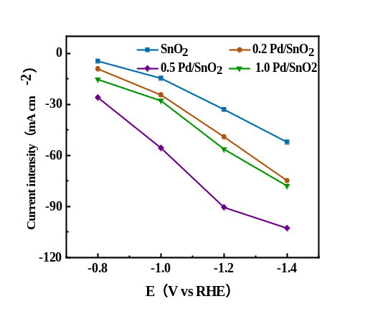b 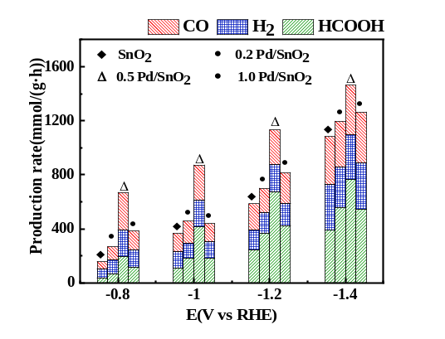
Figure S4. (a) Partial current density of formic acid at the same potential (b) Yield of product at different reduction potentials
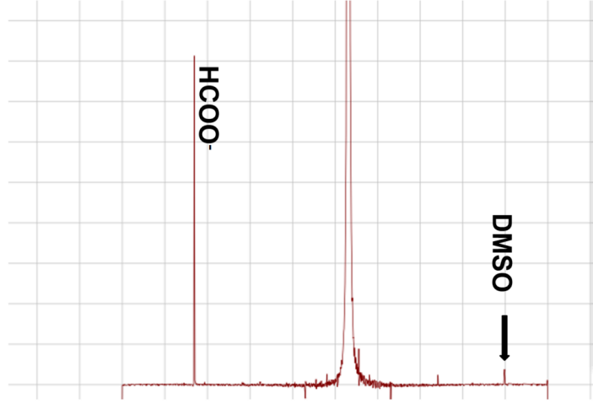
Figure S5. NMR hydrogen spectrum of anodic electrolyte with catalyst 0.5 Pd/SnO₂ at potential -1.2 V vs RHE

a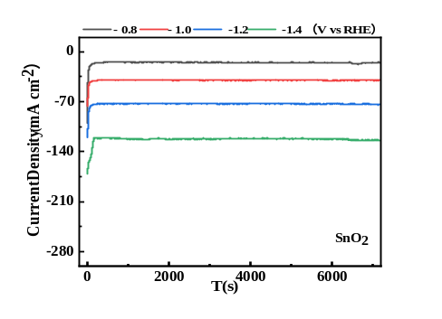b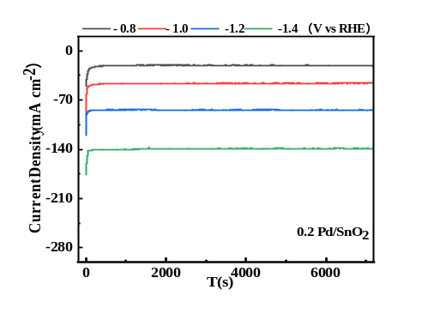
c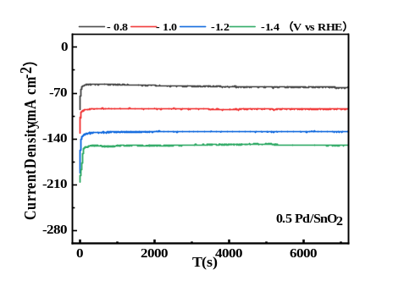d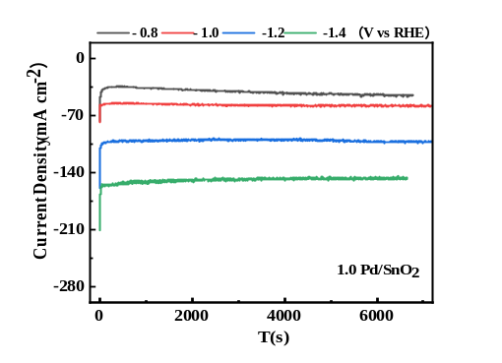
Figure S6. i-t plots of Pd/SnO₂ with different doping concentrations at different potentials (a) SnO₂ (b) 0.2 Pd/SnO₂ (c) 0.2 Pd/SnO₂ (d) 1.0 Pd/SnO₂

Table S1. Detailed Material Information Sheet for Preparation of Pd/SnO₂ Nanoparticles
Catalysts | solvents | Palladium diacetylacetonate(g) | 2-ethylhexanoate(mol) | Precursor flow(mL.min⁻¹) | Dispersed gas flowgas  (L.min⁻¹) | Methane flame premix gas(L.min⁻¹)
SnO₂ | Ethanol/Acetic acid  (4/1) | 0 | 0.04 | 3 | 5(1.5bar) | 0.75(CH₄)  1.6(O₂)
0.2Pd/SnO₂ | Ethanol/Acetic acid  (4/1) | 0.024
0.5Pd/SnO₂ | Ethanol/Acetic acid  (4/1) | 0.061
1.0Pd/SnO₂ | Ethanol/Acetic acid  (4/1) | 0.122

Table S2. Electronic structure energy, zero-point energy, entropy, and Gibbs free energy of formic acid generated on the catalyst surface at room temperature
 | Adsorption surface | E(eV) | ZPE(eV) | TS（eV） | G(eV) | ΔG(eV)
CO₂ |  | -22.98 | 0.31 | 0.66 | -23.33
 | SnO₂ | -674.51 |  |  | -697.84
 | Pd/SnO₂ | -671.6 |  |  | -694.93 | 0
CO₂*⁻ | SnO₂ | -697.9 | 0.34 | 0.23 | -697.79 | 0.05
CO₂*⁻ | Pd/SnO₂ | -694.9 | 0.34 | 0.23 | -694.83 | 0.10
HCOO*⁻ | SnO₂ | -701.11 | 0.65 | 0.15 | -700.61 | 0.63
HCOO*⁻ | Pd/SnO₂ | -699.23 | 0.65 | 0.15 | -698.73 | -0.45
HCOOH | SnO₂ | -705.45 | 0.97 | 0.19 | -704.67 | -0.61
HCOOH | Pd/SnO₂ | -702.77 | 0.97 | 0.19 | -701.99 | 0.19

Table S3. Electronic structure energy, zero-point energy, entropy, and Gibbs free energy for CO generation on the catalyst surface at room temperature
 | Adsorption surface | E(eV) | ZPE(eV) | TS(eV) | G(eV) | ΔG(eV)
CO₂ |  | -22.98 | 0.31 | 0.66 | -23.33
 | SnO₂ | -674.51 |  |  | -697.84
 | Pd/SnO₂ | -671.6 |  |  | -694.93 | 0.00
COOH* | SnO₂ | -697.9 | 0.34 | 0.23 | -697.79 | 0.05
COOH* | Pd/SnO₂ | -694.94 | 0.34 | 0.23 | -694.83 | 0.10
CO* | SnO₂ | -699.85 | 0.61 | 0.24 | -699.48 | 1.76
 | Pd/SnO₂ | -698.64 |  |  | -698.27 | 0.01
CO | SnO₂ | -689.89 | 0.18 | 0.19 | -689.9 | -1.28
CO | Pd/SnO₂ | -687.48 | 0.18 | 0.19 | -687.49 | -0.08

References
[1] Kresse G, Furthmuller J. Phys Rev B Condens Matter(Physical review. B, Condensed matter), 1996, 54(16):11169-11186.
[2] Blanc X, Cancès É, Dupuy M. Comptes Rendus Mathematique, 2017, 355(6):665-670.
[3] Grimme S, Antony J, Ehrlich S, Krieg H. J Chem Phys(The Journal of chemical physics), 2010, 132(15):154104.
[4] Nørskov J K, Rossmeisl J, Logadottir A, Lindqvist L, Kitchin J R, Bligaard T, Jónsson H. The journal of physical chemistry. B, 2004, 108(46):17886-17892.

