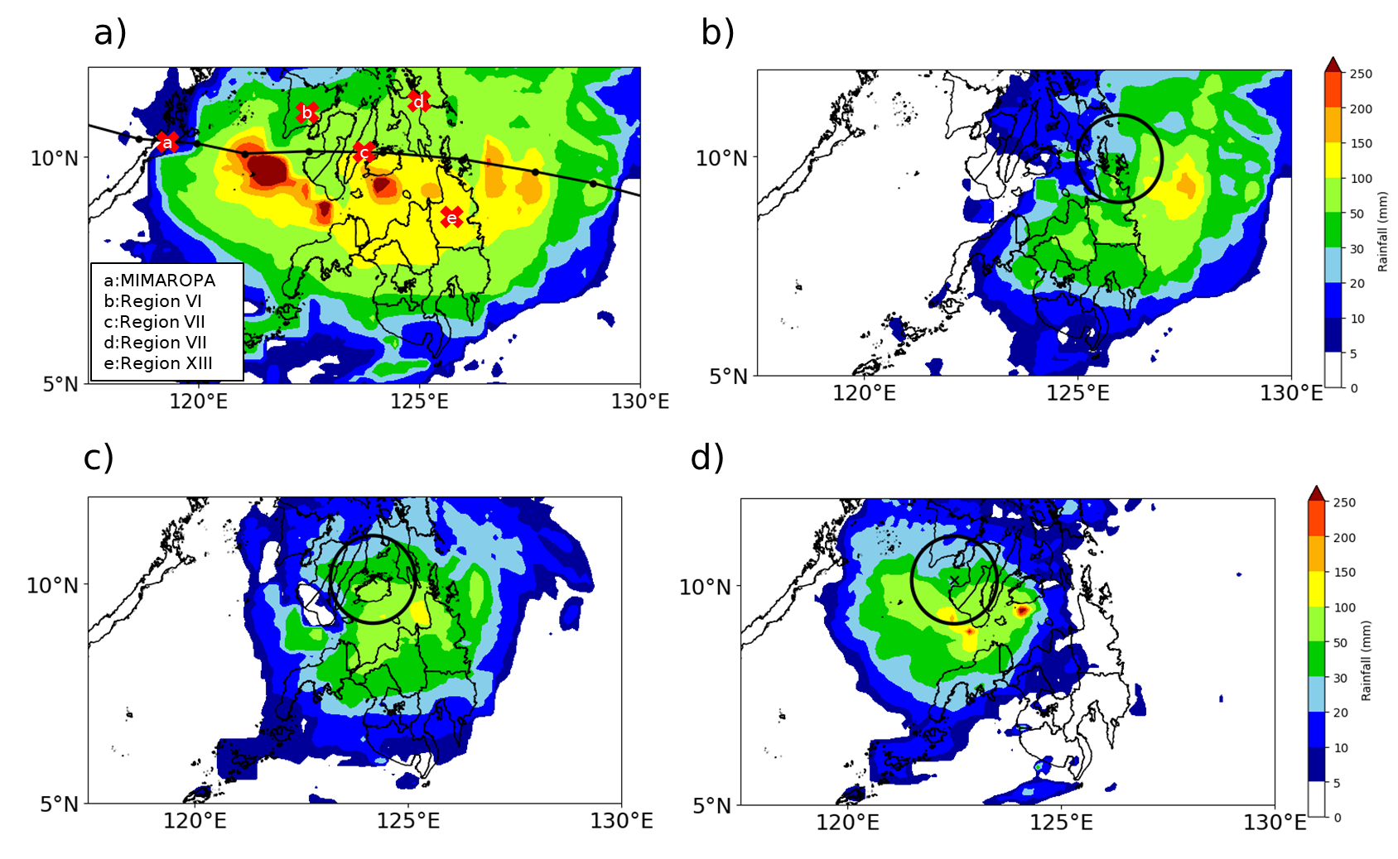
Figure S1. The a) 24-hourly accumulated rainfall on December 16 with the track of TC RAI with the x-cross marking the heavily hit provinces. The 6-hourly accumulated rainfall of TC RAI at December 16 b) 06Z, c) 12Z, and d) 18Z with the x-mark as the TC radius and the black circle denoting the 1° radius of the TC.

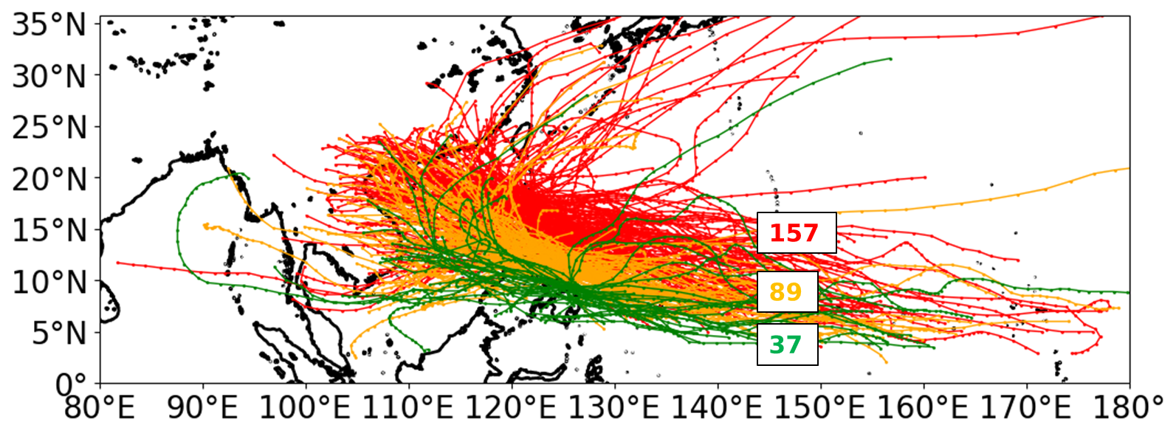

Figure S2. Tracks of all landfalling TCs from 1979–2020 using the IBTrACS-WMO data set. Color coded numbers show the number of TCs that made landfall in Luzon (red), Visayas (orange), and Mindanao (green).

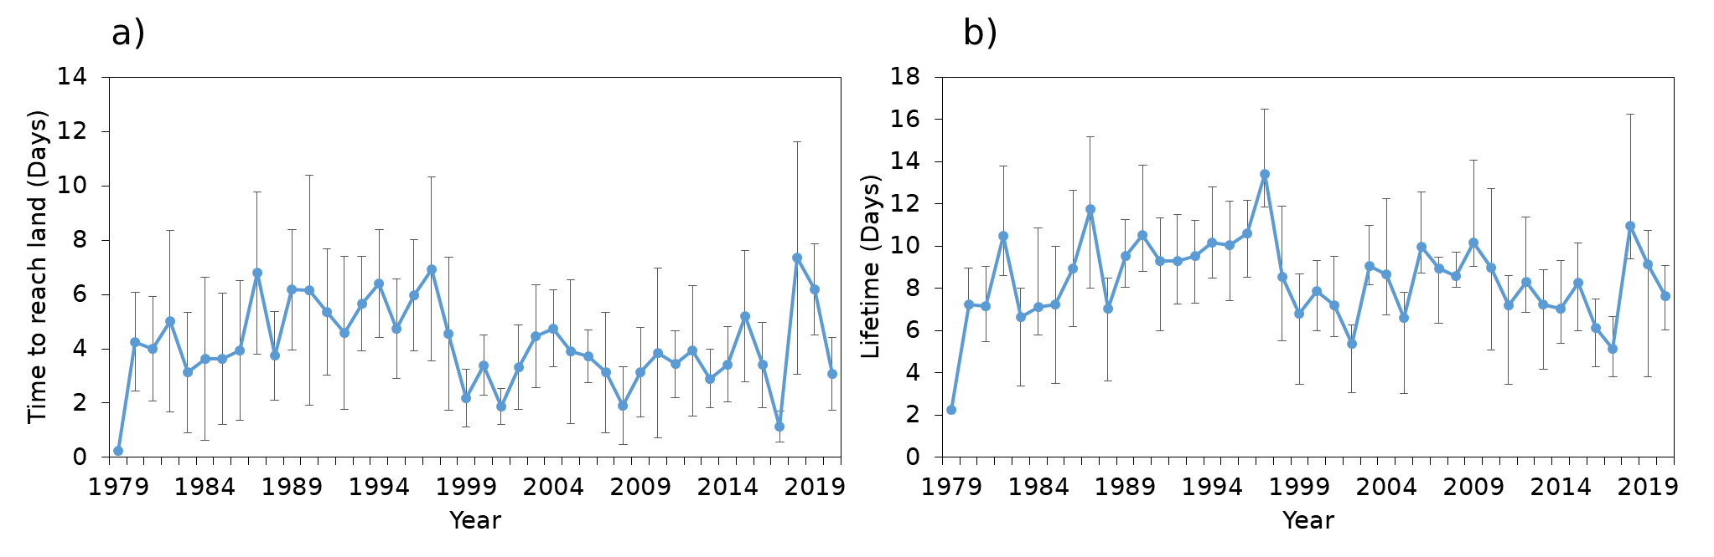
Figure S3. Time series of TC a) time taken to reach land (from genesis to landfall in the Philippines) and b) lifetime (genesis to dissipation) in days. The dots represent annual mean durations and error bars represent 95% CI.

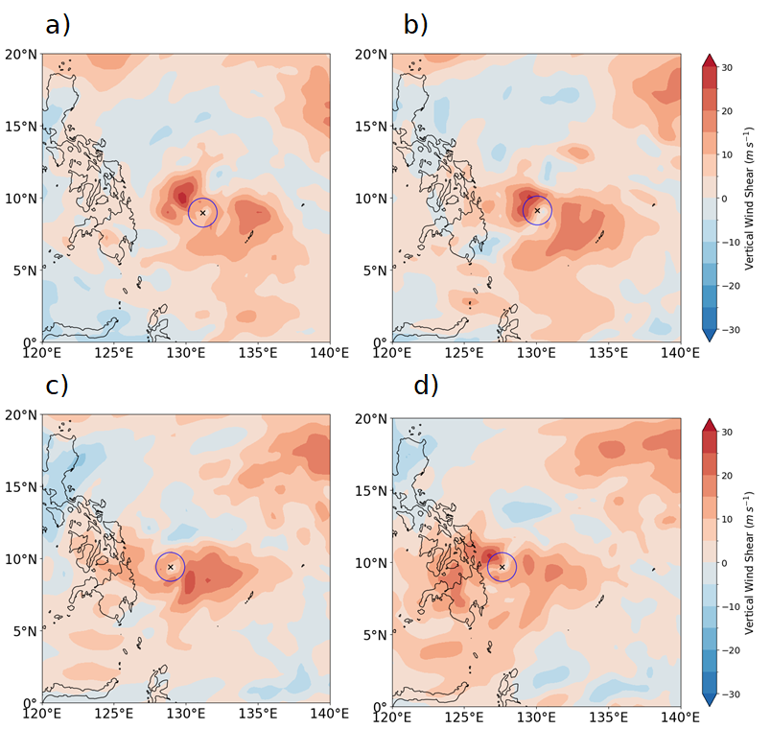

Figure S4. Similar to Figure 6, but the difference between TC RAI and the composite.

