Supplementary Material
Predicting Particulate Matter (${PM}_{10}$) Levels in Morocco: A 5-Day Forecast Using the Analog Ensemble Method
Submitted to the Environmental Monitoring and Assessment journal
Anass Houdou^{1,2*}, Kenza Khomsi³, Luca Delle Monache⁴, Weiming Hu⁵, Saber Boutayeb MD, PhD^{2,6}, Lahcen Belyamani MD^{2,6}, Fayez Abdulla⁷, Wael K. Al-Delaimy⁸, Mohamed Khalis^{1,2,9,10}
- ¹International School of Public Health, Mohammed VI University of Sciences and Health, Casablanca, Morocco
- ²Mohammed VI Center for Research & Innovation, Rabat, Morocco
- ³General Directorate of Meteorology, Mohammed VI University of Sciences and Health, Casablanca, Morocco
- ⁴Center for Western Weather and Water Extremes, Scripps Institution of Oceanography, University of California San Diego, USA
- ⁵School of Integrated Sciences, James Madison University, Virginie, USA
- ⁶Faculty of Medicine, Mohammed VI University of Sciences and Health, Casablanca, Morocco
- ⁷Civil Engineering Department, Jordan University of Science and Technology, Irbid 22120, Jordan
- ⁸School of Public Health, University of California San Diego, La Jolla, CA 92093-0628
- ⁹Laboratory of Biostatistics, Clinical, and Epidemiological Research, & Laboratory of Community Health (Public Health, Preventive Medicine and Hygiene), Department of Public Health, Faculty of Medicine and Pharmacy, Mohammed V University in Rabat, Rabat, Morocco
- ¹⁰Higher Institute of Nursing Professions and Technical Health, Rabat, Morocco
∗ Corresponding author: E-mail address: ahoudou@um6ss.ma
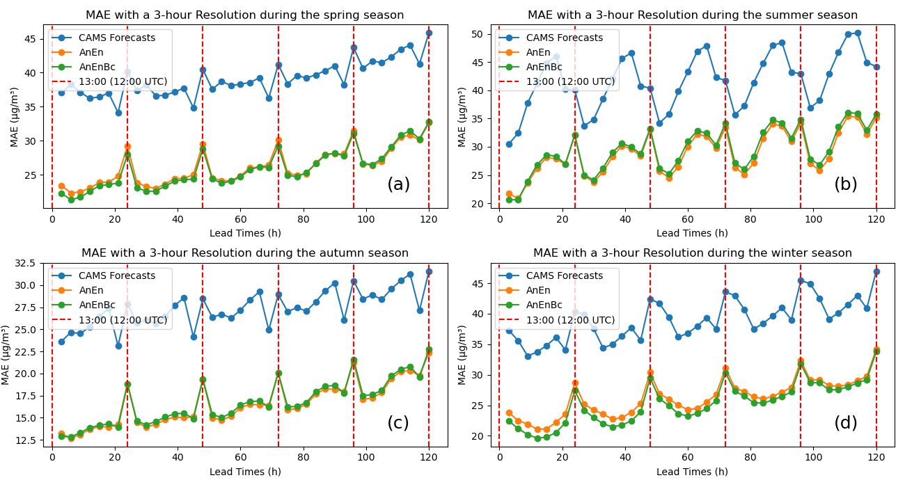

Figure S1. Mean absolute error (MAE) of the models with a 3-hour time resolution for the 5-day forecast in each season. CAMS Forecasts: CAMS global atmospheric composition forecasts. AnEn: Analog Ensemble Model. AnEnBc: Bias Correction technique. (a) MAE of the models during the spring season. (b) MAE of the models during the summer season. (c) MAE of the models during the autumn season. (d) MAE of the models during the winter season. These performances were calculated by reshaping the data from four to two dimensions, while maintaning the dimention of the lead times. The red dashed line is when the CAMS forecasts were produced at 12:00 (UTC).

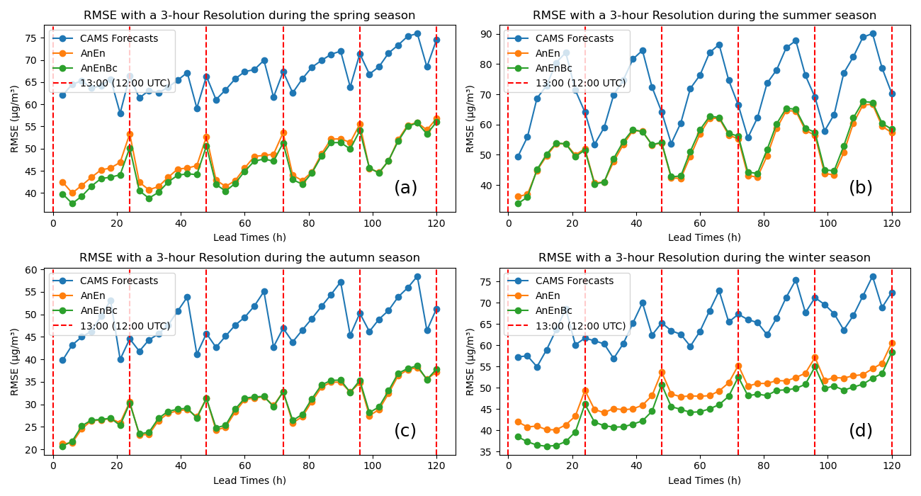
Figure S2. Root mean square error (RMSE) of the models with a 3-hour time resolution for the 5-day forecast in each season. CAMS Forecasts: CAMS global atmospheric composition forecasts. AnEn: Analog Ensemble Model. AnEnBc: Bias Correction technique. (a) RMSE of the models during the spring season. (b) RMSE of the models during the summer season. (c) RMSE of the models during the autumn season. (d) RMSE of the models during the winter season. These performances were calculated by reshaping the data from four to two dimensions, while maintaning the dimention of the lead times. The red dashed line is when the CAMS forecasts were produced at 12:00 (UTC).

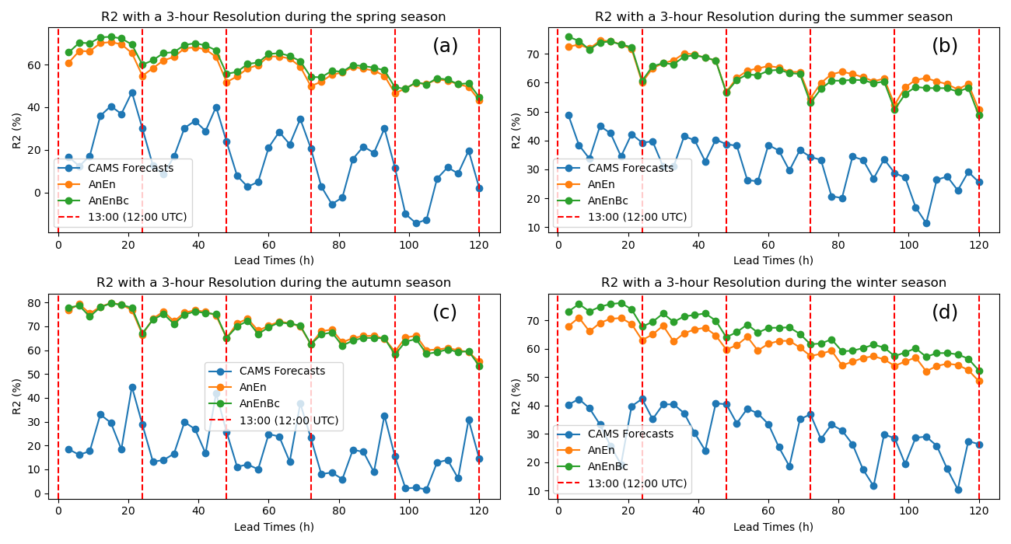
Figure S3. Coefficient of determination ($R^{2}$) of the models with a 3-hour time resolution for the 5-day forecast in each season. CAMS Forecasts: CAMS global atmospheric composition forecasts. AnEn: Analog Ensemble Model. AnEnBc: Bias Correction technique. (a) $R^{2}$ of the models during the spring season. (b) $R^{2}$ of the models during the summer season. (c) $R^{2}$ of the models during the autumn season. (d) $R^{2}$ of the models during the winter season. These performances were calculated by reshaping the data from four to two dimensions, while maintaning the dimention of the lead times. The red dashed line is when the CAMS forecasts were produced at 12:00 (UTC).

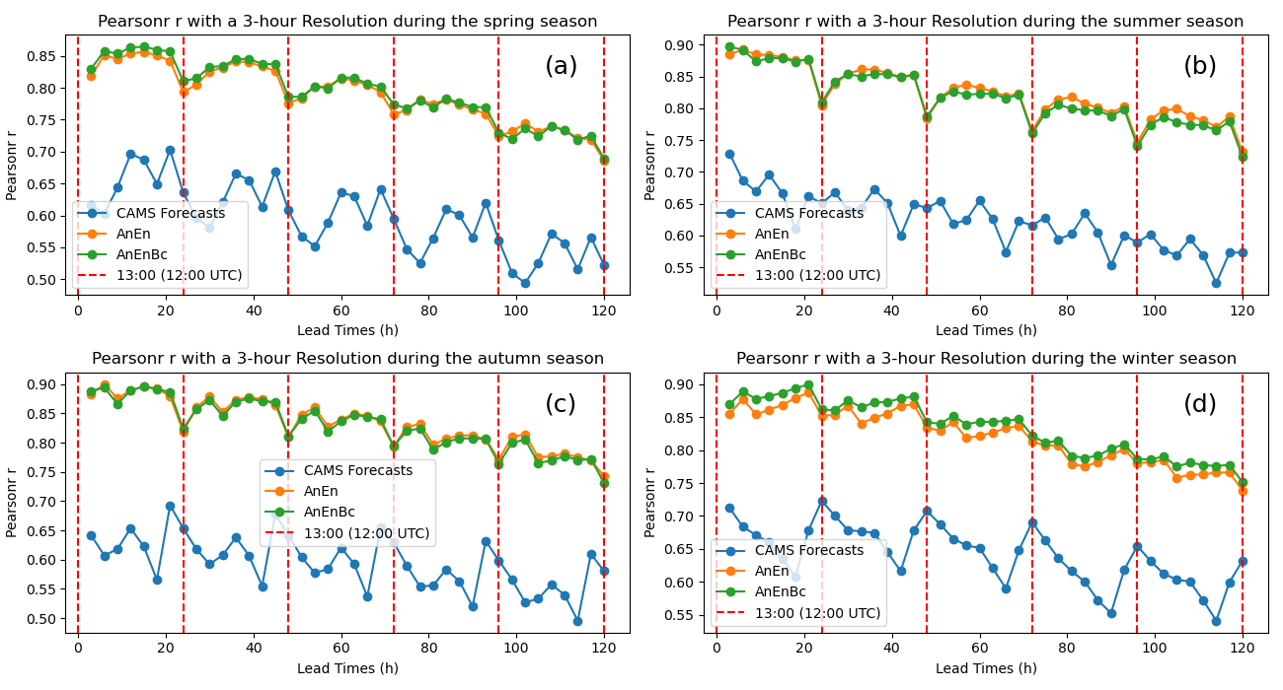
Figure S4. Pearson correlation coefficient (Pearsonr r) of the models with a 3-hour time resolution for the 5-day forecast in each season. CAMS Forecasts: CAMS global atmospheric composition forecasts. AnEn: Analog Ensemble Model. AnEnBc: Bias Correction technique. (a) Pearsonr r of the models during the spring season. (b) Pearsonr r of the models during the summer season. (c) Pearsonr r of the models during the autumn season. (d) Pearsonr r of the models during the winter season. These performances were calculated by reshaping the data from four to two dimensions, while maintaning the dimention of the lead times. The red dashed line is when the CAMS forecasts were produced at 12:00 (UTC).
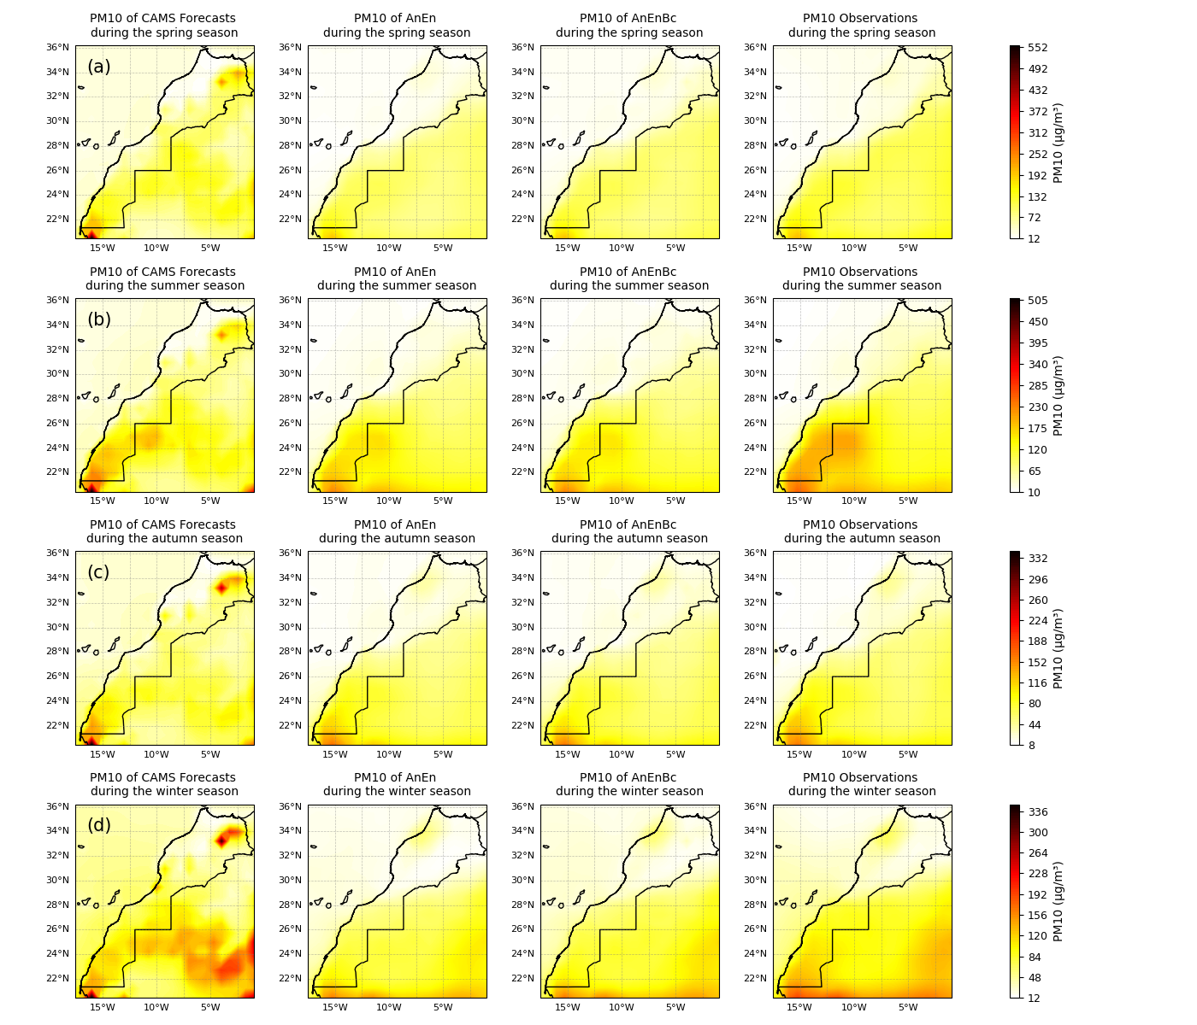
Figure S5. Spatial comparison of the predictions and the observations overall in each season. CAMS Forecasts: CAMS global atmospheric composition forecasts. AnEn: Analog Ensemble Model. AnEnBc: Bias Correction technique. Observations: CAMS reanalysis data. (a) PM10 during the spring season. (b) PM10 during the summer season. (c) PM10 during the autumn season. (d) PM10 during the winter season. These results were obtained by averaging the reshaped data, flattening the lead time and daily time dimensions while maintaining the latitude and longitude dimensions.
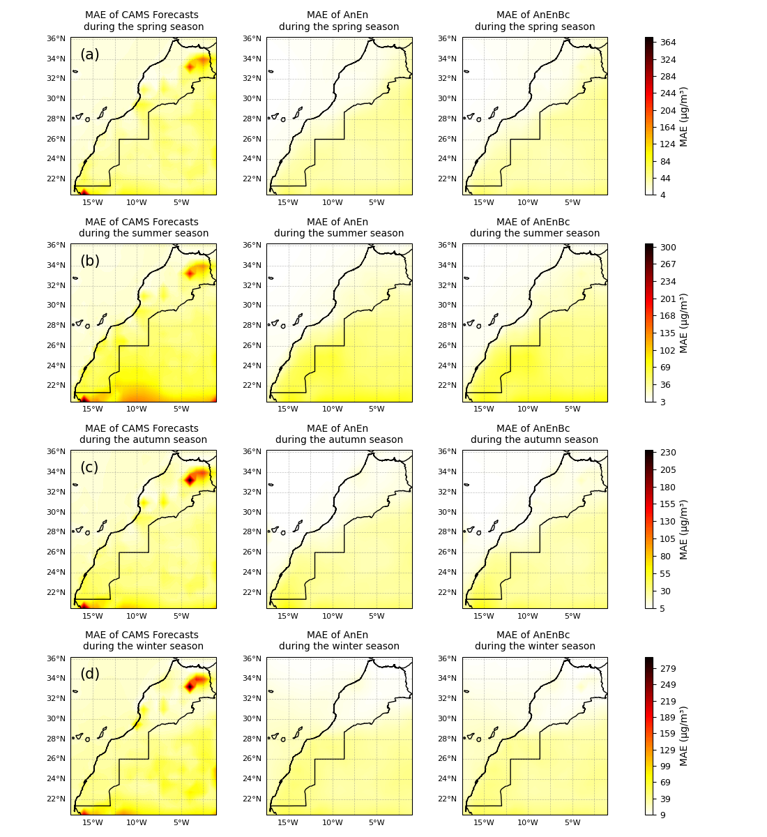
Figure S6. The spatial mean absolute error (MAE) of the models overall in each season. CAMS Forecasts: CAMS global atmospheric composition forecasts. AnEn: Analog Ensemble Model. AnEnBc: Bias Correction technique. (a) MAE of the models during the spring season. (b) MAE of the models during the summer season. (c) MAE of the models during the autumn season. (d) MAE of the models during the winter season. These performances were calculated by reshaping the data, flattening the lead time and daily time dimensions while maintaining the latitude and longitude dimensions.
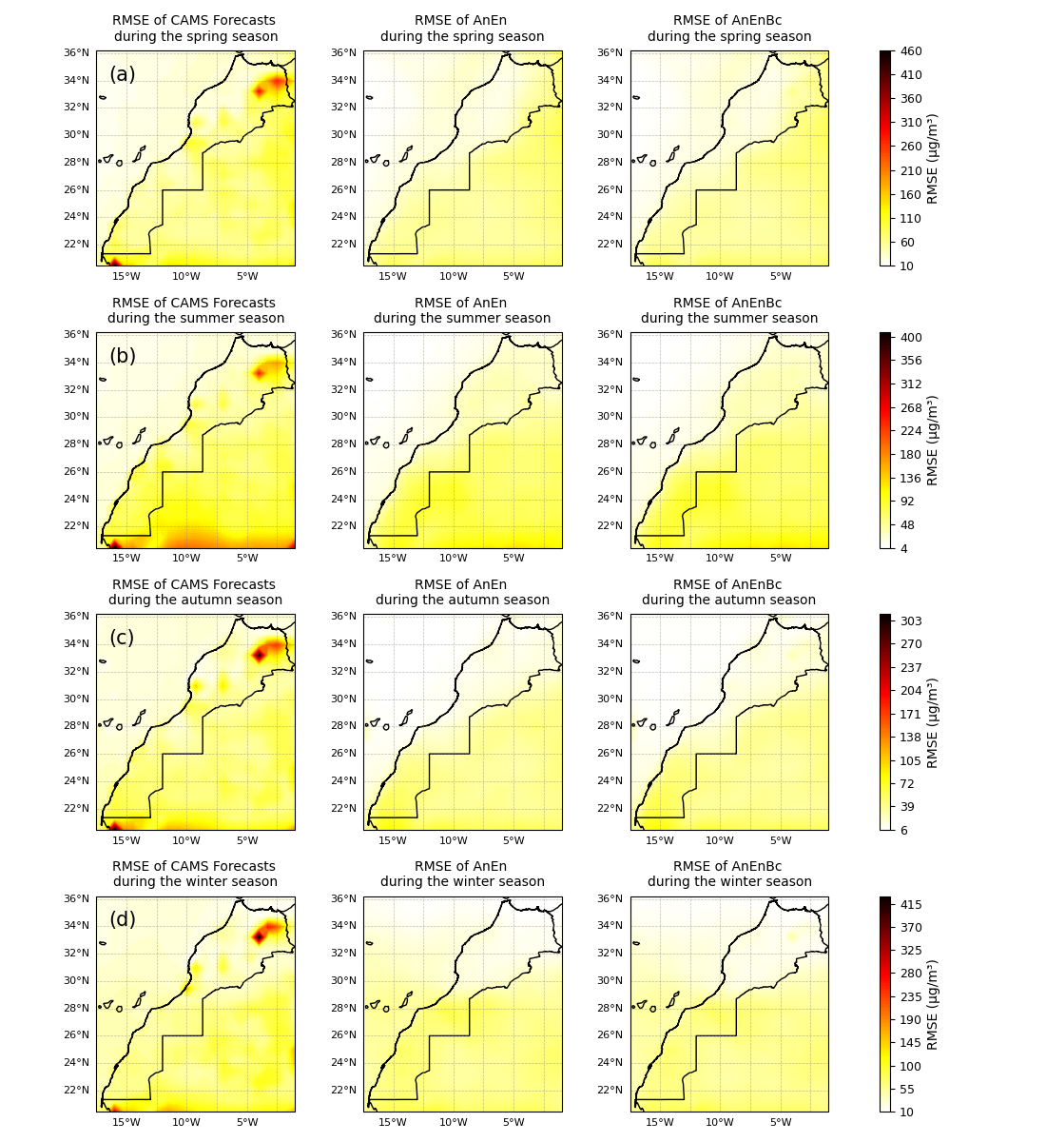
Figure S7. The root mean square error (RMSE) of the models overall in each season. CAMS Forecasts: CAMS global atmospheric composition forecasts. AnEn: Analog Ensemble Model. AnEnBc: Bias Correction technique. (a) RMSE of the models during the spring season. (b) RMSE of the models during the summer season. (c) RMSE of the models during the autumn season. (d) RMSE of the models during the winter season. These performances were calculated by reshaping the data, flattening the lead time and daily time dimensions while maintaining the latitude and longitude dimensions.

Table S1. Overview of predictions and the observations.
 | Observations | CAMS Forecasts | AnEn | AnEnBc
count | 7286400 | 7286400 | 7286400 | 7286400
mean | 63,707 | 66,777 | 53,088 | 54,652
std | 75,82 | 69,946 | 53,584 | 54,657
min | 0 | 0,253 | 0 | 0
5% | 4,24 | 12,599 | 8,478 | 8,43
25% | 14,009 | 26,283 | 15,906 | 17,19
50% | 33,815 | 41,842 | 31,051 | 33,339
75% | 86,739 | 82,88 | 74,212 | 75,211
99% | 349,104 | 328,564 | 247,512 | 252,753
max | 1051,553 | 2983,314 | 829,686 | 1501,64

All units are in µg/m³, except for count and std. CAMS Forecasts: CAMS global atmospheric composition forecasts. AnEn: Analog Ensemble Model. AnEnBc: Bias Correction technique.

