Electronic Supporting Information
Magnetic DL-methionine grafted to chitosan by EDTA linker nanomaterial: a highly efficient multifunctional organocatalyst for the synthesis of highly substituted imidazole derivatives under green conditions
Mohammad Dohendou¹, Mohammad G. Dekamin¹*, Zahra Dehnamaki¹, Danial Namaki¹ and Suranjana V. Mayani²
¹Pharmaceutical and Biologically-Active Compounds Research Laboratory, Department of Chemistry, Iran University of Science and Technology, Tehran 16846-13114, Iran.
²Department of Chemistry, Marwadi University, Rajkot-Morbi Road, P.O. Gauridad, Rajkot 360003, Gujarat, India.
Tel: +98-21-77240640-50; fax: +98-21-73021584; e-mail: mdekamin@iust.ac.ir

Page | Table of Contents
S1 | Title page
S3 | Fig. S1. The procedure for the preparation of magnetic CS-EDTA-MET@Fe₃O₄ organocatalyst (1)
S4 | Fig. S2. FTIR spectra of the commercial Chitosan (a), CS-EDTA-MET@Fe₃O₄ nanomaterial (1, b)
S5 | Fig S3. EDS spectra of the CS-EDTA-MET@Fe₃O₄ organocatalyst (1)
S5 | Fig S4. FESEM images of CS-EDTA-MET@Fe₃O₄ nanocomposite (1)
S6 | Fig S5. TGA and DTA curves of CS-EDTA-MET@Fe₃O₄ nanomaterial (1)
S7 | Fig S6. Wide-Angle XRD pattern of the CS-EDTA-MET@Fe₃O₄ nanomaterial (1)
S8 | Fig S7. VSM patterns of the Fe₃O₄ and CS-EDTA-MET@Fe₃O₄ nanocatalyst (1)
S8 | Fig S8. Reusability of the CS-EDTA-MET@Fe₃O₄ organocatalyst (1) in the model reaction to afford 5a.
S9 | Table S1. Systematic study for optimization of three-component reaction between benzoin (2), 4-chlorobenzaldehyde (3a), and ammonium acetate (4) under different conditions
S9 | Table S2. Synthesis of 2,4,5- trisubstituted imidazole derivatives via one-pot three-component condensation of benzoin (2), 4-chlorobenzaldehyde (3a), and ammonium acetate (4) under different conditions in the presence of CS-EDTA-MET@Fe₃O₄ catalyst (1)
S10 | Table S3. Synthesis of 1,2,4,5-trisubstituted imidazole derivatives via one-pot four-component condensation of benzoin (2), 4-chlorobenzaldehyde (3a), ammonium acetate (4) and primary amine (6a-c) under different conditions in the presence of CS-EDTA-MET@Fe₃O₄ catalyst (1)
S11 | Fig 9. The most plausible mechanism for the synthesis of tetra- and tri- substituted imidazole derivatives 5 or 7 in the presence of CS-EDTA-MET@Fe₃O₄ organocatalyst (1)
S13 | Table S3. Comparative results of the activity of different catalysts for the synthesis of 5a
S14 | Fig S9. ¹H NMR spectrum of 4,5‑Diphenyl‑2‑(p‑tolyl) -1H‑imidazole (5e).
S14 | Fig S10. ¹H NMR spectrum of 2‑(4‑methoxyphenyl) - 4,5‑diphenyl‑1H‑imidazole(5f)
S15 | Fig S11. FTIR spectrum of 2-(3-nitrophenyl)-1,4,5-triphenyl-1H-imidazole (7b)
S15 | Fig S12. ¹H NMR spectrum of 2-(3-nitrophenyl)-1,4,5-triphenyl-1H-imidazole (7b)
S16 | Fig S13. FTIR spectrum of N,N-dimethyl-4-(1,4,5-triphenyl-1H-imidazol-2-yl)aniline (7g)
S16 | Fig S14. ¹H NMR spectrum of N,N-dimethyl-4-(1,4,5-triphenyl-1H-imidazol-2-yl)aniline (7g)
S17 | Fig S15. FTIR spectrum of 2-(4-methoxyphenyl)-4,5-diphenyl-1-(p-tolyl)-1H-imidazole (7m)
S17 | Fig S16. ¹H NMR spectrum of 2-(4-methoxyphenyl)-4,5-diphenyl-1-(p-tolyl)-1H-imidazole (7m)
S18 | Fig S17. FTIR spectrum of 1-benzyl-2-(4-methoxyphenyl)-4,5-diphenyl-1H-imidazole (7t)
S18 | Fig S18. ¹H NMR spectrum of 1-benzyl-2-(4-methoxyphenyl)-4,5-diphenyl-1H-imidazole (7t)

Fig. S1. The procedure for the preparation of magnetic CS-EDTA-MET@Fe₃O₄ organocatalyst (1).

a
b
Fig. S2. FTIR spectra of the commercial Chitosan (a), CS-EDTA-MET@Fe₃O₄ nanomaterial (1, b).
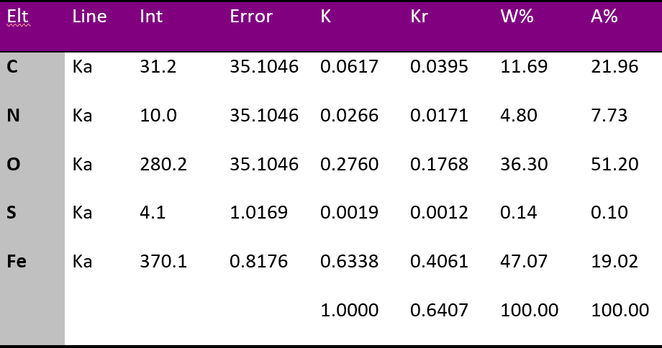
Fig. S3. EDS spectra of the CS-EDTA-MET@Fe₃O₄ organocatalyst (1).

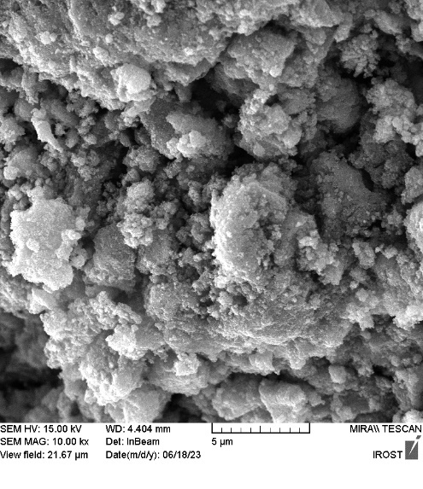 |  | 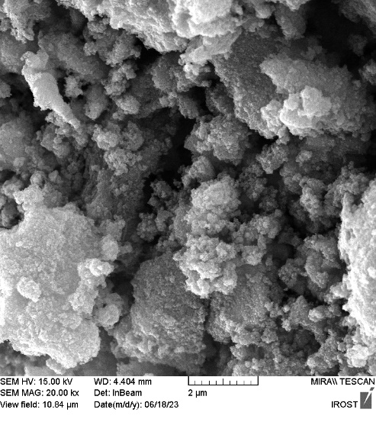
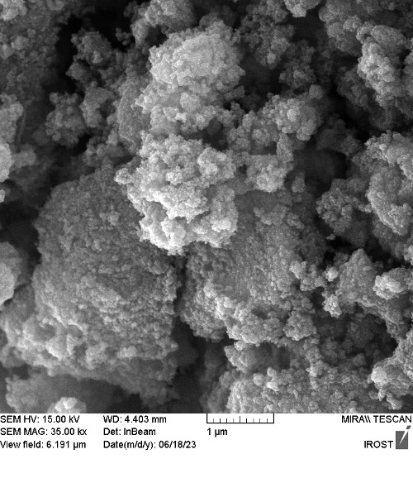 | 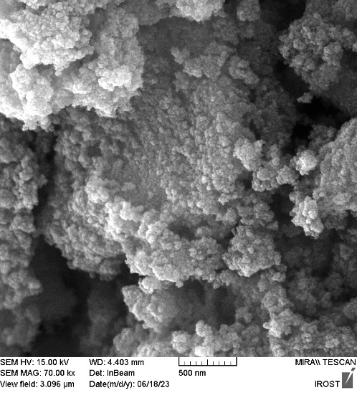 |  | 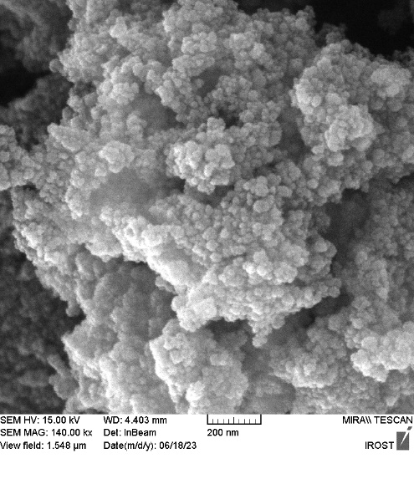
Fig. S4. FESEM images of the CS-EDTA-MET@Fe₃O₄ nanocomposite (1).

Fig. S5. TGA and DTA curves of CS-EDTA-MET@Fe₃O₄ nanomaterial (1).

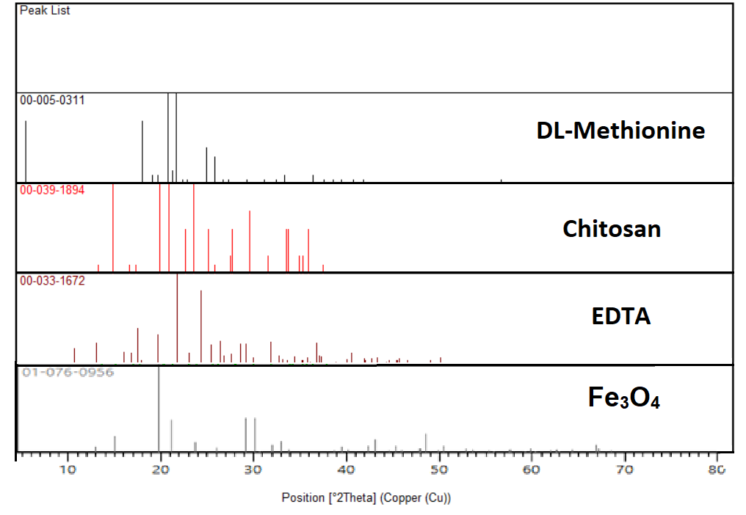

Fig. S6. Wide-Angle XRD pattern of the CS-EDTA-MET@Fe₃O₄organocatalyst (1).

Fig. S7. VSM patterns of theFe₃O₄ and CS-EDTA-MET@Fe₃O₄ catalyst (1).

Fig. S8. Reusability of the CS-EDTA-MET@Fe₃O₄ organocatalyst (1) in the model reaction to afford 5a.

Table S1. Systematic study for optimization of three-component reaction between benzoin (2), 4-chlorobenzaldehyde (3a), and ammonium acetate (4) under different conditions.ª
Entry | Cat. (mg) | Solvent | Temp. (ºC) | Time (min) | Yield (%)^{b}
1 | No catalyst | EtOH | reflux | 360 | N.A
2 | CS-EDTA-MET@Fe₃O₄ (1, 5 mg) | - | 120 | 100 | 50
3 | CS-EDTA-MET@Fe₃O₄ (1, 5 mg) | MeOH | r.t | 60 | 33
4 | CS-EDTA-MET@Fe₃O₄ (1, 5 mg) | H₂O | r.t | 60 | 22
5 | CS-EDTA-MET@Fe₃O₄ (1, 5 mg) | EtOH | r.t | 60 | 45
6 | CS-EDTA-MET@Fe₃O₄ (1, 5 mg) | EtOAC | r.t | 60 | 23
7 | CS-EDTA-MET@Fe₃O₄ (1, 5 mg) | CH₃CN | r.t | 60 | 28
8 | CS-EDTA-MET@Fe₃O₄ (1, 5 mg) | H₂O/MeOH | r.t | 60 | 37
9 | CS-EDTA-MET@Fe₃O₄ (1, 5 mg) | H₂O/EtOH | r.t | 60 | 42
10 | CS-EDTA-MET@Fe₃O₄ (1, 2.5 mg) | EtOH | 60 ºC | 45 | 30
11 | CS-EDTA-MET@Fe₃O₄ (1, 5 mg) | EtOH | 60 ºC | 45 | 65
12 | CS-EDTA-MET@Fe₃O₄ (1, 7.5 mg) | EtOH | 60 ºC | 45 | 84
13 | CS-EDTA-MET@Fe₃O₄ (10 mg) | EtOH | 60 ºC | 45 | 97
14 | CS-EDTA-MET (10 mg) | EtOH | 60 ºC | 45 | 83
15 | Fe₃O₄ (10 mg) | EtOH | 60 ºC | 45 | 44
16 | CS (10 mg) | EtOH | 60 ºC | 45 | 72
17 | Methionine (10 mg) | EtOH | 60 ºC | 45 | 62
18 | EDTA (10 mg) | EtOH | 60 ºC | 45 | 45
ªReaction conditions: Benzoin (2, 1.0 mmol), 4-chlorobenzaldehyde (3a, 1.0 mmol), and ammonium acetate (4, 3.0 mmol) in the presence of the catalyst (1, 10 mg) and solvent (2.5 mL) unless otherwise noted. ^{b}Isolated yield.

Table 2. Synthesis of 2,4,5- trisubstituted imidazole derivatives via one-pot three-component condensation of benzoin (2), 4-chlorobenzaldehyde (3a), and ammonium acetate (4) under different conditions in the presence of CS-EDTA-MET@Fe₃O₄ catalyst (1).ª
Entry | R | Time (min) | Product 5 | Yield^{b} | MP ºC | [Lit.] ºC
1 | 4-Cl | 45 | 5a | 97 | 261 - 263 | 262 - 264¹³⁰
2 | 4-Br | 45 | 5b | 96 | 262 - 264 | 264 - 266¹³¹
3 | 4-OH | 45 | 5c | 86 | 267 - 269 | 268 - 270¹³²
4 | 4-NO₂ | 45 | 5d | 97 | 238 - 239 | 240 - 242¹³¹
5 | 4-CH₃ | 45 | 5e | 91 | 231 - 232 | 232 – 234⁸²
6 | 4-OCH₃ | 45 | 5f | 97 | 226 - 229 | 228 - 230⁸²
7 | 4-NMe₂ | 45 | 5g | 85 | 255 - 257 | 258 - 259¹⁰⁵
8 | 3-Cl | 45 | 5h | 87 | 300 - 302 | 303 - 305¹³³
9 | 3-NO₂ | 45 | 5i | 90 | 314 - 316 | 315 - 317¹³²
10 | 2-Cl | 45 | 5j | 88 | 189 - 191 | 190 - 191¹³⁰
11 | 2,4-di-Cl | 45 | 5k | 95 | 175 -177 | 178 - 180¹³¹
ªReaction conditions: Benzoin (2, 1.0 mmol), aldehyde (3, 1.0 mmol), and ammonium acetate (4, 3.0 mmol) in the presence of the catalyst (1, 10 mg) and solvent (2.5 mL). ^{b}Isolated yield.

Table S3. Synthesis of 1,2,4,5-trisubstituted imidazole derivatives via one-pot four-component condensation of benzoin (2), 4-chlorobenzaldehyde (3a), ammonium acetate (4) and primary amine (6a-c) under different conditions in the presence of CS-EDTA-MET@Fe₃O₄ catalyst (1).ª
Entry | R | R’ | Time (min) | Product 7 | Yield^{b} % | MP ºC | (lit. ºC) [Ref.]
1 | 4-Cl | Phenyl | 45 | 7a | 96 | 165-167 | 167-168¹³⁴
2 | 3-NO₂ | Phenyl | 45 | 7b | 95 | 249-251 | 250-252¹³⁵
3 | 4-OH | Phenyl | 45 | 7c | 90 | 279-282 | 282-284¹³⁶
4 | 4-NO₂ | Phenyl | 45 | 7d | 92 | 211-213 | 212-214¹³⁷
5 | 4-CH₃ | Phenyl | 45 | 7e | 90 | 198-201 | 200-203¹³⁴
6 | 4-OCH₃ | Phenyl | 45 | 7f | 87 | 180-183 | 182-184¹⁰⁴
7 | 4-NMe₂ | Phenyl | 45 | 7g | 88 | 205-207 | 207-209¹³⁸
8 | 4-Cl | 4-MeC₆H₅ | 45 | 7h | 95 | 165-167 | 166-168²³
9 | 3-Br | 4-MeC₆H₅ | 45 | 7i | 96 | 157-160 | 158-160¹³⁵
10 | 3-NO₂ | 4-MeC₆H₅ | 45 | 7j | 92 | 145-148 | 146-149¹³⁴
11 | 4-NO₂ | 4-MeC₆H₅ | 45 | 7k | 90 | 216-219 | 218-220¹³⁹
12 | 4-CH₃ | 4-MeC₆H₅ | 45 | 7l | 88 | 191-194 | 194-197¹³⁶
13 | 4-OCH₃ | 4-MeC₆H₅ | 45 | 7m | 86 | 178-181 | 180-181¹⁴⁰
14 | 4-OH | 4-MeC₆H₅ | 45 | 7n | 87 | 231-234 | 233-235¹³⁶
15 | 4-Cl | Benzyl | 45 | 7o | 96 | 160-162 | 161-163¹³⁶
16 | 2-Cl | Benzyl | 45 | 7p | 95 | 140-143 | 141-142¹³⁴
17 | 4-OH | Benzyl | 45 | 7q | 87 | 130-132 | 131-132²⁵
18 | 3-NO₂ | Benzyl | 45 | 7r | 88 | 150-153 | 152-154¹³⁵
19 | 4-CH₃ | Benzyl | 45 | 7s | 90 | 166-168 | 167-168¹⁴¹
20 | 4-OCH₃ | Benzyl | 45 | 7t | 91 | 156-159 | 158-161¹³⁶
21 | H | Benzyl | 45 | 7u | 86 | 160-163 | 161-163²⁵
ªReaction conditions: Benzoin (2, 1.0 mmol), aldehyde (3, 1.0 mmol), and ammonium acetate (4, 3.0 mmol) in the presence of the catalyst (1, 10 mg) and solvent (2.5 mL). ^{b}Isolated yield.

Fig. 10. The most plausible mechanism for the synthesis of tetra- and tri- substituted imidazole derivatives 5 or 7 in the presence of CS-EDTA-MET@Fe₃O₄ organocatalyst (1).

Table S4. Comparative results of the activity of different catalysts for the synthesis of 5a
Entry | Catalyst | Catalyst loading | Reaction conditions | Time (min)
1 | 3-Picolinic acid | 12 mg | EtOH/80 °C | 120
2 | PANI-FeCl₃ | 200 mg | CH₃CN/ Reflux | 1440
3 | PMAMOS | 15 mg | EtOH/  Reflux | 45
4 | Nano- TiCl₄.SiO₂ | 100 mg | Solvent-free/  130°C | 30
5 | K₅CoW₁₂O₄₀·3H₂O | 32 | Solvent-free/140 °C | 180
6 | Sulfonic acid functionalized silica | 20 mg | Solvent-free/140 °C | 100
7 | CS-EDTA-MET@Fe₃O₄ | 10 mg | EtOH/ 60 °C | 45

Selected spectral data:
4,5‑Diphenyl‑2‑(p‑tolyl)‑1H‑imidazole (5e)
White solid; Yield 92%, mp 230–232 °C (Lit. mp 232–234 °C); ¹H NMR (400 MHz, CDCl₃ ): δ 2.42 (s, 3H, Me), 7.28–7.37 (m, 8H, Ar), 7.56 (d, J = 7.2 Hz, 4H, Ar), 7.82 (d, J = 8.4 Hz, 2H, Ar).
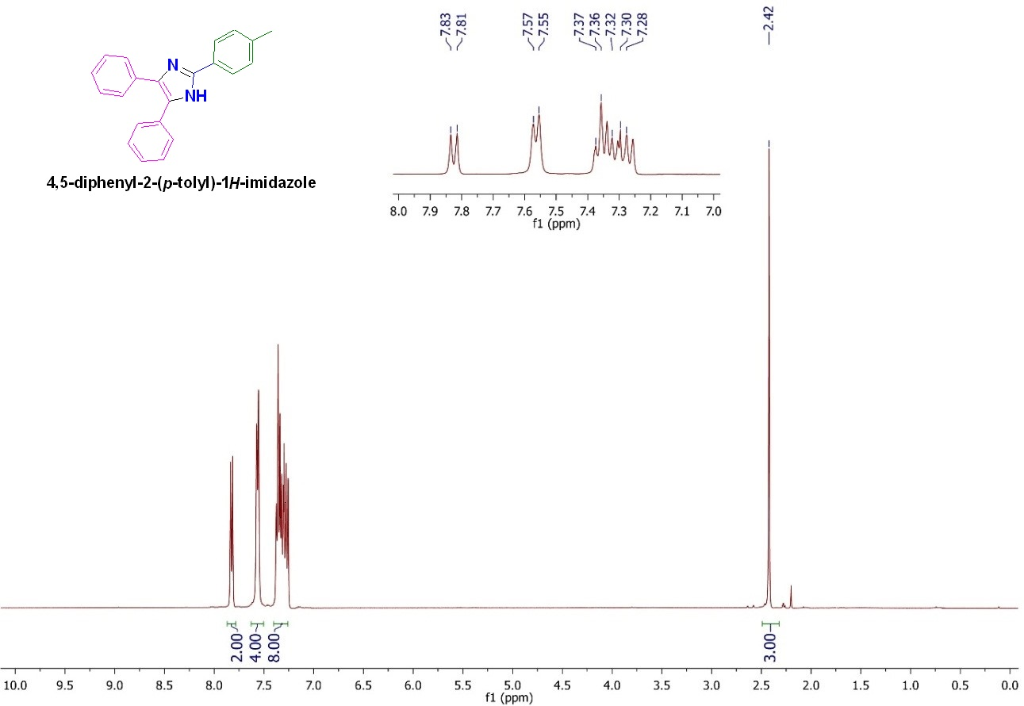
Fig. S10. ¹H NMR spectrum of 4,5‑diphenyl‑2‑(p‑tolyl)‑1H‑imidazole (5e).

2‑(4‑Methoxyphenyl)‑ 4,5‑diphenyl‑1H‑imidazole(5f)
White solid; Yield 93%, mp 226–229 °C (Lit. mp 228–230 °C); ¹H NMR (400 MHz, CDCl₃ ): δ 3.88 (s, 3H,OMe), 6.99 (d, J = 8.4 Hz, 2H, Ar), 7.30–7.77 (m, 10H, Ar), 7.86 (d, J = 8.8 Hz, 2H, Ar), 9.47 (brs, 1H, NH).
Fig. S11. ¹H NMR spectrum of 2‑(4‑Methoxyphenyl)‑ 4,5‑diphenyl‑1H‑imidazole(5f).
2-(3-Nitrophenyl)-1,4,5-triphenyl-1H-imidazole (7b).
Mp: 249-251 °C; Yellow solid; FTIR (KBr; cm⁻¹): 3427, 1525, 1344, 766, 697; ¹H NMR (500 MHz, DMSO-d₆, ppm): δ 8.97 (d, J = 2.3 Hz, 1H), 8.53 (d, J = 7.9 Hz, 1H), 8.23 (d, J = 8.3 Hz, 1H), 8.18 – 8.13 (m, 1H), 7.80 (td, J = 8.2, 1.7 Hz, 1H), 7.61 – 7.26 (m, 14H).

Fig. S12. FTIR spectrum of 2-(3-nitrophenyl)-1,4,5-triphenyl-1H-imidazole (7b).

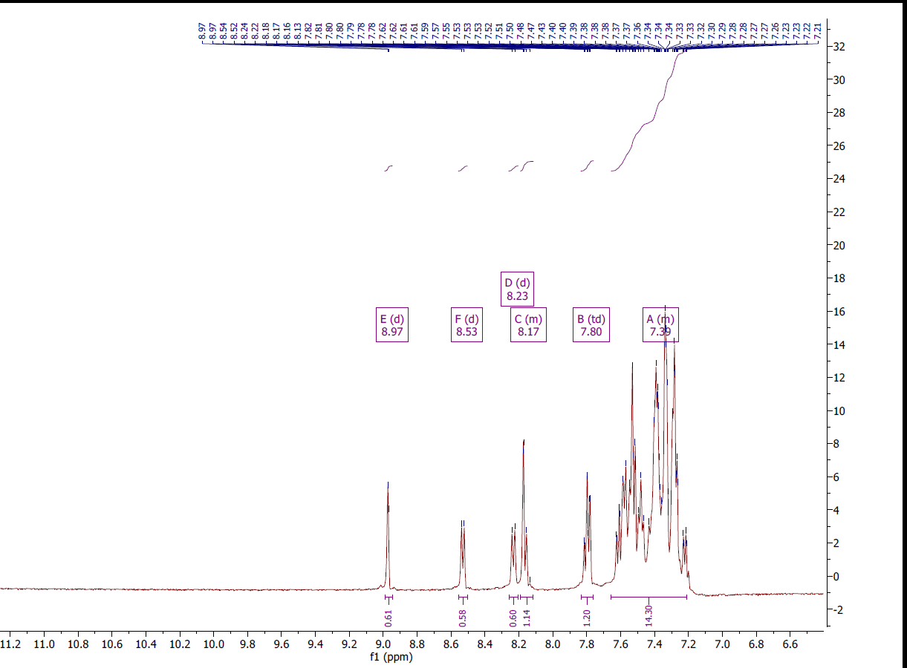
Fig. S13. ¹H NMR spectrum of 2-(3-nitrophenyl)-1,4,5-triphenyl-1H-imidazole (7b).
N,N-Dimethyl-4-(1,4,5-triphenyl-1H-imidazol-2-yl)aniline (7g).
Mp: 205-207 °C; Brown solid; FTIR (KBr; cm-1): 3422, 2926, 2364, 1722, 1612, 1488, 1442, 1370, 816, 694; ¹H NMR (500 MHz, DMSO-d₆, ppm): δ 7.60 – 7.50 (m, 1H), 7.46 (d, J = 8.0 Hz, 2H), 7.37 – 7.31 (m, 4H), 7.21 (m, 10H), 6.56 (d, J = 8.0 Hz, 2H), 2.86 (s, 6H).

Fig. S14. FTIR spectrum of N,N-Dimethyl-4-(1,4,5-triphenyl-1H-imidazol-2-yl)aniline (7g).
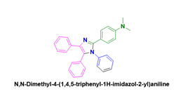
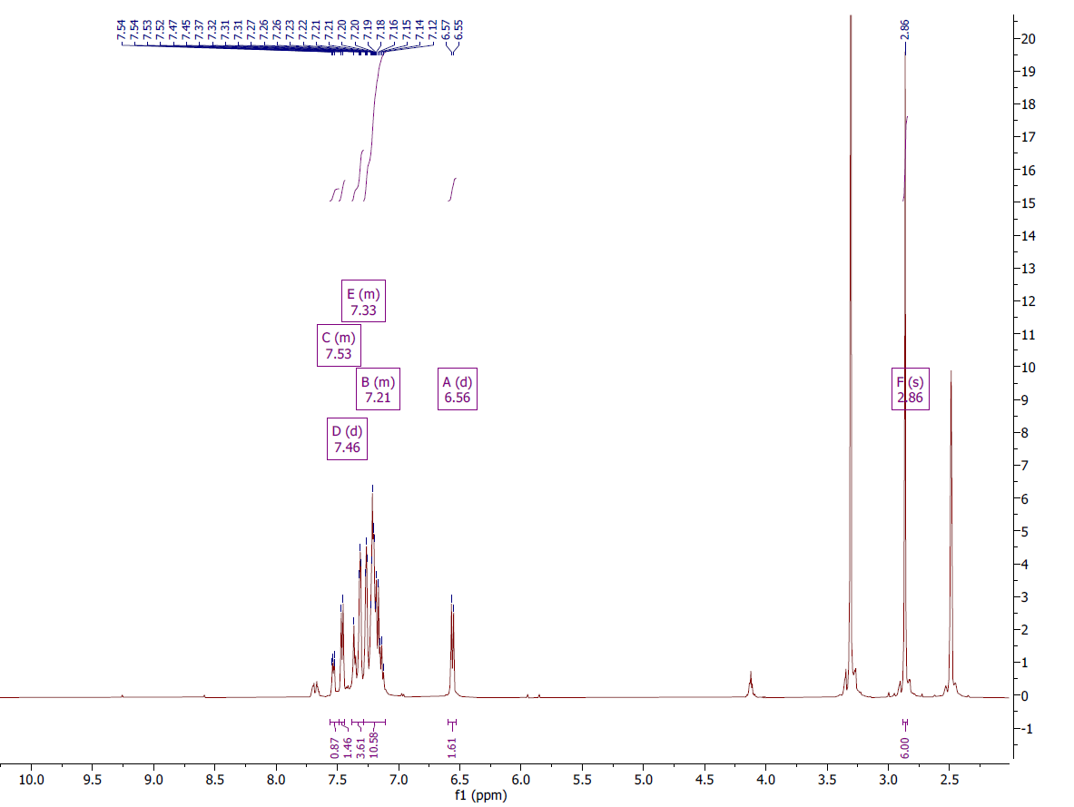
Fig. S15. ¹H NMR spectrum of N,N-Dimethyl-4-(1,4,5-triphenyl-1H-imidazol-2-yl)aniline (7g).

2-(4-Methoxyphenyl)-4,5-diphenyl-1-(p-tolyl)-1H-imidazole (7m).
Mp: 178-181 °C; White solid; FTIR (KBr; cm⁻¹): 2922, 2376, 1606, 1514, 1438, 1368, 1022, 824, 776, 698, 526; ¹H NMR (500 MHz, DMSO-d₆, ppm): δ 7.50 – 7.47 (m, 2H), 7.35 – 7.30 (m, 5H), 7.25 – 7.22 (m, 4H), 7.18 – 7.11 (m, 5H), 6.89 – 6.85 (m, 2H), 3.74 (s, 3H), 2.27 (s, 3H).

Fig. S16. FTIR spectrum of 2-(4-methoxyphenyl)-4,5-diphenyl-1-(p-tolyl)-1H-imidazole (7m).

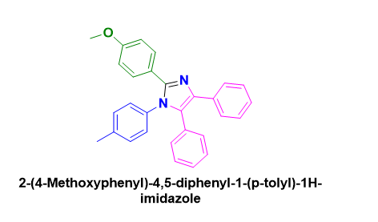
Fig. S17. ¹H NMR spectrum of 2-(4-methoxyphenyl)-4,5-diphenyl-1-(p-tolyl)-1H-imidazole (7m).

1-Benzyl-2-(4-methoxyphenyl)-4,5-diphenyl-1H-imidazole (7t).
Mp: 156-159 °C; White solid; FTIR (KBr; cm⁻¹): 3026, 2929, 2361, 1605, 1530, 1482, 1449; ¹H NMR (500 MHz, CDCl₃, ppm): δ 7.60 – 7.57 (m, 3H), 7.35 – 7.14 (m, 12H), 6.92 (d, J = 8.8 Hz, 2H), 6.82 (dd, J = 7.7, 1.7 Hz, 2H), 5.09 (s, 2H), 3.86 – 3.78 (m, 3H).

Fig. S18. FTIR spectrum of 1-Benzyl-2-(4-methoxyphenyl)-4,5-diphenyl-1H-imidazole (7t).

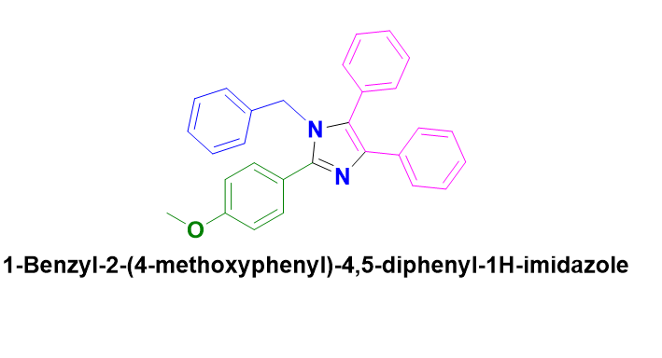
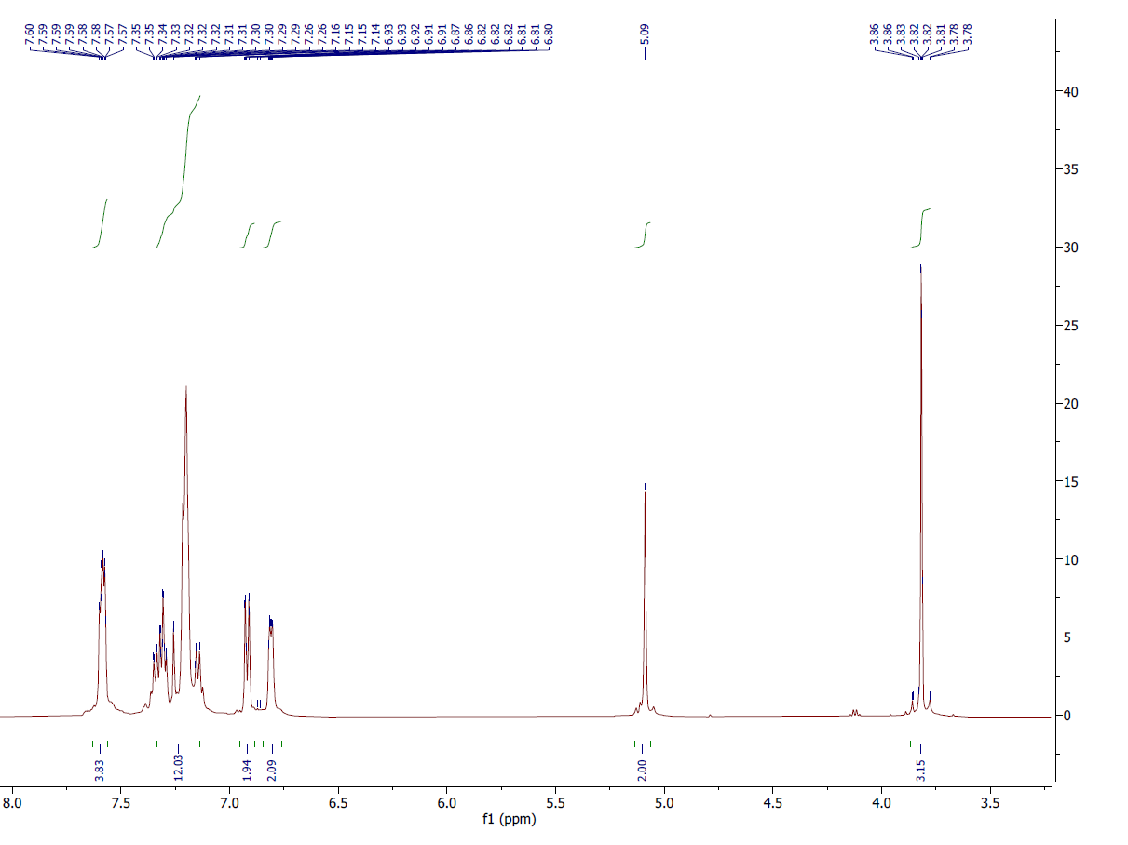
Fig. S19. ¹H NMR spectrum of 1-benzyl-2-(4-methoxyphenyl)-4,5-diphenyl-1H-imidazole (7t).

