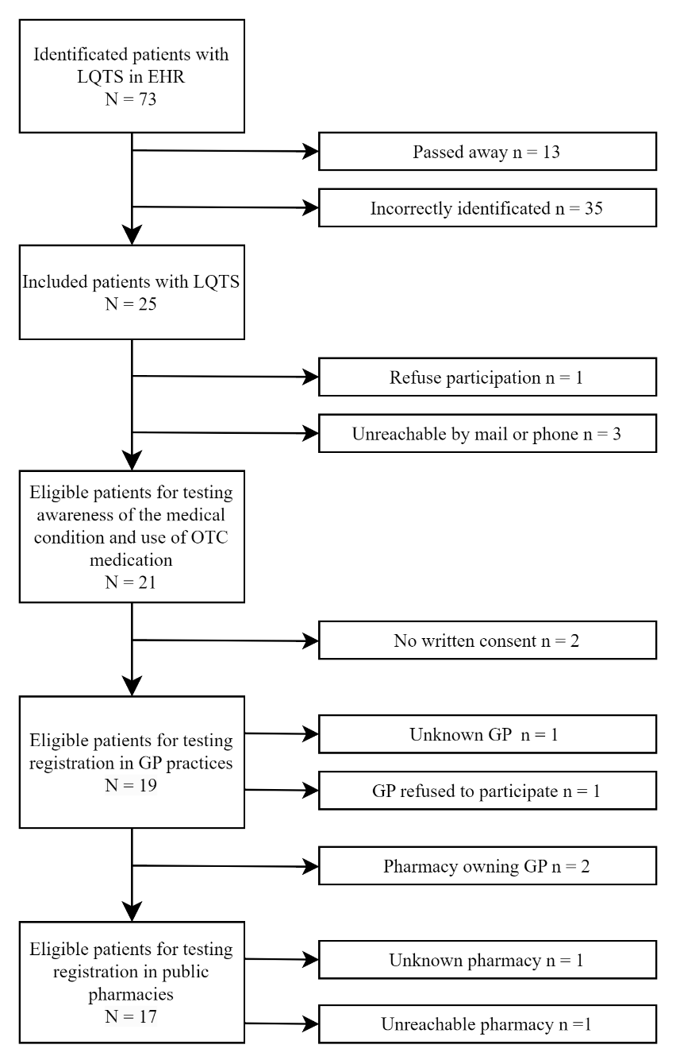
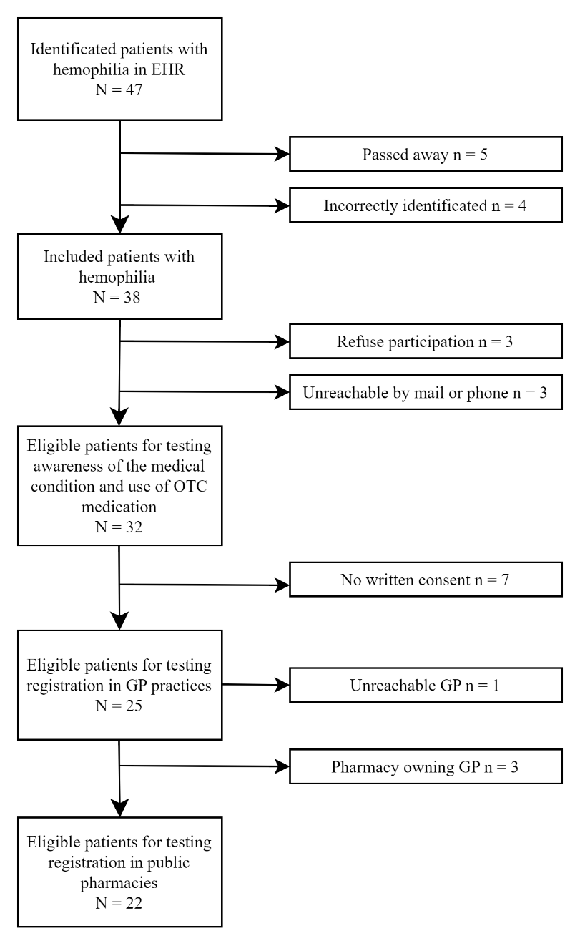
Supplementary file 1
Appendix 1: Schematic representation of the enrolled patients with hemophilia (left flowchart) and patients with Long QT Syndrome (right flowchart). All eligible patients were contacted by telephone for study participation. To examine their registration status with their respective General Practitioner (GP) and pharmacists, participants were required to provide written consent. OTC = Over the Counter.

