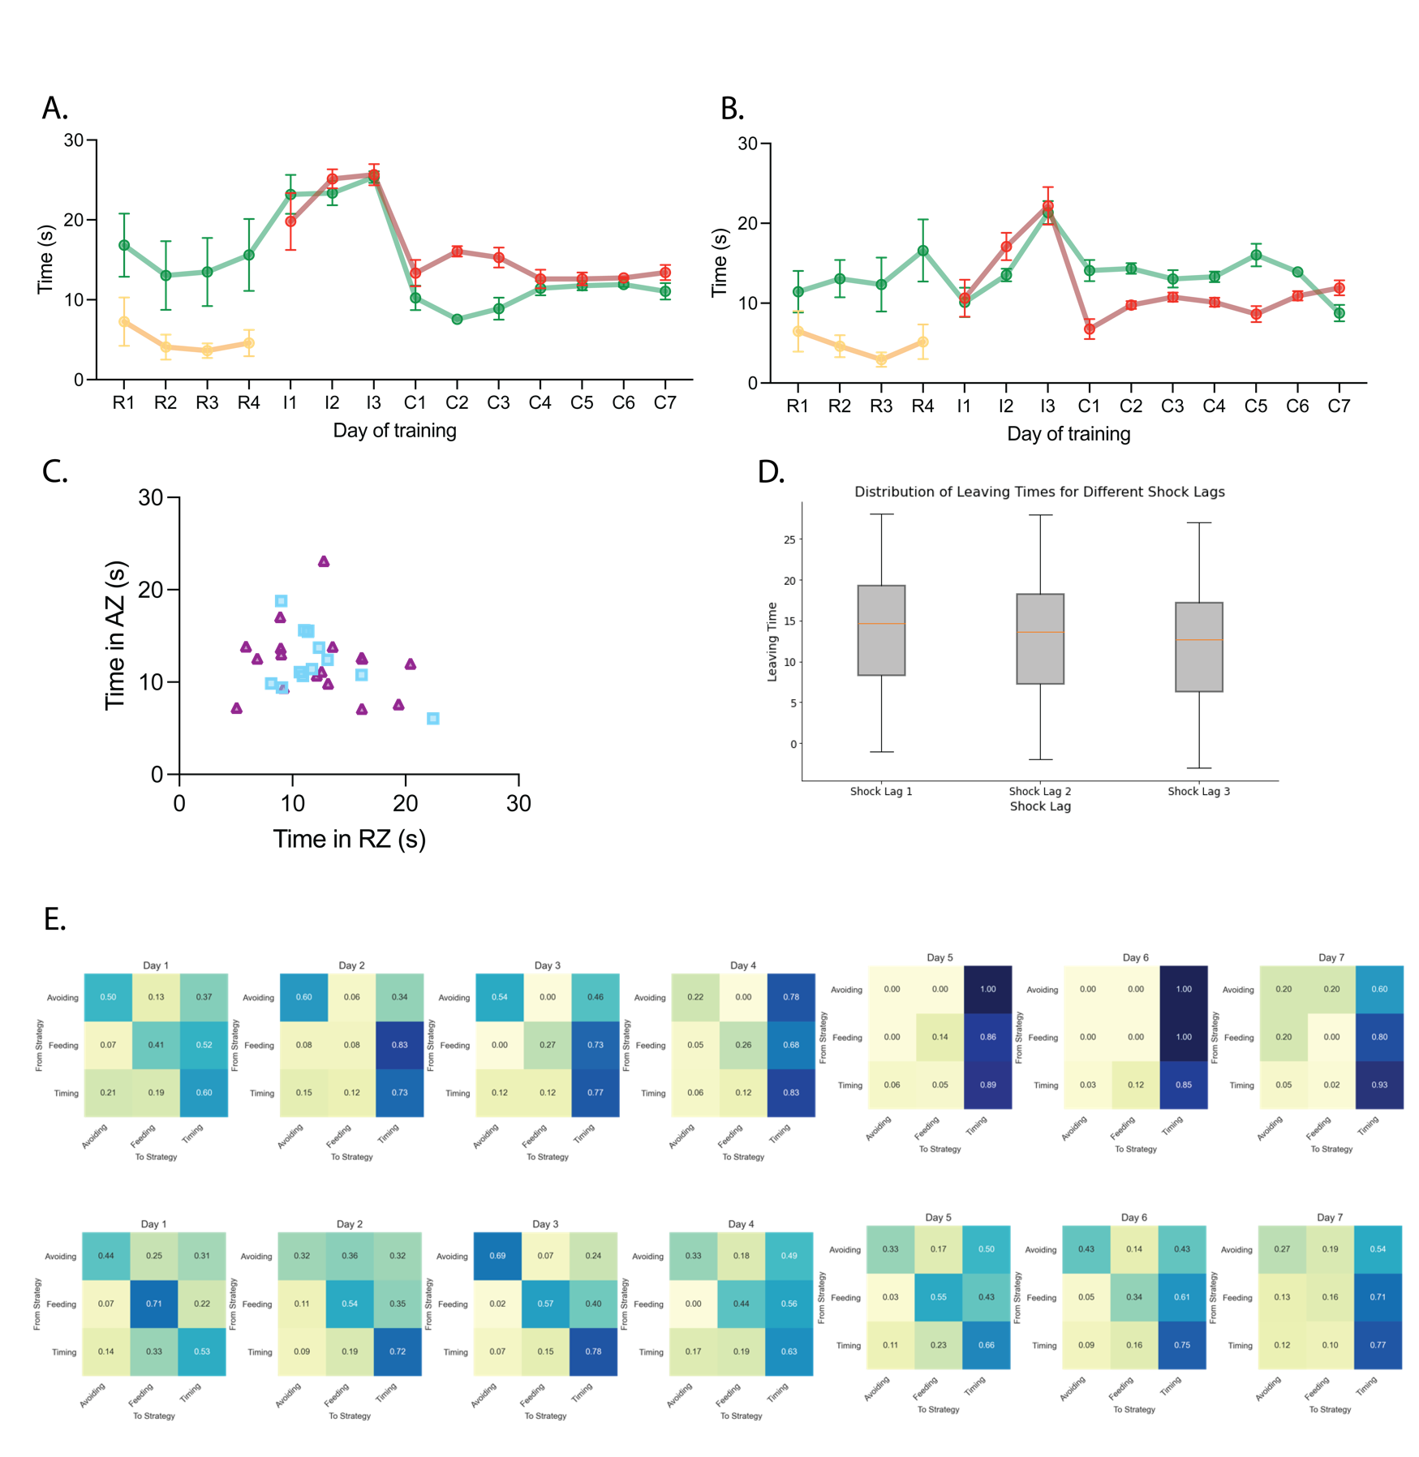

Extended data figure 1. Male and female mice exhibit individual differences in memory-guided conflict resolution. a-b. Time spent poking during the light-cue (TP-on), outside the light-cue (TP-off), and on the platform during the tone-cue (TA-on) across training days for males or females. c. Distributions of switch times from reward seeking to avoiding across training sessions for male and female mice. d. Distribution of latencies to avoid during trials at different lags after a trial in which animals received a shock. e. Average strategy transition probabilities for males (top) and females (bottom) across conflict training days. Error bars represent mean ± Standard mean of error (SEM). Males = 12, females = 16

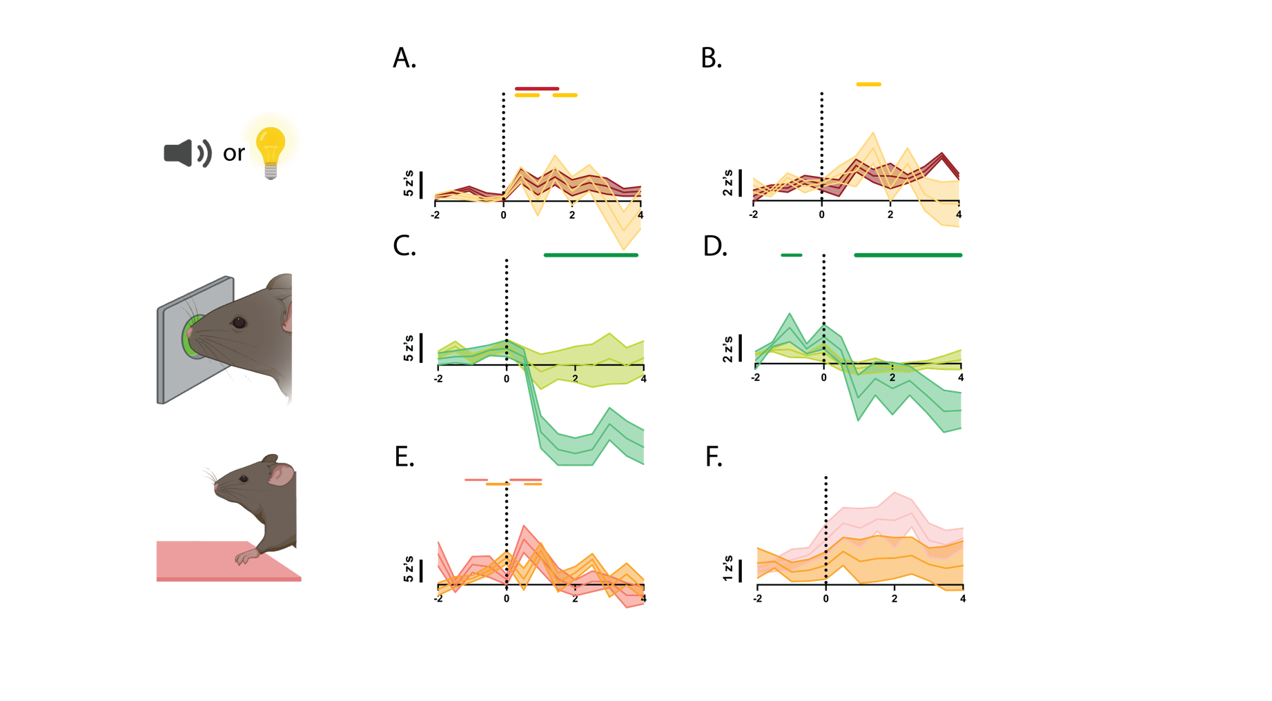
Extended data figure 2. Prelimbic cortex calcium activity during light- and tone- only trials. a-b. Perievent analysis for calcium activity during the trial-start epoch for males and females. c-d. Perievent analysis for calcium activity during nose-poking epoch for males and females. e-f. Perievent analysis for calcium activity during platform mounting epoch for males and females. Calcium activity traces are represented as z-score %dF/F. Onset of each event is represented in dashed lines. Significant epoch is denoted by the color bar above each trace. Male and female comparisons for cue-onset show the average z-score 1s after cue-onset. Male and female comparisons for nose-poking and platform mounting show the average z-score 1s prior to behavioral epoch. Error bars represent mean ± Standard mean of error (SEM). * p < 0.05; males = 6, females = 4.

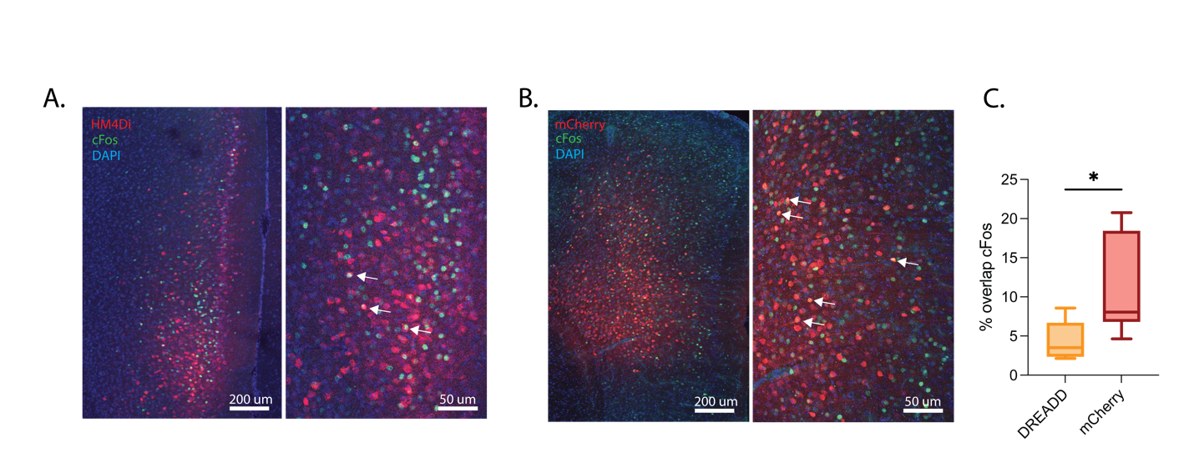

Extended data figure 3. Histological confirmation of HM4Di mediated inhibition of engram cells. a-b. representative histology. b. Quantified cFos+ overlap with tagged cells for HM4Di and mCherry control groups. Error bars represent mean ± Standard mean of error (SEM). t-test. * p < 0.05; n = 4-8.

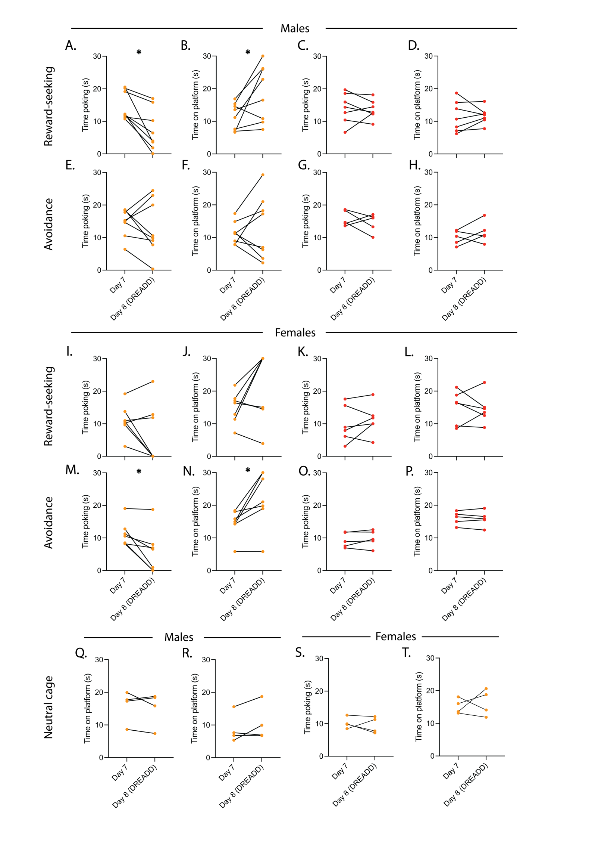
Extended data figure 4. Behavioral effects of silencing reward-seeking and avoidance engrams during conflict training. a-d. Time spent nose-poking and on the platform during the last day of conflict training and test day for male reward seeking engram HM4Di (orange) and mCherry control (red). e-h. Time spent nose-poking and on the platform during the last day of conflict training and test day for male avoidance engram HM4Di (orange) and mCherry control (red). i-l. Time spent nose-poking and on the platform during the last day of conflict training and test day for female reward seeking engram HM4Di (orange) and mCherry control (red). m-p. Time spent nose-poking and on the platform during the last day of conflict training and test day for female avoidance engram HM4Di (orange) and mCherry control (red). q-r. Time spent nose-poking and on the platform during the last day of conflict training and test day for male neutral cage engram HM4Di (orange) and mCherry control (red). s-t. Time spent nose-poking and on the platform during the last day of conflict training and test day for female neutral cage engram HM4Di (orange) and mCherry control (red). Error bars represent mean ± Standard mean of error (SEM). Paired t-test. * p < 0.05; n = 4-8.

