Supplementary Information: Large-vocabulary forensic pathological analyses via prototypical cross-modal contrastive learning

Author names and affiliations: Chen Shen^{1,+}, Chunfeng Lian^{2,6,+,}*, Wanqing Zhang¹, Fan Wang³, Jianhua Zhang⁴, Shuanliang Fan¹, Xin Wei¹, Gongji Wang¹, Kehan Li³, Hongshu Mu⁵, Hao Wu¹, Xinggong Liang¹, Jianhua Ma^{3,6,}*, Zhenyuan Wang^{1,}*

¹ Key Laboratory of National Ministry of Health for Forensic Sciences, School of Medicine & Forensics, Health Science Center, Xi’an Jiaotong University, Xi’an, Shaanxi 710049, China.
² School of Mathematics and Statistics, Xi’an Jiaotong University, Xi’an, Shaanxi 710049, China
³ Key Laboratory of Biomedical Information Engineering of Ministry of Education, School of Life Science and Technology, Xi’an Jiaotong University, Xi’an, Shaanxi 710049, China
⁴ Shanghai Key Laboratory of Forensic Medicine, Shanghai Forensic Service Platform, Academy of Forensic Science, Shanghai 200063, China
⁵ Weicheng Branch, Xian'yang Public Security Bureau, Xian'yang, Shaanxi 710049, China
⁶ Pazhou Lab (Huangpu), Guangzhou 510000, China

⁺ These authors contributed equally to this work.
* Corresponding authors.

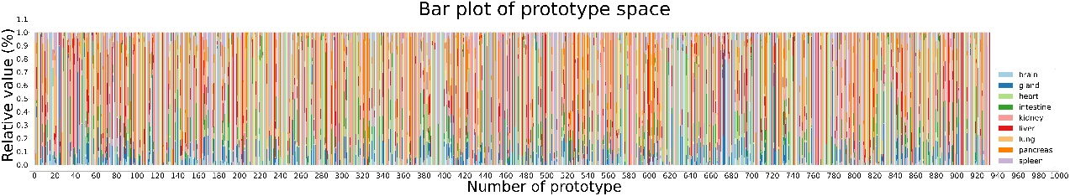
Supplementary Figure 1: Bar plot of the prototype space.
Each bar represents a prototype, with different colors representing the proportion of different tissues represented by this prototype.

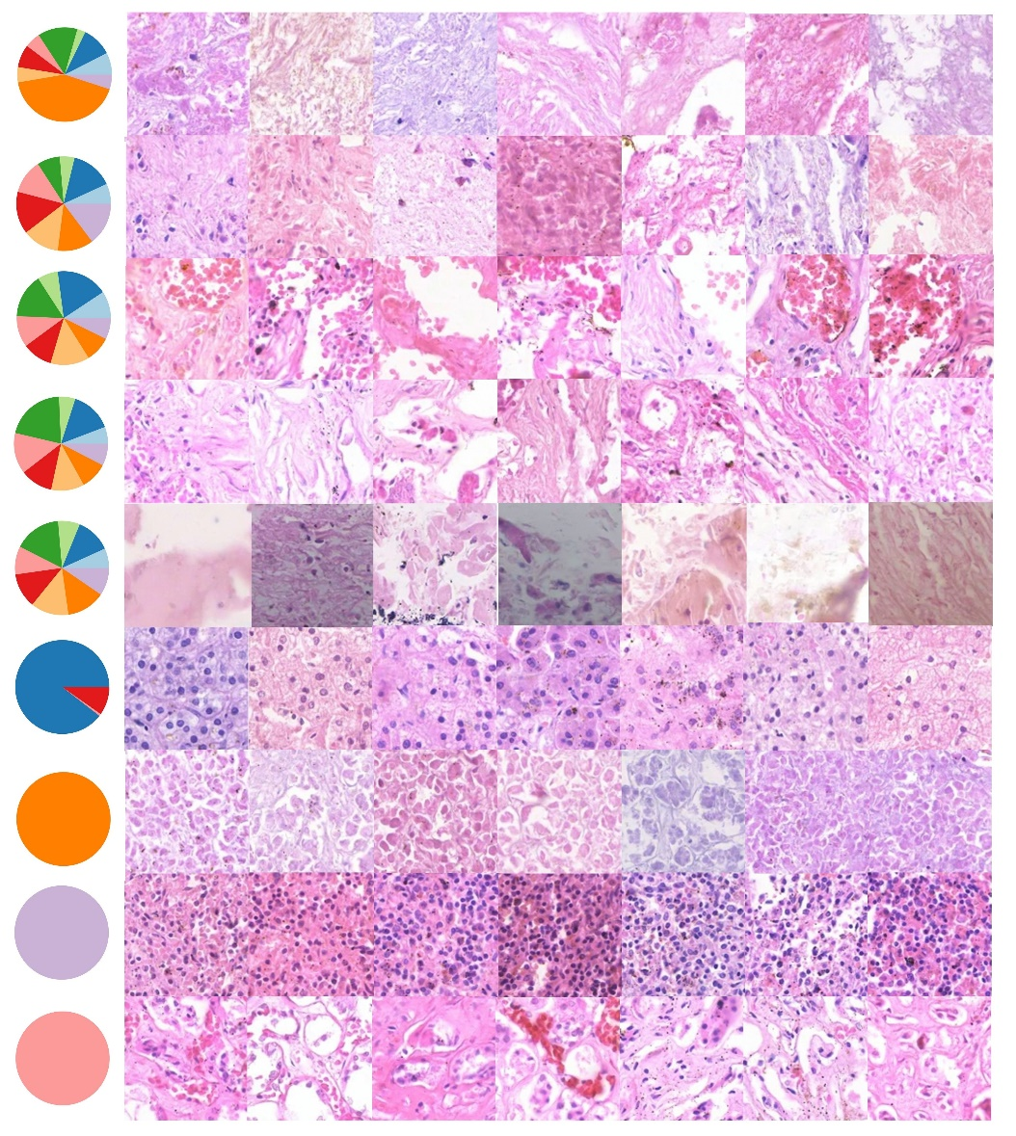
Supplementary Figure 2: Prototype-conditioned patch-level generation results.
Each pie chart represents a prototype. On the right are forensic pathology images (patches) with different semantics generated with the corresponding prototype as a condition.

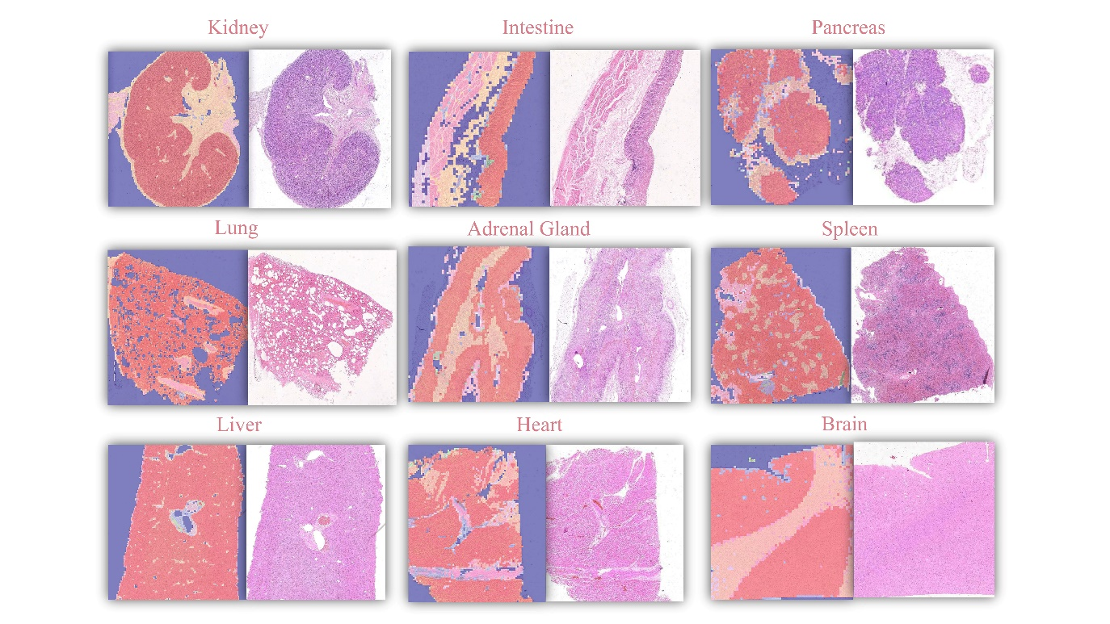
Supplementary Figure 3: Prototype segmentation mask.
Prototype-based histopathological segmentation image masks of different organs.

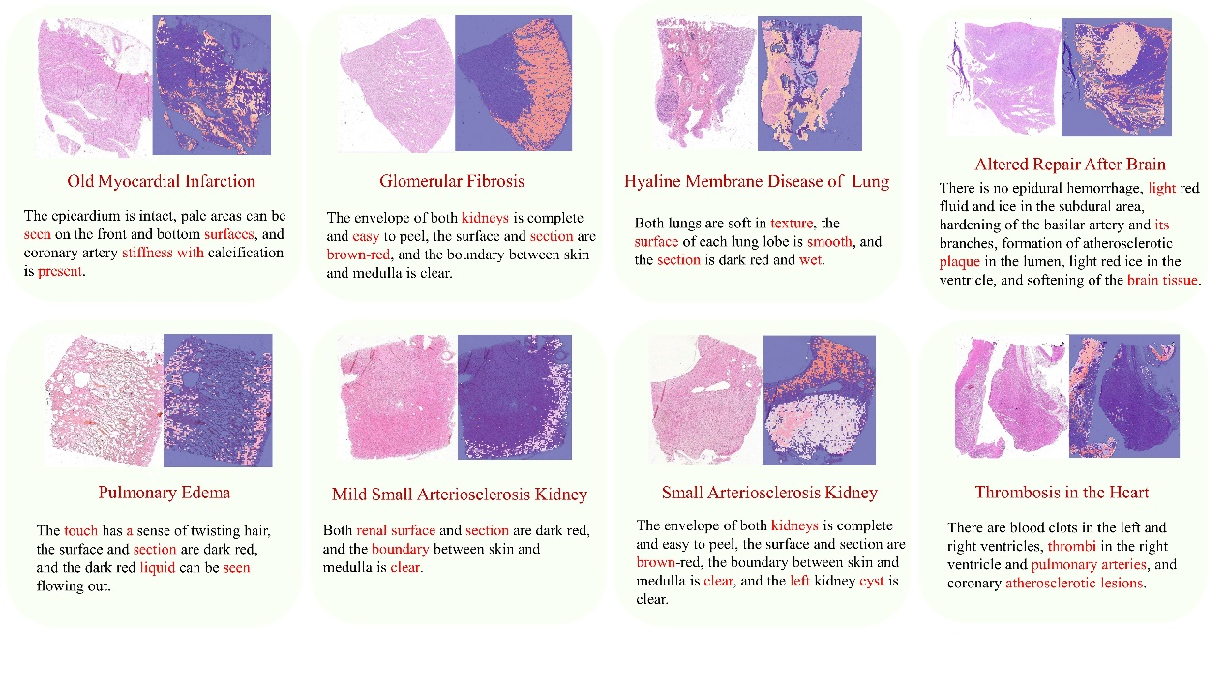
Supplementary Figure 4: Multi-modality attention visualization of SongCi.
The WSI regions corresponding to the prototypes of the top five findings, along with the top five vital descriptors in the gross key findings, are delineated in distinct colors.

Supplementary Table 1:Comparisons of SongCi with state-of-the-art, open-sourced multi-modality fusion methods.
Model | Internal Cohort |  |  | External Cohort I |  |  | External Cohort II
Model | Recall | Precision | IOU | Recall | Precision | IOU | Recall | Precision | IOU
Perceiver | 0.649±0.169 | 0.645±0.178 | 0.487±0.129 | 0.603±0.129 | 0.599±0.160 | 0.407±0.144 | 0.630±0.201 | 0.602±0.216 | 0.482±0.194
BottleNeck-Fusion | 0.600±0.207 | 0.589±0.188 | 0.436±0.166 | 0.578±0.182 | 0.566±0.131 | 0.367±0.144 | 0.613±0.224 | 0.599±0.231 | 0.452±0.179
DLNMS | 0.667±0.184 | 0.667±0.181 | 0.507±0.142 | 0.624±0.187 | 0.603±0.156 | 0.451±0.159 | 0.662±0.201 | 0.643±0.191 | 0.472±0.152
GIT | 0.740±0.136 | 0.719±0.085 | 0.560±0.041 | 0.737±0.176 | 0.720±0.121 | 0.558±0.117 | 0.695±0.189 | 0.670±0.104 | 0.510±0.114
MCAT | 0.637±0.177 | 0.617±0.206 | 0.467±0.152 | 0.595±0.122 | 0.579±0.216 | 0.410±0.179 | 0.624±0.214 | 0.600±0.234 | 0.473±0.203
IRENE | 0.684±0.138 | 0.673±0.176 | 0.528±0.153 | 0.755±0.118 | 0.738±0.065 | 0.593±0.062 | 0.644±0.198 | 0.641±0.130 | 0.467±0.109
SongCi | 0.823±0.119 | 0.814±0.164 | 0.682±0.145 | 0.778±0.091 | 0.773±0.131 | 0.617±0.086 | 0.770±0.132 | 0.742±0.117 | 0.594±0.070
The evaluation benchmarks SongCi against six established models utilizing three key performance metrics: recall, precision, and Intersection over Union (IoU).

