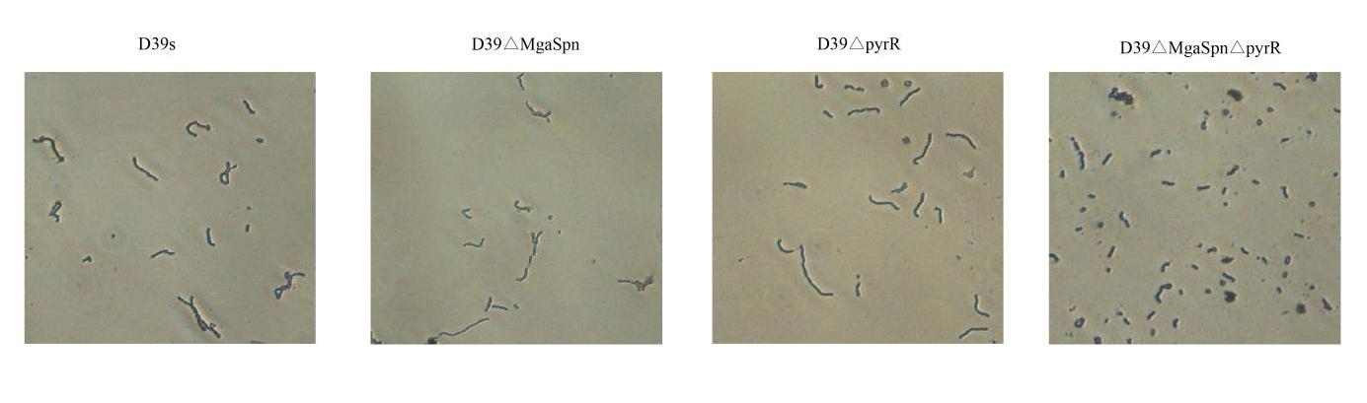
Figure S4. Bacterial morphology. Gram staining was used to observe the Chain length (×40 objective).

