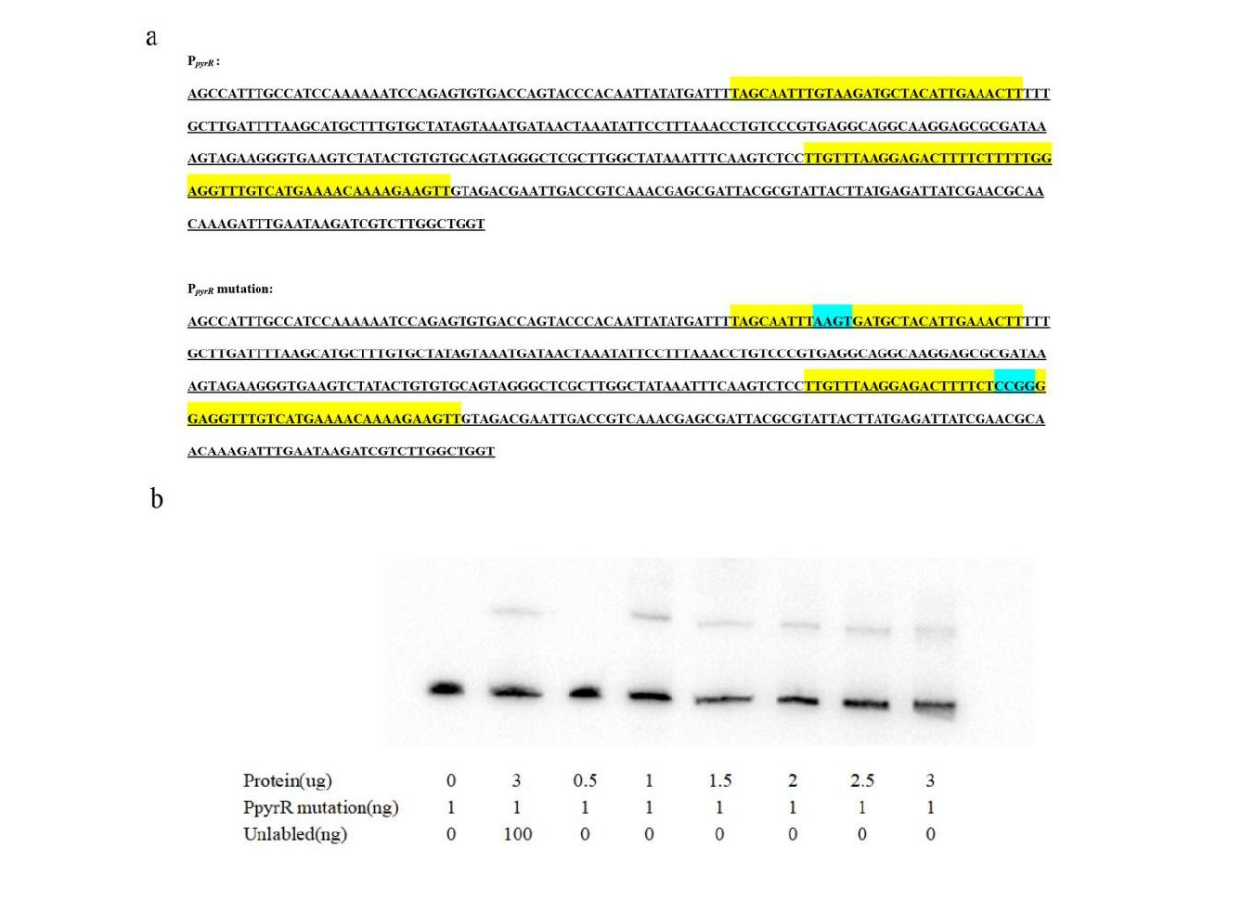
Figure S2. EMSA of MgaSpn protein with PpyrR mutation probes. (a)PpyrR is the original pyrR promoter sequence, PpyrR mutation is the mutant promoter sequence. The yellow background region is the specific recognition site of MgaSpn in PpyrR, while the blue background region is the mutation sequence. (b) EMSA of 6 × His-MgaSpn protein with PpyrR mutation probes.

